**ENGLISH SONGS IN TEACHING ENGLISH PRONUNCIATION**

**(A Descriptive Study at the Seventh Graders of MTs N 01 Jepara in the Academic Year of 2018/2019)**

**THESIS**

Submitted in Partial Fulfillment of the Requirements

for Degree of Bachelor Education in English Education



Composed by:

**MANUNAL AHNA**

133411020

**EDUCATION AND TEACHER TRAINING FACULTY**

**UNIVERSITAS ISLAM NEGERI WALISONGO**

**SEMARANG**

**2019**

**DECLARATION**

I Certify that this thesis is definetely my own work,unaided work. It is being submitted in partial fulfilment for degree of Bachelor of Education in UIN Walisongo, Semarang. It has not been submitted before for another degree or examination. Opinions or findings of others included in this thesis are qooted and cited in accordance with ethical standard. Semarang, 26 July 2019

Reseacrher

Manunal Ahna

NIM. 133411020

ii



**KEMENTERIAN AGAMA**

**UNIVERSITAS ISLAM NEGERI WALISONG**

**FAKULTAS ILMU TARBIYAH DAN KEGURUAN**

Jl. Prof. Dr. Hamka (Kampus II) Ngaliyan

Tel. (024) 7601295 Fax. 7615387 Semarang

RATIFICATION

Thesis with the following identity :

Title : ENGLISH SONG IN TEACHING ENGLISH PRONUNCIATION (A Descriptive Study at the Seventh Graders of MTs N 01 Jepara in the Academic Year of 2018/2019)

Name of Student : Manunal Ahna

Department : English Education Department

Hadhbeen retified by the board of examiner of Education and Teacher Training Faculty Walisongo State Islamic University Semarang can be received as one of any requiretment for gaining the Bachelor Degree in Engling Language Education.

Semarang, 31 July 2019

THE BOARD OF EXAMINERS

Chairperson Secretary

**Dr. Ikhrom, M.Ag** **Nadiah Ma’mun, M.Pd**

NIP. 19650329 199403 1 002 NIP. 19781103 200701 2 016

Examiner I Examiner II

**Dr. Hj. Siti Mariam, M.Pd** **Sayyidatul Fadillah, M.Pd**

NIP. 19650727 199203 2 002 NIP. 19810908 200710 2 011

AdvisorI Advisor II

**Dr. Siti Tarwiyah, S.S. M.Hum Lulut Widyaningrum, M.Pd**

**NIP. 19721108 199903 2 001 NIP. 19800803 200901 2 010**

iii

**MOTTO**

“When you want something, all the universe conspire in helping you to achieve it”

(Paulo Caelho)

“If you’re doing your best, you won’t have any time to worry about failure”

(M. Jackson Brown)

vi

**DEDICATION**

This thesis is dedicated for my beloved father and mother bapak and ibuk, and also for my beloved sister and brother. They who always support me in everything I do. Thank you for always advising me to do the right thing.

vii

**ABSTRACT**

Name : Manunal Ahna

Students Number : 133411020

Title : English Songs in Teaching English Pronunciation (A Descriptive Study at the Seventh Graders of MTs N 01 Jepara in the Academic Year of 2018/2019)

English pronunciation is a problem in learning English for EFL students to pronounce the English words. The same case happens at MTs N 01 Jepara. The purpose of the study was to describe teaching English pronunciation using English song and to find out the problems of teaching English pronunciation using English song.

This study used qualitative method because the data were analyzed using sentences. The data were collected by two techniques; observation and interview. Process of data analysis involved three activities; data reduction, data display, and conclusion or verification. Descriptive analysis was used to present the result of study in the form of descriptive explanation.

The result of this study showed that English song is suitable media to teach English pronunciation. To deal with the problems, the teacher uses song as a media. For the teachers belief is that song can help the students’ pronunciation in pronouncing words. Using English song as a media can help the students to pronounce English words correctly, because the singer is come from native speakers. The students also get another benefits when the teacher using song in learning process, one of them, can give the students enjoy and comfortable to follow the lesson. The researcher state that English song is a matter media but the most important thing is the way teachers presenting the English song, so is really helpful students’ pronunciation.

Keywords: pronunciation, song, teaching English pronunciation.

viii

**ACKNOWLEDGEMENT**

*Bismillahirrahmanirrahim,*

*Alhamdillahirobbil’alamin*. First and foremost, all praises due to Allah SWT, the Almighty God for His blessing, kindness, and inspiration in lending me to accomplish the final project.

Second, sholawat and salam are addressed to the Prophet Muhammad SAW who brings us from darkness to the brightness.

However, this final project will not be complete without the help of others. Many people have helped me during the writing of this final project and it would be impossible to mention all of them. I give my sincerest gratitude and appreciation to:

1. Dr. H. Raharjo, M.Ed. St., the Dean of Education and Teacher Training Faculty (FITK) of Universitas Islam Negeri (UIN) Walisongo Semarang.
2. Dr. H. Ikhrom, M.Ag. the Head of English Language Education Department of Universitas Islam Negeri (UIN) Walisongo Semarang.
3. Dr. Siti Tarwiyah, S.S, M.Hum. as the advisor I and Lulut Widyaningrum, M.Pd. as the advisor II, for their patience in providing careful guidance, helpful corrections, very good advice as well as suggestion and encouragement during the consultation for this paper from beginning until the end.

ix

1. All lectures in English Language Education Department for valuable knowledge and advice during the years of my study.
2. My life time teachers-beloved father and mother, Bapak baidlowi and Ibu Siti Sahiroh. Thank you for everything that you have given to me and I cannot mention one by one, only Allah SWT knows how much you mean to me.
3. My beloved sister and brother, mbak Mala, dek Uul, dek Fina, dek Saskia and dek Adib who always support and pray for me.
4. Last but not least, my best friends, Nor Aini, Rara Sarasmita, Nuri Ahsanti, who have supported, given motivation and prayed for me to finish this thesis.

Finally, the researcher realizes that this thesis is still far from being perfect; therefore, the researcher will be happy to accept constructive criticism in order to make it better. The researcher hopes that this thesis will be beneficial for everyone especially in developing teaching and learning process. Semarang, July 26th 2019

The Researcher,

Manunal Ahna

NIM. 133411020

x

**TABLE OF CONTENT**

**TITLE i**

**DECLARATION ii**

**ADVISOR NOTE iii**

**RETIFICATION v**

**MOTTO vi**

**DEDICATION vii**

**ABSTRACT viii**

**AKCKNOWLEDGEMENT ix**

**TABLE OF CONTENT xi**

**APPENDICES xiv**

**CHAPTER**

1. **INTRODUCTION**
2. Background of the Study 1
3. Reason for choosing the topic 5
4. Questions of the research 5
5. Objectives of the research 6
6. Significance of the research 6
7. Limitation of study 7
8. **REVIEW OF RELATED LITERATURE**
9. Previous Study 8
10. Theoretical Framework 11
11. Song 11

xi

1. The definition of song 11
2. The basic elements of song 12
3. Procedure in applying the songs 14
4. Pronunciation 16
5. English pronunciation 16
6. Consonants 18
7. Vowels 24
8. Dipthongs 25
9. Stress and rhythm 26
10. Intonation 28
11. Teaching pronunciation using songs 29
12. The problem in pronunciation 31
13. The importance of pronunciation 34
14. **METHOD OF THE RESEARCH**
15. Research design 36
16. Research setting 37
17. Research object 37
18. Method of collecting data 38
19. Instrument of the research 40
20. Method of analyzing data 41
21. **RESEARCH FINDING**
22. The ways to teach English pronunciation by using English song to the seven grade of MTs N 01 Jepara in the Academic year of 2018/2019 44

xii

1. The problems face during teaching English by using song to the seven grade of MTs N 01 Jepara in the academic year of 2018/2019 63
2. **CONCLUSION AND SUGGESTION**
3. Conclusion 70
4. Suggestion 71

**BIBLIOGRAPHY**

**APPENDICES**

**CURRICULUM VITAE**

xiii

**APPENDICES**

Appendix 1 DAFTAR KELAS

Appendix 2 Teacher Observations Sheet

Appendix 3 Students Observation Sheet

Appendix 4 Interview

Appendix 5 Observations’ Result

xiv

**CHAPTER I**

**INTRODUCTION**

In this chapter, the researcher presents the background of the study, reason for choosing the topic, question of the research, objectives of the research, significance of the research, limitation of the study.

1. **Background of The Study**

Language is an important thing that should be learnt by people. Language is a tool to make a communication happen. It is impossible to communicate with other people without using language. Every nation has its own language, and the characteristic of one language is different from others. There are so many language in this word, and every language is unique. Rasulullah saw, said:

عَنْ خَارِجَةَ بْنِ زَيْدِ بْنِ ثَابِتٍ عَنْ أَبِيهِ زَيْدِ بْنِ ثَابِتٍ قَالَ أَمَرَنِى رَسُولُ اللَّهِ -صلى الله عليه وسلم- أَنْ أَتَعَلَّمَ لَهُ كَلِمَاتِ كِتَابِ يَهُودَ. قَالَ « إِنِّى وَاللَّهِ مَا آمَنُ يَهُودَ عَلَى كِتَابٍ ». قَالَ فَمَا مَرَّ بِى نِصْفُ شَهْرٍ حَتَّى تَعَلَّمْتُهُ لَهُ قَالَ فَلَمَّا تَعَلَّمْتُهُ كَانَ إِذَا كَتَبَ إِلَى يَهُودَ كَتَبْتُ إِلَيْهِمْ وَإِذَا كَتَبُوا إِلَيْهِ قَرَأْتُ لَهُ كِتَابَهُمْ. قَالَ أَبُو عِيسَى هَذَا حَدِيثٌ حَسَنٌ صَحِيحٌ

From kharijah bin Zaid bin Tsabit, from his father; Zaid bin Tsabit, he said: Rasulullah Shalalluhu alaihi wa sallam asks me to learn (for him) words (language) from Jew’s book (letter), he said: “By Allah, I don’t feel secure of (treason) Jews of my letter.” So, not as far as half of month I can master their language. When I have mastered it, then if he writes a letter to Jew I am who wrote the letter. And when they write a letter to him.” Abu Isa said that this hadits is hasan sahih. [HR. At Tarmidzi no. 2933]

This hadits explains that one of the importances of learning other language is to avoid the trickery of enemy. It also means that we must know and learn language to avoid miscommunication so that something bad would not happen. While, learning is also a command from Allah swt, and one of them is researching language.

Language is forms, sounds, and letters, combined into larger units such as words, sentences, and so forth. English has many words with irregular and unpredictable spellings, and this can lead students to mispronounce those words. For example, if students learn words *rain, plain,* and *maintain,* they will naturally assume that the letters *ain* must represent /eyn/.

As foreign language, English is very difficult study especially for the students whose native language is different. They may encounter many elements of the language which are unfamiliar for them. As a result, they may possibly make a lot of mistakes in using language or misunderstand when they are studying it. For example, many students are not able to identify pronunciation on the lyric of the songs which do not exist in their own language. It will lead them to some difficulties in their learning progress.

Pronunciation is one of the most important parts of English to communicate with others since their differences between the symbol and its sounds. Pronunciation is the way in which we pronounce word, especially in a way that is accepted or generally understood. In English, there are so many sounds and words. Most students incorrectly pronounce or mispronounce the final sound English pronunciation.

Teaching pronunciation not only makes students aware of different sounds and sound features, but also can improve their speaking immeasurably.[1] Teaching English pronunciation does not only mean teaching spelling and speaking, it requires other language skills, such as listening and reading. That is why, method in this case teaching pronunciation can be applied in teaching those language skills all together. It occurs in every level school, including the seventh graders of senior high school.

Pronunciation teaching forms a part of many sequences where students study language form. Pronunciation is an extremely personal matter, and even in monolingual groups, different students have different problems, different needs, and different attitudes to the subject. In multilingual groups, of course, students from different language backgrounds may have very different concerns and issues to deal with. The areas of pronunciation which we need to draw our student’s attention to include individual sounds they are having difficulty with, word and phrase/sentence stress and intonation. But students will also need with connected speech for fluency and with the correspondence, or lack of it, between sounds and spelling.[2]

One of the big problems that we all face, in teaching English for children, is maintaining the learners are interested in our lessons. So, we must be very creative in applying techniques. What makes English song such a great teaching media is it universal connecting all cultures and languages. So, that is why it is one of the best resources in creating the atmosphere class is interesting, fun and enjoyable.

Students at the school were more interested to follow the lesson when the teacher uses songs as media. Besides fun, students can also learn pronunciation correctly. The problems faced by the students when pronouncing the word nearly the same sounds. For example, buy and by, hear and here, see and sea, accept and except, write and right, hurt and hard, than and then, etc.

By using songs as media, the writer hopes that it will be used as alternative technique in enhancing the mastery of English pronunciation of senior high school’s students. They are not only the object of teaching but also participants. In other words, the teacher makes students active instead of being silent. And also the writer wants to change some assumption at the learning English is difficult, boring and confusing for students.

1. **Reason for Choosing The Topic**

According to explanation, it is clear that is very important to improve student skills in study. In fact, English songs can be used in teaching English pronunciation. English songs also can improve students’ English pronunciation at MTs N 01 Jepara.

1. **Question of The Research1470**

This study is guided though the following mayor questions:

1. How to teach English pronunciation using English songs to the seventh graders of MTs N 01 Jepara in the academic year of 2018/2019?
2. What are the problems faced by the teacher in teaching English pronunciation using English song to the seventh graders of MTs N 01 Jepara in the academic year of 2018/2019?
3. **Objectives of The Research**

The objectives of the study are the following:

1. To explain teaching English pronunciation using English songs to the seven graders of MTs N 01 Jepara in the academic year of 2018/2019.
2. To find out the problems of teaching English pronunciation using English songs to the seven grade of MTs N 01 Jepara in the academic year of 2018/2019.
3. **Significance of The Research**

The writer chooses the title Using English Pop Songs to Teach English Consonants (A Descriptive Study of Seventh Graders of MTs N 01 Jepara in Academic Year 2018/2019) in the hope that finding of this study will give great advantages for the following group of people:

1. The writer

The writer will have experience and capability in teaching pronunciation by using songs which is also suitable for senior high school students.

1. The teacher

The results of the study are expected to be used as one of considerations in teaching pronunciation for young learners.

1. The institution

The institution will take a lesson from this thesis about English pronunciation by using songs.

1. The reader

The writer hopes that the result of the study would be worth consideration when people try to improve their pronunciation in English and it would become reference for the next researches of similar study.

1. **Limitation of Study**

To limit the scoop of the research and to analyze the problems, the findings of the research should be limited by the following factors:

1. The writer limits the investigation on teaching English consonants by using songs.
2. The writer holds the study at the seven grade of MTs N 01 Jepara in the Academic Year of 2018/2019.
3. The study is directed at describing teaching English consonants by using English songs; identify the influence of teaching English by using songs on the students’ English consonants and engagement of the students.

**CHAPTER II**

**REVIEW OF THE RELATED LITERATURE**

This chapter presents review of theoretical writings related to the study. These theories are used to provide information in case of answering the question about the study. This part is divided into three sections; previous study, theoretical framework, and hypothesis.

1. **Previous Study**

The writer considered some previous researches related to this study in composing this thesis, these are:

1. Mr. Iman Shahadeh & Mohammed Farrah (2016), *“The Effectiveness of Using Children’s Songs in Developing Elementary Graders’ English Vocabulary and Pronunciation in Jerusalem, Palestine”* Palestine.

This study aimed at investigating the effect of using children’s song in developing the elementary graders’ vocabulary and pronunciation. It aimed also to investigate teachers’ attitudes towards the use of songs in their English classes.

The participants were 123 EFL students of the fourth grade; 72 females and 51 males. Both groups are from four private schools in Jerussalem; two groups for boys, and two groups for girls. One boys’ school and one girls’ school were chosen to be the experimental group consisting of 58 participants, while the other boys’ and girls’ schools’ were chosen to be the control group consisting of 65 participants. Study data were collected via students’ pre and post test and teachers’ questionnaire.

Exams results showed that students have improved their vocabulary and pronunciation due to the use of songs in learning. Questionnaire results showed that teachers have positive attitudes towards the use of songs in their classes as songs have positive effects in increasing students’ achievement, interest and motivation.[3]

The writer of this study thought that this study related with her research. Because this study had similar purpose, which was to improve students’ pronunciation. The differences between the studies of Iman Shehadeh & Mohammed Farrah with the study she conducted were about the technique they used in their study. Iman Shehadeh & Mohammed Farrah used both of the technique pre & post test and questionnaire, while, the study of the writer used are observation and interview.

1. Mr. Supeno (2018), *“Using songs to improve students’ pronunciation”* Universitas Wijaya Kusuma Surabaya, Indonesia.

This study was about songs to improve students’ pronunciation. This study was done to understand and improve the production of the various sounds and the supra-segmentel features of English as a foreign language. The subject of this study is all of the 30 students of SMA Hang Tuah 2 Surabaya. According to 8 questions of questionnaire, 27 of the 30 students choose A (for question no. 8). It means that the students themselves absolutely agree that using songs to improve the [4]students’ pronunciation is a suitable technique.

This study is discussed descriptive-qualitatively based on the author’s personal experience as a foreign language learner and teacher. It is discussed how using songs in the English classroom can help students improve their English pronunciation. Supported with a simple questionnaire given to secondary school students, it is also found that most students have a strong interest in listening and understanding popular English songs.

The writer of this study stated that study had similar purpose, which was to find a technique for pronunciation to students. The difference between Supeno’s studies with the writer’s study was about the subject of the study and the technique of collecting the data. Supeno took senior high school students for being the subject of the study and questionnaire for collecting data, while, this study took students of junior high school for being the subject of the study and observation and interview for collecting the data.

1. **Theoretical Framework**
2. Song
3. The Definition of Song

A song is a short piece in one concise movement for the medium of solo voice and piano.[5] Song is considered to help and encourage the students to make and sustain their effort because they will be a lot of opportunity to practice their language more freely. Song in foreign language classes maybe use to motivate students and to create a more relaxing foreign language classes. Because by English songs also are effective to make the students to remember the words easily and feel more motivated in the class because learning process interesting.

Song is an interesting media that offers the high imagination. The language of song is usually easy to be understood. It gives motivation and makes the relation between the teacher and students closer. And the relation will make the students have bravery to ask the teacher about everything including new vocabularies in song that they learn.

1. The Basic Elements of Song

A song is like a magic that can hypnotize us, therefore, when we hear the song we could be brought into the songs. For example, when someone is listening to a song, he/she can be brought into the story of the lyrics and the melody will play his/her emotion or feelings.

When the teachers choose the song to teach students, the teacher should know what is the basic elements of song. The basic elements of song there is six elements. First, Pitch. Pitch is organization of pitches with a pattern of intervals between them creates scales. Words we might use to describe scales: major/minor, chromatic, gapped, pentatonic.[6]

Second, Rhythm. Rhythm is the time element of music. A specific rhythm is a specific pattern in time. We usually hear these in relation to a steady pulse, and mentally organize this pulse or tempo into meter (sometimes called a “time signature”). Meter organizes beats into groups, usually of two or three. Beats can be divided into small units 2, 3, or 4 subdivisions.

Third, Melody. Melody or musical line is a combination of pitch and rhythm (some say “duration”). Sometimes a melody is considered to be the theme of a composition. We might characterize melody by its contour (rising or falling) and the size of the intervals in it. A melody that uses mostly small intervals (or scale steps) and is smooth is said to be a conjunct melody. Not surprisingly, a melody that uses large intervals is called a disjunct melody. A motif (or motive) is either a very short melody or a distinctive part of a longer melody.[7]

Fourth, Timbre. Timbre is sound quality or tone color. Timbre is the characteristic that allows us to distinguish between one instrument and another, and the difference between vowel sounds (for example, long “a” or “ee”). Terms we might use to describe timbre: bright, dark, brassy, reedy, harsh, noisy, thin, buzzy, pure, raspy, shrill, mellow, and strained.

Fifth, Dynamics. Dynamics is a composition that has extremely soft passages as well as extremely loud passages is said have a large or wide dynamic range. Dynamic can change suddenly or gradually (crescendo, getting louder, or decrescendo, getting softer).

Sixth, Texture. The part of texture is Monophonic (one voice or line), Polyphonic (many voices, usually similar, as in Renaissance or Baroque counterpoint), Homophonic (a melody with simple accompaniment, chords moving in the same rhythm (homorhythmic)), Heterophony (“mixed” or multiple similar versions of a melody performed simultaneously), and Collage (juxtaposition and superimposition of extremely different textures or sound).[8]

1. Procedure in Applying the Songs

To apply songs in the classroom, the teacher should also plan application sequence of the songs. In applying songs, the research offers two procedures suggested by Ur and Wright and Haycraft.

1. The procedure suggested by Ur and Wright as follows:
2. Preparation: select a tape recording of a song so that you can sing it. Prepare an overhead transparency (or a poster/hand out) of the words of the song.
3. Procedure: first, play the song on a tape or sing it to yourself; second, show the words of the song; third, ask the students to follow the words; fourth, sing while you play it again.[9]
4. The procedure suggested by Haycartf as follows:
   1. Play the tape as many times as necessary and ask questions;
   2. Get the class to use line by following the tape
   3. Divide up the class and have agroup, each singing a line. Reply the tape as often as necessary. Find out who has a good voice and try to get solos. Bring out the student to conduct different combination until the song is familiar.
   4. Play and sing whenever you want to revise. It is good to play songs at the beginning of class, while everyone is setting down.[10]
5. **Pronunciation**
6. English Pronunciation

Pronunciation is the way a word or a language is usually spoken, the manner in which someone utters a word. Hornby says that pronunciation is the way in which a language is spoken, the way in which a word is pronounced, the way a person speaks the words of a language. From the definitions above, it shows conclusion that pronunciation is the way person utters a word or a language.[11]

Based on the definition above, all the word or words that produced from the mouth of the people has the rule for each of them. Which its rule can make the word or words produced correctly. To get the good pronunciation, learners also need a good teaching from professional teacher.

The production of all vowels needs vibration. That’s why it is said that vowels are voiced. Which part of the tongue, how high it is raised and the shape of lips are involved in the classification of vowels. In producing those, our organs of speech remain at the same position (no movement).[12]

E.g:

|  |  |  |
| --- | --- | --- |
| Phonetic Symbols | Key word in Orthography | Phonetic Writing |
| /i:/ | Bee  Even  Eager | /bi:/  /’i:vn/  /’i:ge(r)/ |
| /I/ | Sit  Exit | /sIt/  /’eksIt/ |

As in the production of vowels our speech organ remains in the same position. In producing diphthong, we glide our speech organs to the next vowel position.

E.g:

|  |  |  |
| --- | --- | --- |
| Phonetic Symbols | Key word in Orthography | Phonetic Writing |
| eI | Page  Lay  Erase | **/**peId3/  /leI/  /’ireIz:/ |
| aI | Five  Lie  Iris | /faIv/  /laI/  /’aIƏris/.  etc. |

1. Consonants

Consonant is negatively defined, that is, sounds which are not vowels are consonants.[13] It is, therefore, of some use if the basic features of vowels are more closely examined.

The natural consequences of this definition are as follows:

* All voiceless sounds, i.e. sound in which the vocal cords are not in vibration, are consonants, for example: /s, f, θ, k, h/;

/s/ backs /bæks/

/f/ leaf /lif/

/θ/ teeth /’ti:θ/

/k/ keep /ki:p/

/h/ heart /ha:t/, etc.

* All sounds in which the air goes out through the sides of the tongue (nasal sounds) are consonants, e.g. /m, n, η/;

/m/ lamp /læmp/

/n/ plants /plænts/

/η/ sung /sʌng/

* All sounds in which the air goes out through the sides of the tongue (lateral sounds) are consonants, e.g. /l/;

/l/ lift /lift/

* All sounds in which there is an interruption of closing and opening of the air passage (trilled sounds) are consonants, e.g. /r/ or the lingual trilled sound as produced in Scotch or Indonesian, /R/, the uvular rolled sound in German, Dutch, and French.

/r/ run /rʌn/

* All sounds in which meet with a complete stoppage or complete obstruction somewhere in the mouth or speech tract are consonant; these are called plosive sounds or stops, e.g. /p, b, t, k, g, t∫, dʒ/.

/p/ pan /pæn/

/b/ cab /kƏb/

/t/ late /leit/

/k/ can /kƏn/

/g/ green /gri:n/

/t∫/ which /wIt∫/

/dʒ/ judge /dʒʌdʒ/

* All sounds in which the air meets with a partial obstruction somewhere in the speech tract or mouth, so that a frictional sound is heard, are consonants; e.g. /f, v, s, z, θ, ð, ∫, ʒ, h/

/f/ life /laif/

/v/ very /very/

/s/ see /si:/

* All sounds which are not syllabic are also considered as consonants, e.g. /y, w/, and are usually called semivowels.

/y/ you /ju:/

/w/ why /wƏI/

1. The manner of articulation

The manner of articulation refers to the interaction between the various articulators and the airstream.[14] The various terms used are explained below:

(Plosive), a complete closure is made somewhere in the vocal tract and the soft palate is also raised. Air pressure (closure) behind the (closure), and is then released ‘explosively’, e.g. /b/, /g/, and /p/.

(Affricate), a complete closure is made somewhere in the mouth, and the soft palate is raised. Air pressure increase behind the closure, and is then released more slowly than in plosives, e.g /dƷ/, /v/, /ð/, and /z/, /Ʒ/, /h/. (Fricative), when two vocal organs come close enough together for the movement of air between them to be heard, e.g /f/ and /v/.

(Nasal), a closure is made by the lips, or by the tongue against the palate, the soft palate is lowered, and air escapes through the nose, e.g /m/, /n/, and /η/.

(Lateral), a partial closure is made by the blade of the tongue against the alveolar ridge. Air is able to flow around the sides of the tongue, e.g /l/.

(Approximant), vocal organs come near to each other, but not so close as to cause audible friction, e.g /r/, /j/ and /w/.[15]

1. The place of articulation

Place of articulation gives more information about what the various articulators actually do.[16] The chief points of articulation with special reference to the sounds for English are the following:

(Bilabial), the two lips are the primary articulation, e.g (p, b, m).

(Labio-dental), the lower lip articulates with the upper teeth, e.g (f, v).

(Dental), the tongue tip and rims articulate with the upper teeth, e.g (ð, θ).

(Alveolar), the blade, or tip and blade, of the tongue articulate with the alveolar ridge, e.g (t, d, l, n, s, z).

(Retroflex), the tip of the tongue is curled back to articulate with the part of the hard palate immediately behind the alveolar ridge, e.g (r).

(Pala-alveolar), the blade, or the tip and the blade, of the tongue articulates with the alveolar ridge and there is at the same time a raising of the front of the tongue towards the hard palate, e.g (∫,Ʒ, t∫, dƷ).

(Palatal), the front of the tongue articulates with the hard palate, e.g (j, k, g, c).

(Velar), the back of the tongue articulates with the soft palate, e.g (k, g, η).

(Uvula), the back of the tongue articulates with the uvula, e.g (r).

(Glottal), an obstruction, or narrowing causing fiction but not vibration, between the vocal cords, e.g (h).[17]

1. The force of articulation

While, force of articulation concerns on fortis or strong, and lenis or weak. Fortis happens to unvoiced sounds, and lenis happens to voiced sounds.[18] Thus, Adrian mention this section by voiced and unvoiced, whereas Gymson name it by regressive plutonic consonantal sounds.

A voiceless/voiced pair such as (s, z) are distinguish not only by the presence or absence of voice but also by the degree of breath and muscular effort involved in the articulation. Those English consonants which are usually voiced tend to be articulated with relatively strong. Thus, it may be important to define (s), for instance, as strong or forties and (z) as weak or lenis.[19]

1. Vowels

A vowel has been defined as a voice sound (resonant) during the production of which air goes out through the mouth (oral) along the middle part of the tongue (central) in a continuous stream without meeting such a narrowing in the mouth as would result in an audible fiction.[20] E.g. /u, æ, Ə/.

/u/ suit /su:t/

/æ/ hair /bæt/

/ Ə/ above / Əbʌv/

1. Diphthongs

A diphthong is kind of vowel with a special features, that is a deliberate glide made from one vowel position to another vowel position, and which produced in one syllable. The term ‘glide’ here refers to the rationale sounds heard when the speech organs move from one position for a given sound to that for another. There are four English centering diphthongs: /eI, oU, aI, aU, ƆI, IƏ, ƐƏ, uƏ, ƆƏ/.

Example:

/eI/ lay /leI/

/oU/ no /noU/

/aI/ lie /laI/

/aU/ how /haU/

/ƆI/ boy /bƆI/

/IƏ/ here /hIƏ/

/ƐƏ/ hair /hƐƏ/

/uƏ/ poor /puƏ/

/ƆƏ/ yours /yƆƏz/.

**Vowels and dipthongs**

|  |  |  |  |
| --- | --- | --- | --- |
| VOWELS | | DIPTHONGS | |
| i: | Bead | eI | Cake |
| I | Hit | ƆI | Toy |
| Ʊ | Book | aI | High |
| u: | Food | I Ə | Beer |
| E | Left | Ʊ Ə | Fewer |
| Ə | About | e Ə | Where |
| ɜ: | Shirt | Ə Ʊ | Go |
| Ɔ: | Call | a Ʊ | House |
| Æ | Hat |  |  |
| Λ | Run |  |  |
| ɑ: | Far |  |  |
| ɒ | Dog |  |  |

Table. Gerald Kelly “How to teach Pronunciation”

1. Stress and Rhythm

English is a lexical stress language, which means that in any English word with more than one syllable, the syllables will differ in their relative salience. Word stress in English is variable-any syllable of a polysyllabic word can carry the main stress.[21]

Many writers have said that English word stress is so difficult to predict that it is best to treat stress placement as a property of the individual word, to be learned when the word itself is learned.

In order for one syllable to be perceived as stressed, the syllables around it need to be unstressed. For stressed syllables, three features were identified: loudness, pitch, change and a longer syllable. Unstressed may be described as the absence of these.[22] Obviously, single-syllable words present no problems. While, two or more syllable are need to be noticed.

In sentence stress, the stressed word usually occurs on the vital clues that the speaker want the listener know from his message. This explanation base3d on Kelly’s explanation, he explains sentence stress is an important feature of language which provides listeners with vital clues as the prominent points of the speaker’s message.[23] One sentence can have a different meaning with different stressed words.

Another feature of pronunciation in this section is rhythm. According to Joanne, rhythm is a product of word stress and the way in which important items are fore grounded through their occurrence on a strong beat, and unimportant items are back grounded by their occurrence on a week beat.[24] The stressed syllable/word occurs on weak beat.

1. Intonation

The third feature of English language is intonation. The term intonation refers to the way of the voice rise of fall in pitch when we are speaking. Based on Connor, he said every language has melody in it, and every language is spoken by a different musical note on the time. English intonation also has own model of intonation. We must learn the meanings of the English shapes and tunes, for example, thank you has two models in producing it. First, it will be starts with low voice and ends with high voice and this shows real gratitude. Second, it will be starts with low voice and this shows a rather casual acknowledgement of something not very important.[25]

Marnie also states intonation is the use of pitch variations in the voice of communication phrasing and discourse meaning in varied linguistic environments.[26] Pitch refers to the relative frequency of vibration while low pitch refers slow vibration.

1. Teaching Pronunciation using songs

A song can be used to practice the pronunciation which is kept the brain memory unconsciously. This situation creates a relax and amusing learning process, the students are well motivated to learn the correct pronunciation.

Harmer, states that music is a powerful stimulus for student engagement precisely because it speaks directly to our emotions while still allowing us to use our brains to analyze it and its effects if we so wish.[27] Song is a good resource for English teaching.

There many factors that influences language teaching especially English pronunciation teaching. Besides teacher should select the media that suitable to be applied in teaching English pronunciation, they also should know how to teach pronunciation well. By knowing the goal way in English pronunciation, the result that is received will be more maximal and alternative in pronunciation is teaching.[28]

Songs can help the students to pronounce some words well. The students can discuss the different topics in the lyrics like love, hate, revenge, and in this manner, they can practice speaking by expressing opinions and reflections about the contents of the songs. There are some techniques how to teach pronunciation by using English song: first, guess the vocabulary is missing in song lyric; this method is usually done when the teacher wants to exercise listening and writing the students. Second, ask the students to sing a song in front of the class; this method can be used to know how the students pronounce a word correctly. Third, wrote the song lyric from the listening of song; this technique more difficult than before, because the students were asked to write the lyrics without the help.

According to Odishi, teaching pronunciation is liked two-way traffic in which both directions of movement are needed in order to complete the cycle of communication.[29] Means, to get a good pronunciation, both of theory and practice of pronunciation are needed in order to get a good result.

Pronunciation teaching not only makes students aware of different sound and sound features, but can also improve their speaking immeasurably. Concentrating on sounds, showing where they are made in the mouth. Moreover, under the pressure of such cultural considerations it has become customary for language teachers to consider intelligibility as the prime goal of pronunciation teaching.

Using songs in teaching process will be possible to the effectiveness of teaching language. Beside, using song in learning process will make students be pleasure. Songs learnt by heart have less controlled language but nay give the child access to language chunks which the child linguistic data base from which generalizations may be made. Students often find great pleasure in learning English song.

1. The Problem in Pronunciation

In learning or teaching pronunciation, the learners and teachers should have to find the problems in their learning or teaching. According to Gilbert, he explains teaching pronunciation involves a variety of challenges. One of it, teachers often fined that they do not have enough time in class to give proper attention to this aspect of English instruction.[30]

Gerald Kelly explained that there are two key problems in teaching pronunciation, once it tends to be neglected, while the other it tends to be reactive. He stated that teachers‟ lacking interest in the subject is not the primary problem in teaching English pronunciation, but feeling of doubt in the way how to teach it was the primary problem. Largely, teachers and students emphasize in grammar instead of pronunciation whereas they often show considerable enthusiasm in pronunciation. They feel that pronunciation is needed for their better communication. Thus, teacher should regard to features of pronunciation and they ought to plan their pronunciation teaching well. To make success in teaching pronunciation, kelly stated that teachers need a good grounding in theoretical knowledge, practical classrooms skill and also access to good ideas for classroom activities.[31]

In addition, Joanne explains one of teacher’s roles is to help learners perceive sounds. Learners will have a strong tendency to hear the sounds of English in terms of the sounds of their native language.[32] Because of their mother tongue and also some sounds of English do not occur in other languages, learners often make some problem when they produce or imitate new sounds, then, the teacher may give hints to the learners which may help them to produce the new sounds.

The students’ pronunciation always is provided by their teacher in English class. But, when the student is out in an English-using environment and ‘on his own’ new and unfamiliar words will be met, many of them will find some confusing situation , and learners need to be equipped with a knowledge of the spelling conventions of English in order to decide how to pronounce them.

According to Connor, the main problem of English pronunciation is to build a new set of boxes corresponding to the sounds of English, and to break down the arrangement of boxes which the habits of our native language have so strongly built up.[33] From the explanations that have been mentioned above by some writers of the book, the researcher can conclude that most of pronunciation problems faced by the students is because of their mother tongue which is usually produce their first language instead of English language as their foreign or second language.

1. The Importance of Pronunciation

All the components of English language is very needed for all people, for example pronunciation. A good pronunciation could make a good communication. In business or another situation, good communication are very needed to make understand each other, and most of the people use English language to communicate when they come together with the people from another language community.

Kelly explains learners’ pronunciation errors which can make unsuccessful communication is an important thing on which to assess why it is important to deal with pronunciation in the classroom. A learner who often mispronounces some of phonemes will make difficult for the speaker from another country with another language community to understand. Even if students with a good grammar and lexis, but they also will face some difficult when they couldn’t make a good communication with a good pronunciation.[34]

Once learners are aware that English words have a stress pattern, that words can be pronounced in slightly different ways, that the pitch of the voice can be used to convey meaning, then they will know what to pay attention to and can build upon this basic awareness. Learners also need to develop a concern for pronunciation. They must recognize that poor, unintelligible speech will make their attempts at conversing frustrating and unpleasant both for themselves and for their listeners.[35]

**CHAPTER III**

**METHOD OF THE RESEARCH**

This chapter discusses several things which are; research design, research setting and research object, method of collecting data, validity and technique of data analysis.

1. **Research Design**

Research design refers to the outline, plan, or strategy specifying the procedure to be used in collecting data in research. This study used descriptive qualitative research. According to Lexy J. Moleong, Qualitative method is a research procedure that obtains descriptive data in written or spoken from the people and their behavior which is being observed.[36]

Considering data and the aims of research, the researcher uses qualitative research to conduct this study. Qualitative research is multi-method in focus, involving an interpretative, naturalistic approach to its subject matter. This means that qualitative researchers study things in their natural settings, attempting to make sense of or interpret phenomenon in terms of the meanings people bring to them.

The research conducts to analyze the use of English songs to teach English pronunciation in the seven grade students of MTs N 01 Jepara. The researcher uses qualitative method in order to know the real condition or situation while teaching and learning process. So that, the researcher can finds out the positive influence of using song in teaching English.

1. **Research Setting**
2. Research Place

This research was conducted in MTs N 01 Jepara. It is located on Tahunan-Batealit km 3.5 Jepara Street.

1. Research Time

This research was conducted in two weeks, from the 15th until 27th of July 2019. During the research time, the 1st and 2nd weeks were used to observation, interview, analyze the data and make a research report.

1. **Research Object**

The objects of this research are the students in the 7th grade of MTs N 01 Jepara. The reason for choosing the 7th grade to be the object of this research was because the students in this grade are still beginner. The researcher taught that their pronunciation is still bad. To authenticate the opinion, the researcher chose the students of 7th B grade of MTs N 01 Jepara where that class is the best class.

1. **Method of Collecting Data**

The researcher used the descriptive method in this research, so in conducting this research the researcher do some ways to collect data, such as doing observation and interview. The descriptions of each technique are given in the following:

1. Observation

Observation is one of primer data collection technique. It is very useful, systematic and selective way in monitoring and listening to interaction or phenomena which happened.

The researcher observes the teacher and students during the teaching and learning process, in the observation the researcher takes notes:

1. Student’s activities in pronunciation.
2. Student’s responses while teaching and learning process.

While the process of teaching and learning is going on the researcher observes the teacher’s role, students’ role, method of teaching and the lesson that is delivered by the teacher.

1. Interview

Instrument means equipment for collecting the data in doing research. Based on the statement, instrument takes an important role in conducting a research because it will gather the data accurately. The instrument in this research is list of interview questions to get information from the teacher about the use of English songs in teaching English.

According to Denzin and Lincoln, the interview is a conversation, the art of asking questions and listening. It is not neutral tool, for the interviewer creates the reality of the interview situation. In this situation, answer is given. Thus interview produces situated understandings grounded in specific interactional episodes. This method is influenced by the personal characteristics of the interviewer, including race, class, ethnicity and gender.[37]

The researcher uses interview as an instrument in collecting the data of using English song in teaching English pronunciation. The researcher will do interview section with the English teacher of 7B directly.

1. **Instrument of The Research**

The research used two instruments to gather the data. The instruments were observation and interview.

1. Observation

On the observation, the researcher used observation checklist as the instrument for collecting data. Observation checklist will be collecting data how is the teaching English pronunciation by using song.

The researcher observes the teacher and students during the teaching and learning process. In the observation, the researcher takes notes about:

1. Students’ activities in pronunciation class;
2. Students’ responses during teaching and learning process by using song.

You can see part of Appendix 2 & 3.

1. Interview

The next instrument is interview. According to Ary, the interview is one of the most widely used methods for obtaining qualitative data. Interviews are used to gather data on subjects’ opinions, beliefs, and feelings about situation in their own words. The qualitative interview is typically more probing and open ended less structured.[38]

The researcher was interviewed Mrs. Lis as English teacher at MTs N 01 Jepara. The researcher needs to know the problems faced by the teacher in teaching English pronunciation by using song. The question of interview can be seen totally in Appendix 4.

1. **Method of Analyzing Data**

After collecting the data, the next step is analyzing the data. The researcher will use technique Miles and Huberman Model. They said that qualitative data are collected through various techniques such as interviews, observation, documentation, notes, etc. Look more like words than numbers. Therefore the data must be processed and analyzed before use. Miles and Huberman offer a general pattern of analysis using a flow model, in which the researcher performs three simultaneous analysis activities: (i) data reduction (ii) display data (iii) conclusion / verification, which will be described in more detail as a follow:

1. Data Reduction

Data reduction refers to the process of selecting, refining, simplifying, segregating, and transforming "raw" data visible in field written notes. Therefore, data reduction took place during the research activities carried out. Here, the researcher will sharpen, select, focus, discard and organize data in one way, where the final conclusions can be described and verified.[39] The researcher makes coding and categorizes the data. The codes and categorization can help to break the data down into manageable pieces, it allows for the identification of relationship between units of meaning.

1. Data Display

In this second step, the set of information that has been compiled, the researcher will begin drawing conclusions and taking action.In this research activity carried out by making a display of data descriptions, or charts the data reduction results. By such reason, researchers couldn’t more easily understand what is happening, and then from that further work is planned based on what is already understood. Data displays were used to analyze the data which were taken from the data collection. The result of data display showed the real data. By displaying data, it were making the result explained easier what happen in the place that was observed.

1. Conclusion / verification

The next step was to make inferences and or verification. Based on this model, it was deemed that there was an interactive relationship between the changes process major components of the analysis. Therefore, the verification step in this research was done by looking back at the data reduction and display so that the conclusion does not deviate from the data analyzed.[40]

First, all of the data that had been collected through observation and interview will categorize to be as follows: teacher readiness, students readiness, teaching process, learning process, student’s response.

Then, the researcher conducted the triangulation process which the researcher selected the significant data. Finally, the researcher was concluded by rechecking the data.

In this research conclusion drawing / verification was done by analyzing the findings in the field, then the conclusions drawn previously checked and searched a valid facts to support the conclusion first. So the conclusion was drawn that could be said to be a credible conclusion.

**CHAPTER IV**

**RESEARCH FINDING**

This chapter presents the findings and discussion. In this chapter, the gathered data provided in case of answering the research problem in the research. This chapter discuss about result of research finding.

1. The ways to teach English pronunciation using English song to the seventh graders of MTs N 01 Jepara in the academic year of 2018/2019

Songs in the classroom are a wonderful way to learn English. According to Collin, a teacher in learning used song must give more attention to their students and a teacher can able to guide her/his students was sung.[41] By using song, a teacher teaches about music, intonation, pronunciation and a teacher can give a brief and translate even if their initial understanding of the vocabulary is poor.

The ways to teach English pronunciation by using English song are the following:

1. Choosing the right songs

It is easy to understand that using songs will offer a lot of advantages for the teacher and students. The teacher needs to find out if the rhythm is comprehensible, the singers voices are clear enough, the speed of the song, and the complexity of the structures and the vocabulary.

When the teacher teaches simple present tense, the teacher uses ‘on my way’ song by Alan walker. This song is easy to listen; the singer voice also clear enough, the lyric contains a simple present tense sentence, and also including the popular song. The lyrics are following:

[Verse 1: Sabrina Carpenter]  
I'm sorry but  
Don't wanna talk, I need a moment before I go  
It's nothing personal  
I draw the blinds  
They don't need to see my cry  
'Cause even if they understand  
They don't understand

[Pre-Chorus: Sabrina Carpenter]  
So then when I'm finished  
I'm all 'bout my business and ready to save the world  
I'm taking my misery  
Making my bitch; can't be everyone's favorite girl

[Chorus: Sabrina Carpenter]  
So take aim and fire away  
I've never been so wide awake  
No, nobody but me can keep me safe  
And I'm on my way  
The blood moon is on the rise  
The fire burning in my eyes  
No, nobody but me can keep me safe  
And I'm on my way

[Verse 2: Farruko]  
(Ya, ya)  
(Farru, yeah, guaya)  
Lo siento mucho (Farru), pero me voy (Eh)  
Porque a tu lado me di cuenta que nada soy (Eh-ey)  
Y me cansé de luchar y de guerrear en vano  
De estar en la línea de fuego y de meter la mano  
Acepto mis errore', también soy humano  
Y tú no ve' que lo hago porque te amo (Pum-pum-pum-pum)

[Pre-Chorus: Farruko]  
Pero ya (Ya) no tengo más na' que hacer aquí (Aquí)  
Me voy, llegó la hora 'e partir (Partir)  
De mi propio camino, seguir lejos de ti

[Chorus: Sabrina Carpenter]  
So take aim and fire away  
I've never been so wide awake  
No, nobody but me can keep me safe  
And I'm on my way  
The blood moon is on the rise (Is on the rise, na-na)  
The fire burning in my eyes (The fire burning in my eyes)  
No, nobody but me can keep me safe  
And I'm on my way

[Instrumental Break]

[Bridge: Sabrina Carpenter & Farruko]  
I'm on my way  
Everybody, everybody keep me safe  
Everybody, everybody keep me safe  
Everybody, everybody keep me safe  
Everybody, everybody keep me safe  
Everybody, everybody on my way

[Chorus: Sabrina Carpenter]  
So take aim and fire away  
I've never been so wide awake  
No, nobody but me can keep me safe  
And I'm on my way  
The blood moon is on the rise  
The fire burning in my eyes  
No, nobody but me can keep me safe  
And I'm on my way

Source: <http://www.metrolyrics.com/on-my-way-lyrics-alan-walker.html>

1. Get the lyrics

The teacher can get the lyrics from the internet or write by the teacher. It is important because it can help the students to pronounce well when they know the word. The lyrics that the teacher’s writing are the following:

**On My Way**

By: Alan Walker feat Sabrina Carpenter and Farruko

[Verse 1: Sabrina Carpenter]

I’m sorry but

Don’t wanna talk, I need a moment before I go

It’s nothing personal

I draw the blinds

They don’t need to see me cry

Cause even if they understand

They don’t understand

[Pre-Chorus: Sabrina Carpenter]

So then when I’m finished

I’m all ‘bout my business

And ready to save the world

I’m taking my misery

Making my bitch

Can be everyone’s favorite girl

[Chorus: Sabrina Carpenter]

So take aim and fire away

I’ve never been so wide awake

No, nobody but me can keep me safe

And I’m on my way

The blood moon is on the rise

Fire burning in my eyes

No, nobody but me can keep me safe

And I’m on my way

[Instrumental Break]

[Chorus: Sabrina Carpenter]

So take aim and fire away

I’ve never been so wide awake

No, nobody but me can keep me safe

And I’m on my way

The blood moon is on the rise (Is on the rise, na-na)

The fire burning in my eyes (The fire burning in my eyes)

No, nobody but me can keep me safe

And I’m on my way

[Instrumental Break]

[Bridge: Sabrina Carpenter & Farruko]

I’m on my way

Everybody, everybody keep me safe

Everybody, everybody keep me safe

Everybody, everybody keep me safe

Everybody, everybody keep me safe

Everybody, everybody on my way

[Chorus: Sabrina Carpenter]

So take aim and fire away

I’ve never been so wide awake

No, nobody but me can keep me safe

And I’m on my way

The blood moon is on the rise

The fire burning in my eyes

No, nobody but me can keep me safe

And I’m on my way

1. Use power point

To show the lyrics for the students, the teacher need power point slide. This will be more helpful for the teacher because the teacher can put the different color of the words which it is difficult to pronounce. The teacher can also manipulate the activities more variably. The colored words are the following:

**On My Way**

By: Alan Walker feat Sabrina Carpenter and Farruko

[Verse 1: Sabrina Carpenter]

I’m sorry but

Don’t wanna talk, I **need a moment** before I go

It’s nothing **personal**

I draw the **blinds**

They don’t need to see me cry

Cause even if they **understand**

They don’t **understand**

[Pre-Chorus: Sabrina Carpenter]

So then when I’m **finished**

**I’m all ‘bout** my business

And ready to save the world

I’m taking my **misery**

Making my **bitch**

Can be **everyone’s** favorite girl

[Chorus: Sabrina Carpenter]

So **take aim** and **fire away**

I’ve never been so **wide awake**

No, nobody but me can keep me safe

And I’m on my way

The **blood moon** is on the rise

Fire **burning** in my eyes

No, nobody but me can keep me safe

And I’m on my way

[Instrumental Break]

[Verse 2: Farruko]

(Ya, Ya)

(Farru, yeah, guaya)

Lo siento mucho (Farru), pero me voy (Eh)

Porque a tu lado me di cuenta que nada soy (Eh-ey)

Y me cansé de luchar y de querrear en vano

De estar en la línea de fuego y de meter la mano

Y tú no veˈ que lo hago porque tea mo (Pum-pum-pum-pum)

[Pre-Chorus: Farruko)

Pero ya (Ya) no tengo más naˈ que hacer aquí (Aquí)

Me voy, llegó la hora ˈe partir (Partir)

De mi propio camino, seguir lejos de ti

[Chorus: Sabrina Carpenter]

So **take aim** and **fire away**

I’ve never been so **wide awake**

No, nobody but me can keep me safe

And I’m on my way

The **blood moon** is on the rise (Is on the rise, na-na)

The fire **burning** in my eyes (The fire burning in my eyes)

No, nobody but me can keep me safe

And I’m on my way

[Instrumental Break]

[Bridge: Sabrina Carpenter & Farruko]

I’m on my way

Everybody, everybody keep me safe

Everybody, everybody keep me safe

Everybody, everybody keep me safe

Everybody, everybody keep me safe

Everybody, everybody on my way

[Chorus: Sabrina Carpenter]

So **take aim** and **fire away**

I’ve never been so **wide awake**

No, nobody but me can keep me safe

And I’m on my way

The **blood moon** is on the rise

The fire **burning** in my eyes

No, nobody but me can keep me safe

And I’m on my way

Source: <http://www.metrolyrics.com/on-my-way-lyrics-alan-walker.html>

1. Read the lyrics before listen to the song

To understand what the song about and how to pronounce it, the students must read the lyric first. Pay attention to the colored words that teachers do.

1. Listen to the song

After the students read the lyrics, the students listen to the song. The teacher can play twice or more.

This is the lyric of the song ‘On My Way’.

**On My Way**

By: Alan Walker feat Sabrina Carpenter and Farruko

[Verse 1: Sabrina Carpenter]

I’m sorry but

Don’t wanna talk, I need a moment before I go

It’s nothing personal

I draw **the blinds**

They don’t need to see me cry

Cause even if they **understand**

They don’t **understand**

[Pre-Chorus: Sabrina Carpenter]

So then when I’m **finished**

**I’m all ‘bout** my business

And ready to save the world

I’m taking my **misery**

Making my **bitch**

Can be **everyone’s** favorite girl

[Chorus: Sabrina Carpenter]

So **take aim** and **fire away**

I’ve never been so **wide awake**

No, nobody but me can keep me safe

And I’m on my way

The **blood moon** is on the rise

Fire **burning** in my eyes

No, nobody but me can keep me safe

And I’m on my way

[Instrumental Break]

[Verse 2: Farruko]

(Ya, Ya)

(Farru, yeah, guaya)

Lo siento mucho (Farru), pero me voy (Eh)

Porque a tu lado me di cuenta que nada soy (Eh-ey)

Y me cansé de luchar y de querrear en vano

De estar en la línea de fuego y de meter la mano

Y tú no veˈ que lo hago porque tea mo (Pum-pum-pum-pum)

[Pre-Chorus: Farruko)

Pero ya (Ya) no tengo más naˈ que hacer aquí (Aquí)

Me voy, llegó la hora ˈe partir (Partir)

De mi propio camino, seguir lejos de ti

[Chorus: Sabrina Carpenter]

So **take aim** and **fire away**

I’ve never been so **wide awake**

No, nobody but me can keep me safe

And I’m on my way

The **blood moon** is on the rise (Is on the rise, na-na)

The fire **burning** in my eyes (The fire burning in my eyes)

No, nobody but me can keep me safe

And I’m on my way

[Instrumental Break]

[Bridge: Sabrina Carpenter & Farruko]

I’m on my way

Everybody, everybody keep me safe

Everybody, everybody keep me safe

Everybody, everybody keep me safe

Everybody, everybody keep me safe

Everybody, everybody on my way

[Chorus: Sabrina Carpenter]

So **take aim** and **fire away**

I’ve never been so **wide awake**

No, nobody but me can keep me safe

And I’m on my way

The **blood moon** is on the rise

The fire **burning** in my eyes

No, nobody but me can keep me safe

And I’m on my way

Source: <http://www.metrolyrics.com/on-my-way-lyrics-alan-walker.html>

The teacher can play the songs many times. If you want to improve listening skill, pronunciation, intonation, you have to repeat the song a view times.

1. Focus on a particular verb tense or aspect of grammar

This is too good an opportunity to pass up in terms of uncovering the grammar. The teacher can start with questions such as: how many examples can you find of the simple present tense in the lyrics? The lyrics with the simple present tense sentence are the following:

**On My Way**

By: Alan Walker feat Sabrina Carpenter & Farruko

[Verse 1: Sabrina Carpenter]  
I'm sorry but  
Don't wanna talk, I need a moment before I go  
It's nothing personal  
I draw the blinds  
They don't need to see my cry  
'Cause even if they understand  
They don't understand

[Pre-Chorus: Sabrina Carpenter]  
So then when I'm finished  
I'm all 'bout my business and ready to save the world  
I'm taking my misery  
Making my bitch; can't be everyone's favorite girl

[Chorus: Sabrina Carpenter]  
So take aim and fire away  
I've never been so wide awake  
No, nobody but me can keep me safe  
And I'm on my way  
The blood moon is on the rise  
The fire burning in my eyes  
No, nobody but me can keep me safe  
And I'm on my way

[Verse 2: Farruko]  
(Ya, ya)  
(Farru, yeah, guaya)  
Lo siento mucho (Farru), pero me voy (Eh)  
Porque a tu lado me di cuenta que nada soy (Eh-ey)  
Y me cansé de luchar y de guerrear en vano  
De estar en la línea de fuego y de meter la mano  
Acepto mis errore', también soy humano  
Y tú no ve' que lo hago porque te amo (Pum-pum-pum-pum)

[Pre-Chorus: Farruko]  
Pero ya (Ya) no tengo más na' que hacer aquí (Aquí)  
Me voy, llegó la hora 'e partir (Partir)  
De mi propio camino, seguir lejos de ti

[Chorus: Sabrina Carpenter]  
So take aim and fire away  
I've never been so wide awake  
No, nobody but me can keep me safe  
And I'm on my way  
The blood moon is on the rise (Is on the rise, na-na)  
The fire burning in my eyes (The fire burning in my eyes)  
No, nobody but me can keep me safe  
And I'm on my way

[Instrumental Break]

[Bridge: Sabrina Carpenter & Farruko]  
I'm on my way  
Everybody, everybody keep me safe  
Everybody, everybody keep me safe  
Everybody, everybody keep me safe  
Everybody, everybody keep me safe  
Everybody, everybody on my way

[Chorus: Sabrina Carpenter]  
So take aim and fire away  
I've never been so wide awake  
No, nobody but me can keep me safe  
And I'm on my way  
The blood moon is on the rise  
The fire burning in my eyes  
No, nobody but me can keep me safe  
And I'm on my way

Source: <http://www.metrolyrics.com/on-my-way-lyrics-alan-walker.html>

1. Focus on vocabulary, idioms and expressions

It is also useful to focus on the creative and artistic use of vocabulary in lyrics. The teacher can start with questions like: what does ‘………..’ mean?

Songs often serve as really good contents for phrases and idioms, but it is good to make sure that the meaning is clear. The meaning of the lyrics is the following:

On My Way – Alan Walker

[Versi 1: Sabrina Carpenter]

Saya minta maaf, tapi

Tak ingin bicara, aku butuh waktu sebelum aku pergi

Ini bukan masalh pribadi

Aku menarik tirai

Mereka tak perlu melihat tangisanku

Karena jika mereka mengerti

Mereka tak mengerti

[Pre-Chorus: Sabrina Carpenter]

Jadi, saat aku selesai

Tentang semua urusanku

Dan siap menyelamatkan dunia

Aku mengambil penderitaanku

Dan menjadikanku

Bisa menjadi gadis favorit semua orang

[Chorus: Sabrina Carpenter]

Jadi, bidik dan tembak

Aku belum pernah terjaga sejauh ini

Tidak, tidak ada orang yang bisa menjagaku tetap aman selain aku

Dan aku dalam perjalananku

Gerhana bulan total di atas

Api membakar mataku

Tidak, tidak ada orang yang bisa menjagaku tetap aman selain aku

Dan aku dalam perjalananku

[Instrumental Break]

[Verse2: Farruko]

[Chorus: Sabrina Carpenter]

Jadi, bidik dan tembak

Aku belum pernah terjaga sejauh ini

Tidak, tidak ada orang yang bisa menjagaku tetap aman selain aku

Dan aku dalam perjalananku

Gerhana bulan total di atas

Api membakar mataku

Tidak, tidak ada orang yang bisa menjagaku tetap aman selain aku

Dan aku dalam perjalananku

Source: the researcher

1. Ask the students to practice the song in front of the class

To make sure that the students improve their pronunciation, the teacher ask some students (randomly) to come forward and sing a song, also the teacher can correct the students pronunciation.

1. The problems face during teaching English pronunciation using english song to the seventh graders of MTs N 01 Jepara in academic year of 2018/2019

The researcher finds the problems faced by the teacher are following:

1. The lack of students’ activity

It happens because the students think that English is difficult to learn. Some students mostly disturb the other and talk to their friends during the lessons. The teacher only focuses who sit on the front were active in the class. The teacher hasn’t really come closer to the students who at the back.

1. Students become overly dependent on the teacher

The students will automatically look to the teacher for correct answer instead of trying themselves. If the teacher obliges them with the answer each time, it can become a detrimental problem. Instead, focus on giving positive encouragement. This will help to make students more comfortable and more willing to answer.

1. Persistent use of first language

When teaching English as foreign language, this is possibly the most common problem. It is important to encourage the students to use English and only English. The students must always use English than the mother language.

1. Student is defiant, rowdy or distracting of others

This will happen, no matter what, in every classroom. If the entire class is acting up, it may be the fault of the teacher, like boring material or poor classroom management.

1. Students are bored, inattentive, or unmotivated

This problem can be solved with proper planning. The teacher can use a media like song in learning process. The students can relate to and they will enjoy. This will automatically give them some motivation and interest in learning process.

There are four problems that can be taken according to the teacher of the seventh grade of MTs N 01 Jepara (Mrs. Lis Mudmainah) there are the results of the interview:

*R: Do you like music?*

*ET: Of course.*

*R: Why do you choose English songs as one of the media in teaching English?*

*ET: Because music is one thing that is liked by junior high school students, so I have an idea to use music or song as a media in learning English especially in pronunciation and speaking.*

*R: How did the students respond?*

*ET: Well. Sometimes, the students really interested but sometimes no. most of them, interested and enjoy the learning process.*

*(yaaa macam-macam mbak. Ada yg benar-benar tertarik tp ada juga yang acuh tak acuh. Tp kebanyakan dari mereka tertarik dan bisa menerima pembelajaran dengan baik.)*

*R: Does using English song make you easier to teach English pronunciation?*

*ET: Of course. I didn’t need correct their pronunciation, because the song can give them a correct pronunciation and it is from native speakers.*

*(tentu saja mbak. Saya tidak perlu memberikan mereka pronunciation yang because the song memberikan mereka pronunciation yang benar and it is from native speakers.)*

*R: What are the positive influences have you got during the learning process in using English song?*

*ET: For me? Uhmmm… I feel more comfortable because I can give example after listening to the music, I also must be careful in giving example. Before that, I was prepared some example because the students more leaning to imitate. It is not easy when they imitate the something wrong from the teacher. For the students? They feel enjoy and interesting to follow the learning when I uses song as a media. They also can learn pronunciation from the native speaker or the singer itself.*

*(For me? Uuhmm… saya merasa lebih nyaman because saya bisa memberikan contoh after listening to the music, saya juga harus berhati-hati dalam memberikan contoh. Sebelumnya saya sudah menyiapkan beberapa contoh karenaa anak-anak lebih condong untuk meniru. It is not easy untuk membenarkan mereka ketika mereka meniru sesuatu yang salah dari guru mereka. For the students? Mereka lebih menikmati pembelajaran ketika saya menggunakan song sebagai media. Mereka juga bisa belajar pronunciation from the native speakers atau dengan kata lain penyanyi itu sendiri.)*

*R: What difficulties have you got during the learning process using English song?*

*ET: The difficulty is how to set the students. When we listening to the music seriously, there are some students dancing, hit the table and so on. The students are less motivation in learning English and think that English is difficult to learn.*

*(Difficulties. Ya bagaimana mengatur anak-anak. Ketika kita sedang mendengarkan lagu dengan serius, ada beberapa anak yang menari, memukul-mukul meja, dan lainnya. Anak-anak juga kurang motivasi dalam mempelajari bahasa inggris dan masih berfikir bahwa bahasa inggris itu sulit dipelajari.)*

*R: How are the procedures in teaching English pronunciation using English song?*

*ET: There is no procedure. I see the situation and condition, it’s a lesson plan that I made. It’s just the lesson plan and the applications according to the students’ situation.*

*(Tidak ada procedurenya. Saya melihat situasi dan kondisi, itu adalah rencana pembelajaran yang saya buat. Ini Cuma rpp dan pengaplikasiannya sesuai dengan kondisi siswa.)*

*R: What variations of interactions do you usually employ in your class when you teach English pronunciation using song?*

*ET: As usually. I ask them to get ready for the lesson or something like that. I like them because when I ask them to come forward, they went without pointed the other friends.*

*(seperti biasanya, saya menanyakan kabar mereka dimana mereka siap untuk belajar atau tidak dan semacamnya. Yang saya suka dari mereka adalah, ketika mereka ditunjuk untuk maju ke depan, mereka langsung maju tanpe oper-operan dengan teman yang lain.)*

Based on interview results above there are four problems that is said by Mrs. Lis Mudmainah.

1. The teacher difficult to manage the students during the learning process.
2. The students thought that learning English is difficult.
3. The students less motivation to learn English
4. There is no variation in teaching.

Based on the data above, the researcher described that song that are used by the teacher in teaching English in seven grade of MTs N 01 Jepara is very useful. The students could know well how to pronounce well word by word. But the students were very crowded in the class while teaching and learning process.

**CHAPTER V**

**CONCLUSION AND SUGGESTION**

This chapter presents the conclusion and suggestion from the researcher.

1. **Conclusion**

Based on this research, the researcher conclude that the ways to teach English pronunciation by using English song to the seventh graders of MTs N 01 Jepara in the academic year of 2018/2019 are the following; choosing the right songs, get the lyrics, use power point, read the lyrics before listen to the song, listen to the song, focus on a particular verb tense or aspect of grammar, and focus on vocabulary, idioms and expressions.

The problems face during teaching English pronunciation using English song to the seventh graders of MTs N 01 Jepara in the academic year of 2018/2019 are the following; the lack of students’ activity, students become overly dependent on the teacher, persistent use of first language, student is defiant, rowdy or distracting of others, students are bored, inattentive, or unmotivated.

In conclusion, using songs as the learning source is a great choice to develop skill in learning English. The teacher could apply song in teaching English even the teacher teaches outside of the class.

1. **Suggestion**

Based on the conclusion above, here are some suggestions to the teachers, students and next researchers:

1. For the next researchers

Hopefully it will be helpful for the next researcher. The next researchers can continue the research by observing the influence of using song in teaching and learning English.

1. For the teachers

The English teacher should be able to adapt their own strategy, techniques or method in teaching English as well with the students’ learning strategies, because teachers take an important role in the students’ successfulness in learning.

**BIBLIOGRAPHY**

Arikunto, Suharsimi, *Prosedur Penelitian: Suatu Pendekatan Praktik,* (Jakarta: Rineka Cipta, 2013)

Bryan, Simms R, *the Art of Music. An Introduction,* (USA: Harper Collins College Publishers, 1993)

Collin, William, *English Nursery Rhymes for Young Learners,* (Hongkong: Wing King Tong Ltd, 1990)

Gilbert, Judy B, *Teaching Pronunciation Using Prosody Pyramid,* (USA: Cambridge university Press, 2008)

Gymson, A.C, *An Introduction To the Pronunciation of English,* (England: J.W. Arrowsmith Ltd, 1970)

Harmer, Jeremy, *the Practice of English Language Teaching Fourth Edition,* (UK: Longman, 2013)

Haycarft, *An Introduction to English Language Teaching,* (London: Longman Group Ltd, 1983)

Hornby, A.s, *Oxford Advance Learner’s Dictionary,* (Great Britain:Oxford University Press, 1995)

Kelly, Gerrald, *How to Teach Pronunciation,* 6th published, (Malaysia: Longman, 2005)

Kenworthy, Joanne, *Teaching English Pronunciation,* (New York: Longman Inc, 1987)

Kristina, Dina, *Pronunciation,* (Kediri: Daffodil, 2004)

Mardliyatun, 2007, *CHILDREN SONGS AS MEDIA IN TEACHING ENGLISH PRONUNCIATION (The Case of Fourth Graders of SD N 01 Sekaran Gunung pati in the Academic Year 2006/2007),* in <https://lib.unnes.ac.id/1733/> accessed on January, 21 2019

Moleong, Lexy J., *Metodologi Penelitian Kualitatif (edisi revisi),* (Bandung: PT Remaja Rosdakarya, 2010)

O’Connor, J.D., *Better English Pronunciation. 2nd. ed.* (Cambridge: Cambridge University Press, 1980)

Odishi, Edward, *Pronunciation is in the Brain, not in the Mouth,* (USA: Gorgias Press, 2014)

Ramelan, *English Phonetic,* (Semarang: UNNES PRESS, 2003

Reed, Marnie and John M. Levis, *The handbook of English Pronunciation,* (UK: Wiley Blackwell Publisher, 2015)

Sugiyono, *Metode Penelitian Kuantitatif, Kualitatif dan R&D*, (Bandung: Alfabeta, 2009)

Ur and Wright, *Teaching Listening Comprehension*, (Cambridge: University Press, 1993)

Ahmad Yazid, *Children Songs as Medium in Teaching English Pronunciation (A Case of Fifth graders of SDN Bawang 02 Batang in Academic year 2008/2009),* in <http://eprints.walisongo.ac.id/id/eprint/3807> , accessed on January 21, 2019

Yusuf, A. Muri, *Metode Penelitian Kuantitatif, Kualitatif, dan Penelitian Gabungan,* (Jakarta: Ppenadamedia, 2014)

<http://accounts.smccd.edu/mecklered/mus250/elements.htm> accessed on 22/04/2019/9.30 pm

<http://www.teachingenglish.org.uk/article/developing-pronunciation-through-songs> accessed on 20/072019/10.00

Appendix 1

**DAFTAR KELAS**

Tahun Pelajaran 2018/2019

Kelas VII B

Wali Kelas: Lis Mudmainah, S.S

|  |  |  |  |
| --- | --- | --- | --- |
| **No. Urut** | **NIS** | **Nama Siswa** | **L/P** |
| 1 | 170033 | Ahmad Jawahir Ludfi | L |
| 2 | 170034 | Ahmad Syafi’i | L |
| 3 | 170035 | Ahmad Syaikhu Mujahidin | L |
| 4 | 170036 | Amelia Qonita Najwa | P |
| 5 | 170037 | Arianti Wulan Savitri | P |
| 6 | 170038 | Azkiyatul Laili Rahma | P |
| 7 | 170039 | Berlian Ramadan Faham Ulumi | P |
| 8 | 170040 | Claresta Eka Naomy | P |
| 9 | 170041 | Dinda Manunal Ahna | P |
| 10 | 170043 | Eldiana Soumi Fadillah | P |
| 11 | 170044 | Evanesia Annora Zahrah | P |
| 12 | 170045 | Fadhilah Surya Yasmin | P |
| 13 | 170046 | Farrel Ibnu Zaky | L |
| 14 | 170047 | Hana Latifatul Habibah | P |
| 15 | 170048 | Hilya Za’imatun Najwah | P |
| 16 | 170049 | Is’adia Sri Muthi’ah | P |
| 17 | 170050 | Khanifatus Sa’diyah | P |
| 18 | 170051 | Lailatul Itsnaini Musthofiyah | P |
| 19 | 170052 | Leili Julia Wulandari | P |
| 20 | 170053 | Muhammad Abdul Hady Noor | L |
| 21 | 170054 | Muhammad Izzadin Ali | L |
| 22 | 170055 | Muhammad Nafi’ Alifuddin Syakh | L |
| 23 | 170056 | Muhammad Sofyan Ardani | L |
| 24 | 170057 | Muhammad Wildanul Aula | L |
| 25 | 170058 | Nixie Sachiko Fabrian | L |
| 26 | 170059 | Putri Dheya Vatika Sari | P |
| 27 | 170060 | Qonita Rifdah Nur Wanna | P |
| 28 | 170061 | Renata Dwi Yasarah | P |
| 29 | 170062 | Sobkha Dina Qonita | P |
| 30 | 170063 | Zahrotul Jamalia | P |
| 31 | 170064 | Zhafran Ubaidillah | L |

Laki-laki : 11 Perempuan : 20 Jumlah : 31

Appendix 2

**Teacher Observations Sheet**

Class observed :

Setting :

Number of students :

Meeting :

Assessment criteria :

A = Good (>80) C = Low (<60)

B = Fair (>60<80)

|  |  |  |  |  |  |  |
| --- | --- | --- | --- | --- | --- | --- |
| No. | Aspect | Indicator | Description of Condition | Score | | |
| A | B | C |
| 1. | The teacher delivers the goal of lesson and does building knowledge the students. | * The teacher explains the learning objectives to the students based on the lesson that the teacher will deliver. |  |  |  |  |
| * The teacher explains the important of studying the lesson. |  |  |  |  |
| * The teacher prepares the students to learn by building their knowledge first. |  |  |  |  |
| 2. | Explain the material of lesson. | * The teacher explains the material of lesson. |  |  |  |  |
| 3. | Guide the students in order to make them understand about the material that delivered by the teacher. | * The teacher prepares the material that will be delivered to the students. |  |  |  |  |
| * The teacher try to guide the students for making them understand more about the material. |  |  |  |  |
| 4. | Check the students' understanding and give them feedback. | * The teacher gives some questions and asks them to practice, to check their understanding. |  |  |  |  |
| * The teacher gives appreciation to the students who can practice well. Such as by giving applause, candies etc. |  |  |  |  |
| 5. | the teacher gives chance to students for doing practice. | * The teacher have been preparing for the opportunity to do next training. |  |  |  |  |

Appendix 3

**Students Observation Sheet**

Class observed :

Setting :

Number of students :

Meeting :

Assessment criteria :

A = Good (>80) C = Low(<60)

B = Fair (>60<80)

|  |  |  |  |  |  |  |
| --- | --- | --- | --- | --- | --- | --- |
| No. | Aspect | Indicator | Description of Condition | Score | | |
| A | B | C |
| 1. | Pay attention to learning objectives. | * Student’s readiness in following lesson. |  |  |  |  |
| * Student’s enthusiasm in following lesson. |  |  |  |  |
| * Students activeness in ask. |  |  |  |  |
| * Student’s activeness in taking lessons. |  |  |  |  |
| 2. | Listen to the material explanation. | * Student’s enthusiasm in following lesson. |  |  |  |  |
| 3. | Involvement in learning. | * The difference interaction during the lesson. |  |  |  |  |
| * Student’s participation in following lesson. |  |  |  |  |
| * Student’s mastery in pronouncing some sounds after listening to the song. |  |  |  |  |
| 4. | Understand the task. | * Conclude the learning material. |  |  |  |  |
| * Working on practice questions. |  |  |  |  |

Appendix 4

**INTERVIEW**

1. Do you like music?
2. Why do you choose English songs as one of the media in teaching English?
3. How did the students respond?
4. Does using English song make you easier to teach English pronunciation?
5. What are the positive influences have you got during the learning process in using English song?
6. What difficulties have you got during the learning process using English song?
7. How are the procedures in teaching English pronunciation using English song?
8. What variations of interactions do you usually employ in your class when you teach English pronunciation using song?

Appendix 5

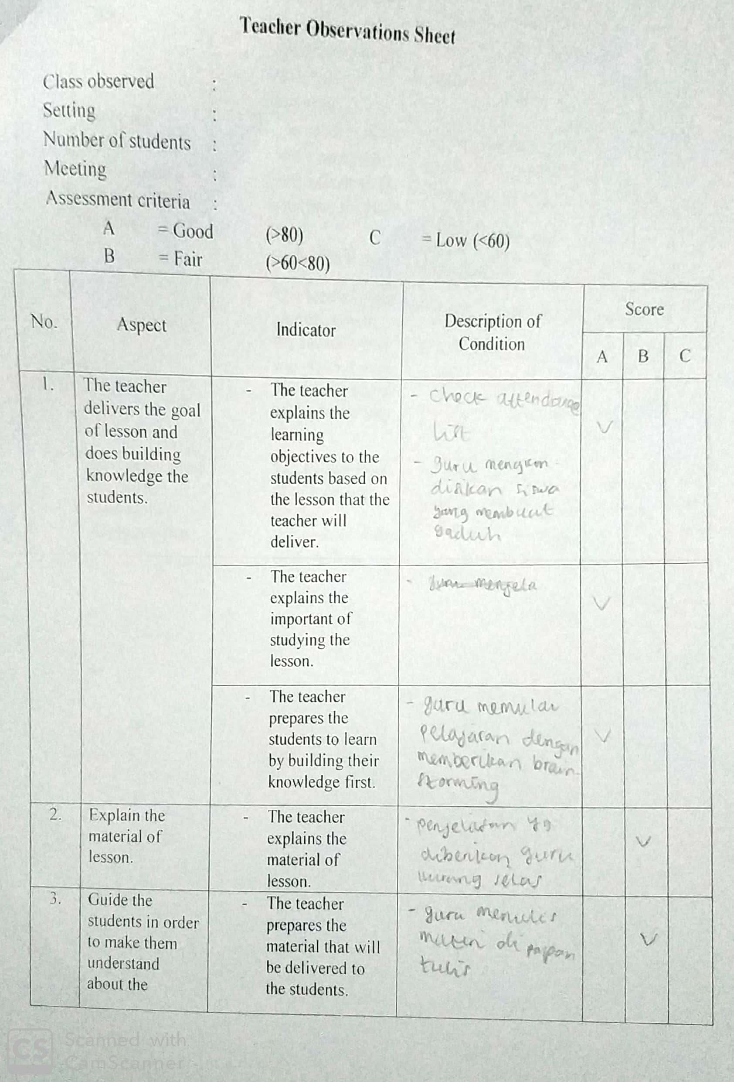

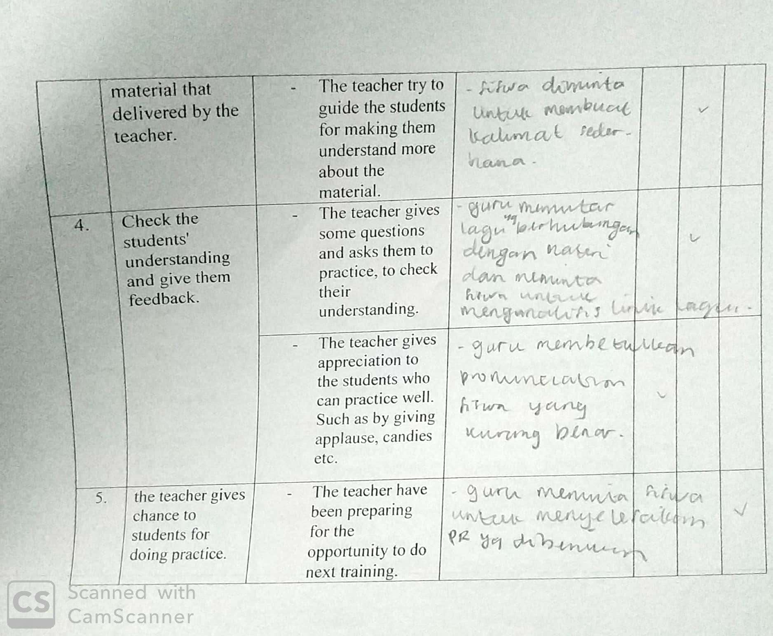

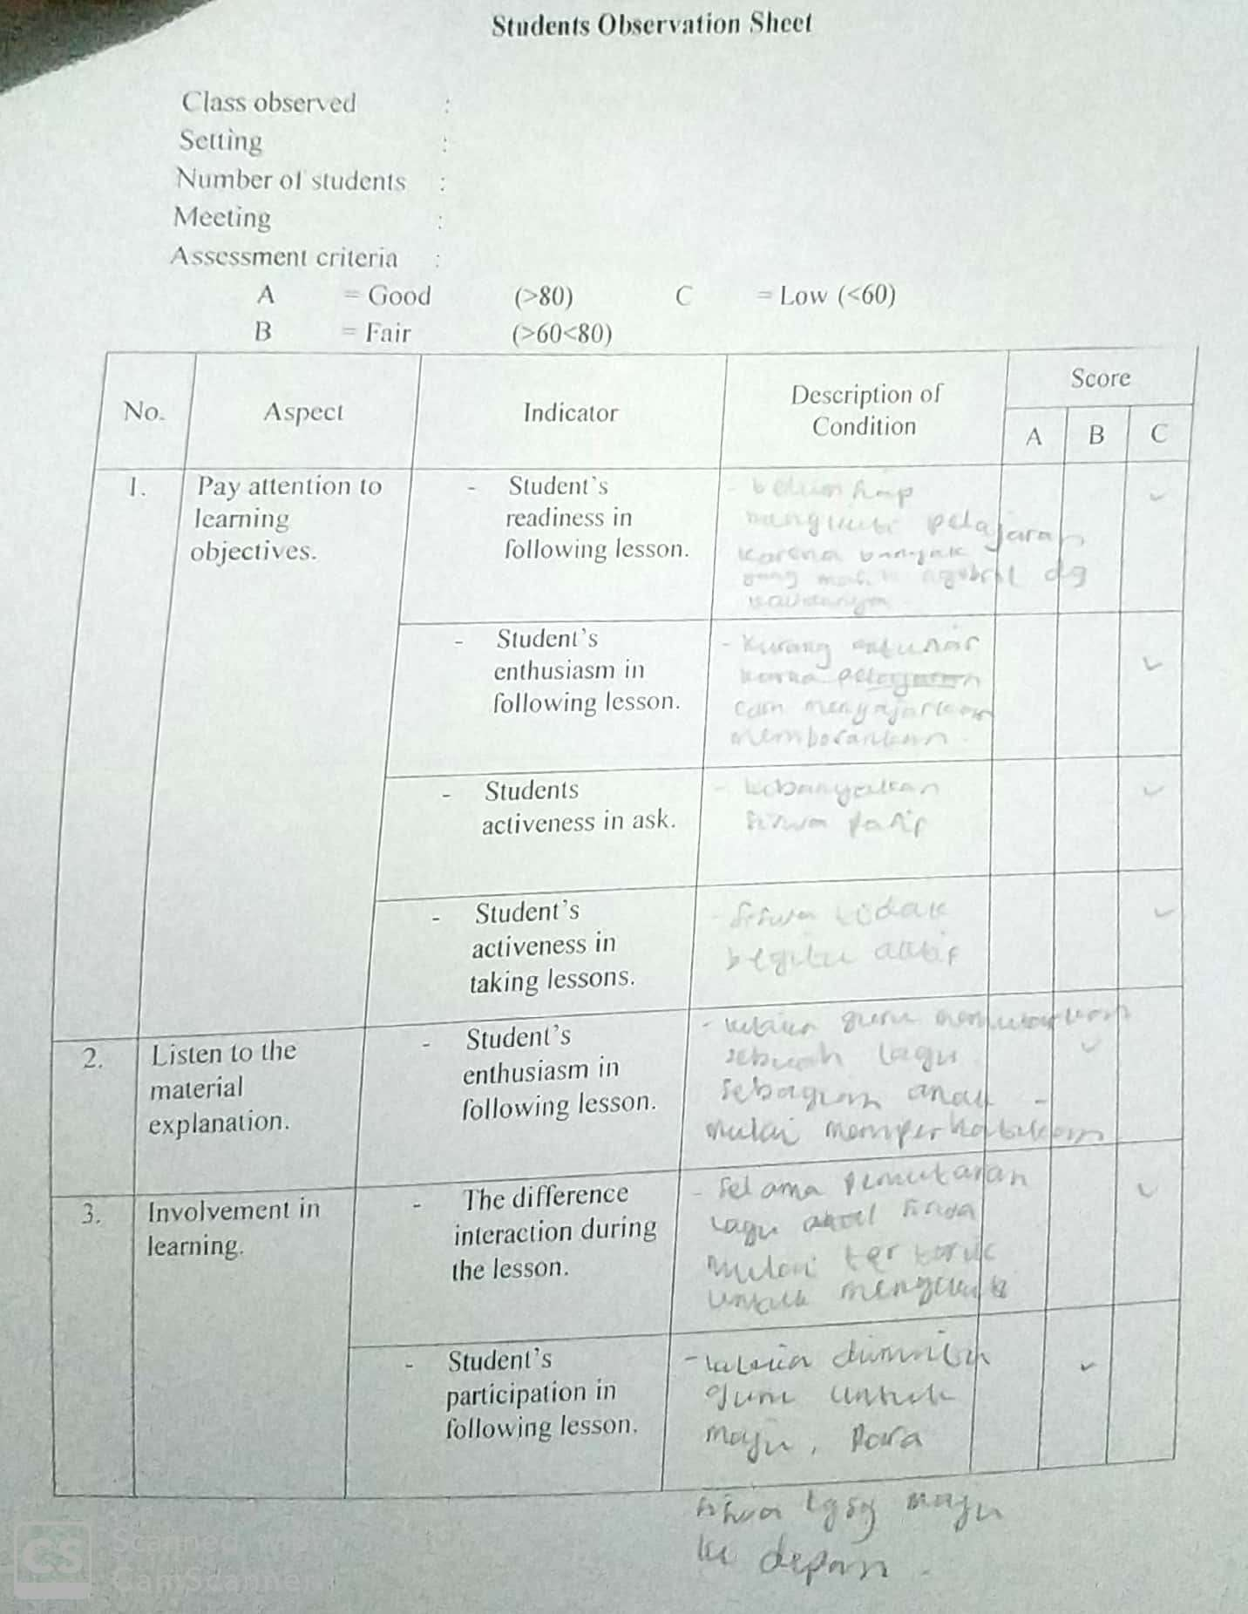

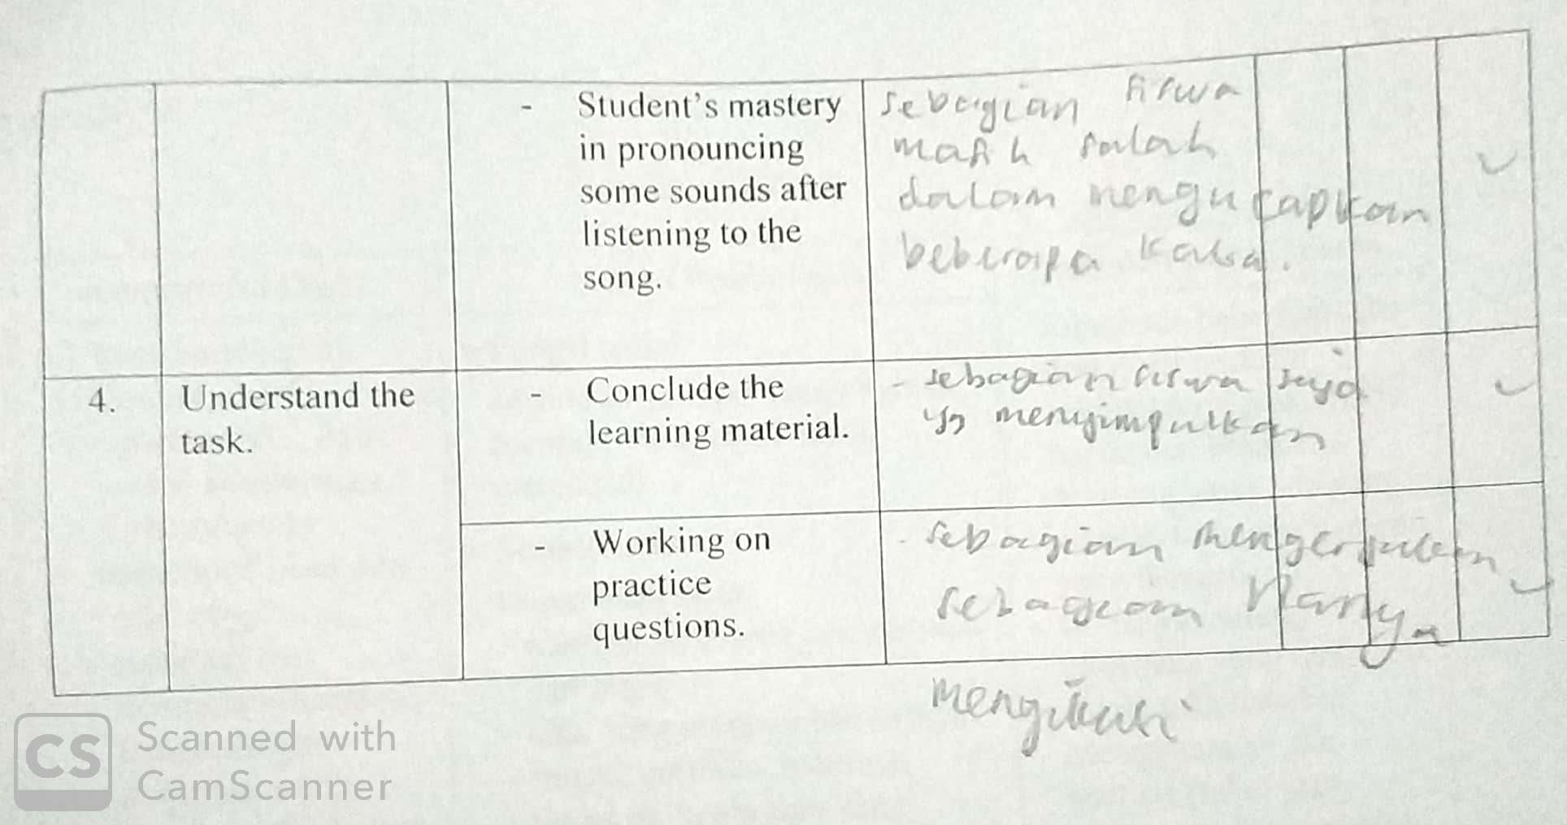

**CURRICULUM VITAE**

Name : Manunal Ahna

Place and Date of Birthday : Kudus, 28 Oktober 1995

Original Address : Ds. Singorojo RT 08 RW 01 Kec. Mayong Kab. Jepara Prov. Jawa Tengah 59465

Dominator Address : Jln. Wismasari Raya No. 08 RT 01 RW 08 Kec. Ngaliyan Kab. Semarang Prov. Jawa Tengah

Phone Number : 085826670250

Email : [manunal.ahna20@gmail.com](mailto:manunal.ahna20@gmail.com)

Formal Education:

1. 2001-2007 SD N 02 Singorojo Jepara
2. 2007-2010 MTs N 01 Jepara
3. 2010-2013 SMA NU AL – MA’RUF KUDUS

Semarang, 26 Juli 2019

**Manunal Ahna**

NIM. 133411020

1. Jeremy Harmer, *The Practice of English Language Teaching Fourth Edition,* (UK: Longman, 2013), p.243
2. Jeremy Harmer, *The Practice of English Language Teaching Fourth Edition,* (UK: Longman, 2013), p.252-253
3. Iman Shehadeh & Mohammed Farrah, “The Effectiveness of Using Children’s Songs in Developing Elementary Graders’ English Vocabulary and Pronunciation in Jerusalem, Palestine”, *Journal of Creative Practices in Language Learning and Teaching (CPLT)* (Vol. 4, No. 2, *November,* 2016).
4. Supeno, “Using songs to improve students pronunciation” *Proceeding of the 65th international conference* (Vol. 65, No. 1 July/2018).
5. Simms R. Bryan, *The Art of Music. An Introduction,*  (USA: Harper Collins College Publishers, 1993), p.29
6. <http://accounts.smccd.edu/mecklered/mus250/elements.htm>. accessed on 22/04/2019/9.30 pm
7. <http://accounts.smccd.edu/mecklered/mus250/elements.htm>. accessed on 22/04/2019/9.30 pm
8. <http://accounts.smccd.edu/mecklered/mus250/elements.htm>. accessed on 22/04/2019/9.30 pm
9. Ur and Wright, *Teaching Listening Comprehension*, (Cambridge: University Press, 1993), p.77-78
10. Haycarft, An *Introduction to English Language Teaching,* (London: Longman Group Ltd, 1983), p.93
11. Hornby, A.s, *Oxford Advance Learner’s Dictionary,* (Great Britain:Oxford University Press, 1995), p.928
12. Dina Kristina, *Pronunciation,* (Kediri: Daffodil, 2004), p.18
13. Ramelan, *English Phonetic,* (Semarang: UNNES PRESS, 2003), p.99
14. Gerald Kelly, *How To Teach Pronunciation,* (Edinburgh: Pearson education Limited, 2000), p.47
15. Gerald Kelly, *How To Teach Pronunciation,* (Edinburgh: Pearson education Limited, 2000), p.6
16. Gerald Kelly, *How To Teach Pronunciation,* (Edinburgh: Pearson education Limited, 2000), p.47
17. Gymson, A.C, *An Introduction To the Pronunciation of English*, (England: J.W. Arrowsmith Ltd, 1970), p.29-30
18. Gerald Kelly, *How To Teach Pronunciation,* (Edinburgh: Pearson education Limited, 2000), p.47
19. Gymson, A.C, *An Introduction To the Pronunciation of English*, (England: J.W. Arrowsmith Ltd, 1970), p. 32
20. Ramelan, *English Phonetic,* (Semarang, UNNES press, 2003), p.
21. Gymson, A.C, *An Introduction To the Pronunciation of English,* (England: J.W. Arrowsmith Ltd, 1970), p.32
22. Gerrald Kelly, *How to Teach Pronunciation,* 6th published, (Malaysia: Longman, 2005), p.67
23. Gerrald Kelly, *How to Teach Pronunciation,* 6th published, (Malaysia: Longman, 2005), p.84
24. Joanne Kenworthy, *Teaching English Pronunciation,* (New York: Longman Inc, 1987), p.59
25. J.D. O’Connor, *Better English Pronunciation. 2nd. ed.* (Cambridge: Cambridge University Press, 1980), p.108
26. Marnie Reed and John M. Levis, *The handbook of English Pronunciation,* (UK: Wiley Blackwell Publisher, 2015), p.139
27. Jeremy Harmer, *The Practice of English Language Teaching.* ( London: Longman Group LTD, 2000), P.242
28. Jeremy Harmer, *The Language Practice teaching,* (Malaysia: Person Educated Person, 2002), p.12
29. Edward Odishi, *Pronunciation is in the Brain, not in the Mouth,* (USA: Gorgias Press, 2014), p.84
30. Judy B Gilbert, *Teaching Pronunciation Using Prosody Pyramid,* (USA: Cambridge university Press, 2008), p.1
31. Gerald Kelly, *How to teach Pronunciation,* (Edinburgh: Pearson education Limited, 2000), p.13
32. Joanne Kenworthy, *Teaching English Pronunciation,* (New York: Longman Inc, 1987), p.1
33. J. D. O’Connor, *Better English Pronunciation,* (New York: Cambridge university Press, 1980), p.3
34. Joanne Kenworthy, *Teaching English Pronunciation,* (New York: Longman Inc, 1987), p.11
35. Joanne Kenworthy, *Teaching English Pronunciation,* (New York: Longman Inc, 1987), p.27
36. Lexy J. Moleong, *Metodologi Penelitian Kualitatif (edisi revisi),* (Bandung: PT Remaja Rosdakarya, 2010), p.4
37. Imam Gunawan, *Metode Penelitian Kualitatif Teori dan Praktik,* (Jakarta: Bumi Aksara, 2015), p.161
38. Donald Ary, *Introduction to Research in Education (8th ed),* (Belmont: Wadsworth, 2010), p.480
39. A. Muri Yusuf, *Metode Penelitian Kuantitatif, Kualitatif, dan Penelitian Gabungan,* (Jakarta: Ppenadamedia, 2014), p 407.
40. Sugiyono, *Metode Penelitian Kuantitatif, Kualitatif dan R&D*, (Bandung: Alfabeta, 2009), p. 252.
41. William Collin, *English Nursery Rhymes for Young Learners,* (Hongkong: Wing King Tong Ltd, 1990), p.52