IMPLEMENTING HOTS IN ENGLISH TEACHING-LEARNING PROCESS

THESIS
Submitted in Partial Fulfillment of the Requirement
for Gaining the Degree of Bachelor in English Education

By:
SEPTIANA DWI PRAPTIWI
Student Number: 1803046078

ENGLISH EDUCATION DEPARTMENT
EDUCATION AND TEACHER TRAINING FACULTY
UNIVERSITAS ISLAM NEGERI WALISONGO
SEMARANG
2022

THESIS PROJECT STATEMENT
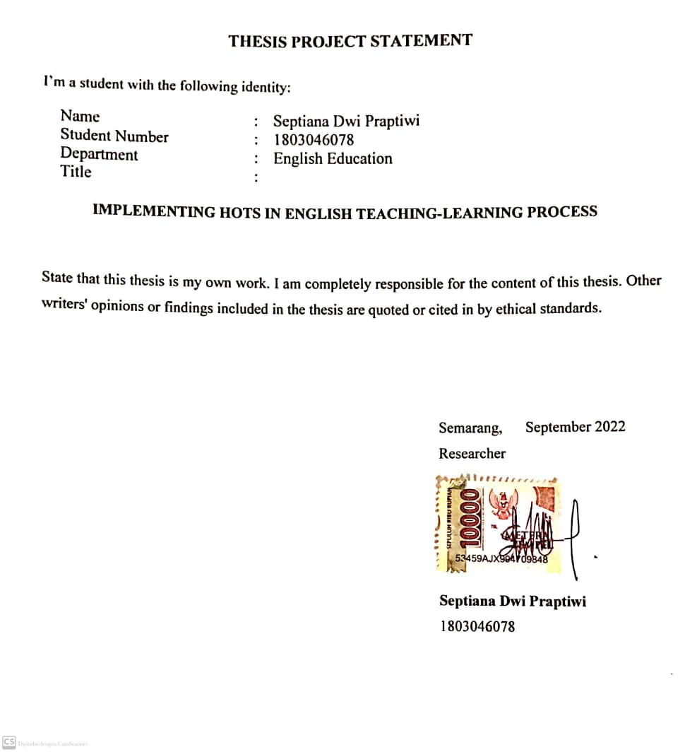

RATIFICATION
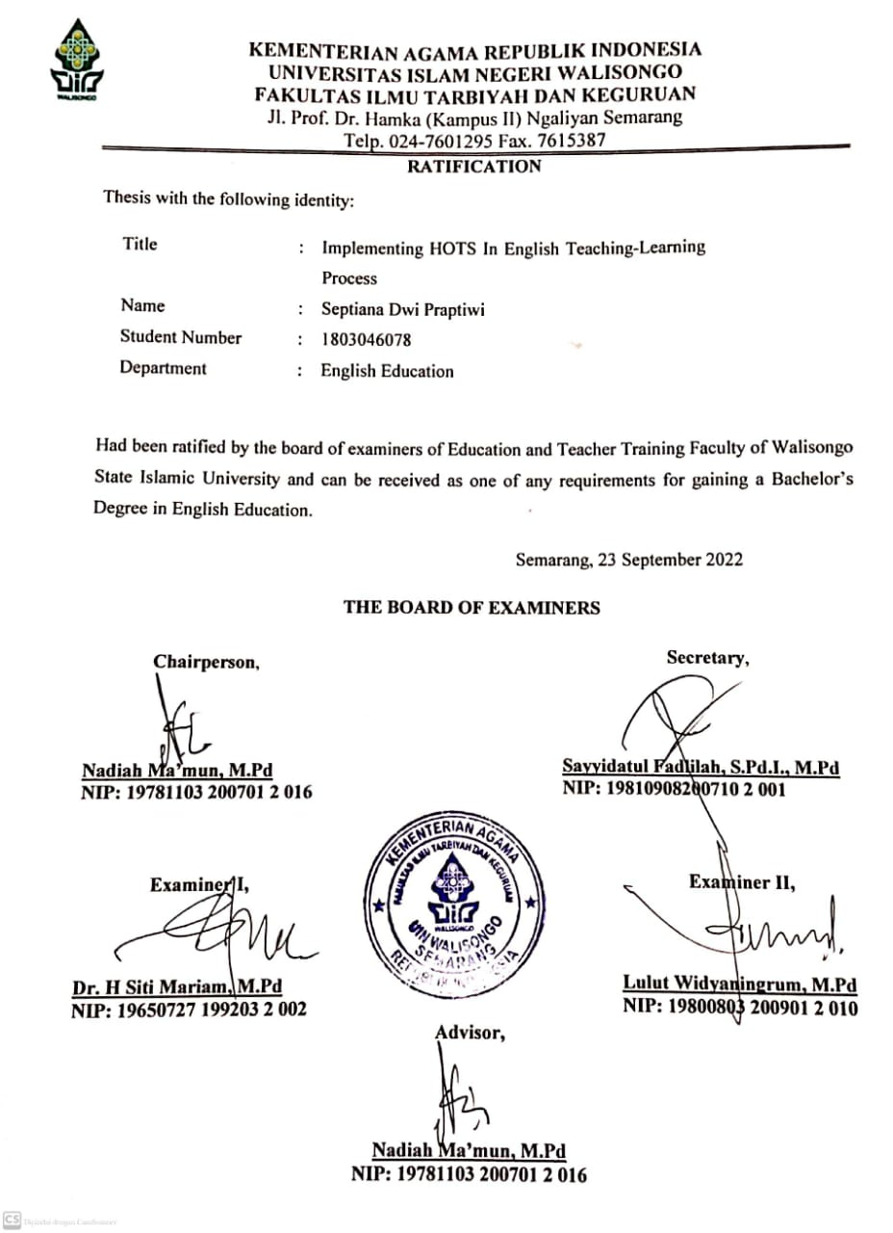

ADVISOR APPROVAL
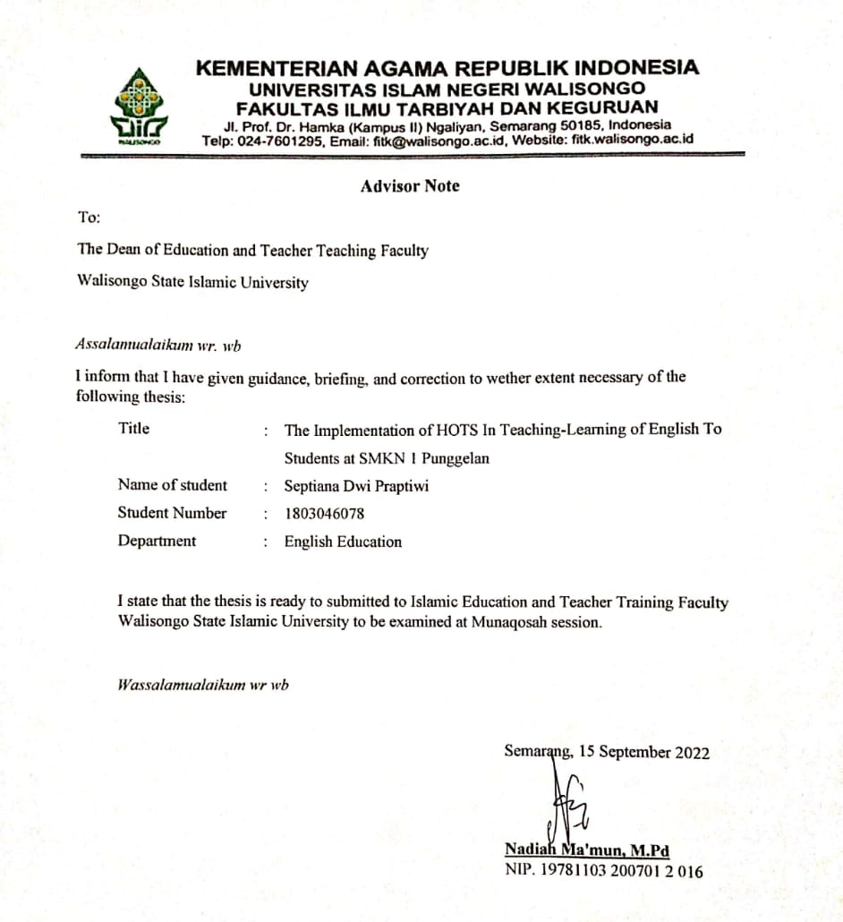

DEDICATION
Praise is given to Allah ta’ala who has blessed the researcher so that the researcher could finish the thesis.
This thesis is dedicated to all English teachers and everyone who supported the researcher in accomplishing the thesis, especially to my beloved father, mother, and sister who always give support, motivation, and endless love.

MOTTO

طَلَبُ الْعِلْمِ فَرِيْضَةٌ عَلَى كُلِّ مُسْلِمٍ وَمُسْلِمَةٍ
"Seeking knowledge is obligatory for every Muslim male and female Muslim." (Narrated by Ibn Abdil Barr)

ABSTRACT
Title | : | Implementing HOTS In English Teaching-Learning Process
Name of student | : | Septiana Dwi Praptiwi
Student Number | : | 1803046078

This study aims to explain the implementation of Higher Order Thinking Skills (HOTS), namely analyzing (C4), evaluating (C5), and creating (C6) in teaching activities carried out by XII grade English teachers at SMKN 1 Punggelan, Banjarnegara, Jawa Tengah whether they are applied by properly or not. This research used a qualitative method and a descriptive research design. Data were collected through interviews, observation, and documentation. The research participants were three twelfth-grade English Teachers at SMKN 1 Punggelan in the academic year 2022/2023. The findings generally show that those teachers implement the skills (HOTS) of analyzing, evaluating, and also creating is well with some of the obstacles experienced by teachers in implementing HOTS in the teaching process, namely the background knowledge of students, mental readiness of students in receiving the material, and the lack of students in understanding the material.
Keywords: English Teaching-Learning, Higher Order Thinking Skills, Teachers.

ACKNOWLEDGEMENT
Bismillahirrohmanirrohim,
Praise is always given to Allah ta’ala as the most beneficial and the most merciful who blessed the researcher so this thesis is completely finished. Shalawat and salam also raised up to Prophet Muhammad who brings ummat from the darkness era into the brightness era.
In arranging this thesis, the researcher realizes that many people were willing to help, whether directly or indirectly. Hence, in this chance, the researcher would like to express great appreciation to:
- Dr. Ahmad Ismail, M.Ag. as the Dean of Faculty of Education and Teacher Training of Walisongo State Islamic University.
- Sayyidatul Fadlilah, M.Pd. as the Head of English Language Education.
- Nadiah Ma’mun, M.Pd. as the academic advisor for her patience and willingness in providing guidance, helpful corrections, advice as well as suggestion, and encouragement during consultation.
- All lectures of the English Language Education Department who give input and advice to the researcher during conducting this study.
- Moreover my support system, Mamah, Bapak, Mba Ika, Rafania, Bude Lusi, and Mozza, thank you for always praying for the best for me. Thank you for never letting me down and reminding me that I can get through it.
- My dearest love and friends, Saga Rahardian, Mba Dyah Puspaningrum, Delia Fatchia, Fista Pujiyani, Ella Zakiya, Winanti Utami, Ike Astriyani, Itahul Jana, Khoirunnisa, Sarah Wijayanti, Fahmadila Jilan, and Fitri Rahmawati, Siti Nuraisyah, Dewi Farikha, Pratiwi, Putri Aprilia, Marzuqotun, thank you for the everlasting support.
- Bu Lusinah, Pak Didiet Wisang Wibowo, Pak Suparman, Pak Asmoko and SMKN 1 Punggelan. Thank you for providing a valuable experience for me.
Finally, the researcher realizes that this thesis is still far from the perfect arrangement. Therefore, the researcher will be happy to accept constructive suggestions in order to make this thesis better. Last but not least, the researcher hopes this thesis would benefit others, especially the researcher himself.

Semarang,
The Researcher,
Septiana Dwi Praptiwi
Student Number: 1803046078

LIST OF CONTENTS

COVER i
THESIS PROJECT STATEMENT ii
RATIFICATION iii
ADVISOR APPROVAL iv
DEDICATION v
MOTTO vi
ABSTRACT vii
ACKNOWLEDGEMENT viii
LIST OF CONTENTS xi
LIST OF APPENDICES xiv
LIST OF TABLES xv
CHAPTER I 1
INTRODUCTION 1
A. Research Background 1
B. Research Question 9
C. Research Objectives 9
D. Significances of the Research 10
E. Scope and Limitation of The Study 11
CHAPTER II 12
THEORETICAL FOUNDATION 12
A. PREVIOUS RESEARCH 12
B. LITERATURE REVIEW 16
1. Higher Order Thinking Skills (HOTS) 17
2. Teacher 25
3. English Teaching-Learning 27
CHAPTER III 31
RESEARCH DESIGN 31
A. Research Approach 31
B. Research Setting 32
1. Research Location 32
2. Research Time 32
C. Participant 32
D. Source of Data 33
E. Technique of Data Collection 35
1. Interviews 35
2. Observation 37
3. Documentation 38
F. Technique of Data Analysis 38
1. Data Reduction 39
2. Data Display 39
3. Conclusion Drawing/Verification 39
CHAPTER IV 41
FINDING AND DISCUSSION 41
A. Research Finding 41
1. Teachers’ implementation of C4 (analyzing) in their teaching-learning activities 41
2. Teachers’ implementation of C5 (evaluating) in their teaching-learning activities 45
3. Teachers’ implementation of C6 (creating) in their teaching-learning activities 47
4. Teachers’ obstacles in implementing HOTS 49
B. Discussion 51
1. Teachers’ implementation of C4 (analyzing) in teaching-learning activities 52
2. Teachers’ implementation of C5 (evaluating) in teaching-learning activities 54
3. Teachers’ implementation of C6 (creating) in teaching-learning activities 55
4. Teachers’ obstacles in implementing HOTS 56
CHAPTER V 57
CONCLUSION AND SUGGESTION 57
A. Conclusion 57
B. Suggestion 58
1. For The Researcher 59
3. For The Next Researcher 60
Bibliography 61

LIST OF APPENDICES

Appendix 1 | Interview guideline | 65
Appendix 2 | Interview Transcription | 66
Appendix 3 | Observation Guideline | 83
Appendix 4 | Observation Data | 85
Appendix 5 | Document Study Guideline | 93
Appendix 6 | Documentation | 94
Appendix 7 | School Information | 102
Curriculum Vitae

Table 2.1 | Cognitive Process according to Bloom's cognitive level | 22
Table 2.2 | Affective domain | 23
Table 3.1 | Interview guideline | 36

LIST OF TABLES

CHAPTER I

INTRODUCTION
This chapter comprises the background of the study, the problems of the study, the purpose of the study, the significance of the study, the scope and limitation, the definition of the key terms, and the organization of the study.
- Research Background
Indonesia has many languages ​​in each region, and each person from each region can speak their mother tongue. Everyone has learned to communicate using their mother tongue since they were children. Regardless of their mother tongue, they will encounter foreign language subjects in their junior high/senior high school years, one of which is English. It is undeniable, that many students still have difficulty following English lessons. This is certainly one of the challenges for teachers to further improve their strategies in teaching English so that students can receive English lessons well. English is gaining importance in India and more people are bound to use it in future, as demand for English medium schools is rising. While language development involves a continuous process of constructing new knowledge of that language.
Education is a fundamental thing in human life. Education has an aspect and part that is essential for human life in terms of cognitive, affective (attitude), and psychomotor aspects. Education is also believed to be an important provision for each individual to have to live their life. As stated in Law Number (No). 20 of 2003, “Education is a conscious and planned effort to create a learning atmosphere and learning process so that students actively develop their potential to have religious-spiritual strength, self-control, personality, intelligence, noble character, and skills needed by themselves, society, nation, and state.” Education can be defined as a system including objectives, methods, materials (curriculum), educators, students, educational tools, and an elementary environment. The command to learn is contained in the Qur'an Surah Al-Alaq: 1
اقْرَأْ بِاسْمِ رَبِّكَ الَّذِي خَلَقَ
Read in (mentioning) the name of your Lord Who created, (Al-Alaq: 1)
Q.S Ali-Imran; 137-139:
قَدْ خَلَتْ مِنْ قَبْلِكُمْ سُنَنٌۙ فَسِيْرُوْا فِى الْاَرْضِ فَانْظُرُوْا كَيْفَ كَانَ عَاقِبَةُ الْمُكَذِّبِيْنَ
هٰذَا بَيَانٌ لِّلنَّاسِ وَهُدًى وَّمَوْعِظَةٌ لِّلْمُتَّقِيْنَ
وَلَا تَهِنُوْا وَلَا تَحْزَنُوْا وَاَنْتُمُ الْاَعْلَوْنَ اِنْ كُنْتُمْ مُّؤْمِنِيْنَ
Systems have passed away before you. Do but travel in the land and see the nature of the consequence for those who did deny (the messengers). This is a declaration for mankind, a guidance and an admonition unto those who ward off (evil). Faint not nor grieve, for ye will overcome them if ye are (indeed) believers. (Ali Imran: 137-139).
(Surah 3:137) This (Qur'an) is a light for all mankind, and a guide and a lesson for those who are pious. (Surah 3:138) Do not be weak, and do not (also) be sad, even though you are the people of the highest (degree) if you are believers. (Surah 3:139).
The relationship between the Qur'an Surah Ali-Imran verses 137-139 is, as educators, we should have prepared for teaching, namely educational tools or educational media, if educators take an educational trip to certain places, educators should be able to provide benefits to students, and the last one, learning should be carried out a positive impact on students, such as being able to create a sense of optimism and confidence.
The teaching methods used by teachers are usually seen from students' abilities. Teachers teach with methods that are following expectations to improve students’ thinking skills in a complex manner so that they can describe the material, draw conclusions, present the material, analyze, and use the most basic mental activities. Based on Bloom’s Taxonomy, skills are divided into two skills, the first is lower-order thinking skills (LOTS) which consist of remembering, understanding, and applying, and the second is higher-order thinking skills (HOTS) consist of analyzing, evaluating, and creating. Higher-order thinking skills are closely related to the ability to think following the cognitive, affective, and psychomotor domains in the teaching and learning process.
In line with the 2013 curriculum in Indonesia, higher-order thinking skills must be maximized in students' teaching and learning activities. Teachers are expected to be able to make students in developing higher-order thinking skills, in this case, students are expected to be able to analyze, evaluate, and create. There are many considerations when using HOTS in teaching and learning activities. The teachers implement HOTS according to students' conditions. As explained from the TIMSS (Trend in International Mathematics and Science Study) results in the journal belonging to Umi Pratiwi and Eka Farida Fasha (2013), it can be said that the higher-order thinking skills of Indonesian students are still low. Educational stakeholders involved in continuing professional development activities and assisting teachers in their classrooms also have an implicit influence on teachers directly. Although teachers may face many difficulties in implementing HOTS in teaching-learning, teachers as professional educators must still strive to implement HOTS following curriculum 2013. As professional educators, teachers are expected to be able to implement the principles of professionalism.
The implementation of HOTS allows students and teachers to further explore their abilities. According to (Ellen and Tatiana 2022) it would be more eventful to start teaching with simpler examples first so that people understand them better, then start to give more difficult examples so that they will apply and analyze them. As written by (Errastus & Lauren, 2020) Higher-order thinking will help to enhance the knowledge, skills, and proficiency of students who needed to demote aptitude failure and thereby, lower the number of failures or challenges in the project. Teachers have a very important role in designing learning and evaluation activities that teach HOTS. Discovery and inquiry learning methods can be used to teach HOTS. HOTS learning evaluation uses a stimulus that stimulates students' thinking. Each student has a different background experience in learning English, both at school and outside of school. Student learning experiences with a comfortable learning environment will produce an atmosphere that will provide enthusiasm for students. Although the use of LOTS is still often used even though it has been recommended to be abandoned, the use of HOTS has certainly been widely used by English teachers in the teaching-learning process. Mrs. Lusinah (an English teacher at SMKN 1 Punggelan) stated that the English lesson in her class, those are the TKR (Teknik Kendaraan Ringan) classes, the use of English is used only so that students understand little by little about English, she as a teacher does not require students to be students who must be very good at English, this is because the basic skills they must master are light vehicle engineering (TKR) skills.
Teachers implementing HOTS that start from C4 to C6, namely analyzing, evaluating, and creating in English teaching are very interesting to be studied. How teachers can implement HOTS so that students can analyze, evaluate, and create. In implementing HOTS, teachers may experience several obstacles, either from the facilities or from the students themselves that make them implement the HOTS activity reffers to the conditions of the students in the class. Giving attention to feedback from teachers that teach class XII is seen as an effective treatment because it often offers valuable suggestions. Furthermore, this research is entitled Implementing HOTS In English Teaching-Learning Process.
- Research Question
The problem that is going to be discussed in this paper can be stated as follow:
- How do the teachers implement analyzing (C4) levels in their teaching-learning process?
- How do the teachers implement evaluating (C5) levels in their teaching-learning process?
- How do the teachers implementing creating (C6) levels in their teaching-learning process?
- Are there any obstacles in implementing HOTS in the teaching-learning process?

- Research Objectives
The objectives of the study are to describe English teachers implement HOTS in their teaching-learning. They are, English teachers implement analyzing (C4), English teachers implement evaluating (C5), English teachers implement creating (C6), and obstacles experienced by teachers in implementing HOTS.
- Significances of the Research
The researcher hopes that the result of this research gives brief information and contribution theoretically and practically as follows:
- Theoretical Significance
This research will give additional information to the readers about the teachers’ implementation of HOTs, and how the teachers implement analyzing (C4), evaluating (C5), and creating (C6) for their students.
- For the teachers
This research is expected to provide information to teachers about how to implement HOTS in teaching-learning activities and help make it easier for teachers to teach using HOTS to students.
- For the researcher
This research is hoped to help the researcher complete her studies. In addition, the researcher also expected that the information obtained from this research can provide useful information for her to develop teaching-learning activities.
- For the next researcher
The researcher expects that this research can be a reference for the next researcher that will conduct similar research.

- Scope and Limitation of The Study
To avoid deviations in this research, the researchers limited the scope of this study. This research was conducted on three twelfth grade English teachers at SMKN 1 Punggelan regarding the implementation of HOTS in English teaching-learning.

CHAPTER II

THEORETICAL FOUNDATION
This chapter provides information on theoretical reviews related to research problems and a review of several previous types of research that were conducted in the same field related to this research topic.
- PREVIOUS RESEARCH
Several researchers have conducted research related to HOTs in teaching English. previous studies are as followed:
The first research was conducted by Mursyid and Nia Kurniawati (2019) entitled “Higher Order Thinking Skills Among English Teachers Across Generation In EFL Classroom”. This research aims to investigate the perceptions, the practice, and the constraints in endorsing higher-order thinking skills in teaching foreign language. This research is a descriptive qualitative study where the data were collected through open-ended questionnaire, classroom observation, and document analysis for triangulation purpose. This research was conducted at SMAN 2 Cianjur, a public senior high in the center of Cianjur, by involving senior high school teachers from different generations (Baby Boomers, Generation X, and Generation Y). Results shows that teachers of all generations are aware of HOTS and they apply it in their teaching in a different way. However, there are still some obstacles to implementing HOTS in their classes.
The next research was conducted by Muhammad Ansori (2019) entitled “English Teachers’ Efficacy in Using Pedagogical Techniques to Promote Higher Order Thinking Skills”. This study aims to find out English teachers efficacy in using interactive, critical thinking and meta-cognitive pedagogical techniques to promote HOTS in the learning process. This research employed a survey research method. The research approach used was descriptive-quantitative. The participants of this research are 15 in-service English teachers at the secondary high school level. The researcher stated that English teachers have high self-efficacy in using interactive, critical thinking, and metacognitive pedagogical strategies to promote HOTS in the learning process. In addition, the teachers’ understanding of HOTS can guide them in implementing HOTs in teaching activities.
The third research was conducted by Undang Rosidin, Agus Suyatna, and Abdurrahman Abdurrahman (2019) entitled “A Combined HOTS-Based Assessment/STEM Learning Model to Improve Secondary Students’ Thinking Skills: A Development and Evaluation Study”. This research aimed to investigate the development and evaluate a combined HOTS-based assessment/STEM (Science, Technology, Engineering, and Mathematics) learning model to enhance students’ thinking skills. The participants of this research are 24 eleventh graders of SMAN 1 Kotabumi at North Lampung and 30 tenth graders of SMA YP Unila at Bandar Lampung involved in limited and field trials, respectively. This research used a model designed to follow the seven steps of Borg & Gall’s research and development. The researcher stated that the learning process through STEM affects the development of the student’s performance tests both in the control class and the experimental class. In addition, the research recommends teachers and educational practitioners use a combination of the STEM learning approach with HOTS assessment as an alternative strategy to improve the students’ thinking skills.
The fourth research was conducted by Kuniawan Ahmad (2018) entitled “The Implementation of Teaching LOTS and HOTS in English Teaching-Learning Process in Senior High School”. This research aimed to describe whether the implementation of lower-order thinking skills and higher-thinking skills are applied properly or not. This research used a qualitative-designed through observation using field notes. The participant of this research is an English Teacher in grade XI. The result of this research was the teacher taught remembering skills, understanding skills, applying skills, analyzing skills, and creating skills but the teacher did not teach evaluating skills.
The last research was conducted by I Yusuf, S W Widyaningsih, Z K Prasetyo, and E Istiyono (2021) entitled “Blended learning: its effect on Higher Order Thinking Skills (HOTS)”. This research aimed to evaluate the HOTS of the students after implementing the blended learning model. This research used a quasi-experimental type of pre-test post-test control group design. The participants of this research are students’ HOTS obtained from pre-test and post-test scores. The researcher stated that HOTS taught by students through blended learning is better than conventional models.
However, the differences from this study are the variables since this study investigated the teachers' implementation of HOTS in English teaching-learning. Moreover, this study was conducted through the qualitative method.
- LITERATURE REVIEW
- Higher Order Thinking Skills (HOTS)
The actuality of the 2013 curriculum awaits students to attain various competencies by applying HOTS or Higher Order Thinking Skills. These competencies are critical thinking, creativity and innovation, communication skills, collaboration with others, and confidence. The five things that are handed over to the government that became the target character of students were attached to our evaluation system in the national examination and were the 21st century. In line with the 2013 curriculum which allows teachers to be able to develop students' higher-order thinking skills, namely students can analyze, evaluate, and create. Higher-order thinking skills were also applied following the low ranking of the Programme for International Student Assessment (PISA) and Trends in International Mathematics and Science Study (TIMSS) are assimilated with other countries so that national examination questions are tried to be increased to catch up.
  - The Concept of Higher Order Thinking Skills
In a book written by (Yura and others, 2018) higher-order thinking skills which in common colloquial are known as higher-order thinking skills (HOTS) are actuated by four conditions:
- An unspecified learning situation that demands specific learning strategies and cannot be used in other learning situations.
- Intelligence is no longer seen as an ability that cannot be changed, but as a unity of knowledge influenced by various factors, including the learning environment, strategies, and awareness of learning.
- View understanding that has shifted from unidimensional, linear, hierarchical, or spiral towards understanding views to be multidimensional and, interactive.
- More specific higher-order thinking skills such as reasoning, analytical skills, problem-solving, and critical and creative thinking skills.
Higher-order thinking skills (HOTS) are higher-order thinking skills that include three stages, they are analyzing (C4), evaluating (C5), and creating (C6). Bloom's Taxonomy is an instrument used to measure certain skills and cognitive abilities in exam papers based on certain criteria. it was first coined in 1949 and includes Knowledge, Understanding, Application, Analysis, Synthesis, and Evaluation. The taxonomy was then revised in 2001 which includes Remembering (C1), Understanding (C2), Applying (C3), Analyzing (C4), Evaluating (C5), and Creating (C6).
Higher-order thinking skills are divided into 3 aspects (Afandi & Sajidan. 2017), namely Higher Order Thinking Skills in the Transfer of Knowledge, Higher Order Thinking Skills in Critical and Creative thinking, and Higher Order Thinking Skills in Problem Solving. On Higher Order Thinking skills as Transfer of Knowledge, higher-order thinking skills are nearly connected to thinking skills by the cognitive, affective, and psychomotor domains that become constitutive in the learning and teaching process. In the cognitive domain, this domain is related to students' abilities in thinking, competence in developing knowledge, recognition, understanding, conceptualization, and reasoning.
COGNITIVE PROCESSES |  |  | DEFINITION
C1 | L  O  T  S | Remembering | Taking relevant knowledge from memory.
C2 |  | Understanding | Building meaning from the learning process,  including oral, written, and graphic communication
C3 |  | Applying | Performing or using procedures at  in an unusual situation
C4 | H  O  T  S | Analyzing | Breaking down material into its parts and determining how the parts are related between the parts and to the structure or purpose of the whole
C5 |  | Evaluating | Make judgments based on criteria or standard
C5 |  | Creating | Putting elements together to form a whole coherent or functional; rearranging elements into new patterns or structures.
Table 2.1. Cognitive Process according to Bloom's cognitive level.
The affective domain, Kartwohl & Bloom also explained that the affective domain is related to attitudes, values, feelings, emotions, and the degree of acceptance or rejection of an object in learning activities and divide the affective domain into 5 categories:
Affective Processes |  | Definitions
A1 | Reception | a kind of sensitivity in receiving stimuli or stimulation from outside that comes to students.
A2 | Respond | an attitude that shows active participation to involve himself in certain phenomena and make a reaction to it with one of the methods.
A3 | Evaluation | provide value, respect, and trust  to a particular symptom or stimulus.
A4 | Manage | conceptualization of values ​​into a value system, as well as  strengthening and prioritizing existing values.
A5 | Characterization | the integration of all existing value systems someone who influences personality patterns and  her behavior.
Table 2.2 Affective domain
In the psychomotor domain, psychomotor process skills are skills in doing work involving body parts related to physical movement (motor) which consists of reflex movements, basic movement skills, perceptual, precise, complex, expressive, and interactive skills. On Higher Order Thinking Skills as critical and creative thinking, critical thinking claims to be a process in which all knowledge and skills are placed in solving problems that arise, making decisions, analyzing all assumptions that arise, and conducting investigations or research based on data and information that has been obtained so that produce the desired information or conclusion. Higher-order thinking skills such as problem-solving are very important in the learning process because learning is designed with an approach high-level skill-oriented learning is inseparable from a combination of thinking skills and creative skills to solve problems.
- Teacher
The teacher is one of the most crucial elements in the teaching and learning process because the teacher is the main material transmitter as well as a model in the teaching and learning process. Seeing the importance of the teacher's role in the teaching and learning process, it is appropriate in the education process to provide accomplished and competent teachers in their fields. Teachers have a role in helping the development of students to realize their life goals optimally. In Indonesia, all teachers (elementary school, primary school, junior high school, and senior high school) must be at least Bachelor's Degree. Teachers have duties, both tied to the service and outside the service, in the form of dedication. If we group there are three types of teacher tasks, namely: (a). Tasks in the field of Profession, (b). Humanitarian duties, (c). Tasks in the field of Community. In the Law of the Republic of Indonesia No. 20 of 2003 concerning the National Education System article 39 paragraphs 1 and 2, it is stated that: 1) Education personnel is tasked with carrying out administration, management, development, supervision, and technical services to support the educational process in the education unit. 2) Educators are professionals in charge of carrying out the learning process, assessing learning outcomes, conducting guidance and training, as well as research and community service, especially for educators at universities.
- English Teaching-Learning
The teaching and learning process can be defined as a transformation process of knowledge from teachers to students. It is referred to as the combination of various elements within the process where an educator identifies and establishes the learning objectives and develops teaching resources and implements the teaching and learning strategy. On the other hand, learning is a cardinal factor that a teacher must consider while teaching students.
The term learning has begun to be widely known in the community, after the enactment of the Republic of Indonesia Law Number 20 of 2003 on the National Education System, which legally formally provides an understanding of learning. In Article 1 point 20 learning is Interpreted as “... the process of interaction between students and educators and learning resources in a learning environment”. Learning as a Pedagogic concept can technically be interpreted as a systematic effort and systemically to create a learning environment that has the potential to produce a learning process that leads to the development of individual potential as learners.
According to Samrin, the process of teaching and learning interaction (teaching) is the conscience of educational activities. Success in the teaching and learning process has a positive impact on students, namely increasing the abilities, skills, knowledge, and values ​​possessed by students. The teaching and learning process between teachers and students creates interaction between the two, students will observe and understand what is conveyed and done by the teacher, in this process, it is hoped that there will be results that can foster a positive side for students. In learning English there are four skills that students must master namely listening, speaking, reading and writing. Learning English is a subject that not all students master. As explained earlier, Indonesia has many languages ​​in each region which is their mother tongue. In addition, Indonesian is also the national language in Indonesia. This is one of the reasons why many students have difficulty learning foreign languages, one of which is English. Learning English language is considered as an important aspect at every stage of educational process. In learning English there are four skills that students must master, they are listening, speaking, reading and writing. In schools, the language teaching focuses on factors like marks, completion of syllabus and practice or coaching for students to write examinations. Students' background of English is also the reason why many students have difficulty in learning English. Therefore, teachers need to be professional in teaching English so that students can follow the lessons well.

CHAPTER III

RESEARCH DESIGN
This chapter presents the research approach employed in this study, the research setting, the participants of the study, the technique of data collection, and data analysis.
- Research Approach
Qualitative and descriptive research methods have been very common procedures for conducting research in many disciplines, including education, psychology, and social sciences. A qualitative method is an interpretive approach used to gain insight into information about the meaning and certain behaviors that occur in a particular social phenomenon through a subjective process participant’s experience. The design of this study exists, can be customized, and adjustable along with the phenomena that occur. The credibility of the qualitative method can be proven by using a combination of data collection methods (a process known as triangulation) and data analysis by more than one person. Examples of qualitative methodologies that can be used include interviews, focus groups, observations, and/or chart reviews.
- Research Setting
- Research Location
This research was conducted in SMKN 1 Punggelan which is located in JL. Raya Pasar Manis, Loji, Punggelan, Kec. Punggelan, Kab. Banjarnegara Prov. Jawa Tengah. The reason why the researcher chose this school is the English teaching and learning process of this school has been implementing HOTS and the location of this school is in one residency with the researcher’s domicile.
- Research Time
The research was started on July 27th – August 5^{th,} 2022. The time the researcher chose coincided with the entry of the new academic year 2022/2023.
- Participant
The sample in qualitative research is not respondents, but resource persons, or participants, informants. The sample in qualitative research is not called a statistical sample, but a theoretical sample, because the purpose of qualitative research is to generate theory. This research will use purposive sampling. Purposive sampling is a sampling technique of data sources with certain considerations. This particular consideration, for example, is the person who is considered to know the most about what we hope, or maybe he is the ruler so that it will make it easier for the researcher explores the object of the social situation under study. In this case, the participant is chosen because they are very affable with the study problem or it is an expert in the field so that they can provide information following the central phenomenon of the research and get the research objectives. Those participants are three English teachers in class XII at SMKN 1 Punggelan who had taught English by implementing HOTS in their teaching-learning process. The researcher described the implementation of HOTS.
- Source of Data
To find out the source of the data to be obtained, research data sources need to be determined following the purpose of the research. All information acquired from the subjects is the source of primary in this study. Primary data is the main record obtained through interviews and observations participate which is the result of a joint effort from seeing, hearing, and asking. The primary data can be in the form of words and actions of people who are observed and recorded through type video/audio recording, or pictures. The primary data in this research is the 12th-grade English teacher at SMKN 1 Punggelan. Field notes from the class observation, interview transcripts, and data audio or video recordings relating to the topic can all be used to gather information. Besides, documentation is used as a supporting data. Supporting data from this research is documentation of HOTs implementation activities.
The transcript of interviews with English teachers of SMKN 1 Punggelan, as well as field notes taken during the observation, are some of the data used in this study. In this study, the researcher used three respondents, there is a female teacher, her name is Mrs. Luisnah (50 years old), and two male teachers, Mr. Didiet Wisang Wibowo (40 years old) and Mr. Suparman (50 years old). Mrs. Lusinah has experience teaching English for about 23 years, Mr. Suparman has been teaching English for about 22 years, and Mr. Didit has been teaching for about 15 years. Furthermore, the subject teachers involved in this study are:
- Mrs. Lusinah, S.Pd who teaches class XII TKR (Teknik Kendaraan Ringan) 1, 2, 3.
- Mr. Suparman, S.Pd who teaches class XII SIJA (Sistem Informasi Jaringan dan Aplikasi) 1, 2, 3.
- Mr. Didiet Wisang Wibowo who teaches class XII AKL (Akuntasi dan Keuangan Lembaga) 1, 2, 3, 4.
- Technique of Data Collection
Every research should require a method appropriate and also the ability to choose and compile data collection techniques and tools because it will greatly affect the objectivity of the research results. Seen from in terms of data collection methods or techniques, then data collection techniques can be done by observation, interview, questionnaire, documentation, and a combination of the four. In this study, the researcher uses interviews, observation, and documentation to collect the data.
- Interviews
The interview is one of the data collection techniques in qualitative research. An interview is the collection of data obtained in the form of perceptions, opinions, feelings, and knowledge. In this study, researchers conduct in-depth interviews with structured interviews and unstructured interviews. Structured interview in which the interviewer sets the problem herself and questions to be asked before the interview. While the unstructured interview is the implementation of flowing questions and answers as in daily conversation.
Interviews referred to in this research is an interview about how the implementation of HOTS by English teachers in teaching-learning. The interviews were obtained utilizing carrying out direct questions and answer to the English teachers at SMK 1 Punggelan.
Table 3.1 Interview Guideline
No. | Questions
 | How long have you known HOTS in teaching-learning?
 | Do you always use HOTS in teaching English?
 | In teaching-learning process, what obstacles or difficulties did you experience in implementing HOTS?
 | Can you explain how the implementation of analyzing (C4) in English teaching activities?
 | Can you explain how the implementation of evaluating (C5) in English teaching activities?
 | Can you explain how the implementation of creating (C6) in English teaching activities?
 | In your opinion, how important is the implementation of HOTS in teaching activities?

- Observation
Observation can be interpreted as observation and systematic recording of symptoms that are seen in the object of research. Live observation is carried out on the object where the event takes place so that the observer is with the object under investigation. Terms of what is observed are about the profile implementation of HOTS (implementing analysis, evaluating, and creating) by English teachers.
- Documentation
Documentation is a data source that is used to complete research, either in the form of written sources, image, or works of monumental information that provides information for the process study. The researcher will take several pictures during teaching and learning English to support the research data so that it is more credible and valid.
- Technique of Data Analysis
The next stage after the data is collected completely based on the literature and the field is data analysis. Data analysis is the process of finding and systematically compiling the data obtained from various sources and categorizing the data into categories, break down into parts, arrange in a pattern, and conclude. Thus the data analysis technique is a way of which is used to describe the information from the data obtained. To analyze the data, the researcher used Miles and Huberman's data analysis model in Sugiyono. There are three stages in data analysis, namely data reduction, data display, and conclusion drawing/verification. The steps in data analysis include:
- Data Reduction
Reducing data means summarizing the main points, focusing on the important things, and omitting the things that are not needed. When all the data has been collected, the next step is to examine all the data collected available from various sources. After being studied and studied, then conducting data reduction. Data reduction is a process of data merging and uniformity of all forms of the data obtained into a written form that will be analyzed. The results of interviews, observations, and documentation are changed to writing by the format.
- Data Display
After reducing data, the next stage is to display or present data. The goal is to simplify information, from complex information to simple information. So that makes it easier to understand the meaning.
- Conclusion Drawing/Verification
The next stage in data analysis qualitative is concluding and verifying. Author in making withdrawals conclusion by observing and using a developed mindset. Withdrawal the conclusions from the results of this study answer all the formulation of the problem that has been determined by the researcher.

CHAPTER IV

FINDING AND DISCUSSION
This chapter presents research findings and discussion which include the explanation of teachers’ implementation of HOTS (analyzing, evaluating, and creating) in English teaching-learning.
- Research Finding
- Teachers’ implementation of C4 (analyzing) in their teaching-learning activities
The observation and interview conducted by the researcher have the main purpose to observe and obtain data on the implementation of C4 (analyzing) in the English learning-teaching activities. For the interview, the researcher asked three English teachers that teach class XII. The interview was held directly in SMKN 1 Punggelan. Analyzing (C4) activities allow students to be able to analyze, distinguish, or describe. In this case, of course, the teacher must be able to carry out an activity that can create these activities. Analyzing activities allows students to be able to analyze, distinguish, or describe. In this case, of course, the teacher must be able to carry out an activity that can create these activities. According to Mrs. Lusinah's statement, analyzing (C4) activities can be carried out by providing an example for later analysis by students, asking for vocabulary in English and its translation, according to her statement when interviewed as follows.
“Pertama untuk di C4 kan intinya menganalisa, jelas. Setiap pembelajaran pasti ada mengevaluasi, atau disuruh menganalisa karena setiap KD anak diminta untuk menganalisa, contohnya kalo di menganalisa itu struktur bahasanya terutama atau makna dari sebuah kalimat atau kata”.
“Contoh menganalisis langsung ya menganalisa tadi, hari ini materinya ini, tentang reading atau dialog, misal reading saya kasihkan dulu, saya kasih pemanasan seperti menanyakan kosa kata dalam bahasa inggris lalu artinya juga, kalo sudah, anak sudah paham, tahapan-tahapan dalam membaca itu,misalnya tentang sesuatu,nanti diakhir pembelajaran saya kasih struktur bahasanya, dan anak disuruh menganalisa, tapi sebelumnya sudah saya ajarkan terlebih dahulu struktur bahasa yang dipakai dalam teks itu. Lalu juga tentang tenses, modal, atau vocabulary.”

In line with the statement of Mr. Suparman in the implementation of C4:
“Dalam pengajaran, salah satu yang saya lakukan,siswa pertama langsung pada pertanyaan-pertanyaan umum, kemudian mengerucut ke pertanyaan-pertanyaan yang terkait dengan meteri yang akan disampaikan, kemudian setelah itu anak langsung diberi materi, kemudian dibahas, kemudian siswa berdiskusi baik secara perkelompok ataupun perorangan, agar anak-anak bisa membuat kesimpulan apa yang disampaikan guru dan bisa membuat pertanyaan sendiri. Jadi guru hanya sebagai fasilitator yang mengarahkan siswanya, sehingga siswa tidak hanya terfokus pada guru saat pembelajarannnya, tapi terfokus pada siswa dan kreatifitas siswa. Biasanya juga menganalisis kalimat, seperti menganalisa struktur bahasa yang digunakan dalam kalimat. Ketika membahas materi struktur, ataupun ekspresi yang terdapat dalam dialog, maka siswa diminta untuk mencari expression permision, misal dalam dialog tersebut ada berapa ekspresi, maka diminta untuk menggaris bawahi, kemudian siswa mengucapkannya atau mempraktikkan. Biasanya saya juga meminta siswa untuk mencari teks yang ada di internet, lalu satu-persatu siswa diminta untuk menunjukkan bacaan yang telah ditemukan, dan meminta siswa untuk menemukan kata-kata yang dianggap sulit lalu juga digaris bawahi dan mencari arti dari kata tersebut beserta maknanya.

In addition, analyzing activities are also carried out by giving examples through video shows, then students are asked to be able to analyze as shown in the example. the statement presented by Mr. Didiet during the interview activities are as follows:
“Dalam pengajaran yang biasanya saya lakukam adalah, ini contoh yang saya lakukan dalam tema kali ini adalah simple report ya yang saya terapkan itu ya yang memberikan contoh melalui tayangan video, anak saya minta untuk membaca, memahami, agar mampu menganalisis paling tidak dalam laporan sederhana ini yang saya dapatkan adalah struktur nya apa. Jadi mereka bisa menyimpulkan sendiri tanpa saya beri tau tapi ketika anak saya paksa baca dan beri contoh untuk menganalisis dengan menyimpul kesana dengan panduan dan arahan sehingga nanti anak bisa menyimpulkan itu o nanti dalam laporan itu saya membuatnya urutannya semacam ini semacam ini dan semacam itu. Saya beri contoh jadi mungkin mulai dari struktur seperti ada title, anak saya beri contoh title, dengan cara seperti ini, ini, ini,jadi anak bisa menyimpulkannya sendiri, ada previous kata pengantar, jadi anak saya beri contoh lalu memahami sendiri sehingga nanti mereka bisa membuat dengan mudah. Seperti itu. Sementara pada tema yang lain ya biasanya saya diawal setelah saya memberikan motivasi dan sebagainya kepada mereka, diawal saya berikam contoh, kemudian anak membaca, lalu menganalisis sendiri sampai dia bisa menyimpulkan sendiri dengan beberapa pancingan pertanyaan yang saya lontarkan.”
- Teachers’ implementation of C5 (evaluating) in their teaching-learning activities
At the evaluation stage (C5) it is expected that students can draw conclusions, and come up with ideas from sources that have been obtained, describe, and interpret. In this case, of course, the teacher can guide students to be able to carry out evaluation activities. According to information from Mrs. Lusinah, evaluation activities that can be carried out are asking students to be able to conclude again by giving questions in the form of correcting or justifying. As explained by Mrs. Lusinah implementing Evaluating activities (C5) in teaching activities are as follows:
“Kalo evaluasi ya menyimpulkan kembali, misal hari ini tentang apa materinya seperti itu, atau membetulkan dan membenarkan dengan memberikan soal yang isinya tentang evaluasi.”

In line with Mrs. Lusinah, Mr. Suparman in evaluating (C5) activities are carried out by asking students to be able to conclude and then practice the contents of the material that has been obtained. Mr. Suparman stated in the interview as follow:
“Biasanya saya meminta siswa untuk menyimpulkan apa yang sudah disampaikan guru dan dipelajari, kemudian di praktekkan. Jadi kalo disini kan pembelajaran saya bermacam-macam,jadi misal pembahasan tentang struktur ya paling 2/3 kali pertemuan selesai. Biasanya jika terkait dengan teks, siswa diberi tugas untuk menyimpulkan isi bacaannya.”
While the statement from Mr. Didiet that evaluation activities are carried out by asking questions whose answers are by student understanding so that students can issue ideas. Mr. Didiet stated:
“Biasanya saya memberikan pertanyaan yang jawabannya bukan sekedar jawaban menghafal, tapi jawaban-jawaban yang sekiranya dari pemahaman mereka sendiri. Jadi saya menghindari pertanyaan menggunakan apa, siapa, kapan, dimana, saya cenderung memberikan pertanyaan dengan mengapa, temukan, dan sebagainya. Sehingga anak bisa mengeksplor memang kemampuannya sendiri tidak dengan cara menghafal tetapi dengan pemahamannya sendiri, syukur dia bisa mengeluarkan apa yang menjadi ide dan gagasannya dari tema yang dipelajari.”

- Teachers’ implementation of C6 (creating) in their teaching-learning activities
Creating activities allow students to be able to create and produce something. In this case, the teachers guide students to be able to create something. Deep creation activities can be done by asking students to make a sentence, an essay, a simple report, or a video. Creating work in the form of a report after explaining and giving the steps is one of the things that Bu Lusinah does. As she explained in the interview are as follows:
“Kalo mencipta ya itu, setelah anak memganalisa dan mengevaluasi, anak diminta untuk mencipta. Membuat produknya apa. Kalo menulis, seperti KD yang sedang saya ajarkan, tentang simple report writing, saya dalam tahapan mengajar disini, kebetulan kelas 12, saat kelas 11 mereka memiliki pelaksanaan PKL (Praktek Kerja Lapangan) selama enam bulan. Disitu kan anak setiap hari harus menulis jurnal kegiatan. Hal itu saya sambungkan di kelas 12, diminta untuk membuat laporan singkat yang sederhana dari dia mengikuti kegiatan PKL. Jadi anak-anak mengingat sendiri apa yang dia laksanakan di tempat PKL. Lalu saya ajarkan langkah-langkah untuk menulis simple report writing, bahasanya ya yang sederhana saja. Sesuai bahasa siswa. Karena itu sudah kelas tinggi, yaitu mencipta.”

In line with Mrs. Lusinah, Mr. Suparman and Mr. Didiet also added that creating activities can be done by making sentences or products in the form of videos. As Mr. Suparman stated:
“Biasanya untuk ekspresi ataupun teks, saya meminta siswa untuk membuat kalimat sederhana terkait dengan itu. Biasanya kalo listening lebih cenderung ke dialog atau short conversation. Jadi kalo kombinasi dari writing sama reading itu ada bacaan sama struktur jadi siswa bisa menulis dan siswa bisa menganalisa struktur kalimat yang ada disitu. Kemudian kalo speaking modelnya siswa diberi tugas untuk project learning. Yaitu siswa saya minta untuk mengeksplor potensi daerah, seperti tempat wisata atau home industry, yaitu mewawancara pemilik atau pengelola. Siswa membuat video tentang wawancara tersebut, dan di video tersebut diberi terjemahan/translate bahasa Inggris. Itu adalah tugas kelompok.”

And Mr. Didiet stated:
“Mencipta. Hampir disetiap tema itu, disetiap KD itu ada creating atau mencipta pada ranah keterampilan. Nah pada tema yang saya ajar kali ini yaitu writing simple report ya anak diharapkan nanti mampu untuk membuat laporan sederhana tentang kegiatan yang baru saja mereka laksanakan yaitu PKL. Kalo pada tema-tema KD text based on genre itu jenis- jenis bacaan itu ya endingnya mereka mampu membuat kalimat sesuai tema yang sedang dipelajari, seperti itu. Kegiatan menciptanya seperti itu. Membuat teks semacam itu. Biasanya diakhir pembelajaran itu, sesuai KD selalu anak saya tuntut untuk menciptakan, hasil.”

- Teachers’ obstacles in implementing HOTS
In implementing HOTS, teachers may experience some obstacles during the teaching-learning process. As stated by Mrs. Lusinah:
Hambatan yang saya alami terutama anak-anak, yang jelas background pengetahuan anak kan berbeda. Terus kesiapan mental anak dalam belajar juga, kemudian bekal pemahaman yang dimiliki juga berbeda-beda. Itu sulitnya disitu.

Mr. Suparman stated:
Iya hambatannya itu karena siswa kurang bisa menganalisa dan memahami apa yang disampaikan guru, ada yang memang sudah bagus, ada yang perlu bimbingan. Terkadang siswa jika diberi pertanyaan itu sering menjawab dengan jawaban yang mengarang saja.
…….Kalo di pembelajaran saya cenderung ke HOTS karena supaya anak-anak lebih kritis lah, tidak ikut-ikutan malas-malasan karena diberi tantangan untuk saat pembelajaran misalkan disitu langsung latihan-latihan kemudian di buat soal yg berbeda dari contohnya kemudian ketika pembelajaran yang contohnya membahas tentang teks ya berarti anak harus membaca teksnya terlebih dahulu kemudian setelah itu langsung diberi pertanyaan tentang seputar teks apa yang dibahas itu dengan pertanyaan-pernyataan yang sederhana hingga yang lebih rumit

Mr. Didiet stated:
…Ya mohon maaf, di hampir mungkin sebelumnya kam saya di sekolah yang input siswanya tidak sebagus seperti input siswa yang ada disekolah sudah yang maju. Ada beberapa jurusan yang anak-anaknya basic English nya masih kurang itu tidak selalu saya paksakan dengan hots. Ya karena saya masih mengalami kesulitan yang juga menjadi bahan evaluasi untuk diri saya sendiri untuk bagaimana cara menemukan hots pada kelas-kelas yang basic English siswanya itu masih rendah.
Dalam mengimplementasikan hots itu kan dalam ranah kognitif itu kan ada analysing, evaluating, dan creating ya. Nah terutama hambatannya pertama pada analysing ya mungkin dengan panduan-panduan guru itu mungkin anak bisa menjalankan, tapi kalo sudah mulai di evaluating kan menurut saya berarti siswa sudah mampu untuk mengartikan ide, gagasan, pendapat semacam itu kan masih sulit itu. Dan kemudian pada creating atau mencipta itu ya kesulitannya anak harus bisa sendiri ya kesulitannya ada disitu.

- Discussion
This section presents information about the results of the discussion of the findings after getting the results of the research. After conducting the data analysis, the researcher knows the teachers' explanation in implementing the level of HOTS (analyzing or C4, evaluating or C5, and creating or C6). After that, it relates to the theory. The implementation of the HOTS level in teaching is a crucial thing to create more competent students. In this case, the role of the teacher is certainly very important to be able to produce competent students. the implementation of HOTS by teachers becomes something important in teaching activities. Research by Sunwinarti, M Samani, Muhaji, S Muslim, K S Budi in chapter IV, High order thinking skills (HOTS) can be developed in each learning activity by integrating assessment into learning. Assessment can be done by looking at how students respond to questions from the teacher, activities in class, and assignments given.
- Teachers’ implementation of C4 (analyzing) in teaching-learning activities
Regarding the research which was conducted at SMKN 1 Punggelan, the researcher found both from the observation and the interview data that teachers’ implementing analyzing (C4) in their teaching-learning activities had a significant influence on students' skills in analyzing. The activities carried out by the teacher cause students to be able to analyze, although it is simple. Students are actively able to answer questions or complete assignments from the teacher.
Higher order thinking skills (HOTS) a skill that should be present in every teaching. Mei and Joko explain that in an ideal condition, teachers need to provide the students with HOTS-based questions which are related to Bloom’s taxonomy. In teaching English to high school students, indispensable to consider increasing students' ability to analyze.
During the observation, the researcher figured out that the teachers actively asked questions that could be actively answered by the students. When entering the subject matter, the teacher asks about vocabulary in English that begins with the letters A and I along with their meaning in Indonesian, which is then answered by the students. Another analyzing activity is analyzing the structure of a text being discussed. In addition, the teacher also asked about the use of grammar in a text, analyzed the use of active and passive sentences, asked students to search for English texts and find passive sentences in the text, and then read them in front of the teacher. Another analyzing activity is asking students what cause and effect is, who then asks students to make sentences about cause and effect in both Indonesian and English.
- Teachers’ implementation of C5 (evaluating) in teaching-learning activities
Most educators agreed that developing HOTS skills among the students is necessary to improve their skills to produce nations that are competent enough in the industrial revolution era 4.0. HOTS are the thinking skills activated when individuals encounter unfamiliar problems, uncertainties, questions, and dilemmas. The aspects of C5 (evaluate) can be improved by giving various cases, then students are asked to comment on the case.
During the observation, the researcher figured out that the teachers implement evaluating level (C5). The activities carried out include the teacher asking students to compare the grammatical structures contained in passive voice sentences and active voice sentences. In addition, the teachers also evaluate the work of students, by correcting students' answers and then helping students revise them.
- Teachers’ implementation of C6 (creating) in teaching-learning activities
C6 can be improved by practical learning. Based on research conducted on the implementation of HOTS in teaching by teachers, researchers found that the implementation of creating is the teachers asking students to be able to create a product.
During the observation, the researcher figured out that teachers gave assignments to students, both individually and in groups. The activities carried out are asking students to make simple report letters on paper, or make sentences that match the material being discussed, the sentences are written on paper or written on the whiteboard.
- Teachers’ obstacles in implementing HOTS
In the interview activity, the teacher explained about the obstacles experienced during the teaching process. The obstacles experienced are, the background knowledge of students about English, students' mental readiness, lack of understanding of students in understanding the material,

CHAPTER V

CONCLUSION AND SUGGESTION
This is the final chapter of the research study. This chapter comprises conclusions and suggestions of what has been discussed in this study.
- Conclusion
The data obtained from the observation and interview have concluded as follows:
First, the implementation of HOTS by the eleventh-grade English teacher at SMKN 1 Punggelan has been carried out well. In its implementation, the teachers still see the condition of the students and the state of the class.
Second, the implementation of HOTS in analyzing level activities implemented in learning activities such as; analyzing text structure, sentence structure, and vocabulary in both English and Indonesian that allows students to think critically and actively speak in the classroom.
Third, in evaluating level. This level allows the teacher to find out how far the students understand in receiving the learning material. After knowing the extent of student understanding, the teacher can continue the steps that must be taken next.
Forth, in creating level. This level allows teachers to know the products created by students. This activity allows students to be able to create something according to the material that has been studied.
Last, some obstacles experienced during the teaching-learning process. The obstacles experienced are, the background knowledge of students about English, students' mental readiness, lack of understanding of students in understanding the material,

- Suggestion
Although this research was conducted in a short and limited time with a small number of participants, the researcher hopes that this research can provide valuable information about the importance of implementing HOTS in teaching activities by teachers to grow students' capabilities in critical thinking that was derived from the teaching of English activities at SMKN 1 Punggelan. Here are some suggestions that the researcher can over:
- For The Researcher
Since this is the first experience for the researcher to conduct research, several obstacles arise in the research setting. This research was held at the beginning of the odd semester with full face-to-face schools after the Covid-19 pandemic which required students to study offline or on a limited basis. school regulations that held an introduction to the school environment (MPLS) for new students for a full week at the beginning of entry made it a little difficult for researchers to conduct interviews, so it was postponed during the introduction to the school environment (MPLS).
- For The Teachers
Involving HOTS in teaching activities is the best thing to improve students' capability in critical thinking. The teacher can apply several activities in this case study for teaching methods.
- For The Next Researcher
The researcher hopes that this research can be used as a good reference for future researchers who want to do the same topic. The researcher suggests to the next researcher to prepare everything possibilities and problem-solving before researching so that this research can be carried out as expected. Lastly, the researcher suggests to future researchers to prepare all possibilities and problem solving before doing research, so that research can be done as they expected, also the next researcher can add elaboration about the application of HOTS.

Bibliography
Ahmad, Kuniawan, ‘The Implementation of Teaching LOTS and HOTS in English Teaching-Learning Process in Senior High School’, Retain, 6.1 (2018), 121–28
Anderson, Lorin W, David R Krathwohl Peter W Airasian, Kathleen A Cruikshank, Richard E Mayer, Paul R Pintrich, James Raths, and others, Taxonomy For_ Assessing a Revision 0F Bl00M’S Tax0N0My 0F Educati0Nal Objectives, 2001 <https://www.uky.edu/~rsand1/china2018/texts/Anderson-Krathwohl - A taxonomy for learning teaching and assessing.pdf>
Ansori, Muhammad, ‘English Teachers’ Efficacy in Using Pedagogical Techniques To Promote Higher Order Thinking Skills’, Celtic: A Journal of Culture, English Language Teaching, Literature and Linguistics, 6.2 (2019), 1–13 <https://doi.org/10.22219/celtic.v6i2.9860>
Arifin, Zaenal, ‘Menjadi Guru Profesional (Isu Dan Tantangan Masa Depan)’, Edutech, 13.1 (2014), 132 <https://doi.org/10.17509/edutech.v13i1.3225>
Ariyana, Yoki, Ari Pudjiastuti, Reisky Bestary, and Zamromi Zamromi, ‘Buku Pegangan Pembelajaran Keterampilan Berpikir Tingkat Tinggi Berbasis Zonasi’, Direktorat Jendral Guru Dan Tenaga Kependidikan, 2018, 1–87
Ariyana, Yoki, Ari Pudjiastutu, and Reisky Bestary, ‘Buku Pegangan Pembelajaran Berorientasi Pada Ketrampilan Berfikir Tingkat Tinggi Modul Belajar Mandiri Calon Guru Pegawai Pemerintah Dengan Perjanjian Kerja’, Direktorat Jenderal Guru Dan Tenaga Kependidikan Kementrian Pendidikan Dan Kebudayaan, 2018, 65–80
Boeren, Ellen, and Tatiana Íñiguez-Berrozpe, ‘Unpacking PIAAC’s Cognitive Skills Measurements through Engagement with Bloom’s Taxonomy’, Studies in Educational Evaluation, 73.March (2022), 101151 <https://doi.org/10.1016/j.stueduc.2022.101151>
Faizah, Silviana Nur, ‘Hakikat Belajar Dan Pembelajaran’, At-Thullab : Jurnal Pendidikan Guru Madrasah Ibtidaiyah, 1.2 (2020), 175 <https://doi.org/10.30736/atl.v1i2.85>
Ichsan, I., D. V. Sigit, M. Maisyarah, A. Ali, W. P. Arif, and T. A. Prayitno, ‘HOTS-AEP: Higher Order Thinking Skills from Elementary to Master Students in Environmental Learning’, 8.4, 935–42 <https://doi.org/10.12973/eu-jer.8.4.935>
Indriyana, Bernadeta Siska, and Paulus Kuswandono, ‘Developing Students ’ Higher Order Thinking Skills ( HOTS ) in Reading : English Teachers ’ Strategies in Selected Junior High Schools’, 5.October 2019, 204–16
Jurusan, Dosen, Tarbiyah Stain, and Sultan Qaimuddin, ‘KONSEP DASAR PENGELOLAAN PENGAJARAN’, 90–107
Karanja, Erastus, and Laurell C. Malone, ‘Improving Project Management Curriculum by Aligning Course Learning Outcomes with Bloom’s Taxonomy Framework’, Journal of International Education in Business, 14.2 (2020), 197–218 <https://doi.org/10.1108/JIEB-05-2020-0038>
Kristiyono, Agus, ‘Urgensi Dan Penerapan Higher Order Thingking Skills’, Jurnal Pendidikan Penabur, 17.31 (2018), 36–46
Mubin, Fatkhul, ‘Pengertian, Unsur, Prinsip Dan Ruang Lingkup Perencanaan Pendidikan’, 2020, 1–12 <https://doi.org/10.31219/osf.io/q24jz>
Munna, Afzal Sayed, and Md Abul Kalam, ‘Teaching and Learning Process to Enhance Teaching Effectiveness: Literature Review’, International Journal of Humanities and Innovation (IJHI), 4.1 (2021), 1–4 <https://doi.org/10.33750/ijhi.v4i1.102>
Mursyid, Mursyid, and Nia Kurniawati, ‘Higher Order Thinking Skills Among English Teachers Across Generation in Efl Classroom’, English Review: Journal of English Education, 7.2 (2019), 119 <https://doi.org/10.25134/erjee.v7i2.1775>
Nasional, Undang-undang Sistem Pendidikan, ‘Undang-Undang Sistem Pendidikan Nasional’, 2003
Nassaji, Hossein, ‘Qualitative and Descriptive Research: Data Type versus Data Analysis’, Language Teaching Research, 19.2 (2015), 129–32 <https://doi.org/10.1177/1362168815572747>
Neldawati, Neldawati, ‘Deskripsi Lingkungan Belajar Siswa Terhadap Mata Pelajaran Fisika Di SMA Ferdy Ferry Putra Kota Jambi’, Journal Evaluation in Education (JEE), 1.1 (2020), 01–07 <https://doi.org/10.37251/jee.v1i1.12>
Nguyễn, Thị Minh Tâm, and Thị Thùy Linh Nguyễn, ‘Influence of Explicit Higher-Order Thinking Skills Instruction on Students’ Learning of Linguistics’, Thinking Skills and Creativity, 26 (2017), 113–27 <https://doi.org/10.1016/j.tsc.2017.10.004>
Palmer, Cathryne, and Amanda Bolderston, ‘A Brief Introduction to Qualitative Research’, Canadian Journal of Medical Radiation Technology, 37.1 (2006), 16–19 <https://doi.org/10.1016/s0820-5930(09)60112-2>
‘PENDIDIKAN DALAM PERSPEKTIF ALQURAN(MIFTH).Pdf’
Pratiwi, Umi, and Eka Farida Fasha, ‘Pengembangan Instrumen Penilaian Hots Berbasis Kurikulum 2013 Terhadap Sikap Disiplin’, Jurnal Penelitian Dan Pembelajaran IPA, 1.1 (2015), 123 <https://doi.org/10.30870/jppi.v1i1.330>
Raco, Jozef, ‘Metode Penelitian Kualitatif: Jenis, Karakteristik Dan Keunggulannya’, 2018 <https://doi.org/10.31219/osf.io/mfzuj>
RI, Lajnah Pentashihan Mushaf Ql-Qur’an Badan Litbang dan Diklat Kementrian Agama, ‘No Title Al-Qur’an Dan Terjemahannya Edisi Penyemournaan 2019’
Rosidin, Undang, Agus Suyatna, and Abdurrahman Abdurrahman, ‘A Combined HOTS-Based Assessment/STEM Learning Model to Improve Secondary Students’ Thinking Skills: A Development and Evaluation Study’, Journal for the Education of Gifted Young Scientists, 7.3 (2019), 435–48 <https://doi.org/10.17478/jegys.518464>
Rusdiana, and Yeti Heryati, ‘Pendidikan Profesi Keguruan Menjadi Guru Inspiratif Dan Inovatif’, 2015, p. 350 <http://digilib.uinsgd.ac.id/29404/1/16-Penddk Prof Kegruan 2015.pdf>
Singh, Charanjit Kaur Swaran, and Pavalaarasi Marappan, ‘A Review of Research on the Importance of Higher Order Thinking Skills (HOTS) in Teaching English Language’, Journal of Critical Reviews (Innovare Academics Sciences Pvt. Ltd, 2020), 740–47 <https://doi.org/10.31838/jcr.07.08.161>
Sopian, Ahmad, ‘Tugas, Peran, Dan Fungsi Guru Dalam Pendidikan’, Raudhah Proud To Be Professionals : Jurnal Tarbiyah Islamiyah, 1.1 (2016), 88–97 <https://doi.org/10.48094/raudhah.v1i1.10>
Sugiyono, ‘Metode Penelitian Pendidikan, Pendekatan Kuantitatif’, 2010, p. 12
Sulaiman, T., V. Muniyan, D. Madhvan, R. Hasa, and S. Rahim, ‘Implementation of Higher Order Thinking Skils in Teaching of Science: A Case Study in Malaysia’, in International Research Journal of Education and Science (IRJES), 2017, i, 1–3
Sunwinarti, Sunwinarti, M Samani, Muhaji Muhaji, S Muslim, and K Budi, ‘Strategy for Developing High Order Thinking Skills in Basic Automotive Technology Subjects at Jetis 1 in SMK Mojokerto’, 1, 2020, 1–10 <https://doi.org/10.4108/eai.3-8-2019.2290743>
Syarifudin, Akbar, ‘LOTS AND HOTS OF TEACHER-MADE TEST IN JUNIOR HIGH SCHOOL LEVEL IN KEFAMENANU’, 2507.February (2020), 1–9
T I, Renjini, and Shaifali Rachna Puri, ‘English Language Learning: Challenges and Strategies of Young Learners’, IDC International Journal, 7.WS02 (2020), 45–49 <https://doi.org/10.47211/idcij.2020.v07iws02.009>
Tyas, Mei Ardaning, Joko Nurkamto, Sri Marmanto, and Hening Laksani, ‘Developing Higher Order Thinking Skills (HOTS) – Based Questions: Indonesian EFL Teachers’ Challenges’, 2019, pp. 52–63 <https://doi.org/10.17501/26307413.2019.2106>
Vijaya Bhaskar, C., and S. Soundiraraj, ‘A Study on Change in the Attitude of Students towards English Language Learning’, English Language Teaching, 6.5 (2013), 111–16 <https://doi.org/10.5539/elt.v6n5p111>
Yang, Ya-ting Carolyn, Jeffrey Hugh Gamble, Yu-wan Hung, and Tzu-yun Lin, ‘An Online Adaptive Learning Environment for Critical-Thinking-Infused English Literacy Instruction’, 2013, 1–25 <https://doi.org/10.1111/bjet.12080>
Yusuf, I., S. W. Widyaningsih, Z. K. Prasetyo, and E. Istiyono, ‘Blended Learning: Its Effect towards Higher Order Thinking Skills (HOTS)’, Journal of Physics: Conference Series, 1832.1 (2021) <https://doi.org/10.1088/1742-6596/1832/1/012039>

Appendix 1
Interview Guideline
Day/date | :
Place | :
Respondent | :

- How long have you known HOTS in teaching-learning?
- Do you always use HOTS in teaching English?
- Have you ever experienced difficulties in implementing HOTS?
- Can you explain how the implementation of analyzing (C4) in English teaching activities?
- Can you explain how the implementation of evaluating (C5) in English teaching activities?
- Can you explain how the implementation of creating (C6) in English teaching activities?
- In your opinion, how important is the implementation of HOTS in teaching activities?

Appendix 2
Interview Transcription
Interview 1 with teacher Mrs. Lusinah, S.Pd
Wednesday, July 27th 2022, SMKN 1 Punggelan

R | : | Assalamu'alaikum, ma’am. Let me introduce myself, I am Septiana Dwi Praptiwi from UIN Walisongo Semarang. What is your name, ma'am?
T | : | Wa’alaikumussalam, iya mba. Nama saya Bu Lusinah.
R | : | Well. Right away, ma'am?
T | : | Iya mbak. Silahkan.
R | : | Well. Previously, how long have you known about HOTS in teaching activities, ma'am?
T | : | High order thinking (berfikir tingkat tinggi) itu sebetulnya kan tahapan dari teori siapa? Taksonomi bloom ya. Yang jelas dari C4 sampai C6. Sebetulnya hots itu sendiri si, pengajarannya itu ya sudah dari dulu harusnya ya. Cuma, taunya istilah HOTS kan akhir-akhir ini, tapi penerapan pengajaran hots itu sendiri kan dari dulu lah ya. Terutama yang untuk kelas 12 itu kan sudah mulai ini menerapkan hots, C4 sampai C6. Menganalisis, mengevaluasi, dan produk, mencipta. Itu sesuai dengan KD yang sudah disiapkan untuk kelas 12 sebetulnya. Kebetulan saya kan ngajar kelas 12 sudah dari tahun '97. Cuma kan tanpa disadari sebetulnya ya, siswa disitu kan di suruh untuk, pertama untuk di C4 kan intinya menganalisa, jelas. Setiap pembelajaran pasti ada mengevaluasi, atau disuruh menganalisa karena setiap KD anak diminta untuk menganalisa, contohnya kalo di menganalisa itu struktur bahasanya terutama. Terus pada mengevaluasi anak diminta untuk menyimpulkan. Itu salah satu dari pengajaran yang hots. Terus mencipta jelas produknya nanti pasti goal nya anak diminta untuk bisa mencipta. Kalau bahasa ya biasanya dalam mencipta adalah menulis, kalo speaking itu berbicara atau prrsentasi. Kalo listening ya menyimak.
R | : | Does that mean it's been a long time since you understand about HOTS?
T | : | Iya sudah lama tapi tanpa disadari. Taunya ya pas akhir-akhir ini lah, taun sebelum pandemi sepertinya sudah ada istilah-istilah seperti itu. Berarti kurikulum 13 spertinya dimulai ada pencetusan HOTS. Walaupun tahapan-tahapan hots sudah muncul lama taksonomi bloom itu penerapannya sebetulnya ya.
R | : | How did you know about the term HOTS, from what activities, for example, ma'am?
T | : | Biasanya dari kegiatan Bintek. Bintek kurikulum 13 itu ada istilah-istilah itu diajarkan. Terus juga Pak Nadim menggalakkan merdeka belajar, disitu juga ada. Tapi setau yang terbaru ya pada waktu itu. Ikut kurikulum 13 sudah disajikan hal itu.
R | : | Do you always use HOTS in every teaching activity?
T | : | Ya tergantung juga. Kadang-kadang tergantung kd nya, tapi untuk selama ini untuk KD yang harus di pelajari di kelas 12 memang menuntut anak untuk menggunakan penerapan hots, karena disitu anak harus menganalisa, mengevaluasi, dan mencipta.
R | : | Does that mean it depends on the basic competence (KD), right, ma'am?
T | : | Iya tergantung Kd nya apa, tapi selama ini untuk kelas 12 seperti itu.
R | : | In teaching-learning procses, what obstacles or difficulties did you experience in implementing HOTS?
T | : | Hambatan yang saya alami terutama anak-anak, yang jelas background pengetahuan anak kan berbeda. Terus kesiapan mental anak dalam belajar juga, kemudian bekal pemahaman yang dimiliki juga berbeda-beda. Itu sulitnya disitu.
R | : | So the students’ knowledge really influences, right?
T | : | Iya. Sangat mempengaruhi sekali. Dari smp nya bagaimana, ada yang sama sekali tidak memiliki bekal pemahaman, itu sulitnya disitu. Dari situ kita menjadi menyamakan dengan yang sudah memiliki modal pengetahuan sebelumnya. Tapi biasanya ada pengayaan. Perlakuan antara anak yang sudah siap untuk dilanjutkan dengan yang belum ya memang beda. Guru harus pintar-pintar.
R | : | Can you explain how you implement analysing (C4) activities in teaching-learning activities?
T | : | Contoh menganalisis langsung ya menganalisa tadi, hari ini materinya ini, tentang reading atau dialog, misal reading saya kasihkan dulu, saya kasih pemanasan, kalo sudah, anak sudah paham, tahapan-tahapan dalam membaca itu,misalnya tentang sesuatu,nanti diakhir pembelajaran saya kasih struktur bahasanya, dan anak disuruh menganalisa, tapi sebelumnya sudah saya ajarkan terlebih dahulu struktur bahasa yang dipakai dalam teks itu. Lalu juga tentang tenses, modal, atau vocabulary.
R | : | Can you explain how you implement evaluating (C5) activities in teaching-learning activities?
T | : | Kalo evaluasi ya menyimpulkan kembali, misal hari ini tentang apa materinya seperti itu, atau membetulkan dan membenarkan dengan memberikan soal yang isinya tentang evaluasi.
R | : | Can you explain how you implement C6 in teaching activities?
T | : | Kalo mencipta ya itu, setelah anak memganalisa dan mengevaluasi, anak diminta untuk mencipta. Membuat produknya apa. Kalo menulis, seperti KD yang sedang saya ajarkan, tentang simple report writing, saya dalam tahapan mengajar disini, kebetulan kelas 12, saat kelas 11 mereka memiliki pelaksanaan PKL (Praktek Kerja Lapangan) selama enam bulan. Disitu kan anak setiap hari harus menulis jurnal kegiatan. Hal itu saya sambungkan di kelas 12, diminta untuk membuat laporan singkat yang sederhana dari dia mengikuti kegiatan PKL. Jadi anak-anak mengingat sendiri apa yang dia laksanakan di tempat PKL. Lalu saya ajarkan langkah-langkah untuk menulis simple report writing, bahasanya ya yang sederhana saja. Sesuai bahasa siswa. Karena itu sudah kelas tinggi, yaitu mencipta.
R | : | During teaching using HOTS, did you experience any difficulties?
T | : | Kesulitan pasti ada. Seperti kemampuan anak. Kadang menulis saja bingung, kosa kata mereka masih sangat terbatas. Karena keterbatasan kosa kata, lalu juga cara menyusunnya. Apalagi selama 2 tahun kebelakang kan hilang pembelajaran secara langsung di kelas dan sangat bingung. Kalo anak yang kurang paham ya cuma bingung saja karena malu bertanya. Keterbatasan vocabulary dan kemampuan anak-anak menjadi faktor utama menurut saya. Apalagi adanya pandemi selama 2 taun yang tidak diimbangi dengan aktif belajar dirumah sendiri kan jadi ada yang hilang.
R | : | That's right, ma'am, especially for class 12, the term is class 1-2 learning from home.
T | : | Iya betul. Kelas 1-2 dirumah, kemudian walaupun saya contoh, kasih penjelasan, catatan, latihan, ataupun evaluasi pasti ada. Kalo yang paham, yang sudah membaca, minimal kan sudah ada pengalaman sendiri, kalo enggak kan hilang. Terus ditambah lagi materinya kan banyak. Produktif misalnya, yang normatif adaptif kadang dikesampingkan dulu. Yang penting praktek. Apalagi kalau saat PKL, siswa jelas hanya memikirkan PKL nya saja, pelajaran Bahasa Inggris gk pernah. Ya kekurangannya di SMK ya seperti itu untuk Bahasa Inggris. Karena yang diutamakan adalah skill. Skill yang sesuai dengan jurusan mereka. Jadi kalo pelajaran bahasa Inggris kan adaptif ya, jadi ya kurang diminati kalo yang gk suka itu. Hanya berapa persen yang suka. Saat pembelajaran saya suka memberikan pemanasan, seperti menanyakan kosa kata dalam bahasa Inggris. Kosa kata masih sangat terbatas sekali, ya karena mereka kurang berminat, dan hanya sekedar mengikuti saja mungkin ya
R | : | According to your opinion of the three levels, which one is the most difficult to implement?
T | : | Paling susah diterapkan, menurut saya, berarti kan kalo menganalisa anak harus paham dulu apa yang saya jelaskan, terus disitu ada kelemahannya juga ya kalo anak dari background yang kurang. Kalo pas mengevaluasi kan sudah tingkat naik lagi ya. Menyimpulkan kan yaa sama aja menurut saya. Creating juga sama saja kalau anak belum paham
R | : | In your opinion, how important is the implementation of HOTS in teaching-learning activities?
T | : | Menurut saya penting sekali. Ini harus ada. Kan anak diminta untuk berfikir tingkat tinggi, yaitu menganalisa, mengevaluasi dan mencipta. Goal terakhir kan itu dalam pembelajaran.

Interview Transcription
Interview 2 with teacher Mr. Suparman, S.Pd
Wednesday, July 27th 2022, SMKN 1 Punggelan

R | : | Assalamu'alaikum, ma’am. Let me introduce myself, I am Septiana Dwi Praptiwi from UIN Walisongo Semarang.
T | : | Wa’alaikumussalam. Iya mbak.
R | : | Well. Right away, sir?
T | : | Iya mba silahkan.
R | : | Ok, sir. May I know your name?
T | : | Nama saya Pak Suparman.
R | : | How long have you been teaching?
T | : | Saya sudah mengajar sejak tahun 2000an. Bahkam sebelumnya, tahun 1999 saya sudah menjadi guru.
R | : | How long have you known about HOTS, sir?
T | : | Baru kurikulum 2013, karena sebelumnya kan belum ada istilah itu, istilah higher order thinking skills itu baru kurikulum yang 13 itu.
R | : | From what activities did you know about HOTS?
T | : | Dari pelatihan di kurikulum, waktu itu ada IHT (In House Training) dan BIMTEK (Bimbingan Teknis) yang di mentori oleh kurikulum yang menjurus pada evaluasi atau pembuatan soal-soal. (2 menit)
R | : | Do you always use HOTS in every teaching?
T | : | Pada pelaksanaannya itu kita menyesuaikan, jadi karena di SMK N1 Punggelan ini ada berbagai macam siswa yang punya kemampuan yang bagus dan ada yang tidak maka saya menggunakan HOTS yang dikombinasikan dengan LOTS. Jadi dikombinasikan.
R | : | In teaching-learning procses, what obstacles or difficulties did you experience in implementing HOTS?
T | : | Iya hambatannya itu karena siswa kurang bisa menganalisa dan memahami apa yang disampaikan guru, ada yang memang sudah bagus, ada yang perlu bimbingan. Terkadang siswa jika diberi pertanyaan itu sering menjawab dengan jawaban yang mengarang saja.
R | : | Does that mean that because of the different abilities and backgrounds of students, do you sometimes communicate between HOTS and LOTS like that, sir?
T | : | Iya betul sekali.  Kalo di pembelajaran saya cenderung ke HOTS karena supaya anak-anak lebih kritis lah, tidak ikut-ikutan malas-malasan karena diberi tantangan untuk saat pembelajaran misalkan disitu langsung latihan-latihan kemudian di buat soal yg berbeda dari contohnya kemudian ketika pembelajaran yang contohnya membahas tentang teks ya berarti anak harus membaca teksnya terlebih dahulu kemudian setelah itu langsung diberi pertanyaan tentang seputar teks apa yang dibahas itu dengan pertanyaan-pernyataan yang sederhana hingga yang lebih rumit
R | : | In teaching activities, how do you implement C4 or analyzing activities?
T | : | Dalam pengajaran, salah satu yang saya lakukan,siswa pertama langsung pada pertanyaan-pertanyaan umum, kemudian mengerucut ke pertanyaan-pertanyaan yang terkait dengan meteri yang akan disampaikan, kemudian setelah itu anak langsung diberi materi, kemudian dibahas, kemudian T:siswa berdiskusi baik secara perkelompok ataupun perorangan, agar anak-anak bisa membuat kesimpulan apa yang disampaikan guru dan bisa membuat pertanyaan sendiri. Jadi guru hanya sebagai fasilitator yang mengarahkan siswanya, sehingga siswa tidak hanya terfokus pada guru saat pembelajarannnya, tapi terfokus pada siswa dan kreatifitas siswa. Biasanya juga menganalisis kalimat, seperti menganalisa struktur bahasa yang digunakan dalam kalimat. Ketika membahas materi struktur, ataupun ekspresi yang terdapat dalam dialog, maka siswa diminta untuk mencari expression permision, misal dalam dialog tersebut ada berapa ekspresi, maka diminta untuk menggaris bawahi, kemudian siswa mengucapkannya atau mempraktikkan. Biasanya saya juga meminta siswa untuk mencari teks yang ada di internet, lalu satu-persatu siswa diminta untuk menunjukkan bacaan yang telah ditemukan, dan meminta siswa untuk menemukan kata-kata yang dianggap sulit lalu juga digaris bawahi dan mencari arti dari kata tersebut beserta maknanya.
R | : | In English teaching-learning activities, how do you implement C5 or evaluating activities, sir?
T | : | Biasanya saya meminta siswa untuk menyimpulkan apa yang sudah disampaikan guru dan dipelajari, kemudian di praktekkan. Jadi kalo disini kan pembelajaran saya bermacam-macam,jadi misal pembahasan tentang struktur ya paling 2/3 kali pertemuan selesai. Biasanya jika terkait dengan teks, siswa diberi tugas untuk menyimpulkan isi bacaannya.
R | : | In teaching activities, how do you implement C6 or creating activities, sir?
T | : | Biasanya untuk ekspresi ataupun teks, saya meminta siswa untuk membuat kalimat sederhana terkait dengan itu. Biasanya kalo listening lebih cenderung ke dialog atau short conversation. Jadi kalo kombinasi dari writing sama reading itu ada bacaan sama struktur jadi siswa bisa menulis dan siswa bisa menganalisa struktur kalimat yang ada disitu. Kemudian kalo speaking modelnya siswa diberi tugas untuk project learning. Yaitu siswa saya minta untuk mengeksplor potensi daerah, seperti tempat wisata atau home industry, yaitu mewawancara pemilik atau pengelola. Siswa membuat video tentang wawancara tersebut, dan di video tersebut diberi terjemahan/translate bahasa Inggris. Itu adalah tugas kelompok.
R | : | In your opinion, which of the three levels is the most difficult?
T | : | Menurut saya yang menciptakan. Karena siswa terkadang kalo gk disuruh dan diarahkan betul-betul, sebagian kecil si terkadang malah seenaknya sendiri. Kalo misal menganalisa kan bisa dilakukan dengan menunjuk siswa, "ini bagaimana contohnya" kan mereka seringnya bisa. Tapi kalo menciptakan itu siswa masih susah ya, masih pasif dan bingung.
R | : | In your opinion, how important is the implementation of hots in teaching activities?
T | : | Sangat penting karena kalo kita pembelajaran hanya terfokus pada guru, tapi sekarang guru kan hanya fasilitator saja, jadi anak dituntut untuk kreatif dan bisa menganalisa dalam pembelajaran. Dan itu akan meningkatkan prestasi siswa yang pasti. Karena dengan meningkatkan sikap kritis siswa itu otomatis anak bisa memecahkan permasalahan. Bisa kritis dan bisa langsung menangkap apa yang disampaikan guru. jadi menurut saya HOTS itu penting sekali walaupun pada kenyataannya, saat pelaksanaannya siswa tidak memiliki kemampuan yang sama jadi saya masih mengkombinasikan hots dan yang bukan hots. Fleksibel menyesuaikan pada kemampuan siswa.

Interview Transcription
Interview 3 with teacher Mr. Didiet Wisang Wibowo, S.Pd
Wednesday, July 27th 2022, SMKN 1 Punggelan

R | : | Assalamu'alaikum, ma’am. Let me introduce myself, I am Septiana Dwi Praptiwi from UIN Walisongo Semarang.
T | : | Wa’alaikumussalam warrahmatullahi wabarakatuh
R | : | Well. Right away, sir??
T | : | Silahkan, mba.
R | : | Ok, sir. May I know your name?
T | : | Nama saya Didiet Wisang Wibowo.
R | : | Since when have you started teaching?
T | : | Saya mengajar itu mulai dari 2007. Dulu mengajar di kab. Wonosobo, kemudian baru tahun 2020 baru di kabupaten Banjarnegara ini
R | : | It's been a long time, sir.
T | : | Iya lumayan lama.
R | : | Have you known HOTS since when, sir?
T | : | Mengenal hots itu sejak mengikuti pelatihan 1/2 kali tentang implementasi hots dalam pengajaran dan pembuatan soal. Tapi itu sudah lama sekali, sekitar tahun 2015/2016, kemudian sampai saat ini ya belum mengikuti pelatihan lagi. Jadi ada yang terlupakan, ada yang masih ingat seperti itu.
R | : | May I know what kind of activity is that, sir?
T | : | Itu semacam diklat yang diselenggarakan MGMP (Musyawarah Guru Mata Pelajaran) yang saya ingat itu judulnya Penyusunan Soal Hots. Seperti itu.
R | : | Do you always use HOTS in teaching activities?
T | : | Ketika mengajar dalam mengimplementasikan baik dalam pembelajaran maupun soal ya, saya tidak selalu memaksakan dengan HOTS ya, karena saya sesuaikan dengan kondisi kelas. Ya mohon maaf, di hampir mungkin sebelumnya kam saya di sekolah yang input siswanya tidak sebagus seperti input siswa yang ada disekolah sudah yang maju. Ada beberapa jurusan yang anak-anaknya basic English nya masih kurang itu tidak selalu saya paksakan dengan hots. Ya karena saya masih mengalami kesulitan yang juga menjadi bahan evaluasi untuk diri saya sendiri untuk bagaimana cara menemukan hots pada kelas-kelas yang basic English siswanya itu masih rendah. Makanya selama ini ketika saya terapkan hots pada kelas-kelas itu saya kesulitan makanya ya terkadang saya pakai yang LOTS, tapi kadang saya sisipi dengan HOTS, ya tidak seratus persen dengan HOTS seperti itu. Cuma jika di kelas yang anak-anaknya basic English nya sudah bagus ya menggunakan hots meskipun tidak seratus persen.
R | : | Does that mean it depends on the student's background, sir?
T | : | Iya betul. Mungkin si seharusnya harus dipaksakan dengan hots, tapi ya bagi saya pribadi ya masih sulit kalo saya paksakan pada kelas-kelas yang basic English masih kurang. Ya guru harus banyak menuntun, menjelaskan, motivasi dan sebagainya. Karena sudah sebagus apapun saya sudah memberikan motivasi, kalo anak masih butuh adaptasi ya masih sulit.
R | : | Earlier, sir, you explained that there were some difficulties and obstacles when implementing hots, right, sir, besides that, sir, were there any other difficulties or obstacles that you experienced when implementing hots?
T | : | Dalam mengimplementasikan hots itu kan dalam ranah kognitif itu kan ada analysing, evaluating, dan creating ya. Nah terutama hambatannya pertama pada analysing ya mungkin dengan panduan-panduan guru itu mungkin anak bisa menjalankan, tapi kalo sudah mulai di evaluating kan menurut saya berarti siswa sudah mampu untuk mengartikan ide, gagasan, pendapat semacam itu kan masih sulit itu. Dan kemudian pada creating atau mencipta itu ya kesulitannya anak harus bisa sendiri ya kesulitannya ada disitu.
R | : | Can you explain how you implemented the C4 or analyzing activities?
T | : | Dalam pengajaran yang biasanya saya lakukam adalah, ini contoh yang saya lakukan dalam tema kali ini adalah simple report ya yang saya terapkan itu ya yang memberikan contoh melalui tayangan video, anak saya minta untuk membaca, memahami, agar mampu menganalisis paling tidak dalam laporan sederhana ini yang saya dapatkan adalah struktur nya apa. Jadi mereka bisa menyimpulkan sendiri tanpa saya beri tau tapi ketika anak saya paksa baca dan beri contoh untuk menganalisis dengan menyimpul kesana dengan panduan dan arahan sehingga nanti anak bisa menyimpulkan itu o nanti dalam laporan itu saya membuatnya urutannya semacam ini semacam ini dan semacam itu. Saya beri contoh jadi mungkin mulai dari struktur seperti ada title, anak saya beri contoh title, dengan cara seperti ini, ini, ini,jadi anak bisa menyimpulkannya sendiri, ada previous kata pengantar, jadi anak saya beri contoh lalu memahami sendiri sehingga nanti mereka bisa membuat dengan mudah. Seperti itu. Sementara pada tema yang lain ya biasanya saya diawal setelah saya memberikan motivasi dan sebagainya kepada mereka, diawal saya berikam contoh, kemudian anak membaca, lalu menganalisis sendiri sampai dia bisa menyimpulkan sendiri dengan beberapa pancingan pertanyaan yang saya lontarkan.
R | : | Does that mean using a question like that, sir?
T | : | Iya sebelum mereka membaca biasanya saya berikan arahan pertanyaan pancingan sehingga anak membaca itu mampu nanti bisa menganalisa apa yang harus saya dapatkan dari comtoh itu.
R | : | Can you explain how you implemented the C5 or evaluating activities?
T | : | Biasanya saya memberikan pertanyaan yang jawabannya bukan sekedar jawaban menghafal, tapi jawaban-jawaban yang sekiranya dari pemahaman mereka sendiri. Jadi saya menghindari pertanyaan menggunakan apa, siapa, kapan, dimana, saya cenderung memberikan pertanyaan dengan mengapa, temukan, dsb. Sehingga anak bisa mengeksplor memang kemampuannya sendiri tidak dengan cara menghafal tetapi dengan pemahamannya sendiri, syukur dia bisa mengeluarkan apa yang menjadi ide dan gagasannya dari tema yang dipelajari.
R | : | Can you explain how you implemented the C6 or creating activities?
T | : | Mencipta. Hampir disetiap tema itu, disetiap KD itu ada creating atau mencipta pada ranah keterampilan. Nah pada tema yang saya ajar kali ini yaitu writing simple report ya anak diharapkan nanti mampu untuk membuat laporan sederhana tentang kegiatan yang baru saja mereka laksanakan yaitu PKL. Kalo pada tema-tema KD text based on genre itu jenis- jenis bacaan itu ya endingnya mereka mampu membuat kalimat sesuai tema yang sedang dipelajari, seperti itu. Kegiatan menciptanya seperti itu. Membuat teks semacam itu. Biasanya diakhir pembelajaran itu, sesuai KD selalu anak saya tuntut untuk menciptakan, hasil.
R | : | In your opinion, how important is the implementation of hots in teaching-learning activities?
T | : | Sangat penting. Meskipun tadi di awal saya katakan pada kelas-kelas tertentu dengan basic English anak yang belum bagus itu selalu saya paksakan dengan menggunakan HOTS, tapi pada anak-anak pada kelas-kelas tertentu yang level basic English nya sudah mapan. Untuk saya pribadi HOTS itu sangat penting karena disini akan membentuk karakter siswa, untuk mental siswa. Dimana anak-anak punya kemampuan skills of problem solving, karena mereka nanti setelah lulus juga dituntut seperti itu didunia kerja, di kehidupan sehari-hari, mereka harus punya kemampuan problem solving. Nah di pembelajaran dengan HOTS itu kan menuntut anak seperti itu. Mereka punya critical thinking, punya ide-ide yang bagus, punya problem solving dan itu sangat-sangat penting, meskipun saya menerapkannya dengan cara bertahap.
R | : | In your opinion, which of the three levels is the most difficult?
T | : | Menurut saya yang tersulit itu yang evaluatingnya. Karena disini sulit sekali dengan karakter anak tertentu itu evaluating itu kan anak itu ciri-cirinya itu mampu mengeluarkan ide, pendapat, begitu kan di evaluating. Itu sangat sulit sekali tidak bisa dipaksakan seperti itu. Kalo di analysing itu seperti yang saya lakukan itu saya beri materi dan saya pandu mereka mampu menganalisis, kemudian pada creating, dengan memberikan panduan dan contoh-contoh anak sudah bisa menciptakan. Tapi kalo evaluating ini murni bener- bener indikator yang saya terapkan ini anak mampu mengeluarkan ide, wawasan, dan pendapat-pendapat ini masih kesulitan bagi saya. Bagaimana anak bisa memiliki keterampilan itu pada evaluating. Dimana anak mampu berargumen, mengeluarkan pendapat, ide-ide, dsb. Itu pekerjaan berat sekali bagi saya.

Appendix 3
Observation Guideline
OBSERVATION GUIDELINE
Day/date | :
Place | :
Object | :

Level Thought of HOTs |  | Action Verb Used | Activity(s)
Analyzing
Evaluating
Creating

Appendix 4
Observation Data
Observation Sheet
Mr. Suparman
Friday, July 29^{th,} 2022
Level Thought of HOTs |  | Action Verb Used | Activity(s)
Analyzing |  | - Analyze  - Show | - The teacher asks students to analyze the structure of cause and effect sentences.  - The teacher asks students to analyze the grammar feature.  - The teacher asks students to show the translation of sentences from Indonesian to English
Evaluating |  | Evaluate | - The teacher guides the students to jointly evaluate the example sentences made by students which are written on the whiteboard
Creating |  | Make | The teacher asks students to make sentences about cause and effect.

Observation Data
Observation Sheet
Mrs. Lusinah
Wednesday, August 3rd 2022
Level Thought of HOTs |  | Action Verb Used | Activity(s)
Analyzing |  | - Analyze  - Show | - The teacher asks students to show English vocabulary starting with the letters A and I along with their meanings in Indonesian  - The teacher asks students in groups to analyze the structure in simple written letters.
Evaluating |  | Evaluate | - The teacher asks students to evaluate what things should be in a simple writing report about their activities during fieldwork practice (PPL) in grade 11
Creating |  | Make | The teacher asks students in groups to make simple written reports on a piece of paper.

Observation Data
Observation Sheet
Mr. Didiet
Wednesday, August 3rd, 2022
Level Thought of HOTs |  | Action Verb Used | Activity(s)
Analyzing |  | - Analyze  - Show | - The teacher presents several sentences in a table in the form of passive voice and active voice sentences, then asks students to analyze the differences between these sentences.  - The teacher asks students to analyze passive voice sentences.  - The teacher divides students into groups of 3-4 students to conduct discussions, to analyze active voice and passive voice sentences in paragraphs.  - The teacher asks students to search for English texts on the internet and shows examples of passive voice sentences from the text.
Evaluating |  | Evaluate | - The teacher evaluates student answers and revises if there are student answers that are not correct
Creating |  | Make | The teacher asks students to make five passive voice sentences in a piece of paper.

Appendix 5
Document Study Guideline
Teachers’ implementation activities of HOTs in English Teaching-Learning.

Appendix 6
Documentation
- Teachers’ implementation of C4 (Analyzing)
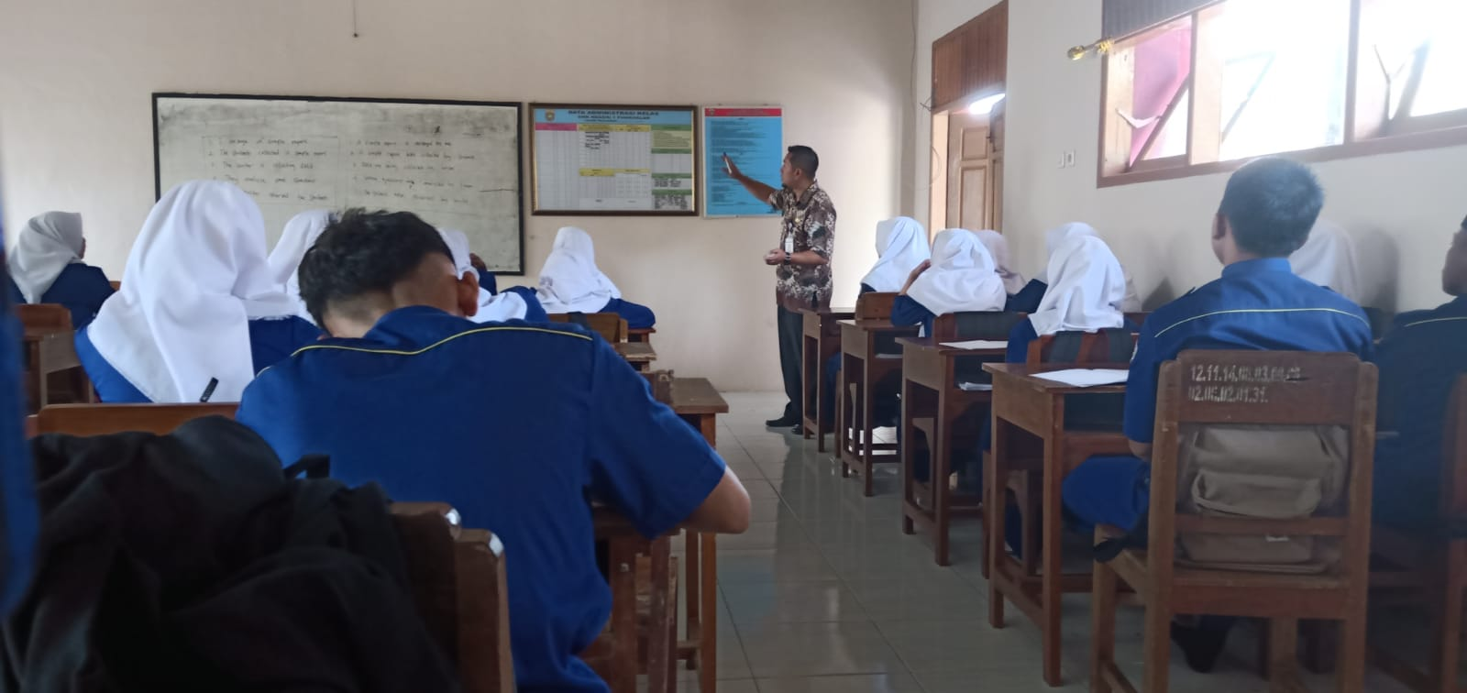
The teacher asks students to analyze the differences between passive voice and active voice.
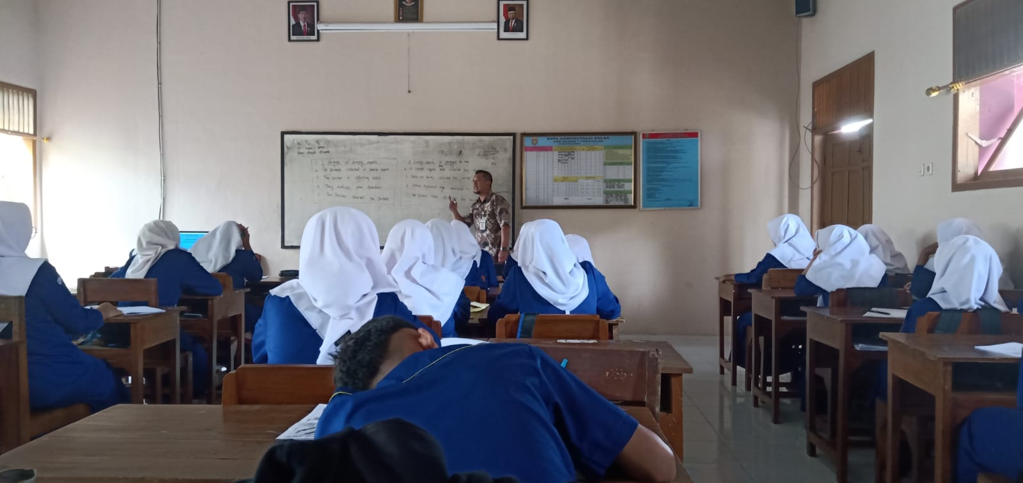
The teacher asks students to analyze passive voice sentences.
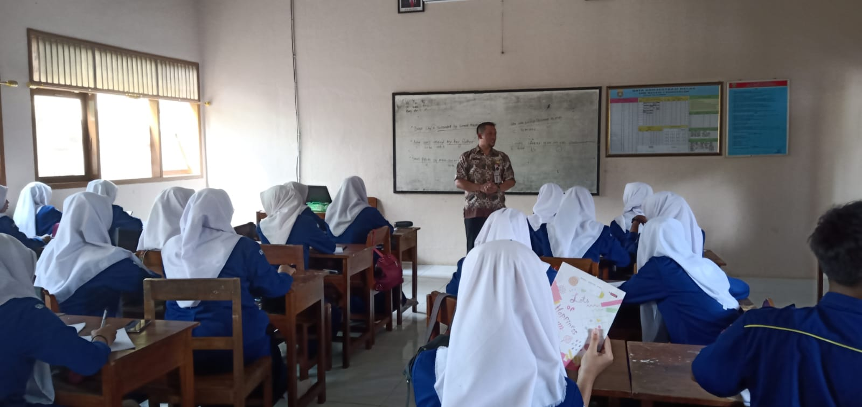
The teacher asks students (in groups) to find out English text in the Internet, then analyze the passive voice sentence.
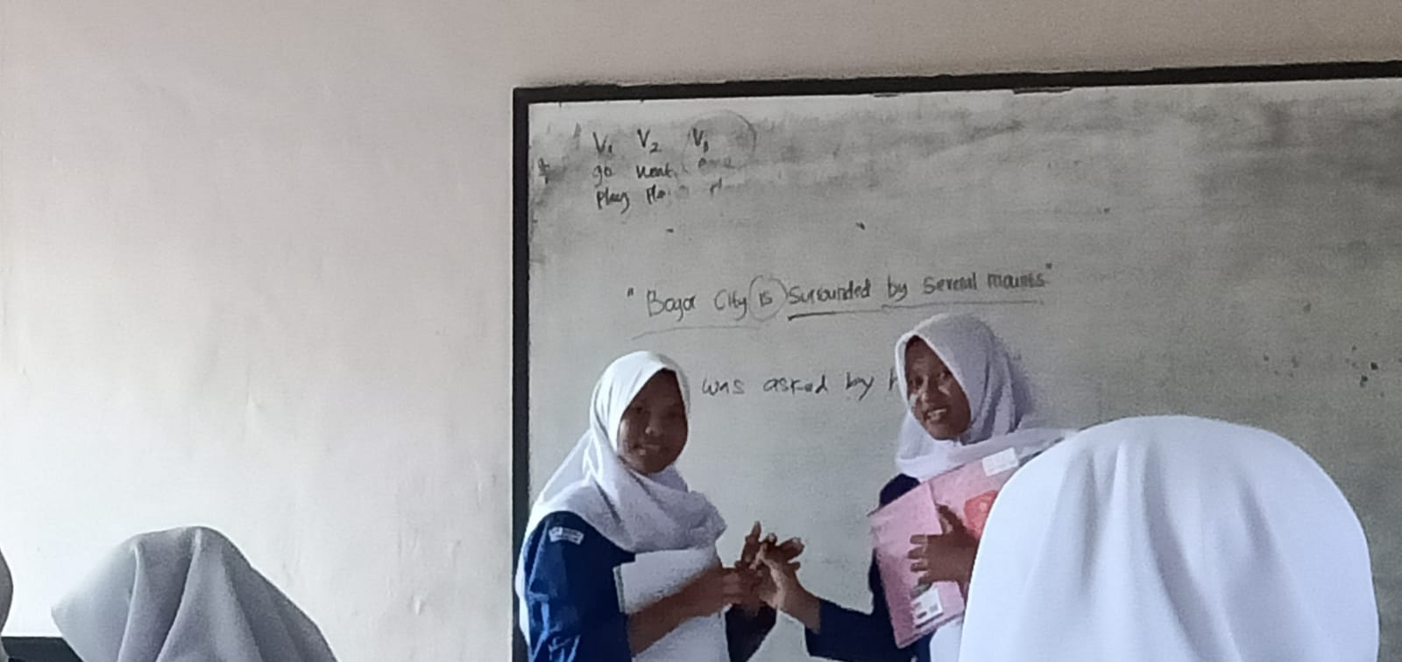
The teacher asks students to show the passive voice sentence from the text.

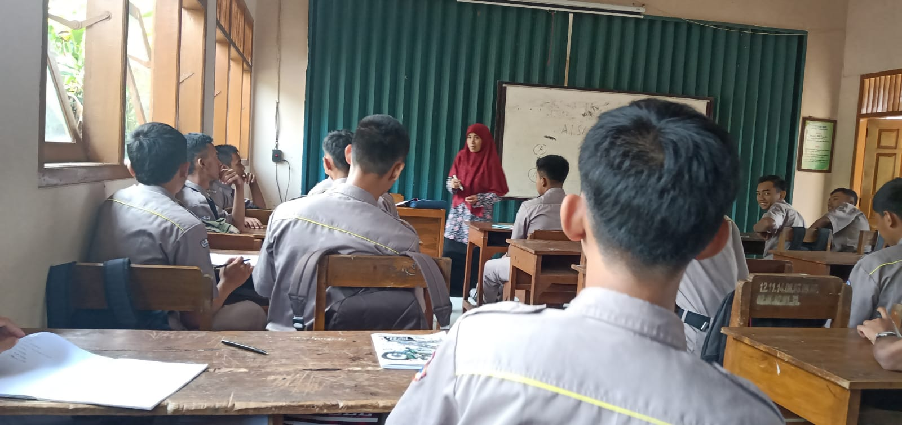
The teacher asks students to show English vocabulary starting with the letters A and I along with their meanings in Indonesian.
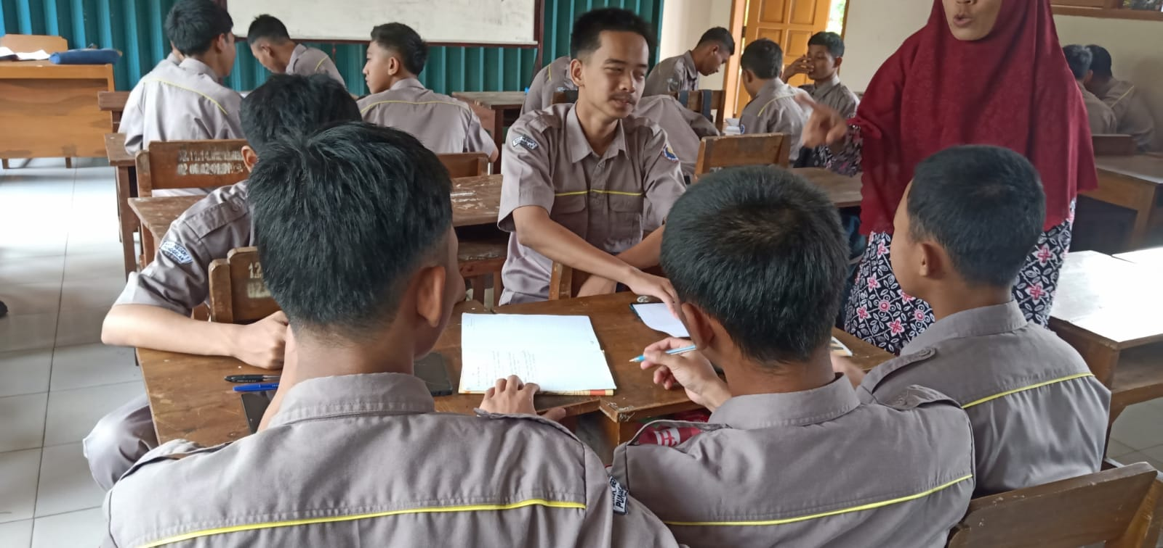
The teacher asks students to discuss and analyze the elements of simple written report.
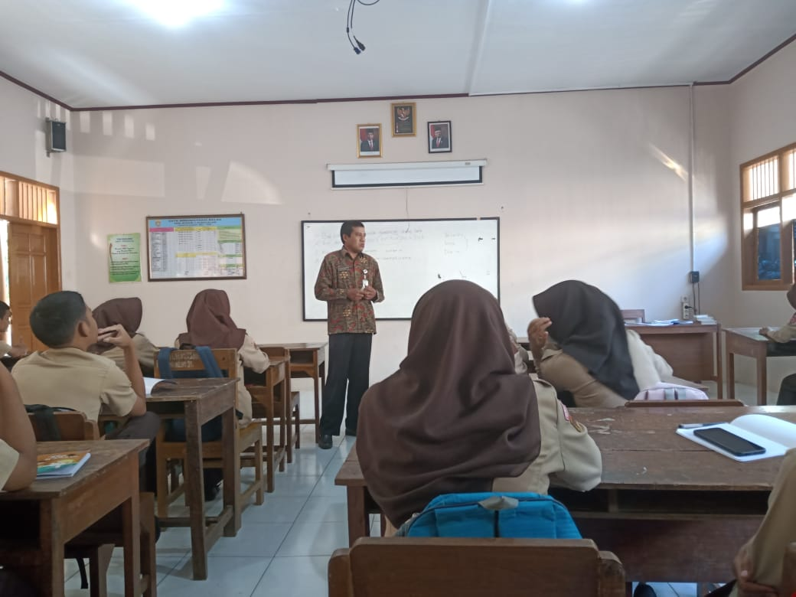
The teacher asks students to analyze the structure of cause and effect sentences.
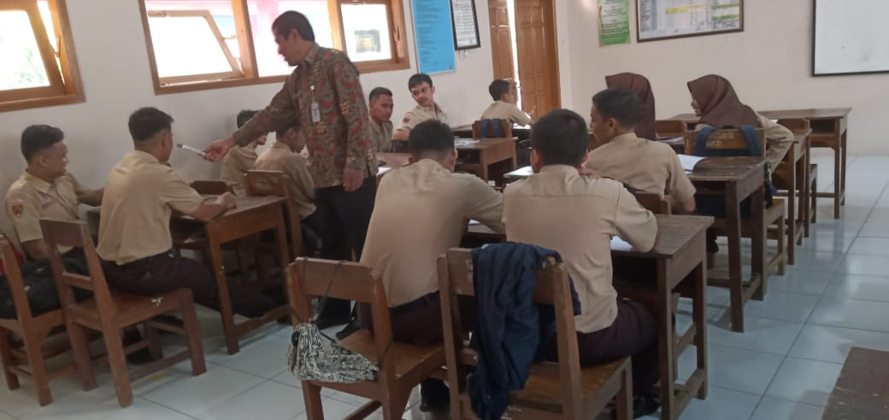
The teacher asks students to show the translation of sentences from Indonesian to English.
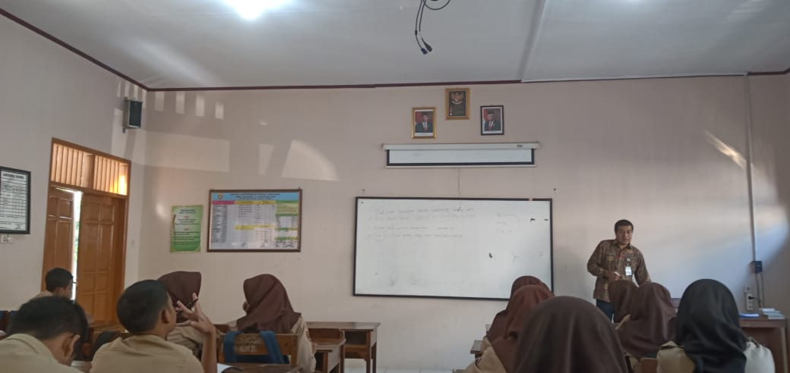
The teacher asks students to analyze the grammar feature.
- Teachers’ implementation of C5 (Evaluating)
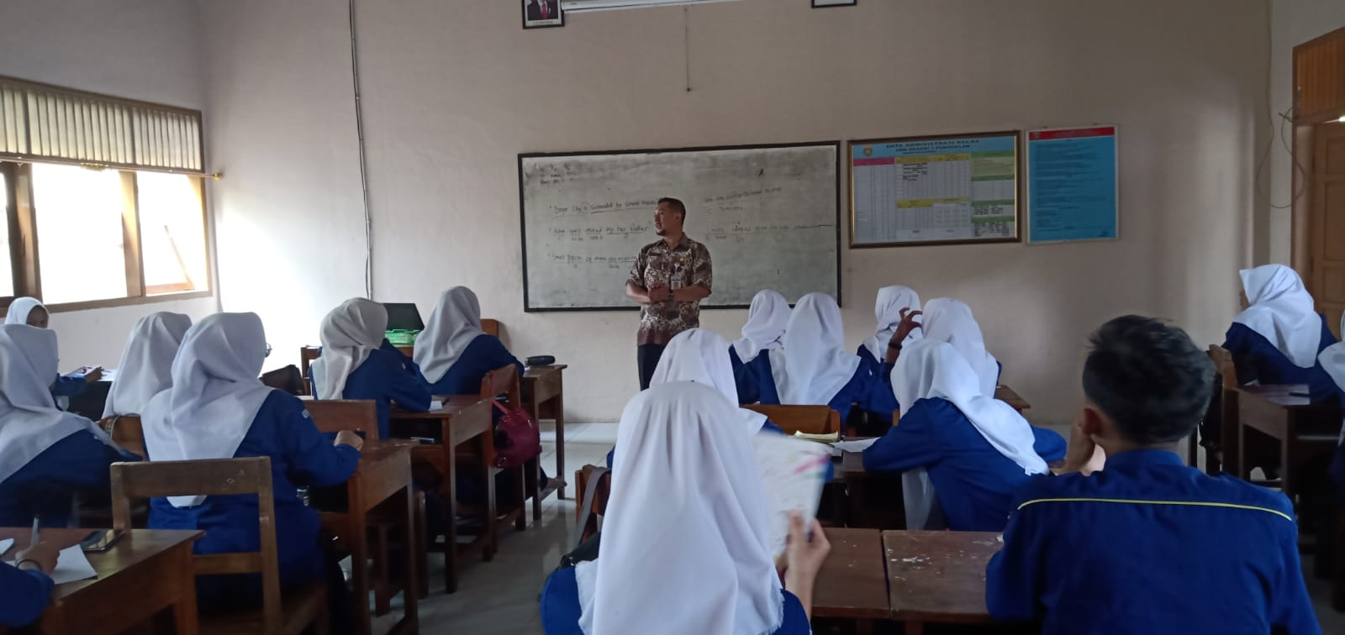
The teacher evaluates student answers and revises if there are student answers that are not correct.
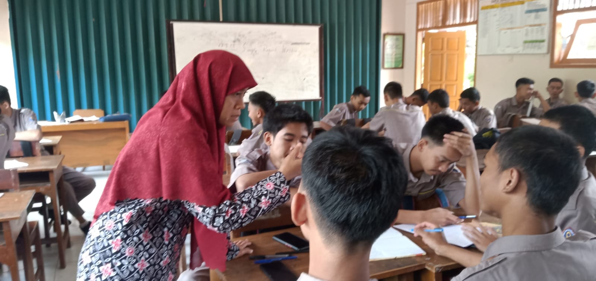
The teacher asks students to evaluate what things should be in a simple writing report about their activities during fieldwork practice (PPL) in grade 11.
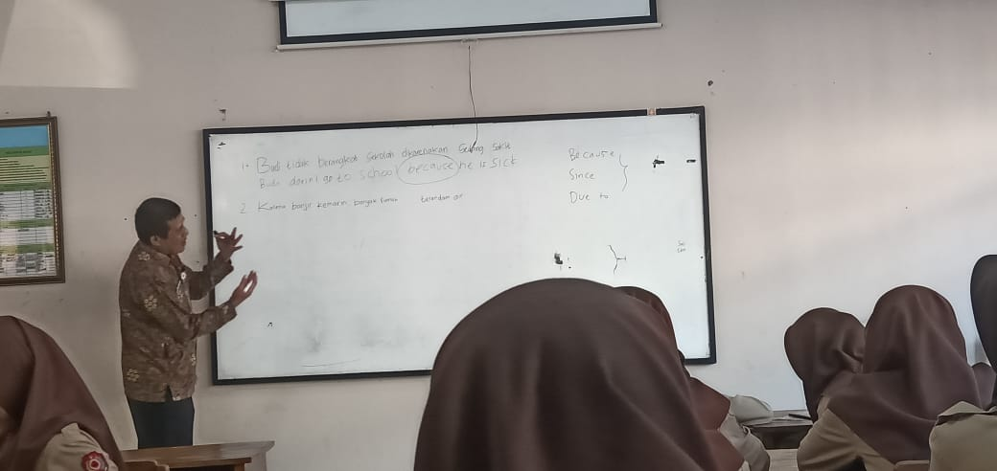
The teacher guides the students to jointly evaluate the example sentences made by students which are written on the whiteboard.
- Teachers’ Implementation of C6 (Creating)
The teacher asks students to make five passive voice sentences in a piece of paper.
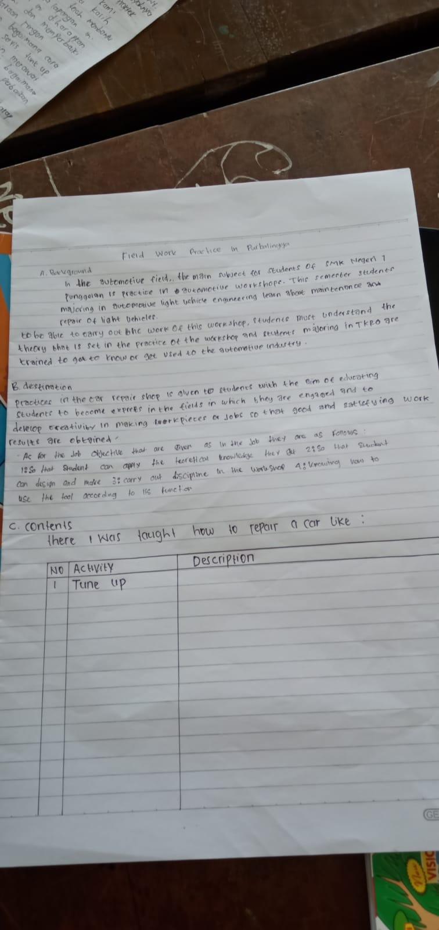
The teacher asks students in groups to make simple written reports on a piece of paper.
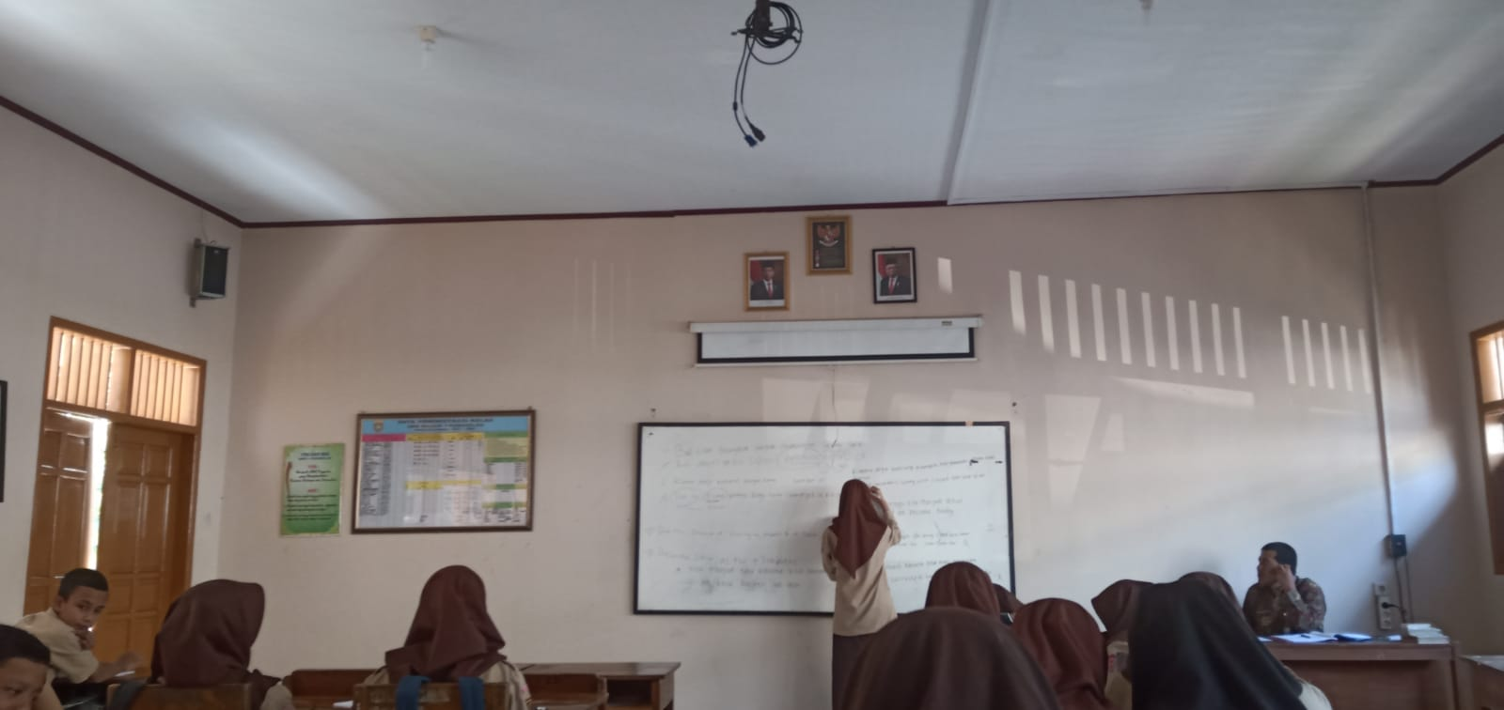
The teacher asks students to make sentences about cause and effect on the whiteboard.
Appendix 7
School Information
The basis for the establishment of SMK Negeri 1 Punggelan is the Decree of the Regent of Banjarnegara Number 421/20 of 2007 concerning the Establishment and Operational Permit of SMK Negeri 1 Punggelan Dated 15 Eebruary 2007. Construction of the SMK Negeri 1 Punggelan building on a land area of ​​20,000 m2 which was purchased by the government from village land Pinggelan. In the 2006/2007 academic year, SMK Negeri 1 Punggelan accepted the registration of new prospective students with the Department of Automotive Mechanical Engineering (TMO) with 72 students divided into 2 groups. While waiting for the construction of the building, the students were entrusted to SMP Negeri 1 Punggelan.
The first Principal of SMK Negeri 1 Punggelan, namely Drs. Endhi Sasongiati M.M, assisted by 3 honorary teachers and 3 guns from SMK Negeri 1 Bawang and several teachers of SMPN 1 Punggelan.
After the construction of the building into 3 rooms and 1 main workshop, the students moved to a new building with the address at SMK Negeri 1 Punggelan, Jalan Raya Pasar Manis Loji Punggelan, 2 rooms were used for learning, 1 room was used for the Principal, Teachers and Administration room for the 2007 academic year. /2008 SMK Negeri 1 Punggelan added a major, namely Automotive Body Repair Engineering (TPBO). Due to the health condition of the principal who was seriously ill and eventually died, in 2008 Drs Mungalim was replaced as the Principal of SMK Negeri 1 Punggelan. In 2009 Mr. Firdaus Ahmad. MM was assigned as Head of SMK Negeri 1 Punggelan. In 2011 the Regent of Banjarnegara (Bp. Djasri) declared Banjarnegara Regency as a Vocational Regency which was declared at SMK Negeri 1 Punggelan. In the 2009/2010 academic year, SMK Negeri 1 Punggelan proposed additional majors to the Banjarnegara Regency Youth and Sports Education Office and the Recommendation for Additional Accounting (Finance) Study Programs (AK), number 423.5/2231 dated June 1, 2009.
In 2012 there was a transfer of the Principal, Bp. Drs. Keriyanto served as Principal of SMK Negeri 1 Punggelan until 2014. The next rotation of Principals in 2014 was SMK Negeri 1 Punggelan led by Drs. Puryanto. A year later (in 2015) Mr. Imam Tejo Manvoto, SPd. MM serves as the head of SMK Negeri 1 Punggelan. New student candidates are increasingly unaccommodated, so in 2017 proposed the addition of a new skill program, namely the Network and Application Informatics System (SIJA) 4 years program. On September 2, 2019, there was a transfer of the principal who was assigned as the principal of SMK Negeri 1 Punggelan, namely Bp. Adi Suswanto, SPd until January 2022. On January 7, 2022, there was a transfer of the principal and the one who was assigned as the head of SMK Negeri 1 Punggelan, namely Bp. Drs. Supriyadi until now, the number of students in the 2022/2023 academic year is 1483 divided into 42 groups and 4 skill programs, those are:
- Teknik Mekanik Otomotif now to Teknik Kendaraan Ringan (TKR).
- Teknik Perbaikan Bodi Otomotif now to Teknik Bodi Otomotif (TBO).
- Akuntansi now to Akuntansi dan Keuangan Lembaga (AKL)
- Sistem Informatika Jaringan dan Aplikasi (4 years) or SIJA.
- Vision of SMKN 1 Punggelan:
”Menjadi SMK unggulan yang menghasilkan tamatan bertaqwa, kompeten dan siap kerja”
- Missions of SMK Negeri 1 Punggelan
- Menerapkan Sistem Manajemen Mutu dalam pengelolaan sekolah
- Mendidik siswa menjadi manusia yang beriman, berakhlak mulia, sehat jasmani dan rohani.
- Mengembangkan potensi siwa sesuai dengan bakat, minat dan kompetensinya
- Melatih dan membiasakan siswa untuk menjadi manusia yang berjiwa wira usaha, kompeten dan mandiri
- Menyiapkan sumber daya manusia yang mampu berfikir kritiis, kreatif, komunikatif dan kolaboratif berbasis literasi di tingkat lokal, nasional dan internasional.
- Goals of SMKN 1 Punggelan
      - Menjadi SMK yang menerakan Sistem Manajemen Mutu dalam pengelolaan sekolah.
      - Terwujudnya manusia yang beriman, berakhlak mulia, sehat jasmani dan rohani.
      - Berkembangnya potensi siwa sesuai dengan bakat, minat dan kompetensinya
      - Terwujudnya tamatan yang berjiwa wira usaha, kompeten dan mandiri
      - Terbentuknya sumber daya manusia yang mampu berfikir kritiis, kreatif, komunikatif dan kolabotratif di tingkat lokal, nasional dan internasional.

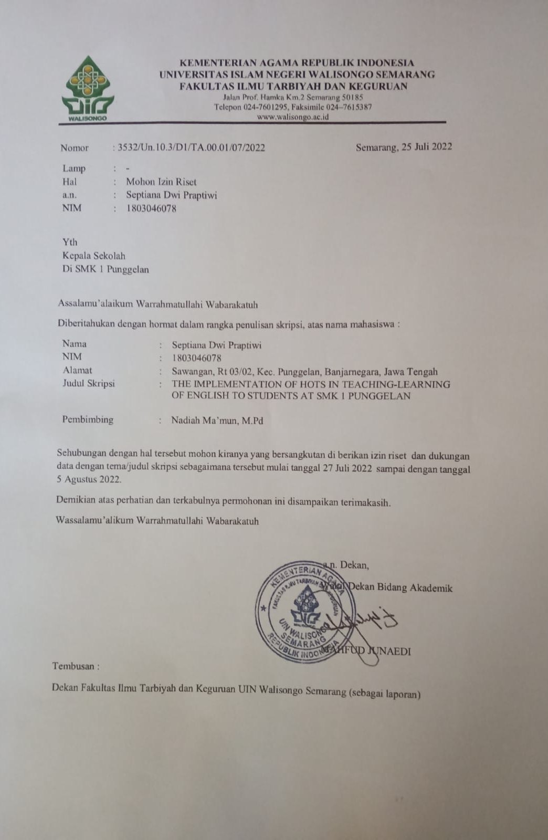

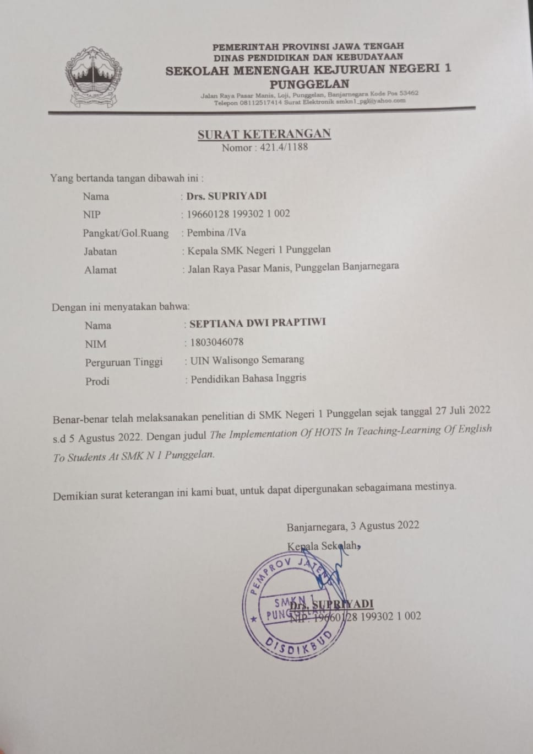
CURRICULUM VITAE
Personal Data
Name | : | Septiana Dwi Praptiwi
Place of birth | : | Banjarnegara
Date of birth | : | 16th September 2000
Address | : | Jl. Guruh Sawangan, Punggelan, Banjarnegara, Jawa Tengah
Formal Education:
- MI Cokroaminoto Sawangan
- SMP Negeri 2 Rakit
- SMA Negeri 1 Wanadadi
- English Education Department, Faculty of Education and Teacher, UIN Walisongo Semarang.

Semarang,
The Researcher,
Septiana Dwi Praptiwi
NIM: 1803046078

Hadits tentang menuntut ilmu, https://www.muttaqin.id/2018/03/hadits-tentang-menuntut-ilmu-artinya.html. Accessed at September 15^{th,} 2022
Renjini T I and Shaifali Rachna Puri, ‘English Language Learning: Challenges and Strategies of Young Learners’, IDC International Journal, 7.WS02 (2020), 45–49 <https://doi.org/10.47211/idcij.2020.v07iws02.009>.
Ya-ting Carolyn Yang and others, ‘An Online Adaptive Learning Environment for Critical-Thinking-Infused English Literacy Instruction’, 2013, 1–25 <https://doi.org/10.1111/bjet.12080>.
Fatkhul Mubin, ‘Pengertian, Unsur, Prinsip Dan Ruang Lingkup Perencanaan Pendidikan’, 2020, 1–12 <https://doi.org/10.31219/osf.io/q24jz>.
Undang-undang Sistem Pendidikan Nasional, ‘Undang-Undang Sistem Pendidikan Nasional’, 2003.
‘PENDIDIKAN DALAM PERSPEKTIF ALQURAN(MIFTH).Pdf’.
Lajnah Pentashihan Mushaf Ql-Qur’an Badan Litbang dan Diklat Kementrian Agama RI, ‘No Title Al-Qur’an Dan Terjemahannya Edisi Penyemournaan 2019’.
RI.
‘Ayat Al-Qur’an’ https://ayatalquran.net/2015/01/surah-ali-imran-%D8%A2%D9%84-%D8%B9%D9%85%D8%B1%D8%A7%D9%86-the-family-of-imraan-terjemah-bahasa-inggris/ [accesed at 8th September 2022]
https://alquranmulia.wordpress.com/2015/03/16/tafsir-ibnu-katsir-surah-ali-imraan-ayat-137-143/
‘PENDIDIKAN DALAM PERSPEKTIF ALQURAN(MIFTH).Pdf’.
Yoki Ariyana and others, ‘Buku Pegangan Pembelajaran Keterampilan Berpikir Tingkat Tinggi Berbasis Zonasi’, Direktorat Jendral Guru Dan Tenaga Kependidikan, 2018, 1–87.
Ariyana and others.
Umi Pratiwi and Eka Farida Fasha, ‘Pengembangan Instrumen Penilaian Hots Berbasis Kurikulum 2013 Terhadap Sikap Disiplin’, Jurnal Penelitian Dan Pembelajaran IPA, 1.1 (2015), 123 <https://doi.org/10.30870/jppi.v1i1.330>.
Lorin W Anderson and others, Taxonomy For_ Assessing a Revision 0F Bl00M’S Tax0N0My 0F Educati0Nal Objectives, 2001 <https://www.uky.edu/~rsand1/china2018/texts/Anderson-Krathwohl - A taxonomy for learning teaching and assessing.pdf>.
Ellen Boeren and Tatiana Íñiguez-Berrozpe, ‘Unpacking PIAAC’s Cognitive Skills Measurements through Engagement with Bloom’s Taxonomy’, Studies in Educational Evaluation, 73.March (2022), 101151 <https://doi.org/10.1016/j.stueduc.2022.101151>.
Erastus Karanja and Laurell C. Malone, ‘Improving Project Management Curriculum by Aligning Course Learning Outcomes with Bloom’s Taxonomy Framework’, Journal of International Education in Business, 14.2 (2020), 197–218 <https://doi.org/10.1108/JIEB-05-2020-0038>.
Agus Kristiyono, ‘Urgensi Dan Penerapan Higher Order Thingking Skills’, Jurnal Pendidikan Penabur, 17.31 (2018), 36–46.
Neldawati Neldawati, ‘Deskripsi Lingkungan Belajar Siswa Terhadap Mata Pelajaran Fisika Di SMA Ferdy Ferry Putra Kota Jambi’, Journal Evaluation in Education (JEE), 1.1 (2020), 01–07 <https://doi.org/10.37251/jee.v1i1.12>.
Mursyid Mursyid and Nia Kurniawati, ‘Higher Order Thinking Skills Among English Teachers Across Generation in Efl Classroom’, English Review: Journal of English Education, 7.2 (2019), 119 <https://doi.org/10.25134/erjee.v7i2.1775>.
Muhammad Ansori, ‘English Teachers’ Efficacy in Using Pedagogical Techniques To Promote Higher Order Thinking Skills’, Celtic: A Journal of Culture, English Language Teaching, Literature and Linguistics, 6.2 (2019), 1–13 <https://doi.org/10.22219/celtic.v6i2.9860>.
Undang Rosidin, Agus Suyatna, and Abdurrahman Abdurrahman, ‘A Combined HOTS-Based Assessment/STEM Learning Model to Improve Secondary Students’ Thinking Skills: A Development and Evaluation Study’, Journal for the Education of Gifted Young Scientists, 7.3 (2019), 435–48 <https://doi.org/10.17478/jegys.518464>.
Kuniawan Ahmad, ‘The Implementation of Teaching LOTS and HOTS in English Teaching-Learning Process in Senior High School’, Retain, 6.1 (2018), 121–28.
I. Yusuf and others, ‘Blended Learning: Its Effect towards Higher Order Thinking Skills (HOTS)’, Journal of Physics: Conference Series, 1832.1 (2021) <https://doi.org/10.1088/1742-6596/1832/1/012039>.
Ariyana and others.
Bernadeta Siska Indriyana and Paulus Kuswandono, ‘Developing Students ’ Higher Order Thinking Skills ( HOTS ) in Reading : English Teachers ’ Strategies in Selected Junior High Schools’, 5.October 2019, 204–16.
Ariyana and others.
Ariyana and others.
Akbar Syarifudin, ‘LOTS AND HOTS OF TEACHER-MADE TEST IN JUNIOR HIGH SCHOOL LEVEL IN KEFAMENANU’, 2507.February (2020), 1–9.
Syarifudin.
Ariyana and others.
Yoki Ariyana, Ari Pudjiastutu, and Reisky Bestary, ‘Buku Pegangan Pembelajaran Berorientasi Pada Ketrampilan Berfikir Tingkat Tinggi Modul Belajar Mandiri Calon Guru Pegawai Pemerintah Dengan Perjanjian Kerja’, Direktorat Jenderal Guru Dan Tenaga Kependidikan Kementrian Pendidikan Dan Kebudayaan, 2018, 65–80.
Ariyana, Pudjiastutu, and Bestary.
Ariyana, Pudjiastutu, and Bestary.
Ariyana and others.
Ahmad Sopian, ‘Tugas, Peran, Dan Fungsi Guru Dalam Pendidikan’, Raudhah Proud To Be Professionals : Jurnal Tarbiyah Islamiyah, 1.1 (2016), 88–97 <https://doi.org/10.48094/raudhah.v1i1.10>.
Rusdiana and Yeti Heryati, ‘Pendidikan Profesi Keguruan Menjadi Guru Inspiratif Dan Inovatif’, 2015, p. 350 <http://digilib.uinsgd.ac.id/29404/1/16-Penddk Prof Kegruan 2015.pdf>.
Zaenal Arifin, ‘Menjadi Guru Profesional (Isu Dan Tantangan Masa Depan)’, Edutech, 13.1 (2014), 132 <https://doi.org/10.17509/edutech.v13i1.3225>.
Sopian.
Sopian.
Afzal Sayed Munna and Md Abul Kalam, ‘Teaching and Learning Process to Enhance Teaching Effectiveness: Literature Review’, International Journal of Humanities and Innovation (IJHI), 4.1 (2021), 1–4 <https://doi.org/10.33750/ijhi.v4i1.102>.
Silviana Nur Faizah, ‘Hakikat Belajar Dan Pembelajaran’, At-Thullab : Jurnal Pendidikan Guru Madrasah Ibtidaiyah, 1.2 (2020), 175 <https://doi.org/10.30736/atl.v1i2.85>.
Dosen Jurusan, Tarbiyah Stain, and Sultan Qaimuddin, ‘KONSEP DASAR PENGELOLAAN PENGAJARAN’, 90–107.
C. Vijaya Bhaskar and S. Soundiraraj, ‘A Study on Change in the Attitude of Students towards English Language Learning’, English Language Teaching, 6.5 (2013), 111–16 <https://doi.org/10.5539/elt.v6n5p111>.
Vijaya Bhaskar and Soundiraraj.
Hossein Nassaji, ‘Qualitative and Descriptive Research: Data Type versus Data Analysis’, Language Teaching Research, 19.2 (2015), 129–32 <https://doi.org/10.1177/1362168815572747>.
Cathryne Palmer and Amanda Bolderston, ‘A Brief Introduction to Qualitative Research’, Canadian Journal of Medical Radiation Technology, 37.1 (2006), 16–19 <https://doi.org/10.1016/s0820-5930(09)60112-2>. J
Sugiyono, ‘Metode Penelitian Pendidikan, Pendekatan Kuantitatif’, 2010, p. 216.
Sugiyono.
Sugiyono.
Jozef Raco, ‘Metode Penelitian Kualitatif: Jenis, Karakteristik Dan Keunggulannya’, 2018 <https://doi.org/10.31219/osf.io/mfzuj>. p. 110
Sunwinarti Sunwinarti and others, ‘Strategy for Developing High Order Thinking Skills in Basic Automotive Technology Subjects at Jetis 1 in SMK Mojokerto’, 1, 2020, 1–10 <https://doi.org/10.4108/eai.3-8-2019.2290743>.
T. Sulaiman and others, ‘Implementation of Higher Order Thinking Skils in Teaching of Science: A Case Study in Malaysia’, in International Research Journal of Education and Science (IRJES), 2017, i, 1–3.
Mei Ardaning Tyas and others, ‘Developing Higher Order Thinking Skills (HOTS) – Based Questions: Indonesian EFL Teachers’ Challenges’, 2019, pp. 52–63 <https://doi.org/10.17501/26307413.2019.2106>.
Charanjit Kaur Swaran Singh and Pavalaarasi Marappan, ‘A Review of Research on the Importance of Higher Order Thinking Skills (HOTS) in Teaching English Language’, Journal of Critical Reviews (Innovare Academics Sciences Pvt. Ltd, 2020), 740–47 <https://doi.org/10.31838/jcr.07.08.161>.
Thị Minh Tâm Nguyễn and Thị Thùy Linh Nguyễn, ‘Influence of Explicit Higher-Order Thinking Skills Instruction on Students’ Learning of Linguistics’, Thinking Skills and Creativity, 26 (2017), 113–27 <https://doi.org/10.1016/j.tsc.2017.10.004>.
I. Ichsan and others, ‘HOTS-AEP: Higher Order Thinking Skills from Elementary to Master Students in Environmental Learning’, 8.4, 935–42 <https://doi.org/10.12973/eu-jer.8.4.935>.
Ichsan and others.

