**TEACHER'S PERCEPTION OF USING VIDEO LEARNING TO ENHANCE STUDENT'S LISTENING**

# THESIS

Submitted in Partial Fulfillment of the Requirements for Degree of Bachelor of Education in English Education



By:

**Yudhystira**

**1803046001**

**ENGLISH EDUCATION DEPARTMENT FAKULTAS ILMU TARBIYAH DAN KEGURUAN UNIVERSITAS ISLAM NEGERI WALISONGO SEMARANG**

**2023**

# A THESIS STATEMENT

# 

# ADVISOR NOTE

# MOTTO

**فَإِنَّ مَعَ الْعُسْرِ يُسْرًا , إِنَّ مَعَ الْعُسْرِ يُسْرًا**

**“ So verily with hardship, there is ease."**

**(QS.Al Insyirah 5-6)**

# ABSTRACT

Title: Teacher’s Perception Of Using Video Learning To Enhance Student's Listening.

Writer: Yudhystira

Students ID: 1803026001

Through learning videos, students can practice English listening easily and not be bored. This thesis aims to find out teachers' perceptions about the use of learning videos in facilitating English listening skills. The participants were twenty-seven students of class XI IIS SMA Bangun Cipta Rumbia. This research is descriptive qualitative research whose data were obtained from questionnaires, observations, and interviews. Data analysis in this study includes the stages of data reduction, data presentation, and drawing conclusions. Based on the findings of this study, the teacher believes that students have a positive perception of the use of learning videos in class XI IIS, and learning videos can also provide many benefits for students because they improve the ability to understand dialogue in English.

**Keywords: Teachers’ Perception, Video Learning, Listening Skill.**

# DEDICATION

In the Name of Allah, the Most Beneficent, the Most Merciful, this thesis is dedicated to:

1. UIN Walisongo Semarang
2. Education and Teacher Training Faculty
3. English Education Department
4. MAN 1 Kota Metro
5. MTSN 1 Kota Metro
6. SD Metro Selatan

# ACKNOWLEDGEMENT

*Bismillahirrahmanirrahim*

All praises are given to Allah Subhanahu Wa Ta'ala, who has been giving us blessings and the most mercies who blessed the researcher that has finished this thesis. Peace and great salutation may always be delivered to our Prophet Muhammad SAW, who has guided us from the darkness to this bright modern era.

During arranging the thesis, the researcher was truly grateful and the deepest thanks to all support systems who had given contributions to the research:

* 1. Dr. KH. Ahmad Ismail, M.Ag., M. Hum. As the Dean of the Faculty of Education and Teacher Training of Walisongo State Islamic University.
  2. Dra. Nuna Mustikawati Dewi, M.Pd. as the Head of English Language Education
  3. Nadiah Ma’mun, M.Pd., is the advisor who always guided this chapter containing conclusions and suggestions.
  4. All my biggest love, my father, Toni, my mom Binti Ngasaratun and my brothers, Erlangga.
  5. All the students of Class XI IIS SMA Bangun Cipta Rumbia.
  6. All the lectures of English Education UIN Walisongo Semarang.
  7. Team PPL FITK UIN Walisongo Semarang 2021 in SMK Darul A’mal Metro Lampung
  8. Headmaster Nyoman Suparto and All Staff off SMA Bangun Cipta Rumbia.
  9. My beloved Faridatun Ni'mah, who has supported and helped complete this thesis patiently and is full of motivation.
  10. All friends of the English Education Department 2018, special to PBI A 18, thanks for four years.
  11. Big Family of hostel Beringin Asri D23 and For all great people.

Semarang, 8 April 2023

Regard from Writer

Yudhystira

1803046001

# TABLE

THESIS 1

A THESIS STATEMENT  ii

ADVISOR NOTE iii

MOTTO iv

ABSTRACT v

DEDICATION vi

ACKNOWLEDGEMENT vii

TABLE ix

CHAPTER I INTRODUCTION 1

A. Background of The Research 1

B. Research Questions 4

C. Research Objectives 4

D. Pedagogical Significance 5

CHAPTER II 7

LITERATURE REVIEW 7

A. Previous Researches 7

B. Theoretical Framework 9

1. The Meaning of Listening 9

2. Teaching Listening 10

3. The Implementation of Video Learning 12

4. Perception 14

CHAPTER III RESEARCH METHOD 18

A. Research Design 18

B. Research Setting 19

C. Research Participants 19

D. Data Collection Technique 19

E. Instrument of the Research 21

1. Questionnaire 21

2. Observation 23

3. Interview 24

F. Data Analysis Technique 25

1. Data Reduction 25

2. Data Display 26

3. Conclusion Drawing 26

CHAPTER IV 28

RESEARCH FINDINGS AND DISCUSSION 28

A. Findings 28

1. Implementation of Learning Video in the Classroom 28

2. Students' perceptions of using learning videos to improve the listening skills 30

3. Implementation of Video Learning in the Classroom 32

4. Students’ Perception of Using Video Learning in Facilitating English Listening Skill 34

B. DISCUSSION 41

1. Strenght and Weakness 41

2. Implication 42

3. Limitation 43

CHAPTER V 44

CONCLUSION AND SUGGESTION 44

A. Conclusion 44

B. Suggestion 46

REFERENCES 47

APPENDIX I 1

CURRICULUM VITAE 29

# CHAPTER I INTRODUCTION

This chapter contains the Background of the research, research questions, research objectives, pedagogical significance, and research limitations.

## **Background of The Research**

English has a significant role in today's society as an international language. English is suitable for use in education. In various fields of life, English is needed. There are many people who are useful in speaking English in this world. The four main English skills are speaking, listening, reading, and writing. In Indonesia, students have studied English material from Elementary to University. Speaking, listening, reading, and writing are all skills that we must acquire to communicate in English. However, listening is considered by most students as the most challenging activity.

[1]It is crucial for people to study English because it is one of the languages that is commonly spoken in this era of globalization. English has been taught in Indonesian schools since the very beginning. From kindergarten through senior high school and university, English is taught. Thus, language acquisition requires four skills, one of which is listening.

Learning English is tough for many people. One of the reasons is since they are learning English, they seldom ever utilize it in their regular talks. Most people believe that learning English is more difficult than another, according to Nunan (2020). It is critical to develop a method that can spur students' interest in and enthusiasm for learning English.[2]

Listening can be taught through a variety of methods. Learning videos are one of them. Through these videos, students can practice their English skills (Nunan, 2020).

The Researchers found that most of the listening difficulties were related to self-confidence and self-doubt in the classroom. Researchers found that when Indonesians started listening to English, they were very worried and afraid of making mistakes or listening to the wrong words. The researcher found that the simplest method, using video media, was the most interesting and widely used method in English class activities while learning to listen to English in various ways.[3]

Because listening is such a useful skill, learning listening skills can be challenging. The need for students to communicate with each other expands their vocabulary. Listening is a skill that is often used by everyone in their daily activities.

English learning videos are important skills that are applied to hone English listening skills. English learning videos facilitate English listening learning. As its main goal is to increase student contribution in class and encourage students to be brave in explaining what they hear in English, learning videos can be very powerful instruments in the hands of teachers.[4]

Listening is very important in several sectors today. Video learning is a method to improve listening skills. Students' communication skills can be developed.[5]

Video lessons are a great practice for students to practice and build confidence while also giving them the opportunity to use their English efficiently to boost their listening skills. Because they probably behave like professionals when they are learning videos, students may also feel as if they are involved in the conversation.[6]

One technique for practicing listening skills is learning videos. “Learning videos can be an excellent tool in a teacher's toolbox because their main goal is to increase student engagement in the classroom and encourage learning in theoretical understanding of language in action." (Kusnierek, 2015).

"Learning videos provide many opportunities for students to listen because they are the subject of practice; with learning videos, students have plenty of time to listen to more vocabulary.," claimed Rahman, Yassi, and Arafah (2016).

Video learning is a technique where students watch and listen to conversations from the contents of the video so that it is very adaptable, proactive, and imaginative.[7]

## **Research Questions**

This study aims to determine Teachers' Perception In Using Video Learning To Enhance Student's Listening. The researcher conducted two research questions:

* 1. How is the application of learning videos in Facilitating English Listening Skills?
  2. What is the teacher's Perception of the use of learning videos in facilitating English listening skills?

## **C. Research Objectives**

The researcher conducted two objectives based on the research questions above:

1. To find out the implementation of the use of learning videos in facilitating English listening skills.
2. To find out the teacher's Perception of the use of learning videos in facilitating English listening skills.

## **Pedagogical Significance**

The researcher expected this research could give some advantages to the teacher, the students, and the future researcher both theoretically and practically.

1. Theoretically, the researcher hopes to provide theoretical significance in learning English, especially in listening skills. On the other hand, this research serves as a framework, guide, and reference for future researchers regarding research.
2. Practically, the result of this study is beneficial:
   * 1. English teacher of SMA Bangun Cipta Rumbia.

Researchers hope that this research can help teachers' understanding of teacher perceptions in using learning videos to facilitate students in English language skills. Teachers have different perceptions, whether they are positive or negative perceptions.

* + 1. Students’ Class XI IIS of SMA bangun Cipta Rrumbia

The researcher hopes that students know that learning videos develop students' listening skills. Students also realize and find their problems using learning videos to facilitate English listening skills.

* + 1. Researchers

The researcher hopes that this research can raise the next researcher in doing a thesis related to this topic. Hopefully, future researchers can obtain more information about the use of learning videos in listening skills.

# CHAPTER II

# LITERATURE REVIEW

This chapter discusses the theoretical framework and previous research.

## **Previous Researches**

The author of this thesis took into account several previous research that were relevant to it. These are

The first research, An Publication Journal of Rishi Khothori Nina Suzanne (2020) entitled, Students’ Perception on the Video Used by English Teachers as Instructional Media. This study aims to find out students' perceptions of how the learning videos used by English teachers can influence students' English skills in EFL/ESL classes. Qualitative methods through interviews are used in this study.[8]

Second research, A Publication Journal of A.A.C. Cahyana (2020) entitled, the use of Video Learning in Teaching English for foreign language at vocational high school. Aimed of this research is to indicate the impact of Video Learning on students listening performance. The result is that video learning is an impactful part of improving student listening performance.[9]

Third research, An International Journal of Maria Asuncion Rojas, Johnny Villafuerte, entitled, The Influence of Implementing Learning Video as an Educational Technique on EFL Listening Development. Aimed of this research is to explore the influence of implementing Learning Videos in EFL Listening. Quantitative method used in this research. The result of this research shows implanted learning Videos on EFL students most used in Listening development.[10]

Fourth research, An International Publication Journal of Binod Neupane (2019) entitled, Effectiveness of Video Learning in Improving Listening Skill. The experimental approach was used in this research. The aim of the research is to find out the effectiveness of Video Learning in improving Listening skills. The researcher finds out that role is effective in improving Listening skills.[11]

Fifth research, A Publication Journal of Maria Fatima Jaina, Sukmawati, Suharti Sirajuddin entitled, Improving Students' Listening Skill by Using Video Learning at Class XI MIPA Students of SMA Negeri 12 Makassar. Aimed of this research is to investigate Video Learning in improving students' listening skills. Qualitative description used in this research. The result of the data findings is that most students have problems when listening to English without the right technique.

In the Maria Fatima Jaina Publication Journal, Sukmawati, Suharti Sirajuddin entitled, Improving Students' Listening Skills by Using Video Learning in Class XI MIPA Students at SMA Negeri 12 Makassar. This study aims to investigate video learning in improving students' listening skills. Qualitative descriptive is used in this research. The results of the data findings that most students have problems when listening to English without the right technique. Then the researcher innovates in choosing media so students don't have problems when listening to English without the right technique. The researcher tried to use the learning video technique as the medium in this study. The researcher used the same descriptive qualitative method used by previous researchers. The difference between previous researchers was in determining an efficient technique for improving students' English listening skills using learning videos.

## **Theoretical Framework**

### **The Meaning of Listening**

One of the basic skills in learning English is listening. The importance of listening ability stems from its use in communication. Listening is a form of communication, according to Jones (2017). Make sure what you mean matches what you say and that you communicate it in the most effective way possible. Listening is very important when trying to communicate with other people, in short. Listening ability is as important as literary ability in first and second languages.[12]

One of the most frequently evaluated abilities is also a great vehicle for fostering social cohesion, social status, career advancement, and successful commercial practice. Listening will be necessary in every setting this term, and listening skills can benefit students in English language classes in particular.[13]

Listening is the act of pronouncing words or sentences in a communication or conversation to impart knowledge, ideas, and information to the other participants.[14]

### **Teaching Listening**

Speaking and listening are closely related as forms of communication. This implies that speaking ability and listening ability interact during the discussion. By using the skills they have, students must explain what they hear to the audience.[15] When conveying messages, sometimes students make mistakes. Communication has problems with spelling, grammar, vocabulary, and social and cultural norms. When composing a speech, it is important to pay attention to several different elements, such as sentence production, stress, intonation, and rhythm. When using a second language, these elements can be significant and useful.[16]

However, based on Nunan (2020), there are five guidelines for teaching listening.

First, the teacher is able to distinguish between the context of second language acquisition and foreign language acquisition. Language learning refers to a foreign language environment. The language used for communication is referred to as the second language context. Second, the teacher provides challenges to see and listen to Learning Videos for students to practice their newly acquired listening skills correctly and fluently. Thirdly, teachers need to give students opportunities to write while limiting their own writing time. This implies that the teacher only facilitates and gives instructions when students are asked to collect written results. Fourth, educators need to replay learning videos by actively involving students in the learning process. Last but not least, as a guide for actual practice, teachers are expected to design some classroom learning videos that incorporate verbal transactions and exchanges. Transactions and interactions are different. The difference is that the purpose of the interaction is to uphold and build social bonds, whereas verbal transactions primarily focus on conveying the meaning of the message.[17]

### **The Implementation of Video Learning**

In the classroom, the video learning technique is often used. Each student only needs to pay attention; learning videos must be completed. Use of meetings with learning videos challenge. The students had to record certain sentences that they found difficult and unfamiliar. Students benefit greatly from the opportunity to practice listening. In addition, this method allows students to understand new sentences and increase their vocabulary. According to Lad Ousse, mentioned by Rayhan (2018), a role is a person in certain circumstances, and playing needs to be done in a safe atmosphere where children can express their creativity. Students participating in the learning videos experience the world of their imaginations. In listening classes, learning videos is a popular exercise. Students need extra time to pay attention. The learning videos offer students several opportunities to use the script, regardless of the challenges. The learning videos can be directed by the teacher.

The method used to determine the score is the degree of reactivity to complexity. Test takers become simpler, more focused, and more responsive using this method. In taking notes, students are given the opportunity to review the learning videos. They are informed about the flow of the video that will be played, so they can think of a plot that fits the learning video that will be played, and occasionally the teacher will ask them to respond to questions based on that.[18]

On their personal Perception. Students are involved in the learning videos while paying attention to the learning videos. Students note difficult and unfamiliar sentences differently. Students pay attention to the scenarios in this activity. Characters and characterizations are all present in the dialogues produced by students. Learning videos are considered one of the communicative-based activities that enable learners to practice the target language and engage with others for their competency purposes. Referenced in Livingstone by Blatner (2009). Video lessons are a class practice that fits Livingstone, as stated by Krebt (2017), providing opportunities for students to engage actively and thoroughly with language.[19]

In other words, learning videos facilitate students to improve their listening skills.[20] 23 Several benefits have been suggested for learning videos as fluency exercises if done in class, according to Hedge, as mentioned in Yuliana (2014). The sentence that students want to record is their choice. The findings of the third related study show that classroom video is an effective way to develop students' English proficiency (Oradee, 2013).

The findings from the fourth related study indicate that video learning increases students' success in achieving their goals (Oradee, 2013). The final findings of recent studies show that learning videos improve students' ability to listen fluently and develop conversational skills (Naksevee, 2013).

### **Perception**

* + 1. **The Meaning of Perception**

Based (Merriam-Webster) (Merriam-Webster) Mental viewpoints, external context, and connectivity in which subjects or components are thought of mentally. According to Altman, Valenzi, and Hodgetts (1985: 85), "the result of meaningfully interpreting the stimuli by which persons chose and group the stimuli" is the notion of Perception. A further definition of Perception given by George and Jones (2005) is the "process of selecting, organizing, and interpreting the input from an individual's senses (hearing, smell, touch, vision, and taste) in order to provide meanings to their environment." Mc Shame and Glinow (2005) defined Perception as the action of ingesting data and evaluating the surrounding world. An object or an event that exists in or occurs in the environment or the outside world is perceived from the point of view of the perceiver. Depending on how people think, it's possible for everyone to perceive a phenomenon in a different way. A person's Perception of something is how they view it, and how they see something affects how they perceive it.[21] Collins Dictionary defines pere as a specific way of thinking, especially one that is influenced by your views or experiences. It serves as a reminder of how important Perception is.

* + 1. **Perception Works**

When the individual's sensor chooses the data from the stimulus, a perceptual process begins, according to Altman et al. (1985:86). The stimuli that come from the environment are stored by sensory receptors before being sent to the brain. The sensor chooses the data from the stimulus and enables the individual to interpret the sensory information, according to Altman et al. (1985:86). The brain interprets the stimulus, and then Perception is created. Finally, the outcome of the individual's view will cause them to respond differently to conduct.

* + 1. **The Factor Affecting Perception**

The selection of stimuli, the structuring of stimuli, the context, and the subject's self-concept are the four elements that can affect a person's Perception, according to Altman et al. (1985). The selection of stimuli is the first component that can impact Perception. Despite being surrounded by many stimuli, people tend to focus on a small number of them. Selecting refers to this process. It explains why different people have diverse perspectives on events.

The structuring of the stimuli is the second factor. It is necessary to arrange the data in a meaningful way once it has been through the screening process. The situation is the following element. A person's experience, expectations, and familiarity with a situation all have an impact on how that person sees it. Self-concept is the final component. The way a person views and feels about themselves is their self-concept. People's perceptions of their own selves have an impact on how they perceive the world. The way people see themselves in their minds influences a lot of what they think, feel, and act, so self-concept is crucial. The majority of the time, as a person ages, their self-concept evolves.

# CHAPTER III RESEARCH METHOD

The primary emphasis of this chapter is on the research methodology applied to this research. The research design, research setting, research participants, method of data collection, research instrument, and technique of data analysis are some of the subchapters.

## **Research Design**

Research design is the method used to choose how to proceed with data acquisition for a research study. This thesis uses descriptive qualitative. The aim of this study was to characterize teacher perceptions broadly and in-depth about the use of video lessons in facilitating English listening skills. This was done using a descriptive qualitative design. Moreover, qualitative research is defined as characteristics of substance, process, and meaning rather than being tested experimentally or measured in terms of quantity, amount, intensity, or frequency, according to Denzin and Lincoln (2000). Data collection was carried out by observation, interviews, and questionnaires in qualitative research methods. The results of qualitative descriptive research are the data collected.

## **Research Setting**

This research was conducted at the Cipta Rumbia SMA Bangun. This research is planned for December 2022.

## **Research Participants**

The participants in this study were 27 students of class XI IIS and one teacher at Bangun Cipta Rumbia High School. The material about using learning videos to learn to listen to English was used in class XI IIS. Therefore, the researcher chose this particular class. The researcher chose this class which is closely related to the research topic.

## **Data Collection Technique**

The researcher used three instruments to get the data for this study. The study's instruments included questionnaires, interviews, and observations. Researchers employed qualitative research. The researcher did data collection techniques such as giving questionnaires, doing observations, and interviews to gather data. The researcher utilized open-ended questions in a questionnaire to gather data. Researchers observed in the class and conducted interviews using a variety of questions. The information that had been acquired was also completely documented and detailed in Chapter 4. Tables and charts were used to present the questionnaire's results. Table 3.1, the questionnaire had scores for each choice.

Table 3.1

The Statement’s Score

|  |  |  |
| --- | --- | --- |
| Symbol | Index | Score |
| SA | Strongly Agree | 4 |
| A | Agree | 3 |
| D | Disagree | 2 |
| SD | Strongly Disagree | 1 |

The average score for each question in this study was gathered in order to establish the primary response. To calculate the average score, researchers used the formula below.



𝑥̅ = Mean

X = Raw Data = Cumulative Respondents X= Raw Data

Z =Final Score

The researcher also determined each statement's median value in order to obtain the center score for each one. This score was used to evaluate the most unfavorable and favorable perceptions. The researcher summarized the information contained in the charts and tables when all calculations were complete.

## **Instrument of the Research**

Three different types of research equipment were employed in this study to gather data, including questionnaires, observations, and interviews

### **Questionnaire**

A questionnaire is a research tool in which participants or respondents offer answers, either by writing them down or by marking items that reflect their responses. In this study, a two-part questionnaire was used. Open-ended questions made up the first section, and closed-ended questions made up the second. The open-ended questions, in contrast to the close-ended ones, allow participants to voice their thoughts without fear of being swayed, according to Foddy (as cited in Reja at All, 2018). The primary data collection tool employed for this research's execution was a questionnaire. This questionnaire had 30 closed-ended questions in three categories.

The thirteen statements in the first category discuss the application of Learning Videos in class XI IIS. Students and teachers were asked about the Learning Videos used in classes in this category.

Ten statements about the benefits of learning videos in class XI IIS are the second category. Students were asked about what they had learned from the learning videos they had seen in Class XI IIS in this category. The seven statements about how teachers perceive the use of learning videos in facilitating English listening skills are the third category. The students were asked about their overall thoughts on using learning videos to improve their English skills in this section.

Table 3.2

Classification of Statements

|  |  |  |
| --- | --- | --- |
| No. | Statement | Classification  Numbers |
| 1 | Implementation of Video Learning in the Classroom | Two until 14 |
| 2 | Advantages of Using Video Learning in the Classroom | 15 until 24 |
| 3 | Teachers' Perception of using video learning to enhance student listening | 1 and 26 until 30 |

To assess the questionnaire, the researcher employed a Likert scale. The Likert scale summarizes evaluations by asking respondents to indicate whether they strongly agree, agree, disagree, or strongly disagree with each of a series of statements addressing the subject (Ary, Jacobs, Sorensen, and Razavieh, 2010). A number sign was used in this study as the indicator of the responses. To symbolize the indicator of the responses in this study, the researcher employed a numerical sign.

Table 3.3

Questions Sample

|  |  |  |  |  |  |
| --- | --- | --- | --- | --- | --- |
| No. | Statement | strongly agree | Agree | Disagree | StronglyDisagree |
| 1 | I have used learning videos in Elementary School or previous high school |  |  |  |  |
| 2 | Students write difficult and unfamiliar sentences. |  |  |  |  |
| 3 | the learning video is repeated three times |  |  |  |  |

### **Observation**

Observation was the second research method used. To gather the necessary data for this study, the researcher employed a checklist. Checklists are the most straightforward tool that may be used in qualitative research, according to Ary et al. (2010); they are made up of a list of certain points that are noticed. The researcher concentrated on 8 points during the observation in order to collect some evidence. Table 3.4 presents an example of an observation sheet.

Table 3.4

Observations’ Sample

|  |  |  |  |
| --- | --- | --- | --- |
| No. | Statement | Yes | No |
| 1 | Students are willing to help  during the learning video |  |  |
| 2 | The learning videos that are played are related to English. |  |  |
| 3 | Sentences in learning videos that are commonly used so that students can easily understand and remember them |  |  |

### **Interview**

Interviews were the third tool utilized in this study. Interviews are typically defined as a method of spoken questioning of a person (Ary et al., 2010). Interviews can be used as the main method of data gathering or in conjunction with other techniques, such as observation and document analysis, according to Bogdan and Biklen (as cited in Hoepfl, 1997). The interview was used by the researcher to support the information obtained from the questionnaire and the observation, to gather further information or data, and to clarify the final findings. Ten of the participants' students were chosen by the researcher as a sample for this interview. Five of the ten students had positive perceptions of the teacher’s Perception of using video learning to enhance students' listening, while five had negative perceptions.

## **Data Analysis Technique**

The researcher employed descriptive-qualitative techniques to examine and characterize the data while they were being arranged and searched for as the study's findings. This approach gathers qualitative data through a variety of methods, including questionnaires, observations, interviews, and documentation. It appears that more words than numbers are gathered. As a result, before being used, the facts should be processed and analyzed. An analysis, according to Miles and Huberman in Sugiyono, was one that was used in this study. Data reduction, data display, and conclusion drawing are all components of data analysis. Data collection methods, such as questionnaires, observations, interviews, and others, are used in data analysis, which is the act of finding and organizing the data systems. Based on the collected data, this sought to provide a description of the research topic. Therefore, it can be easy for the researcher and others to comprehend the findings. The steps for data analysis are broken down below.

### **Data Reduction**

Data reduction refers to selecting, highlighting, and summarizing significant data after information was collected from questionnaires, observations, and interviews. Categorized and identifiable data. The data was evaluated to include important details about teachers' perceptions of Teachers' Perception To In Using Video Learning To Enhance Student Listening.

### **Data Display**

Data were shown in the form of descriptions regarding the students' Perception of the teacher's Perception of using video learning to enhance students' listening after the necessary data had been gathered and recognized.

### **Conclusion Drawing**

The conclusion serves as the research's finding as a result of data analysis. The study's findings are presented as a summary of the teacher's Perception of using video learning to enhance students' listening. The review of the data that have been analyzed is referred to as conclusion drawing and verification. The researcher recognized the outcomes of the questionnaire, observation, and interview after gathering the data. The researcher analyzed the information gleaned from the observation, then provided paragraph-length explanations of the findings. The information gathered from the questionnaire was then processed by the researcher. To determine which people to interview for this study, the researcher computed the questionnaire responses. The researcher then sorted the questionnaire's statements into three categories. Following that, the researcher computed the average of each indication across those three parts. The data was then presented by the researcher in charts and tables.

# CHAPTER IV

# RESEARCH FINDINGS AND DISCUSSION

The researcher's results are presented in this chapter. Answers to the research questions were given using the gathered data. The discussion section then briefly covered the results.

## **Findings**

The results of the research are discussed in this section. The researcher examines the use of teacher perceptions in using learning videos to improve the listening skills of class XI IIS students in the first part of this section. The results of the research based on the observation of learning videos in class XI IIS are presented in this section. The second part discusses how teachers perceive the use of learning videos to improve students' English skills. This section also includes an analysis of information collected from questionnaires, interviews, charts, and tables showing how students view the use of instructional videos to improve students English proficiency.

### **Implementation of Learning Video in the Classroom**

This section provides answers to the first research question posed in the first chapter. The initial research topic asked, "How is the application of Learning Videos in the classroom?" Researchers made observations in class XI IIS to find answers to this research question. Researchers used a checklist when making observations to obtain important information about the use of learning videos in class XI IIS.

The researcher concluded from the observation that the students had prepared well to listen to the learning videos. To boost performance, they also look at the video. When paying attention to learning videos, students are taught to visualize themselves in situations that might actually occur in the dialogue. Then, students are required to act as if they were in that situation by seeing and imagining what they see in the learning video. This study found that when students watched learning videos, this study also found that each student paid attention and took good notes.

Video learning is a teaching strategy that emphasizes the social aspect of learning and is part of the social family model. They see cooperative activity as a student's academic and social development. Some students did not remember the dialogues or sentences they had written after their writing was collected. They started writing of their own accord to write sentences that they considered foreign and rarely heard of. Direct writing can improve their listening skills. Learning videos clearly have the potential to improve communication, interpersonal skills, and both.

### **Students' perceptions of using learning videos to improve the listening skills**

Researchers found that 59.25 percent of students, or 16 out of 27 students, strongly agreed that they had previous experience using instructional videos. This section utilizes the information collected from a questionnaire about the use of learning videos in class XI IIS. The first theme discusses students' early experiences in using video learning in elementary or junior high schools. Out of 27 students, eight agreed, or 29.62 percent, had used SD or SMP learning videos. Meanwhile, 11.11 percent of students, or three students, did not agree to use learning videos in junior high schools. This statement is used to evaluate students' initial reactions to video learning in class and to measure how familiar they are with video learning. The researcher found from the results of the questionnaire data that 33.33 percent, or 9 out of 27 students, strongly agreed that they were enthusiastic when using learning videos in class. Fourteen students, or 51.85 percent of the class, agree that Video Learning would be beneficial. Four students, or 14.81 percent, disagreed, and none of the students strongly disagreed. It was determined that the majority of students expressed enthusiasm for Video Learning in the classroom.

In addition, 29.62 percent of students, or eight students, strongly agreed that Video Learning is an effective strategy that must be used in class. 62.96 percent of students, or 17 students, agreed, while 7.40 percent, or two students, did not agree that learning videos were a strategy that must be applied in class, and no one strongly disagreed. Video Learning is an excellent approach to implement in the classroom, according to the questionnaire's results. Since the students gained knowledge from Video Learning, it really works. Critical thinking, originality, and student listening should be enhanced. Students can listen freely and choose new sentences from their video lessons, which is another advantage of video study. Participants must listen and pay close attention to the learning video. They then determine the sentences that are foreign and rarely heard.

Using the data gathered from the questionnaire's responses, it was determined that the majority of students could perceive the benefits of video learning in the classroom. 20 or 74.04 percent of students strongly agree with those who responded to the questionnaire's questions fifteen, sixteen, and seventeen, that video learning helped them pronounce words more fluently and accurately. Seven students, or 25.92 percent of the class, decided to agree, whereas none of the students decided to disagree and strongly disagreed. The students were asked if video learning exercises may boost their creativity for question number eighteen. The study found that 16 students, or 59.25 percent, students strongly agree with this statement, relatively 11 students, or 40.74 percent, agree, and there are no students who disagree and strongly disagree. In addition, the students responded positively to the claim that video learning could improve their critical thinking skills. This statement strongly agrees with 41.74 percent of seven graders, agrees with 48.14 percent or 13 students, and disagrees with 11.1 percent or three students; none of the selected students strongly agree. A student's ability to listen naturally is mentioned in question 20. This study found that 12 students, or 44.44 percent, strongly agreed, and 15 students, or 55.55 percent chose, agreed. It was discovered that the majority of students perceive that video learning enables them to enhance their English- listening ability.

## **Implementation of Video Learning in the Classroom**

This section describes the findings of class XI IIS observations. The instructor for each student is allowed to prepare writing instruments such as pens and paper for video learning sessions. The teacher prepares a learning video that will be played. The overall topic of the learning video is provided by the teacher, and students are then free to choose sentences that they think are foreign and rarely heard. Each student is given the opportunity to review the learning video up to 3 times. The students did excellent preparation. To determine sentences that they feel foreign and rarely heard. While listening to the learning videos was done very carefully, especially when they skipped their parts, the students did some spontaneous improvisations. Students work individually. While listening to the learning video, they listened carefully to each other.

Students will write when they find sentences that are unfamiliar and rarely heard. Although occasionally, they are still confused in determining their own sentences, they take the time to take good notes. A brief explanation was given by the teacher at the beginning of class when it was their turn to complete the challenge. The teacher explains everything in English. After that, the teacher only plays and repeats the learning video in class and reminds again about the challenge that has been given. The teacher provides some additional details and explanations about the learning video after each student completes their challenge. The learning videos played flawlessly, as inferred. Students are well prepared. They work well independently. Even though they are sometimes preoccupied with their listening preparation, students still focus their attention on the learning videos being played. It is conducted entirely in English. The teacher provides some additional details and explanations about the learning video after each student has finished their work. The challenge was executed flawlessly, as summed up.

### **Students’ Perception of Using Video Learning in Facilitating English Listening Skill**

The statements from the questionnaire were divided into the individual student by the researcher. The implementation of learning through video is the first topic. The benefits of video learning in class XI IIS are the second category topic, and the teacher's Perception of video learning in class XI IIS is the topic of the last category. Researchers provide comprehensive information regarding how the students felt about the use of video learning in class XI IIS in the first category. There were thirteen statements in this classification. The researcher displayed the mean scores of every statement throughout this classification inside the format of a table and chart to obtain the complete data.

Chart 4.1

presented the first category’s detailed data

|  |  |
| --- | --- |
| **Variety** | **Students’ Amount** |
| SA | 7 |
| A | 13 |
| D | 6 |
| SD | 1 |
| **Total** | **27** |

The percentage of students who responded positively and negatively towards the implementation of video learning in class XI IIS is shown in Table 4.1. The implementation of Video learning in class XI IIS was perceived negatively by 7 out of the 27 respondents. Six respondents selected disagree, while one selected strongly disagree. Twenty respondents had positive views of the implementation of Video learning. Thirteen respondents opted to agree, while seven respondents chose to strongly agree.

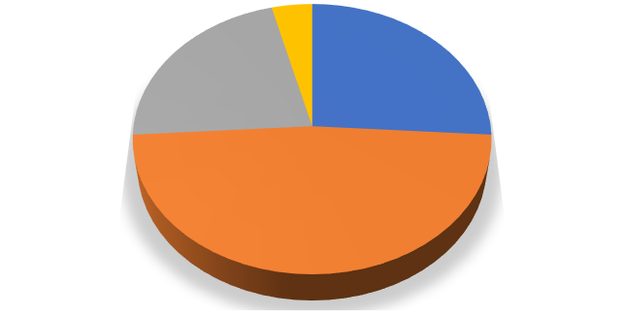

**Category 1**

**Implementation of Learning videos in the Classroom**

**4%**

**22%**

**26%**

**48%**

SA S D

SD

Chart 4.1

Implementation of Learning ‎videos in the classroom

In addition, chart 4.1. presented percentage data regarding the implementation of video learning in class XI IIS. The adoption of video learning in class XI IIS was seen as a success by the majority of respondents, as shown in chart 4.1. As much as 48% of respondents agreed, while 26% selected to strongly agree. As a result, several respondents expressed negative opinions of the use of Video learning in class XI IIS. Regarding the implementation of video learning in class XI IIS, there were 22% selected to disagree, and 4% strongly disagreed. The benefits of Video learning in the class as the second category. As indications of Benefits, in-class learning videos as the second category. As an indication of the benefits of video learning, ten statements are used. These varieties: 1) students' hearing, 2) students' listening fluency is improved by video learning, 3) students' listening accuracy is improved by video learning, 4) students' creativity when listening to English is improved by video learning, 5) students' critical thinking is improved by learning videos, 6) students listen clearly through learning videos, 7) from learning videos students get new sentences, and 8) when video learning is done students find it easier to listen to English, 9) video learning helps students understand the material, and 10) students expressed enthusiasm in the use of learning videos in class.

Chart 4.2

presents the second category's detailed data.

|  |  |
| --- | --- |
| **Variety** | **Students’ Amount** |
| SA | 13 |
| A | 11 |
| D | 3 |
| SD | 0 |
| **TOTAL** | **27** |

The specific information on the advantages of using video learning in class XI IIS was presented in Chart 4.2. The chart above led to the conclusion that the majority of respondents had a positive opinion of the advantages of video learning in class XI IIS. Eleven respondents selected "agree," while thirteen selected "strongly agree." Some students had a negative opinion of the advantages of Video learning in class XI MIIS. Three participants selected "disagree," while none of them selected "strongly disagree."



**Category 2**

**Advantages of Learning Videos**

**11% 0%**

**48%**

**41%**

SD A D

SD

Chart 4.2

Advantages of ‎Learning Videos

The second category describes the advantages of video learning in class XI IIS, shown in Chart 4.2. The results showed that 48 percent of students selected strongly agree, and 41 percent selected agree regarding the advantages of implementing video learning in class XI IIS. None of the students selected strongly disagree, while 11 percent of students selected disagree. The majority of students had positive perceptions of the benefits of using Video learning in class XI IIS, as shown by the data of the second category.

The teacher's Perception of the use of learning videos in class XI IIS became the topic of the final statement category questionnaire. There are six statements in this category. Based on these data findings, the majority of students expressed a positive perception of the learning videos in class XI IIS as very helpful. Therefore the teacher's Perception of the use of learning videos in class XI IIS The chart stated a positive perception of the learning videos in class XI IIS was very helpful 4.3 contains all the information detail for the third category.

Chart 4.3

presented the third category’s detailed data.

|  |  |
| --- | --- |
| **Variety** | **Students’ Amount** |
| SA | 8 |
| A | 14 |
| D | 4 |
| SD | 1 |
| **TOTAL** | **27** |

The majority of students, as shown in Chart 4.3, expressed a positive perception of using video learning in class XI IIS. Eight students selected "strongly agree," and fourteen selected "agree." Additionally, several respondents had a negative view of this category. One student decided to strongly disagree, and four students decided to disagree. Additionally, it was found that video learning in class XI IIS had been seen positively by 22 respondents and negatively by five respondents.

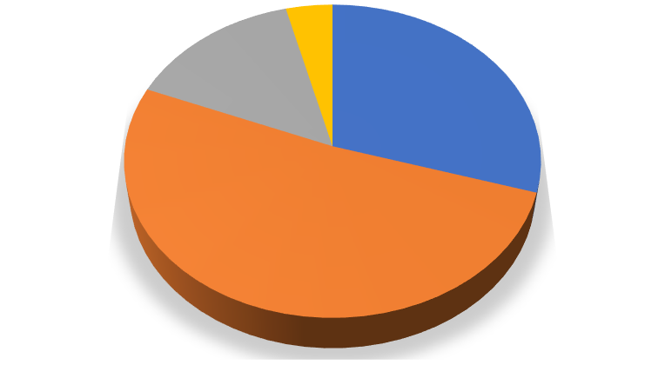

**Category 3**

**Students' Perception of Using video learning in Class XI IIS**

**15%**

**4%**

**30%**

**51%**

SA A D

SD

Chart 4.3

Students' Perception of Using ‎video learning in Class XI IIS

The specific results for the third category are shown in Chart 4.3. It was clear that more respondents overall expressed a positive perception of using video learning in class XI IIS than a negative perception. In this category, 60 percent of students obviously agreed, and 30 percent of students chose to strongly agree. Fifteen percent of students selected to disagree, while 4 percent chose to strongly disagree. The questionnaire's findings showed that the majority of students' Perception was positive about utilizing video learning in class XI IIS. Video learning was effectively applied in class XI IIS, as indicated by the data gathered from the questionnaire.

The findings of the first category show that the majority of students who were selected strongly agree and agree on the thirteen category statements. Another conclusion that can be obtained is that students benefit from using learning videos in class. Students' critical thinking, pronunciation, creativity, fluency, and accuracy have been facilitated by learning videos. Students can listen naturally while studying videos and learning new sentences. In addition, students become more confident when listening to English. Students are generally interested in utilizing learning videos in class.

## **DISCUSSION**

### **Strenght and Weakness**

In the Maria Fatima Jaina Publication Journal, Sukmawati, Suharti Sirajuddin entitled, Improving Students' Listening Skills by Using Video Learning in Class XI MIPA Students at SMA Negeri 12 Makassar. This study aims to investigate video learning in improving students' listening skills. Qualitative descriptive is used in this research. The results of the data findings that most students have problems when listening to English without the right technique. Then the researcher innovates in choosing media so students don't have problems when listening to English without the right technique. The researcher tried to use the learning video technique as the medium in this study. The researcher used the same descriptive qualitative method used by previous researchers. The difference between previous researchers was in determining an efficient technique for improving students' English listening skills using learning videos.

### **Implication**

The implication of this research is knowing teachers' perceptions about the Use of Video Learning to Improve Students' Listening, teachers can use this research as a reference to add to their information about using and implementing Learning Videos. Besides that, the researcher also concluded that it was successfully implemented in class XI IIS. Students practice listening to the video that has been played; Then, the students were very enthusiastic and excited when the listening challenge started. This study further found that students worked seriously and carried out orders well. They watched the videos and did the challenge quite carefully.

### **Limitation**

In this study, researchers determine the limits this research uses learning videos and improvisational activities to improve students' listening skills, but only to answer the questions "what and how".

Such as What is the teacher's Perception of the use of learning videos in facilitating English listening skills, and How is the application of learning videos in Facilitating English Listening Skills.

# CHAPTER V

# CONCLUSION AND SUGGESTION

This chapter contains conclusions and suggestions. The conclusion based on the data analysis was found that were discussed in Chapter IV.

## **Conclusion**

The aim of this study was to investigate the implementation of video learning in class XI IIS as well as to investigate teachers' Perceptions of using video learning to enhance students' listening, as indicated in Chapter I. The researcher employed a questionnaire, observation, and interviews to gather the data for this study. The first research question concerning the implementation of video learning in class XI IIS was answered utilizing observation. The teacher's Perception of using video learning to enhance students' listening in class XI IIS was the second research question and was already answered by utilizing the questionnaire.

The researcher concluded from the observations that video learning was successfully implemented in class XI IIS. The students practice listening to the video that has been played; then, the students are very enthusiastic and enthusiastic when the listening challenge begins. This study further found that students work seriously and carry out orders well. They watched the video and did the challenge quite carefully.

To collect data for the second research question, which aims to find out how students perceive the use of video learning in facilitating English listening skills, the researcher conducted a questionnaire and interviews. A total of 27 students of class XI IIS took part in the questionnaire. Five open questions and thirty closed questions, all divided into three sections. The first part discusses the application of video learning in class XI IIS. The second part discusses the advantages of video learning in class XI IIS. And the last section deals with how teachers perceive the use of video learning in facilitating English listening skills.

The first category's results the finding that the majority of students' Perception about the implementation of video learning in class XI IIS was positive. Thirteen students, or 48 percent, agreed, while seven students, or 26 percent selected, strongly agreed. The implementation of video learning in class XI IIS was perceived negatively by some students. Six respondents, or 22 percent, selected disagree, while one, or 4 percent, selected strongly disagree.

The second category also gained Perception's positive Perception. The majority of students expressed a perception's positive advantages of video learning in class XI IIS. Thirteen students, or 38 percent, selected "strongly agree," while eleven students, or 41 percent, selected "agree." Yet, several students expressed a perception's negative of the advantages of using video learning in class XI IIS. None students selected strongly disagree, and three students, or 11 percent selected disagree.

As with the first and second categories, the third category's finding was essentially the same. A higher percentage of students with positive perceptions than negative perceptions of using video learning in class XI IIS. Eight students, or 27 percent, selected "strongly agree," while fourteen students, or 52 percent, selected "agree." The utilization of video learning in class XI IIS also has negative perceptions by some students. Only one respondent, 4 percent selected, strongly disagreed, while four students, or 15 percent selected, disagreed. The majority of the students had Perception's positive Perception of using video learning in class XI IIS, as indicated by the overall statement category inside the questionnaire.

## **Suggestion**

Following research findings, learning videos to improve their English listening skills. The more effective the student's video learning, the better. To improve performance, it is very important to prepare well. Students who pay attention and are enthusiastic about learning new sentences and those they think are foreign and rarely heard in everyday life.

The final suggestion is for upcoming researchers. The researcher is conscious of the fact that there are still numerous flaws in this work that remain far from excellent. The researcher aspires for the following researcher to conduct and analyze this research in a better way.

# REFERENCES

Ahmada, Adib, Lailatul Munawaroh, and Darussalam English Journal, 'The Use of Video Learning Method to Improve Speaking Skills,' *Darussalam English Journal*, 2.1 (2022), 2807–3223

<https://doi.org/10.30739/dej.v2i1.1506>

Bencic, Nathalie, and Lina Rosenkvist, ‘Students ’ Perception on video Learning in EFL / ESL-Classrooms in Relation to Their Speaking Ability <https://doi.org/10.17507/tpls.0807.02>

Clarita, Nichella Ayu, Indah Rahmawati, and Solikin Sudibyo, ‘The Impact Of Video Learning Technique On The Students' English Listening Skill,' *ETERNAL (English, Teaching, Learning, and Research Journal)*, 6.1 (2020)

<https://doi.org/10.24252/eternal.v61.2020.a4>

Neupane, Binod, ‘The Impact Of Video Learning Technique On The Students' English Listening Skill,' *ETERNAL (English, Teaching, Learning, and Research Journal)*, 6.1 (2020), 42

<https://doi.org/10.24252/eternal.v61.2020.a4>

Jaina, Maria Fatima, and Suharti Siradjuddin, ‘Improving Students ’ Listening Skill by Using Scripted Video Learning at Class XI MIPA-2 Students of SMA Negeri 12 Makassar’, *Education, Language, and Culture*, 2.1 (2022), 55–66 <https://doi.org/10.17507/tpls.0807.02>

Khasbani, I, and F Seli, 'The Impact of Video Learning on Students' Listening Performance,' *Linguists: Journal Of Linguistics and Language Teaching*, 7.2 (2021), 2355–2069

<https://doi.org/10.29300/ling.v7i2.5216>

Lestari, Fifa, ‘An Analysis Of Student Listening Skill Using Video Learning Method,' *Project (Professional Journal of English Education)*, 3.1 (2020)

<https://doi.org/10.22460/project.v3i1.p114-119>

Mustafa Altun, ‘Using Video Learning Activities to Develop Listening Skills: A Case Study in the Language Classroom,' *International Journal of Social Sciences & Educational Studies*, 1.4 (2015), 1–59

[<w](http://www.ijssesjournal.org/)w[w.ijssesjournal.org](http://www.ijssesjournal.org/)>

Neupane, Binod, 'Effectiveness of Video learning in Improving Listening Skill,'*Journal of NELTA Gandaki*, 1.1992 (2019), 11–18<https://doi.org/10.3126/jong.v1i0.24454>

Rao, P. S, ‘The Importance of Listening Skills in English Classrooms’, *Alford Council of International English & Literature Journal*, 2.2 (2019), 6–18 [<w](http://www.acielj.com/)w[w.acielj.com](http://www.acielj.com/)>

Rojas, Maria Asuncion, and Johnny Villafuerte, 'The Influence of Implementing Video Learning as an Educational Technique on EFL Listening Development,' *Theory and Practice in Language Studies*, 8.7 (2018), 726–32 <https://doi.org/10.17507/tpls.0807.02>

Rood, Craig, ‘Rhetorics of Civility: Theory, Pedagogy, and Practice in Listening and Writing Textbooks,' *Rhetoric Review*, 32.3 (2013), 331–<https://doi.org/10.17507/tpls.0807.02>

# APPENDIX I

**Questionnaire Guideline**

|  |  |  |  |  |  |
| --- | --- | --- | --- | --- | --- |
| Number | Statement | Strongly  Agree | Agree | Disagree | Strongly  Disagree |
| 1 | I have used learning videos in elementary or middle school before |  |  |  |  |
| 2 | learning videos made by the teacher |  |  |  |  |
| 3 | Learning videos contain conversations about everyday life. |  |  |  |  |
| 4 | I am willing to listen and pay close attention to the learning videos. |  |  |  |  |
| 5 | I really pay attention  challenge from the teacher |  |  |  |  |
| 6 | Use sentences that are used in real life. |  |  |  |  |
| 7 | I am excited to pay attention to the learning videos played by the teacher. |  |  |  |  |
| 8 | The sentences you hear are full of memories  as long as the learning video is played |  |  |  |  |
| 9 | Spontaneously write foreign sentences. |  |  |  |  |
| 10 | I can listen freely and clearly when learning videos are played. |  |  |  |  |
| 11 | I listened to full English while the learning videos were playing. |  |  |  |  |
| 12 | I listened intently as the lesson videos were played back. |  |  |  |  |
| 13 | After the learning video is finished playing, the teacher corrects the sentences written by the students. |  |  |  |  |
| 14 | After the learning video is finished playing, the teacher explains the sentences that the students have written, and they feel foreign and rarely heard. |  |  |  |  |
| 15 | my English  listening improves with learning videos |  |  |  |  |
| 16 | My listening accuracy  enhanced with learning videos |  |  |  |  |
| 17 | My creativity when listening to English  enhanced with learning videos |  |  |  |  |
| 18 | My critical thinking skills improved based on learning videos. |  |  |  |  |
| 19 | My listening was enhanced with learning videos. |  |  |  |  |
| 20 | I can listen more freely  when the learning video is playing |  |  |  |  |
| 21 | I took some new sentences from  Played learning videos |  |  |  |  |
| 22 | After using the learning videos, I am more confident when listening in English. |  |  |  |  |
| 23 | Learning videos are great  a way for me to imagine the subject |  |  |  |  |
| 24 | Interesting learning videos for me |  |  |  |  |
| 25 | Learning videos are a great way to facilitate  English skills |  |  |  |  |
| 26 | Utilize deep learning videos in class. |  |  |  |  |
| 27 | Learning videos are suitable for  provided material |  |  |  |  |
| 28 | Learning videos are interesting when the subject is from real life. |  |  |  |  |
| 29 | Learning videos are more interesting for students when they hear a lot of foreign sentences. |  |  |  |  |
| 30 | I have a lot of experience using learning videos. |  |  |  |  |

**Observation Guideline**

|  |  |  |  |
| --- | --- | --- | --- |
| Number | Statement | Yes | No |
| 1. | learning video challenges are done by each individual |  |  |
| 2. | Each student writes sentences that they think are foreign and rarely heard. |  |  |
| 3. | Students are willing to pay attention while the learning video is playing. |  |  |
| 4. | The topic related to a real-life scenario |  |  |
| 5. | the video is played back after it finishes playing |  |  |
| 6. | Spontaneous listening |  |  |
| 7. | After the learning video is played, the teacher explains sentences written by students that they think are foreign and rarely heard. |  |  |

**Teachers Interview Guidelines**

|  |  |
| --- | --- |
| **Number** | **Statement** |
| 1. | How do you feel about using learning videos to improve  students' listening skills in English? |
| 2. | What obstacles did you encounter when playing learning videos in class? |
| 3. | Do learning videos help students improve their English listening skills? |
| 4. | What theme do you prefer to use in the learning videos? |
| 5. | Please give your idea for better learning video implementation play in facilitating students' listening skills in English. |

**RPP**

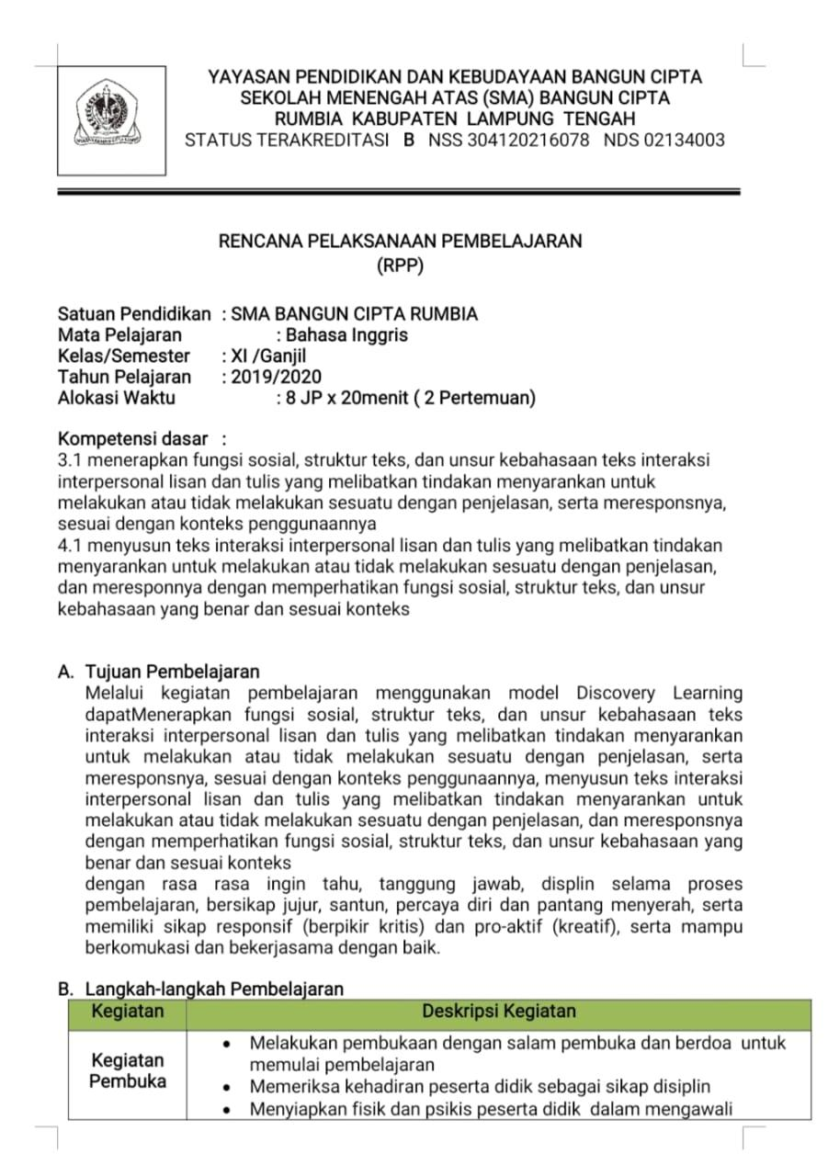

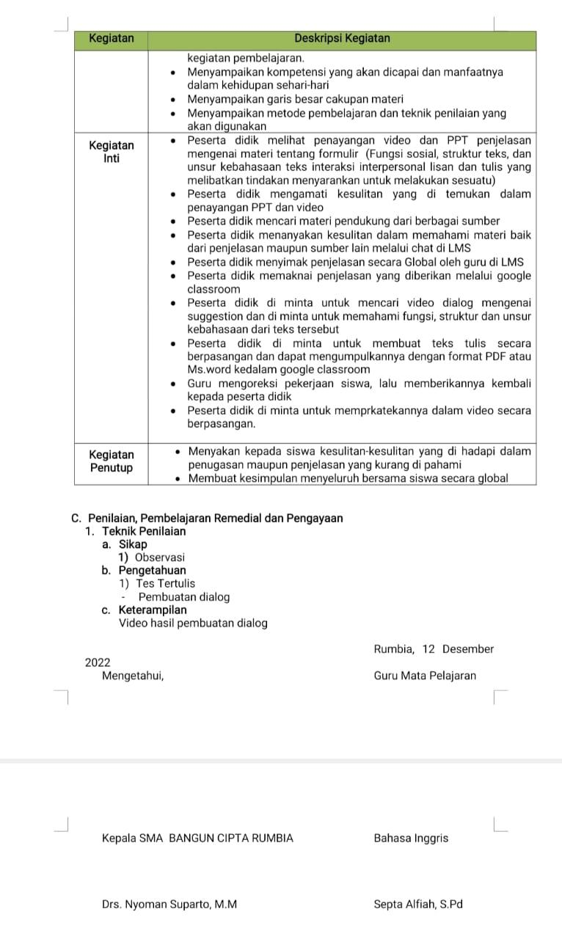

**APPENDIX II**

**Questionnaire’s Results**

|  |  |  |  |  |  |
| --- | --- | --- | --- | --- | --- |
| Number | Statement | Strongly  Agree | Agree | Disagree | Strongly  Disagree |
| 1 | I have used learning videos in elementary or middle school before | 18 | 8 | 3 | - |
| 2 | learning videos made by the teacher | 3 | 7 | 17 | - |
| 3 | Learning videos contain conversations about everyday life | 12 | 14 | 1 | - |
| 4 | I am willing to listen and pay close attention to the learning videos | 14 | 12 | 1 | - |
| 5 | I really pay attention  challenge from the teacher | 12 | 15 | 0 | - |
| 6 | Use sentences that are used in real life | 3 | 18 | 6 | - |
| 7 | I am excited to pay attention to the learning videos played by the teacher | 11 | 15 | 1 | - |
| 8 | The sentences you hear are full of memories as long as the learning video is played | 1 | 13 | 12 | - |
| 9 | Spontaneously write foreign sentences | 1 | 11 | 15 | - |
| 10 | I can listen freely and clearly when learning videos are played | 4 | 14 | 9 | - |
| 11 | I listened to full English while the learning videos were playing | 8 | 16 | 3 | - |
| 12 | I listened intently as the lesson videos were played back | 10 | 16 | 1 | - |
| 13 | After the learning video is finished playing, the teacher corrects the sentences written by the students | 14 | 13 | - | - |
| 14 | After the learning video is finished playing, the teacher explains the sentences that the students have written, and they feel foreign and rarely heard | 12 | 15 | - | - |
| 15 | my English  listening improves with learning videos | 20 | 7 | - | - |
| 16 | My listening accuracy  enhanced with learning videos | 20 | 7 | - | - |
| 17 | My creativity when listening to English is enhanced by learning videos | 20 | 7 | - | - |
| 18 | My critical thinking skills improved based on learning videos | 16 | 11 | - | - |
| 19 | My listening enhanced with learning videos | 11 | 13 | 3 | - |
| 20 | I can listen more freely  when the learning video is playing | 12 | 15 | - | - |
| 21 | I can listen more freely  when the learning video is playing | 9 | 17 | 1 | - |
| 22 | After using the learning videos, I am more confident when listening in English | 9 | 14 | 4 | - |
| 23 | Learning videos are a great way for me to imagine the subject | 5 | 16 | 6 | - |
| 24 | Interesting learning videos for me | 9 | 14 | 4 | - |
| 25 | Learning videos are a great way to facilitate  English skills | 8 | 17 | 2 | - |
| 26 | Utilize deep learning videos in class | 8 | 19 | - | - |
| 27 | Learning videos are suitable for  provided material | 4 | 18 | 5 | - |
| 28 | Learning videos are interesting when the subject is from real life | 8 | 12 | 6 | 1 |
| 29 | Learning videos are more interesting for students when they hear a lot of foreign sentences | 7 | 15 | 5 | - |
| 30 | I have a lot of experience using learning video | 11 | 16 | - | - |

**Questionnaire’s Results in Percent**

|  |  |  |  |  |  |
| --- | --- | --- | --- | --- | --- |
| Number | Statement | Strongly  Agree | Agree | Disagree | Strongly  Disagree |
| 1 | I have used learning videos in elementary or middle school before | 59% | 30% | 11% | - |
| 2 | learning videos made by the teacher | 11% | 26% | 63% | - |
| 3 | Learning videos contain conversations about everyday life | 44% | 52% | 4% | - |
| 4 | I am willing to listen and pay close attention to the learning videos | 52% | 44% | 4% | - |
| 5 | I really pay attention  challenge from the teacher | 44% | 56% | - | - |
| 6 | Use sentences that are used in real life | 11% | 67% | 22% | - |
| 7 | I am excited to pay attention to the learning videos played by the teacher | 41% | 56% | 4% | - |
| 8 | The sentences you hear are full of memories as long as the learning video is played | 4% | 48% | 44% | - |
| 9 |  | 4% | 41% | 56% | - |

|  |  |  |  |  |  |
| --- | --- | --- | --- | --- | --- |
|  | Spontaneously write foreign sentences. |  |  |  |  |
| 10 | Spontaneously write foreign sentences | 15% | 52% | 33% | - |
| 11 | I listened to full English while the learning videos were playing | 30% | 59% | 11% | - |
| 12 | I listened intently as the lesson videos were played back | 37% | 59% | 4% | - |
| 13 | After the learning video is finished playing, the teacher corrects the sentences written by the students | 52% | 48% | - | - |
| 14 | After the learning video is finished playing, the teacher explains the sentences that the students have written, and they feel foreign and rarely heard | 44% | 56% | - | - |
| 15 | my English  listening improves with learning videos | 74% | 26% | - | - |
| 16 | My listening accuracy  enhanced with learning videos | 74% | 26% | - | - |
| 17 | My creativity when listening to English  enhanced with learning videos | 74% | 26% | - | - |
| 18 | My critical thinking skills improved based on learning videos | 59% | 41% | - | - |
| 19 | My listening enhanced with learning videos | 41% | 48% | 11% | - |
| 20 | I can listen more freely  when the learning video is playing | 44% | 56% | - | - |
| 21 | I can listen more freely  when the learning video is playing | 33% | 63% | 4% | - |
| 22 | After using the learning videos, I am more confident when listening in English | 33% | 52% | 15% | - |
| 23 | Learning videos are great  a way for me to imagine the subject | 19% | 59% | 22% | - |
| 24 | Interesting learning videos for me | 33% | 52% | 15% | - |
| 25 | Learning videos are a great way to facilitate  English skills | 30% | 63% | 7% | - |
| 26 | Utilize deep learning videos in class | 30% | 70% | - | - |
| 27 | Learning videos are suitable for provided material | 15% | 66% | 19% | - |
| 28 | Learning videos are interesting when the subject is from real life | 30% | 44% | 22% | 4% |
| 29 | Learning videos are more interesting for students when they hear a lot of foreign sentences | 26% | 55% | 19% | - |
| 30 | I have a lot of experience using learning video | 41% | 59% | - | - |

APPENDIX III

1. **Sample Questionnaire Result**

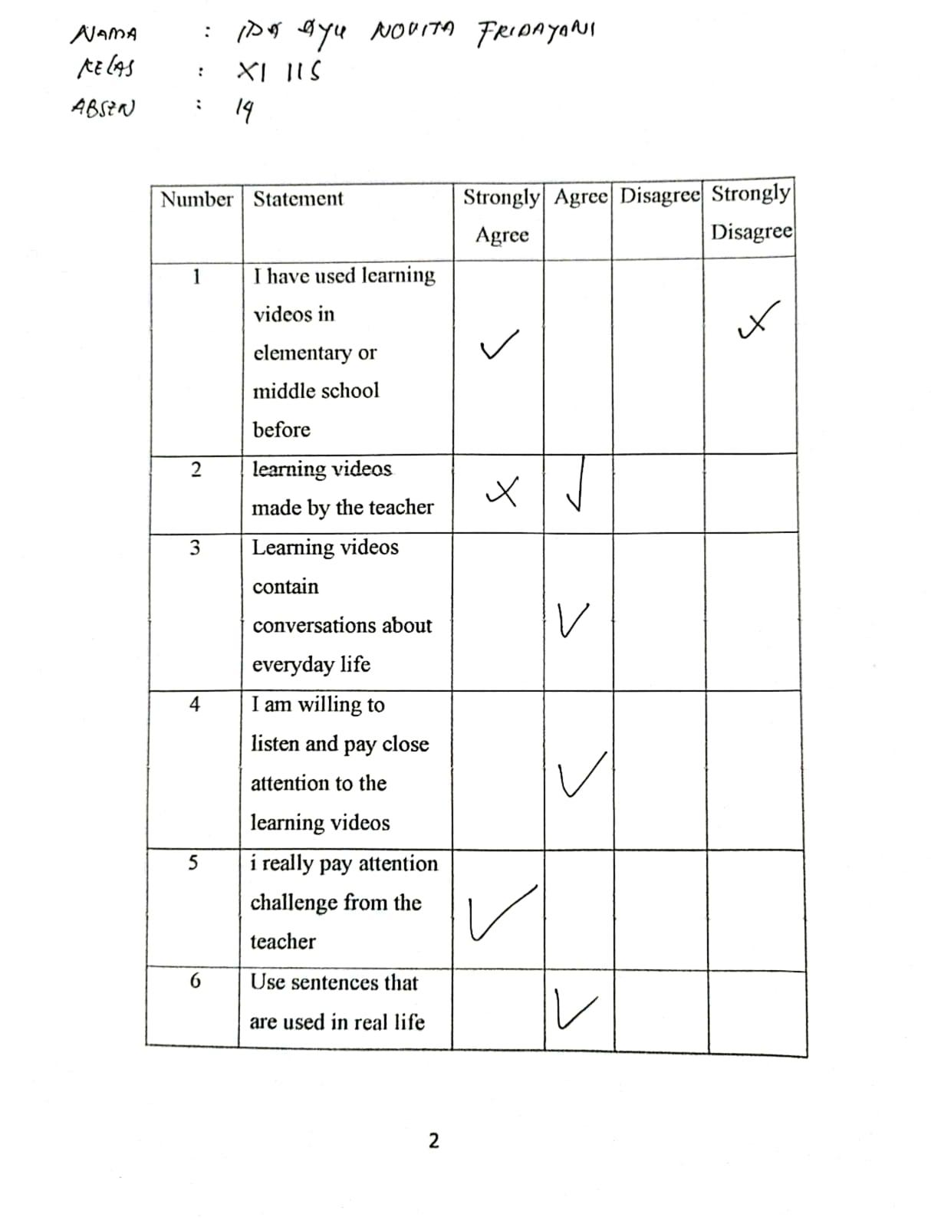

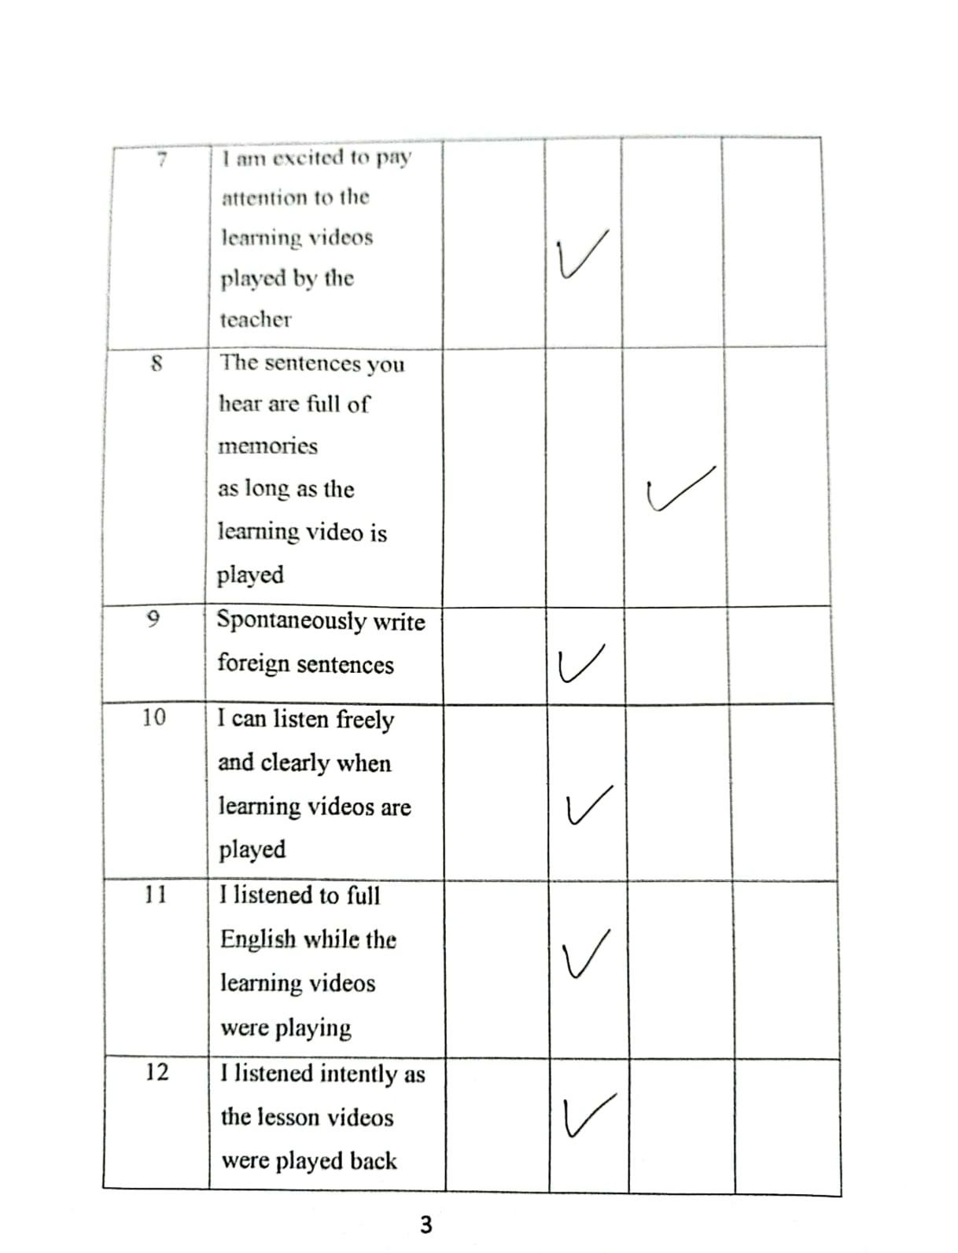

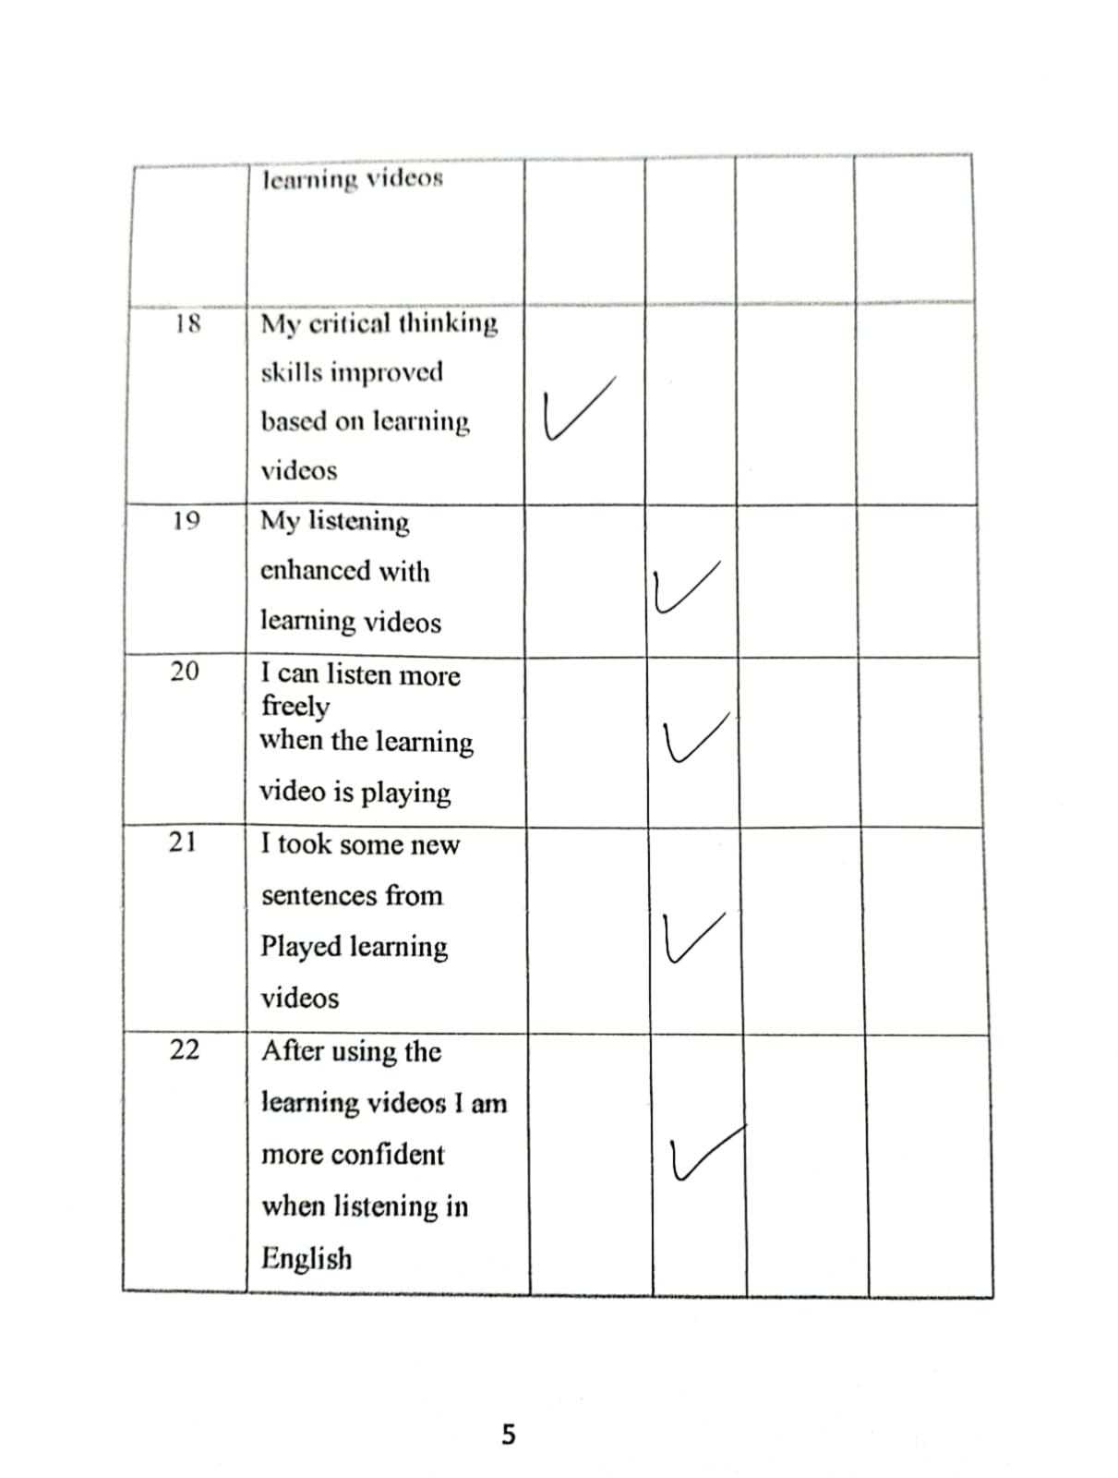

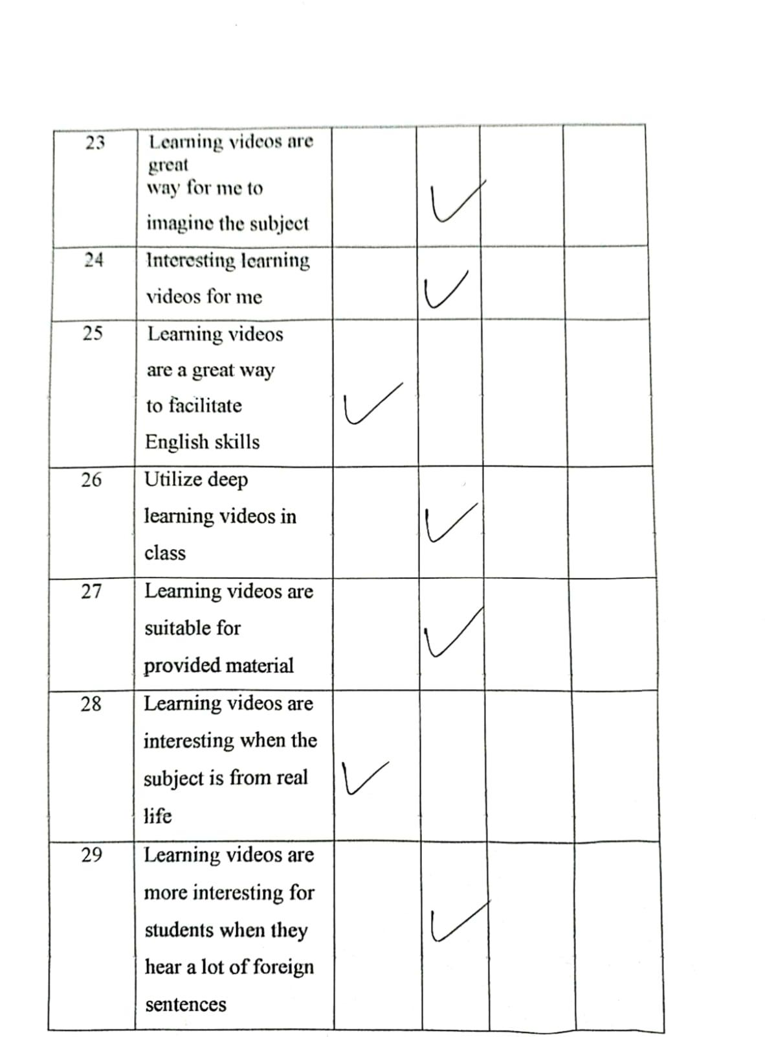

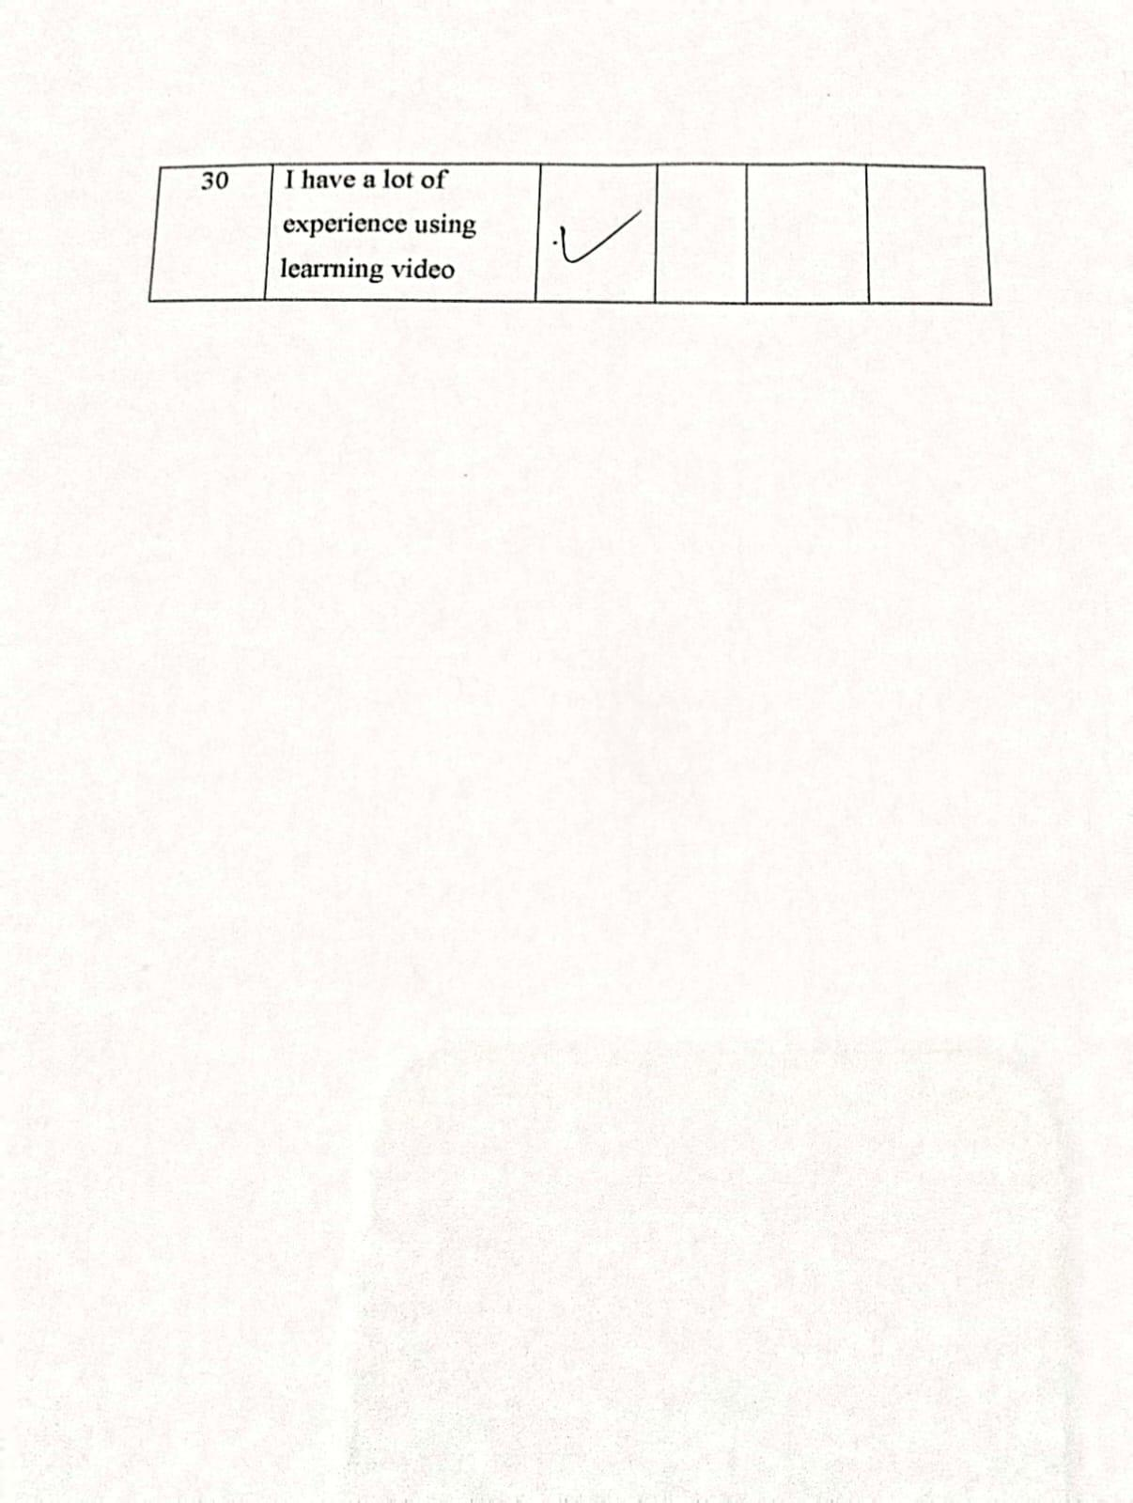

1. **Observation Result**

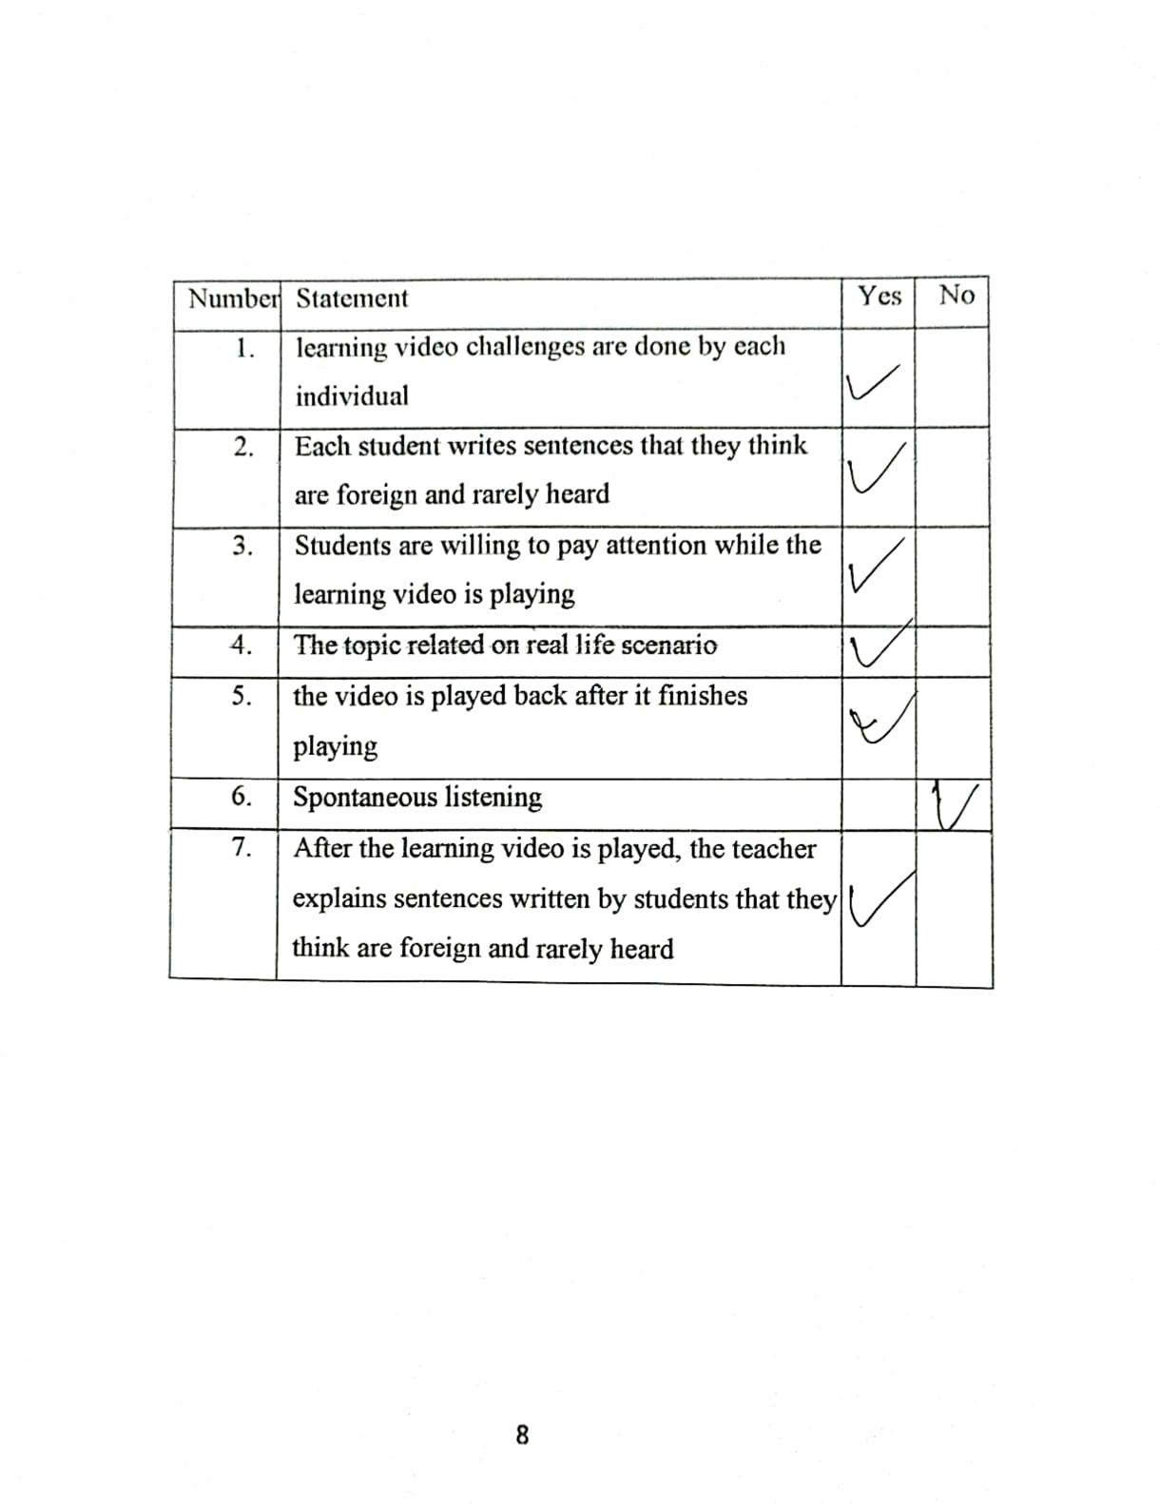

1. **Sample Interview Result**

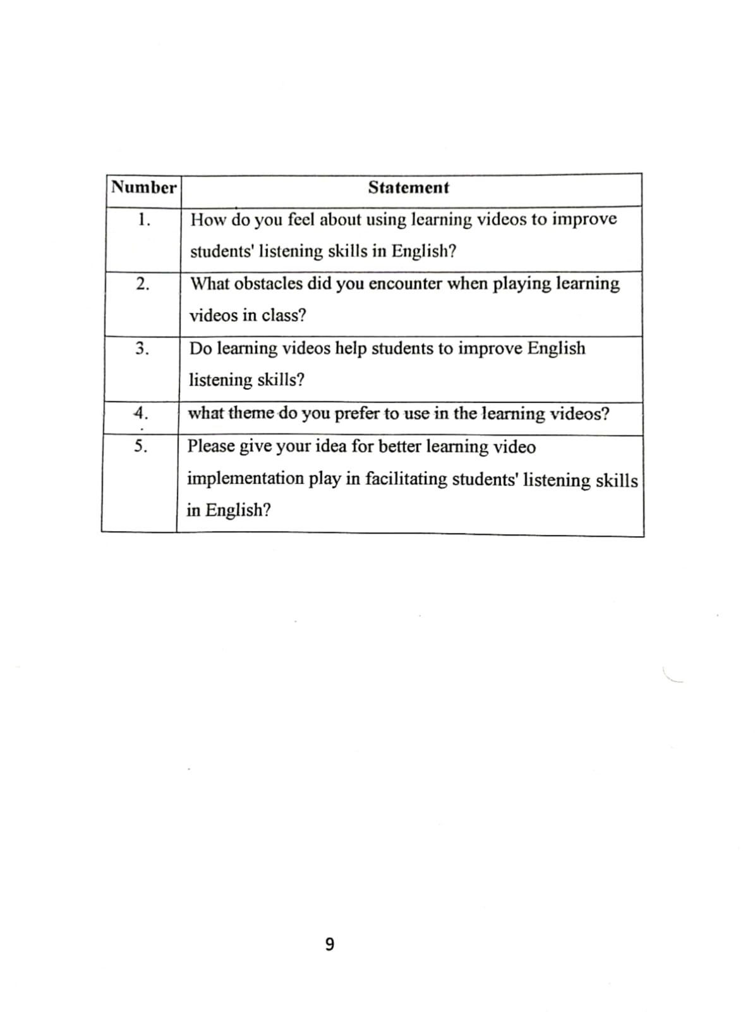

**APPENDIX IV**

**Documentation**

**The teacher explained how the implementation of video learning.**

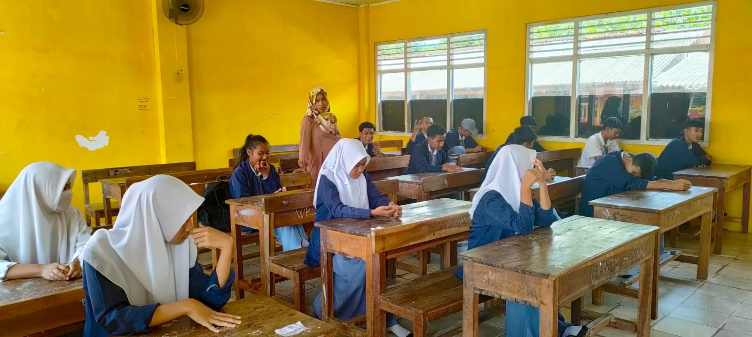

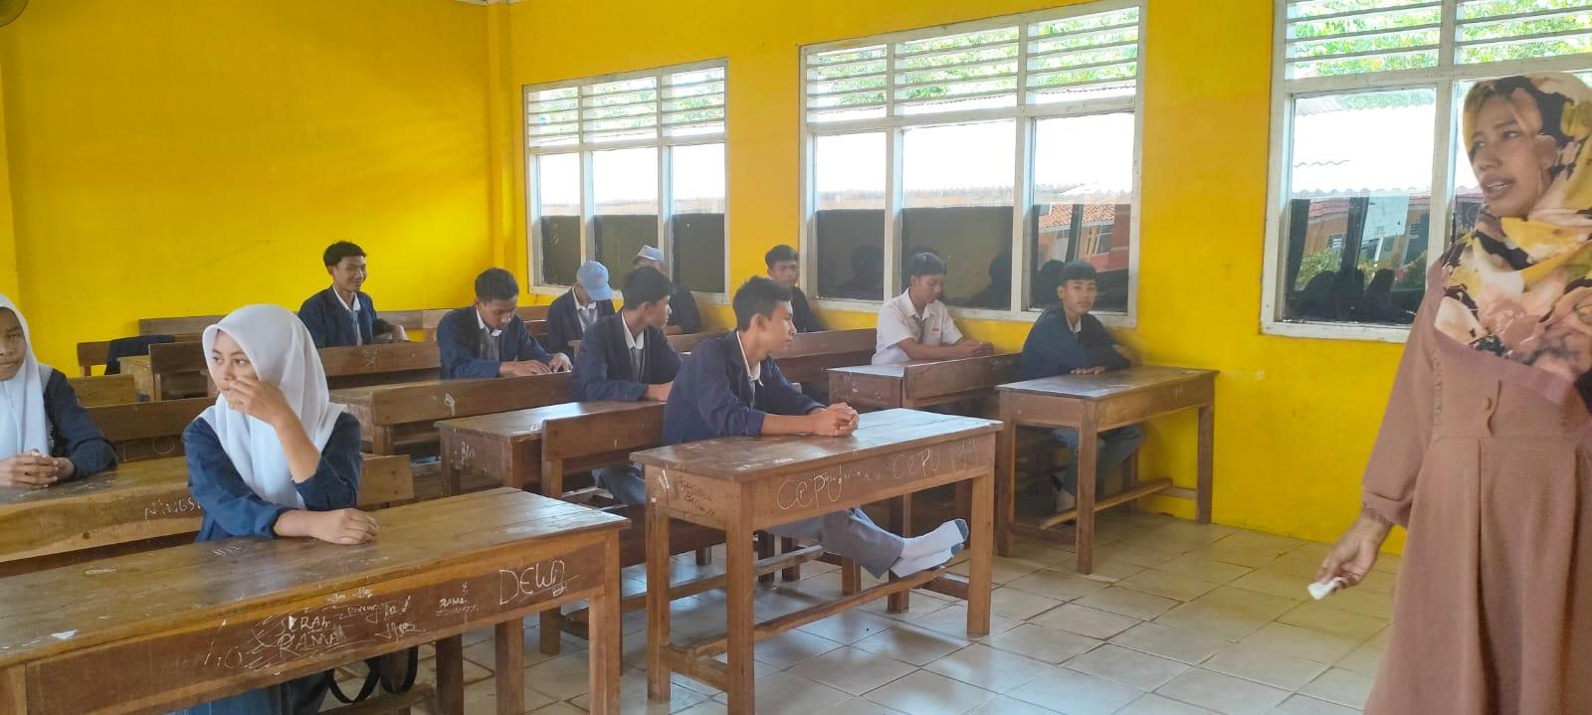

**Students are Practicing Video Learning**

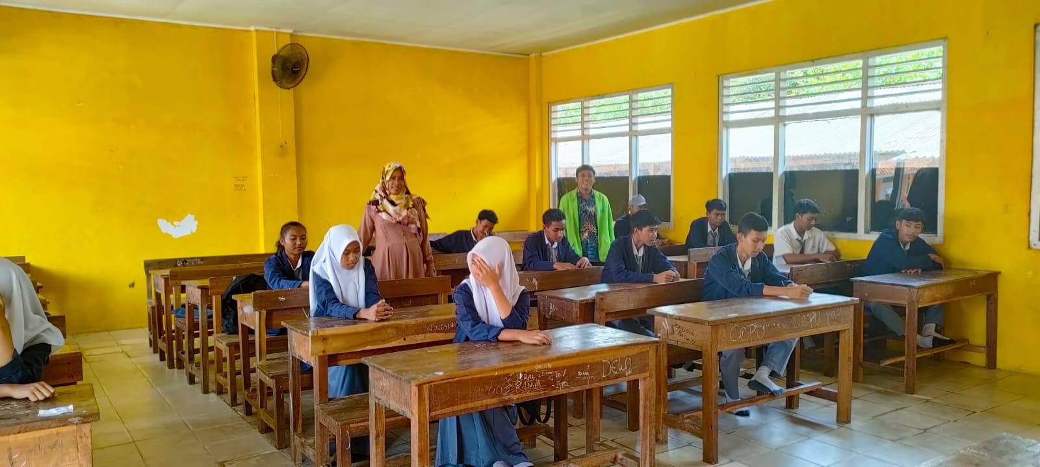

**Students are preparing stationery to write difficult sentences.**

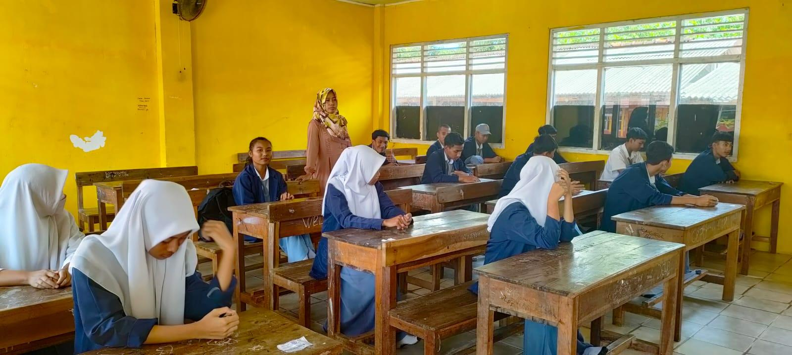

**The researcher gave the questionnaire and interview questions.**

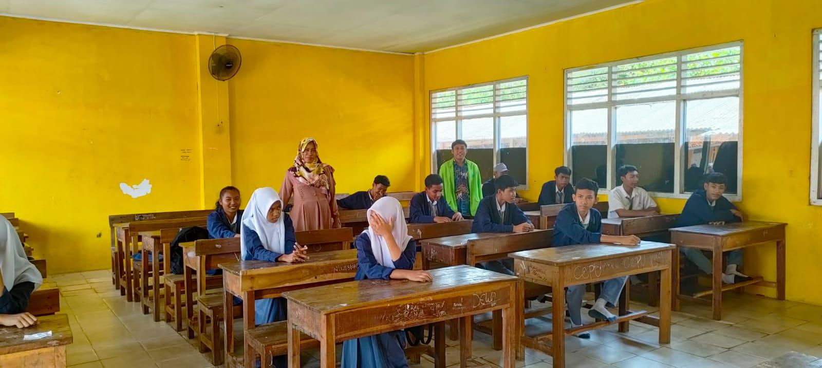

# CURRICULUM VITAE

1. P. S Rao, ‘The Importance of Speaking Skills in English Classrooms’, *Alford Council of International English & Literature Journal*, 2.2 (2019), 6–18 [<w](http://www.acielj.com/)w[w.acielj.com>.](http://www.acielj.com/)
2. Hesty Maulida Eka Putry, dkk, Video Based Learning Sebagai Tren Media Pembelajaran di Era 4.0, Jurnal Pendidikan Ilmiah Vol. 5 No. 1 (Juni) 2020, hlm 1-24
3.
4. Adib Ahmada, Lailatul Munawaroh, and Darussalam English Journal, 'The Use of Video Learning Method to ‎Improve Listening Skills THE USE OF VIDEO LEARNING METHOD TO IMPROVE LISTENING SKILLS The Use of ‎Video Learning Method to Improve listening Skills,' Darussalam English Journal, 2.1 (2022), 2807–3223‎ <https://doi.org/10.30739/dej.v2i1.1506>.‎
5. Arifiana Tri Wulandari, Bambang Widi Pratolo, and Rika Junianti, ‘Students’ Perception on the Use of ‎Video Learning to Improve Students’ Communicative Competence’, UAD TEFL International ‎Conference, 2 (2021), 137‎

   ‎<https://doi.org/10.12928/utic.v2.5748.2019>.‎
6.
7. Craig Rood, ‘Rhetorics of Civility: Theory, Pedagogy, and Practice in Listening and Writing Textbooks,' Rhetoric Review, 32.3 (2013), 331–48‎

   <https://doi.org/10.1080/07350198.2013.797879>.‎
8. Resi Khothori, Nina Suzanne Students' Perception of the Video Used by English Teachers as Instructional ‎Media ‎
9. I Khasbani and F Deli, 'The Impact of Video Learning Students' Listening Performance,' Linguists: Journal Of Linguistics and Language Teaching, 7.2 (2021), 2355–2069

   ‎‎<https://doi.org/10.29300/ling.v7i2.5216>.‎
10. Maria Asuncion Rojas and Jhonny Villafuerte, 'The Influence of Implementing Video Learning as an ‎Educational Technique on EFL Speaking Development,' Theory and Practice in Language Studies, 8.7 (2018), ‎‎726–32‎

    ‎<https://doi.org/10.17507/tpls.0807.02>.‎
11. Binod Neupane, 'Effectiveness of Video Learning in Improving Listening Skill,' Journal of NELTA Gandaki, 1.1992 ‎‎(2019), 11–18

    <https://doi.org/10.3126/jong.v1i0.24454>.‎
12. Muhamad Haris Basyaev, Nur Azmi Afifah, dkk, Diens,Implementasi Pembelajaran dengan Teknologi Video Based Learning, Ejournal.upi.edu, Inovasi Kurikulum 18 (1) (2021) 82-94
13. # Jaina and Siradjuddin.‎" Improving Students’ Listening Skill by Using Video Learning at Class XI MIPA-2 Students of SMA Negeri 12 Makassar”, Education, Language, Culture (EDULEC), Vol. 2, 1, April 2022

   
14.
15. Nurhamimi Togimin and Haliza Jaafar, 'Learning video: An Innovative Approach to Teaching ‎Speaking ‎Skills in an ESL Classroom,' LSP International Journal, 7.2 (2020), 19–36 ‎‎‎<https://doi.org/10.11113/lspi.v7.16310>.‎
16. Craig Rood, 'Rhetorics of Civility: Theory, Pedagogy, and Practice in Listening and Writing Textbooks,' Rhetoric Review, 32.3 (2013), 331–48‎

    <https://doi.org/10.1080/07350198.2013.797879>.‎
17. Neupane.‎ 2004,‎‏ ‏‎’,‎پلیمرها در فناوری کاربرد بر ایی مقدمه ‏Title‏ ‏‎‘No‏ ‏‎,‎اصل خانی کریم حدادی؛وحید ‏
18. Cecilia Wadensjö, 'Perspectives on Video learning: Analysis, Training and Assessments,' ‎Interpreter and Translator Trainer, 8.3 (2014), 437–51‎

    ‎<https://doi.org/10.1080/1750399X.2014.971486>.‎
19. # Toyib and Syafi'I, "Role-Play as a Method To Overcome Students' Anxiety in Listening Skill," Journal of English Teaching and Research, Vol. 3 No.1, May 2018

   
20. Clarita, Rahmawati, and Sudibyo, "The Impact of Learning Video Technique on The Student's English Listening Skill," ‎ Volume 6, Number 1, June 2020
21. Bencic and Rosenkvist.‎