Positive and Negative Emotions in Reading Comprehension of Informal Digital Learning of English among Senior High School Learners

THESIS
Submitted in Partial Fulfillment of the Requirements for Gaining the Degree of Bachelor of English Education in English Education Department



By:
SEKAR MAYANG PUSPORINI
NIM: 2103046097

EDUCATION AND TEACHER TRAINING FACULTY
UNIVERSITAS ISLAM NEGERI WALISONGO
SEMARANG
2025

THESIS STATEMENT
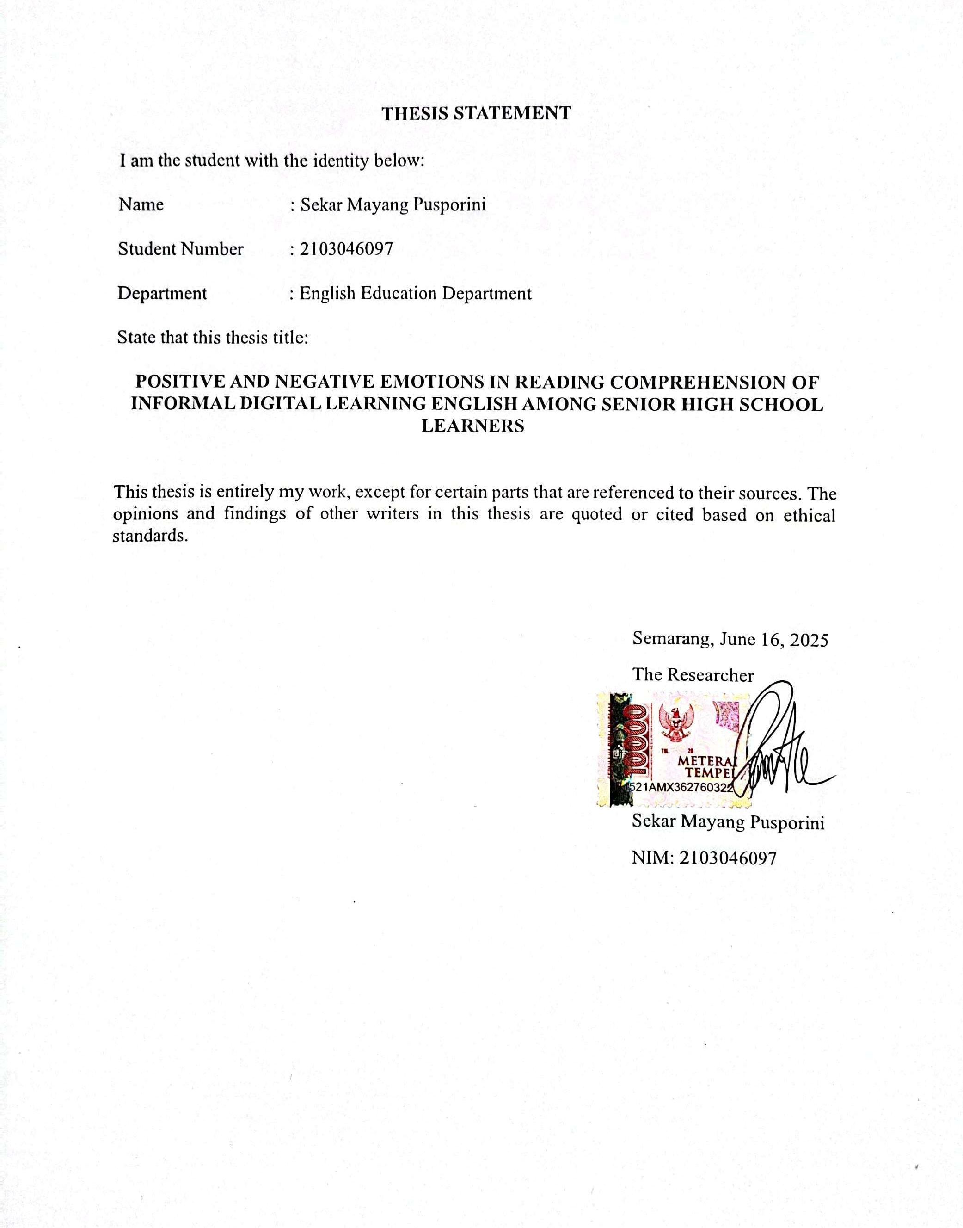

ADVISOR NOTE


RATIFICATION


ABSTRACT
Title : Positive and Negative Emotions in Reading Comprehension of Informal Digital Learning of English among Senior High School Learners
Author : Sekar Mayang Pusporini
NIM : 2103046097
Emotion is one of the aspects that can affect students' understanding of learning materials. In this study, there are four research questions: 1) Do positive emotions affect learners’ reading comprehension in Informal Digital Learning of English? 2) Do negative emotions affect learners’ reading comprehension in Informal Digital Learning of English? 3) Does informal digital learning affect learners’ reading comprehension in English? 4) Do emotions simultaneously affect learners’ reading comprehension in Informal Digital Learning of English? This study uses a quantitative approach, using multiple regression data analysis to test the effect of each independent variable on the dependent variable. In this study, the sample used was 59 eleventh-grade social studies students of MAN Salatiga, with 15 male students and 44 female students. The result of this study showed that each independent variable affects the dependent variable. Positive emotions have a positive effect, negative emotions have a negative effect, and Informal Digital Learning of English has a negative effect on reading comprehension. The objectives in this study: 1) The effect of positive emotions on learners reading comprehension in Informal Digital Learning of English 2) The effect of negative emotions on learners reading comprehension in Informal Digital Learning of English 3) The effect informal digital learning on learners reading comprehension in English 4) To determine whether positive and negative emotions simultaneously affect learners reading comprehension in Informal Digital Learning of English.

Keywords: Positive Emotions, Negative Emotions, Informal Digital Learning of English, Reading Comprehension

MOTTO
“Tuhanmu lebih mengetahui apa yang ada dalam hatimu.”
(QS. Al–Isra’ 17:25)
“You only live once, so don’t be stressed out too much and just live happily.”
(Oh Sehun)
“Don’t think you are not talented, don’t just give up on something, please give it a try.”
(Byun Baekhyun)

DEDICATION
This thesis is dedicated to my beloved mom, my big sis, my lil bro, all English lecturers, family, friends, and the tenderhearted people who always support, motivate, and love the researcher, as well as infinite love for the researcher.

ACKNOWLEDGMENTS

All praise and gratitude to Allah SWT, the Almighty God who has given all the graces and easiness to the author in completing this thesis. Sholawat and Salam are dedicated to the Prophet Muhammad, who has brought us from the darkness to the brightness.
The author finally completed her undergraduate thesis, which was titled “Positive and Negative Emotions in Reading Comprehension of Informal Digital Learning of English among Senior High School Learners.”
During the thesis writing process, the author received many suggestions, guidance, comments, encouragement, prayers, and motivation from people around the researcher. Therefore, the author would like to express her gratitude and appreciation to:
- Prof. Dr. Nizar, M.Ag., the Rector of UIN Walisongo Semarang.
- Prof. Dr. Fatah Syukur, M.Ag., the Dean of the Faculty of Education and Teacher Training at UIN Walisongo Semarang.
- Mrs. Dra. Nuna Mustikawati Dewi, M.Pd., the Head of the English Education Department at Walisongo Islamic State University Semarang.
- Mrs. Lulut Widyaningrum, M.Pd., the Secretary of English Education Department.
- Mr. Daviq Rizal, M.Pd., the thesis advisor who has guided, provided feedback, advice, support, and assistance in completing this thesis.
- Dwi Arni Siti Margiyanti, M.Pd., a lecturer who has guided this thesis at the beginning, provided advice, support and encouragement to complete this thesis.
- All lecturers at the Education and Teacher Training Faculty, especially at the English Education Department, for the knowledge that has been given to the researcher during the study.
- Mrs. Sarinah, S.Pd., as the English teacher at MAN Salatiga, has helped and made it easier for the author to collect data for this thesis.
- My Dearest support system, my mother Indah Kusrini, who has patiently guided and encouraged me. My beloved big sis Toeflina Puspa Ranny, and my lil bro Lintang Fajar Junianto. They are always my biggest reason to keep my spirits up, and they always give me motivation, enthusiasm, and support to keep moving forward and getting better. Thank you for everything.
- My big family, who has encouraged me to keep my spirits up in completing this thesis.
- My best friends who have encouraged, supported, and always advised me when I made mistakes, Valentina Na’immatul Hikmah, Defitri Nur An Nisaa, Arnadita Laila Safitri, Sinta Kusuma Sari, and Salma Ifatuz Zahro. Thank you for being my confidant and for supporting me. Thank you! Good wishes are always with you.
- Sobat Dashyat, Stela, Zahra, Niswa, Anandiya, Iit, Akmal, Azizah, Tegar, Mahfud, who gave a unique color during college. You guys are chaotic but fun, too. Thank you, guys!
- My consultation friends when doing my thesis, Nur and Dea. Thank you for struggling together to complete our thesis and for the helpful guidance all this time.
- For PBI friends, especially class B 2021. Thank you for your help all this time. See u on top, guys!
- My friends who always support, Linda, Sita, and Dinda. Thank you for your help all this time.
- 9 Peterpan, who became my youth, and motivated me to pursue my dreams. Thank you for existing.
- My cutie who can absorb my negative energy, please live longer.
- Whoever the author has not been able to mention one by one, thank you for giving support to the author in completing this thesis.
- Last but not least, thank you to myself for living until this time. Even though I don't know what the future will be like, you keep going, that's more than enough. Stay Gold, Mayoo!
Finally, I would like to thank you very much for the advice, support, and help to make my thesis better. the author hopes that this thesis can provide benefits to anyone who reads this thesis.

Semarang, June 16, 2025
The Writer,

Sekar Mayang Pusporini

Table of Contents
THESIS STATEMENT i
ADVISOR NOTE ii
RATIFICATION iii
ABSTRACT iv
MOTTO v
DEDICATION v
ACKNOWLEDGMENTS vi
LIST OF TABLES xi
LIST OF FIGURES xii
LIST OF APPENDICES xiii
CHAPTER I INTRODUCTION 1
A. Background of the study 1
B. Research Questions 7
C. Research Objectives 7
D. Benefits of research 8
CHAPTER II LITERATURE REVIEW 11
A. Previous Research 11
B. Emotions 16
Positive Emotion 18
Negative Emotion 21
C. Informal Digital Learning of English 23
D. Reading Comprehension 25
E. Hypothesis 28
CHAPTER III RESEARCH METHOD 30
A. Research Design 30
B. Participants 30
D. Data Collection 33
F. Data Analysis 35
CHAPTER IV RESEARCH FINDINGS AND DISCUSSION 40
A. Research Findings 40
B. Discussion 50
CHAPTER V CONCLUSION AND SUGGESTION 57
A. Conclusion 57
B. Suggestion 58
REFERENCES 0
APPENDICES 1
CURRICULUM VITAE 28

LIST OF TABLES
Table 4.1: Result of Validity Items
Table 4.2: Result of Reliability Items
Table 4.3: Result of Normality Test
Table 4.4: Result of Multicollinearity Test
Table 4.5: Result of Heteroscedasticity Test
Table 4.6: T-test

LIST OF FIGURES
Figure 4.1: The Scatterplot of Data
Figure 4.2: Coefficient of Correlation
Figure 4.3: ANOVA
Figure 4.4: Model Summary

LIST OF APPENDICES
Appendix 1: Research Instrument
Appendix 2: Validity Test
Appendix 3: Reliability Test
Appendix 4: Classical Assumption Test
Appendix 5: Descriptive Statistics of Data
Appendix 6: Social media or Applications used by Students
Appendix 7: Students' scores in the research questionnaire
Appendix 8: Documentation
Appendix 9: Research Approval

CHAPTER I

INTRODUCTION
This chapter discusses the research background, research questions, objectives, and benefits related to the research.

Background of the study
Reading is one of the most important skills in English. According to Annury et al., (2019) Reading requires careful study and practice through specific experiences and lessons; it is not just a skill that can be learned up spontaneously or automatically. Besides that, Septiningrum et al., (2018) found that the main requirements for reading as a skill are passion, interest, imagination, and creativity. In addition, according to Bown & White (2010), Emotions of all kinds, including pride, anxiety, embarrassment, boredom, and enjoyment of learning, are common in the language classroom (Shao et al., 2019). Emotion, including both positive and negative emotions, is one of the most important aspects of language learning. For students to comprehend reading effectively, emotions are crucial in reading comprehension. This follows Zhang (2023) Results showing how emotion affects reading comprehension are useful in a variety of contexts and are essential for psychological research and education.
Improving reading comprehension is very important as it is directly related to learners' success in other subjects and their preparation to face challenges in the increasingly competitive world of work. With good reading comprehension, learners can critically analyze and evaluate information, which is very necessary in a society filled with abundant information. Therefore, Reading is a valuable skill that has limitless potential. This skill will not only significantly affect children's lives, but it will also partially show up in their test results. Children's brains become more flexible and can use their brains more often when they read. The dual-coding theory states that when learners read texts, their brains' left and right hemispheres simultaneously encode linguistic and visual information, which helps them develop long-term memories. Reading skills involve both feeling and thinking processes (Zhang, 2023). When emotions are involved in reading activities, they can amplify the learning experience in significant ways. In this context, emotions are a connector that strengthens the dual-coding process. When children feel empathy towards the characters in the story, they are engaged cognitively and emotionally, making the reading experience richer and more meaningful. All things considered, including emotions into the reading process can improve comprehension and reading ability, supporting children's academic success and personal development.
Emotions are a significant factor in the context of learning English. IDLE and WTC interactions are mediated by both positive and negative emotions, whereas L2 enjoyment mediates IDLE and L2 WTC relationships more effectively than L2 anxiety. Thus, this study provides insight into the mediation of emotions between IDLE and L2 WTC (Lee et al., 2021). The results of another study by Zhang (2023) found that positive emotions can improve reading comprehension, particularly in the context of learning a second language. This study suggests that teachers can use emotional stimulation, such as music, to increase students' emotional resonance and assist them in comprehending texts. In addition, negative emotions, such as anxiety and stress, can interfere with reading comprehension, especially among students. A study shows that students with low vocabulary levels tend to experience more negative emotions while reading, which results in a negative evaluation of the text. Furthermore, another study carried out by Shao et al., (2019) discovered that positive emotions like happiness, excitement, and pride can increase students' interest and involvement in the language learning process. On the other hand, depressing feelings like anxiety, shame, and feeling hopeless can interfere with learning and reduce students’ motivation. Thus, this study clarifies how emotions take on a significant part in second language acquisition.
In the context of learning as well as students' emotions, IDLE has a good influence. Lee & Lee (2021) demonstrated that students who take part in IDLE activities more frequently say they enjoy learning English. Therefore, the findings of this study indicate that IDLE significantly improves FLE among South Korean EFL learners. Another study by Fauziah & Diana (2023) found that IDLE contributes to students' self-directed learning, where students can set learning goals, choose the resources they want to use, as well as monitor their progress. This study showed that students' motivation and self-regulation greatly influenced their engagement in IDLE. Therefore, this study provides insight on how Indonesian students use IDLE to independently improve their proficiency in English.
Nevertheless, some studies show that negative emotions have no effect. The results of a study by Lee & Chen Hsieh (2019) discovered that while L2 anxiety had little to no effect on WTC in digital contexts, it had a negative effect on WTC in non-digital circumstances (both within and outside of the classroom). This implies that compared to face-to-face communication, EFL students might feel better at ease communicating digitally.
Previous research has shown that positive emotions can increase student engagement. Conversely, negative emotions can inhibit learning. Emotions are essential to language acquisition in the context of reading and digital learning resources. According to Lee et al., (2024) IDLE provides examples of how students can learn English outside of the traditional classroom by utilizing digital technologies, through social media, YouTube videos, games, podcasts, or learning apps. According to several research, L2 WTC and IDLE were positively and significantly correlated with a lack of L2 anxiety (Lee, 2019b). It can be seen that there is research on emotions in English language learning, especially in speaking skills.
Furthermore, with the rise of informal digital learning techniques, language acquisition in the digital era has experienced substantial change. According to Lee (2020) and Reinders & Benson (2017), digital technology's growing accessibility and availability have given language learners new ways to interact with English outside of the conventional classroom. English is taught as a foreign language (EFL) in Indonesia, where informal digital learning of the language (IDLE) is crucial. Social media platforms, language learning apps, online communities, and authentic English input are just a few of the digital tools and resources that are part of IDLE and help with informal language learning (Tan, 2013; Zhang et al., 2021) (Fauziah & Diana, 2023). This is in alignment with the digital era learning environment at MAN Salatiga. MAN Salatiga uses a lot of digital learning in the classroom, learners also bring their smartphones, which they use for learning both in and out of the classroom. In order to enhance classroom learning, learners utilize projectors. Learners use technology in the classroom effectively both within and outside the classroom. Learners usually use their smartphones to support learning. When learning English, they use online dictionaries or Google Translate to interpret difficult words. Outside of learning, they use their phones to play games, watch YouTube, read online (e.g. comics, web, blog, etc), or watch movies. Learners also use their smartphones to learn English, either from game instructions, watching English movies, or listening to English music.
The impact of emotions on learning English has been the subject of numerous studies. However, less is known about how emotions impact reading comprehension in IDLE. Many studies have demonstrated a connection between emotions and reading comprehension in the classroom, so this study examines emotions and reading comprehension in Informal Digital Learning. Based on this phenomenon, it is critical to examine more how students' reading comprehension is impacted by the positive and negative emotions that arise during informal digital learning. This study entitled Positive and Negative Emotions in Reading Comprehension of Informal Digital Learning of English Among Senior High School Learners objectives to fill the gap through investigating how both positive and negative emotions affect reading comprehension in the context of informal digital learning, as well as the effect of informal digital learning in reading comprehension of MAN Salatiga students. As well as providing empirical evidence on the correlation between reading comprehension and emotions in MAN Salatiga students.

Research Questions
- Do positive emotions affect learners' reading comprehension in Informal Digital Learning of English?
- Do negative emotions affect learners' reading comprehension in Informal Digital Learning of English?
- Does informal digital learning affect learners' reading comprehension in English?
- Do emotions simultaneously affect learners' reading comprehension in Informal Digital Learning of English?

Research Objectives
Based on the research questions above, the objective can be stated as follows:
- The effect of positive emotions on learners' reading comprehension in Informal Digital Learning of English.
- The effect of negative emotions on learners' reading comprehension in Informal Digital Learning of English.
- The effect of Informal Digital Learning on learners' reading comprehension in English.
- To investigate whether positive and negative emotions significantly affect learners' reading comprehension in Informal Digital Learning of English.

Benefits of research
- Theoretical Benefits
Theoretically, this study's findings make a significant contribution to expanding the understanding of the connection between emotions (positive and negative) and reading comprehension in the context of informal digital learning of English. Despite the fact that the significance of emotions in language learning and reading comprehension in general has been thoroughly studied in the past, understanding the role that emotions play in informal digital learning environments is still lacking. This research fills that gap by investigating specifically how emotions influence reading comprehension in a more flexible and informal digital environment. In addition, while previous research focuses on formal classroom learning, this study explores the more relevant context of IDLE in the digital era. As a result, the findings of this study not only advance our understanding of the relationship between language acquisition, digital technology, and emotions, it could also provide new insights for future research.
- Practical Benefits
Practically, this study is anticipated to be beneficial for:
- For the English Department of Semarang State Islamic University
It is expected that this study will benefit students and be used as a reference for English Education Department programs. If they want to research emotion, reading comprehension, or informal digital learning.
- For Teacher
This study is anticipated to help English teachers understand how students' emotions (both positive and negative) affect learners' reading comprehension, so that teachers can implement learning or teaching strategies that can improve learners' learning outcomes. Teachers can also apply digital technology-based learning more effectively to facilitate informal learning that can support learners' reading comprehension.
- For other researchers
It is expected that this study will serve as a resource for researchers in the future who want to conduct research on the connection between emotions, informal digital learning, and English language proficiency, particularly with regard to reading comprehension.

CHAPTER II

LITERATURE REVIEW
This chapter discusses the literature review, previous research, and hypotheses.

Previous Research
The recent references in the related literature to this study are:
First, an International Journal by Lee J, Xie Q, and Lee K (2021) entitled “Informal Digital Learning of English and L2 Willingness to Communicate: roles of Emotions, gender, and educational stage”. The purpose of this study is to determine whether, in an exam-focused EFL context, gender and educational level affect the connection between L2 Willingness to Communicate (L2 WTC) and Informal Digital Learning of English (IDLE). This is achieved by discussing how the negative emotion L2 anxiety and positive emotion L2 enjoyment mediate each other. After completing an online survey, 1,347 Korean EFL students from 10 high schools and 1 university participated in the study's structural equation modeling (SEM) analysis. The study found that emotions, especially L2 enjoyment, moderated the relationship between IDLE and L2 WTC more strongly than L2 anxiety. There are differences in this study, namely, reading comprehension, that will be studied. The similarity between the previous study and this study is positive and negative emotions that affect informal digital learning of English. Significant connections between IDLE and L2 WTC (Lee and Lee 2020a), IDLE and emotions (Lee and Lee 2021), and emotions and L2 WTC (Lee and Hsieh 2019) have been discovered in previous studies. The fundamental processes regulating these interactions are not well articulated. EFL students who practice IDLE potentially follow a complex process going through both positive and negative emotions, such as L2 enjoyment and L2 anxiety, which can either positively or negatively impact their L2 WTC (Lee et al., 2021). The purpose of this study is to fill the gap by investigating the effects of both positive and negative emotions on EFL students' reading comprehension in informal digital learning. By understanding how these emotions play a role, this study can provide insights for language teachers and learning app developers to create more effective learning environments, which can maximize students' participation and engagement in learning English. This study and the previous study are comparable in that both examine emotions within the context of informal digital earning. The difference is in the English language skills studied. If the previous study examines willingness to communicate, then this study examines reading comprehension, as for other differences, there are research methods and research objects.
Second, research by Lee J, and Chen Hsieh J (2019) entitled “Affective Variables and Willingness to Communicate of EFL Learners in in-class, out-of-class, and Digital Contexts”. This study investigated the relationship between willingness to communicate (WTC) in digital, in-class, and out-of-class environments and affective characteristics (L2 confidence, L2 anxiety, L2 motivation, and grit). First, in all three communicative contexts, students who exhibited greater levels of grit and L2 confidence also had higher L2 WTC. Second, students' lack of L2 anxiety in non-digital contexts (in and out of class) but not in digital contexts strongly predicted their L2 WTC. This suggests that contemporary EFL students may feel more comfortable using digital communication strategies than conventional offline ones, regardless of whether they are speaking L1 or L2. Furthermore, according to the study, digital environments may provide psychological advantages, including social support, which could help make the situation less stressful for EFL students. These findings also have educational implications for ELT (Lee & Chen Hsieh, 2019). Similarities between the previous study and this study include the discussion of the relationship between anxiety (negative emotions), and the method used is the same, namely, using multiple regression. The distinction between this study and the previous study is that the English language skills or abilities used are different. if the previous study focuses on the willingness to communicate (speaking ability), then this study focuses on reading comprehension; another difference is in the research subject.
Third, research by Fauziah and Novita Diana (2023) entitled “Exploring Students’ Informal Digital Learning of English (IDLE) and Self-Regulated Language Learning from a Sociocultural Perspective”. In this study, students participating in self-regulating online learning environments examine the phenomenon of informal digital learning of English (IDLE). This study investigates how students independently learn English through informal digital means, with a focus on language development practices, and considers the implications. IDLE promotes student autonomy, assisting in the establishment of learning objectives and goals. They determine their language competency goals, such as increasing their vocabulary, reading comprehension, or conversational abilities. It employs a mixed-methods approach, combining surveys and interviews to collect and analyze data from a diverse group of independent online English learners (N=182) from 23 Indonesian universities (Fauziah & Diana, 2023). Similar to this study, the previous study addresses IDLE in language learning. This study differs from the previous study in that the previous study discussed language skills as a whole, whereas this study focuses on reading comprehension. Another distinction is the research methodology; although the previous study employed mixed methods, this one employs a quantitative approach.
Fourth, an article by Luoyuan Zhang entitled “The Effect of Emotions on Reading Comprehension”. This study examines reading comprehension, which is crucial in daily life. Emotions' impact on human thought and cognition also influences text comprehension, the connection between emotions and reading comprehension is crucial to both educational practice and psychological study. Studies indicate that positive emotions might enhance reading comprehension, especially when learning a second language. For example, music can be utilized to stimulate positive emotions among students. Conversely, negative emotions, such as anxiety, can inhibit reading ability. A study shows that students with low vocabulary tend to experience more negative emotions while reading, which adversely affects their comprehension. This study aims to examine, evaluate, and discuss previous studies in this field in two ways: the impact of positive and negative emotions on reading comprehension independently. The study was conducted by analyzing existing literature, as well as using physiological indicators to measure students' emotional responses while reading. The findings suggest that the application of positive psychology in teaching can help students better manage their emotions (Zhang, 2023). The similarities between this study and the previous study is examining how emotions affect reading comprehension. The distinction from the previous study is that it addresses how emotions impact reading comprehension in the context of education in general, in the context of informal digital learning, this study examines how emotions affect reading comprehension. Another difference is in the research method; the previous study used a Literature Review, however, the methodology used in this study is quantitative.

Emotions
Emotion has been challenging to define in psychology when it has been examined at all. Emotions are "... short-lived, emotions, purpose, expression, and physical responses that help us adapt to the challenges and possibilities presented by important life events" (Reeve, 2014) (p. 340). This explanation states that emotions are both psychological and physical, have a purpose, are reactions to the external environment, and convey physiological functions to the external environment. Reeve (2015) emphasized how cognitively-oriented theories have adopted a different approach, focusing on the variety of emotions that can be experienced, the differences between comparable emotions (such as love for your parents versus love for your spouse), and the abundance of terminology for emotions in languages like English. (Macintyre & Vincze, 2017).
According to Solomon (1980), Positive (pleasant) and negative (unpleasant) emotions are the two primary categories of emotions, which both influence one another. Although basic emotions are universal throughout cultures (Ekman, 1972), an individual's repertoire of emotion schemas might differ depending on their experiences and how they learn to distinguish between emotions. Emotions in this context serve as the foundation for both typical or common experiences and distinctive or individual emotional/motivational combinations. Sorting emotions into positive and negative feelings is arguably the most effective method for separating emotion schemas. (Solomon, 1980). This serves as a caution because the labels positive and negative reflect how the terms are used in normal discourse, i.e., whether the emotion is pleasant or unpleasant, welcome or unwelcome. It is important to remember, nevertheless, that all emotions are adaptable and can support development and well-being. However, because positive and negative emotions produce genuinely different kinds of feelings and have different purposes, a person will experience them very differently. Classifying them as either positive or negative emotions is a useful method of separating emotion schemas (Macintyre & Vincze, 2017).

Positive Emotion
The broaden-and-build theory states that experiencing a range of positive emotions can increase a person's repertoire of short-term ideas and behaviors. In contrast, the same repertoire is narrowed by various negative emotions. Research indicates that students experience both positive and negative emotions (Zembylas et al., 2014). According to this theory, people can develop their long-term personal resources, which include intellectual, social, psychological, and physical resources, as well as their short-term thought-action repertoires, by experiencing certain distinct positive emotions, such as joy, interest, contentment, pride, and love, despite their phenomenological differences (Fredrickson, 2001).
Positive emotions tend to increase one's attentional concentration and help in the development of future resources. Exploration and play are facilitated by positive emotions and are linked to an expanded field of perception and creative problem-solving (Fredrickson, 2013) (Khajavy et al., 2018). A person's awareness is widened by expansive thinking, which is frequently the result of positive emotions. People experiencing positive emotions, for instance, are more likely to notice more objects in their visual area, interact with others more, and feel compelled to behave in a wider range of ways than people experiencing negative emotions. Moreover, the enhanced focus and complex information processing linked to positive emotion have the advantage of fostering the development of future social and personal resources (Gregersen, MacIntyre, & Meza, 2016) (Macintyre & Vincze, 2017).
Dewaele and MacIntyre (2014) argue for a more holistic approach to emotions in the classroom, looking at negative and positive emotions. FL learning requires both FLCA and FLE. Some students stated engaging in activities that would be seen as negative and provoking anxiety, but where FLEs eventually emerged and counteracted the paralyzing effects of FLCA. The authors maintain that pleasure and anxiety are complementary emotions that do not always work together, but they reject the notion that FLCA can be a facilitator. That is, when one increases, the other does not necessarily decrease. (Birkbeck, 2015). The more powerful emotion of love and the positive emotions from FLEs were found to be powerful motivators for four Romanian EFL learners. As a result, there is a wide range of correlations between FLEs and FLCAs over time, from negative to zero to positive (Pavelescu & Petrić, 2018).
MacIntyre, Gregersen, and Mercer (2016) and Dewaele et al. (2018) were two of the first to explicitly incorporate these emotions from a positive psychology perspective into the study of SLA (Seligman & Csikszentmihalyi, 2000). Even though other positive psychological elements, including intrinsic desire, favorable regarding target languages, and strong bonds with L2 native speakers, have long been the subject of research (Dornyei, 2007; Gardner, 1985). Positive emotions are crucial for increasing L2 learners' motivation, creativity, curiosity, performance, and social cohesiveness, according to these authors. It asserted that when faced with dissatisfaction, positive emotions help students expand their perspectives and acquire cognitive resources for L2 learning, but they also support psychological resilience and counteract the long-lasting impacts of negative emotions (Shao et al., 2019).
Consideration of L2 emotions from a holistic perspective is becoming more and more popular in the literature. including both positive (like enjoyment) and negative (like anxiety) (Boudreau, MacIntyre, and J.-M. Dewaele & Dewaele, 2018; J.-M. Dewaele & Li, 2020; Dewaele and MacIntyre 2014; J. M. Dewaele et al., 2018; J. M. Dewaele et al., 2019; Jiang & Dewaele, 2019; Li, 2020). However, rather having a comprehensive understanding of L2 emotions (focusing on both positive and negative emotions), explanations for the association between L2 emotions and IDLE were mostly based on a limited perspective of emotions (emphasis only on positive emotions) (Lee & Lee, 2020).

Negative Emotion
According to Fredrickson (2004), the broaden-and-build theory explains the qualitative distinctions between positive and negative emotions. On the other hand, negative emotions are often linked to a specific through-action propensity that narrows the focus of attention and directs it toward a certain activity. For instance, fear tends to elicit thoughts of self-defense and escape; however, anger often causes a desire to remove obstacles from one's path. (Khajavy et al., 2018). Fredrickson (2001, 2008, 2013a) proposed the broaden-and-build theory, which states that negative emotions are usually focused and associated with specific thought-action pathways (anger à destroyed obstacle) (Macintyre & Vincze, 2017).
This is following Khajavy et al., (2018) results showing that the most studied negative emotion in both foreign languages is anxiety (Dewaele & MacIntyre, 2014) and educational (Frenzel et al., 2007). "Learning or utilizing a second language can cause anxiety and negative emotional reactions." defines foreign language anxiety (MacIntyre, 1999, p. 27). Anxiety can arise from a variety of circumstances in foreign language classes, especially when students are expected to communicate in a foreign language (Horwitz, Horwitz, & Cope, 1986; Khodadady & Khajavy, 2013; Young, 1991). According to research, one of the biggest barriers to promoting WTC is communication anxiety (Khajavy et al., 2016; MacIntyre, Baker, Cl´ement, & Donovan, 2002; Peng & Woodrow, 2010) (Dewaele & MacIntyre, 2014).
Many studies have discovered a strong and significant correlation between L2 WTC and IDLE and the lack of L2 anxiety (Lee, 2019a). Language anxiety has received the most attention among SLA studies that directly address emotion (see Dewaele, 2012; Horwitz, 2010; MacIntyre, in press). The idea that language anxiety decreases motivation for language acquisition and disrupts the learning process has been around for a while (Gardner, 1985; Gregersen & MacIntyre, 2014; Horwitz, Horwitz, & Cope, 1986). A study claims that language anxiety is situation-specific anxiety caused by unfavorable language experiences that make one anticipate further challenges. This term supports the previously discussed concept of an emotion schema (MacIntyre & Gardner, 1989). Difficulties in language processing (MacIntyre & Gardner, 1994), lower academic achievement (Aida, 1994; Horwitz et al., 1986), and Disruption of the social-communicative mechanisms that support language development is one of the issues associated with anxiety (Dewaele, 2002, 2007, 2010), as well as a diminished motivation to communicate in the target language (MacIntyre, Baker, Clement, & Donovan, 2003) (Macintyre & Vincze, 2017).

Informal Digital Learning of English
Increased L2 learning opportunities in digital environments outside of the classroom have contributed to a rise in the number of young EFL learners participating in IDLE(Lee & Lee, 2020). IDLE is a self-directed English language learning practice that occurs digitally outside of the classroom, where students work independently without teacher evaluation. English as a Foreign Language Learners, for instance, can read humorous content (like comic books or trip literature) or engage in conversation with other English speakers on social media. This category of IDLE activities lacks a systematic structure and assessment (Lee et al., 2021).
IDLE in an extracurricular setting refers to self-guided, self-initiated digital English acquisition within a semi-organized, out-of-class atmosphere, which remains connected to the formal language curriculum. For instance, students assume the main responsibility for completing assignments or collaborative projects through self-education (e.g., consulting Wikipedia entries or viewing YouTube tutorials) outside the classroom. Nevertheless, the course is still partially organized by the educator (i.e., semi-organized), who evaluates student performance. Conversely, IDLE outside the classroom represents an independent, naturalistic, and digital approach to learning English in a free-form setting, beyond the confines of formal education. For instance, students might freely engage in casual conversations with other English speakers on Facebook as a means of socializing. Nevertheless, if this interaction is part of a school task within a CALL setting away from the classroom, it is regarded as an unstructured activity within an extracurricular framework since the teacher structures and assesses the task (Lee, 2019b).
IDLE has emerged as a topic of significant interest in the EFL domain. It is primarily characterized by autonomous English learning endeavors that take place outside the classroom within an informal digital context, free from the oversight or authority of a traditional instructor. To put it differently, as outlined by Sockett & Toffoli (2012), in order to support their L2 acquisition outside of formal teaching methods, EFL students make extensive use of a variety of digital tools, including social media platforms, blogs, online communities, speech-to-text apps, and multiplayer online role-playing games (MMORPGs). Nonetheless, when EFL learners engage in L2 activities within virtual settings (e.g., MMORPGs) that are influenced or supported by educators or teacher-researchers, it does not qualify the criteria for IDLE (Informal Digital English Language Learning). (e.g., Reinders & Wattana, 2015) (Lee & Drajati, 2019).

Reading Comprehension
Reading comprehension is a sophisticated thought process in which readers' past experiences and knowledge greatly influence their ability to understand texts. Constructivism is one of the flows in learning theory, this flow was born from the flow of rationalism. Constructivism itself recognizes that the ratio does not work alone but is influenced by empirical facts, (Jamaludin, 2021) and the premise of constructivism uses a contextual approach, so that during learning the teacher provides flexibility in understanding the concepts that students learn which are oriented to the experiences that students have, such as exploration activities or discussions with their friends (Ulya, 2024). In Piaget's theory of constructivism, knowledge is seen as the result of the cognitive construction of reality that occurs when a person does several things. Students collect schemes, groups of concepts, and knowledge structures needed to learn. According to constructivist theory, knowledge cannot simply be transferred from educators to learners. In other words, for learners to build their knowledge structure based on their cognitive maturity, learners must be mentally active (Sugrah, 2020) (Ramadhani et al., 2023).
Reading is a taught skill that starts when children realize that letters make words, and words have decoded meanings. Interaction between the context, the content, and the reader is necessary for the complicated cognitive process of creating meaning through reading comprehension (Gani et al., 2016). Reading comprehension, according to Snow and Sweet (2003), is the process of concurrently creating and comprehending meaning from written language (Babapour et al., 2018).
Reading comprehension is an intricate process of thought in which readers' prior knowledge and experiences play a critical role in comprehending texts. According to this transactional perspective, readers construct meaning through metaphorical interactions with the text authors. According to some reading researchers, decoding is an equally crucial part of reading comprehension and is necessary for reading comprehension to happen (Dymock and Nicholson 2007; Pressley 2002). "The most important academic language skill for second language learners is reading, which can advance their social, professional, and personal growth," according to Khonamri and Karimabadi (2015) (p. 1375). Despite this, Berardo (2006) demonstrates how reading is a complex and varied activity that implies a particular connection between the reader, the writer, and the text. It is typically regarded as a significant source of language input(Babapour et al., 2018).
In its finding Babapour et al., (2019) explained that "The process of interacting with and creating meaning from written language at the same time" is how Snow (2002) described reading comprehension (p. 11). This perspective claims that reading comprehension is composed of three components: the text and its characteristics; the reader's knowledge, motivation, and cognitive ability; and the reading activities, which comprise the goals, strategies, and outcomes of the activity. Vygotskyan sociocultural theory (SCT) states that learning happens in a social environment under the guidance of knowledgeable peers or teachers rather than being an independent activity. (Lantolf and Thorne 2006; Vygotsky 1978; Yang and Wilson 2006; Zuengler and Miller 2006). Commander and Guerrero (2013) emphasize that SCT sees reading comprehension as the outcome of multiple readers collaborating to create meaning.
Three key abilities for learning, cognitive development, and academic success are reading, understanding, and extracting meaning from written content (Singh 2010). Specifically, reading comprehension is characterized as an interactive process that involves transitioning between various sources of knowledge, clarifying meanings or outlining information, assessing the reader’s comprehension of the material, and applying prior knowledge with the text's social context to consider suitable reactions. Bölkbas (2013) argues that a proficient reader easily engages with the material by combining their pre-existing knowledge with textual information to grasp and interpret the content critically. Hence, as Pressley (2002) indicates, a proficient reader actively participates with a text, explores the content, hypothesizes about potential developments, uses background knowledge, tracks their comprehension throughout the narrative, employs context to interpret meanings, restates meanings, and regards reading as a constructive endeavor (Hamedi et al., 2019).

Hypothesis
- H1: There is a significant effect between positive emotions and reading comprehension in informal digital learning of English
H0: There is no significant effect between positive emotions and reading comprehension in informal digital learning of English
- H1: There is a significant effect between negative emotions and reading comprehension in Informal digital learning of English
H0: There is no significant effect between negative emotions and reading comprehension in informal digital learning of English
- H1: There is a significant effect between Informal Digital Learning and reading comprehension
H0: There is no significant effect between Informal Digital Learning and reading comprehension
- H1: Positive and negative emotions significantly affect students' reading comprehension in informal digital learning of English.
H0: Positive and negative emotions do not significantly affect students' reading comprehension in informal digital learning of English.

CHAPTER III

RESEARCH METHOD
This chapter outlines the research design, participants, instruments (including the reading comprehension exam, the IDLE, and questionnaires on positive and negative emotions), data collection, and analysis.

Research Design
This study employed a quantitative survey/explanatory design as its research methodology. The use of this design is adjusted to the research objectives; besides that, researcher use quantitative methods as a form of this research. Quantitative research is a method of knowledge discovery that employs numerical data to determine what individuals are interested in learning. To analyze the data after data collection has been completed, the researcher will use multiple linear regression techniques to analyze how both positive and negative emotions affect high school students' reading comprehension of IDLE.

Participants
The participants in this study were MAN Salatiga social studies students in the eleventh grade. The eleventh-grade social studies class has 144 students in total. The researcher is taking into consideration utilizing digital technology in the classroom when collecting samples from this social studies class in the 11th grade.
To decide how many samples are included in this study, Researcher calculated the number of research samples using the Slovin formula. From the results obtained, the sample used in this study was 59 students out of 144 students. The sample selection was done randomly; each class had 14 to 15 students. There were 59 students that participated in this study, representing a variety of backgrounds. Of these, 15 were male and 44 were female. The participants of the study were 17 years old on average, there were participants with 16 years old and 18 years old. The English level of each participant was different. 38 students chose beginner for their English level, 20 students chose intermediate for their English level, and 1 person chose advanced for their English level, according to their perception.
The researcher employed questionnaires and tests as a data collection method in this study.
- Variable
In this study, there are two variables, namely the independent variable (X) and the dependent variable (Y).
Independent variables (X) are variables that affect or cause changes or the emergence of dependent variables (Y). In this study the independent variables are positive emotions, negative emotions, and Informal Digital Learning of English.
Indicators of positive emotions: Enjoyment, students' pleasure when they read English texts. Confidence, students' belief in their ability to communicate or understand texts in English.
Indicators of negative emotions: Anxiety, the level of anxiety students feel when reading texts in English. Boredom, the student's level of interest in the material being taught. Students who feel bored tend to show low interest.
Indicators of Informal Digital Learning of English: Variety of social media, types of social media or apps used, such as YouTube, Instagram, Duolingo, Google Translate, etc. Usage level, how often students use social media to learn English.
The dependent variable (Y) is the variable that is affected or is the result of the independent variable. In this study, the dependent variable (Y) is Reading Comprehension. Indicators of reading comprehension: Main Idea Identification, the ability of students to find and state the main idea of the text read. Text Summary, the student's ability to summarize the content of the text accurately and clearly.

Data Collection
The researcher employed questionnaires and tests as a data collection method in this study.
In this study, researchers used questionnaires and tests to collect data. This study was conducted in grade 11 social studies at MAN Salatiga, with a total number of participants of 59 students. In every 11th-grade room, there is a Projector or a Smart TV that can be used to support learning in class. Every student also uses their cell phone, both during and outside of class, to search for materials on Google, translate English sentences on Google Translate, watch YouTube, or play games.
First, the researcher determined the sample to be used in this study and distributed questionnaires to the predetermined sample. The participants were given a questionnaire containing positive and negative emotions as well as the impact of informal digital English learning on students' reading comprehension. total of the statements on this questionnaire.
Second, the researcher distributed a test regarding students' reading comprehension. The test contained 10 multiple choice questions with reading text. Participants were asked to answer the questions to find out how much the students' comprehension of the reading text provided.
- Instruments
A research questionnaire is used in this study to gather data. A research questionnaire is one of the tools used to obtain information from respondents. Researchers employ questionnaires to methodically gather information from a preselected sample. The construction and validation of questionnaires is very important to confirm the reliability and validity of the data gathered, thus allowing researchers to draw conclusions.
Questionnaires were distributed by researchers via WhatsApp groups, then students filled in via their respective cellphones. The survey in this study consists of closed-ended questions. The measurement scale used is a Likert scale points 1 (strongly disagree) - 5 (strongly agree). This questionnaire is divided into 4 parts: Participants are required to provide personal information in the first section, including their name, email address, age, gender, and proficiency in English. Then, in the second section, students were asked to fill in statements about positive emotion in reading activities, such as whether students enjoy, understand, or are interested in reading English texts both online and offline. Participants were asked to complete statements concerning negative emotions in reading activities in the third segment, such as whether students feel nervous, bored, or anxious when reading English texts both online and offline. Finally, Participants were asked to complete statements about the usage of informal digital learning in reading activities in the fourth section, such as whether students use online platforms to read or study language learning. Participants were asked to fill in according to their own experience or perspective.
The researcher distributed the tests, containing 10 multiple-choice questions, with the reading text that had been provided. Then, participants were asked to work on the questions. Every 1 question answered correctly will get 10 points, and if all questions are answered correctly, it will get 100 points.

Data Analysis
The two test types required to assess the instruments used in this study are the validity test and the reliability test.
Before researchers conduct research, the instrument validity must be tested first. Examine the instrument's validity using Pearson's Product-Moment correlation formula as follows:
$$rₓᵧ=\frac{n\left(∑XY\right)-\left(∑X\right)(∑Y)}{\sqrt{\left\{n\left(∑X^{2}\right)-{\left(∑X\right)}^{2}\right\} \{n\left(∑Y^{2}\right)-{\left(∑Y\right)}^{2}\}}}$$
Note:
rₓᵧ = correlation coefficient of item score (X) with total score (Y)
n = sample size (respondents)
X = item score
Y = total score
X² = square of item score X
Y² = square of item score Y
XY = multiplication of item score X with item score Y
The instrument is regarded as valid if r_{count} greater than r_{table}. Instruments that are not valid for use in collecting research data must be discarded following testing. Invalid instruments must be thrown away after testing and are not permitted to be utilized to gather research data.
Second, a reliability test evaluates the quality of source data by assessing the consistency of each research question. Before researcher test data reliability, researcher ensure that all data has been tested for validity. The reliability of the scale-based research instrument items is determined using the Cronbach's Alpha formula:
$$r₁₁=\left[\frac{k}{k-1}\right]\left[1\frac{∑Sᵢ²}{∑Sₜ²}\right]$$
Note:
r₁₁ = reliability sought
k = number of test items
∑Sᵢ² = total score item variance
∑Sₜ² = total variance score
After conducting the Validity Test and Reliability Test, the next step that must be taken is the Classical Assumption Test. There are 3 types of tests, namely the Normality Test, Multicollinearity Test, and Heteroskedasticity Test.
The normality test is used to determine if the independent and dependent variables are consistently distributed. A good regression model should have graphical analysis and statistical tests, with the following conditions: If the significance or probability value is higher than 0.05, the hypothesis is accepted since the data is consistently distributed. A significance or probability value below 0.05 indicates that the data is not normally distributed, so the hypothesis is rejected.
The next step is the multicollinearity test. The multicollinearity test is used to assess if independent variables have a substantial association with one another. Multicollinearity can be formulated:
$$VIF=\left(bi^{^}\right)=\frac{1}{(1-Rj^{2})}$$
R² = Coefficient of Determination
Another test used in multiple regression is the heteroscedasticity test. Determining whether the residuals of one observation of heteroskedasticity deviations show disproportionate variance from those of another observation is the aim of the heteroskedasticity test. Heteroskedasticity in regression results using the Spearman correlation with the following formula:
$$t=\frac{rs\sqrt{n}-2}{\sqrt{1}-{\left(rs\right)}^{2}}$$
In the following situations, analyzing the probability numbers forms the basis for making decisions. Since there is no heteroskedasticity in the data, the hypothesis is accepted if the probability or significance value is higher than 0.05. However, because of the heteroskedasticity in the data, the hypothesis is rejected if the probability value or significance value is less than 0.05.
Then, after doing the classical assumption test, the next step is hypothesis testing. Hypotheses are generally tested simultaneously or as a whole and partially or one by one, with the following hypotheses:
The partial test, sometimes called the T-test, is a test of the regression coefficient that determines the importance of each variable. The basic hypothesis of this test is: H0: If T_{count} ≤ T_{table}, then the independent and dependent variables do not affect one another. H1: If T_{count} is greater than T_{table}, then the dependent and independent variables are affected (Hafni Sahir, 2021:53).
The next hypothesis test is the Simultaneous Hypothesis Test (F-test). The F-test in this study is employed to ascertain whether the independent variables (Positive emotion, Negative emotion, and Informal Digital Learning of English) influence together (simultaneously) the dependent variable (Reading Comprehension). The formula for the F Test is as follows:
$$F=\frac{\frac{R²}{k}}{(1-R^{2})(n-k-1)}$$
Note:
R = multiple correlation coefficient
k = number of independent variables
n = number of sample members
H0 is accepted (Ha is rejected) if F_{count} < F_{table}, and H0 is rejected (Ha is accepted) if F_{count} > F_{table}.

CHAPTER IV

RESEARCH FINDINGS AND DISCUSSION
This chapter discusses the data that the researcher collected, including the description of research findings, data analysis, hypothesis testing, and discussion of research findings.

Research Findings
The researcher's objective in this chapter is to present the research findings based on the collected and examined data. This study aims to investigate the impact of both positive and negative emotions on reading comprehension, as well as the consequences of informal digital learning. In informal digital learning that is done independently by students, either by playing games, reading novels, comic articles, or other content, like on Instagram, TikTok, YouTube, or other learning platforms. This study attempts to explore the effect of Positive and Negative Emotions on Reading Comprehension of Informal Digital Learning of English Among Senior High School Learners in the second semester of the 2024/2025 academic year.
This study was conducted from May 5, 2025, to May 7, 2025, at MAN Salatiga. The researcher analyzed quantitative data. Data was collected by distributing questionnaires to 11th-grade social studies learners at MAN Salatiga. The questionnaires collected included Positive Emotion, Negative Emotion, Informal Digital Learning, and learners' reading comprehension test.
In this study, before testing the hypothesis, there must be a prerequisite test, namely, the classic assumption test. The classical assumptions must be tested before the study hypothesis is tested because if the data does not match the requirements, it is considered unusable and hypothesis testing is not possible. Furthermore, the validity and reliability of the data must be examined.
Pre-requisite Test
Analysis of Validity and Reliability of Instruments
Validity Test
In the instrument validity test, researchers used 24 statement items and 15 multiple-choice questions. X1 statement items totaled 8, X2 totaled 7, and X3 totaled 9 statements. When r_{count} is greater than r_{table}, the instrument is considered valid at a 5% significance level. The instrument is considered invalid if r_{count} < r_{table}. The sample in this validity test amounted to 30 students, so the r_{table} used was 0.349 with a significance value of 0.05. Since the significance value in this instrument is less than 0.05 and the Pearson correlation value is more than 0.349, all statements are considered valid.

Table 4.1
Result of Validity Items
Variable | Number of Questions | Criteria
X1 | 1, 2, 3, 4, 5, 6, 8 | Valid
X1 | 7 | Not Valid
X2 | 1, 2, 3, 4, 5, 6, 7 | Valid
X3 | 3, 4, 5, 6, 7, 8, 9 | Valid
X3 | 2 | Not Valid
Y | 1, 3, 4, 5, 6, 7, 8, 9, 10, 11, 13, 14, 15 | Valid
Y | 2, 12 | Not Valid

There were several invalid items, so the researcher removed them. Then, 22 statements were used by researchers in this study, namely X1 (totaling 7 statements), X2 (totaling 7 statements), and X3 (totaling 8 statements). The questions used by researchers on the reading comprehension test are only 10 questions; each correct question has 10 points, so that if all questions are answered correctly, a score of 100 is obtained.
Reliability Test
$$r₁₁=\left[\frac{k}{k-1}\right]\left[1\frac{∑Sᵢ^{2}}{∑Sₜ^{2}}\right]$$
The degree of freedom for the reliability significance test is α = 0.05. The entire scale-based questionnaire instrument is considered reliable if the r_{count} is greater than 0.60. Additionally, if r_{count} is less than 0.60, the scale-based questionnaire instrument is unreliable and should not be used to gather research data. All of the instrument's statements in this study can be regarded as trustworthy because the Cronbach's alpha value is higher than 0.60.
Table 4.2
Result of Reliability of Items
Variable | Cronbach’s Alpha | Criteria
X1 | 0.761 | Reliable
X2 | 0.888 | Reliable
X3 | 0.642 | Reliable
Y | 0.727 | Reliable

Since each instrument's Cronbach's Alpha value is higher than r_{table} (0.60). It can be inferred from Table 4.5, instrument reliability test results, that this research instrument is considered reliable.
Classical Assumption Test
Normality Test
The normality test is to ascertain whether the regression model's variables have a normal distribution.
Table 4.3
Result of Normality Test
N |  | 59
Normal Parameters | Mean  Std Deviation | .0000000  13.86490611
Most Extreme Differences | Absolute  Positive  Negative | .072  .052  -.072
Test Statistic |  | .072
Asymp. Sig. (2-tailed) |  | .200

The Kolmogorov-Smirnov normality test findings above indicate that the data is normally distributed since a significant value of 0.20 is greater than 0.05.
Multicollinearity Test
The multicollinearity test is used to assess whether a connection between the independent variables has been found by the regression model. In order to ascertain whether multicollinearity exists in the regression model. Following testing with SPSS IBM 29.0, the outcomes are shown below:
Table 4.4
Result of Multicollinearity Test
Variable | Tolerance Value | VIF | Criteria
X1 | 0.755 | 1.325 | There is no multicollinearity
X2 | 0.861 | 1.162 | There is no multicollinearity
X3 | 0.828 | 1.208 | There is no multicollinearity

The table above shows that the tolerance values for X1, X2, and X3 are 0.755, 0.861, and 0.828. Along with VIF X1 (1.325), X2 (1.162), and X3 (1.208). The data used does not show multicollinearity, as indicated by the fact that the VIF is not greater than 10 and every variable's tolerance value is at least 0.1.
Heteroscedasticity Test
The existence of inequality of variance from residuals for each observation in the regression model—the heteroscedasticity test—is used to determine whether or not there is a deviation from the classical assumption. Scatterplots are one of the testing techniques that can be employed. Heteroscedasticity does not exist if the dot spreads irregularly.
Figure 4.1
The Scatterplot of Data
It is clear from the scatterplot above that heteroscedasticity does not exist because the dots spread irregularly. The second method involves applying the Glejser test; heteroscedasticity doesn't exist if the significance value is greater than 0.05.
Table 4.5
Heteroscedasticity Test
Variable | Significance | Criteria
X1 | 0.378 | There is no heteroscedasticity
X2 | 0.053 | There is no heteroscedasticity
X3 | 0.473 | There is no heteroscedasticity

According to the above table, X1's significance value is 0.378, X2's is 0.053, and X3's is 0.473. This indicates that the significance values for each of the independent variables are more than 0.05. Therefore, it can be said that heteroscedasticity does not occur.
Hypothesis Testing of Positive Emotions, Negative Emotions, and Informal Digital Learning
T-test
Based on the test results using SPSS IBM 29, the results below are obtained:
Figure 4.2
Coefficient of Correlation
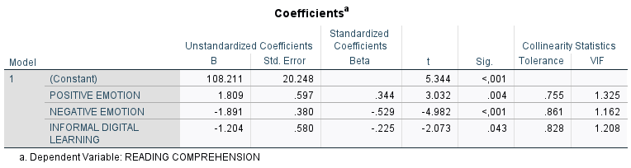
Table 4.6
T-Test
Variable | T_{count} | T_{table} | Significance | Criteria
X1 | 3.032 | 2.004 | 0.004 | Positively Affected
X2 | -4.982 | 2.004 | <,001 | Negatively Affected
X3 | -2.073 | 2.004 | 0.043 | Negatively Affected

  - Positive Emotion in Reading Comprehension
The results of descriptive statistics of positive emotions obtained the minimum score is 15, the maximum score on this emotion is 33, the average score of positive emotions is 24.47, and the standard deviation is 3.607. Furthermore, hypothesis testing was carried out to determine the effect of positive emotions on reading comprehension.
The significant value or the explanation that T_{count} > T_{table} (there is an influence) can be taken from Figure 4.3 and Table 4.8. Each variable has an effect if its significance value is less than 0.05.
According to Table 4.8 above, X1's T_{count} is 3.032, which is higher than the T_{table}. X1's significance value, however, is 0.004. It is clear from the previous findings that X1 (Positive Emotion) has a positive effect on Y (Reading Comprehension).
  - Negative Emotion in Reading Comprehension
From the results of descriptive statistics of negative emotions, the minimum score is 8, the maximum score of this emotion is 30, and the average of negative emotions is 20.68. And the standard deviation is 5.309. The results of the hypothesis test on negative emotions also obtained different results.
The effects of positive and negative emotions on reading comprehension are not the same. In Table 4.8, the T_{count} X2 result is -4.982. While the significance value of X2 is <.001. From the results above, it can be inferred that X2 (Negative Emotion) has a negative effect on Y (Reading Comprehension). This outcome differs from that of positive emotion; if positive emotion has a positive effect on reading comprehension, then negative emotion affects reading comprehension negatively.
  - Informal Digital Learning of English in Reading Comprehension
The results of the descriptive statistics of Informal Digital Learning of English, the minimum score is 14, the maximum score is 30, the mean of Informal Digital Learning of English is 23.51 and the standard deviation is 3.540. The social media used by students vary as many students use Google to learn English, namely 47, Instagram as many as 40, TikTok as many as 41, YouTube as many as 24, X (Twitter) as many as 14, WhatsApp as many as 13, Duolingo as many as 12, and other platforms or applications as many as 8. Students not only use social media to learn English, but they also use other applications or games to learn English.
The results of X3 (Informal Digital Learning of English), as well as positive and negative emotions, are presented in Table 4.8 above. According to the data, X3 has a T_{count} value of -2.073, which is higher than the T_{table} 2.004; in contrast, X3's significance value is smaller than 0.05 with a value of 0.043. X3 (Informal Digital Learning of English) has a negative effect on Y (Reading comprehension).
  - Positive Emotion, Negative Emotion, and Informal Digital Learning of English on Reading Comprehension F-test
The following ANOVA findings can be used to view the F-test results on SPSS.
Figure 4.3
ANOVA
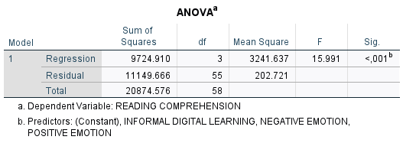
Based on the students' achievement on the reading comprehension test, the scores varied from the lowest to the highest. Students achieved an average score of 85.08, a highest score of 100, and a lowest score of 40. Three of the 59 students who took the reading comprehension test scored the lowest, while the remaining 28 scored the highest.
The data above shows that F_{count} > F_{table} (15.991> 2.77), as shown in Figure 4.3. The significance value is below 0.001. As a result, each independent variable significantly affects Y (Reading Comprehension) at the same time. The significant value also indicates that Y (Reading Comprehension) is impacted by the independent variable, with 0.001 < 0.05.
Coefficient of Determination
The IBM 29.0 SPSS test results' Model Summary shows that the independent variable affects the dependent variable.
Figure 4.4
Model Summary
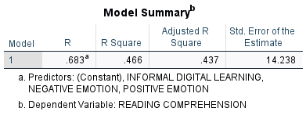
Figure 4.4 shows that the obtained R Square value is 0.466. Accordingly, it may be said that the independent variables (X1, X2, and X3) have a 46.6% influence on Y, with other variables having a greater influence.

Discussion
The data in this study were obtained from 59 students who had filled out questionnaires related to this study. There are 2 stages carried out by researcher to process the questionnaire data, namely the Classical Assumption test and the Hypothesis Test. There are three Classical Assumption tests. First, the normality test showed a significance value for the study data of 0.20 > 0.05. The significance value is greater than 0.05, indicating that the data is normally distributed. To determine if independent variables are correlated, the second test is the multicollinearity test. It is found that the Tolerance value X1 is 0.755, X2 is 0.861, and X3 is 0.828. As well as VIF X1 of 1.325, X2 of 1.162, and X3 of 1.208. Since the tolerance value of each variable is not less than 0.1 and the VIF is not greater than 10, it can be said that the data does not show multicollinearity. Finally, the heteroscedasticity test from the results obtained the significance value of X1 is 0.378, X2 is 0.053, X3 is 0.473, so all of the independent variables' significance values are higher than 0.05. Therefore, it can be said that heteroscedasticity does not exist. The next stage is to test the hypothesis after the classical assumption test has been completed.
Two methods are used in hypothesis testing: the partial hypothesis test (T-test) and the simultaneous hypothesis test (F-test). Based on the findings in this study, it is found that first, the T_{count} of X1 is 3.032 and the T_{table} is 2.004. This shows T_{count} > T_{table}, so H1 is accepted and H0 is rejected. This means that the first hypothesis is accepted and shows a significant positive influence between Positive Emotions and reading comprehension. This is consistent with the broaden and build theory, which explains how different kinds of positive emotions are used to increase a person's repertoire of short-term thoughts and actions. which is a theory that explains that various types of positive emotions serve to expand a person's momentary thought-action repertoire. Positive emotions tend to increase one's concentration of attention and aid the development of future resources. Exploration and play are facilitated by positive emotions and associated with expanded fields of perception and creative problem solving (Fredrickson, 2013) (Khajavy et al., 2018). Previous studies have shown that positive emotions have a good impact on a variety of English language skills. Students' motivation and involvement in the language learning process can be raised by positive emotions like pride, excitement, and hope (Shao et al., 2019). Emotions that are both positive and negative emotions IDLE and WTC have a moderate relationship, but L2 enjoyment mediates IDLE and L2 WTC relationships more effectively than L2 anxiety. Thus, this study provides insight into the mediation of emotions between IDLE and L2 WTC (Lee et al., 2021) The difference between this study and previous studies, especially on positive emotions, is the same both have a positive effect, but the point of difference is in English language skills. If this research focuses on reading comprehension, it differs from previous studies that concentrated more on speaking abilities or willingness to communicate (WTC).
The second finding is that the T_{count} of X2 is -4.982, and the T_{table} is 2.004. This shows that T_{count} > T_{table}, Consequently, H0 is rejected and H1 is approved. This means the second hypothesis is accepted and indicates a significant negative influence between negative emotions and reading comprehension. This study discovered that when reading in a digital environment, negative feelings have a negative impact on comprehension. This is in line with the broaden and develop approach (Fredrickson, 2004), which explains the qualitative differences between positive and negative emotions. In addition to discussing positive emotions, broaden-and-build theory also mentions negative emotions that often coexist with positive emotions. Negative emotions are often connected to certain action tendencies that narrow the focus of attention and direct it towards certain activities. For instance, anger tends to fuel the desire to get rid of obstacles from one's path, but fear tends to evoke thoughts of escape and self-defense (Khajavy et al., 2018).
However, other study indicates that negative emotions are ineffective in digital contexts. In non-digital contexts (in and out of class), L2 anxiety had a negative effect on WTC; however, in digital settings, the effect was not significant (Lee & Chen Hsieh, 2019). This implies that compared to face-to-face communication, EFL students might feel better at ease communicating digitally. According to several studies, L2 WTC and IDLE were positively and significantly correlated with a lack of L2 anxiety (Lee, 2019b). It can be observed that research on emotions in English language learning, particularly in speaking skills, is prevalent. Negative emotions, therefore, had a negative impact on reading comprehension in this study, while the results of other studies indicate that they either have no effect at all or have a beneficial effect, particularly on speaking abilities.
The third finding is that the T_{count} of X3 is -2.073, and the T_{table} is 2.004. This shows that T_{count} > T_{table}, so Ha is accepted and H0 is rejected. This means the third hypothesis is accepted and indicates a negative influence between informal digital learning and reading comprehension. This is in line with digital technology engagement encouraging shallow information processing, where individuals only skim and do not engage deeply with the content presented. As young learners may be more familiar with digital reading in leisure contexts rather than learning contexts, they may associate digital reading with low engagement and distraction. Even when deeper processing is indicated by task demands, such as when using digital devices for learning, digital modes may encourage shallower processing (Annisette & Lafreniere, 2017; Kaufman & Flanagan, 2016) (Futura Tüchler, 2024).
If the results of this study indicate that informal digital learning has a negative impact, the results of other studies showing that it has a good effect are inversely proportional. Students who participate in IDLE programs more regularly report enjoying their English language studies more. Accordingly, the study's findings imply that IDLE significantly improves FLE among South Korean EFL learners (Lee & Lee, 2020). Other studies state that IDLE has a positive effect, IDLE contributes to students' self-directed learning, where students can set learning goals, choose the resources they want to use, as well as monitor their progress. Consequently, this research offers insight into how Indonesian students utilize IDLE to enhance their English language proficiency on their own (Fauziah & Diana, 2023). There are times when using technology negatively affects learning, therefore, informal digital learning does not always help people learn English.
The second hypothesis is the F-test. In this hypothesis test, to ascertain whether or not there is an influence on the dependent variable, the independent variables are tested collectively. This study's F-Test obtained F_{count} 15.991 and F_{table} 2.77. This indicates that H1 is accepted while H0 is rejected since F_{count} > F_{table}. This demonstrates that, in the setting of informal digital English learning, both positive and negative emotions have an impact on students' reading comprehension. Additionally, the R Square value, which is known to be 0.466, shows how much of an impact the independent variable has on the dependent variable in this study. The independent variables (X1, X2, and X3) have a 46.6% influence on Y; the remaining portion is determined by variables not included in this regression equation or that are not being examined. Based on the study's discussion, it can be said that the variables have an impact on MAN Salatiga grade 11 students. The influence of the variables in the study on grade 11 students is also different, such as positive emotions have a positive effect on students' reading comprehension, negative emotions have a negative effect, and Informal Digital Learning English has a negative effect on the reading comprehension of grade 11 MAN Salatiga students. Additionally, it was stated in the previous discussion that both the independent and dependent variables have a positive and negative impact on students' reading comprehension.

CHAPTER V

CONCLUSION AND SUGGESTION
In this chapter, conclusion and suggestion are presented. The author provides a summary of the research findings in this chapter, which helps readers comprehend the study's findings.

Conclusion
Based on the opinions or perceptions of the sample of 11th-grade social studies students of MAN Salatiga, positive emotions, negative emotions, and Informal Digital Learning of English influence students' reading comprehension. In this study, informal digital learning has a negative effect on students' reading comprehension, while positive emotions have a positive effect, and negative emotions have a negative effect.
Based on participant perceptions, it may be inferred that students' scores increase with the degree of positive emotions or enjoyment they obtain from reading the texts. Vice versa, if students' negative emotions are higher or they feel nervous or bored when reading, the lower the score they get. From the perception of the sample of 11th-grade social studies students of MAN Salatiga, it can also be concluded that Informal Digital Learning, such as TikTok, YouTube, Instagram, Google, WhatsApp, or other online applications/websites, does not guarantee that students will enjoy learning through digital technology. The influence of Informal Digital Learning English on learning can also be seen from students' perceptions. Some students prefer conventional learning because they find the course material easier to understand, and not all students will enjoy learning digitally. In the perception of 11th-grade social studies students of MAN Salatiga, not all students disagree with digital self-learning, but some students agree with digital self-learning. The result obtained in this study is that Informal Digital Learning negatively affects the reading comprehension of 11th-grade social studies students of MAN Salatiga.

Suggestion
From the findings and conclusions above, the researcher would like to make some suggestions:
  - For Students
Students are expected to be able to use digital technology as well as possible. Students are also expected to learn independently, to add insight and knowledge, both for English learning and for other subjects, both academic and non-academic. By utilizing digital technology, it is hoped that students can be motivated to learn more English for future provision.

  - For Teachers
If digital technology is used appropriately and successfully in the classroom, it can enhance learning. Teachers can also give students motivation to learn independently using digital technology, so that digital technology is used properly and is useful for students. teachers can also provide good examples or input for the use of digital technology in learning English.
  - For Further Research
This research requires further research in order to get the best and diverse findings. Such as examining what factors influence emotions, both positive and negative in Informal Digital Learning and etc. Further research can also examine using other English language skills, such as writing and listening.

REFERENCES
Annury, M. N., Mujiyanto, J., Saleh, M., & Sutopo, D. (2019). The use of metacognitive strategies in EFL reading comprehension. Proceedings of the First International Conference on Administration Science (ICAS 2019), 62–66. https://doi.org/10.2991/icas-19.2019.13
Babapour, M., Ahangari, S., & Ahour, T. (2018). The effect of shadow reading and collaborative strategic reading on EFL learners’ reading comprehension across two proficiency levels. Innovation in Language Learning and Teaching, 13(4), 318–330. https://doi.org/10.1080/17501229.2018.1465059
Birkbeck, J.-M. D. (2015). On emotions in foreign language learning and use. JALT Publications, 13–15. https://doi.org/10.37546/JALTTLT39.3-3
Dewaele, J.-M., & MacIntyre, P. D. (2014). The two faces of Janus? Anxiety and enjoyment in the foreign language classroom. Studies in Second Language Learning and Teaching, 4(2), 237–274. https://doi.org/10.14746/ssllt.2014.4.2.5
Fauziah, F., & Diana, N. (2023). Exploring students’ informal digital learning of English (IDLE) and self-regulated language learning from a sociocultural perspective. Indonesian TESOL Journal, 5(2), 197–214. https://doi.org/10.24256/itj.v5i2.4225
Fredrickson, B. L. (2001). The Role of Positive Emotions in Positive Psychology The Broaden-and-Build Theory of Positive Emotions. American Psychologist, 56, 218–226. https://doi.org/https://doi.org/10.1037/0003-066X.56.3.218
Futura Tüchler, A. (2024). Reading print vs. on screen: Exploring reading comprehension, information location recall, and reading habits across media.
Gani, S. A., Yusuf, Y. Q., & Susiani, R. (2016). Progressive outcomes of collaborative strategic reading to EFL learners. Kasetsart Journal of Social Sciences, 37(3), 144–149. https://doi.org/10.1016/j.kjss.2016.08.004
Hafni Sahir, S. (2021). Metodologi penelitian (T. Koryati, Ed.; I). PENERBIT KBM INDONESIA.
Hamedi, S. M., Pishghadam, R., & Fadardi, J. S. (2019). The contribution of reading emotions to reading comprehension: The mediating effect of reading engagement using a structural equation modeling approach. Educational Research for Policy and Practice, 19(2), 211–238. https://doi.org/10.1007/s10671-019-09256-3
Khajavy, G. H., MacIntyre, P. D., & Barabadi, E. (2018). Role of the emotions and classroom environment in willingness to communicate. Studies in Second Language Acquisition, 40(3), 605–624. https://doi.org/10.1017/S0272263117000304
Lee, J. S. (2019a). EFL students’ views of willingness to communicate in the extramural digital context. Computer Assisted Language Learning, 32(7), 692–712. https://doi.org/10.1080/09588221.2018.1535509
Lee, J. S. (2019b). Quantity and diversity of informal digital learning of English. Language Learning & Technology, 23(1), 114–126. https://doi.org/https://doi.org/10125/44675
Lee, J. S., & Chen Hsieh, J. (2019). Affective variables and willingness to communicate of EFL learners in in-class, out-of-class, and digital contexts. System, 82, 63–73. https://doi.org/10.1016/j.system.2019.03.002
Lee, J. S., & Drajati, N. A. (2019). Affective variables and informal digital learning of English: Keys to willingness to communicate in a second language. Australasian Journal of Educational Technology, 5, 35. https://doi.org/https://doi.org/10.14742/ajet.5177
Lee, J. S., & Lee, K. (2020). The role of informal digital learning of English and L2 motivational self system in foreign language enjoyment. British Journal of Educational Technology, 52(1), 358–373. https://doi.org/10.1111/bjet.12955
Lee, J. S., Xie, Q., & Lee, K. (2021). Informal digital learning of English and L2 willingness to communicate: roles of emotions, gender, and educational stage. Journal of Multilingual and Multicultural Development, 45(2), 596–612. https://doi.org/10.1080/01434632.2021.1918699
Macintyre, P. D., & Vincze, L. (2017). Positive and negative emotions underlie motivation for L2 learning. Studies in Second Language Learning and Teaching, 7(1), 61–88. https://doi.org/10.14746/ssllt.2017.7.1.4
Pavelescu, L. M., & Petrić, B. (2018). Love and enjoyment in context: Four case studies of adolescent EFL learners. Studies in Second Language Learning and Teaching, 8(1), 73–101. https://doi.org/10.14746/ssllt.2018.8.1.4
Ramadhani, Y. R., Ananda, A., & Mukhaiyar, M. (2023). Hubungan pendekatan konstruktivisme terhadap kecemasan belajar mahasiswa ditinjau dari self-regulated learning. Jurnal Education and Development, 11(2), 298–304. https://doi.org/10.37081/ed.v11i2.4617
Reeve, J. (2014). Understanding motivation and emotion (C. Johnson, Ed.; 6th ed.). George Hoffman.
Septiningrum, K. A., Tarwiyah, S., & Mariam, S. (2018). A Portrait of Learner’s Autonomy through Metacognitive Strategy on Reading Comprehension (A Study At SMP N 32 Semarang). Vision: Journal for Language and Foreign Language Learning, 7(1), 66–82. https://doi.org/10.21580/vjv7i12805
Shao, K., Pekrun, R., & Nicholson, L. J. (2019). Emotions in classroom language learning: What can we learn from achievement emotion research? System, 86. https://doi.org/10.1016/j.system.2019.102121
Ulya, Z. (2024). Penerapan teori konstruktivisme menurut Jean Piaget dan teori Neuroscience dalam pendidikan. Journal of Education, 7(1). https://doi.org/10.32478/m1778y41
Zembylas, M., Charalambous, C., & Charalambous, P. (2014). The schooling of emotion and memory: Analyzing emotional styles in the context of a teacher’s pedagogical practices. Teaching and Teacher Education, 44, 69–80. https://doi.org/10.1016/j.tate.2014.08.001
Zhang, L. (2023). The effect of emotions on reading comprehension. Lecture Notes in Education Psychology and Public Media, 22(1), 221–227. https://doi.org/10.54254/2753-7048/22/20230313

APPENDIX 1
Research Instrument
Personal Data
Email:
Name:
Age:
- 14
- 15
- 16
- 17
- 18
- 19
Gender:
- Male
- Female
Grade:
- X
- XI
- XII
English Proficiency Level:
- Beginner
- Intermediate
- Advance

For the Informal Digital Learning instrument, Positive and Negative Emotions are measured using a Likert scale of 1 (Strongly disagree) - 5 (Strongly agree).
RQ 1: How do positive emotions affect learners' reading comprehension in informal digital learning of English?
RQ 2: How do negative emotions affect learners' reading comprehension in informal digital learning of English?
RQ 3: How do emotions simultaneously affect learners' reading comprehension in informal digital learning of English?
POSITIVE EMOTIONS
Enjoyment-self
- I don’t get bored when reading English texts
- Strongly Disagree
- Disagree
- Neutral
- Agree
- Strongly Agree
- I enjoy reading English texts online (e.g., blogs, articles, comics)
- Strongly Disagree
- Disagree
- Neutral
- Agree
- Strongly Agree
- I feel I can understand English texts better now
- Strongly Disagree
- Disagree
- Neutral
- Agree
- Strongly Agree
- I feel confident in reading English materials
- Strongly Disagree
- Disagree
- Neutral
- Agree
- Strongly Agree
- I have learned interesting things by reading English texts
- Strongly Disagree
- Disagree
- Neutral
- Agree
- Strongly Agree
Enjoyment-teacher
- My English teacher encourages me to read more English materials
- Strongly Disagree
- Disagree
- Neutral
- Agree
- Strongly Agree
- There is a positive atmosphere during reading activities in my English class
- Strongly Disagree
- Disagree
- Neutral
- Agree
- Strongly Agree

NEGATIVE EMOTION
Reading anxiety-online
- I feel nervous when reading and replying to strangers in English on social media
- Strongly Disagree
- Disagree
- Neutral
- Agree
- Strongly Agree
- I feel anxious when reading English articles or posts in social media
- Strongly Disagree
- Disagree
- Neutral
- Agree
- Strongly Agree
- I feel nervous when reading game-related English texts while playing online games
- Strongly Disagree
- Disagree
- Neutral
- Agree
- Strongly Agree
Reading anxiety-offline
- Even if I am prepared, I feel anxious when asked to read English texts aloud
- Strongly Disagree
- Disagree
- Neutral
- Agree
- Strongly Agree
- I feel nervous when I have to read an English text in front of other students
- Strongly Disagree
- Disagree
- Neutral
- Agree
- Strongly Agree
- I am afraid that my classmates will laugh if I mispronounce something while reading in English
- Strongly Disagree
- Disagree
- Neutral
- Agree
- Strongly Agree
- I feel anxious when I am asked to read an English text by my teacher
- Strongly Disagree
- Disagree
- Neutral
- Agree
- Strongly Agree

RQ 2: How does informal digital learning affect learners' reading comprehension in English?
INFORMAL DIGITAL LEARNING OF ENGLISH (IDLE)
- What apps or digital learning resources do you use?
- Instagram
- TikTok
- YouTube
- Duolingo
- X (Twitter)
- Google
- WhatsApp
- Others:
- I learn English vocabulary by reading content on language-learning apps
- Strongly Disagree
- Disagree
- Neutral
- Agree
- Strongly Agree
- I read game instructions or dialogue in English while playing digital games (e.g., Star Craft, FIFA, The Sims, Mobile Legend, PUBG)
- Strongly Disagree
- Disagree
- Neutral
- Agree
- Strongly Agree
- I read entertaining online content in English (e.g., comics, travel blogs, product reviews, novel, etc)
- Strongly Disagree
- Disagree
- Neutral
- Agree
- Strongly Agree
- I read English news articles or news programs online or on TV
- Strongly Disagree
- Disagree
- Neutral
- Agree
- Strongly Agree
- I read English subtitles when watching English-language shows or movies
- Strongly Disagree
- Disagree
- Neutral
- Agree
- Strongly Agree
- I read music lyrics online on Spotify, YouTube, or other platforms to improve my English.
- Strongly Disagree
- Disagree
- Neutral
- Agree
- Strongly Agree
- I search for and read information in English to improve my reading comprehension
- Strongly Disagree
- Disagree
- Neutral
- Agree
- Strongly Agree

READING COMPREHENSION TEST
The results of the reading comprehension test will be calculated by score. Each question is scored 10, so if there are 10 questions the total score is 100.
Take a look at the text below!
Mark Zupan
A terrible accident in 1993 made Mark Zupan a quadriplegic and changed his life forever. He cannot move his arms or legs normally, and he has to take medication so his legs don't shake. However, after a lot of hard work, he can now use his arms to move his wheelchair, and he can even stand for a short time and take a few slow steps. Zupan- or Zup to his friends plays quad rugby- a sport for people in wheelchairs. He's a quad rugby champion, winning a gold medal in the 2008 Paralympic Games. "I dream about running all the time," he says, "but you can't live in the past."
Today, Zupan gives talks and raises money for his sport. Anyone who spends time with him forgets that he's in a wheelchair. He lifts weights at the gym every day, drives a cat, and goes to rock concerts. "A lot of people think quadriplegics can't do anything," he said. To stay in shape, Zupon is careful about his diet and avoids unhealthy and fatty foods. "Just think of me as a human being and an athlete. Because that's who I am.”
- What does Mark Zupan emphasize about his identity after becoming a quadriplegic?
- His limitations as a person with a disability
- His need for assistance in daily life
- His past as a successful athlete
- His identity as a human being and an athlete
- How does Mark Zupan inspire others through his actions?
- By demonstrating physical prowess
- By competing in numerous sports
- By sharing motivational speeches and fundraising
- By promoting wheelchair designs

Read the text below!
Bethany Hamilton
Surfer Bethany Hamilton had a dream. She wanted to be a champion in her sport. But in 2003, she lost her left arm when she was attacked by a shark in Hawaii. Three weeks later, she was surfing again. Because she can only use one arm, she has to use her legs more to help her go in the right direction. She's a strong competitive surfer, winning first place in 2005 in the NSSA National Championships. She appears on TV and writes books about her experience.
Hamilton wants to help other people follow their dreams, even when they face great difficulties. "People can do whatever they want if they just set their hearts to it, and just never give up Just go out there and do it," she says
- How does Bethany Hamilton adapt her surfing technique after losing her arm?
- She uses a special surfboard
- She relies more on her legs for balance
- She surfs in calmer waters only
- She practices less often
- What underlying message does Bethany Hamilton convey about overcoming challenges?
- Success is only for those who never fail
- It's important to focus on physical abilities
- Challenges should be avoided whenever possible
- Perseverance can lead to achieving dreams
Read the 3 short texts below!
Go skiing and snowboarding in Valle Nevado
Just 60 kilometers/37 miles from Santiago
"We just got back! There was nothing but sun and snow, but there was plenty to do. We went dancing every night in a terrific disco. We swam every day in a heated pool and worked out in an incredible gym. The shopping was terrific! And there were so many great restaurants to choose from. Oh, and I almost forgot the views of the Andes Mountains were amazing!" - Alison Ned Montreal, Canaga

Enjoy some of the world's top spas
Luxury and service at prices you can afford
"Back home, we work very hard, and we really needed a vacation. The staff at the spa knew just how to take care of us. My wife and I got wonderful massages and other spa treatments. They even put hot rocks on our backs! We enjoyed excellent healthy meals every day. We loved our spa vacation in Thailand. It was really hard to come back home!" - Kenji Watanabe, Nagoya, Japan

Learn about another culture and help the world
No experience necessary
"My vacation in Tajikistan lasted twenty-six days, and we helped to build new homes for ten of those days. The other days we went sightseeing and bought souvenirs. The people were incredibly nice, and I loved the food. There were twelve other volunteers on this trip. The work was actually fun, and we got to know each other really well. In the end we felt really good. I'd definitely do it again!" -Arturo Manuel Reyes, Monterrey Mexico

- How does Kenji Watanabe's description of his spa vacation reflect a broader trend in travel?
    - It emphasizes the importance of adventure over relaxation.
    - It highlights the increasing demand for wellness and self-care.
    - It suggests that vacations should be more about luxury than experience.
    - It indicates that people prefer short trips over long vacations.
- What can be inferred about the volunteer experience in Tajikistan based on Arturo Manuel Reyes?
- It was primarily a sightseeing trip with minimal work involved.
- The group faced significant challenges that hindered their efforts.
- The social interactions among volunteers were as valuable as the work done.
- The local culture was difficult to engage with and understand.
- Considering the experiences shared, what theme emerges regarding the purpose of travel for these individuals?
- Travel is mainly for indulgence and luxury experiences.
- Short trips are more fulfilling than lengthy vacations.
- Engaging with different cultures and activities enriches personal experience.
- Travel should be planned meticulously to avoid any inconveniences.

Dear Josephine:
This popular and effective surgery lifts the face and the neck in one operation. But a face-lift is surgery, and afterwards you will have to stay home for a number of days. It takes time to recover. Before you decide to have a face-lift, ask your dermatologist or a cosmetic surgeon about a chemical peel. A chemical peel removes the top layer of skin and can improve the appearance of the skin without surgery. Compared to surgery, a half-hour visit to your dermatologist would be a piece of cake! Good luck!
Gail Weiss, M.D
- What does a facelift surgery do?
A. Lifts the face and neck
B. Removes scars
C. Changes skin color
D. Increases body weight
- What is the advantage of a chemical peel compared to a facelift?
A. It is more expensive
B. It requires a longer recovery time
C. It does not require surgery
D. The results are more permanent
- What is the main purpose of a chemical peel as mentioned in the text?
A. To lift the face and neck
B. To remove the top layer of skin
C. To change skin color
D. To enhance facial features

APPENDIX 2
Validity Test
X1
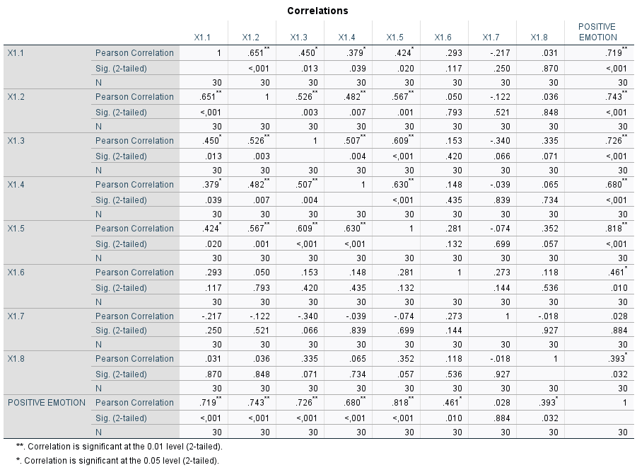
X2

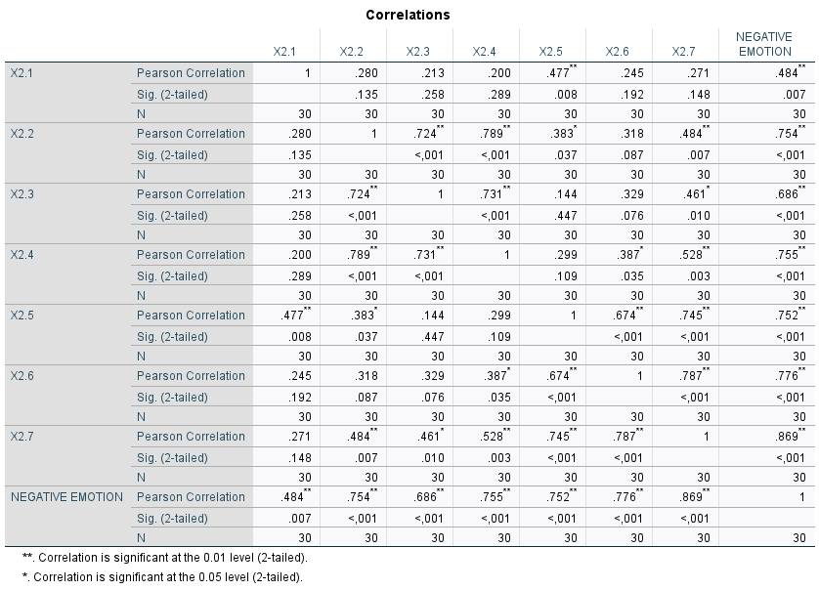
X3

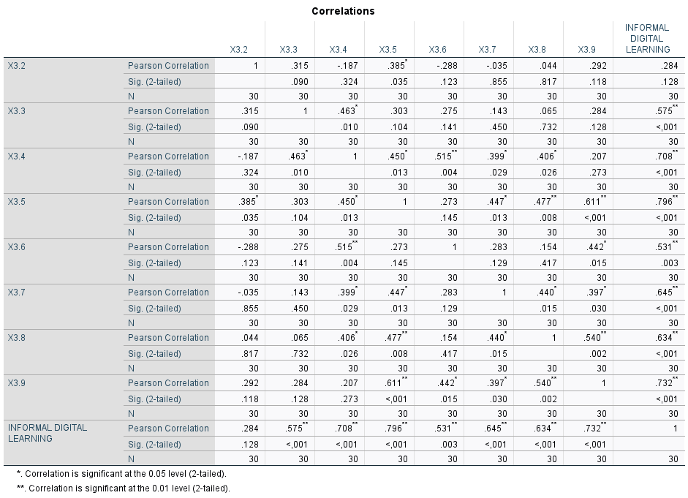
Y

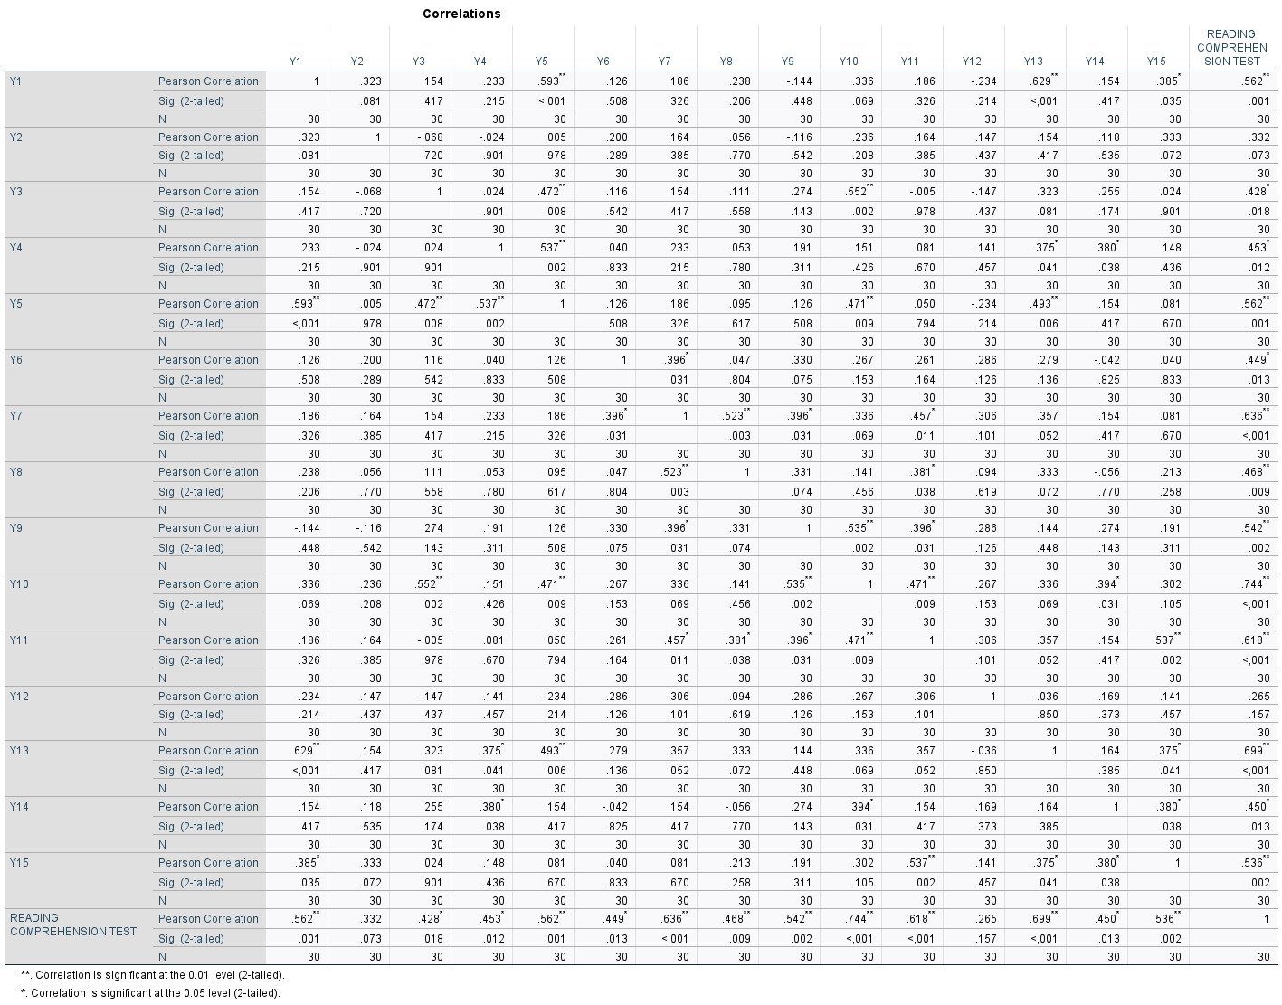
APPENDIX 3
Reliability Test
X1
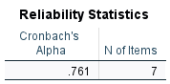

X2
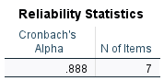
X3
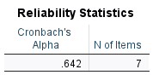

Y
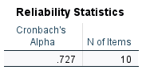

APPENDIX 4
Classical Assumption Test
Normality Test (NPar Tests)
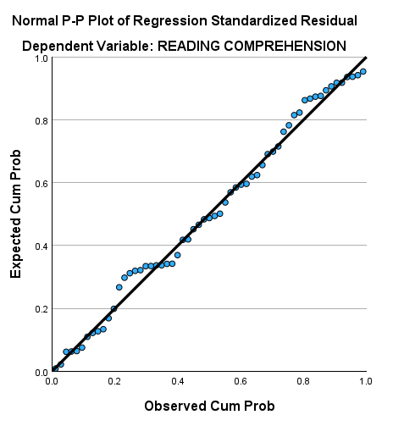
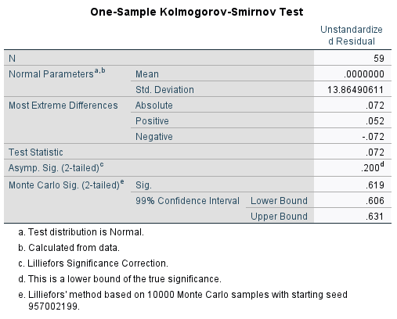

Multicollinearity Test

Heteroscedasticity Test
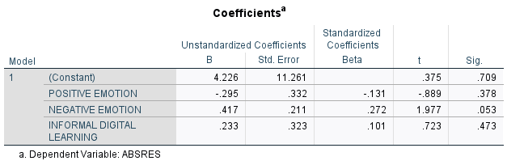

APPENDIX 5
Descriptive Statistics of Data

 | Minimum | Maximum | Mean | Std. Deviation
Positive Emotion | 15 | 33 | 24,47 | 3.607
Negative Emotion | 8 | 30 | 20,68 | 5.309
Informal Digital Learning | 14 | 30 | 23,51 | 3.540

Reading Comprehension Score
Reading Comprehension Score | Number of Students
40 | 3
50 | 5
60 | 2
70 | 3
80 | 10
90 | 8
100 | 28
N | 59
Minimum | 40
Maximum | 100
Mean | 85,08
Std. Deviation | 18.971

APPENDIX 6
Social media or apps used by students

APPENDIX 7
Students' scores in the research questionnaire
No | Name | Positive Emotion | Negative Emotion | Informal Digital Learning | Reading Comprehension Test
1 | P1 | 33 | 11 | 26 | 100
2 | P2 | 27 | 21 | 21 | 80
3 | P3 | 26 | 23 | 26 | 80
4 | P4 | 25 | 21 | 27 | 100
5 | P5 | 27 | 26 | 23 | 100
6 | P6 | 25 | 18 | 22 | 100
7 | P7 | 24 | 10 | 30 | 90
8 | P8 | 23 | 16 | 21 | 100
9 | P9 | 21 | 18 | 23 | 100
10 | P10 | 23 | 9 | 21 | 90
11 | P11 | 25 | 21 | 22 | 100
12 | P12 | 24 | 21 | 28 | 100
13 | P13 | 28 | 24 | 22 | 80
14 | P14 | 26 | 20 | 17 | 100
15 | P15 | 19 | 25 | 23 | 90
16 | P16 | 21 | 29 | 27 | 50
17 | P17 | 22 | 27 | 21 | 50
18 | P18 | 25 | 30 | 25 | 50
19 | P19 | 24 | 26 | 27 | 70
20 | P20 | 23 | 22 | 20 | 100
21 | P21 | 30 | 12 | 30 | 90
22 | P22 | 21 | 19 | 23 | 90
23 | P23 | 28 | 28 | 25 | 70
24 | P24 | 30 | 12 | 28 | 100
25 | P25 | 27 | 16 | 26 | 100
26 | P26 | 22 | 29 | 22 | 60
27 | P27 | 21 | 17 | 22 | 80
28 | P28 | 23 | 20 | 25 | 90
29 | P29 | 26 | 14 | 25 | 100
30 | P30 | 17 | 28 | 20 | 40
31 | P31 | 25 | 27 | 20 | 100
32 | P32 | 23 | 25 | 22 | 100
33 | P33 | 25 | 21 | 27 | 80
34 | P34 | 28 | 27 | 28 | 40
35 | P35 | 21 | 25 | 25 | 40
36 | P36 | 15 | 27 | 20 | 60
37 | P37 | 18 | 20 | 14 | 80
38 | P38 | 23 | 8 | 24 | 100
39 | P39 | 29 | 20 | 14 | 100
40 | P40 | 26 | 22 | 24 | 80
41 | P41 | 23 | 18 | 21 | 70
42 | P42 | 22 | 22 | 24 | 80
43 | P43 | 19 | 27 | 21 | 50
44 | P44 | 21 | 23 | 17 | 100
45 | P45 | 25 | 23 | 25 | 90
46 | P46 | 27 | 22 | 27 | 80
47 | P47 | 24 | 19 | 24 | 100
48 | P48 | 29 | 13 | 25 | 100
49 | P49 | 28 | 22 | 28 | 100
50 | P50 | 21 | 22 | 19 | 80
51 | P51 | 26 | 20 | 28 | 100
52 | P52 | 29 | 21 | 21 | 100
53 | P53 | 29 | 14 | 26 | 100
54 | P54 | 26 | 17 | 27 | 90
55 | P55 | 28 | 23 | 22 | 100
56 | P56 | 30 | 17 | 28 | 100
57 | P57 | 21 | 19 | 25 | 100
58 | P58 | 27 | 18 | 22 | 100
59 | P59 | 20 | 25 | 21 | 50

APPENDIX 8
Documentation
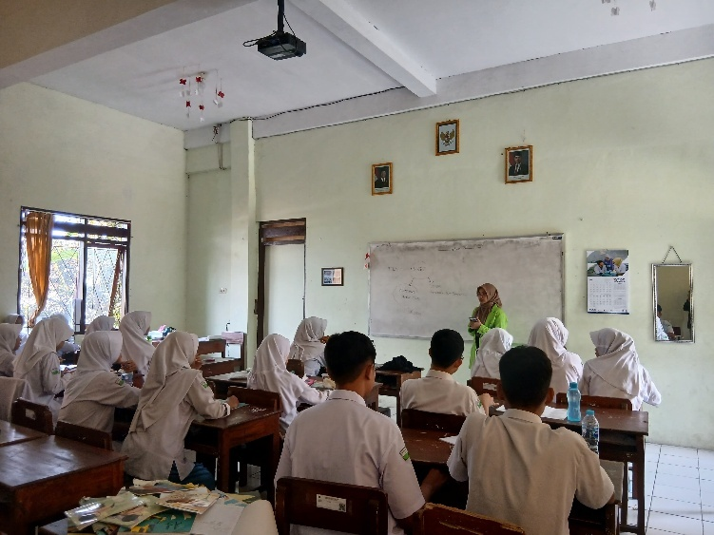

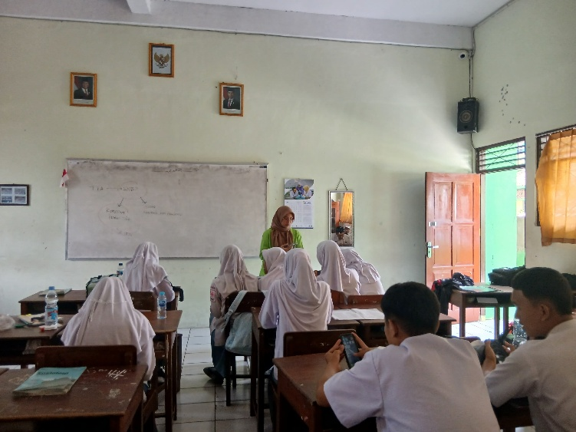

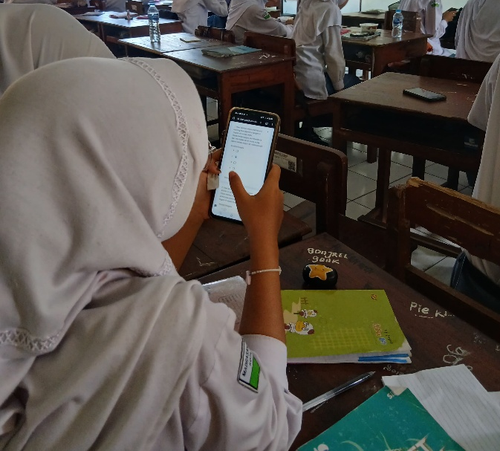

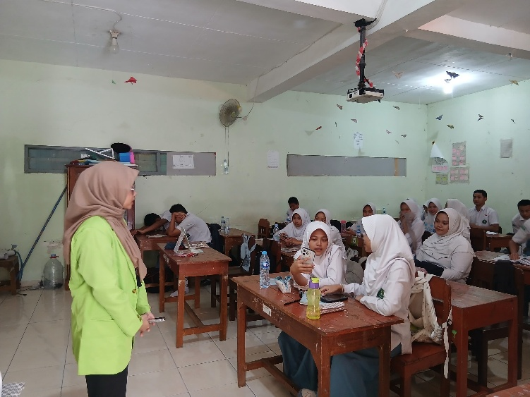

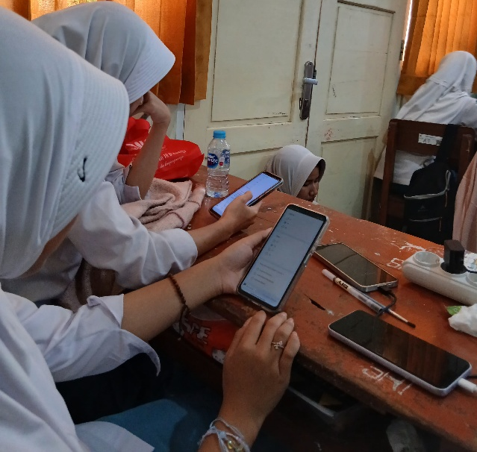

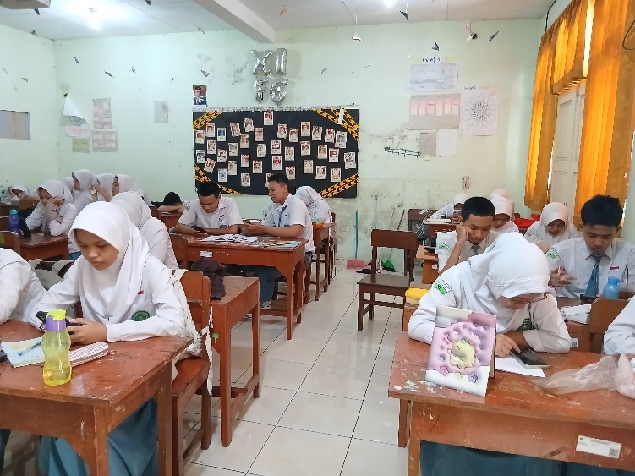

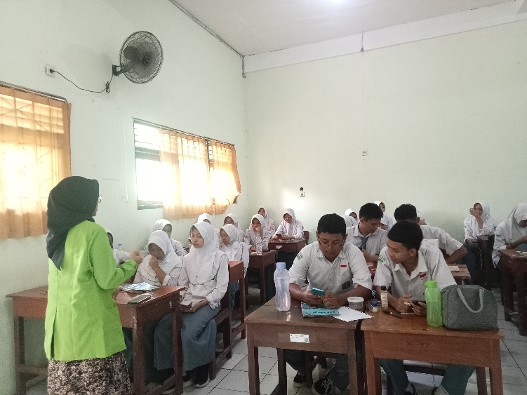

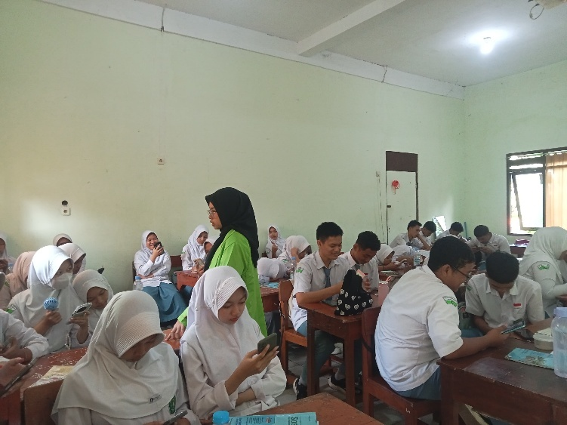





APPENDIX 9
Research Approval
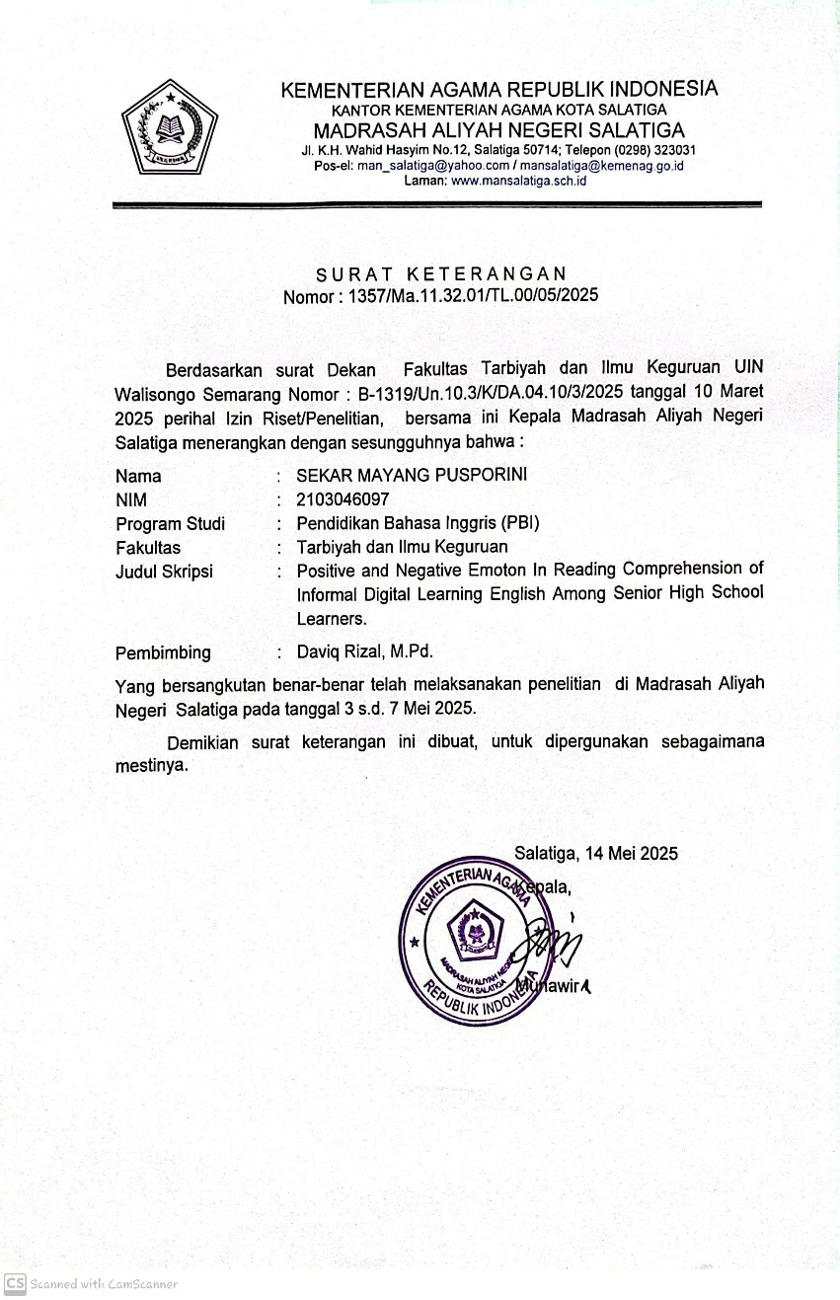

CURRICULUM VITAE
- Personal Data
- Name : Sekar Mayang Pusporini
- Born : Salatiga, 21 January 2003
- Address : Perumahan Bawen Bukit Permai B.35 RT/RW:06/01
- Phone Number : 089508885497
- E-mail : sekarmayang210@gmail.com

- Educational Background
- RA Sudirman Ambarawa
- SDN Kupang 01 Ambarawa
- SMPN 1 Bawen
- MAN Salatiga
- English Education UIN Walisongo Semarang

Semarang, June 16, 2025

Sekar Mayang Pusporini
2103046097

