INDONESIAN CONSUMER KNOWLEDGE MANAGEMENT OF FURADA HAJJ PRODUCTS: A NETNOGRAPHIC STUDY ON THE FACEBOOK PLATFORM

Selly Novita Sari¹, Kurnia Muhajarah² Abdul Rozaq³
Universitas Islam Negeri Walisongo , Semarang, Jawa Tengah, 50185, Indonesia¹²³
2101056044@student.walisongo.ac.id¹, kurniamuhajarah@walisongo.ac.id² abdulrozaq@walisongo.ac.id³
 |  | Abstract
Received:  Revised:  Accepted: |  | This study aims to explore netizens' knowledge regarding the Furada Hajj product, a type of non-quota Hajj characterized by limited information and uncertain serives guarantees. Using a qualitative approach, the data are presented descriptively. The method used is netnography, where the researcher analyzes natural discussions among Facebook users. This study draws on 260 comments from 64 Facebook posts discussing Furada Hajj, spanning from 2019 to December 2024. The findings show that knowledge about the identity of Furada Hajj dominates, with 168 comments addressing this topic, while satisfaction was the least discussed topic, with only 23 comments. The limited availability of information did not hinder netizens from seeking more detailed information about Furada Hajj. These digital discussions indicate that knowledge—ranging from product, purchasing, to usage knowledge—originates from various sources. This diversity enriches the discussions with multiple perspectives. The study is expected to contribute to efforts in regulating the dissemination of information about Furada Hajj on media platforms to ensure alignment with prevailing regulations
Keywords: |  | Consumer Knowledge, Furada Hajj, Netnography, Facebook
(*) Corresponding Author: |  | Selly Novita Sari, 2101056044@student.walisongo.ac.id, 0895360543746

INTRODUCTION

Hajj is a mandatory act of worship that Muslims who are physically, financially, and mentally capable must perform once in their lifetime (Sattar et al., 2023). The regulations related to the organization of Hajj are systematically arranged under Law No. 8 of 2019 (JDIH, 2019), Minister of Religious Affairs Decrees (KMA), and Ministerial Regulations (PMA). Linguistically, Furada comes from the Arabic word Farada, which means "alone" or "single" (Ramadhani & Azizi, 2018). In the context of Hajj, Furada is someone who performs Hajj independently, without going through the government quota or official national programs. Furada Hajj refers to a Hajj performed using a direct invitation visa from the Government of Saudi Arabia (Ritonga & Nadirah, 2022). This route allows pilgrims to depart without the long waiting list, although it comes with relatively higher costs compared to other Hajj pathways. Eko Hartono, the Consul General of the Republic of Indonesia, stated that the Saudi Arabian government has long provided Hajj quotas with special royal visas (Furada/mujamalah) (Linawati, 2022).
Although it has attracted public attention in recent years (Suherli, 2025), information about Furada Hajj reminds insufficient to address public concerns regarding the certainty of departure, safety, and services (Khoeroen, 2023). Amid the widespread discussion of Furada Hajj among netizens, information on this topic often appears scattered and uncontrolled. Statements regarding its legality, regulations, and certainty of departure have become topics vulnerable to misinformation. Access to information and transparency about Furada Hajj is not as open as those related to government-organized Hajj programs. Essentially, every matter requires guidelines to serve as a foundation for individuals to achieve their goals (Nurdiansyah et al., 2023). According to the Ministry of Religious Affairs, the certainty of services for Furada Hajj has also not been openly communicated to the public, unlike the Regular Hajj and Special Hajj programs (Khoeroen, 2023).
This phenomenon confuses a segmen of the public, who are consumers of Furada Hajj product, in understanding the service. Prospective pilgrims, as consumers of the Furada Hajj product, continuously seek information through social media (Ardani, 2022). Consumer behavior in seeking product information has now transformed where it once relied on word-of-mouth culture, a new trend has emerged known as EWOM (Electronic Word of Mouth) (Priambodo et al., 2017).
Social media has become a platform for exchanging information and discussions about Furada Hajj. People take advantage of the conveniences offered by the times to engage in discussions or simply express themselves regarding Furada Hajj content freely, without fear of intervention from other parties. This situation also represents a wave of change occurring in many sectors, including the marketplace. Consumers can easily carry out purchasing activities from making decisions and purchases to reviewing products all through their smartphones. Technology has transformed many human activities from the physical to the virtual. It helps human work become faster and no longer bound by space or time. The importance of an information medium is also mentioned in a verse from the Qur’an as follows:
وَلَقَدْ جِئْنَاهُمْ بِكِتَابٍ فَصَّلْنَاهُ عَلَى عِلْمٍ هُدًى وَرَحْمَةً لِقَوْمٍ يُؤْمِنُونَ

The meaning: “Indeed, We have brought them a Book (the Qur’an) which We have explained with knowledge, as guidance and mercy for those who believe.” (Q.S. Al-A‘raf: 52).

This shift is also what shapes new habits and cultures within society. Netnography is the field of study that seeks to understand the cultures that emerge in the virtual world. In digital spaces, individuals have absolute freedom in responding to information, whereas the reactions that arise are organic because they are free from external intervention.
Discussions about Hajj Furada need to be managed wisely so they provide added value for the innovation and future development of Furada Hajj, rather than merely turning into endless debates. With a positive and well-directed approach, these discussions have the potential to become a starting point for important reforms that can improve Furada Hajj's services and strengthen its reputation in the future.
This research was conducted using the netnography method, focusing on discussion spaces within the Facebook platform that present content related to Furada Hajj. The discussions took place without sacrificing place, time, or cost. The chosen platform was Facebook, as data shows it is the most widely used application in the world, reaching 3 billion users (Muhamad, 2024). The researcher, as a netnographer, also observed other similar social media platforms and found that discussions about Furada Hajj were more active and lively on Facebook. The reviews shared by netizens on this platform were more detailed and engaged.
Several studies related to Furada Hajj have been conducted. For example, research by Rizaldi Ahmad Biben (Biben, 2024) titled “Pelayanan Haji Furoda di Travel Jannah Firdaus.” The similarity between that study and this current research lies in the shared theme, both focusing on the Furada Hajj product. However, the difference lies in the issue being examined Biben’s (2024) study explores the services provided by the organizers, whereas this research examines consumers’ knowledge on social media about the Furada Hajj product.
Next, a study by Anik Farida in 2019 titled “Penanganan Kasus Penyelenggaraan Haji Furodah (Kasus Jawa Barat)” (Farida, 2019) also relates to this topic. The similarity lies in the focus on the organization of Furada Hajj, but the difference is in the research setting: Farida’s study is set in the physical world, while this research focuses on the virtual space. A similar study was also conducted by (Ritonga & Nadirah, 2022), titled “Penyelesaian Sengketa Wanprestasi Oleh Travel Umroh Atas Jamaah Haji Furoda/Umroh Di Indonesia.” The similarity between their study and this research is the shared theme of Furada Hajj, but the key difference lies in the field of focus. Farida’s (2019) study centers on legal aspects, while this research focuses on consumer behavior.
Previous research has mostly been conducted in real-world field locations, whereas there has not yet been a study on Furada Hajj carried out in the virtual world. This study attempts to examine the Furada Hajj phenomenon as it unfolds on the social media platform Facebook because expressions of interest in Furada Hajj occur not only in the physical world but also online.
The research question of this study is: How is the knowledge management of Indonesian consumers regarding the Furada Hajj product? The purpose of this research is to provide recommendations to stakeholders and relevant authorities to pay attention to the flow of information regarding Hajj Furada on Facebook a platform that has often been overlooked as attention shifts to other platforms. Facebook is still the medium most used by the age groups that make up the main target market for Furada Hajj.

RESEARCH METHODS

This study uses a qualitative research approach, specifically employing the netnography method. Netnography is a method dedicated to exploring the culture of Internet users (Eriyanto, 2021). The social media platform chosen for this study is Facebook, with data sourced from 260 comments by Indonesian netizens across 64 photo posts, using documentation techniques. The comments are categorized based on levels of consumer knowledge. The selected content consists of photo posts with a minimum of 10 comments. The posts analyzed were uploaded between 2019 and December 2024. The comments chosen are those that contain information related to Furada Hajj. The reason the researcher chose the ethnographic approach is that it allows the collection of natural data from the discussions and interactions of netizens without the need for interviews that could potentially disrupt the organic nature of the discussion forums or data.
The stages used in research, based on (Kozinets, 2019) are (1) Planning, namely planning the research topic in this case is Hajj Furada . (2) Data collection, in this research is done by lurking. Researchers only observe the comment column without engaging in communication. All data collected is publicly available data without the need for special permission. (3) Data analysis, researchers analyze data to find patterns, meanings, or cultural symbols. By the researcher, the analysis was carried out by coding techniques on selected comments. (4) Research ethics, To maintain respondent anonymity, researchers refer to users by initials and blur photos and usernames in comment screenshots. (5) Representation of research results, researchers present in the form of diagrams and explained descriptively.




The tools used for presenting the data are Nvivo and Microsoft Excel. Nvivo processes the collected data and generates a word frequency diagram from all comments across 64 contents. Coding is conducted in Microsoft Excel after the filtering process of comments containing information on Furada Hajj. The coding is based on categories reflecting the level of consumer knowledge, namely: knowledge of identity, knowledge of benefit, knowledge of satisfaction, store search, product search, and knowledge of usage.
Source: Data coded in Microsoft Excel.

RESULTS AND DISCUSSIONS

  - Theoretical Review
  - Theory of Customer Knowledge Management
Customer knowledge management is an effort to manage consumer knowledge by integrating processes, human resources, and technology to create added value through the effective utilization of consumer knowledge (Al-Shammari, 2009). The purpose of an organization's CKM (Customer Knowledge Management) practices is to enhance the understanding of consumers, support decision-making, and drive service innovation. In CKM, there are three important components, namely: (1) People who are key actors in knowledge management practices because knowledge resides within each person/individual and is transferred to other individuals. Thus, the knowledge value of a group can be determined by the knowledge of each individual. (2) Process, which refers to the activities of collecting, storing, and distributing consumer knowledge. (3) Technology, the tools used to support the processes of managing consumer knowledge.
The conclusion of consumer knowledge management (CKM), according to (Al-Shammari, 2009), is an effort to manage consumer knowledge by integrating processes, human resources, and technology to seek new findings that can support the innovation of a group/organization.

  - Theory of Consumer Knowledge
First, Knowledge of product
Product knowledge includes information related to the product such as brand, price, terminology, identity, and the level of trust in the product. The amount of information about product details and knowledge related to product information breaks down the set of information into three instruments, namely: knowledge about identity, knowledge about the level of benefits, and knowledge about satisfaction.
Second, Knowledge of purchase
Purchase knowledge is a set of information that answers questions of where, when, and how the purchase of the product can be carried out. Purchasing knowledge is also divided into three instruments, namely: store search and product search.
Third, Knowledge of usage
Knowledge about usage is the information consumers have regarding how to use and the condition of the product at the time of purchase.
The conclusion of the theory of consumer knowledge, according to Engel, is that consumer knowledge is divided into three main interrelated aspects in the consumer decision-making process. First, product knowledge consists of the product identity instrument, the benefits offered, and the level of satisfaction felt by consumers, which serve as the basis for assessing the value and credibility of the product. Second, purchase knowledge focuses on technical aspects such as store information, product search activities, and purchasing methods, which enable consumers to acquire products effectively and efficiently. Third, usage knowledge emphasizes the consumer's ability to use the product correctly, as well as understand the condition of the product at the time of purchase, which affects the post-purchase experience and satisfaction. These three dimensions show that a comprehensive consumer understanding is very important in shaping wise and rational consumption behavior.
- General Overview of Furada Hajj in Facebook Social Media Discourse
Hajj Furada is a pilgrimage performed using a special invitation visa from the Kingdom of Saudi Arabia (mujamalah visa) (Maulana et al., 2024). All activities are carried out independently without government intervention. This type of hajj is the only hajj outside the government quota that has an official quota from the Government of Saudi Arabia (Farida, 2019). The organization of Hajj Furada is officially legalized under Law Number 8 of 2019, Article 18, which states that there are two types of visas permitted for performing Hajj in Indonesia: the government quota visa and the Mujamalah visa (a visa issued by invitation from the Kingdom of Saudi Arabia). The law also mandates that pilgrims using a Mujamalah (Furada) visa must go through officially licensed Special Hajj Organizers (PIHK) authorized by the Ministry of Religious Affairs (JDIH, 2019). In Saudi Arabia’s legal framework, the System of Domestic Hajj Services (cf. Articles 16–17) regulates that all Hajj operations, including those using Mujamalah visas, must be carried out through official institutions (Dewan Otoritas Arab Saudi, 2005). Hajj Furada has become a popular product in pilgrimage travel packages, offering direct departure registration amid the noisy dynamics of the long hajj waiting list in Indonesia (Farhanah, 2016).
Facebook has become the most accessible discussion platform to obtain information about Hajj Furada (Susanti & AlFurqan, 2022). The content posts related to the discussion of Hajj Furada on the Facebook platform are very diverse, ranging from pilgrims’ travel experiences and news/issues about the failure of Hajj Furada to the promotion of Hajj Furada products carried out by travel agencies.
The communication styles used in these discussions vary greatly and depend on each individual. Netizens comment and express themselves freely in the comment sections. The reviews provided are not limited by word count, specific topic restrictions, or word choice alone. Netizens are also free to express themselves using certain animations/emojis on the content they choose. This is one of the benefits of the freedom offered by social media (Angga et al., 2023).
The attention given by Facebook netizens* to the topic of Hajj Furada is very high. Netizens’ interest in the Hajj Furada product is shown through positive reviews in the form of hopes and prayers, as presented in the following diagram by the researchers. The diagram below presents the most frequently mentioned words in the comment sections. From the data traces of the discussions among netizens on Facebook, three major themes were found that are often raised in the comments. The first theme is that Hajj Furada is a high-risk hajj, with 46 reviews; the second theme is that Hajj Furada is a business, with 22 reviews; and the third theme is that Hajj Furada is a no-queue hajj, with 16 comments.
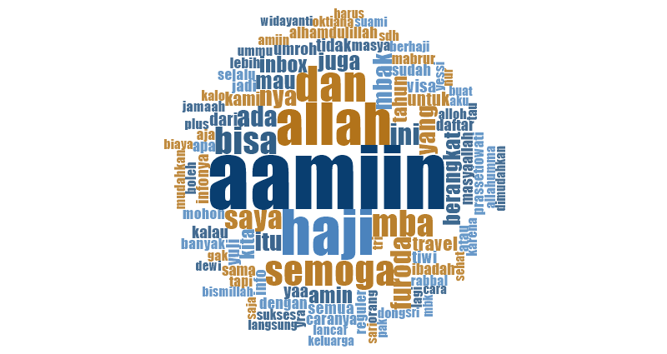
Source: Processed data in NVivo derived from netizen comments spanning 2019–2024.

- Analysis of Consumers’ Knowledge Regarding Furada Hajj
Based on the analysis, netizens’ product knowledge exceeds their knowledge of purchasing and usage. Upon closer examination, the high level of netizens’ knowledge regarding the Hajj Furada product is focused mainly on the identity knowledge instrument. The motivation to depart for Hajj as soon as possible leads most netizens to understand Furada Hajj merely as an official Hajj program without a waiting list, often referred to as a government-invited Hajj, with a shorter implementation period compared to similar Hajj products without studying other aspects such as risk levels and expected satisfaction.
For some people, cost is not an issue when it comes to fulfilling religious obligations like Hajj (Farida, 2019), because the perception of Hajj as a symbol of social status still persists in society (Wulandari, 2023). This situation creates a loophole that can be exploited by unscrupulous service providers to manipulate the price and facilities of the Furada Hajj product, which has the potential to deceive prospective pilgrims (Ritonga & Nadirah, 2022).
The marketing activities of travel agencies within discussion spaces also shape netizen opinions regarding the implementation of Furada Hajj (Nabilah et al., 2024), especially regarding the use of visas other than the mujamalah visa for Furada Hajj. Moreover, few netizens take the step to verify the accuracy of the information related to Furada Hajj. Netizens’ knowledge comes from various sources, some based on personal experiences or those of people close to them, making the comments they provide subjective. Netizens tend to share information they believe to be true, even if it is inaccurate (Goebel et al., 2024).
The abundance of information sources referenced in discussions prevents the conversations from reaching a clear resolution. The lack of official information regarding Furada Hajj makes each netizen confident in defending their opinions based on personal experience (Siebert & Siebert, 2023). This condition leads individuals to be reluctant to confirm the accuracy of the information they believe.

  - Knowledge of the Product
The knowledge of netizens regarding the Hajj Furada product is much higher than the knowledge of netizens regarding its purchase and use; this statement is indicated by the number of reviews in the product knowledge category, totaling 126 reviews. From the analysis conducted, it was found that Facebook netizens possess information related to the type of product.
In the discussion, it was explained that Furada Hajj with a special invitation visa (mujamalah) is not merely an invitation as is commonly understood like an invitation from someone to a planned individual where the invitation is free of charge. There is a process that must be undertaken, involving a lengthy administrative procedure to obtain the invitation visa. Furada Hajj is also one of the non-governmental hajj arrangements that is legally authorized. Although categorized as non-governmental hajj, Furada Hajj does not take the quota allocated for Regular Hajj. This information is confirmed as true after finding a scientific study that expresses the same point from the account owner, in line with the research by (Farida, 2019). Consumer knowledge of the products they favor, according to the theory of consumer knowledge by (Engel et al., 1994), is divided into three categories of knowledge:
    - Knowledge of Identity







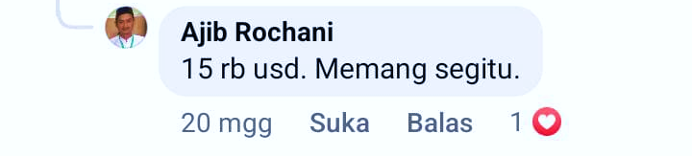
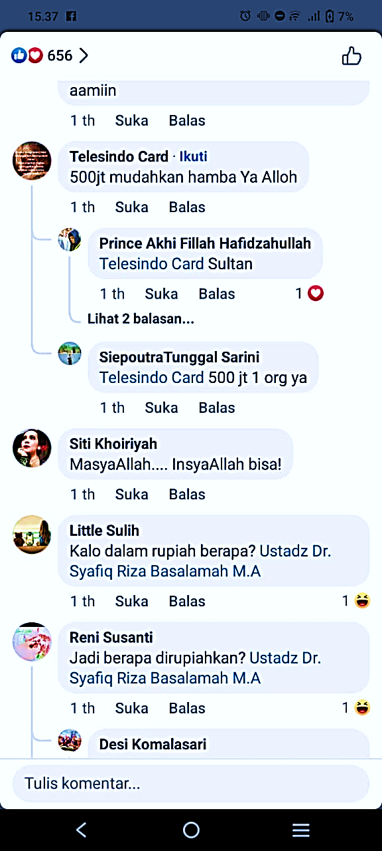
The analysis that has been carried out produced data as presented in the consumer knowledge graph. A total of 64 netizen comments were recorded indicating awareness of information related to product prices. It is known that, according to netizens, the price of the Furada Hajj product ranges from Rp. 145,000,000.00 to Rp. 500,000,000.00 in rupiah currency, and from $12,500 to $25,000 in dollar currency.
Figures 1 and 2: Captured screenshots of Facebook comments.

Basically, there is still no definite standard that can control the price of Furada Hajj. Nevertheless, the government continues to strive to respond to this issue. In 2025, the Chairman of Commission VIII of the Indonesian House of Representatives (DPR RI), Marwan Dasopang, proposed the drafting of a law regarding the cost threshold for Furada Hajj, even though the organization of Furada Hajj is entirely in the hands of the private sector. This is because, without clear cost control, it opens opportunities for unscrupulous individuals to deceive pilgrims (HIMPUH, 2025).
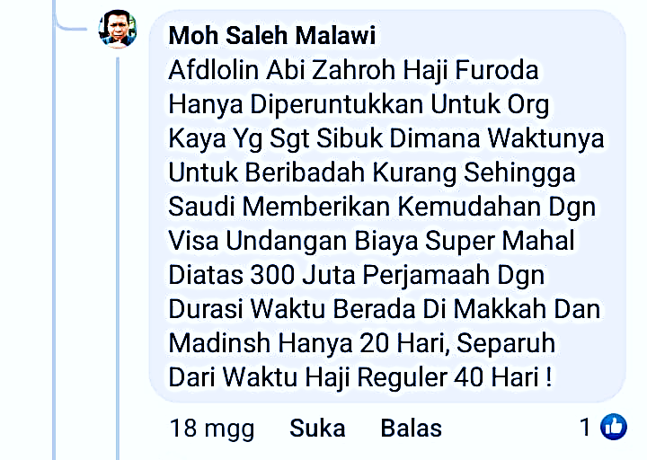


The duration of the pilgrimage using the mujamalah visa is also known by netizens to be shorter compared to the pilgrimage organized by the government. From the information revealed in Facebook comments analyzed by the researcher, the duration of Furada Hajj ranges between 16 to 24 days (Pamela, 2024)(Pamela, 2024).
Figures 3: Captured screenshots of Facebook comments.

The high level of netizens’ knowledge regarding product identity compared to other types of knowledge is because the required information is limited or intentionally made limited to create an exclusivity effect on the product (Philip & Kevin, 2016). The tension between religious authorities seeking to preserve the sanctity of the Hajj and commercial actors taking advantage of market demand creates asymmetrical information (knowledge imbalance) in Hajj service transactions (Qurashi, 2017).

    - Knowledge of Benefits


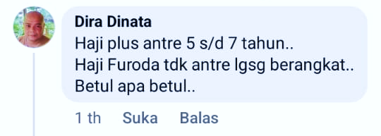
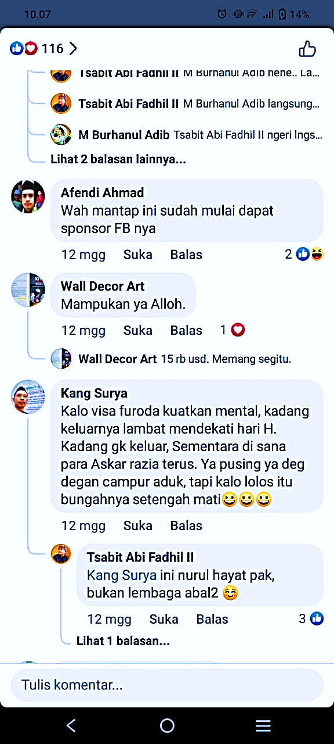
The benefits to be received from the use of the Furada Hajj product are as previously offered. Furada Hajj is a non-queue Hajj, which serves as the only fastest solution to address the waiting time problem (Farida, 2019). Netizens believe that Furada Hajj is a non-queue Hajj that carries proportional benefits and risks. With the advantages of no queue and a shorter implementation period, pilgrims must accept the reality that visa approval from the Saudi Arabian Embassy is the greatest risk they have to face, as reflected in reviews from users identified by the initials KS and DD.

Figures 4 and 5: Captured screenshots of Facebook comments.

However, the majority of them emphasize the benefits rather than disclosing the potential risks in their reviews. This is a natural occurrence, as information regarding risks is often not conveyed transparently. Meanwhile, efforts to validate such information require time, effort, and an adequate level of digital literacy. This phenomenon also occurs due to the effect of product exclusivity, which narrows the space for consumers to engage in (risk) consideration (Herdiati et al., 2021).

    - Knowledge of Satisfaction
The majority of netizens, as shown in the data presented in the graph, are already aware of the satisfaction they will gain if they use the Hajj Furada product. The researcher took a sample from one of the users with the initials L and LD, who expressed their knowledge of the satisfaction they would experience when using the Furada Hajj product, based on their personal experience.

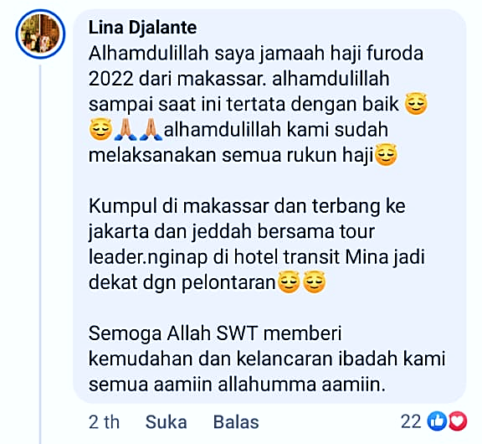
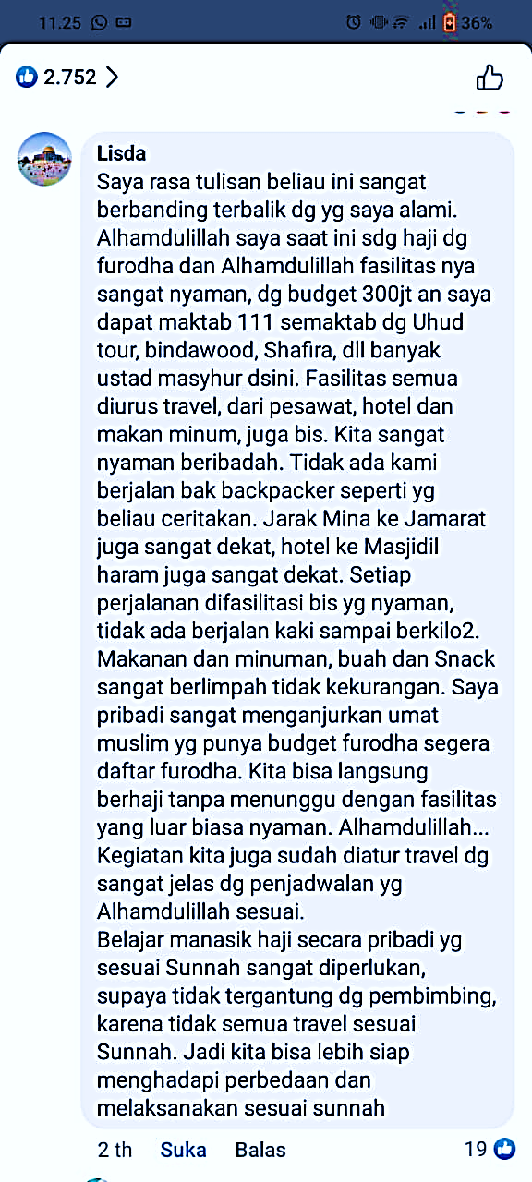
Satisfaction can be felt after consumers use the intended product. In the review, the account holder shared their experience using the Hajj Furada product and made a comparison between their perception and the actual performance of the product. This aligns with the theory of consumer satisfaction as stated by Kotler (Dewa et al., 2022).
Figures 6 and 7: Captured screenshots of Facebook comments.

Consumer knowledge of satisfaction ranks lowest among the the expressed opinions. This is suspected to be because religious consumers are less vocal in expressing complaints, as it is considered inconsistent with religious teachings, namely the value of forgiveness (Iram et al., 2023). Furthermore, overly positive expressions are instead perceived as leading toward the behavior of riya’ (showing off).

  - Knowledge of Purchase
Netizens’ knowledge of Furada Hajj, based on the analysis results, has reached the category of purchase knowledge. The information gathering regarding the purchase of the Hajj Furada product conducted by netizens meets the categories of store search and product search. Some of them even recommend travel agents they have used to other Facebook users.
Netizens’ knowledge about purchasing comes from various sources. Netizen reviews containing purchasing knowledge serve as part of the consideration material to reach a purchase decision (Mendur et al., 2021). Other reviews that attempt to promote the stores or products they use represent consumer loyalty stemming from the satisfaction that has passed through the considerations during store search, product search, and good relationships with travel services (Mointi & Sauw, 2023). The analysis results found that netizens’ knowledge regarding purchasing falls into the categories of store search and product search:

    - Searching for Stores


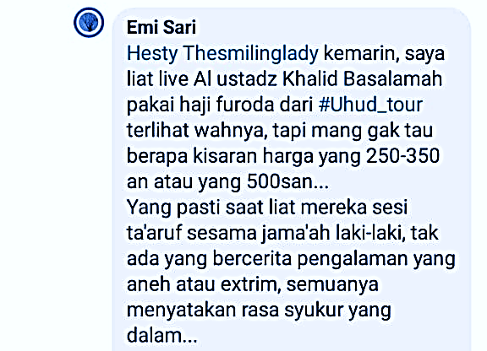
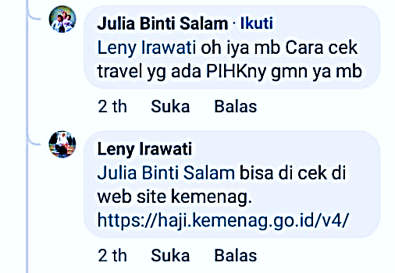
Their stores search is based on knowledge of travel agency evaluation. This knowledge naturally serves as their foundation to avoid rampant fraud. One effort made to assess a store/travel agent for Furada Hajj trips is by checking the status and operational license of a bureau/store on the official website created by the Ministry of Religious Affairs, as revealed by account holders with the initials LI and ES. This method is the easiest and is recommended by the Ministry of Religious Affairs to avoid fraud and irresponsible travel agents (Kanwil Kemenag Jawa Timur, 1970).

Figures 8 and 9: Captured screenshots of Facebook comments.

Some other netizens who know information about stores/travel agents obtain it from the experiences of close acquaintances or their digital role models, as revealed by the account holder with the initials ES two years ago. Discussions can sometimes also be utilized by business owners or individuals affiliated with the store to interact with consumers and ultimately serve as activities for marketing and introducing their stores (Rozanah & Fauzana, 2022).
This is a common phenomenon in marketing practice, where the influence of such marketing strategies on purchase decisions has been proven to be quite significant (Meilano & Hidayat, 2020). Therefore, prospective consumers must always verify the accuracy of information before using services and not solely rely on the flow of comments that may have been taken over by parties with vested interests (Hayati et al., 2023).

    - Searching for Products
Netizens conduct product searches in various ways, one of which is by searching for products at travel agencies they have previously used. For example, users with the initials NMDH and DR searched for product information at travel agencies they had used for Umrah services. In the discussions that took place, the situation was similar to the previous narrative. In this case, comment sections are sometimes exploited by interested parties to promote their stores and products in a non-aggressive manner (soft selling) by engaging in discussions to increase sales figures (Akbar et al., 2025). Therefore, prospective consumers must study product details carefully and create a list of mandatory questions as recommended by the Ministry of Religious Affairs before seeking answers in discussions.


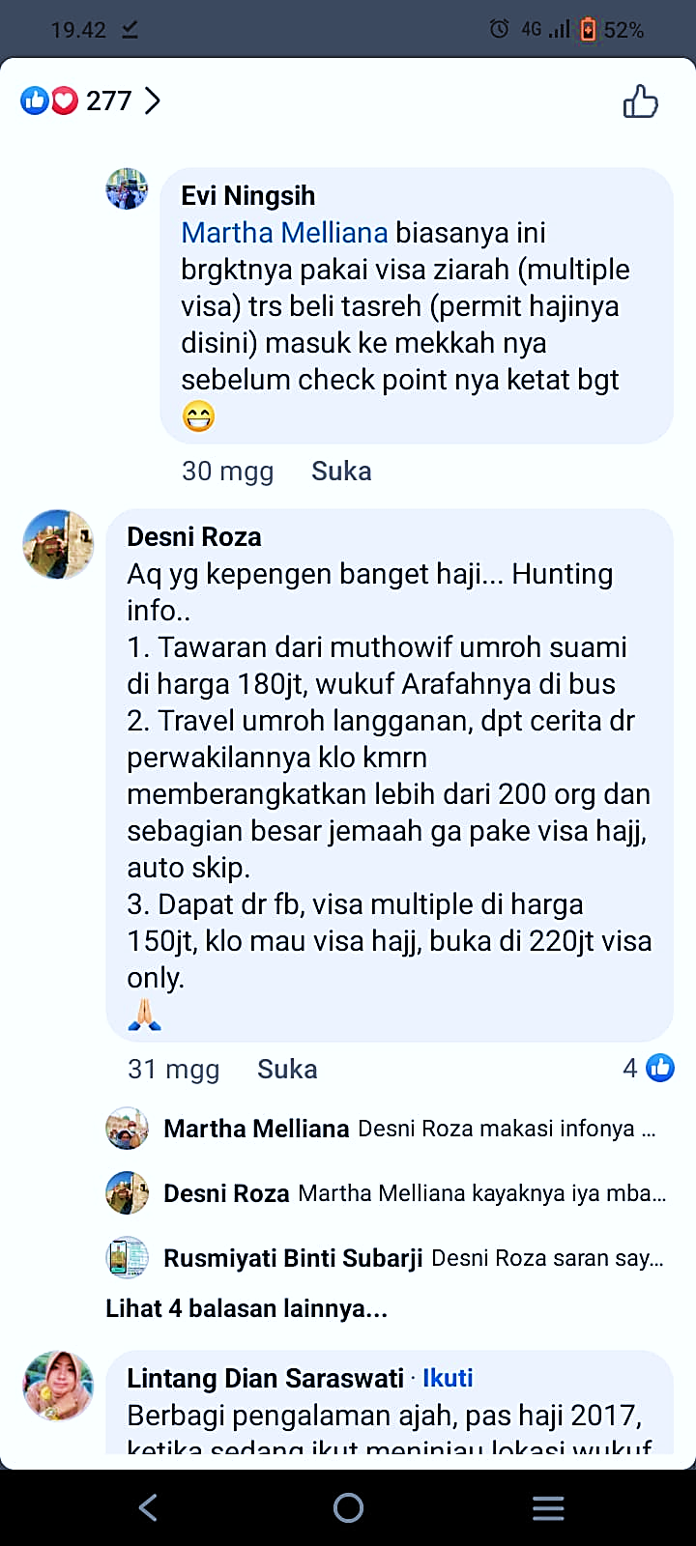
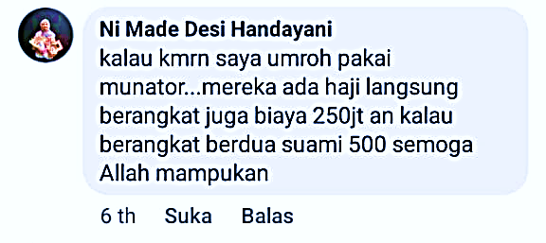
Figures 10 and 11: Captured screenshots of Facebook comments.

  - Knowledge of Usage
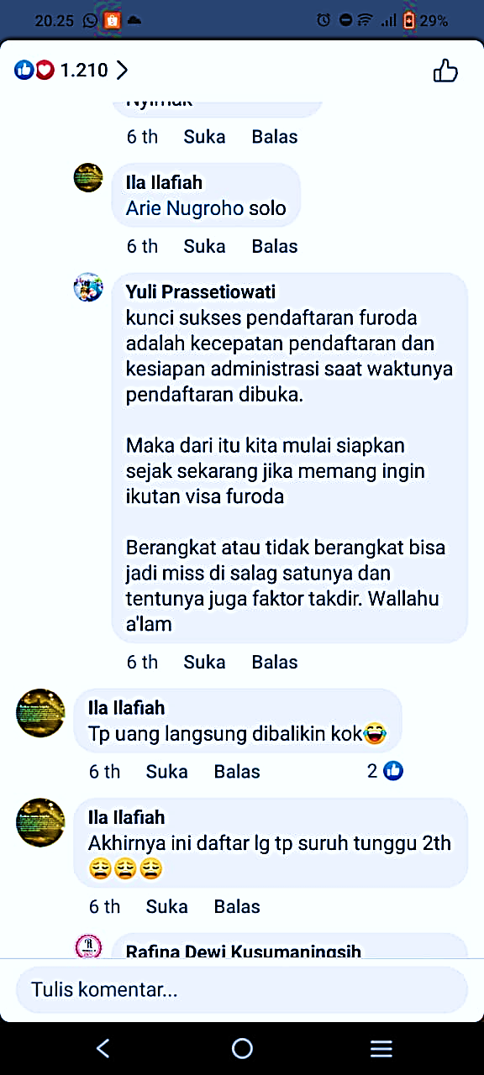
The data reveals that 47 out of 258 reviews contain knowledge about the procedures for carrying out Furada Hajj. In consumer knowledge theory, this falls under consumer knowledge about usage procedures, ranging from registration methods to tips for obtaining approval from the Saudi Arabian Embassy, as stated by the account holder with the initials YP.
Figures 12: Captured screenshots of Facebook comments.

The information related to Furada Hajj procedures held by netizens varies. This is due to the lack of valid information. Nevertheless, it does not dampen the persistence of netizens in seeking information. One of the most common approaches found among the majority of netizens is using the services of a travel agency. Through this channel, prospective pilgrims need to pay the Furada Hajj fee according to the agreed amount and facilities, while the rest from visa application, accommodation, transportation, catering, and so on will be handled by the organizing travel agency. This information is confirmed by details shared on the official HIMPUH website, stating that performing Furada Hajj must go through PIHK/travel agencies (HIMPUH, 2024) and is supported by scientific study (Farida, 2019). This kind of process was also described in more detail by the user with the initials L in the earlier discussion on satisfaction knowledge. However, differing information was also presented by the account holder with the initials JSN, who, two years ago, claimed that Furada Hajj is similar to backpacker-style hajj. According to his experience registering for Furada Hajj, many things had to be arranged independently without the involvement of a bureau.
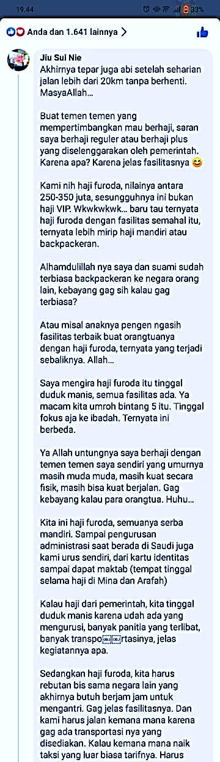
This review reveals that even when using PIHK (travel), Furada Hajj pilgrims still need to manage many necessities on their own, which does not align with the official information reported on the HIMPUH website. Therefore, it is important that before using a travel agency for Furada Hajj, prospective pilgrims carefully review the track record of the agency to avoid fraud and undesirable misunderstandings (HIMPUH, 2024).
Figures 13: Captured screenshots of Facebook comments
.
In another finding, netizens also know that the official visa used for the Furada Hajj journey is the mujamalah visa. This visa is granted based on a recommendation or invitation from the Kingdom of Saudi Arabia. However, the data also shows that netizens are aware that many travel agencies organize Furada Hajj using multiple visas, such as multiple-entry visas, ziarah (pilgrimage) visas, business visit visas, local resident visas, or amil (charity worker) visas. One such example was revealed by the account holder with the initials SG.
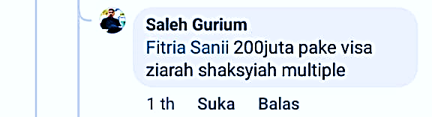
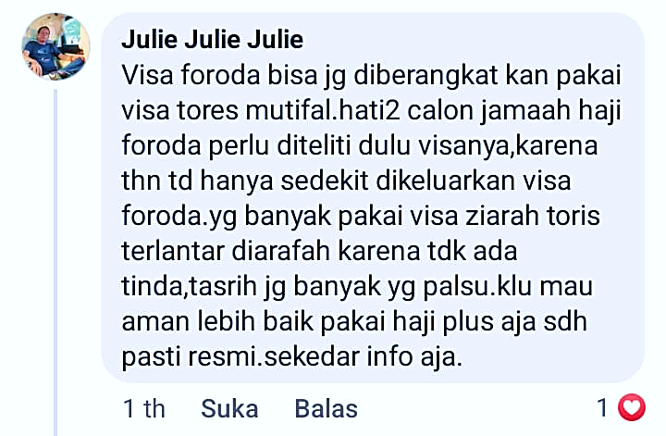
Figures 14 and 15: Captured screenshots of Facebook comments.

Some of them also normalize the use of non-Hajj visas other than the mujamalah visa. This attitude violates existing regulations. The Chairman of Commission VIII of the Indonesian House of Representatives, Ashabul Kahfi, has urged all Muslims not to use non-government Hajj visas other than the mujamalah visa for Hajj travel, as the Saudi Arabian government will impose sanctions on pilgrims who violate this rule, including a fine of 10,000 riyals and a 10-year entry ban to Saudi Arabia (DPR RI, 2024).
Several comments also confirmed the existence of travel agencies using non-Hajj visas while promising tasreh hajj, namely, a permit letter to enter Mecca and Medina (Yusra, 2024), as a form of protection from inspections by authorities, as revealed by account holders with the initials BR and EN.
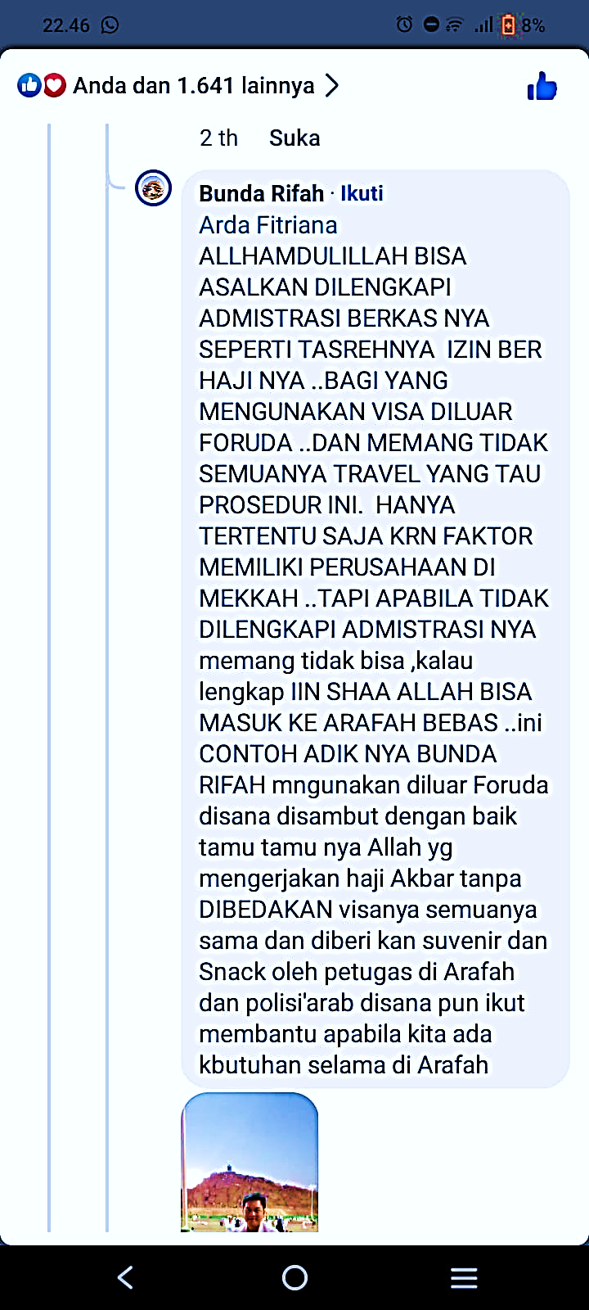
Figures 16 and 17: Captured screenshots of Facebook comments.

In this digital era, false information spreads easily, and illegal activities begin to appear normal when they are continuously campaigned and supported by the right strategies in their dissemination on social media (Kumar & Shah, 2018). Information dissemination techniques continue to evolve, driven by advances in machine learning that generate texts, videos, and audio that appear authentic and logical (Kumar & Shah, 2018). It is not a new phenomenon that illegal Furada Hajj arrangements receive little opposition in discussions. This situation will have negative consequences for the future of Furada Hajj.
Source: Data processed and analyzed using Microsoft Excel software.

CONCLUSION
From the research conducted, the data indicate that netizens’ understanding meets the criteria of product knowledge, purchase knowledge, and usage knowledge. Some netizens have fairly good information about the concept, procedures, and legality of Furada Hajj as a non-queue Hajj program using the mujamalah visa. Others understand Furada Hajj mechanisms that tend to involve legal violations, particularly regarding visa use. The discussions occurring on Facebook show that the information used by netizens comes from many sources, resulting in misconceptions about the costs, registration process, and risks that Furada Hajj pilgrims may face.

RECOMMENDATIONS
This study encourages stakeholders and the Ministry of Religious Affairs to pay attention to the discussions about Haji Furada taking place on the Facebook platform. The shift in the focus of information dissemination to other platforms has led to misconceptions among Facebook users. Meanwhile, Facebook users largely belong to the age group targeted by the Haji Furada product, and discussions continue to evolve, forming deeper forums. The researcher also hopes that the Ministry of Religious Affairs will provide educational channels and official discussion spaces on social media, This would make it easier to monitor discussions trough its official platforms and allow the Ministry to take part in technological advancements by utilizingcybersecurity system to prevent thr spread of false information. Future research should explore group and community discussions to gain a deeper understanding of netizen behavior and the spread of information being shared.

ACKNOWLEDGMENTS
I would like to express my gratitude to Prof. Dr. Moh. Fauzi, M.Ag, as the Dean of the Faculty of Da’wah and Communication at UIN Walisongo Semarang; Dr. H. Abdul Rozaq, M.S.I., as the Head of the Hajj and Umrah Management Department at UIN Walisongo Semarang; and Mustofa Hilmi, M.Sos., as the Secretary of the Hajj and Umrah Management Department at UIN Walisongo Semarang, as well as all the lecturers of the Faculty of Da’wah and Communication at UIN Walisongo Semarang, who have guided and educated me throughout my undergraduate studies in the Hajj and Umrah Management Study Program. I also extend my deepest thanks to my parents, who have continuously provided their support.

REFERENCES
Akbar, A., Universitas, S., Surabaya, N., Keluarga, S., & Jambi, B. (2025). Penerapan Teknik Soft Selling dalam Pemasaran Produk di Media Sosial terhadap Peningkatan Penjualan Produk dan Brand Awerness. Jurnal Ilmiah Universitas Batanghari Jambi, 25(1), 573–579. https://doi.org/10.33087/JIUBJ.V25I1.5219
Al-Shammari, M. (2009). Customer Knowledge Management People, Processes, and Technology. Information Science Reference.
Angga, S., Poa, A. A., & Rikardus, F. (2023). Communication Ethics of Indonesian Netizens on Social Media as a Democratic Space in the Study of Public Sphere by Jurgen Habermas. Jurnal Filsafat Indonesia, 6(3), 384–393. https://doi.org/10.23887/JFI.V6I3.59229
Ardani, W. (2022). Pengaruh Digital Marketing Terhadap Perilaku Konsumen. Jurnal Tadbir Peradaban, 2(1), 40–47. https://doi.org/10.55182/JTP.V2I1.102
Biben, R. A. (2024). Pelayanan haji furoda di travel Jannah Firdaus.
Dewa, C. B., Pradiatiningtyas, D., & Safitri, L. A. (2022). Perilaku Konsumen dan Strategi Pemasaran. Expert.
Dewan Otoritas Arab Saudi. (2005). نظام خدمة حجاج الداخل. https://laws.boe.gov.sa/BoeLaws/Laws/SearchDetails/?Query=&Id=f55f0003-8b87-4ff0-8f0f-a9a700f20578
DPR RI. (2024). Hindari Sanksi Berat Arab Saudi, Timwas Minta Jemaah Non-Visa Haji Resmi Segera Pulang. Emedia DPR RI Pusat Pemberitaan Parlemen. https://emedia.dpr.go.id/2024/06/15/hindari-sanksi-berat-arab-saudi-timwas-minta-jemaah-non-visa-haji-resmi-segera-pulang/
Engel, J. F., Blackwell, R. D., & Miniard, P. W. (1994). Perilaku Konsumen. Bina Rupa Aksara.
Eriyanto. (2021). Metode Netnografi Pendekatan Kualitatif Dalam Memahami Budaya Pengguna Media Sosial (Nur Asri (ed.)). PT Remaja Rosdakarya.
Farida, A. (2019). Penanganan Kasus Penyelenggaraan Haji Furodah (Kasus Jawa Barat). Penamas, 32(1), 635–654. https://doi.org/10.31330/PENAMAS.V32I1.305
Goebel, J. T., Susmann, M. W., Parthasarathy, S., El Gamal, H., Garrett, R. K., & Wegener, D. T. (2024). Belief-consistent information is most shared despite being the least surprising. Scientific Reports 2024 14:1, 14(1), 1–13. https://doi.org/10.1038/s41598-024-56086-2
Hayati, A. N., Araf, A., Marzuki, A., Firmanditya, N., Riset, B., & Nasional, I. (2023). ULASAN PALSU DI PLATFORM DIGITAL: PERLINDUNGAN HUKUM BAGI KONSUMEN DAN PELAKU USAHA. Masyarakat Indonesia, 49(1), 123–134. https://doi.org/10.14203/JMI.V49I1.1172
Herdiati, M. F., Iriawan, A., & Fitriyah, H. (2021). Keputusan Pembelian Produk Limited Edition: Systematic Review. Jurnal Sains Pemasaran Indonesia (Indonesian Journal of Marketing Science), 20(1), 73–87. https://doi.org/10.14710/JSPI.V20I1.73-87
HIMPUH. (2024). Mengenal Haji Furoda, Haji dengan Visa Undangan Arab Saudi dan Biaya Perjalanannya. HIMPUH. https://himpuh.or.id/blog/detail/1509/mengenal-haji-furoda-haji-dengan-visa-undangan-arab-saudi-dan-biaya-perjalanannya
HIMPUH. (2025). DPR Wacanakan Atur Batas Biaya Haji Furoda untuk Lindungi Jemaah. HIMPUH. https://himpuh.or.id/blog/detail/2159/dpr-wacanakan-atur-batas-biaya-haji-furoda-untuk-lindungi-jemaah
Iram, F., Bakar, A., & Ali, A. (2023). Silence Speaks: An Exploratory Study of Underlying Motives of Non-Complaining Customers. Pakistan Journal of Humanities and Social Sciences, 11(2). https://doi.org/10.52131/PJHSS.2023.1102.0436
JDIH. (2019). UU Nomor 8 Tahun 2019. https://peraturan.bpk.go.id/Details/106346/uu-no-8-tahun-2019
Kanwil Kemenag Jawa Timur. (1970). Daftar Resmi Penyelenggara Ibadah Haji Khusus dan Penyelenggara Umroh Provinsi Jawa Timur. https://jatim.kemenag.go.id/berita/241645/daftar-resmi-penyelenggara-ibadah-haji-khusus-dan--penyelenggara-perjalanan-ibadah-umroh-provinsi-jawa-timur
Khoeroen, M. (2023). Jemaah Haji Mujamalah Perlu Kepastian Layanan Haji di Saudi. Kemenag. https://kemenag.go.id/kolom/jemaah-haji-mujamalah-perlu-kepastian-layanan-haji-di-saudi-3FAnS
Kozinets, R. V. (2019). Netnography The Essential Guide to Qualitive Social Media Research. SAGE Publication.
Kumar, S., & Shah, N. (2018). False Information on Web and Social Media: A Survey. https://doi.org/10.1145/nnnnnnn.nnnnnnn
Linawati, M. (2022). KJRI Jeddah: Visa Mujamalah Kebijakan Kerajaan Arab Saudi - Islami Liputan6.com. Liputan6. https://www.liputan6.com/islami/read/5006304/kjri-jeddah-visa-mujamalah-kebijakan-kerajaan-arab-saudi
Maulana, R., Rizki, B., Ahlibaet, A., Putri, A., & Hafiz, A. (2024). Perbedaan Haji Furoda, Haji ONH Plus, dan Haji Regular. Rayah Al-Islam, 8(3), 1045–1063. https://doi.org/10.37274/RAIS.V8I3.1055
Meilano, Y., & Hidayat, R. (2020). Analisis Pengaruh Customer Engagement Dan Brand Trust Terhadap Keputusan Pembelian Produk Skind Aesthetic. EProceedings of Applied Science, 6(2). https://openlibrarypublications.telkomuniversity.ac.id/index.php/appliedscience/article/view/12059
Mendur, M. E. M., Tawas, H. N., & Arie, F. V. (2021). PENGARUH PERSEPSI HARGA, KUALITAS PRODUK DAN ATMOSFER TOKO TERHADAP KEPUTUSAN PEMBELIAN PADA TOKO IMMANUEL SONDER. Jurnal EMBA : Jurnal Riset Ekonomi, Manajemen, Bisnis Dan Akuntansi, 9(3), 1077–1086. https://doi.org/10.35794/EMBA.V9I3.35296
Mointi, R., & Sauw, O. (2023). Promosi Cashback, Kepuasan dan Loyalitas Pelanggan dalam Pelayanan E-Commerce (Studi Kasus Pelanggan Tokopedia). YUME : Journal of Management, 6(1), 251–259. https://doi.org/10.37531/YUM.V6I1.3547
Muhamad, N. (2024). 10 Media Sosial dengan Pengguna Terbanyak di Dunia 2023. Databoks. https://databoks.katadata.co.id/teknologi-telekomunikasi/statistik/66a749d5af300/10-media-sosial-dengan-pengguna-terbanyak-di-dunia-2023
Nabilah, S., Uin, A., & Surabaya, S. A. (2024). Efektifitas Strategi Pemasaran Digital melalui Media Sosial Studi pada Akun Instagram Mikhayla_shop. Jurnal Manajemen Dan Inovasi (MANOVA), 7(2), 39–55. https://doi.org/10.15642/MANOVA.V7I2.1583
Nurdiansyah, E., Maftuh, B., & Malihah, E. (2023). Tepung Tawar Perdamaian: Resolusi Konflik Berlandaskan Nilai-Nilai Pancasila di Sumatera Selatan. Satwika : Kajian Ilmu Budaya Dan Perubahan Sosial, 7(2), 285–294. https://doi.org/10.22219/SATWIKA.V7I2.26352
Pamela. (2024). Ini Dia Perbedaan Haji Furoda vs Haji Plus - Ajaib. https://ajaib.co.id/haji-furoda-vs-haji-plus/
Philip, K., & Kevin, K. (2016). Marketing Management. Pearson Education.
Priambodo, G., Subyanto, M., Pascasarjana, M., Undip, I. K., Erlangga, J., Vii, B., & 33 Semarang, N. (2017). Peran Komunikasi Word Of Mouth Tradisional dan Electronic Word Of Mouth Terhadap Merek. KOMUNIKOLOGI: Jurnal Ilmiah Ilmu Komunikasi, 14(1). https://doi.org/10.47007/JKOMU.V14I1.173
Qurashi, J. (2017). Commodification of Islamic Religious Tourism: from Spiritual to Touristic Experience. International Journal of Religious Tourism and Pilgrimage, 5(1), 9. https://doi.org/https://doi.org/10.21427/D7JX40
Ramadhani, S., & Azizi, F. (2018). Kamus Bahasa Arab. Cemerlang Publishing.
Ritonga, S., & Nadirah, I. (2022). Penyelesaian Sengketa Wanprestasi Oleh Travel Umroh Atas Jamaah Haji Furoda/Umroh Di Indonesia. Moralita, 3(2), 62–74.
Rozanah, H., & Fauzana, R. (2022). Interaksi pada Content Marketing TikTok @vieraoleholeh Pekanbaru. Komunikasiana: Journal of Communication Studies, 4(2), 136–150. https://doi.org/10.24014/KJCS.V4I2.25544
Sattar, A., Hasanah, H., Kunci, K., Pemahaman, T., Manasik, P., & Profesional, H. (2023). Tingkat Pengetahuan Peserta Sertifikasi Pembimbing Manasik Haji Profesional: Catatan Angkatan VI Dari Semarang. Multazam : Jurnal Manajemen Haji Dan Umrah, 3(1), 43–54. https://doi.org/10.32332/MULTAZAM.V3I1.7096
Siebert, J., & Siebert, J. U. (2023). Effective mitigation of the belief perseverance bias after the retraction of misinformation: Awareness training and counter-speech. PLOS ONE, 18(3), e0282202. https://doi.org/10.1371/JOURNAL.PONE.0282202
Suherli, E. (2025). Eksklusif, Ketum IPHI Erman Suparno: Haji Furoda Tidak Mendidik dan Mengekspos Ketidakadilan. VOI. https://voi.id/en/interviu/468904
Susanti, N., & AlFurqan. (2022). Analisis Dampak Penggunaan Media Sosial Facebook terhadap Akhlak Ibu-Ibu Rumah Tangga di Kampung Durian Kandang | AS-SABIQUN. 4(5). https://ejournal.stitpn.ac.id/index.php/assabiqun/article/view/2260
Wulandari, B. F. (2023). Gelar Haji Sebagai Stratifikasi Sosial Pada Masyarakat. Jurnal Ilmiah Sosiologi Agama (JISA), 6(1), 1–18. https://doi.org/10.30829/JISA.V6I1.12962
Yusra, H. (2024). Kedudukan Tasrih Haji dan Korelasinya dengan Syarat Wajib dan Mabrur Haji. Islamika : Jurnal Ilmu-Ilmu Keislaman, 24(1), 124–142. https://doi.org/10.32939/ISLAMIKA.V24I1.4031

