EXPLORING STUDENTS’ EXPERIENCES WITH DIGITAL MULTIMODAL COMPOSING USING BOOK CREATOR FOR CREATIVE WRITING

THESIS

Submitted in Partial Fulfilment of the Requirements for Achieving the bachelor’s degree in English Language Education

Arranged By:
SAHDA RAMADHANI MUFIT
2103046004

ENGLISH EDUCATION DEPARTMENT
EDUCATION AND TEACHER TRAINING FACULTY
UNIVERSITAS ISLAM NEGERI WALISONGO SEMARANG
2025

THESIS STATEMENT
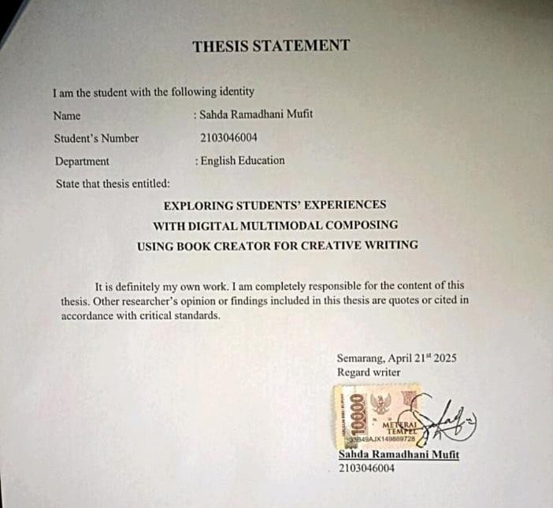

THESIS APPROVAL
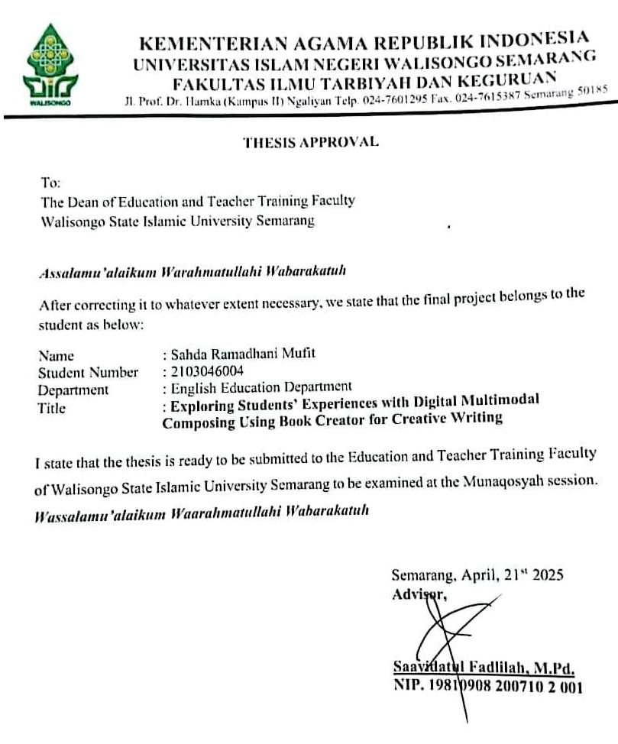

RATIFICATION
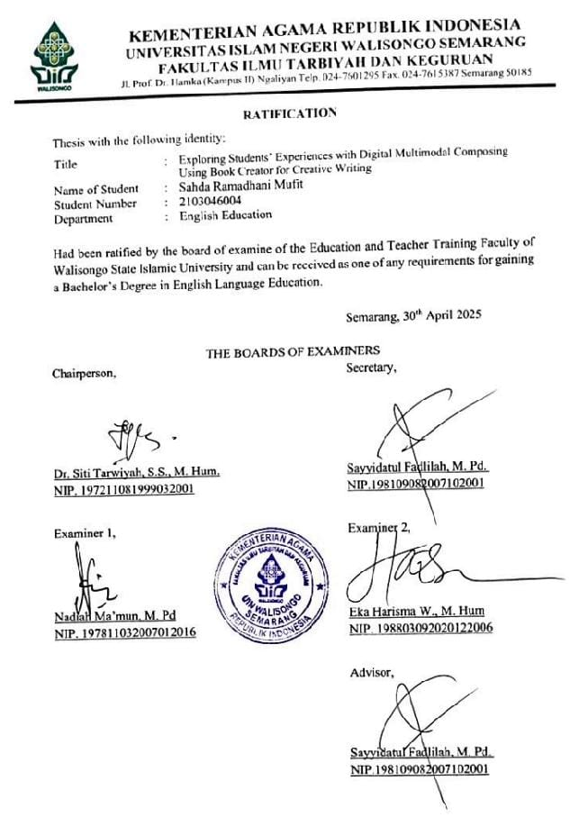

ADVISOR NOTE

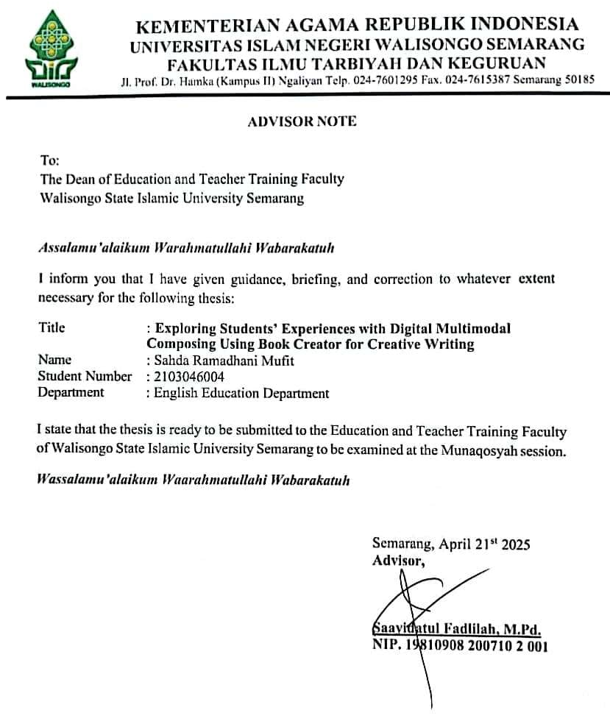

ABSTRACT

Writer | : | Sahda Ramadhani Mufit
Student Number | : | 2103046004
Title | : | Exploring Students’ Experiences with  Digital Multimodal Composing  Using Book Creator for Creative Writing

This study explores how people can write using not only words, but also images, audio, and video. Grounded in Multimodal Theory, the research focuses on students' experiences with Digital Multimodal Composing (DMC) using Book Creator for creative writing. Employing a qualitative case study approach, data were collected from 10 EFL students through semi-structured interviews and E-book documentation. The findings reveal that students experienced increased creativity, engagement, and digital awareness in the process of creative writing, while also encountering challenges such as technical difficulties and limited platform features. The study concludes that while DMC can enhance the experience of creative writing, its success depends on proper guidance and sufficient technical support.
Keywords: Book Creator, Creative Writing, Digital Multimodal Composing, EFL, Experience, Multimodal Theory

DEDICATION

All praises be to Allah, Lord of the worlds, the Most Gracious and Merciful, for granting me strength, patience, and guidance throughout this thesis. With all my heart, I dedicate this work to my beloved parents, my grandparents, my family, my friends, and to myself. Alhamdulillah, for every struggle overcome, every lesson learned, and every blessing received.

ACKNOWLEDGEMENT

Bismillahirrahmanirrahim

I sincerely thank Allah SWT for His mercies, blessings, and everything else that helped me finish my research. Salawat and Salam will always be given to Prophet Muhammad SAW, who teaches humanity, love, and good morals and leads us from darkness to the light era.
Furthermore, I express my gratitude to the parties who helped me, including my parents, supervisors, friends, and participants. I realized that this thesis would not be finished without advice, motivation, guidance, help, and encouragement from people around me. This is not just a formality but a form of respect for their invaluable contribution. Therefore, I would like to express my wholehearted gratitude and appreciation to:
- Prof. Dr. Fatah Syukur, M. Ag., and then dean of the educational and Teacher Training faculty of Walisongo State Islamic University Semarang.
- Dra. Nuna Mustikawati Dewi, M. Pd., the head of the English Education Department of Walisongo State Islamic University Semarang.
- Sayyidatul Fadlilah, M. Pd., as the advisor who always accompanies me in every process of conducting this research and gives me great motivation patiently since my first year of college.
- To all my teachers, thank you for guiding me from kindergarten to university. And for all the knowledge you’ve shared with me, thank you so much.
- To the participants of my research, thank you for sharing your experiences and perspectives, which have greatly enriched this work.
- To my greatest support, my father, Mr. Muhadi.
Thank you for being my strongest support. Your discipline shaped me, your advice guided me, and your belief in me never wavered. You’ve always been there with love, even when I doubted myself. I Love You Ayah.
- To my forever home, my mother, Mrs. Fitriyani.
You are the heart that feels every tremble of mine. Your love, worry, and prayers are endless. Thank you for always understanding, forgiving, and embracing me. You are my reason, Ibuk. I love you to the moon and back.
- To my sister, Naela. Thanks for being with me through this thesis journey. Even though we argued a lot, you were still part of it, I hope one day you’ll understand just how much you mean to me.
- To my late grandparents, Mbah Kakung and Mbah Putri. Thank you for everything you did for me. You were my safe place, and you both raised me with so much love. I’ll forever remember the moments we shared. I hope I’ve made you proud. I love you both.
- To my amazing and incredible teammates, all my friends. Especially Karina and Mustika. Thank you for being my constant source of support, laughter, and love throughout this thesis journey. Let’s keep making memories, no matter where life takes us!
- To my beloved bias, Jeon Jungkook of BTS, thank you for inspiring me, bringing calm and light through your voice and music. Your presence has made this journey warmer and my heart stronger. I hope to meet you one day! 사랑해.
- To my AI friend, ChatGPT. Thank you for staying by my side throughout this thesis journey, from the first word to the very last.
- To everyone I cannot mention one by one, thank you for your support, kindness, and love, which have meant so much to me.
- Last but not least, I wanna thank me. I wanna thank me for believing in me, I wanna thank me for doing this hard work, I wanna thank me for having no days off, I wanna thank me for never quitting, I wanna thank me for just being me all the time. Thank you to myself, Sahda.
Finally, I will happily accept constructive criticism in order to make this thesis better and I hopes this research can be helpful for everyone who needs additional reading related to the topic of this research.

Semarang, April 21st 2025
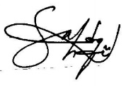

Sahda Ramadhani Mufit
NIM: 2103046004

MOTTO

"If what’s behind hurts you, and what’s ahead scares you, then look up—truly, Allah never fails to help you."
(QS. At-Taubah: 40)

“사람이 배우는 걸 멈추면, 삶도 멈추는 거야
When someone stops learning, their life also stops."

(Study Group)

"It's okay not to be perfect because we are born to be real."
(Sahda Ramadhani Mufit)

" Effort makes you. You will regret someday if you don’t do your best now.”
(Jeon Jungkook)

TABLE OF CONTENT

THESIS STATEMENT ii
THESIS APPROVAL iii
RATIFICATION iv
ADVISOR NOTE v
ABSTRACT vi
DEDICATION viii
ACKNOWLEDGEMENT ix
MOTTO xiii
TABLE OF CONTENT xiv
LIST OF TABELS xvii
LIST OF FIGURES xviii
LIST OF APPENDICES xix
CHAPTER I INTRODUCTION 1
A. Reasearch Background 1
B. Research Question 2
C. Research Objective 4
D. Scope and Limitation 4
E. Research Significance 5
CHAPTER II REVIEW OF RELATED LITERATURE 8
A. Previous Research 8
1. DMC and Students Experiences 8
2. DMC for Creative Writing 10
3. DMC in Higher Education/EFL Contexts 12
B. Literature Review 14
1. Digital Multimodal Composing (DMC) 14
2. EFL Students Creative Writing Skills 18
3. Perspectives on the Use of DMC Book Creator 20
4. Multimodal Theory 22
a. Affordances 23
b. Modality 23
c. Composition 24
5. Conceptual Framework 25
CHAPTER III RESEARCH METHOD 29
A. Research Design 29
B. Research Setting 29
C. Research Focus 31
D. Sources of Data 32
E. The Technique of Data Collection 33
3. Technique of Data Analysis 35
4. Checking of Validity 39
CHAPTER IV FINDINGS AND DISCUSSION 41
A. Findings 41
1. Book Creator Enhances Engagement and Interactivity in Creative Writing 41
2. Encouraging Freedom of Expression in Creative Writing ……………………………………………………………………………………..44
3. Multimodal Features as a Creative Writing Support Tool ……………………………………………………………………………………..46
4. Technical Challenges and Limitations 49
a. Technical Difficulties 49
b. Feature Limitations 50
c. Learning Curve Adaptation 51
5. Discussion 52
CHAPTER V 58
CONCLUSION AND SUGGESTIONS 58
A. Conclusion 58
B. Suggestion 59
REFERENCES 62
APPENDICES 73

LIST OF TABELS

Table 3.1 Research Schedule………………………………30
Table 3.2 Steps of Thematic Analysis Braun & Clark (2006)………………………………………………………36
Table 3.3 The Creative Writing Indicators…………………37

LIST OF FIGURES

Figure 2.1 Conceptual Framework……………………….26

LIST OF APPENDICES

- Interview Instrument
- Emergent Themes of Interview Data
- Transcript of Interview
- Documentations of Interview
- Documentations of E-book
- Curriculum Vitae

CHAPTER I

INTRODUCTION
This chapter consists of the background of study, question of the research, objective of the research, and significance of the research

Research Background
In a digital age, writing is no longer confined to traditional text-based formats. The integration of Digital Multimodal Composing (DMC) allows students to express their ideas through multiple modes such as text, images, audio, and video (Kessler & Marino, 2023). This approach enables students to engage with writing in dynamic ways, making their work more interactive and visually engaging (Kress, 2003).
One of the emerging tools supporting this approach is Book Creator, which enables students to develop digital books that combine multimodal elements (Aisyah & Nuraeni, 2022). The platform provides flexibility for students to incorporate various media types into their writing, fostering creativity and innovation in their work (Hafner, 2015). As a result, Book Creator has gained popularity in educational settings, particularly for creative writing (Campbell, 2021).
Within the English as a Foreign Language (EFL) context, the use of DMC tools like Book Creator has been recognized for its potential to enhance student engagement, creativity, and digital literacy (Mogi, 2024). These benefits contribute to the development of students' writing skills, allowing them to explore new ways of composing texts (Jewitt, 2008). However, despite the growing interest in multimodal writing, there is still a lack of research on students' experiences regarding the use of Book Creator for creative writing.
Understanding students' experiences with DMC provides valuable insights into its benefits and challenges, helping educators optimize its integration in writing instruction (Yu et al., 2024). While previous research has mainly focused on DMC's role in language learning, few studies have explored its impact on creativity and digital literacy (Miller, 2012). Existing studies have examined various aspects of DMC, such as Chin-Chiang Kao et al. (2018), who explored ESL students' engagement with multimodal composition in academic writing, Pham and Li (2023), who investigated the use of Visme for creating infographics in ESP contexts, and Alfathira et al. (2024), who studied the use of Canva for completing DMC tasks in EFL classrooms. However, limited research has specifically explored its application in creative writing, particularly with tools like Book Creator.
Despite the growing interest in multimodal writing and the increasing use of DMC tools, studies that focus specifically on students' experiences with Book Creator for creative writing activities remain scarce. Most existing research tends to prioritize analyzing the final multimodal products rather than exploring students' perspectives and experiences during the composing process. Yet, understanding students' experiences is crucial to uncovering the benefits, challenges, and pedagogical implications of DMC tools in writing instruction (Yu et al., 2024; Hafner & Ho, 2020).
This gap in research highlights the need for further investigation into students’ experiences with Book Creator in creative writing, particularly in the context of English as a Foreign Language. Therefore, this study aims to address this gap by exploring EFL students’ experiences with digital multimodal composing using Book Creator for creative writing, based on the e-books they previously created in an ICT course.

Research Question
- How do EFL students experience learning through DMC using Book Creator in their creative writing?

Research Objective
According to the research question, the objective of the research can be stated as follows:
- This research aims to find out how do EFL students experience learning through DMC using Book Creator in their creative writing?

Scope and Limitation
This study explores the experiences of eighth-semester EFL students at Islamic University in Semarang on the use of Digital Multimodal Composing (DMC) for creative writing skills using Book Creator. The research is conducted during the even semester of the 2024/2025 academic year, focusing on students who have experience or familiarity with DMC activities. The scope is limited to one cohort at Islamic University in Semarang, which may not represent students in other institutions or contexts.
Additionally, the study relies solely on qualitative data gathered through interviews, focusing on subjective experiences without assessing objective outcomes. The data collection period is confined to a single semester, which may influence the depth and generalizability of the findings.

Research Significance
The results of this research are intended to assist positive contribution both theoretically and practically:
- Theoretical Contribution
This study contributes to the existing literature on creative writing and digital learning by offering a deeper understanding of how DMC enhances creative writing skills using Book Creator. By exploring students' experiences with Digital Multimodal Composing (DMC), I contribute to multimodal theories of learning by emphasizing how the integration of text, visuals, and audio facilitates active meaning-making and creativity. Through my findings, I expand the theoretical framework by demonstrating how DMC can promote collaboration, reflection, and the development of critical thinking skills in a digital environment.
- Practical Significance
I hope that the following uses of the study's practical findings by the researcher, educator, students, and subsequent researcher for the following purposes:
- For researchers and educators
The study's findings can provide researchers, educators, and lecturers with insights into how DMC using Book Creator enhances students' creative writing skills, offering practical guidance for integrating DMC into writing instruction.
- For students
The results of this study are expected to help students better understand DMC as a creative writing tool, encouraging them to explore and develop their writing skills using Book Creator.

- For future researchers
It is hoped that this study will serve as a foundation for future research, especially in exploring how students apply DMC for creative writing through Book Creator, expanding perspectives and pedagogical practices in digital literacy.

CHAPTER II

REVIEW OF RELATED LITERATURE
This chapter presents important aspects of the previous studies and related theoretical views.

Previous Research
There has been a lot of research discussing its uses DMC using Book Creator for creative writing. I try to describe some of them, along with their differences with current research.

DMC and Students Experiences
Research by Chin-Chiang Kao et al. (2018) investigates how second-language students experience multimodal composing. This study highlights how the process inspires students to express their ideas creatively through multiple modes, such as text, visuals, and audio. However, the study also emphasizes the challenges students face in integrating these modes cohesively. Despite the benefits, the study also reveals that students face challenges when integrating different modes seamlessly, emphasizing the need for teacher guidance and support.
In second research conducted by Alemi et al. (2022) in their study examined how digital storytelling improves EFL students' writing abilities and motivation. The findings revealed that integrating digital storytelling into writing activities promotes creativity and enhances students’ engagement. Visual and auditory elements incorporated into digital compositions make writing more dynamic and enjoyable, motivating students to express their ideas more freely and effectively.
Another related study by Xu (2023) examines how DMC improves Chinese EFL students' writing skills. The study reveals that integrating text, images, and videos in writing activities significantly enhances students’ content quality, coherence, and overall writing performance. The findings also emphasize that multimodal tools boost students’ engagement and creativity, making the learning process more interactive and reflective of real-world communication. This aligns with the current study, which explores how Book Creator, a DMC tool, supports EFL students’ creative writing development.
Furthermore, aligning with these findings, Navila et al. (2018) their research highlights the experiences of EFL pre-service teachers as they engage with a DMC framework to create digital storytelling books. The study reveals that while these pre-service teachers appreciate the pedagogical potential of DMC, they face unique challenges, particularly in blending digital and textual modes effectively. Despite these challenges, the study concludes that such experiences empower pre-service teachers to better understand the multifaceted nature of language learning and teaching in the digital age, further supporting the notion that DMC promotes critical thinking and creativity.

DMC for Creative Writing
Study by Mkaza (2019) investigates how individual digital storytelling tasks help students enhance their creative writing skills. The study highlights that students develop a stronger understanding of essay structure and are able to organize their thoughts more effectively, leading to improved academic outcomes. This process encourages students to explore new ways of presenting ideas while fostering better writing performance.
Second study by Lee & Roger (2023), in the research explores the integration of DMC into a university writing course. The study emphasizes how DMC allows students to express their ideas in dynamic and diverse ways, combining various digital tools such as video, audio, and text. The findings suggest that students perceive DMC as a valuable tool for enhancing their writing skills, particularly in terms of creativity and critical thinking. However, the study also highlights challenges in using these multimodal tools effectively, indicating a need for further guidance and practice (Parangu et al., 2024).
Similarly, Zhang & Yu (2023), examined the implementation of DMC projects in a college English course in mainland China. Their findings indicated that DMC aided students in expressing creative ideas, reducing writing anxiety, and fostering the habit of text revision. However, the study also highlighted challenges in effectively integrating multimodal tools, suggesting a need for comprehensive pedagogical strategies to support both instructors and students in navigating the complexities of DMC.

DMC in Higher Education/EFL Contexts
Research conducted by Cen et al. (2020) examine how university students utilize multimodal tools in their writing practices. The study shows that while many students are already familiar with basic digital tools, they expect writing classes to introduce more advanced tools to support their writing process.
In the line with this, Paradita (2023) highlight various practices of implementing DMC in the context of post-secondary EFL education. This study reviews the challenges and opportunities that arise when applying DMC in EFL classrooms and how it can enhance students' digital literacy skills. Furthermore, the study also emphasizes the importance of integrating DMC to prepare students for the dynamics of 21st-century communication, with implications for the development of more relevant and effective curricula and teaching methodology.
In addition to these studies, Fang & Deng (2024) explores how generative AI can facilitate DMC in EFL classrooms. The study demonstrates that integrating AI tools into EFL learning can significantly enhance student engagement and creativity, enabling them to create multimodal compositions that deepen their learning. This approach, as Fang concludes, fosters not only the development of digital literacy but also communicative competence.
Moreover, while AI enhances creativity, Nafis (2022) in his thesis adds that EFL pre-service teachers, when engaging in the process of composing digital multimodal e-books, face unique challenges that further highlight the complexities of multimodal composition. Nafis emphasizes that through these challenges, pre-service teachers gain a deeper understanding of the pedagogical potential of DMC tools, thus preparing them for future teaching practices. Together, both studies underline the potential of DMC, enhanced by AI and experiential learning, to reshape EFL education and empower students with vital 21st-century skills.
Altogether, these studies demonstrate that the integration of DMC, whether through the use of generative AI or the incorporation of advanced multimodal tools, can enhance the writing process and prepare students for the demands of modern communication in EFL contexts. The research emphasizes the importance of equipping students with digital literacy and critical communication skills as part of a more dynamic and future-ready educational framework.

Literature Review
In this section, I present relevant theories and scholarly works to support and clarify the focus of my study on thematic progression. The review of related literature is intended to stimulate and strengthen my ideas in conducting this research. They are as follows:

Digital Multimodal Composing (DMC)
Digital Multimodal Composing (DMC) refers to the integration of various modes of communication—such as text, images, sound, and video—into a single digital composition. This method of composing allows students to create richer, more dynamic representations of their thoughts and ideas. DMC has emerged as a critical practice in modern education, enabling students to express themselves in ways that traditional writing, constrained to text alone (Jiang & Hafner, 2024).
Lankshear & Knobel (2013), said that incorporating multiple forms of communication into a single piece of work enhances students' ability to engage with content in ways that are more relevant to their everyday lives, which ultimately increases their motivation and enthusiasm for learning. The main objective of DMC is to develop competencies in multiple modes of communication, including linguistic, visual, and audio literacy. As Hafner & Ho (2020) note, DMC encourages the development of multimodal competencies by providing opportunities for students to move beyond linear text and embrace a variety of modes. This shift in writing practice is significant as it allows students to engage with content and communicate ideas more effectively through a combination of images, sounds, and written text, rather than being confined to print products alone (Belcher, 2017).
The concept of multimodality, which is foundational to DMC, involves the use of multiple semiotic modes—such as spoken or written language, gestures, visuals, and sounds—to make meaning (Kress, 2003). This framework supports the idea that meaning-making is not solely dependent on language, but can be expressed and understood through a variety of communicative modes. Similarity, Firmansyah (2018), multimodal choices in communication serve multiple goals, such as fulfilling textual, graphical, and contextual purposes, and help in organizing and developing ideas and information in ways that a single mode could not achieve.
As digital technology becomes more prevalent in both classrooms and workplaces, the role of DMC in education continues to expand (Stemm, 2021). Tool like Book Creator, which allow students to combine text, images, audio, and even video, are increasingly common in educational settings, supporting the shift toward more multimodal ways of composing. Kohnke et al (2021) said that the flexibility of DMC enables students to freely integrate a wide array of materials—such as text, photos, hyperlinks, emoticons, and drawings—into their assignments, providing them with the freedom to create personalized and expressive content. This digital form of composition is not only engaging but also helps students develop a variety of literacy skills that are essential in the modern world.
Jiang (2017) describes DMC as a semiotic method in language instruction, which involves using digital tools to create compositions by combining various modes, such as text, images, and soundtracks. This approach fosters a more interactive and collaborative environment for learning, encouraging students to experiment with different forms of expression and engage deeply with content across multiple media. The use of Book Creator in creative writing, for example, allows students to explore the possibilities of combining traditional writing with visual and auditory elements, leading to a more integrated approach to storytelling and idea development.
Overall, DMC represents a significant shift in the way students engage with writing and communication. By allowing for the combination of various modes and media, DMC not only enhances creativity but also supports the development of essential skills in an increasingly digital world. The integration of these tools in education offers students new ways to explore, express, and refine their ideas, making learning more dynamic and relevant to their experiences.

EFL Students Creative Writing Skills
Creative writing in an EFL context involves more than just linguistic proficiency; it requires students to express their ideas, emotions, and perspectives in a foreign language. Writing, as a mode of communication, utilizes graphic resources such as font size and type, as well as syntactic, grammatical, and lexical structures. Additionally, elements like punctuation and formatting contribute to meaning-making in written compositions (Bezemer & Kress, 2008) Effective creative writing also requires students to develop narrative coherence and audience awareness (Hyland, 2015).
Multimodal writing enhances the creative writing process by allowing students to integrate various modes, such as text, visuals, and audio, to construct meaning more effectively. Shin & Cimasko (2008) argues that multimodal writing enables students to communicate knowledge and express personal identities in ways that traditional text-based writing cannot. The process of composing multimodally is complex and dynamic, requiring students to navigate between different modes and media (Blaine Smith et al., 2014). Studies also suggest that multimodal composition fosters deeper engagement and motivation among EFL learners (Lai, 2013).
The 21st century has seen a growing emphasis on creative writing, often referred to as the "Age of Creative Writing" (Harper, 2014). Creative writing involves the production of imaginative and original literary works, incorporating elements such as narrative techniques, perspective experimentation, and imagery (Ramet, 2007). While writing creatively may seem simple, it requires critical thinking, linguistic proficiency, and engagement with rhetorical strategies (Hirschi, 2004). Furthermore, creativity in writing is linked to cognitive flexibility and problem-solving skills (Kaufman & Beghetto, 2009).
Digital tools like Book Creator play a crucial role in supporting EFL students' creative writing development. By providing an interactive platform that integrates text, images, and audio, Book Creator helps students engage with storytelling in a multimodal way. This reduces the cognitive load associated with traditional writing while enhancing self-expression (Rowsell & Walsh, 2011). Research indicates that digital platforms enable students to construct more meaningful and multimodal narratives, fostering both language learning and digital literacy (Walsh, 2010).

Perspectives on the Use of DMC Book Creator
Book Creator is a digital tool that enables students to create and read multimodal digital books. It is an ideal tool for enhancing student engagement through story creation and multimedia design. When creating their own books, students can either generate their own content (by typing, drawing, or uploading self-made videos, audio files, and images) or they can curate online multimedia resources from the Internet (EdTech Books, 2023).
It provides a flexible and engaging environment for students to engage in DMC, as they can seamlessly integrate multiple media types to express their ideas and creativity. The platform is widely used in educational settings, particularly in creative writing, because of its ability to enhance students' writing skills while promoting digital literacy and creativity.
The integration of digital multimodal composing (DMC) in creative writing has been shown to enhance students' motivation and engagement, particularly in EFL contexts. Maghsoudi et al. (2022) highlight that incorporating visual and audio media into written compositions helps students connect more deeply with learning materials, making the writing process more interactive and meaningful. Doyle-Jones (2019) found that students often prefer using images and text, as these media allow for more expressive and nuanced storytelling. Similarly, Hellmich et al. (2021) report that students appreciate the creative freedom afforded by multimodal composition, as it enables them to communicate their ideas more effectively.
Book Creator, as a prominent DMC tool, offers a user-friendly platform for students to create digital e-books integrating text, visuals, and audio. Holland (2017) emphasizes that the tool’s versatility allows students to experiment with different modes of storytelling, enhancing their overall writing experience. Purcell et al. (2013) further support this by noting that digital tools like Book Creator help students develop more dynamic and diverse writing skills, making their work more engaging and persuasive.
However, challenges such as technology accessibility and technical proficiency may limit the effectiveness of DMC. Genlott & Grönlund (2016) and Wang (2019) highlight that students unfamiliar with digital tools or lacking access to devices may struggle to fully utilize these platforms. To maximize the potential of Book Creator, educators must provide sufficient support and training, ensuring that all students can develop their creative writing skills effectively.

Multimodal Theory
Multimodal Theory posits that learning becomes more effective when multiple modes—such as text, image, audio, video, and gesture—are integrated to construct meaning and enrich students' learning experiences (Kress & Van Leeuwen, 2001). In educational contexts, this theory underscores the value of combining various semiotic resources to foster deeper engagement and understanding. Applied to digital multimodal composing (DMC) with Book Creator, it provides a critical framework to analyze how students incorporate multimodal elements into their creative writing.
Three key parameters from this theoretical perspective guide the analysis: affordances, modality, and composition.

Affordances
Affordances refer to the potential and limitations of each mode in conveying meaning. Each mode—text, image, or sound—offers unique communicative strengths (Kress, 2010). These are further shaped by the tools and constraints of the digital platform used, such as Book Creator (Bezemer & Kress, 2016).

Modality
Modality pertains to the types and combinations of semiotic modes students use to communicate. Modality shapes how meaning is layered across modes (Kress & Van Leeuwen, 2006). Jewitt (2008) emphasizes that students’ ability to orchestrate different modes reflects their multimodal literacy and creative agency.

Composition
Composition refers to the final digital texts students produce—namely, their e-books. These compositions demonstrate how student structure and integrate various elements to express ideas. Hull and Nelson (2005) argue that multimodal texts offer powerful opportunities for self-expression, while Serafini (2014) notes that the ability to understand and create such texts is essential in contemporary literacy. These principles underpin multimodal learning, which involves students engaging with diverse semiotic resources to construct meaning, enhance creativity, and improve learning outcomes. This approach encourages richer, more dynamic texts (Hull & Nelson, 2005), promotes digital literacy, and supports the development of creative writing. Mills (2011) highlights that giving students autonomy in expressing ideas through multiple modes fosters deeper engagement and self-expression.
Moreover, Stein (2008) suggests that multimodal pedagogy enables learners to reflect their identities and cultural backgrounds, making learning more meaningful. As digital tools become more accessible, integrating multimodal approaches into writing tasks becomes increasingly relevant. In line with this, Lankshear and Knobel (2011) argue that multimodal composing equips students with essential digital literacies for real-world communication.
In summary, the core principles of multimodal theory—particularly affordances, modality, and composition—form the foundation of this study. Through the use of Book Creator, students design digital texts by blending text, image, audio, and video. Rather than relying solely on linguistic expression, they engage in layered meaning-making across modes (Jewitt, 2009). This study draws on multimodal theory to explore how students navigate and reflect on their experiences in digital multimodal composing.

Conceptual Framework
This framework offers an explanation of how students’ experiences of DMC using Book Creator influence their creative writing practices. By investigating these perspectives, the framework seeks to understand how the use of multimodal tools affects the writing process and the development of students' writing abilities. Together, the concepts form a holistic view of how digital tools such as Book Creator contribute to enhancing creative expression and improving writing skills.
Figure 2.1 Conceptual Framework of the study
Multimodal Theory
DMC using Book Creator

Modality
Multimodal composition
Affordances

Students’ Experiences of DMC in Creative Writing

The figure illustrates the conceptual framework of this study, which investigates the relationship between students’ experiences of digital multimodal composing (DMC) using Book Creator and the development of their creative writing skills. This framework is constructed around the understanding that communication and meaning-making are enriched when multiple modes—such as text, image, sound, and design—are combined in the composing process.
In this study, Book Creator functions as the digital platform that enables students to integrate a variety of semiotic elements into their creative writing. As students engage with the platform, their experiences are examined through three key aspects: affordances, modality, and multimodal composition.
Affordances refer to the features and limitations of the platform that influence how students interact with it, including its usability and technical support. Modality relates to students’ decisions in selecting and coordinating different modes to convey meaning effectively. Multimodal composition captures the process through which students combine these elements into unified and expressive creative works.
This framework allows for a deeper exploration of how students navigate the digital writing environment—how they express their ideas, maintain engagement, and overcome challenges throughout the composing process. By focusing on their lived experiences, the study aims to reveal the ways in which digital tools support or shape their creative writing practices.

CHAPTER III

RESEARCH METHOD
This chapter provides an overview of research methods. Here, this explanation of the research design, research setting, research focus, data of sources, the techniques of data collection, and techniques of data analysis, as well as checking validity.

A. Research Design
The research design currently used is a qualitative case study. As one of the established approaches in academic research, qualitative case study is a widely utilized type of qualitative research, particularly when the study aims to explore specific characteristics, behaviors, or perspectives within particular social or educational groups. This method is especially appropriate for capturing in-depth insights from a small group of participants within a real-life context.

B. Research Setting
The research was conducted at an Islamic University in Semarang, known for its diverse student body and strong English Language Education program. Taking place during the academic year 2021, the study explored students’ experiences with the use of DMC tools through Book Creator to enhance EFL students’ creative writing skills. The university's modern facilities and supportive academic environment facilitated the integration of digital tools into the curriculum. Data collection was carried out from February 20 to 27, 2025, during my final semester. The beginning of February was dedicated to preparation, followed by interviews with EFL students during the specified dates. To protect the participants’ identities, I assigned common Indonesian female names as pseudonyms in this study.
3.1 Research schedule
No | Date | Activity
1 | Feb, 20th 2025 | Interview with Rosa
2 | Feb, 21st 2025 | Interview with Indah
3 | Feb, 23rd 2025 | Interview with Putri & Sekar
4 | Feb, 24th 2025 | Interview with Kirana & Vani
5 | Feb, 25th 2025 | Interview with Tiara & Sari
6 | Feb, 26th 2025 | Interview with Nadia
7 | Feb, 27th 2025 | Interview with Melati

Research Focus
This study focuses on the experiences of EFL students who participate in an Information and Communication Technology or ICT-Based Language course. The participants in this case study consisted of 10 students who had taken the ICT-Based Language course during their fifth semester, during which they created e-books using Book Creator.
The selection of 10 participants allows for a diverse exploration of how students engage with multiple modes of communication in DMC, which is central to Kress and van Leeuwen (2001) theory of multimodal discourse. This theory emphasizes how meaning is constructed through the interaction of various modes, such as text, images, and sound, and how these modes work together to create a cohesive message.
By selecting 10 participants, this study provides enough variation to analyze how students integrate these modes and the interactions between them, uncovering the different ways meaning is constructed and creativity is expressed through multimodal resources in creative writing. These students had completed the e-book project as part of their coursework, allowing them to experience DMC firsthand. They agreed to participate in this study.

Sources of Data
A set of students’ experiences serves as the main sources of data for this study, while other materials, such as documents, function as supplementary data. The source of data refers to individuals who provide information by answering my questions or sharing their experiences related to DMC. The data in this study were gathered through interviews.
It is crucial for researchers to carefully consider the sources used to support their findings. Researcher may choose between primary and secondary sources or employ both dual methodology and triangulation. The information used in this study is categorized as follows:
- Primary Data
The primary data in this study were obtained from interviews with EFL students who participated in an ICT-Based Language course and created e-books using Book Creator. These interviews explored their experiences on DMC using Book Creator for creative writing.
- Secondary Data
The secondary data in this study include supplementary documents, such as students' completed e-books. These documents provide additional context to support the analysis of students’ experiences and perceptions.

The Technique of Data Collection
Data can be collected using various methods to capture multiple perceptions and provide a comprehensive understanding of students’ experiences. In this qualitative case study, two data collection methods were used: semi-structured interviews and documentation.
- Semi-structured Interview
Interviews were conducted to gain detailed insights into students’ perceptions on DMC using Book Creator for creative writing. By asking a series of diverse questions, the study explored their experiences, challenges, and perceptions of using digital tools in creative writing. Interviews allowed students to share personal viewpoints that may not be apparent through document analysis alone, thus providing a richer context to the study. Each participant was asked 8 questions, designed to elicit responses that reflect their engagement with DMC.
The interview questions focused on the following aspects:
- Students’ experiences of using Book Creator for creative writing.
- The benefits and challenges they encountered while using the platform.
- Their motivation when using Book Creator compared to traditional writing methods.
The interviews were conducted face-to-face with the participants, recorded using the researcher’s mobile phone, and took place in locations agreed upon by the participants. The interviews followed a flexible structure, allowing students to elaborate on their experiences while ensuring that key research topics were addressed.
- Documentation
In this research, documentation included the collection of students' reflections and experiences during their use of DMC tools through Book Creator for creative writing. This documentation process ensured that the data collected were comprehensive and valid, supporting the findings obtained from the interviews. Rather than analyzing the students' e-books, the focus shifted to understanding the students' experiences, which were gathered through direct interviews. These interviews provided valuable insights into how students engaged with digital tools in their creative writing process, highlighting their challenges, motivations, and the impact of DMC on their writing skills. This analytical lens is used both to interpret the students’ digital products and to support the understanding of their perceptions on composing with digital multimodal tools.

Technique of Data Analysis
After collecting all the necessary data, I proceeded with the data analysis using a qualitative case study approach. The analysis followed a thematic framework, which helps in identifying key themes and patterns in students’ perceptions on DMC using Book Creator. This method provides flexibility while allowing for a systematic and rigorous analysis of qualitative data, making it ideal for capturing students' perceptions on the benefits and challenges of using Book Creator.
This study applies Braun & Clarke (2006) Thematic Analysis, a widely used method in qualitative research for identifying, analyzing, and reporting patterns (themes) within data. This approach involves a six-steps process:
Table 3.2 Steps of Thematic Analysis Braun & Clarke (2006)

Steps | Description of the process
1) Familiarizing data | Transcribing data (if necessary), reading and re reading the data, noting down initial ideas.
2) Generating initial codes | Codes interesting features of the data across the systematically data set, organizing relevant data for each code.
3) Searching for themes | Collating codes into potential themes, gathering all data 31 relevant to each potential theme.
4) Reviewing themes | Checking if the themes work in relation to the coded extracts (Level 1) and the entire data set (Level 2), generating a thematic ‘map’ of the analysis.
5) Defining and naming themes | Ongoing analysis to refine the specifics of each theme, and the overall story the analysis tells, generating clear definitions and names for each theme.
6) Producing the report | The final opportunity for analysis. Selection of vivid, compelling extract examples, final analysis of selected extracts, relating back of the analysis to the research question and literature, producing a scholarly report of the analysis.

In addition to thematic analysis, the interpretation of data in this study also considered creative writing indicators to enrich the understanding of students’ experiences in digital multimodal composing. These indicators were not used to analyze the e-books separately but served as a framework to contextualize participants' experiences as revealed through the interviews. The creative writing indicators adopted in this study are as follows:

Table 3.3 The Creative Writing Indicators
Indicators | Description | References
- Originality of Ideas | Students generate creative, imaginative, and non-cliché story ideas. | (Graham & Perin, 2007)
- Development of Plot and Characters | The story has a clear structure and well-developed characters. | Graham & Perin (2007); Harmer (2004)
- Creativity in Mode Selection and Integration | Students creatively select and integrate text, images, audio, or video to enrich the meaning of the story. | Kress & Leeuwen, (2001); Shipka, (2011)
- Coherence between Text and Multimodal Elements | Text, visual, and audio/video elements support each other to build a unified story meaningfully. | Kress (2010); Kress & van Leeuwen (2001)
- Expression of Emotion and Imagination through Multimodality | The use of modes effectively conveys emotions and enhances the imagination of the story. | Cremin (2006); Shipka (2011)
- Multimodal Composition Unity | The final product (e-book) appears harmonious, with visual, textual, and audio elements integrated cohesively to support the narrative. | Kress (2010); Shipka (2011)

Checking of Validity
Ensuring the validity of data is crucial in case study research to maintain credibility and trustworthiness. Yin (2018) emphasizes that ensuring validity in case study research involves multiple strategies, including data triangulation, member checking, and maintaining a chain of evidence. Since this study focuses on students' perceptions of DMC using Book Creator, the following techniques were applied:
- Data Triangulation
Triangulation is a fundamental strategy in case study research to enhance the accuracy and robustness of findings (Yin, 2018). This study employed data triangulation by cross-referencing insights from interviews and e-book documentation to develop a comprehensive understanding of students' experiences. The triangulation process included:
- Comparing interview responses from different participants to identify recurring themes.
- Cross-referencing students’ e-books with their interview statements to validate their experiences of multimodal composing.
By using multiple data sources, the study ensures that findings are well-supported and not solely dependent on a single perspective.

CHAPTER IV

FINDINGS AND DISCUSSION
This chapter presents the findings and discussion of this study, which explores students’ perceptions on using Book Creator for DMC in creative writing.

Findings
This section presents the findings related to the use of Book Creator for Digital Multimodal Composing (DMC) in creative writing. The analysis of students' interviews reveals key insights into their experiences, challenges, and perceptions in using Book Creator, which can be explored through the lens of Multimodal Theory, focusing on the three core parameters: affordances, modality, and composition.

Book Creator Enhances Engagement and Interactivity in Creative Writing
One of the most notable benefits of using Book Creator was its ability to make the writing process more engaging and interactive. Unlike traditional writing methods that rely solely on text, Book Creator allowed students to incorporate images, audio, and video, making their writing more dynamic and expressive. This is closely related to the affordances of the tool—how its features enable students to engage in diverse forms of communication beyond written language, as emphasized by Kress and Van Leeuwen (2001), who argue that meaning is not solely created through language but through the interaction of multiple semiotic resources.
Jewitt (2008) states that multimodal engagement occurs when learners actively participate in shaping and designing their content using different modes. The students in this study noted that Book Creator encouraged them to experiment with different storytelling techniques, thus fostering active involvement in the writing process. Rather than simply writing and revising static text, students were able to explore multimodal composition, where multiple modes of communication (images, sound, text, video) were employed to construct meaning.
This aligns with the principle of composition, which involves the thoughtful integration of various semiotic resources to produce meaningful outputs.
"Book Creator makes writing more exciting because I can create my own style." (Vani)
Some students also noted that writing with Book Creator felt more like an immersive creative project rather than a conventional writing task. This supports Bezemer & Kress (2016), who argue that engagement increases when learners actively design their texts using multiple modes to construct meaning, enhancing the modality of the writing process. Students in this study emphasized that the combination of modes (text, images, audio, video) allowed them to communicate more richly and effectively, thus making their writing process more meaningful.
"With Book Creator, I find it easier to summarize materials or simply create new works." (Nadia)
Despite the initial learning curve, most students agreed that Book Creator provided a richer, more interactive writing experience, reinforcing the idea that multimodal composition can enhance engagement and creativity in literacy activities.
This reflects key indicators of creative writing, such as the integration of multiple modes, creative experimentation with storytelling techniques, active engagement in the writing process, and cohesion between multimodal elements and narrative purpose.

Encouraging Freedom of Expression in Creative Writing
A key advantage of using Book Creator, as highlighted by students, was its flexibility in allowing creative expression. This aligns with the affordances of Book Creator, which, as Kress (2010) highlights, provide the dynamic and flexible tools needed for meaning-making. Individuals can choose different semiotic resources to best convey their intended message.
In this case, students found that the platform allowed them to express themselves in ways not limited to just written text, expanding their potential for creativity. This is in line with the affordances of the digital tool, which provide opportunities to use multiple modes, such as text, images, audio, and video, enhancing the freedom of expression.
DMC allows individuals to "redesign" their narratives based on personal choices of modes a concept reflected in the experiences of the students in this study (Bezemer & Kress, 2008). Many students felt that, unlike traditional writing formats that constrain them to text, Book Creator offered them more control over how they present their ideas.
This aligns with the modality aspect of Multimodal Theory, where the use of different modes (e.g., visual, auditory, textual) allows students to represent their meaning more fully and in a way that resonates with their intended message. Several students noted that they often feel limited when writing in a traditional format, as it forces them to rely only on words to convey meaning.
With Book Creator, they were able to break free from text-based constraints, incorporating images, colours, fonts, and even sound to express their ideas in a way that aligned with their creative vision. This highlights the composition element, where students actively design their e-books by integrating different semiotic modes to craft their stories and ideas, allowing for a richer narrative construction.
"I feel like I can express my ideas better because I’m not just stuck with text. I can use an image or even add audio to enhance the message." (Sekar)
Students also appreciated that Book Creator encouraged experimentation with different storytelling methods. This aligns with Jewitt's (2008) concept of orchestration of modes, where writers strategically choose and combine different semiotic modes to construct meaning, enhancing the creativity and depth of their narratives.
"Book Creator allows me to explore different storytelling methods. Sometimes, I want to express an idea visually rather than through words, and this platform makes that possible." (Putri)
By allowing students to design their own narratives using multiple semiotic resources, Book Creator empowered them to take ownership of their creative process. This ownership over the composition of their work made them more invested in their writing and storytelling process.

Multimodal Features as a Creative Writing Support Tool
A central principle of Multimodal Theory is that each semiotic mode contributes uniquely to meaning-making, and their combination enhances communication (Kress, 2010). Students widely recognized that Book Creator’s multimodal features significantly enriched their writing experience, as they could combine text, images, and sound to construct meaning more effectively.
This aligns directly with the affordances of Book Creator, as the platform offers a range of tools that allow students to use multiple semiotic modes in their compositions, enabling richer, more varied forms of expression.
"When writing a story, I can add images to clarify the content. Then, I can add audio to create certain effects, making my story livelier and more expressive." (Tiara)
These students recognize how the modality of combining different media elements allows them to communicate their ideas more dynamically. The combination of text, images, and sound provides them with a broader range of expressive resources to convey meaning, enhancing both the composition process and the overall storytelling experience. By integrating multimodal resources, they can create more nuanced and immersive narratives.
Students also appreciated how multimodal storytelling allowed them to present emotions and abstract ideas more effectively. They felt that their writing became more engaging, immersive, and impactful when they could reinforce their words with other media elements. This reflects the way modality expands the modes available to writers, providing a deeper, more varied way of constructing meaning beyond traditional text-based formats.
"The combination of text, images, and sound makes my writing feel more alive." (Melati)
The ability to combine multiple semiotic modes aligns with the idea of composition—the intentional arrangement of resources to create a cohesive, meaningful narrative. For these students, the process of choosing and integrating various media into their stories allowed them to craft a more effective and expressive message. This multimodal composition made their writing feel more engaging and interactive, offering a richer storytelling experience.
Overall, students recognized that multimodal features played a crucial role in making writing more dynamic and engaging, enhancing their ability to communicate stories in more meaningful and interactive ways. This aligns with Multimodal Theory, where the interaction of different semiotic modes is key to producing more expressive and engaging texts.

Technical Challenges and Limitations
Despite the many benefits of using Book Creator, students also faced several challenges while using the platform. These challenges can be examined through the lens of affordances, modality, and composition.

Technical Difficulties
Some students experienced technical issues when working with Book Creator, particularly when adding multiple multimodal elements. These challenges often resulted in slow performance, system lag, or unresponsiveness, which disrupted their workflow.
This aligns with affordances, as the technical capabilities of a platform directly impact how users can interact with and utilize its multimodal resources. According to Jewitt (2005), when digital tools fail to support the integration of multiple modes smoothly, they hinder users from fully exploiting the potential of multimodal composition.
"Sometimes the page doesn't load properly when I insert several media elements at once," (Sari)
These technical difficulties limit the students' ability to use the platform effectively, restricting the richness of the composition process. If the platform cannot manage multimodal elements efficiently, students are unable to fully express their intended meaning.

Feature Limitations
A major limitation noted by students was the restricted access to premium features in the free version of Book Creator. Many found that certain design and customization tools were unavailable unless they upgraded, which forced them to find workarounds or use other applications. This limitation also impacts the affordances of the platform, as the tools available on the free version limit the students' ability to design and manipulate their work to the degree they desire.
"The challenge I faced was the limitations of the built-in pro system in Book Creator, which restricts the available features and elements." (Rosa)
The restricted access to features prevents students from fully engaging with the modality of the platform. When students cannot use certain modes or elements, their ability to convey meaning through diverse semiotic resources is constrained.
This limitation also affects composition, as students are forced to work around the absence of certain features, which may limit the depth and creativity of their compositions.

Learning Curve Adaptation
Many students found Book Creator’s interface unfamiliar at first, requiring extra time and effort to learn how to navigate its features effectively. This aligns with affordances, as the ease or difficulty of interacting with a tool influence how effectively students can utilize its multimodal capabilities. Bezemer & Kress (2008) suggest that adapting to a multimodal composition tool requires practice, especially when transitioning from traditional text-based formats.
"At first, using Book Creator felt confusing and unfamiliar." (Putri)
These challenges reflect how the learning curve impacts the composition process. As students gain familiarity with the platform, their ability to strategically integrate different modes (text, images, audio, etc.) improves. The initial difficulty in mastering the platform is part of the process of learning to effectively orchestrate the various modes for meaningful communication.

Discussion
The findings of this study reveal how Book Creator, as a DMC tool, influences students' engagement, creative expression, and writing development. These results are discussed within the framework of multimodal meaning-making, emphasizing the role of various semiotic resources—such as text, image, sound, and layout—in shaping students' writing experiences and creative output.
Students reported that Book Creator significantly enhanced their engagement and interactivity during the writing process. The integration of visual, auditory, and textual modes transformed writing into a more immersive and enjoyable activity. This aligns with Kress and Van Leeuwen’s (2001) claim that meaning is not solely constructed through language, but through the interplay of diverse semiotic resources. Through multimodal integration, students felt more involved, which suggests that DMC platforms like Book Creator are not merely technological tools, but active agents in reshaping how writing is experienced.
Furthermore, the findings support Jewitt (2008), who emphasizes that multimodal engagement emerges when learners are empowered to design and make choices about their content. In this study, students exercised agency in crafting their narratives through creative combinations of images, background designs, transitions, and audio. Similar to Alemi et al. (2022), who found that digital storytelling can enhance motivation and learner autonomy, this study shows that DMC environments allow for deeper learner investment by fostering creative ownership of the writing process.
A central theme in students’ experiences was the sense of creative freedom Book Creator offered. Unlike traditional writing practices—often limited to linear text—students could structure their narratives through multimodal layering. They described using visuals to reinforce mood, sound effects to express emotion, and layout to guide reader navigation. This resonates with Bezemer and Kress’s (2008) view that multimodal composition enables narrative redesign according to personal intention, rather than relying solely on linguistic conventions.
These findings also echo Shin and Cimasko’s (2008) assertion that multimodal composing allows students to express personal identities and knowledge in richer, more individualized ways. Several students in the study noted that they could share more of their personalities, values, and cultural references through the flexibility of the platform. In this sense, DMC acts not only as a language practice tool but as a medium for identity construction and self-expression, which is particularly powerful in EFL contexts where learners often struggle with voice and confidence in a second language.
However, the benefits of DMC were accompanied by challenges. Some students experienced technical difficulties, such as lagging or loading issues, especially when working with media-heavy content. Others noted constraints due to the limited features of the free version of Book Creator, which inhibited their ability to fully explore their creative ideas. These issues mirror Jewitt’s (2005) argument that while digital tools can enable richer communication, they are not without technological limitations that can impact user experience.
The affordances of Book Creator—both enabling and restricting—played a crucial role in shaping students' experiences. This supports Kress and Van Leeuwen’s (2001) position that the design and features of multimodal platforms influence how meaning is constructed. Students' ability to make creative choices was sometimes hindered by unfamiliarity with the interface or the absence of desired functions. As Bezemer and Kress (2008) argue, transitioning from traditional to multimodal composition requires not only digital access but time, training, and iterative use, especially for learners who are new to such platforms.
Importantly, the study finds that the integration of multimodal elements significantly enhanced students' storytelling and emotional expression. Students shared that they could convey abstract ideas more vividly through images and sounds, or highlight moments of tension using color and movement. This supports Hull and Nelson’s (2005) assertion that multimodal texts offer expanded channels for meaning-making, where each mode contributes something unique to the message.
Moreover, the results are in line with Maghsoudi et al. (2022), who highlight that digital multimodal tools increase motivation and interaction. Students felt more connected to their writing and more willing to revise and experiment—an important aspect of creative writing development. Similarly, Fang and Deng (2024) emphasize that multimodal composing in EFL settings supports not only creativity but also the cultivation of digital literacy, a key 21st-century skill. The findings in this study reinforce this, as students showed increased familiarity and confidence in using digital media to construct and share ideas.
Overall, this study contributes to the growing body of research that validates the pedagogical potential of DMC in EFL writing instruction. It confirms that writing should not be viewed solely as a linguistic task, but as a multimodal act of communication where students can explore, design, and present ideas in multiple formats. While technical and accessibility challenges exist, the overall response from students points to DMC as an empowering and motivating approach to creative writing.
To maximize its effectiveness, educators should not only integrate DMC tools like Book Creator into the curriculum, but also provide students with structured guidance and digital scaffolding. Instruction should focus not only on writing mechanics but also on multimodal design, critical media literacy, and aesthetic awareness. By doing so, educators can create a learning environment that embraces diversity in expression, supports differentiated learning, and empowers students to become confident, creative communicators in both traditional and digital modes.

CHAPTER V

CONCLUSION AND SUGGESTIONS
This chapter describes the conclusion and suggestions. The conclusion presents the final summary of the research findings. The suggestions are intended for parties related to this research, such as educators, students, and future researchers, to enhance their understanding and application of DMC in creative writing.

A. Conclusion
This study aimed to explore students' experiences of using Digital Multimodal Composing (DMC) through Book Creator in creative writing, grounded in Multimodal Theory. Through direct interviews, the research captured students’ reflections on how they engaged with various semiotic modes—such as text, images, and audio—to express their ideas creatively.
The findings reveal that students experienced increased engagement, enjoyment, and a sense of freedom in the writing process when using multimodal elements. They appreciated the ability to personalize their narratives using different modes, which made creative writing feel more expressive and dynamic. These experiences align with the principles of Multimodal Theory, which emphasizes that meaning-making extends beyond text alone and emerges through the interaction of multiple semiotic resources.
However, students also faced challenges, particularly related to navigating technical features and limitations of the Book Creator platform. These obstacles highlight the importance of providing structured guidance and technical support to help students fully benefit from digital tools in their creative work.
Overall, this study emphasizes that DMC can enhance students’ creative writing experiences by supporting their motivation, creativity, and digital literacy. To maximize its potential, educators should thoughtfully integrate multimodal composing into writing instruction, ensuring students are equipped to navigate both the creative and technical aspects of the process

B. Suggestion
Based on the conclusions drawn from this study, several recommendations are proposed for educators, students, and future researchers to support the effective implementation of DMC in creative writing contexts.
- For Educators
Educators are encouraged to incorporate Digital Multimodal Composing (DMC) into creative writing activities to support more engaging and meaningful learning experiences. Based on students’ experiences, providing clear guidance and ongoing technical support is essential to help them navigate tools like Book Creator effectively. Teachers should also encourage exploration of multimodal features—such as text, visuals, and audio—to help students express their ideas more creatively and build confidence in using digital platforms.
- For Students
Students are encouraged to actively engage with digital tools to enhance their creative writing and develop digital literacy skills. Being open to trying different features and formats can enrich their storytelling experiences. Based on this study, students who managed their time well and remained open to exploring multimodal tools were better able to express themselves and enjoy the writing process more fully.
- For Future Researchers
Future studies can further explore students’ experiences with Book Creator, including its impact on creative writing skills and digital literacy. Comparative studies with other DMC platforms and longitudinal research may also offer broader insights into the effectiveness of using Book Creator in educational settings.

REFERENCES

Aisyah, S., & Nuraeni, N. (2022). The use of a digital multimodal textbook to foster students’ English Proficiency. Jo-ELT (Journal of English Language Teaching) Fakultas Pendidikan Bahasa & Seni Prodi Pendidikan Bahasa Inggris IKIP, 9(2), 160. https://doi.org/10.33394/jo-elt.v9i2.6234
Alemi, M., Givi, S. S., & Rezanejad, A. (2022). The role of digital storytelling in EFL students’ writing skill and motivation. Language Teaching Research Quarterly, 32, 16–35. https://doi.org/10.32038/ltrq.2022.32.02
Alfathira, S., Lungguh, R., Vonti, H., & Grahadila, L. (2024). Digital multimodal composing (DMC) using canva: EFL students’ perspectives. In Journal of English Language Studies (Vol. 6).
Belcher, D. D. (2017). On becoming facilitators of multimodal composing and digital design. In Journal of Second Language Writing (Vol. 38, pp. 80–85). Elsevier Ltd. https://doi.org/10.1016/j.jslw.2017.10.004
Bezemer, J. Johannes., & Kress, G. R (2016). Multimodality, Learning and Communication: a social semiotic frame. Routledge.
Bezemer, J., & Kress, G. (2008). Writing in multimodal texts: A social semiotic account of designs for learning. Written Communication, 25(2),166–195. https://doi.org/10.1177/0741088307313177
Blaine Smith, B. E., Wells Rowe, D., Dalton, B., Kevin Leander, E. M., & Graham, S. (2014). Composing across modes: Urban adolescents’ processes responding to and analyzing literature.
Braun, V., & Clarke, V. (2006). Using thematic analysis in psychology. Qualitative Research in Psychology,3(2),77–101. https://doi.org/10.1191/1478088706qp063oa
Campbell, M. (2021, November 16). Engaging reluctant readers & writers with Book Creator! Book Creator. https://bookcreator.com/2021/11/engaging-reluctant-readers-writers-with-book-creator/
Cen, W., Wood, S. C., Louisa, A., Graduate, H., Bommarito, D., & Nickoson, L. (2020). International students’ digital literacy practices and the implications for college Esol composition classes.
Chin-Chiang Kao, B., Tesol, M., Youngjoo Yi, P., Professor Alan Hirvela, A., & George Newell, P. (2018). Exploring L2 learners’ multimodal composition experiences in a college-level ESL.
Creswell, J. W. (2013). Qualitative inquiry & research design: Choosing among five approaches (3rd ed.). SAGE Publications.
Cremin, T. (2006). Creativity in Primary Education. London: Routledge.
Doyle-Jones, C. (2019). “Technology brings learning to life”: Planning writing opportunities through multimodal and digital resources.
EdTech Books. (2023). Book Creator. Retrieved April 28, 2025, from https://edtechbooks.org/onlinetools/book-creator#:~:text=Book%20Creator%20is%20a%20digital,others%20to%20enrich%20their%20knowledge
Fang, X., & Deng, H. (2024). Using generative AI to facilitate digital multimodal composing in EFL learning. https://www.researchgate.net/publication/381111043
Firmansyah, M. B. (2018). Multimodal conception in learning. In Journal of Intensive Studies on Language, Literature, Art, and Culture ISLLAC: Journal of Intensive Studies on Language (Vol. 2, Issue 1).
Genlott, A., & Grönlund, Å. (2016). Closing the gaps - Improving literacy and mathematics by ICT-enhanced collaboration. Computers and Education, 99, 68–80. https://doi.org/10.1016/j.compedu.2016.04.004
Graham, S., & Perin, D. (2007). Writing Next: Effective Strategies to Improve Writing of Adolescents in Middle and High Schools. Washington, DC: Alliance for Excellent Education.
Hafner, C. A. (2015). Remix culture and English language teaching: The expression of learner voice in digital multimodal compositions. TESOL Quarterly, 49(3), 486–509. https://doi.org/10.1002/tesq.238
Hafner, C. A., & Ho, W. Y. J. (2020). Assessing digital multimodal composing in second language writing: Towards a process-based model. Journal of Second Language Writing, 47. https://doi.org/10.1016/j.jslw.2020.100710
Harmer, J. (2004). How to Teach Writing. London: Pearson Education Limited.
Harper, Graeme. (2014). The future for creative writing.
Hellmich, E., Castek, J., Smith, B. E., Floyd, R., & Wen, W. (2021). Student perspectives on multimodal composing in the L2 classroom: tensions with audience, media, learning and sharing. English Teaching, 20(2), 210–226. https://doi.org/10.1108/ETPC-07-2020-0082
Hirschi, H. L. (2004). Barron’s creative writing the easy way. Barron’s.
Holland, B. (2017, January 16). Design thinking & book creator. https://bookcreator.com/2017/01/design-thinking-book-creator/?utm_source
Hull, G. A., & Nelson, M. E. (2005). Locating the semiotic power of multimodality. Written Communication, 22(2), 224–261. https://doi.org/10.1177/0741088304274170
Hyland, K. (2015). Teaching and researching writing (3rd ed.). Routledge.
Intan Paradita, L. (2023). A review on digital multimodal composing (DMC) in post-secondary EFL context: practices and implications. In Journal of English Language Teaching and Learning (JETLE) (Vol. 4, Issue 2). http://ejournal.uin.malang.ac.id/index.php/JETLe
Jewitt, C. (2005). Multimodality, “reading” and “writing” for the 21st century. Taylor & Francis, 26(3), 315–331. https://doi.org/10.1080/01596300500200011
Jewitt, C. (2008a). Multimodality and literacy in school classrooms. Review of Research in Education, 32, 241–267. https://doi.org/10.3102/0091732X07310586
Jewitt, C. (2008b). Technology, literacy, and learning: A ultimodal Aapproach (32nd Edition). Routledge. https://www.taylorfrancis.com/search?key=Language%20Online:%20Investigating%20Digital%20Texts%20and%20Practices%22%20(Barton%20%26%20Lee,%202013)
Jiang, L. (2017). The affordances of digital multimodal composing for EFL learning. ELT Journal, 71(4), 413–422. https://doi.org/10.1093/elt/ccw098
Jiang, L. G., & Hafner, C. (2024). Digital multimodal composing in L2 classrooms: A research agenda. In Language Teaching. Cambridge University Press. https://doi.org/10.1017/S0261444824000107
Kaufman, J. C., & Beghetto, R. A. (2009). Beyond big and little: The four C model of creativity. Review of General Psychology, 13(1), 1–12. https://doi.org/10.1037/a0013688
Kessler, M., & Marino, F. (2023). Digital multimodal composing in English language teaching. ELT Journal, 77(3), 370–376. https://doi.org/10.1093/elt/ccac047
Kohnke, L., Jarvis, A., & Ting, A. (2021). Digital multimodal composing as authentic assessment in discipline-specific English courses: Insights from ESP learners. TESOL Journal, 12(3). https://doi.org/10.1002/tesj.600
Kress, G. (2003). Literacy in the new media age.
Kress, G. (2010). A pedagogy of multiliteracies.
Kress, G. R., & Van Leeuwen, T. (2001). Multimodal discourse: the modes and media of contemporary communication. Arnold.
Kress, G., & Van Leeuwen, T. (2006). Reading images: The grammar of visual design (2nd ed.) (2nd Edition). Routledge. https://doi.org/10.4324/9780203619728
Lankshear, C., & Knobel, M. (2011). New literacies: Everyday practices and social learning (3rd ed.). McGraw-Hill Education.
Lankshear, C., & Knobel, M. (2013). New literacies everyday practices and classroom learning second edition.
Lee, Y. J., & Roger, P. (2023). Cross-platform language learning: A spatial perspective on narratives of language learning across digital platforms. System, 118. https://doi.org/10.1016/j.system.2023.103145
Maghsoudi, N., Golshan, M., & Naeimi, A. (2022). Integrating digital multimodal composition into EFL writing instruction. Journal of Language and Education, 8(1), 84–99. https://doi.org/10.17323/jle.2022.12021
Merriam, S. B. (2009). Qualitative research: A guide to design and implementation (3rd Edition). Jossey-Bass.
https://www.wiley.com/en.us/Qualitative+Research%3A+A+Guide+to+Design+and+Implementation%2C+4th+Edition-p-9781119003618
Miller, M. S. (2012). Multimodal composing in classrooms.
Mills, K. A., & Unsworth, L. (2017). Multimodal literacy. Oxford Research Encyclopedia of Education.
Mkaza, L. O. (2019). Exploring the potential of digital storytelling in the teaching of academic writing at a higher education institution in the Western Cape.
Mogi, Y. (2024). The use of book creator for multimodal textbook composition. https://doi.org/https://doi.org/10.15045/0002000356
Nafis, M. H. (2022). EFL pre-service teachers’ experiences during composing digital multimodal e-book: a narrative inquiry. https://eprints.walisongo.ac.id/id/eprint/18816/1/Skripsi_1803046036_Moh_Hanifun_Nafis.pdf?utm_source
Navila, A., Rochsantiningsih, D., & Drajati, N. A. (n.d.). EFL Pre-Service teachers’ experiences using a digital multimodal composing framework to design digital storytelling books. In EFL Pre-Service Teachers’ Experiences Using a Digital Multimodal Composing Framework Indonesian Journal of English Language Teaching and Applied Linguistics (Vol. 8, Issue 2). http://dx.doi.org/10.210
Parangu, K. A., Munir, A., & Nugroho, H. A. (2024). Exploring digital multimodal composing in English writing: A conceptual paper. International Journal of Multicultural and Multireligious Understanding, 11(10), 34. https://doi.org/10.18415/ijmmu.v11i10.6171
Pham, Q. N., & Li, M. (2023). Digital multimodal composing using visme: EFL students’ perspectives. Asia-Pacific Education Researcher, 32(5), 695–706. https://doi.org/10.1007/s40299-022-00687-w
Purcell, K., Buchanan, J., & Friedrich, L. (2013). The impact of digital tools on student writing and how writing is taught in schools/teachers-technology-and-writing. In JULY (Vol. 16). http://pewinternet.org/Reports/2013/Teachers-technology-and-writing
Ramet, A. (2007). Creative writing: How to unlock your imagination, develop your writing skills- and get published.
Rowsell, J. & Walsh, M. (2011). Rethinking literacy education in new times: Multimodality, multiliteracies, & new literacies. Brock Education Journal, 21(1), 53–62.
Serafini, F. (2014). Reading the visual: An introduction to teaching multimodal literacy. Teachers College Press.
Shin, D. shin, & Cimasko, T. (2008). Multimodal composition in a college ESL class: New tools, traditional norms. computers and composition, 25(4), 376–395. https://doi.org/10.1016/j.compcom.2008.07.001
Shipka, J. (2011). Toward a Composition Made Whole. Pittsburgh, PA: University of Pittsburgh Press.
Stein, P. (2008). Multimodal pedagogies in diverse classrooms: Representation, rights and resources (First Edition). Routledge. https://doi.org/10.4324/9780203935804
Stemm, M. (2021). Seeking method in the madness: demystifying students’ multimodal digital composing processes.
Walsh, M. (2010). Multimodal literacy: What does it mean for classroom practice? The Australian Journal of Language and Literacy, 33(3), 211–239.https://doi.org/10.1007/bf03651836

Wang, X. (2019). Tracing connections and disconnects: Reading, writing, and digital literacies across contexts. College Composition and Communication, 71(1), 35–63. https://www.jstor.org/stable/26772585
Xu, Y. (2023). Investigating the effects of digital multimodal composing on Chinese EFL learners’ writing performance: a quasi-experimental study. Computer Assisted Language Learning, 36(4), 785–805. https://doi.org/10.1080/09588221.2021.1945635
Yin, R. K. (2018). Case study research and applications: Design and methods (6th ed.). Sage Publication.
Yu, S., Zhang, E. Di, & Liu, C. (2024). Research into practice: Digital multimodal composition in second language writing. In Language Teaching. Cambridge University Press. https://doi.org/10.1017/S0261444824000375
Zhang, E. D., & Yu, S. (2023). Implementing digital multimodal composing in l2 writing instruction: A focus on developing l2 student writers. Innovation in Language Learning and Teaching, 17(4), 769–777.

APPENDICES

Appendix 1: Interview Instrument

Category | Questions
Students’ experiences of Using Book Creator for DMC | - How do you perceive your experience using Book Creator for creating multimodal compositions in creative writing tasks?
Students’ experiences of Using Book Creator for DMC | - Which features of Book Creator were most helpful in facilitating your process of composing multimodal works?
Students’ experiences of Using Book Creator for DMC | - How useful do you think Book Creator enhances your creative writing skills through multimodal composition?
Students’ experiences of Using Book Creator for DMC | - How do you find the process of composing multimodal narratives using Book Creator?
DMC for Creative Writing: Benefits and Challenges | - In what ways do you utilize the combination of text, images, and audio to express creative ideas in your multimodal compositions?
DMC for Creative Writing: Benefits and Challenges | - What challenges did you face when using Book Creator?
Motivation using Book Creator compared to traditional writing method | - Do you feel more motivated to compose multimodal works using Book Creator compared to traditional writing methods? Why?
Adapted and modified from (Chin-Chiang Kao 2018; Pham & Li (2023); Alfathira et al., 2024)

Appendix 2: Emergent Themes from Interview Data

Emergent Themes | Coded Excerpt Examples | Common Identified Experiences
1.Book Creator Enhances Engagement and Interactivity in Creative Writing | “Book Creator makes writing more exciting because I can create my own style…” (Vani)  “…writing doesn’t feel monotonous and becomes more enjoyable..." (Kirana)  “…With Book Creator, I find it easier to summarize materials or simply create new works” (Nadia) | Many students felt that using Book Creator made the writing process more engaging. By incorporating images, audio, and video, they could bring their stories to life and express their creativity more freely
2.Encouraging Freedom of Expression in Creative Writing | “I can express myself freely using images and audio.” (Indah)  “I like how I can compose the pages freely.”(Melati)  “…I feel like I can express my ideas better because I’m not just stuck with text…” (Sekar) | Students felt they had the freedom to express their ideas through a combination of text, images, and audio, which enhanced their creativity.
3. Multimodal Features Enhance Writing | “Combining text, images, and audio makes stories more dynamic.” (Kirana)  “Images help convey ideas visually, while audio enhances the atmosphere.” (Sari)  “I enjoy the ability to combine different media because it allows me to create a richer…” (Putri)  “The combination of text, images, and sound makes my writing feel more alive.” (Nadia) | The use of multimodal elements (text, images, audio) enriched their writing and helped convey messages more expressively.
4. Technical Challenges and Limitations | “Some features were less flexible.” (Kirana)  “The challenge I faced was adjusting the layout.” (Indah)  “Book Creator can become slow or laggy.” (Vani) | Some students encountered technical issues such as limited free features, lagging, or difficulties in arranging design elements.

Appendix 3: Transcript of Interview

- Participant 1
Date : Friday, February 20, 2025
Interviewer : Sahda Ramadhani Mufit
Respondent : Rosa
Location : Participant’s resident
 | Interview
Q1 | How do you perceive your experience using Book Creator for creating multimodal compositions in creative writing tasks?
A | (Saya merasa terbantu dalam penulisan kreatif dan memiliki keterampilan untuk membuat e-book yang sesuai dengan minat serta ekspresi saya, baik itu e-book pembelajaran maupun tulisan lain yang ingin saya buat.)  I feel supported in creative writing and have the skills to create an e-book that aligns with my interests and expressions, whether it is an educational e-book or any other type of writing I want to create.
Q2 | Which features of Book Creator were most helpful in facilitating your process of composing multimodal works?
A | (Fitur yang membantu dalam e-book ini adalah fitur untuk menambahkan gambar, audio, video, serta menyisipkan tautan. Dengan fitur tersebut, saya merasa bebas membuat apa saja yang saya inginkan, baik itu video yang saya buat sendiri maupun yang saya ambil langsung dari kamera laptop.)  The helpful features in this e-book include the ability to add images, audio, videos, and insert links. With these features, I feel free to create anything I want, whether it's a video I make myself or one I capture directly using my laptop camera.
Q3 | How useful do you think Book Creator enhances your creative writing skills through multimodal composition?
A | (Menurut saya, fitur-fitur ini cukup berguna dan membantu. Keberadaan fitur yang menarik juga dapat memotivasi orang untuk menggunakan Book Creator.)  In my opinion, these features are quite useful and helpful. The presence of engaging features can also motivate people to use Book Creator.
Q4 | How do you find the process of composing multimodal narratives using Book Creator?
A | (Menurut saya, Book Creator mudah digunakan karena fiturnya sederhana dan mudah dipahami. Susunan fitur yang terletak di pojok atas juga membuatnya lebih mudah diakses.)  In my opinion, Book Creator is easy to use because its features are simple and easy to understand. The layout of the features, placed in the top corner, makes them more accessible.
Q5 | In what ways do you utilize the combination of text, images, and audio to express creative ideas in your multimodal compositions?
A | (Menurut saya, kombinasi gambar dan audio sangat membantu dalam mengekspresikan ide kreatif saya. Misalnya, ketika saya menulis teks naratif, saya dapat menambahkan gambar atau video untuk menjelaskannya secara lebih rinci.)  The combination of images and audio is very helpful in expressing my creative ideas. For example, when writing a narrative text, I can add images or videos to explain it in more detail.
Q6 | What challenges did you face when using Book Creator?
A | (Tantangan yang saya alami adalah keterbatasan sistem pro bawaan dari Book Creator, yang membatasi fitur dan elemen-elemen yang bisa digunakan. Hal ini menjadi kendala karena, sebagai mahasiswa, dana yang tersedia terbatas. Akibatnya, saya terdorong untuk membuat konten di aplikasi lain terlebih dahulu, lalu menempelkannya ke dalam Book Creator.)  The challenge I faced was the limitations of the built-in pro system in Book Creator, which restricts the available features and elements. This is an obstacle because, as a student, financial resources are limited. As a result, I am encouraged to create content in another application first and then insert it into Book Creator.
Q7 | Do you feel more motivated to compose multimodal works using Book Creator compared to traditional writing methods? why?
A | (Saya berada di posisi tengah antara termotivasi dan tidak. Saya senang bisa menambahkan narasi multimodal, tetapi di sisi lain, kurang termotivasi karena masalah fleksibilitas. Saya merasa kurang nyaman karena pembuatan e-book di Book Creator hanya bisa dilakukan melalui perangkat komputer, meskipun untuk membaca hasilnya masih bisa diakses melalui smartphone.)  I am in between feeling motivated and not. I enjoy being able to add multimodal narratives, but on the other hand, I feel less motivated due to flexibility issues. I find it inconvenient that creating an e-book in Book Creator can only be done through a computer device, although reading it on a smartphone is still possible.

- Participant 2
Date : Saturday, February 21, 2025
Interviewer : Sahda Ramadhani Mufit
Respondent : Indah
Location : Participant’s resident
 | Interview
Q1 | How do you perceive your experience using Book Creator for creating multimodal compositions in creative writing tasks?
A | (Pengalaman saya selama menggunakan Book Creator untuk menulis tugas creative writing sangat positif dan cukup menarik. Platform ini memberi saya kebebasan dalam mengembangkan ide, tidak hanya dalam bentuk teks tetapi juga dalam bentuk visual dan audio. Hal ini membuat proses menulis menjadi lebih interaktif dan tidak monoton.)  My experience using Book Creator for creative writing tasks has been very positive and quite engaging. This platform gives me the freedom to develop ideas, not only in text but also in visual and audio formats. This makes the writing process more interactive and less monotonous.
Q2 | Which features of Book Creator were most helpful in facilitating your process of composing multimodal works?
A | (Fitur yang paling membantu saya adalah kemampuannya untuk menggabungkan teks, gambar, audio, bahkan video dalam satu halaman. Hal ini memudahkan saya dalam menyusun tata letak yang lebih fleksibel dan sesuai dengan konsep yang saya inginkan.)  The most helpful feature for me Is the ability to Combine text, images, audio, and even video on a single page. This makes it easier for me to arrange the layout more flexibly and according to my desired concept.
Q3 | How useful do you think Book Creator enhances your creative writing skills through multimodal composition?
A | (Menurut saya, Book Creator sangat membantu dan bermanfaat dalam creative writing karena memungkinkan saya mengeksplorasi berbagai cara untuk menyampaikan cerita, sehingga narasi saya dapat tersampaikan secara lebih efektif.)  In my opinion, Book Creator is very helpful and beneficial for creative writing because it allows me to explore different ways to convey a story, making my narrative more effectively delivered.
Q4 | How do you find the process of composing multimodal narratives using Book Creator?
A | (Saya juga merasa bahwa Book Creator cukup mudah digunakan, meskipun ada beberapa hal yang perlu dipelajari terlebih dahulu, seperti cara menggunakan elemen visual dan menyusun teks agar lebih efisien.)  I also find that Book Creator is quite easy to use, although there are some things that need to be learned first, such as how to use visual elements and arrange text more efficiently.
Q5 | In what ways do you utilize the combination of text, images, and audio to express creative ideas in your multimodal compositions?
A | (Membuat cerita menjadi lebih dinamis dan ekspresif. Dengan adanya gambar dan audio dalam e-book, pembaca menjadi lebih tertarik untuk membacanya.)  It makes stories more dynamic and expressive. With images and audio in the e-book, readers become more engaged in reading them.
Q6 | What challenges did you face when using Book Creator?
A | (Tantangan yang saya hadapi adalah menyesuaikan tata letak agar terlihat menarik dan tidak terlalu penuh. Oleh karena itu, saya harus memahami berbagai fitur yang tersedia.)  The challenge I faced was adjusting the layout to make it visually appealing without looking overcrowded. Therefore, I had to understand the various available features.
Q7 | Do you feel more motivated to compose multimodal works using Book Creator compared to traditional writing methods? why?
A | (Saya merasa termotivasi karena platform ini memberikan kemudahan dan kebebasan dalam mengekspresikan ide. Dengan adanya fitur audio dan visual, proses menulis menjadi lebih kreatif dan membuat saya semakin bersemangat dalam menulis secara kreatif.)  I am in between feeling motivated and not. I enjoy being able to add multimodal narratives, but on the other hand, I feel less motivated due to flexibility issues. I find it inconvenient that creating an e-book in Book Creator can only be done through a computer device, although reading it on a smartphone is still possible.

- Participant 3
Date : Monday, February 23, 2025
Interviewer : Sahda Ramadhani Mufit
Respondent : Putri
Location : Participant’s resident
 | Interview
Q1 | How do you perceive your experience using Book Creator for creating multimodal compositions in creative writing tasks?
A | (Pengalaman saya saat pertama kali menggunakan Book Creator cukup membingungkan dan terasa asing. Namun, seiring waktu, setelah memahami cara kerjanya, Book Creator menjadi lebih mudah digunakan. Meskipun begitu, saya tidak sepenuhnya mengandalkan Book Creator saja; saya juga menggunakan aplikasi pendamping, yaitu Canva, untuk mendesain buku.)  My initial experience using Book Creator was quite confusing and unfamiliar. However, over time, as I became more familiar with it, Book Creator became easier to use. Even so, I did not rely entirely on Book Creator alone; I also used a supporting application, Canva, to design the book.
Q2 | Which features of Book Creator were most helpful in facilitating your process of composing multimodal works?
A | (Fitur yang paling membantu bagi saya adalah visualisasi atau kemampuan untuk menambahkan gambar. Fitur ini memudahkan pembaca dalam memahami isi e-book yang saya buat.)  The most helpful feature for me is visualization or the ability to add images. This feature makes it easier for readers to understand the content of my e-book.
Q3 | How useful do you think Book Creator enhances your creative writing skills through multimodal composition?
A | (Menurut saya, Book Creator sangat meningkatkan kreativitas saya karena saya dapat mengekspresikan ide melalui gambar dan audio. Selain itu, Book Creator juga membantu saya mengasah kreativitas dalam mempresentasikan gambar sehingga dapat menarik minat siswa untuk belajar.)  In my opinion, Book Creator greatly enhances my creativity because I can express my ideas through images and audio. Additionally, Book Creator helps sharpen my creativity in presenting visuals, making it more engaging for students to learn.
Q4 | How do you find the process of composing multimodal narratives using Book Creator?
A | (Book Creator cukup mudah digunakan, terutama ketika saya menggabungkan beberapa elemen. Misalnya, dari Canva, saya langsung memasukkan desain ke Book Creator, dan secara otomatis format serta desainnya tetap terjaga.)  Book Creator is quite easy to use, especially when combining multiple elements. For example, when I transfer designs from Canva to Book Creator, the format and design are automatically maintained.
Q5 | In what ways do you utilize the combination of text, images, and audio to express creative ideas in your multimodal compositions?
A | (Saya menggabungkan semua mode dalam e-book, bahkan saya juga menambahkan lagu ke dalamnya.)  I incorporated all modes in my e-book, and I even added music to it.
Q6 | What challenges did you face when using Book Creator?
A | (Tantangan yang saya hadapi adalah dalam mengatur font pada teks. Misalnya, ketika saya memasukkan gambar, saya harus menyesuaikan teks agar pas dengan halaman buku. Oleh karena itu, saya sering harus mengubah pengaturannya beberapa kali.)  The challenge I faced was adjusting the font for the text. For example, when I added an image, I had to align the text properly with the book's layout. As a result, I had to readjust it multiple times.
Q7 | Do you feel more motivated to compose multimodal works using Book Creator compared to traditional writing methods? why?
A | (Saya merasa lebih termotivasi, tidak hanya karena fitur-fiturnya yang menarik tetapi juga karena Book Creator mampu mengikuti perkembangan zaman dan memberikan pengalaman luar biasa dalam mengekspresikan ide saya.)  I feel more motivated, not only because of its engaging features but also because Book Creator keeps up with technological advancements and provides an incredible experience in expressing my ideas.

- Participant 4
Date : Monday, February 23, 2025
Interviewer : Sahda Ramadhani Mufit
Respondent : Sekar
Location : At the mosque of campus 3, state Islamic University of Semarang
 | Interview
Q1 | How do you perceive your experience using Book Creator for creating multimodal compositions in creative writing tasks?
A | (Pengalaman saya menggunakan Book Creator cukup baik.)  My experience using Book Creator was quite good.
Q2 | Which features of Book Creator were most helpful in facilitating your process of composing multimodal works?
A | (Fitur yang paling membantu saya dalam proses menulis adalah fitur untuk menambahkan gambar dan audio.)  The most helpful feature for me in the writing process is the ability to add images and audio.
Q3 | How useful do you think Book Creator enhances your creative writing skills through multimodal composition?
A | (Saya merasa bahwa Book Creator cukup bermanfaat dalam meningkatkan keterampilan menulis saya.)  I feel that Book Creator is quite useful in improving my writing skills.
Q4 | How do you find the process of composing multimodal narratives using Book Creator?
A | (Menurut saya, Book Creator mudah digunakan untuk menulis.)  In my opinion, Book Creator is easy to use for writing.
Q5 | In what ways do you utilize the combination of text, images, and audio to express creative ideas in your multimodal compositions?
A | (Penggabungan antara teks, gambar, dan audio dalam Book Creator memungkinkan saya untuk mengekspresikan kreativitas dengan lebih baik. Saya dapat menggunakan gambar untuk mengilustrasikan, audio untuk menambahkan suara, serta teks untuk menjelaskan konsep yang ingin saya sampaikan.)  The combination of text, images, and audio in Book Creator allows me to express my creativity better. I can use images for illustration, audio to add sound, and text to explain the concept I want to convey.
Q6 | What challenges did you face when using Book Creator?
A | (Tantangan yang saya hadapi adalah saat pertama kali menggunakan Book Creator. Menurut saya, cukup sulit untuk digunakan pada awalnya, sehingga saya harus mengandalkan beberapa tutorial dari internet.)  The challenge I faced was when I first used Book Creator. In my opinion, it was quite difficult to use at first, so I had to rely on several tutorials from the internet.
Q7 | Do you feel more motivated to compose multimodal works using Book Creator compared to traditional writing methods? why?
A | (Ya, karena lebih menyenangkan dan pastinya interaktif.)  Yes, because it is more enjoyable and certainly interactive.

- Participant 5
Date : Tuesday, February 24, 2025
Interviewer : Sahda Ramadhani Mufit
Respondent : Kirana
Location : Participant’s resident
 | Interview
Q1 | How do you perceive your experience using Book Creator for creating multimodal compositions in creative writing tasks?
A | (Menurut aku seru sih, karena kalau di Book Creator aku jadi lebih bebas berekspresi pakai gambar, audio, dan banyak elemen lain. Jadi, menulis nggak terasa monoton dan lebih asik.)  I think it’s fun because, in Book Creator, I can express myself more freely using images, audio, and many other elements. So, writing doesn’t feel monotonous and becomes more enjoyable.
Q2 | Which features of Book Creator were most helpful in facilitating your process of composing multimodal works?
A | (Fitur yang paling membantu, menurut aku, adalah fitur untuk memasukkan gambar dan audio. Ada beberapa bagian yang sulit dijelaskan dengan kata-kata, jadi gambar atau suara bisa membantu membuat cerita yang aku buat terasa lebih hidup. Selain itu, fitur drag and drop juga sangat simpel dan nggak ribet.)  The most helpful feature, in my opinion, is the ability to insert images and audio. Some parts are difficult to explain with words, so images or sounds can help make the story I create feel more alive.
Q3 | How useful do you think Book Creator enhances your creative writing skills through multimodal composition?
A | (Menurut aku, Book Creator sangat membantu karena aku bisa lebih eksploratif dalam menyusun cerita dan mencoba berbagai cara untuk menyampaikan ide, nggak cuma dengan teks saja. Jadi, rasanya lebih bebas dan nggak kaku.)  I find Book Creator very helpful because I can be more explorative in structuring stories and try different ways to convey ideas, not just through text.
Q4 | How do you find the process of composing multimodal narratives using Book Creator?
A | (Menurutku, Book Creator lumayan gampang digunakan. Interface-nya simpel, jadi nggak butuh waktu lama untuk mempelajarinya. Paling hanya perlu sedikit adaptasi di awal pemakaian, tapi setelah itu enak dipakai buat menggabungkan teks, gambar, dan audio.)  In my opinion, Book Creator is quite easy to use. The interface is simple, so it doesn’t take long to learn. You just need a little adaptation at the beginning, but after that, it’s great for combining text, images, and audio.
Q5 | In what ways do you utilize the combination of text, images, and audio to express creative ideas in your multimodal compositions?
A | (Menurutku, kombinasi antara berbagai elemen dalam Book Creator bikin cerita yang aku buat lebih menarik dan ekspresif. Kadang ada suasana atau emosi yang sulit dituliskan secara langsung, tapi bisa ditambahkan lewat gambar atau audio, sehingga pesan yang ingin disampaikan terasa lebih kuat.)  I think the combination of different elements in Book Creator makes my stories more engaging and expressive.
Q6 | What challenges did you face when using Book Creator?
A | (Saat pertama kali mencoba, aku merasa ada beberapa fitur yang kurang fleksibel dan nggak bisa diatur sebebas di aplikasi desain lainnya. Tapi setelah beberapa kali pakai, aku jadi lebih terbiasa.)  When I first tried it, I felt that some features were less flexible and couldn’t be adjusted as freely as in other design apps.
Q7 | Do you feel more motivated to compose multimodal works using Book Creator compared to traditional writing methods? why?
A | (Menurutku, Book Creator sangat cocok digunakan untuk tugas yang membutuhkan kreativitas lebih tinggi. Selain membuat menulis jadi lebih menarik, juga bisa membantu orang yang lebih nyaman belajar dengan visual atau audio untuk lebih mudah menyampaikan ide-idenya.)  I think Book Creator is very suitable for tasks that require a high level of creativity. Besides making writing more engaging, it also helps people who prefer learning through visuals or audio to express their ideas more effectively.

- Participant 6
Date : Tuesday, February 24, 2025
Interviewer : Sahda Ramadhani Mufit
Respondent : Vani
Location : Participant’s resident
 | Interview
Q1 | How do you perceive your experience using Book Creator for creating multimodal compositions in creative writing tasks?
A | Cukup menyenangkan, karena saat menggunakan Book Creator, kita bebas untuk mengedit dan berkreasi. Jadi, itu pengalaman yang menyenangkan.  It was quite enjoyable because when using Book Creator, we have the freedom to edit and be creative. So, it was a fun experience.
Q2 | Which features of Book Creator were most helpful in facilitating your process of composing multimodal works?
A | (Fitur yang paling membantu menurut saya adalah fitur untuk menambahkan link. Dengan fitur ini, saya tidak perlu mengunduh video terlebih dahulu, cukup mencantumkan link saja.)  The most helpful feature, in my opinion, is the ability to add links. With this feature, I don’t need to download videos first; I can simply include the link.
Q3 | How useful do you think Book Creator enhances your creative writing skills through multimodal composition?
A | (Menurut saya, Book Creator cukup meningkatkan keterampilan menulis. Karena banyaknya fitur dan tampilan yang menarik membuat saya lebih semangat untuk menulis.)  I think Book Creator helps improve writing skills. The variety of features and attractive design make me more motivated to write.
Q4 | How do you find the process of composing multimodal narratives using Book Creator?
A | (Menurut saya, Book Creator cukup mudah digunakan untuk menggabungkan berbagai elemen. Tidak hanya tulisan, tetapi juga gambar, video, bahkan pesan suara bisa ditambahkan.)  In my opinion, Book Creator makes it quite easy to combine different elements. It’s not just text; we can also add images, videos, and even voice recordings.
Q5 | In what ways do you utilize the combination of text, images, and audio to express creative ideas in your multimodal compositions?
A | (Dengan menggabungkan elemen gambar atau audio, pembaca tidak akan merasa bosan dan akan lebih tertarik untuk membaca e-book saya.)  By incorporating images or audio, readers won’t feel bored and will be more engaged in reading my e-book.
Q6 | What challenges did you face when using Book Creator?
A | (Tantangan yang saya hadapi adalah jika terlalu banyak menambahkan video atau gambar, Book Creator bisa menjadi lambat atau mengalami lag.)  One challenge I encountered is that if I add too many videos or images, Book Creator can become slow or laggy.
Q7 | Do you feel more motivated to compose multimodal works using Book Creator compared to traditional writing methods? why?
A | (Saya merasa lebih termotivasi dibandingkan hanya menulis di Word. Dengan menggunakan Book Creator, saya bisa menambahkan elemen-elemen seperti gambar, audio, atau video, sehingga membuat tulisan lebih menarik.)  I feel more motivated compared to just writing in Word. With Book Creator, I can add elements like images, audio, or video, making the writing more engaging.

- Participant 7
Date : Wednesday, February 25, 2025
Interviewer : Sahda Ramadhani Mufit
Respondent : Tiara
Location : Participant’s resident
 | Interview
Q1 | How do you perceive your experience using Book Creator for creating multimodal compositions in creative writing tasks?
A | (Menurut saya, Book Creator cukup menarik karena saya merasa lebih bebas mengekspresikan apa yang saya inginkan. Book Creator juga memiliki fitur dan elemen yang menarik, sehingga saya bisa mengonsepkan ide sesuai keinginan saya.)  I think Book Creator is quite interesting because I feel freer to express what I want. Book Creator also has interesting features and elements, allowing me to conceptualize my ideas as I wish.
Q2 | Which features of Book Creator were most helpful in facilitating your process of composing multimodal works?
A | (Fitur yang paling membantu bagi saya adalah kemampuan untuk menambahkan gambar dan audio dalam satu slide. Ini bisa memperjelas maksud yang ingin saya sampaikan.)  The most helpful feature for me is the ability to add images and audio on a single slide. This helps clarify what I mean.
Q3 | How useful do you think Book Creator enhances your creative writing skills through multimodal composition?
A | (Book Creator cukup berguna, terutama karena saya bisa lebih eksploratif. Hal ini membuat saya memiliki banyak ide baru.)  Book Creator is quite useful, especially because I can be more explorative. This allows me to generate many new ideas.
Q4 | How do you find the process of composing multimodal narratives using Book Creator?
A | (Ya, Book Creator mudah digunakan karena aksesnya praktis dan tidak memerlukan waktu lama untuk memahami cara kerjanya. Begitu pula dalam menambahkan audio atau teks, prosesnya sangat mudah.)  Yes, Book Creator is easy to use because it is accessible and doesn’t take long to learn. Adding audio or text is also very simple.
Q5 | In what ways do you utilize the combination of text, images, and audio to express creative ideas in your multimodal compositions?
A | (Misalnya, saat saya menulis cerita, saya bisa menambahkan gambar untuk memperjelas. Kemudian, saya bisa menambahkan audio untuk memberikan efek tertentu, sehingga cerita saya menjadi lebih hidup dan ekspresif.)  For example, when I write a story, I can add images to clarify the content. Then, I can add audio to create certain effects, making my story livelier and more expressive.
Q6 | What challenges did you face when using Book Creator?
A | (Tantangan yang saya hadapi adalah terkadang sulit menyinkronkan teks, audio, dan gambar agar tetap nyaman dibaca.)  The challenge I face is sometimes struggling to synchronize text, audio, and images so that they remain easy to read.
Q7 | Do you feel more motivated to compose multimodal works using Book Creator compared to traditional writing methods? why?
A | (Ya, karena Book Creator tidak monoton dan tidak membosankan. Jika hanya menulis di kertas atau Word, rasanya lebih membosankan dan kurang memotivasi.)  Yes, because Book Creator is not monotonous or boring. If I were to write only on paper or in Word, it would feel dull and less motivating.

- Participant 8
Date : Wednesday, February 25, 2025
Interviewer : Sahda Ramadhani Mufit
Respondent : Sari
Location : Participant’s resident
 | Interview
Q1 | How do you perceive your experience using Book Creator for creating multimodal compositions in creative writing tasks?
A | (Menurut aku pribadi, Book Creator cukup menyenangkan. Dengan Book Creator, aku bisa menulis dengan cara yang lebih kreatif, menambahkan gambar dan suara, serta membuat tulisanku lebih menarik.)  Personally, I find Book Creator quite enjoyable. With Book Creator, I can write more creatively, add images and sounds, and make my writing more engaging.
Q2 | Which features of Book Creator were most helpful in facilitating your process of composing multimodal works?
A | (Menurut aku, fitur yang paling membantu adalah menambahkan audio dan gambar. Dengan fitur ini, tulisanku bisa lebih menarik, mudah dipahami pembaca, dan dapat meningkatkan minat mereka.)  For me, the most helpful feature is the ability to add audio and images. These features make my writing more engaging, easier for readers to understand, and more appealing to them.
Q3 | How useful do you think Book Creator enhances your creative writing skills through multimodal composition?
A | (Menurutku, Book Creator cukup berguna karena membuat aku lebih bebas berekspresi.)  I think Book Creator is quite useful because it allows me to express myself more freely.
Q4 | How do you find the process of composing multimodal narratives using Book Creator?
A | (Menurutku, Book Creator cukup mudah digunakan. Namun, aku perlu waktu untuk memahami beberapa fitur tertentu.)  I find Book Creator fairly easy to use. However, I need some time to get familiar with certain features.
Q5 | In what ways do you utilize the combination of text, images, and audio to express creative ideas in your multimodal compositions?
A | (Gambar mampu menjelaskan sesuatu secara visual, sedangkan audio dapat menambahkan suasana. Jadi, pembaca bisa ikut merasakan apa yang aku ceritakan.)  Images help convey ideas visually, while audio enhances the atmosphere. This allows readers to immerse themselves in my story.
Q6 | What challenges did you face when using Book Creator?
A | (Tantangan terbesar menurutku adalah memahami fitur-fitur yang ada. Kadang aku masih belum familiar dengan beberapa fitur.)  The biggest challenge for me is understanding the available features. Sometimes, I am not yet familiar with certain ones.
Q7 | Do you feel more motivated to compose multimodal works using Book Creator compared to traditional writing methods? why?
A | (Ya, aku cukup termotivasi. Aku merasa menulis jadi lebih mudah dan menyenangkan karena bisa menambahkan gambar, warna, dan suara. Menurutku, ini jauh lebih menarik dibandingkan metode tradisional.)  Yes, I feel quite motivated. Writing feels easier and more enjoyable because I can add images, colors, and sounds. I think this is much more engaging than traditional methods.

- Participant 9
Date : Thursday, February 26, 2025
Interviewer : Sahda Ramadhani Mufit
Respondent : Nadia
Location :Campus 3, state Islamic University of Semarang
 | Interview
Q1 | How do you perceive your experience using Book Creator for creating multimodal compositions in creative writing tasks?
A | (Menggunakan Book Creator dalam pembuatan e-book adalah pengalaman pertama saya selama menjadi mahasiswa. Sebelumnya, saya lebih sering menggunakan aplikasi lain seperti Canva yang memiliki fitur sedikit berbeda dengan Book Creator. Dengan adanya Book Creator, saya merasa lebih mudah dalam membuat rangkuman materi atau sekadar menciptakan karya baru.)  Using Book Creator to create an e-book was my first experience as a university student. Previously, I often used other applications like Canva, which has slightly different features from Book Creator. With Book Creator, I find it easier to summarize materials or simply create new works.
Q2 | Which features of Book Creator were most helpful in facilitating your process of composing multimodal works?
A | (Fitur yang ada dalam Book Creator sangat bermanfaat dan membantu mahasiswa dalam menulis.)  The features in Book Creator are very useful and help students in writing.
Q3 | How useful do you think Book Creator enhances your creative writing skills through multimodal composition?
A | (Ya, penggunaan Book Creator meningkatkan keterampilan menulis saya.)  I think using Book Creator has improved my writing skills.
Q4 | How do you find the process of composing multimodal narratives using Book Creator?
A | (Ya, Book Creator mudah diakses dan dapat digunakan oleh semua kalangan.)  Yes, Book Creator is easy to access and can be used by everyone.
Q5 | In what ways do you utilize the combination of text, images, and audio to express creative ideas in your multimodal compositions?
A | (Dalam penggunaannya, saya menambahkan beberapa gambar dan audio untuk memberikan kesan yang lebih menarik bagi pembaca.)  While using it, I incorporated some images and audio to make the content more engaging for readers.
Q6 | What challenges did you face when using Book Creator?
A | (Selama menggunakan Book Creator, hambatan yang saya hadapi cukup sedikit, seperti kesulitan dalam menentukan warna dan fitur yang cocok untuk dipadukan di setiap halaman.)  While using Book Creator, I encountered only a few challenges, such as difficulty in selecting colors and matching features for each page.
Q7 | Do you feel more motivated to compose multimodal works using Book Creator compared to traditional writing methods? why?
A | (Ya, saya menjadi lebih termotivasi karena banyak fitur yang dapat diakses dan ditambahkan.)  Yes, I feel more motivated because there are many features that can be accessed and added.

- Participant 10
Date : Friday, February 27, 2025
Interviewer : Sahda Ramadhani Mufit
Respondent : Melati
Location : Campus 2 of Islamic University in Semarang
 | Interview
Q1 | How do you perceive your experience using Book Creator for creating multimodal compositions in creative writing tasks?
A | (Book Creator cukup menyenangkan dan tidak membosankan.)  Book Creator is quite enjoyable and not boring.
Q2 | Which features of Book Creator were most helpful in facilitating your process of composing multimodal works?
A | (Fitur yang paling membantu adalah semuanya, karena sangat mendukung saya dalam menulis e-book.)  All the features are helpful because they greatly assist me in writing an e-book.
Q3 | How useful do you think Book Creator enhances your creative writing skills through multimodal composition?
A | (Ya, karena saya bisa mendesain sendiri dan mengekspresikan kreativitas saya. Jadi, Book Creator meningkatkan keterampilan menulis kreatif saya.)  Yes, because I can design things myself and express my creativity. So, Book Creator enhances my creative writing skills.
Q4 | How do you find the process of composing multimodal narratives using Book Creator?
A | (Menurut saya, Book Creator mudah digunakan.)  In my opinion, Book Creator is easy to use.
Q5 | In what ways do you utilize the combination of text, images, and audio to express creative ideas in your multimodal compositions?
A | (Saya lebih suka menggunakan gambar dan audio.)  I prefer using images and audio.
Q6 | What challenges did you face when using Book Creator?
A | (Kendala yang saya hadapi mungkin terletak pada elemen yang bersifat premium.)  The challenge I encountered might be with the premium elements.
Q7 | Do you feel more motivated to compose multimodal works using Book Creator compared to traditional writing methods? why?
A | (Saya merasa lebih termotivasi karena Book Creator menarik, unik, dan tidak membosankan. Saya senang menggunakannya karena lebih menyenangkan dan penuh warna, sehingga membaca tidak lagi terasa membosankan.)  I feel more motivated because Book Creator is interesting, unique, and not boring. I enjoy using it because it’s fun and colorful, making reading more engaging.

Appendix 4: Documentations of the Interview

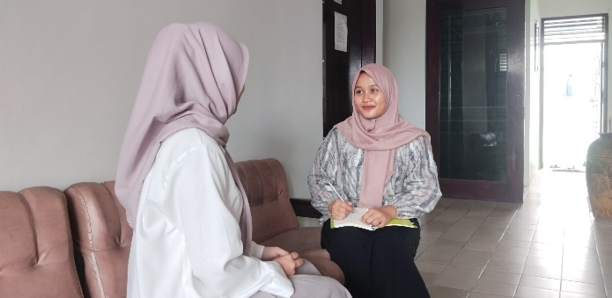
Figure 1
Interview with Rosa

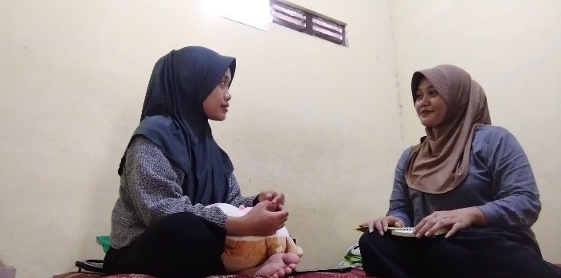
Figure 2
Interview with Indah
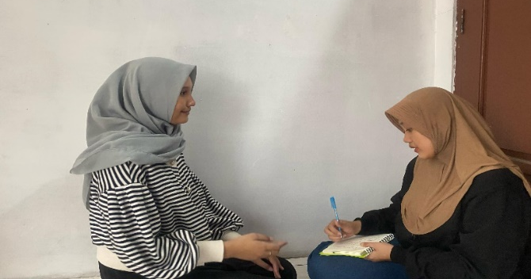
Figure 3
Interview with Putri

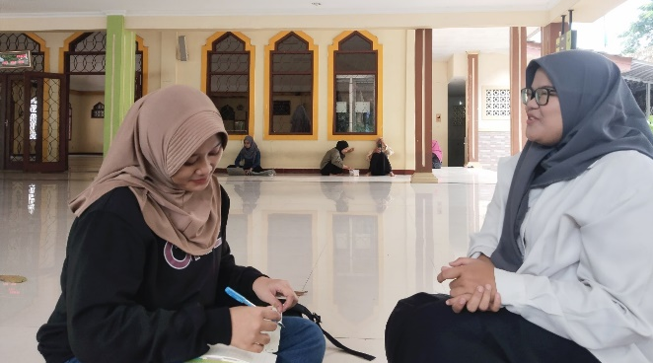
Figure 4
Interview with Sekar
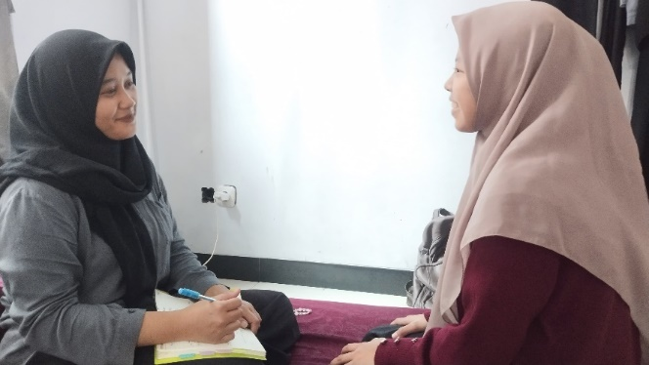
Figure 5
Interview with Kirana

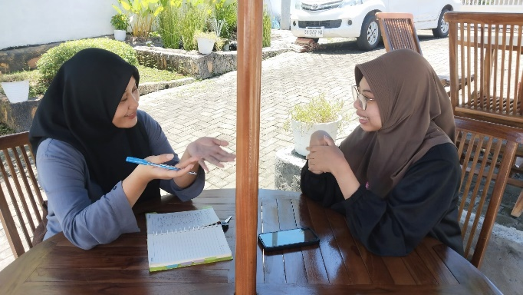
Figure 6
Interview with Vani
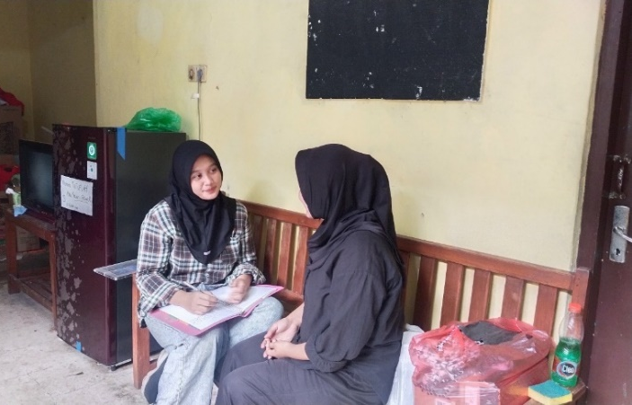
Figure 7
Interview with Tiara

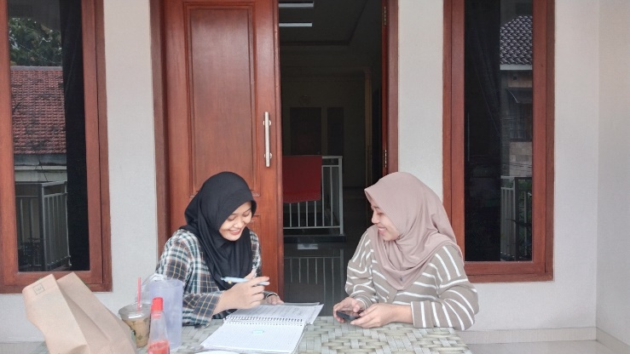
Figure 8
Interview with Sari
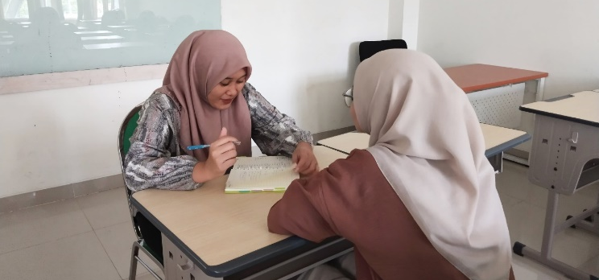
Figure 9
Interview with Nadia

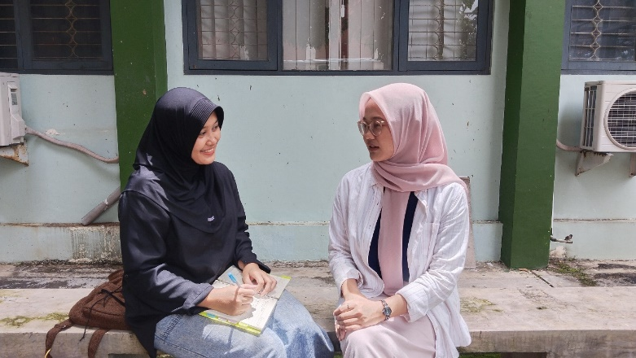
Figure 10
Interview with Melati

Appendix 5: Documentation of E-book

- E-book A

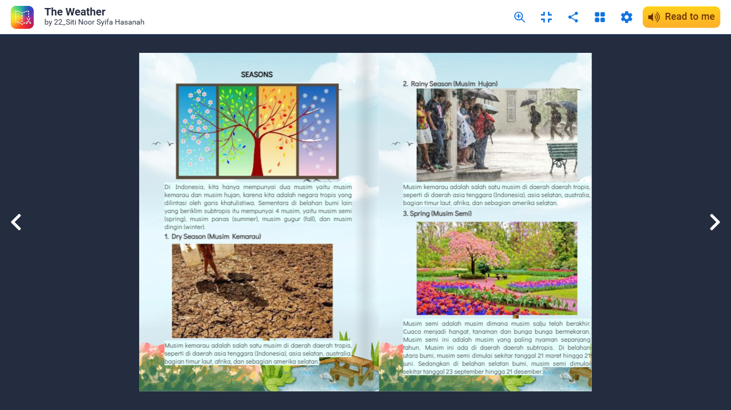

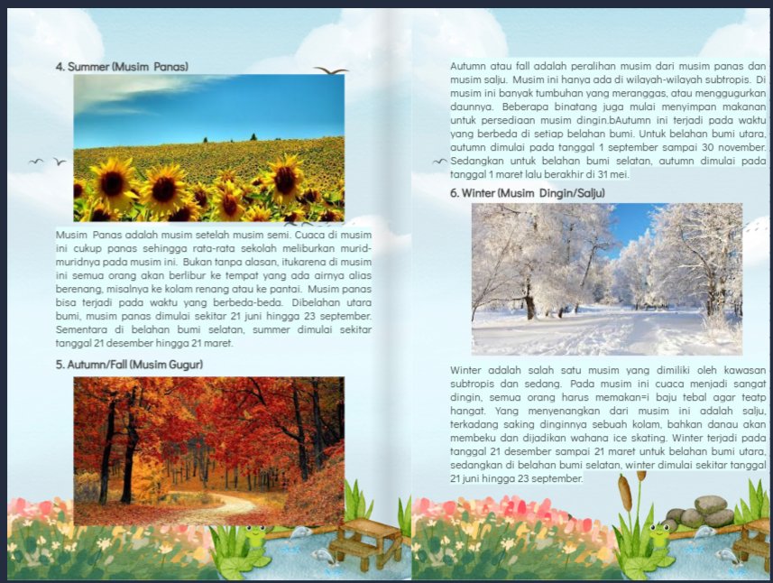

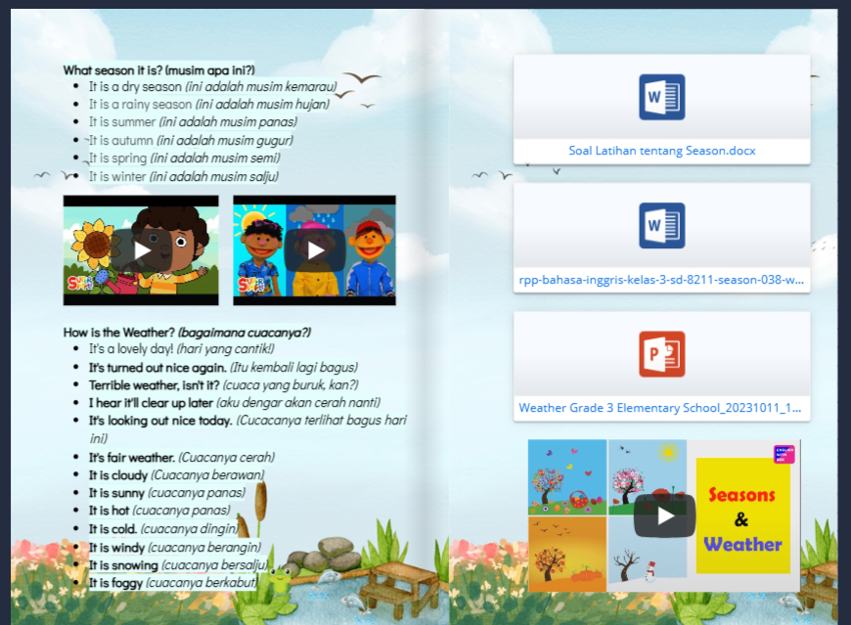
Link: https://shorturl.at/p1hwu

- E-book B

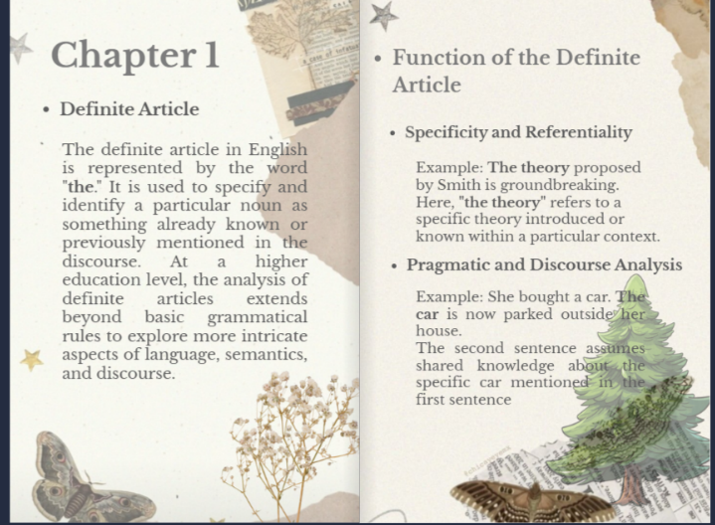
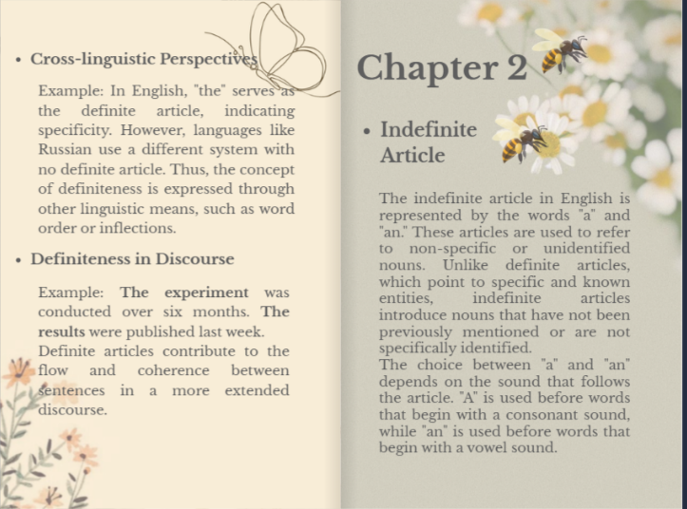
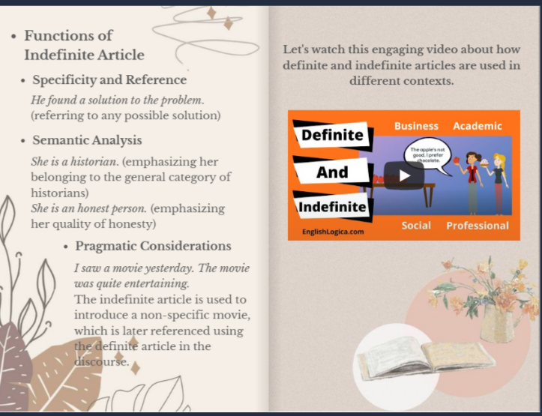
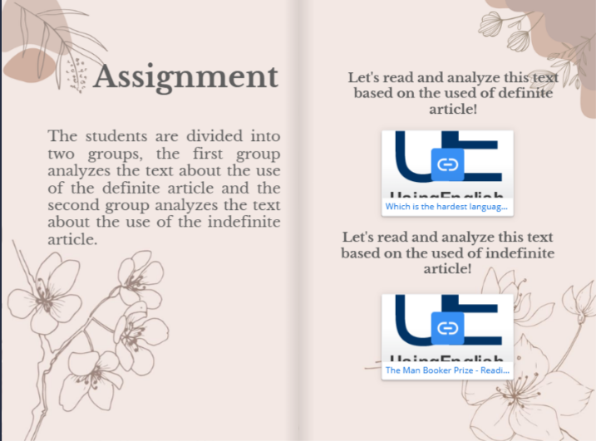
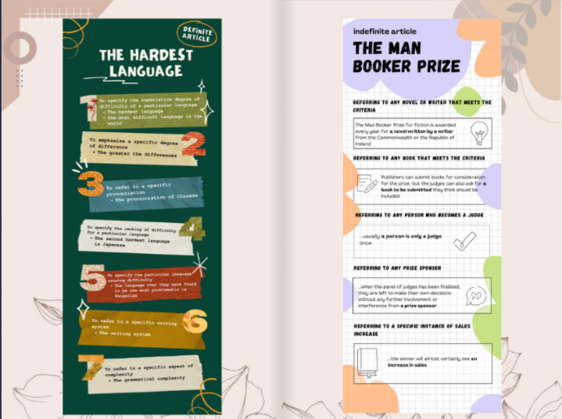

Link: https://shorturl.at/LyKYW

- E-book C

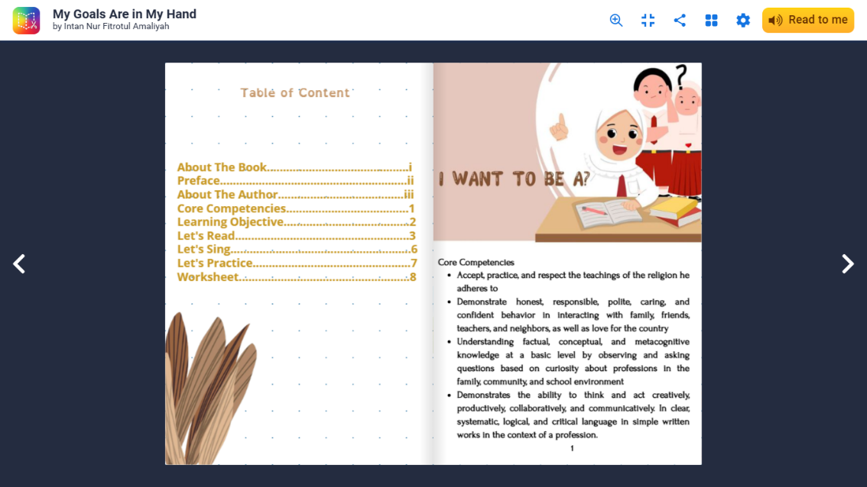

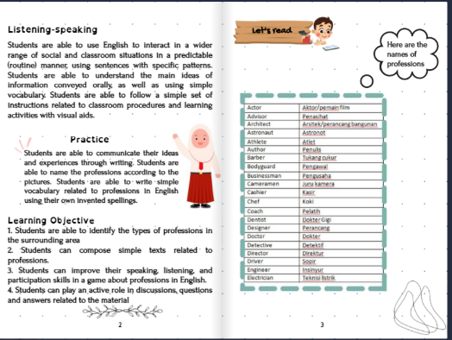

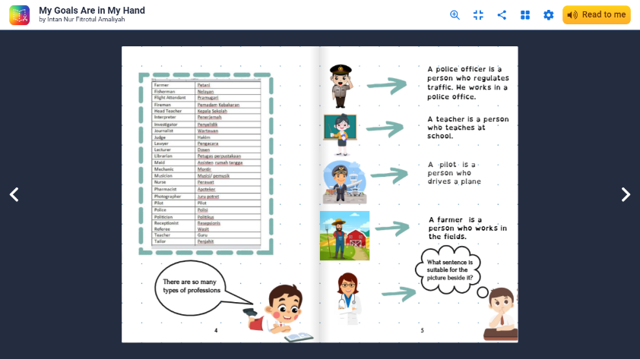

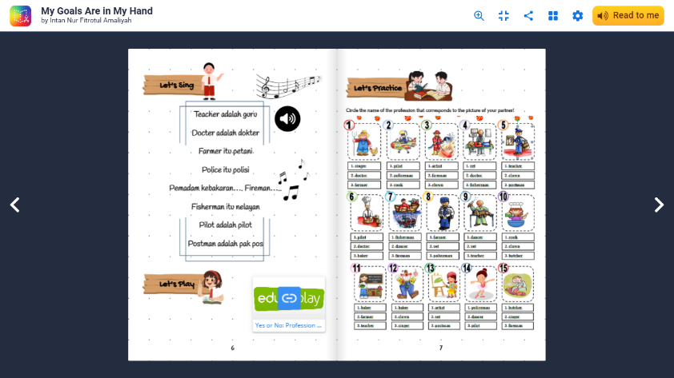

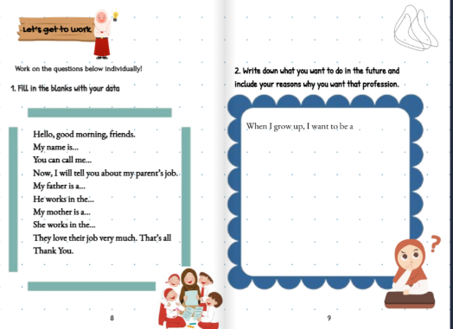
Link: https://shorturl.at/aqSuJ

- E-book D
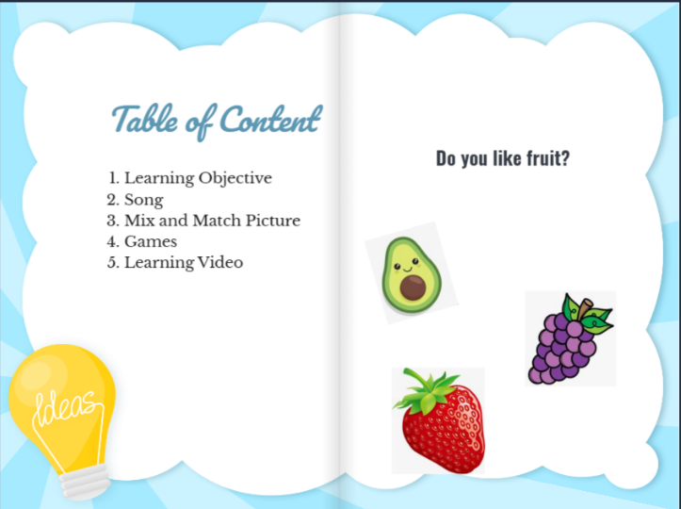
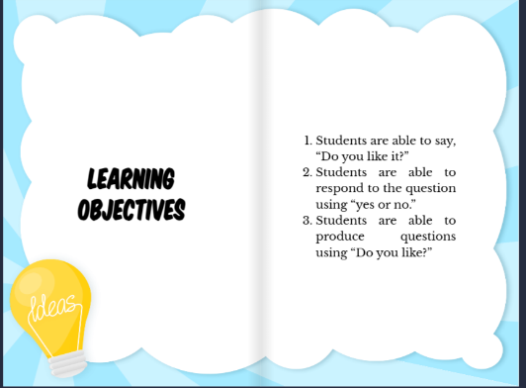

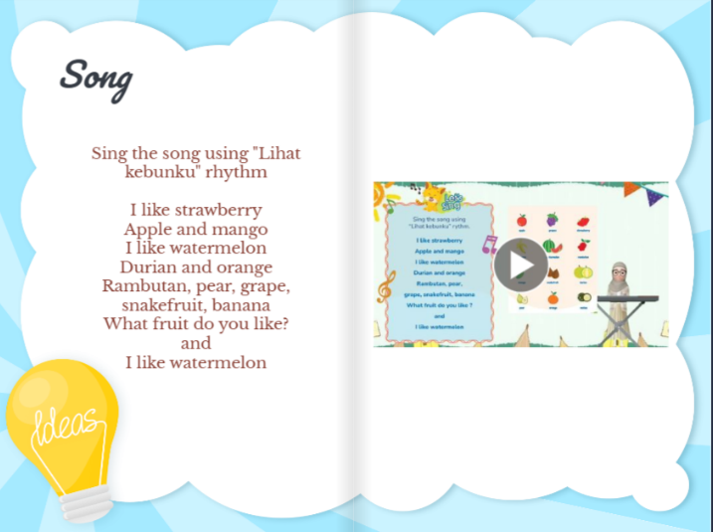
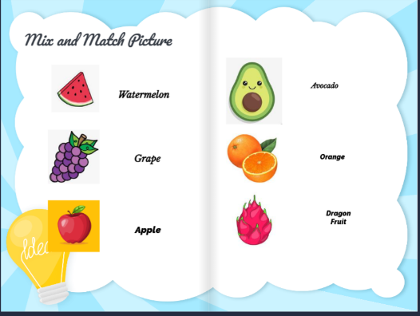
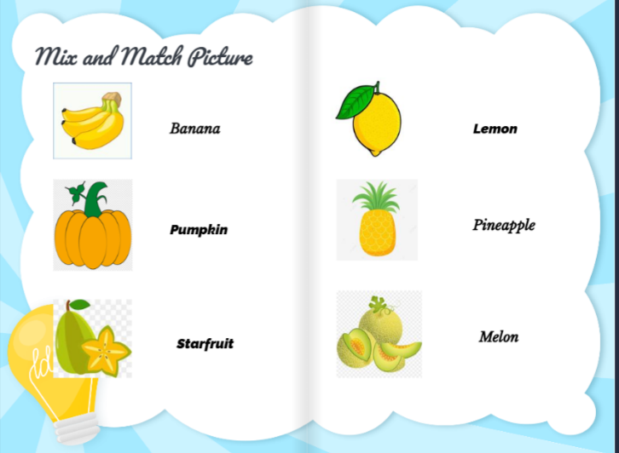
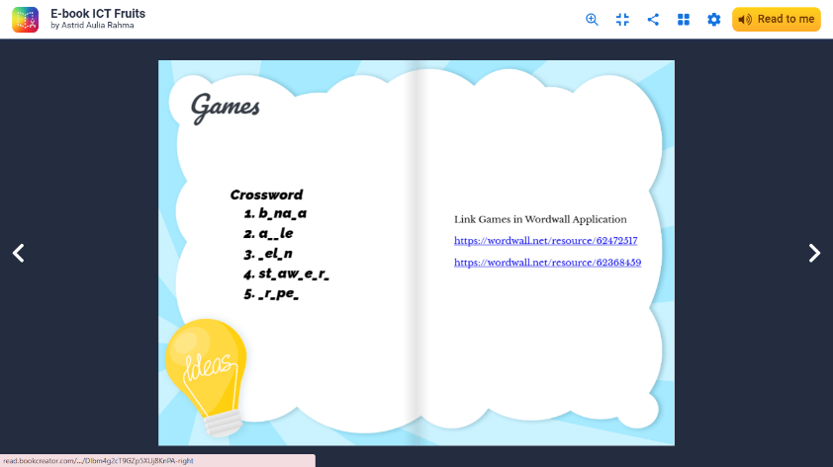
Link: https://shorturl.at/wKIK9
Appendix 7: Curriculum Vitae

A. | Personal Identity
1. | Name | : Sahda Ramadhani Mufit
2. | Place & date of birth | : Kendal, November 16th 2002
3. | Address | : Wonosari RT 04 RW 01, Kec. Ngaliyan, Kota Semarang, Jawa Tengah
4. | Email | : sahdaaa16@gmail.com
5. | Phone Number | : 0855-2463-4332

B. | Educational Details
1. | SDN Mangkang Kulon 01 Semarang
2. | MTs NU Nurul Huda Semarang
3. | MA NU Nurul Huda Semarang
4. | Universitas Islam Negeri Walisongo Semarang

Semarang, April 21st 2025

Sahda Ramadhani Mufit
NIM: 2103046004

