EXPLORING MOTIVATIONS AND CHALLENGES OF EFL PRE-SERVICE TEACHERS IN PURSUING TEACHING CAREERS
THESIS
Submitted in Partial Fulfilment of the Requirements
For Gaining the Degree of Bachelor of Education
In English Language Education

By:
Muna Mabruka Azzahra
Student Number: 2103046167
EDUCATION AND TEACHER TRAINING FACULTY
UNIVERSITAS ISLAM NEGERI WALISONGO
SEMARANG
2025
THESIS STATEMENT


RATIFICATION


ADVISOR NOTE
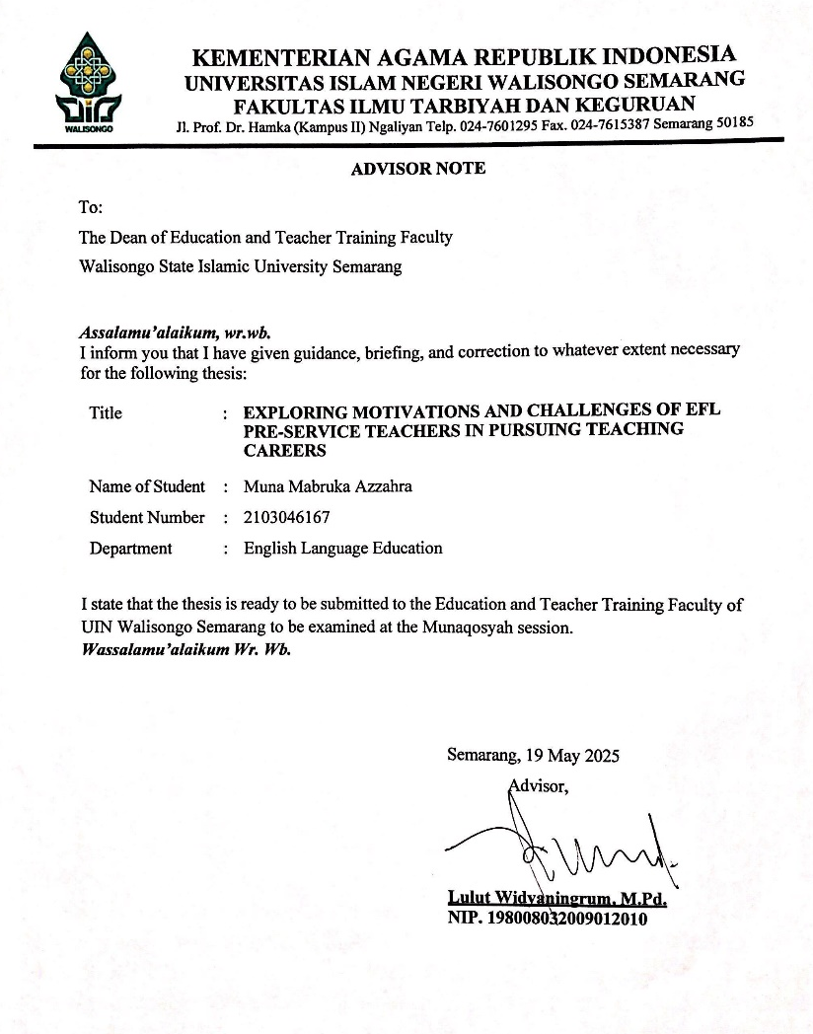

THESIS GUIDANCE SCORE


ABSTRACT
Title : Exploring Motivations and Challenges of EFL Pre-Service Teachers in Pursuing Teaching Careers
Name : Muna Mabruka Azzahra
Student Number : 2103046167
This qualitative study aims to explore the motivations and challenges faced by 30 pre-service EFL teachers in pursuing a career in teaching. Using open-ended questionnaires to gather in-depth insight into their experiences. The conceptual framework of this study identifies two main factors that shape the experiences of pre-service EFL teachers, namely motivation and challenges. Motivation, which can be divided into intrinsic and extrinsic, plays an important role in encouraging individuals to choose and stay in the teaching profession. On the other hand, pre-service EFL teachers also face various challenges, including pedagogical, financial, and academic challenges that can hinder their career development. This study focuses on understanding the interaction between motivation and challenges and how they affect the career journeys of pre-service EFL teachers. The results of this study are expected to provide greater insight into the factors that influence their career decisions and assist educational institutions in designing more effective support for EFL teacher candidates, by improving the quality of teaching in the future.
Keyword: Motivation, Challenges, Pre-Service EFL Teachers, Teaching Career

MOTTO
“And be patient, verily, the promise of Allah is true.”
(Q.s Ar-Ruum:60)
“Gadis kecilku, lihat kamu. Banyak mimpimu sudah terwujud”
(Nadin Amizah)
“Angan-angan yang dulu mimpi belaka, kita gapai segala yang tak disangka” (Hindia)

DEDICATION
The first thing I would like to thank Allah SWT for is all the blessings in the form of health, strength and inspiration that are very much in the process of this thesis. Shalawat and Salam are always bestowed on the Prophet Muhammad SAW. This thesis I present as proof of the spirit of my efforts and my love and affection for the people who are very valuable in my life.
for this work, then the author dedicates it to:
- Special thanks to my first love and role model, My Parents, H. Nurdin and Hj. Siti Hairiah. Thanks for all your sacrifices and sincere love, always giving your best, tirelessly praying, and providing attention and support so that the author can complete college to get a bachelor's degree, may mom and dad be in good health and have a long life.
- To the beloved family whose presence is no less important, Asrari Puadi, Ayu Hernanti, Rahmah Hairunnisa, Rusdiyanto, and all the big family who cannot be mentioned one by one, thanks for being part of the author's life journey.
- To my dearest friends, Bina, Saffana, Maulida, Ismy, Ummu, Atina, Rahma, Rizka, Tasya, Wafi, Azkal, Dimas, Alan, Maman, Ayu, Farrah, Akbar, Firsty, Indri, and Aldiyan. Thanks for being a friend who always strengthens me, takes many important roles behind the scenes, helps in the struggle, and never complains when bothered. see u on top, guys!
- Beloved bestfriend, Icha, Qoyum, Caca, Yaya, Dina, Diva Tika & Salwa. Thanks for being the best place to convey my complaints. accompanying the struggle from afar, providing prayers and full support in the process of completing this education.
- For my college communities: KKN MIT 82, HIMKA, HMJ PBI UIN WALISONGO, DDV JATENG, PBI D 2021 and all of my friends who have been part of these experiences.
- Last but not least, for myself, Muna Mabruka Azzahra. thanks for all the hard work and effort that has brought me to this point. thanks for being strong through the twists and turns of life until now. let's continue to survive and work together to develop into a much better person.

ACKNOWLEDGEMENT
Alhamdulillahi rabbil'alamin, the researcher expresses her deepest gratitude to Allah SWT, who has given His blessings and grace so that the writer can start and finish writing this research report. Shalawat and Salam are delivered to our beloved Prophet Muhammad SAW who has brought people from darkness to lightness.
In writing this thesis, the researcher realized that she received much assistance, suggestions, and advice from many people. Without their help, this thesis would never have existed. Therefore, the researcher would like to express his deepest appreciation and gratitude to them, especially to:
- Prof. Dr. Fatah Syukur, M.Ag. as the Dean of the Faculty of Education and Teacher Training of UIN Walisongo Semarang.
- Dra. Nuna Mustikawati Dewi, M.Pd. as the Head of the English Language Education Department of UIN Walisongo Semarang.
- Lulut Widyaningrum, M.Pd. as the secretary of the English Education Department of UIN Walisongo Semarang and as my beloved advisor who has provided the researcher with guidance, corrections, and all of support from the manuscript preparation stage up to the completion of the writing thesis.
- All the lecturers and staff of English Education Department of Education and Teacher Training Faculty of UIN Walisongo Semarang.
- And all participants who have been willing to spare their energy, time, and thoughts to help the author in completing this thesis.
The researcher realizes that this thesis has limitations and is very open to receiving input and criticism from all parties. The researcher hopes that this work can be useful and become a reference for further research.

Semarang, 18 April 2025
The Researcher

Muna Mabruka Azzahra
2103046167

TABLE OF CONTENT
THESIS STATEMENT i
RATIFICATION ii
ADVISOR NOTE………………………………………………..iii
THESIS GUIDANCE SCORE .iv
ABSTRACT .v
MOTTO .vi
DEDICATION .vii
ACKNOWLEDGEMENT ……..ix
TABLE OF CONTENT…………………………………………xi
LIST OF FIGURES xiii
LIST OF TABLES xiii
LIST OF APPENDICES………………………………………xiii
CHAPTER I INTRODUCTION 1
- Background of The Study 1
- Research Questions 4
- Objective of The Study 4
- Significance of The Study 5
- Limitation of The Study 7
CHAPTER II REVIEW OF RELATED LITERATURE 9
- Previous Study 9
- Literature Review 22
  - Motivation in Educational Context 22
  - Factors Influencing Career Choice 24
  - Challenges in a Teaching Career 28
  - Current Study Context 32
  - Conceptual Framework 33
CHAPTER III METHODOLOGY 35
- Research Design 35
- Research Setting and Participants 36
- Method of Collecting Data 38
- Instruments 39
- Data Analysis 40
- Data Validations 42
CHAPTER IV FINDINGS AND DISCUSSION 44
- FINDINGS 44
  - Intrinsic and Extrinsic Factors Motivating EFL Pre-service Teachers to Pursue Teaching Career 44
  - Pre-service EFL Teachers' Challenges in Pursuing a Teaching Career 49
- DISCUSSION 50
CHAPTER V CONCLUSION AND SUGGESTION 59
- Conclusion 59
- Suggestion 60
REFERENCES 62
APPENDICES…………………………………………………..1
CURRICULUM VITAE………………………………………..68
LIST OF FIGURES
Picture 2.1 Conceptual Framework 33

LIST OF APPENDICES
Appendix 1: Open-ended Questionnaire…………………………1
Appendix 2: Participants’ Demographic Information……………2
Appendix 3: Participants’ Responses…………………………….5
Appendix 4: Coding Process…………………………………….63
Appendix 5: Documentation of Trustworthiness Member Checking………………………………………………………....64
CHAPTER I
INTRODUCTION
This chapter includes the background of the research, the research questions, the objectives of the study, the significance of the study, and the limitations of the research.

- BACKGROUND OF THE STUDY
Motivation has a very important role in the teaching process. A motivated teacher can influence students' awareness and ability to learn, leading to increased student participation in learning and the development of their knowledge and skills (Tira Nur Fitria, 2023). Teacher motivation also helps students overcome obstacles and frustrations in learning, making them more focused and effective in achieving learning goals (Al-Said, 2023). Therefore, it is important for teachers to understand how to increase student motivation through interactive teaching approaches, constructive feedback, and appropriate rewards.
Pre-service teachers' motivation can be divided into three main categories there are intrinsic motivation (internal drives such as interest and personal satisfaction), extrinsic motivation (external factors such as job security and salary), and altruistic motivation (the desire to help others) (Ryan & Deci, 2020). For example, research by (Hartono et al., 2023) showed that extrinsic motivation, such as pride in the profession, sustainability of job demand, inspiration from teachers, and flexible working hours, were the dominant factors for EFL pre-service teachers in choosing a teaching career.
However, despite motivation being an important factor in teaching success, the challenges faced by EFL pre-service teachers also play a significant role in influencing their decision to pursue a career in education. In many countries, including Indonesia, English is not used as a means of daily communication, so learning this language is more academic and structured in the classroom. In addition, challenges in teaching practice, such as classroom management, limited resources and relationships with mentors, are often the main obstacles for pre-service teachers in pursuing their careers (Warahmah et al., 2021). For example, research by (Zultrianti et al., 2024) showed that words of encouragement or praise from teachers can increase students' interest in reading, which also reflects the influence of motivation on teachers' ability to overcome challenges. Challenges such as classroom management, limited resources and relationships with mentors are interconnected and influence teacher candidates' motivation to improve. Therefore, a deep understanding of these motivations and challenges is crucial for educational institutions to design better strategies to support teacher candidates.
Based on previous research, most studies have focused on pre-service teachers' initial motivations for choosing the teaching profession, but not many have addressed how these motivations develop during their education and teaching practice. In addition, previous studies have mostly used quantitative methods, so the previous studies have not explored the subjective experiences of pre-service teachers in depth. Therefore, this study aims to fill this gap with a qualitative approach that explores how pre-service teachers' motivations and challenges form and change in the context of education at UIN Walisongo.
By understanding the factors that motivate pre-service teachers and the challenges face, this research can help design more effective strategies to support them in pursuing a career as an educator. The research also has the potential to contribute to formulating more data-driven education policies, improving certification programs, and improving coaching systems for new teachers. The results of this study could also have broader social and economic impacts, as motivated and prepared teachers have the potential to produce a more qualified generation, which in turn could improve workforce competitiveness and economic growth.
- RESEARCH QUESTIONS
- What are the primary intrinsic and extrinsic factors motivating EFL pre-service teachers at UIN Walisongo to pursue a teaching career?
- What challenges do EFL pre-service teachers anticipate in achieving their professional goals, and how do these perceptions align with their motivations?

- OBJECTIVE OF THE STUDY
- To Identify the intrinsic and extrinsic factors that motivate EFL pre-service teachers at UIN Walisongo to pursue a teaching career.
- To explore the challenges faced by EFL pre-service teachers in achieving their professional goals and to assess how the perceived challenges relate to their motivation to pursue a career as a teacher.

- SIGNIFICANCE OF THE STUDY
This research is expected to provide the following benefits:
- Theoretical benefit
The findings will contribute to the literature on teacher motivation, particularly within the context of EFL education, by identifying key factors that influence career choice.
- Practical significance
The study will inform teacher education programs and policymakers about the needs and expectations of pre-service teachers, enabling them to design more effective recruitment and support strategies.
Additionally, the researcher hopes that the result can be useful for:
  - For students
This research will help English Education students to understand their career motivations and aspirations. By identifying the key factors that influence their career choices, students can make informed decisions and improve their teaching skills. The research also offers strategies to increase their motivation, overcome teaching challenges, and build their confidence to prepare them to become effective English teachers.
  - For lecturers
The findings will assist lecturers in designing teaching methods that align with students' motivational factors. This will make the learning experience more engaging and relevant, helping students stay active in class. Lecturers can also provide better academic and career guidance to help students achieve their professional goals.
  - For researchers
This study contributes to the field of teacher motivation, providing a solid foundation for future research. The study highlights areas that require further exploration, such as the impact of education policy on career choices. This study can guide future research on teachers' careers, especially in the context of Indonesia and UIN Walisongo.
  - For other researchers
These findings can be used by researchers to compare with similar studies in other countries or settings. This will help broaden the understanding of the intrinsic factors, extrinsic factors and challenges that influence career decisions. Future studies could explore additional variables, such as changes in education policy or practicum experiences, that impact on pre-service teachers' motivation.
- Social Impact
By addressing motivational factors, the study can help promote teaching as an attractive and rewarding career option, addressing global shortages of qualified EFL teachers.
- LIMITATION OF THE STUDY
This study has some limitations that need to be recognized. However, these limitations do not diminish the value of this study's contribution to the understanding of the motivations and challenges in choosing an English teaching career.
First, this study only involved pre-service English teachers at UIN Walisongo, so the results may not be generalizable to pre-service teachers at other institutions or in different regions. Variations in the educational and cultural contexts at other institutions may affect the motivation and challenges faced by pre-service teachers.
Secondly, this study did not compare pre-service English teachers' teaching motivation with teachers of other subjects, so generalization of the results of this study can only be done in the same context.
Given these limitations, it is still hoped that this study can contribute to and enrich our understanding of the motivations and challenges of choosing an English teaching career and can provide better guidance for developing effective teacher education programs.

CHAPTER II
REVIEW OF RELATED LITERATURE
This chapter contains a theoretical review related to research problems and a review of several previous studies that have been conducted in the same field related to the topic of this research.
- PREVIOUS STUDY
There are some previous studies that are relevant to this study. This discusses the influence of motivation in pursuing a teaching career and the challenges faced by pre-service English teachers in pursuing a career as a teacher.
      - Motivation of Pre-Service Teachers
The first study was conducted by Shilvia Lailin Naja (2023) and is titled “Pre-Service English Teachers' Perceptions and Motivations in Continuing Their Profession as EFL Teachers.” This study aims to determine the perceptions of pre-service English teachers regarding their choice to continue studying and working as English teachers. It identifies the motivational factors that influence student teachers to pursue their studies and careers in this field. Using a phenomenological approach alongside qualitative methods, the study distributed questionnaires to collect qualitative data on perceptions and motivations, as well as conducted interviews to gather more in-depth qualitative insights into students' experiences and views. The results indicate that pre-service English students hold diverse perspectives on the teaching profession, influenced by several factors that shape their decision to become teachers. The motivational factors identified include intrinsic factors (interest and passion), extrinsic factors (job opportunities and environmental support), and altruistic factors (a desire to contribute to society). While most respondents expressed a positive outlook on the prospect of working as English teachers, some maintained a negative perspective, shaped by their experiences during teaching practice. This study suggests that educational institutions should provide appropriate support and guidance to help students pursue careers as English teachers. This study has similarities in that the same research method uses qualitative. Although the study focused on intrinsic, extrinsic, and altruistic motivational factors, it did not delve into the challenges that pre-service teachers encounter during their teaching practice. Therefore, further research should explore the interrelation between motivation and challenges to provide a more comprehensive understanding of how these factors influence career decisions.
Second, the study conducted by Artini Ayuningtyas and Imam Santosa (2023) by the title “Pre-Service English Teachers’ Motivations Toward the Teaching Profession”. This study aims to determine the motivation of pre-service English teachers at Esa Unggul University after completing teaching practice. It also analyzes how this motivation is influenced by teaching practice experience and other relevant factors. This study uses a mixed methodology that combines qualitative and quantitative methods. The participants were 36 pre-service English teachers by distributing questionnaires. The study found that pre-service English teachers' motivation is dominated by the need for achievement, which includes personal growth, academic excellence and continuous learning. As well as teaching practices that have a significant effect on pre-service teachers' motivation and commitment to a teaching career. This study shows that teaching experience can influence pre-service teachers' motivation, but does not investigate the challenges faced during teaching practice. This research has similarities with future research, both studies examine the motivation of pre-service English teachers and focus on pre-service teachers or pre-service teachers who are still in education. Therefore, further research needs to cover the challenges experienced during this phase, as well as their influence on pre-service teachers' motivation and commitment to their teaching career.
Third, the study conducted by Sadiq Abdulwahed Ahmed Ismail and Adeeb Mohamed Jarrah (2019) the titile “Exploring Pre-Service Teachers’ Perceptions of Their Pedagogical” The aims of This study was to investigate how teaching practice influences pre-service teachers' perceptions of their pedagogical preferences, teaching competencies, and motivations for choosing the teaching profession. This study used a mixed method approach, combining quantitative and qualitative methods. Quantitative data were obtained through a five-point Likert scale questionnaire, while qualitative data were collected through focus group discussion interviews involving 12 students out of a total of 30 research participants. The results showed that in general, pre-service teachers had positive views on the three aspects studied. However, a statistically significant difference was found between the two study program groups-elementary teacher candidates showed higher levels of competence, motivation, and pedagogical preferences than early childhood teacher candidates. On the other hand, the KG group tended to face more difficulties, such as language barriers and administrative tasks during practice. The findings in this study have similarities with future studies showing the importance of intrinsic and extrinsic motivation, as well as active engagement in teaching practice as important factors in shaping pre-service teachers' readiness. Some of the limitations of this study include the relatively small sample size limited to female students at one university and the perceptual focus of the study without direct observation of teaching practices. Nonetheless, this study has high relevance for the study of pre-service teachers' motivations and challenges, especially in the context of teaching English as a foreign language (EFL). This research can be an important reference in designing teacher education programs that are more responsive to the real needs, motivations and difficulties faced by pre-service teachers in the field.
Next, research conducted by Usman Kojo Abonyi, Doreen Awhireng, and Austin Wontepaga Luguterah (2021) entitled “Motivations of Pre-service Teachers in the Colleges of Education in Ghana for Choosing Teaching as a Career” aims to identify factors that motivate pre-service teachers in Ghana in choosing the teaching profession as a career. This study used a quantitative approach with a descriptive survey design, and involved 248 first and second year students from one college of education in Ghana. The instrument used was the FIT-Choice Scale, which measures various motivations such as intrinsic career value, personal utility value, social utility value, perceived teaching ability, social influence, and fallback career motivation. The results showed that the main motivations were the desire to shape children's futures, making a social contribution, previous teaching and learning experiences, and social justice, while the lowest motivation was a backup career choice. Differences in motivations were found based on gender, place of residence, age, and marital status. The research of Abonyi et al. (2021) and the study entitled “Exploring Motivations and Challenges of EFL Pre-Service Teachers in Pursuing Teaching Careers” have a number of significant similarities and differences. Both studies highlight the importance of understanding the motivations of pre-service teachers in choosing the teaching profession, and stem from a concern for the quality and retention of the teaching workforce. Their main focus is to explore the subjective perceptions of pre-service teachers before entering the workforce, which can inform the development of more responsive teacher education policies. However, there are some notable differences. In contrast, the research on EFL teachers specifically targets pre-service teachers of English as a foreign language, which has its own challenges and learning contexts.
On the other hand, a study by Tutku (2021) entitled “I've Decided to Become an English Teacher: Pre-service EFL Teachers' Reasons for Choosing Teaching as a Career” aimed to uncover the reasons pre-service EFL teachers in Turkey choose teaching as a profession, as well as whether the level of education affects their motivations and whether those motivations can predict academic achievement (GPA). Using a quantitative approach and the FIT-Choice Scale instrument, data was collected from 155 English language education students. The results showed that their motivation was quite high, dominated by intrinsic and altruistic reasons, such as the desire to shape children's futures and contribute socially. The level of years of study did not affect motivation, but factors such as time for family, desire to work with children, and intrinsic career value had an effect on GPA. The limitations of the study lie in the limited sample and only using quantitative methods while future research will use qualitative methods by distributing questionnaires to collect data. This study is relevant for understanding how motivation influences prospective teachers to choose teaching as a career.
And the last, is the research conducted by Indah Eka Asriani, Rahayu Apriliaswati, and Dwi Riyanti (2022) the title “Motivational Factors Influencing Pre-Service EFL Teachers to Choose Teaching as a Future Career”. This study aims to identify the motivational factors that influence pre-service English teachers in choosing an English teaching career. It also aims to analyze how these motivations relate to their commitment to the teaching profession. The design of this study used a survey method of 216 student teachers of the English Education study program at FKIP Tanjungpura University Pontianak. Data were collected through an online questionnaire consisting of closed questions adapted from FIT-Choice Scale (Factors Influencing Teaching Choice) and open-ended questions. The findings of this study are The main motivational factors influencing pre-service teachers to choose English teaching as a future career are interest in the subject, intrinsic career value, social utility value, and previous teaching and learning experience. Pre-service teachers perceived the teaching profession as having high task demands, but gave lower ratings to task rewards. In addition, other factors identified through the open-ended questions included the influence of religion, personal and professional development, and the various benefits of learning to be an English teacher. This research has similarities with future research, namely, both studies aim to understand the factors that influence commitment to the teaching profession. This study uses questionnaires as one of the main instruments in data collection to find out what encourages pre-service teachers to pursue the English teaching profession. However, like previous research, this study did not explore the challenges faced during teaching practice. Thus, further research that integrates motivation and challenges is needed to provide a more holistic picture of the factors that influence pre-service teachers' career development.

      - Challenges faced by EFL Pre-Service Teachers
There is a recent study related to the challenges faced by pre-service English teachers in pursuing a career as a teacher. This study was conducted by Feni Maharani and Rahmah Fithriani (2023) entitled “Exploring Challenges EFL Pre-Service Teachers Experience in Teaching Practicum: A Transformative Learning Perspective”. The purpose of this study is to identify and understand the challenges faced by pre-service English teachers during their teaching practice. This research also aims to explore how these challenges can be overcome through a transformational learning perspective, which is expected to help pre-service teachers develop their pedagogical skills and professional identity. This study used a descriptive qualitative approach to explore the experiences of pre-service English teachers, especially the challenges faced during their teaching practice. With 5 students as 7th semester participants of the English education program at UIN North Sumatra, Medan. Data were collected through reflective notes and in-depth interviews, which were then thematically analyzed to identify patterns and themes that emerged from their experiences. The study found that pre-service English teachers face several challenges, including: Tension between vision and reality. Many participants felt unprepared to face the reality in the field, which was different from their expectations. In addition, classroom management was also a challenge for them. Participants found it difficult to manage disruptive student behavior and create a conducive learning environment. The next challenge was limited supervision. The lack of guidance from mentors during teaching practice made them feel less supported. This study shows that through transformational learning, pre-service teachers can overcome these challenges by reflecting on their experiences, exploring assumptions, and changing their teaching approaches to better suit students' needs. This research has similarities with future research in that both studies focus on pre-service English teachers and their experiences during the teaching practicum. This research also focuses on the challenges faced by pre-service teachers during this phase. Previous research and future research have differences in the number of participants.
Second research by Emma Martina Pakpahan (2023) entitled “Challenges Faced by Pre-Service Teachers During Teaching Practicum”. This study aims to investigate the challenges faced by pre-service teachers in teaching practice, focusing on the internal and external factors that affect their performance. The methodology used was a qualitative approach. Data was collected through Diaries by asking participants to write down their daily activities during teaching practice. In addition, Mentor Feedback was also used, Feedback from mentors was used to gain additional perspectives on the challenges faced by pre-service teachers. 3 participants from 3 different universities participated in the study and they practiced teaching in the same school for four weeks. The findings showed that there were two categories of challenges. The first was external factors: Low student motivation and Lack of facilities at school. The second was Internal Factors: Poor classroom management and the teacher's low proficiency in English. The results show that these challenges have a negative impact on the learning process and indicate the need for better preparation for pre-service teachers to face these challenges.
Both previous studies provided in-depth understanding of barriers such as classroom management and lack of mentor support. However, these studies tend to focus on the challenges faced during teaching practice, without exploring the deeper relationship between motivation and these challenges. Future research needs to explore how these challenges influence pre-service teachers' motivation to choose a teaching career.
Last, research by Fadillah, Baso Jabu, and Muhalim (2023) entitled “Pre-Service English Teachers' Challenges of Teaching Practicum in Teaching Assistance (AJARMI) Program” This study aims to find out the challenges faced by pre-service teachers in teaching practice in the AJARMI program. qualitative approach with multiple case study method. obtained data through interviews with 3 Pre-Service English Teachers (PSET) who participated in the AJARMI program. The results of the interviews were analyzed using thematic analysis to find patterns and main themes in the challenges faced. The results of this study show that pre-service teachers face challenges in student behavior, preparation of teaching materials, and mentor guidance. The challenges in student behavior are difficulties in classroom management due to students' diverse characters, students' lack of respect for pre-service teachers, and students' low motivation to learn. The solution to this challenge is for pre-service teachers to adapt their teaching style to students' interests and build closeness so that students are more comfortable and motivated. Next, the challenge in preparing teaching materials is the limited school facilities, such as the lack of LCDs and difficulties in utilizing technology in learning. The solution to this problem is to make a backup plan and develop a more interesting learning strategy. Finally, the challenge of mentorship. Lack of support from mentor teachers who are supposed to guide in managing the classroom and assessing students. The solution is for pre-service teachers to be more independent in learning and finding effective teaching strategies. This study also examined the challenges faced by pre-service English teachers in teaching practice, identifying issues such as diverse student behavior, preparation of teaching materials, and limited mentor guidance. While it provides important insights, it also does not discuss in depth how motivation plays a role in helping pre-service teachers overcome these challenges.

- LITERATURE REVIEW
To support this research, the researcher presents some of literature reviews. The literature review also serves to discuss and put forward various ideas that can be the basis for this research.
      - Motivation in Educational Context
In educational settings, motivation significantly influences students' engagement, achievement, and perseverance. Recent research has highlighted the importance of motivation in English as a foreign language (EFL) learning, particularly for pre-service teachers. (Dewi & Fajri, 2023) found that pre-service teachers' initial motivation to enter a teacher education program was driven by intrinsic factors such as personal interest in teaching and English, as well as previous learning experiences. In addition, teaching practice during the education program contributed significantly to the formation of their professional identity. (Naja, 2023) identified that internal, external, and altruistic factors influenced English education students' decision to pursue the profession as EFL teachers. These findings emphasize the importance of understanding pre-service teachers' perceptions and motivations in order to provide appropriate support during their education. (Hartono et al., 2023) found that extrinsic motivations, such as stability of job demand and flexibility of working hours, were the dominant factors for pre-service teachers in choosing a teaching career. However, there was a positive correlation between teaching motivation and self-efficacy in speaking English, albeit at a moderate level. (Asriani et al., 2022) identified interest in the subject, intrinsic career value, social utility value and previous teaching experience as the main factors influencing pre-service teachers in choosing English teaching as a future career. In addition, previous studies also highlighted the importance of personal and professional development in the decision.
The findings emphasize that intrinsic and extrinsic factors play an important role in pre-service EFL teachers' motivation. With a better understanding of motivation in the teaching career, it is hoped that more effective educational programs can be designed to support teachers' professional development.
      - Factors Influencing Career Choice
Motivation in a teaching career is the drive that encourages individuals to choose and stay in the profession. Various definitions of motivation have been proposed by experts, especially in the context of education. Ryan & Deci (2020) defines motivation as the process that directs, organizes, and sustains individual behavior in pursuit of a specific goal, which in the context of teaching can stem from a desire to contribute to student development. Therefore, Factors that influence one's motivation in choosing a teaching career include personal interests, values, social influences, and career prospects. Interest in the subject being taught and the desire to share knowledge are key drivers (Trisnaeni et al., 2023). Personal values about the importance of education and the role of teachers in society also contribute to motivation. In addition, support from family, friends and the community, as well as considerations regarding job stability and professional development opportunities, influence an individual's decision to enter education (Descals-Tomás et al., 2021). A number of studies have been conducted to explore students' motivations in choosing a teaching career. Research by (Fatawuri Syamsuddin et al., 2023) found that intrinsic motivation, such as the desire to contribute to society, was the main factor, with support from lecturers and social environment playing an important role in increasing motivation. Research by (Wang, 2019) showed that positive experiences in previous education tend to increase students' motivation to teach. Next research by (Ingersoll & Tran, 2023) found that peer support and opportunities for professional development strongly influenced teachers' decisions to stay in the profession. Meanwhile, research by (Hartono et al., 2023) emphasized that self-efficacy and perceived value of the teaching profession contribute to teacher motivation. With a better understanding of motivation in a teaching career, it is expected that more effective educational programs can be designed that support teachers' professional development.
Career choices in education are influenced by a combination of personal, social and institutional factors. Personal factors include intrinsic motivations such as a passion for teaching and a desire to make a difference in students' lives, as well as personal values and interests. A study by (Tira Nur Fitria, 2023) identified internal factors that influence students' decision to pursue a teaching career, such as the perception that teaching is a noble profession and a personal desire to be useful to society.
Social factors include family influences, peers and societal expectations, which often play an important role in determining career aspirations. (Rahma et al., 2022) found that perceptions of the teaching profession significantly influenced students' motivation to become teachers, although parental income had no direct effect.
Institutional factors, such as the availability of teacher education programs and job opportunities, also significantly influence the decision to choose the teaching profession. (Tira Nur Fitria, 2023) highlighted that external factors, including belief in attractive income and good working conditions, as well as positive social perceptions of teachers, contribute to students' interest in pursuing a career as a teacher.
In the Indonesian context, social expectations and institutional support, such as scholarships and mentorship, strongly influence pre-service teachers' career choices. (Asriani et al., 2022) emphasized that motivational factors, including intrinsic and extrinsic motivation, play an important role in pre-service English as a Foreign Language (EFL) teachers' decision to choose teaching as a future career. However, while previous research has provided valuable insights into these factors, there is limited exploration into how these elements interact to shape the motivations of pre-service EFL teachers. This study seeks to address this gap by examining how personal, social, and institutional factors collectively influence pre-service EFL teachers' career decisions.
      - Challenges in a Teaching Career
Challenges for pre-service English teachers can be defined as the various difficulties or obstacles face in their educational process and preparation for entering the teaching profession (Li & Guo, 2024). These challenges can come from a variety of sources, both intrinsic and extrinsic, and can affect pre-service teachers' motivation, performance and professional development (Li & Guo, 2024). Pre-service English teachers' challenges refer to the various obstacles faced in the learning and teaching process, including lack of motivation, limited resources and difficulties in implementing effective teaching methods.
a. Intrinsic Factors
Intrinsic factors refer to challenges that come from the pre-service teachers themselves. One of the main challenges is motivation, where teacher candidates may experience a lack of intrinsic or extrinsic drive to learn and teach. This can be influenced by boredom, burnout, or unclear career goals. In addition, inadequate language skills, such as mastery of grammar, vocabulary and pronunciation, are often a major barrier (Ibrahim, 2023). Pre-service teachers may also face a lack of confidence, especially when it comes to speaking or teaching in English in front of a class. Poor time management is also a common problem, as have to balance academic work, teaching practice and personal life (Li & Guo, 2024). Finally, psychological preparedness such as stress, anxiety or pressure in the face of the learning process and teaching practice can affect their overall performance.
b. Extrinsic Factors
Extrinsic factors include challenges that come from the pre-service teachers' external environment. One of these is the limited availability of resources, such as lack of access to teaching materials, technology or learning support facilities. Lack of institutional support, such as lack of guidance from lecturers, mentors or educational institutions, can also hinder teacher candidates' development (Ryan & Deci, 2020). A non-conducive learning environment, both in the classroom and the school where they practice teaching, can add to their difficulties. In addition, an irrelevant or overcrowded curriculum often makes it difficult to understand and apply the material (Eli Masnawati et al., 2023). Finally, social demands from family, friends or the community towards the teaching profession can add to the pressure felt by pre-serice teachers.
c. The Interaction Between Factors
Intrinsic and extrinsic factors interact and influence each other in shaping teacher candidates' motivation and self-efficacy. For example, limited resources and inadequate training programs (extrinsic factors) can reduce pre-service teachers' intrinsic motivation, leading to a decline in their enthusiasm and commitment to the profession. Conversely, a lack of self-confidence (intrinsic factors) may be exacerbated by unsupportive learning environments and organizational conditions (extrinsic factors), further hampering their teaching effectiveness. However, strong institutional support, such as comprehensive education, training and development programs (extrinsic factors), can enhance the self-efficacy and psychological readiness (intrinsic factors) of pre-service teachers, enabling them to face challenges more effectively. These interactions suggest that challenges in teaching should be seen as part of an interconnected system, where addressing both intrinsic and extrinsic factors is critical to cultivating motivated and competent educators (Windy et al., 2024).
d. Impact on Pre-Service Teachers
The challenges faced by pre-service teachers, both intrinsic and extrinsic, significantly impact their motivation, performance and professional development. Low motivation can cause pre-service teachers to lose interest in learning and teaching, which in turn affects their academic performance. For example, (KULA, 2022) found that pre-service teachers' self-efficacy beliefs and attitudes towards the teaching profession can predict their teaching motivation, which in turn affects their academic success. In addition, unresolved barriers may hinder their professional development, such as readiness to enter the teaching profession and the development of effective teaching skills. Research by (KULA, 2022) emphasizes that pre-service teachers' self-efficacy beliefs and teaching motivation are important predictors of their attitudes towards the teaching profession, which are critical to their professional growth and readiness.
These findings underscore the importance of addressing intrinsic and extrinsic challenges to support pre-service teachers' motivation, performance and professional development.
      - Current Study Context
This literature review reveals critical gaps in the understanding of EFL pre-service teachers' motivations and challenges. While significant research has been conducted on motivation theories and factors influencing career choice, there remains a lack of research specifically addressing the intersection of intrinsic and extrinsic motivation in the pre-service phase of EFL teaching. Additionally, while challenges faced by teachers are well-documented, the unique experiences of pre-service EFL teachers, particularly in relation to their training, have not been explored comprehensively. This research aims to address these gaps by examining the motivational factors and challenges influencing pre-service EFL teachers at the early stages of their careers, ultimately contributing to more effective teacher training and career development programs.

      - Conceptual Framework
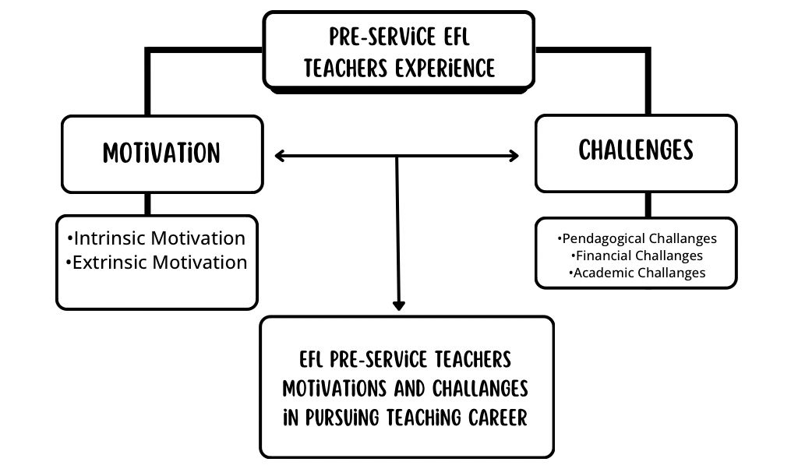
Picture 2.1 Conceptual Framework

This conceptual framework illustrates the complex relationship between motivation and challenges faced by pre-service English language (EFL) teachers in pursuing a teaching career. At its center is the pre-service EFL teacher's experience, which is shaped by two main factors: motivation and challenges. Motivation, which is divided into intrinsic and extrinsic motivation, plays an important role in encouraging individuals to choose and remain in the teaching profession. Intrinsic motivation comes from within the individual, such as interest in the subject and a desire to contribute to education, while extrinsic motivation comes from external factors, such as job stability and career opportunities.
However, pre-service EFL teachers also face various challenges, which are categorized into pedagogical, financial and academic challenges. Pedagogical challenges include difficulties in classroom management and developing effective teaching strategies. Financial challenges relate to tuition fees and salary prospects, while academic challenges involve study demands and pressure to achieve academic excellence. This conceptual framework emphasizes that pre-service EFL teachers' experiences are shaped by the interaction between motivations and challenges. Ultimately, this framework will help to understand how these two factors motivation and challenges interact in influencing their decision to choose a teaching career.

CHAPTER III
METHODOLOGY

This chapter shows the research method of this study. It consists of research design, types and sources of data, research focus, data collection techniques, research instruments, and data analysis techniques.

  - RESEARCH DESIGN
This study used qualitative methods to deeply understand the motivation of EFL pre-service teachers. Qualitative methods were chosen because they are able to produce rich descriptive data in the form of words and behavioral observations, which allow researchers to explore “why” and “how” motivation arises and develops (Alhazmi & Kaufmann, 2022). It serves as a means to investigate and understand the meaning that individuals or groups ascribe to a particular human problem (Creswell, 2007). This research was conducted through a qualitative survey by administering an open-ended questionnaire consisting of nine questions. This approach is well suited to researching complex phenomena such as motivation, which is influenced by a variety of intrinsic and extrinsic factors, including personal beliefs, social environment, and institutional support (Ummah, 2019)
- RESEARCH SETTING AND PARTICIPANTS
- Research Setting
This research was conducted at UIN Walisongo Semarang. This university was chosen because it has a trusted teacher education program and focuses on developing competent pre-service English teachers.
- Research Participants
The participants in this study were EFL students at UIN Walisongo Semarang, with a targeted number of 30 students. The number of participants in this study was 30 EFL Pre-service teachers at UIN Walisongo Semarang. In qualitative research, sample size is not determined by large numbers, but rather by the depth and richness of information obtained from participants.
By involving 30 participants, the researcher believes that the variety of experiences, motivations, and challenges experienced by EFL pre-service teachers can be comprehensively described. This number is also in line with research by Dewi and Al Fajri (2023) who explored the initial motivation and professional identity formation of pre-service EFL teachers in Indonesia through a qualitative approach. This approach emphasizes depth of understanding over breadth, allowing researchers to explore the lived experiences of each participant in detail (Alhazmi & Kaufmann, 2022).
A smaller sample size is manageable for qualitative analysis, which involves time-intensive processes such as transcribing, coding data, and identifying themes. To ensure the relevance and quality of the data, the participants were selected based on certain criteria.
First, they had to be active students enrolled in the English Education study program at UIN Walisongo Semarang, to ensure that their experiences could be directly applied in the context of English teacher preparation. Second, participants are required to have completed at least one semester of microteaching, which involves classroom or simulated teaching practice as part of their curriculum. This experience is crucial, as it gives participants hands-on experience in teaching, allowing them to reflect on their motivations, challenges and aspirations as future English teachers. In addition, the participants should be willing to share their experiences openly, which is crucial for obtaining rich and authentic data.
By focusing on students who had completed microteaching, the researcher was able to explore how practical teaching experiences affected their motivation. The selected participants were expected to provide diverse yet focused insights into the sources of their motivation and the challenges they faced. This careful selection process ensured that the research obtained rich, detailed, and relevant data, in line with the phenomenological methodology that emphasizes the exploration of lived experiences. Ultimately, the insights gained from these 30 participants will make a significant contribution to understanding the complex and diverse nature of motivation among pre-service English teachers.

- METHOD OF COLLECTING DATA
This research was conducted to explore in depth the experiences and views of students of English Education Study Program at UIN Walisongo Semarang. The initial stage of this research involved determining the focus of the research and formulating specific research questions to direct the development of the questionnaire.
Subsequently, an open-ended questionnaire was developed to explore students opinions, experiences and perceptions regarding intrinsic and extrinsic factors affecting their studies. Before being disseminated, the questionnaire was pilot tested with some students to ensure the clarity and relevance of the questions. After that, the questionnaire was distributed to 30 selected students. Data collection was carried out through filling out questionnaires with open-ended questions that allowed respondents to provide more in-depth answers. All data obtained were then transcribed for further analysis.

- INSTRUMENTS
Research instruments are tools or equipment that researchers use to gather data and provide satisfactory results. In this case, the researcher used an open-ended questionnaire as a research method.
Open-ended Questionnaire
The open-ended questionnaire was designed to collect preliminary data on pre-service EFL teachers' motivations for choosing teaching as a profession. The questionnaire is an adaptation and development based on established theories of motivation, such as Self-Determination Theory and Expectancy-Value Theory. By integrating elements from these theories, this open-ended questionnaire aims to explore the various intrinsic and extrinsic factors that influence students' decision to pursue a career in education. This theoretical basis ensures that the questions asked are relevant and targeted, thus providing valuable insights into the motivations of future educators.
The results of this questionnaire were used to determine the motivations and challenges faced by pre-service EFL teachers in their teaching careers. In this case, the participants were asked to share their experiences in detail and thoroughly. The researcher used Google Forms to collect the data, which allowed the participants to easily express their views according to the given questions, as well as feel free to answer anywhere. The use of Google Forms also simplified the data collection process and increased respondent participation.

- DATA ANALYSIS
Data analysis techniques are directed to answer the research problems that have been formulated in a research proposal. The researcher used a thematic technique of analysis.
Thematic analysis is a qualitative research method that researchers use to organise and analyse complex data sets systematically. According to Gerald Holton, this approach is very flexible and can be applied in various types of research. Thematic analysis focuses on identifying patterns of meaning associated with the phenomenon under study, as well as how the phenomenon is understood by the researcher. Thematic analysis aims to uncover themes that represent significant patterns in qualitative data, providing insights into participants' experiences and perspectives.
A thematic approach was used in the qualitative data processing procedure of this research. According to (Braun & Clarke, 2006), to facilitate coding, the first step taken is to understand the data in depth. This procedure is in line with advice to maintain the authenticity of data in qualitative research (Nassaji, 2020). The next step is to develop initial codes based on existing data. At this stage, the researcher carefully examines all the data and assigns an initial code to each word, phrase, or sentence that is considered relevant to the research objectives. The third stage is to look for themes related to the code. The next stage is to re-examine the themes that have been identified to ensure their compatibility with the existing code. Next, define and name the themes that have been identified. The last stage presents the results of the analysis in the form of a systematic and convincing narrative that shows the validity and usefulness of the analysis.

- DATA VALIDATIONS
To ensure the validity of the data in this study, the researcher used the member checking technique, which is one of the most effective triangulation approaches in qualitative research (Ummah, 2019). In the context of this study, the validity of the findings was enhanced through a participant validation process, where the researcher asked participants to verify the interpretation of the research results based on the responses provided through Google Forms. This validation process aimed to ensure that the researcher's understanding of the participants' experiences was accurate and in line with the perceptions held by the participants.
Communication with participants was conducted through the WhatsApp application, which allowed participants to respond flexibly and conveniently. Through WhatsApp, the researcher can send a summary of the research results and interpretations that have been made, and then ask participants to provide feedback or clarification. In this way, participants can easily review and confirm whether the researcher's interpretations reflect their experiences appropriately. This process not only improves data accuracy but also builds trust between researchers and participants, resulting in more valid and reliable data.

CHAPTER IV
FINDINGS AND DISCUSSION
This chapter is to elaborate on the discussions based on the research questions. They are research findings and discussions of the data analysis.
- FINDINGS
- Intrinsic and Extrinsic Factors Motivating EFL Pre-Service Teachers to Pursue Teaching Career
The following are the Intrinsic and Extrinsic Factors that Motivate EFL Pre-service Teachers to Pursue a Teaching Career. Data was obtained from an open-ended questionnaire with nine questions collected via Google Forms.
To simplify the data display, the names of the participants will be prefixed with P1 for participant 1, P2 for participant 2, P3 for participant 3, and so on. The data are described below.
- Intrinsic Motivation
Intrinsic motivation arises as a drive that comes from within the participants, including Personal Connection in English, and the Aspiration to educate.

  - Personal Connection in English
Most respondents like P1, P3, P4, P6, P7, P8, P10, P11, P13, P14, P17, P18, P19, P20, P21, P22, P24, P26, P27, P30 revealed that a deep interest in English, as well as a desire to teach, were their main motivations. They felt that teaching was a calling that gave them satisfaction. For example, one respondent stated, “Because I want to be fluent in English” (P4), indicating a desire to master the language. Another respondent added, “I want to deepen my knowledge and skills in English education” (P10), reflecting their commitment to improving in this area. In addition, another stated, “Previously, because I had an interest in English, I started to try by choosing a major in education, especially in English” (P8).
  - Aspiration to Educate
Some respondents, like P1, P3, P4, P6, P8, P9, P12, P13, P14, P16, P18, P19, P20, P21, P22, P23, P24, P25, P26, P27, P28, P29 revealed that Aspiration to educate and positive experiences with their English teachers during their school days greatly influenced their decision to follow in their footsteps. P1 stated, “My school experience, especially learning English with inspiring teachers, made me interested in this field. I want to be a teacher who can help students understand English in a fun and meaningful way, like I experienced.” Another respondent added, “During my time at school, I had several teachers who made English lessons very fun and easy to understand. They showed me how powerful good communication is, and I want to help others feel the same way” (P6)
Intrinsic motivations such as interest and the desire to make teaching fun reflect the needs for autonomy, competence, and relatedness as described in SDT. Participants felt that teaching was not just a job, but a way to self-actualize and share the positive values they had experienced as students.

- Extrinsic Motivation
Extrinsic motivation refers to external factors that encourage participants to choose the teaching profession, such as support from family, promising job prospects in the field of English, and interest in English media.

2.1 Family Support
Some respondents, like P1, P2, P3, P5, P6, P8, P9, P10, P11, P12, P13, P14, P15, P16, P17, P18, P19, P20, P21, P22, P24, P25, P26, P27, P28, P29, P30 revealed that support from family members, especially parents, emerged as a significant extrinsic motivator. Participants who felt supported by their families were more likely to pursue their chosen career path. P1 stated, “My family is very supportive of my decision." Another respondent added, “They always encourage me and believe in my ability to teach and help others. My family also sees education as something very important, so they support my choice vigorously. This support gives me the confidence and motivation to keep learning and strive to be a better educator” (P8).

2.2 Job Opportunities
Some respondents, such as P1, P3, P6, P8, P10, P11, P14, P15, P16, P17, P18, P19, P20, P21, P22, P23, P24, P25, P26, P27, P28, P29, P30 revealed that the perceived availability of job opportunities in English-related fields was an important extrinsic motivation.
respondent added, “Of course! Knowing that there are solid job prospects in English-related fields, such as teaching, writing or even content creation, definitely played a role in my decision. It's nice to know that there are many options and a stable future if I stay committed” (P6). Furthermore, one respondent explained, “Of course, the promising job prospects in English-related fields greatly influenced my decision. With the increasing need for English skills in various sectors, such as education, business and technology, I see great opportunities to grow in this field” (P8).
This finding supports the EVT theory, which states that utility value, social influence, and interest value influence a person's career decision. Participants felt that external support provided additional confidence to choose a professional path as an English teacher.

2.3 Interest in English Media
Exposure to English-language media, such as movies, music, and television shows, also influenced some participants' interest in English.
Some respondents, such as P1, P2, P3, P4, P6, P7, P8, P9, P10, P12, P13, P14, P15, P16, P18, P19, P21, P22, P23, P24, P25, P26, P27, P28, P29, P30 revealed that such pleasant experiences fostered positive associations with English and contributed to their motivation to learn and teach English. respondent stated, “Yes, English movies, music and TV shows have a big influence on my interest. Through these media, I learn English in a fun way and also understand different cultures and expressions. This makes me more interested in learning English” (P1). Another respondent added, “Yes, it really has an impact, because usually from it I can learn some vocabulary and even new things” (P2). One respondent also explained, “Movies and music made me very interested in this field, because in this industry we understand that learning English is very important” (P9). In addition, another respondent stated, “Yes, music has a big influence on my interest in English. Listening to English songs not only improves my vocabulary and pronunciation, but also makes learning the language more fun. Through music, I realize how fun and meaningful English is, which further strengthens my desire to teach it to others” (P3)

- Pre-service EFL Teacher Challenges in Pursuing a Teaching Career
The main challenges faced by student teachers include difficulties in making lessons interesting and academic difficulties in harmonizing theory and practice.
3.1 Pedagogical Challenges
Some respondents, such as P1, P2, P3, P6, P8, P9, P13, P14, P15, P16, P18, P19, P20, P21, P22, P23, P24, P25, P27, P28, P29, P30 expressed the challenge of making English lessons interesting and accessible to students of different proficiency levels as a major concern. “My biggest challenge is to make the lessons interesting for the students.” (P1) Another respondent added, “The biggest challenge I face is making lessons interesting for students who find it difficult with English and building their confidence to communicate. Understanding each student's learning pace and maintaining their motivation can be difficult. However, I see these challenges as opportunities to grow and develop as a teacher” (P3).
3.2 Academic Challenges
Some respondents, such as P1, P3, P5, P6, P8, P10, P13, P14, P15, P16, P17, P19, P20, P21, P23, P24, P25, P26, P27, P28, P29, P30 expressed difficulty in bridging the gap between theoretical knowledge and practical application in the classroom. This suggests a need for teacher education programs to provide more opportunities for hands-on teaching experience and to better integrate theory and practice. In addition, the respondents also noted academic challenges, such as the pressure to maintain good grades while preparing for a teaching career: “Aligning theory with classroom practice is quite difficult.”(P1)
These constraints suggest that motivation alone is not enough without institutional support. Pedagogical and financial challenges can demoralize students if not addressed with training, good mentors, and adequate facilities. This also reinforces the importance of the relationship between motivation and self-efficacy in dealing with professional barriers.
- DISCUSSION
The findings of this study provide valuable insights into the motivations and challenges faced by pre-service English teachers at UIN Walisongo Semarang. In this study, the data were collected with pre-service English teachers to explore their motivations for pursuing a career in education. The data results revealed various factors that influenced their decisions, which can be grouped into several main themes, namely intrinsic and extrinsic motivation, and challenges faced. This section will discuss the findings in depth with reference to educational psychology theories, particularly Self-Determination Theory (SDT) and Expectancy-Value Theory (EVT), and compare with previous literature.
One of the most dominant findings of the study was the strong intrinsic motivation of the participants in choosing the English teaching profession. Many of them expressed personal connection in English, a sense of fulfillment when teaching others, and a genuine desire to create an enjoyable learning environment for students. This reflects what is referred to as autonomous motivation in Self-Determination Theory by Deci and Ryan in 2008. This theory explains that intrinsic motivation develops when three basic psychological needs are met, namely autonomy (feeling in control of one's own decisions), competence (feeling capable and effective), and connectedness (feeling connected to others or a larger purpose).
For example, participants such as P8 and P10 revealed that they chose to major in English education because they enjoyed and were challenged by the language, not because of external pressure. This aligns with the SDT framework, which emphasizes that true motivation arises when individuals feel they are acting out of personal interest and choice. Other participants, such as P1 and P3, even mentioned that their inspiring English teachers significantly influenced their decision to become educators. This illustrates the role of relatedness in SDT, as these participants felt a strong connection to their positive learning experiences and sought to replicate this impact in their future teaching careers.
Moreover, this intrinsic motivation also reflects the need for competence, as participants expressed a desire to master the English language and become effective educators. This finding is consistent with Ryan and Deci's (2020) claim that a sense of mastery and self-improvement is a powerful motivator. For instance, P10 mentioned a desire to deepen their knowledge of English, highlighting a commitment to professional growth and self-improvement, which are critical components of intrinsic motivation. Participants like P8 and P10 demonstrate this drive by aspiring to become not just proficient in English but also impactful educators who can inspire others. This deeper level of motivation reflects a long-term commitment to teaching as a form of personal fulfillment, beyond mere career advancement.
Furthermore, the importance of positive learning experiences cannot be overstated. For many pre-service teachers, past encounters with inspiring and supportive mentors were crucial in shaping their teaching aspirations. For example, participants like P1 and P3, who recalled impactful interactions with former teachers, are likely to carry these influences into their own teaching practices, striving to recreate similar positive learning environments for their future students.
In addition to intrinsic drivers, extrinsic motivation also significantly influenced their career choice. Family support, particularly from parents, was a consistent driver found in the participants. Some participants, such as P1, P8, and P13, stated that their families were very supportive of their career choices, even when the surrounding environment was dubious about the prospects of the teaching profession. This reflects the influence of collectivistic values in Indonesian culture, where career decisions are often influenced by family expectations and encouragement (Descals-Tomás et al., 2021). This aligns with EVT, which posits that individuals are more likely to pursue a career if they perceive it as valuable and supported by significant others.
Furthermore, the perceived availability of job opportunities in the English teaching field also played a crucial role. According to EVT, individuals choose careers based on their expectations of success and the perceived value of the outcomes. Many participants believed that a career in English teaching offered stable job prospects and financial security, aligning with the 'utility value' concept in EVT (Eccles & Wigfield, 2002). This perspective was evident in the responses of participants like P6 and P8, who saw English teaching as a reliable and rewarding profession in the context of Indonesia's growing demand for English proficiency.
Additionally, some participants highlighted the influence of English-language media, such as movies, music, and TV shows, which made the language more appealing and personally meaningful. This connection to media reflects both the intrinsic interest in the language and the extrinsic motivation driven by cultural exposure, supporting the EVT framework that career choices are influenced by personal interests and external rewards.
While intrinsic and extrinsic motivations were strong, participants also reported significant challenges, particularly in the areas of pedagogy and classroom management. This finding aligns with research by Maharani and Fithriani (2023), which found that pre-service teachers often struggle to balance theoretical knowledge with practical teaching demands.
For example, participants like P1 and P3 noted that creating engaging lessons and managing diverse student needs were particularly challenging, reflecting the importance of teacher preparation programs in building practical teaching skills. Without sufficient training and support, these challenges can reduce motivation and lead to burnout, potentially undermining long-term career commitment.
In summary, this study reveals that pre-service EFL teachers at UIN Walisongo are driven by a combination of intrinsic and extrinsic motivations, both of which are influenced by their personal interests, family support, and exposure to English language media. However, the challenges they face highlight the need for targeted support to strengthen their professional identity and teaching efficacy. Future teacher training programs should incorporate more practical, hands-on experience to better prepare future educators for the realities of classroom teaching, bridging the gap between theory and practice.

CHAPTER V
CONCLUSION AND SUGGESTION

In this chapter, the researcher presents conclusions and suggestions for the following findings of the study.
  - CONCLUSION
This study aims to explore in depth the motivations and challenges faced by EFL pre-service teachers at UIN Walisongo in pursuing a career as a teacher. Through a qualitative approach with an open-ended questionnaire, rich insights were gained into the factors that encourage and hinder participants in the process of becoming professional educators. In general, the results showed that pre-service teachers' motivations fall into two main categories: intrinsic motivation and extrinsic motivation. Intrinsic motivation arises from personal connection in English and aspiration to educate. Many participants expressed that their interest in English and pleasant learning experiences at school were strong foundations in choosing this major. This reflects the important role of psychological needs in shaping motivation, as described by Self-Determination Theory (Deci & Ryan, 2008).
Meanwhile, extrinsic motivation includes support from family, promising job prospects in the field of English language teaching, and the influence of English-language media (movies, music, TV). Participants believe that English proficiency provides extensive career opportunities in the era of globalization. These factors show that career decision-making is not only influenced by personal aspects, but also influenced by social, economic and cultural values as described in Expectancy-Value Theory (Eccles & Wigfield, 2002).
On the other hand, pre-service teachers also face various challenges that can affect their professional development. These challenges mainly include pedagogical difficulties, such as designing engaging and effective lessons, as well as academic challenges in connecting theory with practice in the field. Some participants also experienced pressure in maintaining academic performance, limited facilities, and a lack of support from mentors during teaching practice. If not managed well, these challenges have the potential to reduce prospective teachers' motivation and confidence in their ability to succeed in education.
This research shows that motivation and challenges interact dynamically. Strong motivation can act as a buffer in the face of obstacles, but persistent challenges that are not systematically addressed can reduce motivation and hinder professional development. Therefore, it is important for educational institutions to not only strengthen student motivation but also provide tangible support in dealing with various obstacles in the field.

  - SUGGESTION
Based on the findings of this research, several practical and theoretical recommendations can be offered to enhance the effectiveness of teacher education programs and support pre-service English teachers' professional development.
For Educational Institutions:
Educational institutions play a crucial role in shaping the professional identity and career motivation of pre-service teachers. Therefore, it is essential to:
- Provide comprehensive support, including mentorship, counseling, and peer support, to help pre-service teachers navigate challenges and build resilience.
- Clearly communicate career prospects and long-term benefits to reduce anxiety about future job security.
- Develop curricula that integrate theory with practical teaching skills, bridging the gap between classroom learning and real-world contexts.
- Establish partnerships with schools for authentic teaching practice experiences.
For Lecturers and Teachers:
Lecturers and teacher educators play a critical role in fostering the motivation and professional growth of pre-service teachers. Therefore, they should:
      - Use teaching methods that address both intrinsic and extrinsic motivations, making learning more engaging and meaningful.
      - Provide constructive feedback and mentorship to encourage reflective practice and professional identity formation.
      - Create opportunities for collaborative learning, peer teaching, and critical self-reflection to boost confidence and teaching competence.
For Future Researchers:
Future researchers can expand upon the findings of this study by:
            - Investigate additional factors, such as cultural, institutional, and psychological influences, on career choices and professional development.
            - Explore the long-term impact of different teacher education models on career satisfaction and retention.
For Pre-Service Teachers:
To thrive in their chosen profession, pre-service teachers should:
      - Build a strong network to overcome emotional and academic challenges.
      - Seek professional development opportunities, including workshops and online courses, to enhance teaching skills.
      - Cultivate self-reflection to build confidance and maintain motivation despite challenges.
By implementing these strategies, all stakeholders can contribute to a more effective teacher education system, better prepare future educators, and ultimately strengthen the teaching profession.

REFERENCE
Abonyi, U. K., Awhireng, D., & Luguterah, A. W. (2021). Motivations of pre-service teachers in the colleges of education in Ghana for choosing teaching as a career. Cogent Education, 8(1). https://doi.org/10.1080/2331186X.2020.1870803
Al-Said, K. (2023). Influence of teacher on student motivation: Opportunities to increase motivational factors during mobile learning. Education and Information Technologies, 28(10), 13439–13457. https://doi.org/10.1007/s10639-023-11720-w
Alhazmi, A. A., & Kaufmann, A. (2022). Phenomenological Qualitative Methods Applied to the Analysis of Cross-Cultural Experience in Novel Educational Social Contexts. Frontiers in Psychology, 13(April). https://doi.org/10.3389/fpsyg.2022.785134
Asriani, I. E., Apriliaswati, R., & Riyanti, D. (2022). Motivational Factors Influencing Pre-Service EFL Teachers to Choose Teaching as A Future Career. Jo-ELT (Journal of English Language Teaching) Fakultas Pendidikan Bahasa & Seni Prodi Pendidikan Bahasa Inggris IKIP, 9(1), 38. https://doi.org/10.33394/jo-elt.v9i1.5132
BAŞÖZ, T. (2021). “I’ve Decided to Become an English Teacher”: Pre-Service EFL Teachers’ Reasons for Choosing Teaching as a Career. Kastamonu Eğitim Dergisi, 29(5), 813–821. https://doi.org/10.24106/kefdergi.860727
Borchert, M. (2002). Career Choice Factors 1 CAREER CHOICE FACTORS OF HIGH SCHOOL STUDENTS. 1–82.
Dawadi, S. (2020). Thematic Analysis Approach: A Step by Step Guide for ELT Research Practitioners. Journal of NELTA, 25(1–2), 62–71. https://doi.org/10.3126/nelta.v25i1-2.49731
Deci, E. L., & Ryan, R. M. (2008). Facilitating optimal motivation and psychological well-being across life’s domains. Canadian Psychology, 49(1), 14–23. https://doi.org/10.1037/0708-5591.49.1.14
Descals-Tomás, A., Rocabert-Beut, E., Abellán-Roselló, L., Gómez-Artiga, A., & Doménech-Betoret, F. (2021). Influence of teacher and family support on university student motivation and engagement. International Journal of Environmental Research and Public Health, 18(5), 1–21. https://doi.org/10.3390/ijerph18052606
Dewi, S. S., & Fajri, M. S. Al. (2023). Investigating Pre-Service EFL Teachers’ Initial Motivations and Identity Formation: Evidence From an Indonesian University. SAGE Open, 13(4), 1–11. https://doi.org/10.1177/21582440231209123
Eli Masnawati, Didit Darmawan, & Masfufah Masfufah. (2023). Peran Ekstrakurikuler dalam Membentuk Karakter Siswa. PPIMAN : Pusat Publikasi Ilmu Manajemen, 1(4 SE-Articles), 305–318. https://ejournal-nipamof.id/index.php/PPIMAN/article/view/347
Fatawuri Syamsuddin, A., Rahman, H., & Yusuf, F. (2023). Motivasi dan Persepsi Mahasiswa Pendidikan Guru dalam Memilih Mengajar sebagai Karir Masa Depan: Studi Eksplorasi Pada Mahasiswa PGSD UNM. Jurnal Ilmiah Wahana Pendidikan, 9(10), 719–727. https://doi.org/10.5281/zenodo.7991198
Hartono, H., Hidayati, N., & Wiyaka, W. (2023). Pre-service English teachers’ motivation to pursue a career in teaching viewed from speaking self-efficacy. International Journal of Evaluation and Research in Education, 12(1), 517–526. https://doi.org/10.11591/ijere.v12i1.23358
Henry, A. O., Momoh, I., & Ph, A. (2024). Motivation , Mentorship And Supervision As Determinants Of Student Teachers ’ Teaching Practice Performance In FCT College Of Education Zuba. 14(5), 26–33. https://doi.org/10.9790/7388-1405042633
Ibrahim, R. M. (2023). Investigating Preservice Teachers’ Self-Efficacy and Motivation to Teach English Language Learners (ELLs). International Journal of Modern Education Studies, 7(1). https://doi.org/10.51383/ijonmes.2023.293
Ingersoll, R. M., & Tran, H. (2023). Teacher Shortages and Turnover in Rural Schools in the US: An Organizational Analysis†. Educational Administration Quarterly, 59(2), 396–431. https://doi.org/10.1177/0013161X231159922
Ismail S.A, & Adeeb J.M. (2019). Exploring Pre-Service Teachers’ Perceptions of Their Pedagogical Preferences, Teaching Competence and Motivation. International Journal of Instruction, 12(1), 493–510. www.e-iji.net
Items, R., Rose, W., Rose, W., If, T., & Rose, W. (2020). The Impact of Online Use of English on Motivation to Learn Martin Lamb a and Fauziah Eka Arisandy b.
Jita, T., & Munje, P. N. (2021). Preservice Teachers’ Mentorship Experiences during Teaching Practice in a South African Teacher Preparation Program. International Journal of Higher Education, 11(1), 140. https://doi.org/10.5430/ijhe.v11n1p140
KULA, S. S. (2022). The Predictive Relationship between Pre-Service Teachers’ Self-Efficacy Belief, Attitudes towards Teaching Profession and Teaching Motivation. International Journal of Contemporary Educational Research, 9(4), 705–718. https://doi.org/10.33200/ijcer.1068573
Li, Z., & Guo, W. Y. (2024). Pre-service teachers’ altruistic motivation for choosing teaching as a career: where does it come from? Frontiers in Psychology, 15(April), 1–11. https://doi.org/10.3389/fpsyg.2024.1334470
Lu, H., Wang, X., & Xu, M. (2025). The relationship between perceived peer support and academic adjustment among higher vocational college students : the chain mediating effects of academic hope and professional identity. February. https://doi.org/10.3389/fpsyg.2025.1534883
Mujtahid, N. M., Ngadiso, N., & Supriyadi, S. (2023). Exploring Pre-service English Teachers’ Self-Efficacy in the Practice of Online English Classroom. AL-ISHLAH: Jurnal Pendidikan, 15(4), 4600–4611. https://doi.org/10.35445/alishlah.v15i4.2555
Naja, S. L. (2023). Pre-Service English Teachers ’ Perceptions and Motivations in Continuing Their Profession as EFL Teachers Shilvia Lailin Naja Abstrak. RETAIN (Research on English Language Teaching in Indonesia) (e-Journal), 11(03), 9–15.
Nassaji, H. (2020). Good qualitative research. https://doi.org/10.1177/1362168820941288
Pandya, J. D. (2024). Intrinsic & extrinsic motivation & its impact on organizational performance at Rajkot city: A review. Journal of Management Research and Analysis, 11(1), 46–53. https://doi.org/10.18231/j.jmra.2024.009
Rahma, M. A., Karyaningsih, P. D., & Febriantina, S. (2022). The Influence of Perceptions of the Teacher Profession and Parents’ Income on the Interest in Participating in Teacher Professional Education. Journal of Economic Education, Office and Accounting, 1–22. http://pub.unj.ac.id/index.php/jpepa
Rahman, A. (2021). High Participation, Low Impact: The Challenge for Teacher Professional Development in Indonesia. International Journal of Pedagogy and Teacher Education, 5(1), 1. https://doi.org/10.20961/ijpte.v5i1.46636
Ryan, R. M., & Deci, E. L. (2020). Intrinsic and extrinsic motivation from a self-determination theory perspective: Definitions, theory, practices, and future directions. Contemporary Educational Psychology, 61(April), 101860. https://doi.org/10.1016/j.cedpsych.2020.101860
Sukirman, S. (2023). Exploring the Impacts of the Covid-19 Pandemic on English Language Teachers. Vision: Journal for Language and Foreign Language Learning, 12(1), 1–16. https://doi.org/10.21580/vjv12i216998
Tira Nur Fitria. (2023). Factors Influencing Education Department Students In Choosing A Teacher’s Career. Jurnal Epigram, 20(1), 43–56. https://jurnal.pnj.ac.id/index.php/epigram/article/download/5570/2918/16213
Trisnaeni, N. N., Maryono, & Fuadi, S. I. (2023). Faktor-Faktor yang Mempengaruhi Minat Menjadi Guru Pada Mahasiswa PAI FITK UNSIQ Wonosobo. Jurnal Kajian Penelitian Pendidikan Dan Kebudayaan (JKPPK), 1(3), 32–41.
Ummah, M. S. (2019). Research design: qualitative, quantitative, and mixed methods approaches (4 edition). In Sustainability (Switzerland) (Vol. 11, Issue 1). http://scioteca.caf.com/bitstream/handle/123456789/1091/RED2017-Eng-8ene.pdf?sequence=12&isAllowed=y%0Ahttp://dx.doi.org/10.1016/j.regsciurbeco.2008.06.005%0Ahttps://www.researchgate.net/publication/305320484_SISTEM_PEMBETUNGAN_TERPUSAT_STRATEGI_MELESTARI
Wang, W. (2019). “I really like teaching, but…” A mixed methods study exploring pre-service teachers’ motivations for choosing teaching as a career. https://theses.gla.ac.uk/72474
Warahmah, M., Daud, A., & Novitri, N. (2021). Obstacles Faced By Pre-Service English Teachers During Teachers Professional Education Program (Ppg). International Journal of Educational Best Practices, 5(2), 153. https://doi.org/10.31258/ijebp.v5n2.p153-167
Windy, A., Menno, M., Irma, Y., Simanjuntak, W., & Linda, D. (2024). Overcoming Self-Efficacy Challenges in Teachers Prospective Teachers : Key Factors and Solutions. 7, 285–297.
Yengkopiong, J. P. (2025). East African Journal of Education Studies The Way Forward for Secondary School Students : The Role of Self- Determination Theory and Intrinsic Motivation. 8(1), 288–299. https://doi.org/10.37284/eajes.8.1.2643
APPENDICES
Appendix 1: Open-ended Questionnaire
1. What personal motivation influenced your decision to major in English education?
2. How did your experiences at school influence your choice to become a future English teacher?
3. How do you perceive the career opportunities as an English teacher? Does this play a significant role in your decision to choose this field?
4. How was your family or the support from those around you influenced your decision to pursue a career in English education?
5. Do English movies, music or television shows influence your interests?
6. Do promising job prospects in English-related fields influence your decision?
7. What are the biggest challenges you face as an aspiring English teacher?
8. Were there any particular barriers (e.g. financial, academic, social) that made your journey as a pre-service teacher more difficult? If so, please share in more detail.
9. What challenges have you encountered related to the teaching methods or curriculum used in your English education program?

Appendix 2: Participants’ Demographic Information
No | Initial | Gender | Sem. | Teaching English Experience
1 | SAS | Female | 8 | Teaching Intership (PLP 1 & 2), Research Teaching in School
2 | NSM | Female | 8 | Teaching Intership (PLP 1 & 2), Volunteer, Research Teaching in School
3 | MNL | Female | 8 | Teaching Intership (PLP 1 & 2), Research Teaching in School, Private Teaching
4 | RACN | Female | 8 | Teaching Intership (PLP 1 & 2), Research Teaching in School,Volunteer
5 | AAR | Female | 8 | Teaching Intership (PLP 1 & 2), Research Teaching in School,Volunteer
6 | AL | Female | 6 | Teaching Intership (PLP 1), Research Teaching in School,Volunteer
7 | TAW | Male | 6 | Teaching Intership (PLP 1), Research Teaching in School,Volunteer
8 | EM | Female | 8 | Teaching Intership (PLP 1 & 2), Research Teaching in School, Private Teaching
9 | WFR | Male | 8 | Teaching Intership (PLP 1 & 2), Research Teaching in School
10 | NA | Female | 6 | Teaching Intership (PLP 1), Research Teaching in School, Volunteer
11 | DGR | Male | 8 | Teaching Intership (PLP 1 & 2), Research Teaching in School
12 | AS | Female | 6 | Teaching Intership (PLP 1), Research Teaching in School, Volunteer
13 | FM | Male | 8 | Teaching Intership (PLP 1 & 2), Research Teaching in School
14 | AUMM | Male | 8 | Teaching Intership (PLP 1 & 2), Research Teaching in School
15 | FN | Male | 8 | Teaching Intership (PLP 1 & 2), Research Teaching in School
16 | AFH | Female | 8 | Teaching Intership (PLP 1 & 2), Research Teaching in School
17 | FAJR | Female | 8 | Teaching Intership (PLP 1 & 2), Research Teaching in School
18 | IAR | Male | 6 | Teaching Intership (PLP 1), Research Teaching in School, Private teaching
19 | LFA | Female | 8 | Teaching Intership (PLP 1 & 2), Research Teaching in School
20 | ALI | Male | 6 | Teaching Intership (PLP 1), Research Teaching in School,Volunteer
21 | AK | Male | 6 | Teaching Intership (PLP 1), Research Teaching in School,Volunteer
22 | SNH | Female | 8 | Teaching Intership (PLP 1 & 2), Research Teaching in School
23 | ARJ | Female | 8 | Teaching Intership (PLP 1 & 2), Research Teaching in School
24 | ASS | Female | 8 | Teaching Intership (PLP 1 & 2), Research Teaching in School,Volunteer
25 | ZN | Female | 6 | Teaching Intership (PLP 1), Research Teaching in School, Volunteer
26 | HM | Female | 6 | Teaching Intership (PLP 1), Research Teaching in School,Volunteer
27 | NRP | Female | 8 | Teaching Intership (PLP 1 & 2), Research Teaching in School
28 | AND | Female | 8 | Teaching Intership (PLP 1 & 2), Research Teaching in School
29 | RDS | Female | 8 | Teaching Intership (PLP 1 & 2), Research Teaching in School, Private Tutor
30 | MAM |  | 8 | Teaching Intership (PLP 1 & 2), Research Teaching in School

Appendix 3: Participants’ Responses
P1 |  | CODING
No | Response | CODING
1 | My main motivation for choosing the English Education major was my parents' suggestion. They noticed that I already had a good basic understanding of English, so they thought this major would be easier for me to pursue. Besides that, they also believed that English skills could open up many career opportunities in the future, including in education. | Extrinsic Motivation:  Family support
2 | My school experiences, especially learning English with inspiring teachers, made me interested in this field. I want to become a teacher who can help students understand English in a fun and meaningful way, just like I experienced. | Personal experience and desire to contribute to education
3 | I see career opportunities as an English teacher as quite promising because English is an international language that is always needed in many fields. | Job opportunities
4 | My family, especially my parents, fully supported my decision to pursue English education. They saw my potential in this language and always gave me motivation and encouragement to keep learning. Their support made me more confident that I can succeed in this field. | Extrinsic Motivation:  Family support
5 | Yes, English movies, music, and TV shows have a big influence on my interests. Through them, I learn English in a fun way and also understand different cultures and expressions. This makes me even more interested in learning English | Habits/Favorites (English media)
6 | Yes, the promising job prospects in English-related fields strongly influenced my decision. I see that English skills can open many career opportunities, whether in education, translation, or international business, which encouraged me to choose this field. | Job Opportunities
7 | The biggest challenges I face as an aspiring English teacher are how to teach the language in an engaging and understandable way for students. Additionally, dealing with different levels of language ability among students and keeping them motivated to learn is also a challenge.
8 | One of the challenges I faced in my journey as a prospective teacher was academic difficulty, especially when dealing with complex material that requires deep understanding. Additionally, I sometimes worry about my ability to teach effectively, given the competition in the education field. However, I try to overcome these challenges by continuing to learn and improve myself. | Academic Challanges
9 | One of the challenges I faced with the teaching methods or curriculum in the English education program is how to adjust the teaching approach to the different needs and abilities of students. Sometimes, the material focuses too much on theory and is less connected to practical use, so I feel the need to be more creative in combining both to make it easier for students to understand. | Academic Challanges

P2 |  | CODING
No | Response | CODING
1 | Because of the support from my parents who gave me direction to major in English so that I could teach (become a teacher or lecturer). | Family support
2 | By conducting research into interesting teaching methods and creating a comfortable classroom atmosphere, as well as providing assignments or activities that are not too monotonous for students.
3 | can look for several English schools or courses to prepare for work and teaching. it plays an important role for me in choosing what I should do next.
4 | The support has been very positive, and I always ask for advice on any decision I make.
5 | Yes, it really has an impact, because usually from the media I can learn some vocabulary and even new things. | English Media
6 | Maybe, because everything now requires us to be able to speak English
7 | learn new things about current curriculum and teaching methods
8 | There isn't any
9 | Create lesson plans and look for interesting ideas for teaching. | Pendagogical Challenges

P3 |  | CODING
No | Response | CODING
1 | I chose to major in English Education because I saw that many children find English difficult. I want to be a teacher who can make them feel that learning English is easy, exciting and fun. So, my motivation is to help them change their mindset that English is not as difficult as they imagine. | Interest and Passion
2 | My experience at school was very influential in my decision to become an English teacher. I had an English teacher who was really fun to teach, so I was always excited for every lesson. But I also saw many of my friends struggling. That made me think, "If I become a teacher, I want to teach in a way that is more fun and easy to understand." This experience made me believe that becoming an English teacher is the best way to share my passion. | Personal experience
3 | I see that the opportunities to become an English teacher are quite wide, from schools to course institutions. But, most importantly, I chose this field because I wanted to help students feel confident learning English, not just because of the career opportunities. | Job opportunites
4 | My family has been very supportive, especially since both my parents are also teachers. Seeing them teach with great dedication inspired me to follow in their footsteps. They always support my choice and motivate me that being a teacher is not just a profession, but also a calling to educate and guide the younger generation. | Family support
5 | Yes, music has a big influence on my interest in English. Listening to English songs not only improves my vocabulary and pronunciation but also makes learning the language more enjoyable. Through music, I realized how fun and meaningful English can be, which further strengthened my passion for teaching it to others. | English media
6 | Promising job prospects in English-related fields are a plus, but they're not my main reason. I chose this field because I enjoy teaching and want to help students feel confident in learning English. The career opportunities are an added benefit, but my focus is on making a positive impact through education.
7 | The biggest challenges I face as an aspiring English teacher are making lessons engaging for students who find English difficult and building their confidence to communicate. Additionally, understanding each student's unique learning pace and maintaining their motivation can be tough. But I see these challenges as opportunities to grow and improve as a teacher. | Pendagogical challenges
8 | One of the biggest barriers I've faced is the financial aspect, especially when it comes to investing in resources like books, online courses, and materials for teaching. While there are many affordable options, the costs can add up over time. Another challenge is academic pressure, balancing assignments, and maintaining good grades while preparing for a teaching career. However, with support from my family and a strong passion for teaching, I've been able to overcome these challenges and stay focused on my goal. | Financial challenges
9 | The curriculum feels a bit rigid and doesn't always allow for creative teaching approaches that could make learning more enjoyable. I also find that the curriculum often focuses on grammar and theory, but I want to incorporate more practical, real-life applications of English, such as conversation.

P4 |  | CODING
No | Response | CODING
1 | Because I want to be fluent speaking in English. | Interest and passion in English
2 | Because I have ever joined a storytelling competition in highschool. | Personal experience
3 | I think being an English teacher is not that bad, and with this opportunity I can encourage my experiences in pegagogical aspect.
4 | I have supporting environment, especially friends who also have interest in English.
5 | Ofc, honestly, i am interested in English because of these English media things | English media
6 | Yes, Ofc
7 | Make the students actively respond to our teaching learning process
8 | I think financial, because if we want to learn more in institutions, we need money | Financial challenges
9 | I think the main challenge is we have to make the students understand about the material we taught them.

P5 |  | CODING
No | Response | CODING
1 | I am motivated by my parents who are teachers, especially my father and aunt who are English teachers, so they are my main support. | Family support, desire to contribute
2 | became more open to my surroundings and aware of my children
3 | very important, because teachers are still needed at any time even though they are often underestimated by some parties.
4 | My family all support me to pursue a career in education. | Family support
5 | Everything is okey
6 | Yes, it has an effect
7 | dealing with the unpredictable nature and attitude of children at school
8 | Not yet
9 | Maybe the changing curriculum is a challenge for both teachers and students. | Academic challenges

P6 |  | CODING
No | Response
1 | I chose to major in English education because I've always loved language and storytelling. I want to help others express themselves better and share my passion for words with them. | Interest and passion in English
2 | Going through school, I had a few teachers who made English super fun and relatable. They showed me how powerful good communication can be, and I just wanted to help others feel the same way. | Personal experience
3 | I think being an English teacher opens up a lot of opportunities, not just in schools but also in tutoring, content creation, and even working abroad. It's a solid field with a lot of flexibility, and yeah, that definitely played a role in my decision. It's not just about teaching-it's about all the doors it can open. | Job opportunities
4 | My family's always been super supportive of whatever I wanted to do, but they definitely encouraged me to follow my passion for English. They saw how much I loved reading and writing, so they pushed me to turn that into something real, like teaching. Having that kind of support made it easier to go for it. | Family support
5 | Definitely! English movies, music, and TV shows have had a big influence on me. They've not only helped me improve my language skills but also sparked my interest in storytelling and how language shapes culture. Plus, they're just fun and make learning more relatable and real. | English media
6 | For sure! Knowing there are solid job prospects in English-related fields like teaching, writing, or even content creation definitely played a part in my decision. It's nice to know there are plenty of options and a stable future if I stick with it.
7 | One of the biggest challenges is figuring out how to make lessons engaging for all types of students. Not everyone learns the same way, so I've gotta find creative ways to keep things interesting. Plus, there's the pressure of making sure students actually improve and enjoy the subject. | Pendagogical challenges
8 | Yeah, definitely. Academically, sometimes it feels like there's a lot to learn, especially balancing theory with practical teaching skills. And socially, it's tough to stay motivated when you see others taking different paths, but I keep reminding myself why I'm doing this. | Academic challanges
9 | One challenge I've faced is how some teaching methods feel kinda outdated or not super engaging. The curriculum can be a bit rigid too, so it's hard to bring in more creative or modern approaches. Sometimes it feels like there's not enough room for flexibility in how we teach or connect with students. | Pendagogical academic

P7 |  | CODING
No | Response
1 | because English is interesting to be studied, it is also useful for the future of today's generation. | Interest in english
2 | honestly i dont have any specific experience, but i like english lesson because the teacher is so funny.
3 | i think its good, because everyone has the opportunity to be a teacher, kinda competitive, but still worth to try. yes, it does.
4 | Alhamdulillah, my family support and gives me extra motivation | Family support
5 | Yes, movies and music shows influence my interest | English media
6 | nope, and that motivated me to do something new.
7 | decreasing intention to become a teacher due to the lack of certainty of job prospects and supportive educational environment.
8 | i have a social issue. i dont have any interest to talk to people, because i dont have enough energy to chat with other people.
9 | there are problems related to character building with critical thinking, especially children are asked to dare to speak but are not accustomed to making mistakes, so that many children with non-academic abilities feel sidelined.

P8 |  | CODING
No | Response | CODING
1 | Previously, because I had an interest in English, I started to try by majoring in education, especially in the field of English. | Interest in english
2 | Of course, the experience is very influential on the choice of becoming a teacher in the future because we already have previous experience. | Personal experience
3 | I see career opportunities as an English teacher as promising, especially since English is one of the international languages that is needed in many fields. In addition, I feel that being an English teacher gives me the opportunity to share my knowledge and help others develop, especially in this era of globalization. This choice is also strongly influenced by my interest in languages and the desire to contribute to the world of education. | Job opportunities
4 | They have always encouraged me and believed in my ability to teach and help others. My family also sees education as something very important, so they support my choice passionately. This support gives me the confidence and motivation to keep learning and strive to become a better educator. | Family support
5 | English movies, music and television shows have greatly influenced my interests. Not only do they help me improve my language skills, but they also enrich my understanding of culture, storytelling and creative expression. Watching movies or listening to music in English makes the learning process more fun and interesting, which motivates me even more. | English media
6 | Of course, the promising job prospects in an English-related field greatly influenced my decision. With the increasing need for English proficiency in various sectors, such as education, business and technology, I see great opportunities for growth in this field. | Job opportunities
7 | The biggest challenge I face as an aspiring English teacher is ensuring my teaching methods are effective for different types of students with different backgrounds and abilities.
8 | yes, there are some barriers that make my journey as a future teacher more challenging. Academically, I feel that I need to continuously improve my understanding of teaching methodologies in order to meet the needs of diverse students | Academic challanges
9 | One of the challenges I have encountered regarding teaching methods is ensuring that the material taught is relevant and engaging for students with diverse backgrounds. Some of the teaching methods used sometimes feel less flexible or less contextualized to the needs of students in the field. | Pendagogical challenges

P9 |  | CODING
No | Response | CODING
1 | My main reason is that I want to make children aware of the importance of learning English, the reason is based on the rapid development of the times so that the ability to understand is very important to underlie other skills. | Desire to contribute
2 | When I was in school, I saw that many of my friends had very qualified skills but to deepen these skills they were required to have English language skills, seeing this I realized that English is not just a language, but more than that English is an indispensable basis in the current era. | Personal experience
3 | I don't think there are too many career opportunities to become an English teacher, but that doesn't make me hesitate to become an English teacher.
4 | My family is very supportive of my dream because some of them also have a teacher's background. | Family support
5 | movies and music make me very interested in this field, because in these industries we understand that learning English is very important. | English media
6 | maybe yes, I don't really pay attention to what the future career opportunities are, because all I want is to contribute a little ability that I feel is important for the future.
7 | teaching, my career path as a teacher is only a little, therefore I still don't understand how to teach well and correctly.
8 | The obstacle that I really feel is financial, I come from a fairly simple family, therefore to fulfill my desire to become a teacher I have to find a source of more income | Financial challanges
9 | these two aspects are a challenge for me because as times change, teaching methods and curriculum also change, but as teachers we must be adaptive to be more efficient in teaching. | Pendagogical academic

P10 |  | CODING
No | Response | CODING
1 | I want to deepen my knowledge and skills in the field of English education. | Interest and passion in English
2 | I feel that being a teacher would be better in the future.
3 | I think, being an English teacher will be more needed in the future, not only for students but also for ourselves. And English will be useful anywhere. | Job opportunities
4 | My family is so supportive of whatever my choice is, it's making me excited to choose to become an English teacher. | Family support
5 | Yes, movies, music, and television shows have significantly influenced my interests. | English media
6 | Yes, career opportunities in English-related fields significantly impact my decision. | Job opportunities
7 | Master complex grammar, vocabulary expansion, pronunciation guides, and language evaluation.
8 | Maybe personal barriers, such as self-doubt and time management issues, continue to hinder my progress.
9 | Balancing theoretical foundations with practical applications in the classroom has been challenging. | Academic challanges

P11 |  | CODING
No | Response | CODING
1 | I think i intersted in english music and then i choose english education study | Interest in English media
2 | Its very influenced me because i think its challenging for me
3 | I think the opportunity is quite big because English has a wide scope, i choose this field because of my self | Job opportunities
4 | My family always supports my decision | Family support
5 | Musics
6 | Maybe yes
7 | naughty students
8 | perhaps financially the teacher's salary in this country cannot make a teacher prosperous
9 | teaching methods that are less suited to students' needs

P12 |  | CODING
No | Response | CODING
1 | want to learn english | Desire to contribute
2 | There are English teachers who inspire to become an English teacher.
3 | because English is an international language that is widely used in various aspects of life, from business to culture.
4 | My family and people around me are very supportive of whatever my choice is and facilitate the necessary needs. | Family support
5 | Yes, it really influences my interest | Habits/favorite in English media
6 | Not so much, but is still a consideration.
7 | There are many competitors for prospective teachers in Indonesia,
8 | there is, social. because having friends really influences our enthusiasm for learning. therefore friends play a very important role in our lives.
9 | Sometimes many lecturers rarely come to class, which hinders learning and limits open material.

P13 |  | CODING
No | Response | CODING
1 | I've always had a deep love for language, storytelling, and helping others understand complex ideas. The idea of using my passion to inspire students and make learning meaningful for them motivated me to choose English education. I want to be the kind of teacher who leaves a lasting impact—just like the ones who inspired me. | Interest and passion in English
2 | In school, I had a few English teachers who made literature come alive and helped me find my voice in writing. Their passion and encouragement made me feel seen, and I realized how powerful a good teacher can be. On the other hand, I also saw areas where teaching could improve, and that motivated me to be part of the change. | Personal experience
3 | While teaching may not be the most lucrative career, it offers a deep sense of purpose and stability. I see opportunities to grow as an educator, perhaps by becoming a department head or pursuing further studies. The career prospects weren’t my main motivation, but knowing there’s room to develop helped solidify my decision
4 | My family has been supportive, though initially surprised. They knew teaching is demanding, but they also recognized my passion and encouraged me to follow my heart. Their belief in me gave me the confidence to commit to this path. | Family support
5 | Absolutely. Watching English-language media helped me develop a better ear for the language and a deeper understanding of cultural context. Shows like Dead Poets Society and Freedom Writers especially inspired me—they showed how English teachers can transform lives. | Habits/favorite in English media
6 | Somewhat. Knowing that English education can also lead to careers in writing, editing, communication, or even curriculum design gave me a sense of security. It's nice to know I have options beyond the classroom if I ever want to explore them.
7 | One major challenge is the pressure to meet diverse student needs in one classroom. Every student learns differently, and figuring out how to reach them all effectively takes time and creativity. There's also the challenge of staying updated with teaching methods and curriculum changes. | Academic challenges
8 | Financial barriers were definitely present—I had to juggle part-time jobs with my studies. There were also moments of self-doubt, especially when facing tough academic expectations. However, supportive professors and friends helped me push through. | Financial challenges
9 | Sometimes the curriculum feels outdated or too focused on theory rather than practical application. I wish there were more opportunities to practice teaching in real classrooms earlier in the program. Adapting to diverse student backgrounds also isn’t addressed enough, which can be a hurdle. | Pendagogical challenges

P14 |  | CODING
No | Response | CODING
1 | My personal motivation for choosing English Education as my major comes from my passion for English since I was in high school. I always enjoyed reading English books, watching English movies, and learning about different cultures. I was also inspired by my English teacher, who made learning the language fun and meaningful. I realized I wanted to become someone who could inspire students the same way—by helping them see English not just as a subject, but as a key to global opportunities. That’s why I decided to pursue English Education, so I can become a teacher who makes a difference | Interest and passion in English
2 | My experiences at school played a big role in my decision to become a future English teacher. I had a very supportive and inspiring English teacher in junior high school who made learning enjoyable. Her teaching methods were creative, and she always encouraged us to speak confidently, even if we made mistakes. Because of her, I started to love English and became more confident in using it. That experience made me realize how powerful a teacher’s influence can be. I want to give that same encouragement and support to my future students, and that's why I chose to pursue English education. | Personal experience
3 | I see many promising career opportunities as an English teacher, both in formal education like schools and universities, and in non-formal settings such as language courses or private tutoring. With the increasing importance of English in global communication, I believe the demand for English teachers will continue to grow. This definitely played a significant role in my decision. I want a career that not only aligns with my passion for teaching and language, but also offers stability and opportunities for personal growth. Being an English teacher can also open doors to international experiences, which makes this field even more appealing to me | Job opportunities
4 | My family has always been very supportive of my interest in English. Since I was young, they encouraged me to read English books, watch English movies, and even join English competitions. When I told them I wanted to become an English teacher, they supported my decision because they believed it’s a meaningful profession. Their encouragement gave me the confidence to pursue this path. Besides my family, my friends and some of my teachers also played a role—they always motivated me and said I had the potential to teach and inspire others. That support really strengthened my decision to study English education | Family support
5 | Yes, English movies, music, and television shows have had a big influence on my interest in learning English. I started watching English movies and listening to English songs when I was in school, and it really helped me improve my vocabulary and listening skills in a fun way. Shows like Friends and The Ellen Show made me more curious about how native speakers communicate, and I wanted to understand them without subtitles. Over time, this interest grew into a passion, and it motivated me to study English more seriously and eventually choose English education as my major. | Habits/favorite in English media
6 | Yes, promising job prospects in English-related fields did influence my decision, although my main reason was my passion for English and teaching. I believe that English is an important global language, and being skilled in it opens many career opportunities—not only in teaching, but also in translation, tourism, business, and international communication. Knowing that there are many possible paths after graduation gave me more confidence in choosing this major. It’s encouraging to know that I can do what I love while also having good job prospects in the future. | Job opportunities
7 | As an aspiring English teacher, one of the biggest challenges I face is building my confidence in speaking English fluently in front of others. Sometimes I still feel nervous about making mistakes, especially when speaking in public or in front of a class. Another challenge is learning how to manage a classroom effectively and make lessons interesting for students with different learning styles. However, I see these challenges as opportunities to grow, and I’m working hard to improve my skills through practice, teaching simulations, and learning from my lecturers and peers. | Pendagogical challenges
8 | Yes, I have faced some financial challenges during my journey as a prospective teacher. Coming from a modest family, it hasn’t always been easy to afford tuition fees, books, or internet access for online learning. Sometimes I have to balance my studies with part-time work to support myself. This can be tiring, but it also teaches me time management and persistence. Despite these challenges, I stay motivated because I truly want to become a teacher and make a difference. These struggles have made me stronger and more committed to my goal. | Financial challenges
9 | One of the challenges I’ve encountered in my English education program is that some of the teaching methods are still very traditional and theory-based. While learning the theory is important, I feel there’s not enough practical teaching experience, such as real classroom simulations or microteaching with real students. Sometimes, the curriculum also focuses too much on grammar and linguistics, and less on how to actually manage a classroom or create engaging lesson plans. I believe adding more practical elements would help us as future teachers feel more prepared and confident. | Academic challenges

P15 |  | CODING
No | Response | CODING
1 | To master English well and correctly, because many jobs require people who can speak English. | Job opportunities
2 | I see that English is very important, especially for future work. Therefore, English is very necessary to learn.
3 | For me, a career in education is the same as any other job, the difference is that in education there is devotion to the nation's generation. Yes, of course.
4 | My family support me in my decision to get career in english education, also my friends support me in this decision. | Family support
5 | Lots, they influence me a lot, especially movies. | English media
6 | Of course, many job we can apply.
7 | The biggest challenge for me is that we as a teacher had to handle class with lots of different individual character. | Pendagogical challenges
8 | Financial, so there are called a honorer teacher in indonesia whose income is below standard, even to meet daily needs is still insufficient. | Financial challenges
9 | The problem is just adapting to the changing curriculum from government policy. | Academic challenges

P16 |  | CODING
No | Response | CODING
1 | My passion for English and the desire to help others learn and communicate better motivated me to choose English education. | Desire to contribute
2 | Positive experiences with inspiring English teachers in school made me want to follow in their footsteps. | Personal experience
3 | I see English teaching as a stable and meaningful career. Yes, it influenced my decision because I want a job that’s both impactful and sustainable. | Job opportunities
4 | My family supported my decision and encouraged me to pursue what I love, which gave me confidence. | Family support
5 | Yes, English movies, music, and shows sparked my interest and helped improve my language skills. | English media
6 | Yes, knowing that English opens doors to many job opportunities also influenced my choice. | Job opportunities
7 | The biggest challenge is gaining enough teaching experience and confidence to manage a real classroom. | Pendagogical challenges
8 | Yes, financial limitations made it hard to access resources and join extra programs, but I managed by working part-time and staying focused. | Financial challenges
9 | Some methods are too traditional and don’t engage students well. I think more interactive and student-centered approaches are needed. | Academic challenges

P17 |  | CODING
No | Response | CODING
1 | Because I want to be more proficient in English | Interest in english
2 | Because I think sharing knowledge with others makes me happy
3 | the great opportunities made me want to become a teacher
4 | Yes, it did, because my parents fully supported me to become a teacher. | Family support
5 | Not affect me
6 | Yes influenced me
7 | My ability to speak English
8 | none.
9 | The challenge is related to students who are not all familiar with English. | academic challenges

P18 |  | CODING
No | Response | CODING
1 | My motivation to major in English education stems from a deep passion for language and communication, as well as a desire to make a meaningful impact through teaching. I’ve always believed that language is a powerful tool for connecting people, expressing ideas, and opening doors to global opportunities. English, in particular, plays a vital role in today’s interconnected world. By becoming an English educator, I hope to empower students with the skills they need to succeed academically and professionally, while also fostering critical thinking and cultural awareness. | Passion and Interest in English
2 | having inspiring English teachers who turned our lessons into lively discussions, opportunities to tutor classmates and lead our English club, and experiences in drama and debate that showed me how language can transform confidence and creativity all combined to spark my passion for teaching; these moments made me realize I want to share the same enthusiasm, support students in finding their own voices, and create an engaging classroom where every learner can grow both linguistically and personally. | Personal experience
3 | I see a wide array of career paths for English teachers, ranging from classroom teaching in public or private schools and language institutes to roles in curriculum design, educational publishing, corporate training, and even overseas teaching programs, which means strong job security and opportunities for professional growth, leadership, and travel. While knowing these options exist is reassuring and certainly a bonus, it’s my genuine passion for language, learning, and student development—rather than prospects alone—that ultimately drives my decision to enter this field. | Job opportunities
4 | My family’s unwavering belief in the power of education—and my parents’ constant encouragement of my love for reading and storytelling—gave me the confidence to follow my passion for English; weekend book discussions with my siblings, my mother’s gentle help proofreading my essays, and my father’s reminders that clear communication opens doors all reinforced that teaching language isn’t just a job, but a meaningful way to uplift others, so their support became the foundation for my choice to become an English educator. | Family support
5 | Absolutely—English‐language films, music, and TV have been a huge inspiration: watching movies like The King’s Speech and Stranger Things helped me appreciate different accents and cultural contexts, listening to artists from The Beatles to Billie Eilish sharpened my ear for idiomatic expressions and rhythm, and binge‑watching series with subtitles taught me how narrative structure and dialogue work in real life; these experiences not only deepened my love for the language but also showed me fun, authentic ways to bring English learning alive in the classroom. | English media
6 | While I’m encouraged by the strong job outlook in English education and related fields—whether it’s teaching in schools, developing curricula, working in publishing, or even teaching abroad—it wasn’t the main factor in my decision; knowing there are diverse, stable career paths certainly gives me confidence in my choice, but it’s my genuine love for language, teaching, and helping students grow that truly guides me. | Job opportunities
7 | Balancing the diverse needs and proficiency levels of my future students—while still creating engaging, relevant lessons—is probably the biggest challenge I face: I’ll need to differentiate instruction so that both struggling learners and advanced speakers stay motivated, all within the constraints of a mandated curriculum and limited class time. At the same time, I’m conscious of mastering classroom management strategies to foster a supportive environment, keeping up with evolving educational technologies, and carving out time for my own professional development—so that I can continually refine my teaching practice without burning out. | Pendagogical challenges
8 | Throughout my journey toward becoming an English teacher, I’ve faced a few significant barriers: financially, I juggled part-time jobs to cover tuition and teaching‐prep materials, which sometimes cut into my study and planning time; academically, learning to balance advanced linguistics and pedagogy courses with the practicum hours required real discipline—there were moments I doubted whether I could keep up with both theory and hands-on teaching; and socially, growing up in a community where English was seen as a luxury rather than a necessity meant I often had to overcome skepticism about the value of my chosen field, proving to friends and family that investing in language education could open real doors. These challenges pushed me to develop strong time-management skills, seek out mentors and peer support groups, and stay focused on the long-term impact I want to have as a teacher. | Financial challenges
9 | I’ve noticed that much of the prescribed curriculum still leans heavily on the traditional grammar-translation approach—spending weeks on textbook exercises rather than on real conversation—so it can feel outdated and disengaging. At the same time, many of our methods courses emphasize theory over practice, leaving me wishing for more hands-on workshops where we design and teach mini-lessons under guided supervision. Textbooks often recycle the same old topics and lack cultural diversity, which clashes with my goal of fostering global awareness. Finally, while we’re encouraged to use technology, there isn’t always clear guidance on integrating digital tools meaningfully, so I’ve had to experiment on my own time to figure out how apps, videos, or collaborative platforms can truly enhance language learning rather than distract from it. | pendagogical challenges

P19 |  | CODING
No | Response | CODING
1 | I chose to major in English education because I’ve always loved reading and writing, and I was inspired by a teacher who showed me how powerful language can be. I want to help students find their voice and connect with stories the way I did. | Interest in english
2 | My experiences at school, especially in English classes, showed me how impactful a great teacher can be. The way my teachers encouraged discussion and made literature meaningful inspired me to want to do the same for future students. | Personal experiences
3 | I see strong career opportunities as an English teacher, especially with the need for passionate educators. While job stability is important, my main motivation is the chance to make a difference in students’ lives through language and literature. | Job opportunities
4 | My family has always supported my love for reading and writing. Their encouragement to follow my passion played a big role in my decision to pursue English education, and they’ve always believed I’d make a great teacher. | Family support
5 | Yes, English movies, music, and TV shows have definitely influenced my interest. They helped me see how language can express emotion, tell powerful stories, and connect people across cultures, which deepened my passion for English. | English media
6 | While promising job prospects in English-related fields are a bonus, my main motivation comes from a passion for teaching and sharing the power of language. The career opportunities just help confirm that I’m on the right path. | Job opportunities
7 | One of the biggest challenges I face as an aspiring English teacher is finding ways to keep students engaged, especially in a world full of distractions. I also want to make literature feel relevant and meaningful to all learners, which takes creativity and constant growth. | Pendagogical challenges
8 | Yes, financial challenges have made my journey more difficult. Balancing school with part-time work has sometimes been stressful, but it’s also taught me perseverance and time management—skills that I know will help me in the classroom as a future teacher. | Financial challenges
9 | One challenge I've encountered is balancing traditional teaching methods with the need for more interactive and diverse approaches. Sometimes, the curriculum feels too rigid, and I’ve had to find ways to incorporate modern, engaging techniques to better connect with students.. | Academic challenges

P20 |  | CODING
No | Response | CODING
1 | In senior high school i was studied both arabic and english but i feel to know more about english | Interest in english
2 | My experiences at school influenced my decision to become an English teacher. I was inspired by teachers who made lessons interesting. I also saw how important English is for the future. Because I have experienced difficulties in learning, I want to help other students who may feel the same. I believe education can change lives, and I want to contribute to that. | Personal experience
3 | My experiences at school influenced my decision to become an English teacher. I was inspired by teachers who made lessons interesting. I also saw how important English is for the future. Because I have experienced difficulties in learning, I want to help other students who may feel the same. I believe education can change lives, and I want to contribute to that. | Job opportunities
4 | My family always support what i do, they believe in me | Family support
5 | Yes I do
6 | Yes it does
7 | In the first i know that my speaking in english is not good and i’m not confidient
8 | Yes, challenges that make my journey as a future teacher more difficult. First, there are financial issues, such as the high costs of tuition | Financial challenges
9 | There are teaching methods that use technology (TPACK), but the school does not support them. | Pendagogical challenges

P21 |  | CODING
No | Response | CODING
1 | My self
2 | I'm learning english in my school and i'm interest to deeper understanding | Personal experience, interest in english
3 | Yes, because learning english especially teacher english have career opportunities, not only as teacher but also maybe to be influencer/translator | Job opportunities
4 | Yes, my family and my friend support me | Family support
5 | English movie | English media
6 | Yes, english is very important to know, because english is world language
7 | We must understanding student and management class | Pendagogical academic
8 | Learning methods in campus, mostly lecturer just doin presentation | Academic challenges
9 | We must improve our learning method

P22 |  | CODING
No | Response | CODING
1 | I have been interested in language and communication since senior high school. I believe that learning English broadens my perspective on global culture and ways of thinking. My desire to teach something I genuinely enjoy has been the main motivation behind choosing this major. | Interest and passion in English
2 | My school experiences had a strong influence on my decision to become a future English teacher. I was once taught by a very inspiring English teacher who used various teaching methods in class. The way he often changed teaching techniques made the lessons exciting and engaging. That experience sparked my dream to become a teacher who leaves a lasting impression and meaningful knowledge for my future students. | Personal experience
3 | I see career opportunities as an English teacher as quite broad, whether in formal education, language courses, or jobs related to translation. This flexibility and high demand for English skills in various sectors were important factors in my decision. | Job opportunities
4 | My family has always been supportive of whatever path I choose. | Family support
5 | Yes, English movies, music, and TV shows have strongly influenced my interest. I began learning English independently because I often watched movies and listened to music in English. These media also helped me understand both informal and formal language usage in context. | English media
6 | Absolutely. Promising job prospects in English-related fields, such as teaching, translation, and working in multinational companies, have greatly motivated me to take this field seriously. | Job opportunities
7 | I face is improving my speaking and teaching skills so I can feel more confident in front of the class. I’m also still learning how to manage a class and design creative learning activities. | Pendagogical challenges
8 | So far, my main barrier has been my pronunciation skills, which are still lacking. I still struggle to speak fully in English, especially in real-time conversations. | Pendagogical challenges
9 | the challenges is improving both speaking and teaching skills to build my confidence when teaching. I am also learning how to handle classroom dynamics and plan engaging lesson content. | Pendagogical challanges

P23 |  | CODING
No | Response | CODING
1 | my english proficiency and score exceeding other subjects when i was in school.
2 | i see english as the easiest subject and it is also come from the teachers who teaches english in my school back then, they are not making english as a boring or hard subject, it was enjoyable for me. | Personal experience
3 | i see the career opportunities as a teacher is rather glorious with the current situation in our country. even so, i still aspire to be a good educator for my students. | Job opportunities
4 | i grow up as a child of a teacher in islamic middle school and as a sister of a teacher in elementary school, therefore i see career in education is really near and familiar for me. which made it understandable for me to choose English education as the subject that carry me into the realm of english education career. | Personal experience
5 | yes. my English is developed mostly by the media i consume daily, such as music, movies, and series. | English media
6 | Yes, English-related fields influence my decision | Job opportunities
7 | facilities provided by the government, the school, and the environment to help enhance the students' learning. in some school, it is really concerning how the students are not fully supported, whereas there are a lot of students who have so much potential that is wasted just because the environment choose to ignore it. | Academic challenges
8 | i faced financial barrier in doing my study. even so, i believe there is no limitations in learning. so, i aspire to continue my study on whatever the situation the future holds me.
9 | the only challenge i reckon is the limited support given to the teachers who aspire to give students the best in learning. sometimes, teachers want to apply any methods or adopt any curriculum, but the challenges is on the poor facilities provided, such as limited use of technologies in class, or the wages that is not even balanced with the effort the teacher gives. | Pendagogical challanges

P24 |  | CODING
No | Response | CODING
1 | My motivation for majoring in English education is to develop my passion in developing teaching methods through English. | Passion and interest in English
2 | because I used to go to a language-based boarding school, where I participated in several language activities such as the English club. | Personal experience
3 | Yes, I see this as a good opportunity because English is an international language where teaching staff is still much needed and is my motivation in choosing this major. | Job opportunities
4 | they always motivate me to be a useful and meritorious person through becoming an educator. | Family Support
5 | yes, all of that affects my interest | English media
6 | Yes, the promising job prospects in the field of English greatly influenced my decision. I see many career opportunities such as translator, teacher, content writer, or even working in an international company that requires good English skills. | Job opportunities
7 | the biggest challenge I face is how I can consistently be creative and become a teacher who can continue to innovate to keep up with the times. | Academic challanges
8 | the biggest challenge I face is how I can be consistent to always be creative and become a teacher who can continue to innovate to keep up with the times, unstable finances are a challenge for me. to continue teacher certification education which still requires a fair amount of money is an obstacle. | Financial Challenges
9 | the biggest challenge I face is how I can be consistent to always be creative and become a teacher who can continue to innovate to keep up with the times, unstable finances are a challenge for me. to continue teacher certification education which still requires a fair amount of money is an obstacle to creativity when teaching, a fun carrier, a challenge so that students are always enthusiastic when teaching later.

P25 |  | CODING
No | Response | CODING
1 | I love English and I want to share that passion with others. | Desire to contribute
2 | I had inspiring English teachers who made learning fun and interesting. | Personal experience
3 | Yes, I think being an English teacher has many opportunities, and it motivated me to choose this path. | Job opportunities
4 | My family supported me and encouraged me to follow my passion. | Family Support
5 | Yes, English media helped me improve my English and made me more interested in the language. | English media
6 | Yes, they made me feel that this field has a good future
7 | Building confidence and improving my teaching skills are my biggest challenges. | Academic challanges
8 | Yes, financial problems made it harder for me to access some resources, but I kept going. | Financial Challenges
9 | Sometimes the methods are too traditional and not very engaging for students | Pendagogical challanges

P26 |  | CODING
No | Response | CODING
1 | Ever since I was in middle school, I have had a strong interest in the English language, both in terms of linguistics and the culture attached to it. | Interest in english
2 | My experiences at school have greatly influenced my decision to become an English teacher in the future. During my studies, I had an English teacher who not only mastered the material well, but was also able to deliver the lessons in a fun and motivating way. From there, I began to realize how much of an influence a teacher can have on students' enthusiasm and understanding. | Personal experience
3 | I perceive the career opportunities as an English teacher to be both promising and meaningful. In today’s globalized world, the ability to communicate in English is increasingly valued, not just in education but also in business, tourism, and international relations | Job opportunities
4 | My family and the support from people around me have played a significant role in my decision to pursue a career in English education. From an early age, my parents encouraged me to focus on my studies and always reminded me of the importance of education. | Family Support
5 | Yes, English movies, music, and television shows have had a strong influence on my interest in the language. | English media
6 | Yes, promising job prospects in English-related fields have influenced my decision to pursue this path. English is a global language, and the ability to use it fluently opens doors to various career opportunities not only in education, but also in translation, tourism, international business, media, and even content creation | Job opportunities
7 | One of the biggest challenges I face as an aspiring English teacher is building the confidence to speak fluently and naturally in front of others, especially native speakers or advanced learners. | Academic challanges
8 | Yes, there have been a few barriers that made my journey as a prospective English teacher more challenging. One of the main obstacles has been financial. Pursuing higher education and preparing for a teaching career often requires resources for tuition, books, internet access, and sometimes even for joining workshops or buying teaching materials. | Financial Challenges
9 | One of the challenges I’ve encountered in my English education program relates to the limited variety in teaching methods. Sometimes, the focus is heavily placed on traditional, lecture-based approaches, which don’t always reflect the interactive and student-centered strategies that are more effective in modern classrooms. | Academic challanges

P27 |  | CODING
No | Response | CODING
1 | I chose English education because I’m passionate about the language and I want to help others see it as a tool for opportunity, not a barrier. Teaching allows me to share that passion and make a positive impact. | Interest and passion in english
2 | My positive experiences with inspiring English teachers at school showed me the impact a good teacher can have, motivating me to follow the same path and inspire others. | Personal experience
3 | I see strong career opportunities as an English teacher, both locally and globally. This definitely influenced my decision, as it offers stability and the chance to grow professionally while doing meaningful work. | Job opportunities
4 | My family has always supported my interest in English and encouraged me to pursue teaching, which gave me the confidence to follow this path | Family Support
5 | Yes, English movies, music, and shows sparked my interest and helped me enjoy learning the language naturally. | English media
6 | Yes, promising job prospects in English-related fields influenced me because they offer diverse opportunities and career stability. | Job opportunities
7 | The biggest challenges I face are building confidence in public speaking, managing different student needs, and constantly improving my teaching skills. | Academic challanges
8 | Yes, financial limitations made it challenging to access extra resources and training, and at times I struggled to balance academic demands with part-time work to support my studies. | Financial Challenges
9 | One challenge has been the lack of practical teaching experience in the curriculum. Some methods are too theoretical, making it harder to apply them effectively in real classroom situations. | Pendagogical challanges

P28 |  | CODING
No | Response | CODING
1 | i was motivated by my mother who is English teacher
2 | i had an English teacher in high school and she motivated me in teaching the language. from the way she delivered the material and made students love English | Personal experience
3 | I think taking a career in this field is quite promising besides because there are many schools that need second language teachers, there are also many English language courses that are promising for us English language education students for a career. | Job opportunities
4 | my family has supported me so far, especially my mom. | Family Support
5 | Yes I'm interested with English media. | English media
6 | Yes, promising job prospects in English-related fields can significantly influence my decision, offering broad career opportunities and competitive salaries. | Job opportunities
7 | The biggest challenges faced by aspiring English teachers include building confidence, developing effective teaching strategies, and managing classroom dynamics. | Pendagogical challenges
8 | I faced financial, academic, and social barriers as a prospective teacher, but overcame them with support and resourcefulness. | Financial Challenges
9 | Challenges in English education program include outdated methods, irrelevant curriculum, and lack of practical skills focus. | Academic challenges

P29 |  | CODING
No | Response | CODING
1 | in my oponion english is really important, not only as a trend but also as a necessity. even in public places or public facilities english is a familiar thing
2 | when i was elementary school i learned english with enjoyable ways n so much fun that why i want to become anglish teacher that can teach with fun and enjoyable thing | Personal experience
3 | There are many opportunities to learn English, starting from being a teacher at an educational institution or becoming a private tutor or instructor at an institution. Compared to other teaching professions, the English teaching profession has wider job prospects. | Job opportunities
4 | The people around me support what I have chosen, they support what I have chosen and they also understand that nowadays many institutions/agencies/companies need English teacher graduates. | Family Support
5 | Yes I do | English media
6 | Yes I do | Job opportunities
7 | well actually, i learned hard at grammar The biggest thing that i worried about is when somebody ask me about grammar | Pendagogical challenges
8 | No
9 | The educational curriculum changes quite frequently so that as prospective teachers we have to study everything and understand where the differences | Academic challenges

P30 |  | CODING
No | Response | CODING
1 | my personal motivation is because I almost never see a male english teacher in my entire shcool life since elementary school till vocational high school. but when I was in an english course, I met a lot of fun and highly motivated male english tutors | Interest and desire to contribute
2 | my experience at school showed me that there are a lot of people need english but they couldn't find right way to make english sound easy. my job is to make english as easy as possible, as interesting as possible to all of my students
3 | career opportunities in english field especially in education as teacher or tutor will always be available. the fact that not lots of people can't speak english properly and seeing the requirement of some job vacancies and scholarship really need english | Job opportunities
4 | my family supports me everytime. they also sent me to an english course few years ago which increased my motivation and interest in english subject | Family Support
5 | absolutely. since I was at school, I used to watch some action movies which used english. I had been interested in english movie before interested in being an english teacher. so watching english movie or song is not something new that I'm interested in | English media
6 | yes it does, as I said before. the needs of english teacher and tutor will always be available. not only at school, but also at english course. because I've been teaching in both | Job opportunities
7 | I think the biggest challenge is teaching at formal school because students still try to find their interests and fact that they have no idea yet about the importance of english. so I got more job than just teaching, I also need to make them interested | Pendagogical challenges
8 | I think social barriers, english subject in some moments is still considered as weird language because of its pronunciation, unimportant skill, and also people's perception that english is hard
9 | of course I already encountered about boring teaching method. instead of following everything on lesson plan, I'm more focused on making interactive, fun and varied teaching and learning style to make students as comfortable as possible | Pedagogical challenges

Appendix 4: Coding Process
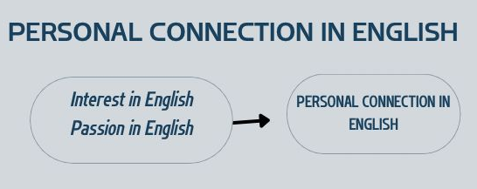
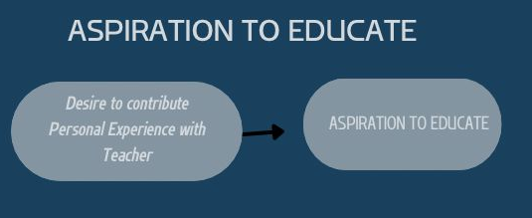
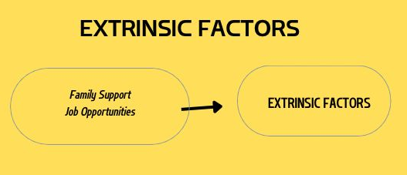
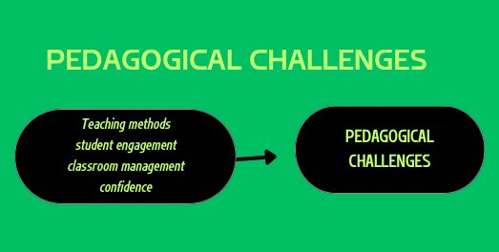
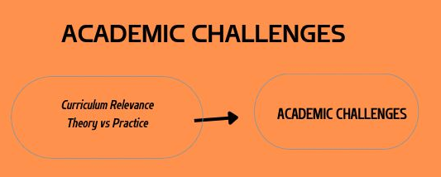
Appendix 5: Documentation of Trustworthiness Member Checking
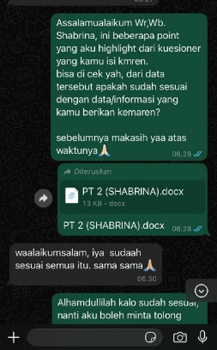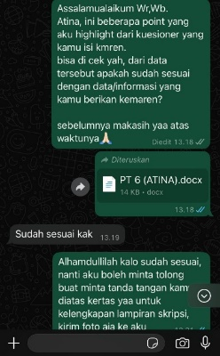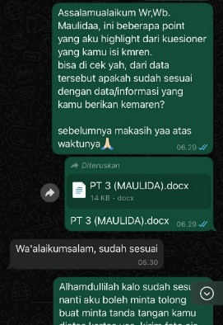
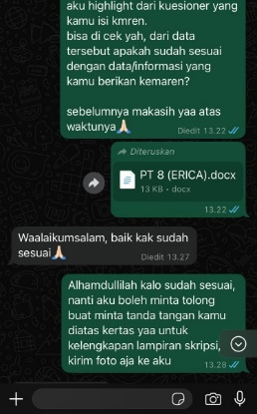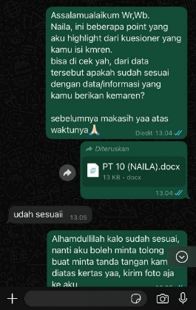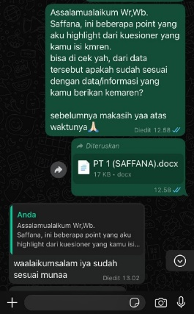
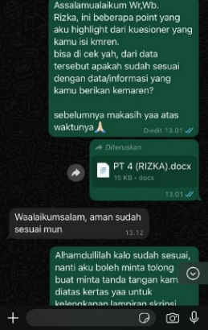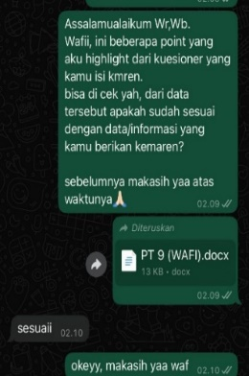
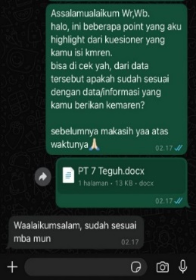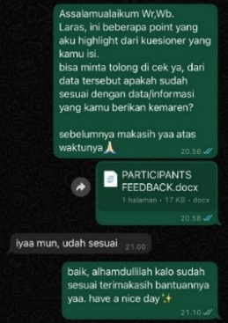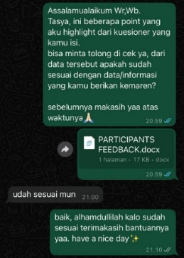
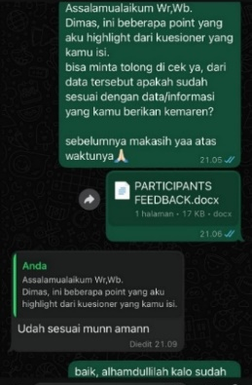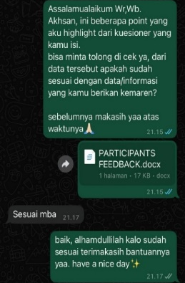

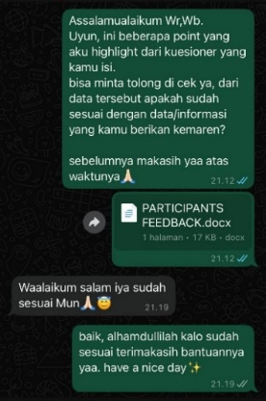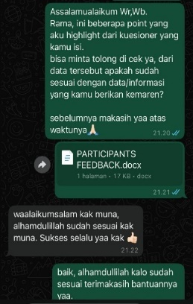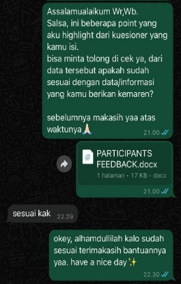
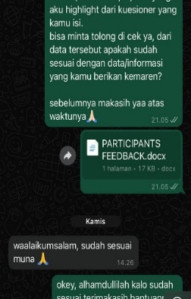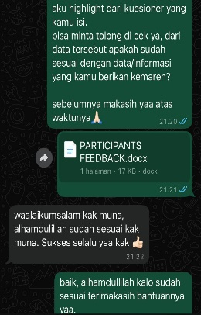
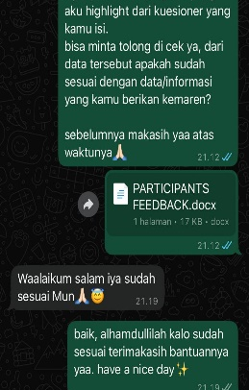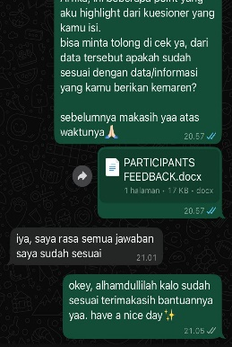
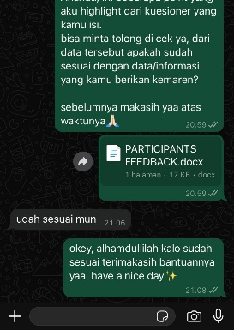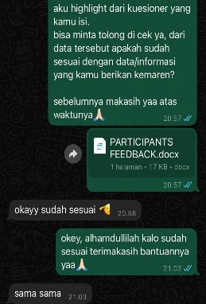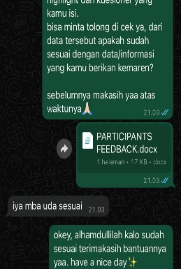
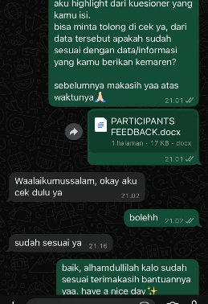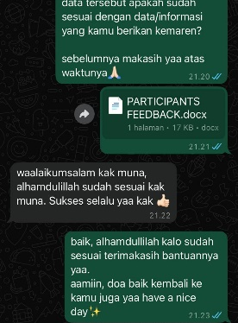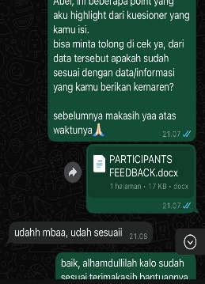

CURRICULUM VITAE
  - Personal Data
Name : Muna Mabruka Azzahra
Place of birth : Kotawaringin Timur
Date of birth : March, 1th 2002
Address : Sampit, Kotawaringin Timur,
Kalimantan Tengah
Email : munaa8087@gmail.com
  - Formal Education
      - TK Rahmat Sampit
      - SD Negeri 3 Ketapang
      - SMP Darul Hijrah Puteri Martapura
      - MAN Kotawaringin Timur
      - Universitas Islam Negeri Walisongo Semarang

Semarang, 18 April 2025
The Researcher
Muna Mabruka Azzahra

