MAXIMIZING STUDENTS’ ENGAGEMENT IN TASK-BASED LANGUAGE LEARNING: EFL TEACHERS' PRACTICE AND STUDENTS’ VIEWS

THESIS
Submitted in Partial Fulfillment of the Requirement
for Gaining the Degree of Education Bachelor in English Language Education



Author:
Amalia Farihal Husna
2103046200

ENGLISH EDUCATION DEPARTMENT
FACULTY OF EDUCATION AND TEACHING TRAINING
UNIVERSITAS ISLAM NEGERI WALISONGO
2025

THESIS STATEMENT
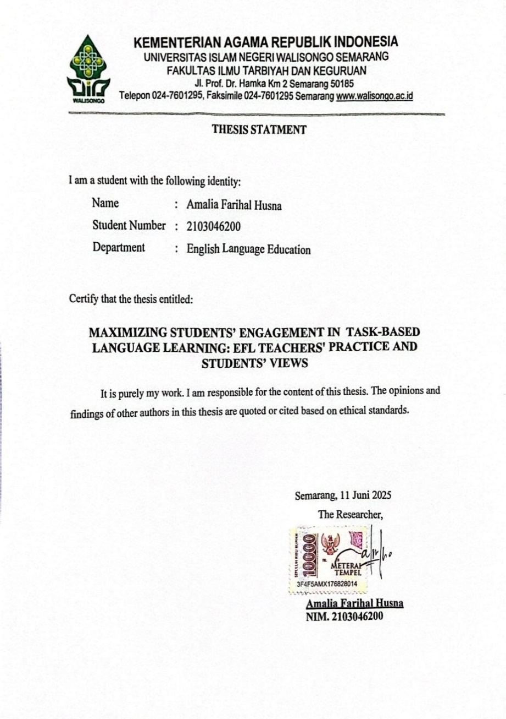

RATIFICATION
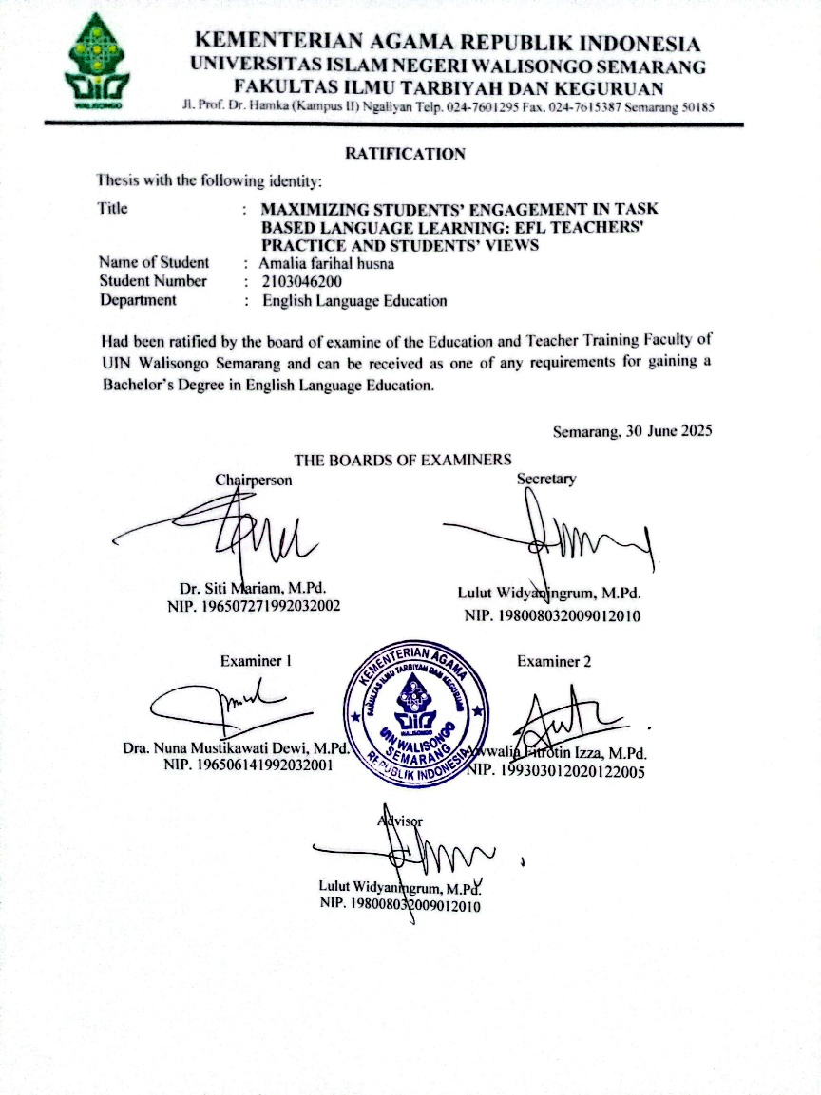

ADVISOR NOTE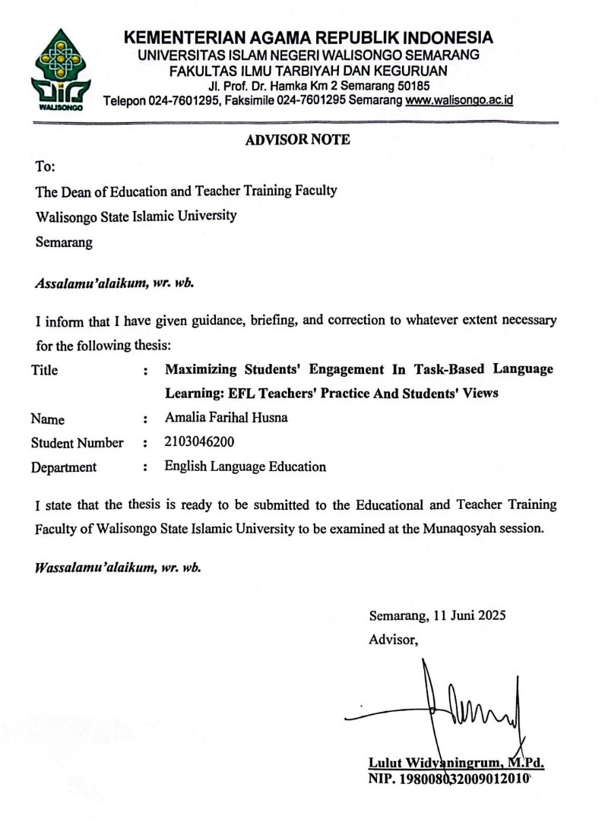

THESIS GUIDANCE SCORE
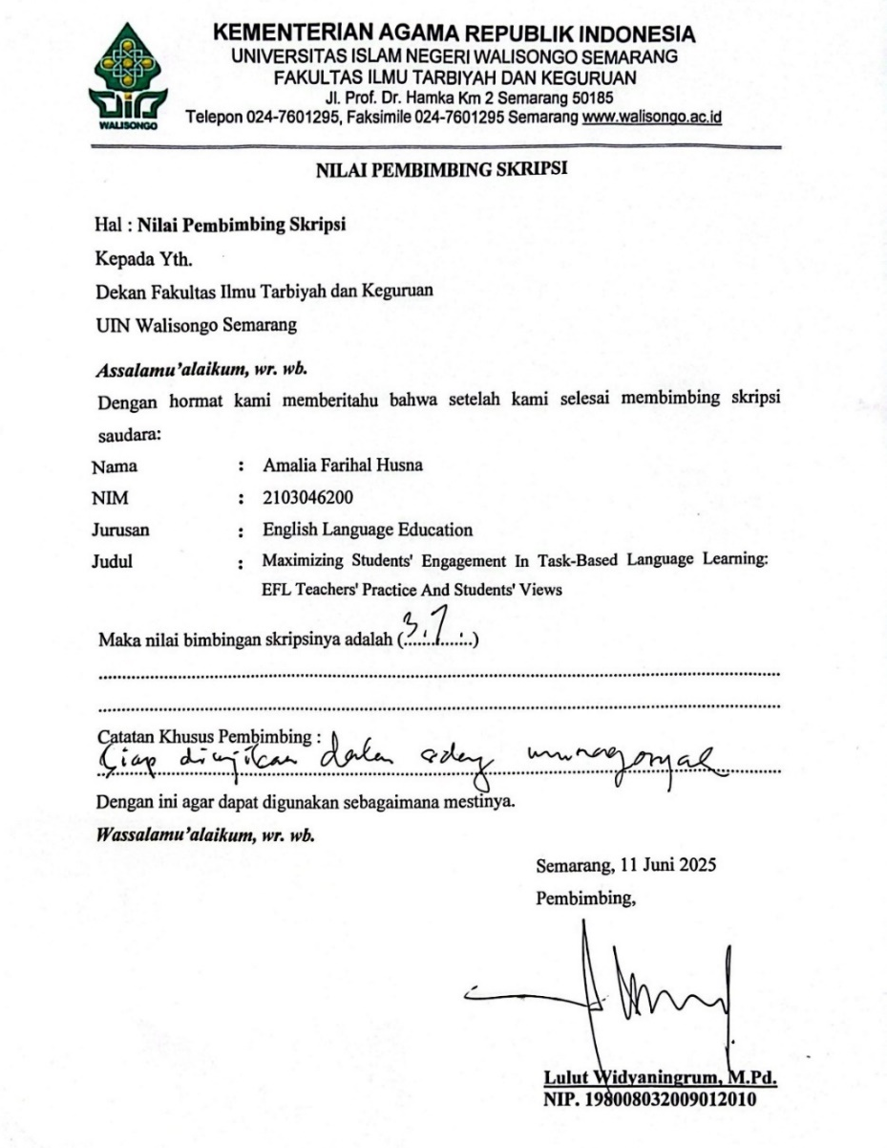
ABSTRACT

Title : Maximizing Students' Engagement in Task-Based Language Learning: EFL Teachers' Practice and Students' Views
Name : Amalia Farihal Husna
Student Number : 2103046200

This study investigates the implementation of Task-Based Language Learning (TBLL) in an English as a Foreign Language (EFL) classroom and explores students’ perceptions of their engagement throughout the process. Using a qualitative descriptive approach, data were collected through classroom observation, a teacher interview, and focus group discussions with students. Thematic analysis was applied to identify key patterns in the data related to emotional, cognitive, and behavioral engagement. Findings show that students generally responded positively to TBLL, especially when tasks were interactive, collaborative, and creatively designed, such as poster-making, role-playing, and group discussions. These tasks enhanced students’ enjoyment and confidence, encouraging them to participate more actively in learning. However, several challenges were noted, including unclear instructions, unequal participation during group work, and a lack of consistent feedback. Despite these limitations, students demonstrated a clear understanding of the types of activities that supported their learning and motivation. The results suggest that TBLL can effectively foster engagement when implemented with clear task guidance, structured peer collaboration, and reflective follow-up. This study highlights the importance of designing tasks that are meaningful, student-centered, and well-facilitated to optimize learning outcomes in the EFL context.

Keywords: Student Engagement, Task-Based Language Learning, EFL Teacher Practice, Students’ Views, Classroom Implementation.
MOTTO

"You don’t have to be great to start, but you have to start to be great."
— Zig Ziglar

"What is meant for you will reach you, even beneath two mountains."

"So verily, with hardship, there is ease."
— Q.S. Al-Inshirah: 6

DEDICATION
All praise and gratitude be to Allah SWT, the Most Gracious and the Most Merciful, for the endless blessings, strength, and guidance that enabled me to complete this thesis. Sholawat and Salam are always devoted to the Prophet Muhammad SAW, who has enlightened our path with knowledge and faith.
This thesis is lovingly dedicated to:
- My beloved parents, Mr. Suharso and Mrs. Hariatun Agustina, for your unconditional love, endless prayers, and immeasurable sacrifices. Your constant support, encouragement, and faith in me have been my greatest strength throughout this journey. I am forever grateful and proud to be your child.
- My extended family, the family of Mbah Kasim, whose warmth and prayers have always accompanied me, near or far. Thank you for being my home and source of strength.
- Mrs. Lulut Widyaningrum, M.Pd, my devoted thesis advisor, for her guidance, support, and insightful advice. Thank you for your patience and encouragement in helping me reach this academic milestone.
- Ibu Eis Sukarsih, S.Pd.., as the participant of this research, and the students of SMP Hasanuddin 6 Semarang, thank you for your cooperation and meaningful contributions during the data collection process.
- To someone special (2205046039), thank you for your endless encouragement, patience, and understanding during the ups and downs of this process.
- Lutfiah AL-asbin Ulyani, Halimatu Sadiyah Nasution, and Siti Nur Hanifah are my best companions in this thesis journey. Thank you for your support, laughter, and the unforgettable memories we shared throughout our journey.
- Amalia, thank you for staying strong when things got tough, believing in your worth, and never quitting. This is your victory, too; wear it with pride.
This thesis is a humble token of my gratitude to all of you. May Allah SWT reward you abundantly and bless you always.

ACKNOWLEDGEMENT
Bismillahirrohmanirrohim, With heartfelt gratitude, the researcher humbly thanks Allah SWT, whose divine grace, strength, and guidance have been a guiding light throughout every step of this academic journey. Without His mercy, this thesis would never have reached completion. Endless blessings and salutations are extended to the Prophet Muhammad SAW, the great teacher of humanity, whose teachings continue to inspire and illuminate the hearts of generations. This thesis stands not only as an academic accomplishment but also as a testimony to the unwavering support and love of many remarkable individuals. Therefore, the researcher sincerely expresses appreciation to:
- Prof. Dr. Fatah Syukur, M.Ag, as the Dean of the Faculty of Education and Teacher Training of UIN Walisongo Semarang.
- Dra. Nuna Mustikawati Dewi, M.Pd, is the Head of the English Language Education Department of UIN Walisongo Semarang.
- Mrs. Lulut Widyaningrum, M.Pd.., as the Secretary of the English Language Education Department and the thesis advisor. Her guidance and encouragement have played a pivotal role in the completion of this thesis.
- Awwalia Fitrotin Izza M.Pd, as my academic advisor, who has given me guidance and suggestions from the beginning of my study.
- All the lecturers and administrative staff of the English Language Education Department have provided knowledge and support throughout the researcher’s study.
Finally, the researcher sincerely welcomes any constructive suggestions and feedback to improve the quality of this thesis. The researcher hopes this study can provide meaningful insight and serve as a useful reference for future readers, educators, and anyone interested in the topic discussed.
Semarang, 11th June 2025

The Researcher,

Amalia Farihal Husna
NIM. 2103046200
TABLE OF CONTENTS
THESIS STATEMENT ………………………………………… i
RATIFICATION ………………………………………………. ii
ADVISOR NOTE ……………………………………………… iii
THESIS GUIDANCE SCORE ………..……………………… iv
ABSTRACT ……………………………………………………. v
MOTTO ……………………………………………………….. vi
DEDICATION …………………..……………………………. vii
ACKNOWLEDGEMENT ……………………………………… ix
TABLE OF CONTENT ……………………………………….. xii
LIST OF FIGURES ……………………………………………. xiiv
LIST OF TABLES …………………………………………….. xiv
LIST OF APPENDICES ……………………………………….. xv

CHAPTER I: INTRODUCTION
- Background of the Research ………..…………………… 1
- Reasons for Choosing the Topic ………….………………. 8
- Research Questions ………………………………………. 9
- Research Objectives ……………………………………… 10
- Significance of the Study …………………………………. 10

CHAPTER II: REVIEW OF RELATED LITERATURE
- Previous Study ……………………………………………… 12
- Learners’ Perceptions of TBLT Phases ……………….. 13
- Teachers’ Attitudes and Implementation Competence … 14
- Hybrid TBLT Models and Engagement Outcomes ……. 16
- TBLT Implementation Challenges in
Indonesian EFL Context ……………………………….. 18
- Literature Review ……………………………………………20
- Task-Based Language Learning (TBLL) ………………. 20
- Student Engagement in Language Learning ……………. 21
- EFL Teacher's Role in TBLL …………………………… 22
- Students' Views and Voices in TBLL …………………… 23
- Conceptual Framework …………………………………… 23

CHAPTER III: RESEARCH METHODOLOGY
- Research Approach …………………………………. 27
- Research Design ……………………………………. 28
- Participants ………………………………………….. 29
- Data Collection Techniques ……………….…………… 30
- Data Analysis Technique ……..…………………………. 32

CHAPTER IV: FINDINGS AND DISCUSSION
- Findings ……………………………………………… 35
  - Teacher Practice ……….………………………….. 35
  - Students’ Views ………..….……………………… 46
  - Favorite Task Types ………..………………….. 46
  - Perceived Boring Tasks ……………………….. 48
  - Feelings About Group or Pair Work …………… 50
  - Whether About Help Improve English Fluency .. 52
  - Suggestion for More Interesting Tasks ………... 54
  - Focus Group Discussion (FGD) ………………..… 57
- Discussion ………………………………………….. 61
- Teacher Practice …………………………………... 61
- Students’ Views …………………………………… 63
CHAPTER V: CONCLUSION AND SUGGESTIONS
- Conclusion ………………..…………………………... 68
- Suggestions ………………………..………………….. 70

REFERENCE .........…………………………………………… 73
APPENDICES …..…………………………………………….. 79
CURRICULUM VITAE ………………..…………………….. 97

LIST OF FIGURES
Figure 2.1 Conceptual Framework ………………………….. 24
Figure 4.1 Source: Researcher’s documentation, class …….. 41
Figure 4.2 Source: Researcher’s documentation, class …….. 42

LIST OF TABLES
Table 4.1 Teacher’s Responses to Interview ……………… 39
Table 4.2 Classroom Observation Checklist ………………. 43

LIST OF APPENDICES
Appendix 1 Teacher Response ……………………………… 79
Appendix 2 Students’ Response to Open-Ended Questions …. 82
Appendix 3 Classroom Observation ………………………… 86
Appendix 4 Rencana Pelaksanaan Pembelajaran (RPP) …….. 88
Appendix 5 Focus Group Discussion (FGD) ………………… 92
Appendix 6 Documentation …………………………………. 95
CHAPTER I
INTRODUCTION
This chapter presents the study's background, including the reasons for choosing the topic, research questions, research objectives, and significance, with a focus on maximizing student engagement in Task-Based Language Learning (TBLL) in EFL classrooms.
    - Background of the study
In English as a Foreign Language (EFL) learning, student engagement has emerged as a crucial focus of educational research. Within the EFL classroom, student engagement reflects the extent to which learners are cognitively, emotionally, and behaviorally involved in the learning process. However, despite its recognized importance, achieving optimal levels of engagement remains a significant challenge. Many students exhibit minimal participation, low motivation, and detachment from learning activities. This gap between pedagogical ideals and classroom realities is particularly visible in Task-Based Language Learning (TBLL) environments, where active student participation is essential. Recent research by (Zhang & Yanfeng, 2025) Revealed that EFL teachers often struggle to maintain consistent student engagement during task-based activities, even though such methods have been shown to effectively enhance language proficiency.
The theoretical foundation for this study is grounded in the multidimensional framework of student engagement proposed by Fredricks, Blumenfeld, & Paris (2004), which highlights three interacting dimensions: behavioral engagement, emotional engagement, and cognitive engagement. In foreign language education, the practical application of this theory becomes pivotal, as language acquisition requires active and meaningful practice, not merely passive absorption of knowledge. Therefore, this study aims to explore how EFL teachers implement strategies to maximize students’ engagement in task-based learning and understand students’ perspectives regarding their learning experiences. In Indonesia, where English is taught as a foreign language in a variety of educational settings, engaging students remains a persistent challenge. Students often show signs of passive learning, a lack of intrinsic motivation, and limited willingness to communicate in English. These issues are particularly pressing in teacher-centered classrooms, where the teaching approach fails to provide meaningful communicative experiences (Zepke, 2015). Also, learners need to consider the whole linguistic form rather than focusing on a single structure. Another reason why Task-Based Language Learning (TBLL) is more appropriate for learners is that the aim is to integrate all four skills and move from fluency to accuracy and fluency (Viriya, 2018).
Student engagement has a significant impact on learning outcomes in foreign language education. Highly engaged students typically demonstrate greater intrinsic motivation, improved academic achievement, and faster development of language skills. Shaikym (2025) confirmed that intrinsic motivation is closely linked to heightened engagement in EFL classrooms, which consequently leads to better learning results (Shaikym MA, n.d.). Although TBLL is considered an effective framework to boost student engagement, its success greatly depends on how teachers implement it in the classroom. Research shows that many EFL teachers experience difficulties in selecting appropriate tasks, contextualizing content for learners, facilitating interaction, and providing timely feedback ( Milon et al., 2023; Pathan et al., 2023). These challenges often result in tasks being reduced to mechanical activities rather than authentic, communicative ones. Furthermore, students often perceive TBLL activities as either overly challenging or lacking relevance, which hinders their active participation (Alfarisi, 2023; Vu Thi Minh & Tran Quoc, 2021).
Despite the growing recognition that Task-Based Language Learning (TBLL) can effectively enhance student engagement, a significant gap remains in understanding how EFL teachers practically implement TBLL to maximize engagement and how students perceive their experiences within this framework, particularly in specific EFL contexts such as Indonesia. While many studies have focused either on the effectiveness of TBLL in general or on isolated perspectives of teachers or students, few have systematically integrated both viewpoints, especially in combination with student perceptions. Among studies from the past five years, only a handful Boots & Engels, 2020;Molnar & Dániel, 2024; Kołsut & Szumilas, 2023) explicitly explore the alignment between instructional implementation and learners’ engagement experiences, particularly in Southeast Asian or Indonesian contexts.
Despite the growing body of literature on TBLL, recent studies have highlighted teachers’ practice as a critical factor that influences student engagement outcomes. Effective implementation of TBLT requires teachers to have a deep understanding of task design, classroom management, and scaffolding strategies that promote participation (Pham et al., 2018; Nguyen et al., 2021). Unfortunately, in many EFL contexts, teachers struggle with applying TBLL principles due to limited training, rigid curricula, or classroom constraints. Research shows that misalignment between TBLL theory and practice can reduce its intended benefits (Littlewood, 2007). In Indonesia, only a handful of studies have systematically examined how EFL teachers practice TBLL in real classrooms (Astuti & Lestari, 2021; Zhao, 2024), and even fewer have included students’ views on their engagement within this framework.
If the gap between teacher practice and student engagement continues unaddressed, the implications may be significant. Disengaged students are more likely to withdraw from learning activities, show lower academic performance, and develop negative attitudes toward English learning. In the long run, these issues contribute to national deficiencies in communicative English competence. (Kołsut & Szumilas, 2023) warn that without strong, task-based implementation from teachers, language classrooms risk becoming “functionally silent” spaces where students lack the confidence to speak. These systemic failures undermine the purpose of TBLL and hinder students from reaching proficiency.
This study focuses on two main components: EFL teachers’ practices in implementing Task-Based Language Learning, and students’ views on their engagement within that instructional framework. It investigates how teachers design, deliver, and support task-based lessons and how students interpret, respond to, and participate in those tasks. Indicators include the structure of the tasks, relevance to learners' context, student interaction, clarity of instructions, and feedback mechanisms. Research conducted by (Tusino et al., 2020) also supports this focus, emphasizing the importance of aligning teacher intention and student response to fully leverage TBLL’s potential for active learning.
Theoretically, this study is significant because it offers in-depth insights into the dynamics of student engagement in Task-Based Language Learning (TBLL) from both teachers' and students' perspectives. It contributes to the growing body of literature that explores how active learning approaches can impact EFL learners’ motivation, participation, and overall achievement. As noted (Boots, n.d.-b), understanding the interaction between meaningful tasks and student engagement is crucial for advancing EFL pedagogy in modern educational contexts. Furthermore, Brooks & Lutes (n.d.) highlight the pedagogical necessity of recognizing students’ affective responses to task-based approaches to fully leverage the engagement potential of TBLL.
Practically, the findings of this research can serve as a valuable resource for EFL teachers by offering evidence-based strategies for designing and implementing more effective task-based learning activities aimed at maximizing student engagement. (Tusino et al. 2020) emphasized that effective TBLL strategies not only enhance task relevance but also foster emotional and behavioral investment among students. Additionally, (Molnar and Daniel 2024) stressed that the proper adaptation of TBLL methodologies provides teachers with actionable frameworks for enhancing classroom interactivity and learner autonomy.
From a broader perspective, this research is also beneficial for curriculum developers and teacher training institutions. (Wenas et al., 2023) demonstrated that incorporating TBLL into EFL curricula significantly boosts active learning, helping learners develop critical thinking and communicative competence more naturally. Moreover, (Khan Milon et al., 2023) underscored the importance of structured TBLL training programs for teachers to ensure the sustainable integration of task-based pedagogy into classroom practice.

    - Reasons for Choosing the Topic
The researcher in this study prefers to investigate Task-Based Language Learning (TBLL) in maximizing students’ engagement in EFL classrooms with the following considerations:
- Student engagement is a crucial factor in successful foreign language acquisition, and its development is essential in EFL learning environments.
- Task-Based Language Learning (TBLL) provides a communicative and interactive framework that promotes active participation and real-world language use.
- TBLL focuses on meaning-making tasks, which can naturally enhance students’ emotional, behavioral, and cognitive engagement during language learning.
- Investigating both EFL teachers’ practices and students’ perceptions offers a comprehensive understanding of how engagement can be maximized through TBLL.
- The findings from this study are expected to contribute practically to the improvement of teaching strategies and theoretically to the development of student-centered learning

    - Research Questions
Based on the research background, several topics can be discussed. In this study, the researcher focuses on maximizing student engagement and the impact of task-based learning in English classes. The following is the problem formulation of this research:
- How do EFL teachers implement strategies to maximize students' engagement in Task-Based Learning?
- What are the students' perceptions of their engagement during the implementation of TBLL in the EFL classroom?

    - Research Objectives
Concerning the problem of the study, the objectives of the study were to find out:
- To investigate how EFL teachers implement Task-Based Learning (TBL) strategies to enhance student engagement in the classroom.
- To analyze students’ perceptions and experiences regarding their engagement during the implementation of Task-Based Language Learning (TBLL).

    - Significance of the Study
The present study is expected to be useful and provide benefits to several parties related to this research, including the following:
- For the Researcher :
By conducting this study, the researcher gains practical experience in implementing and analyzing educational research, particularly in the field of Task-Based Language Learning. It enhances the researcher’s academic competence and critical awareness of teaching practices and student engagement strategies, which are beneficial for future professional development as an educator.
- For the Teachers
The findings of this research offer insights into how TBL can be effectively implemented to improve student engagement in EFL classrooms.
- For the Students
This research highlights students’ voices and perceptions regarding task-based learning, which can inform more inclusive and engaging classroom practices. Through the implementation of meaningful and interactive tasks, students can develop a greater interest in learning English, improve their confidence in using the language, and gain more positive learning experiences that support their language development.

CHAPTER II
REVIEW OF RELATED LITERATURE

This chapter reviews the theoretical frameworks and previous research relevant to TBLT and student engagement, offering insights into the methodology.

    - Previous Study
Research on Task-Based Language Teaching (TBLT) in English as a Foreign Language (EFL) context has expanded substantially in recent years, particularly regarding its potential to enhance student engagement. To present a focused and thematically coherent review, this section organizes relevant studies around key research issues that have emerged in the literature. These include: learners’ perceptions of TBLT stages, teacher competency and attitudes, task design quality, hybrid TBLT models, multidimensional engagement patterns, and student voice in task-based instruction. These themes not only contextualize the current study but also reveal critical gaps that it aims to address.

  - Learners’ Perceptions of TBLT Phases
The first issue relates to how students perceive the structured phases of TBLT, namely pre-task, during-task, and post-task stages, and how these influence their participation. (Ilham, n.d.) found that students valued the systematic nature of TBLL, particularly the clarity and predictability it offered in navigating language tasks. The pre-task phase was seen to assist with mental preparation, while the during-task phase promoted peer interaction and the use of authentic language. In the post-task phase, students appreciated opportunities for reflection and teacher feedback. These structured phases were associated with increased motivation and a sense of learning progression. However, current literature does not yet provide sufficient insight into how each phase specifically contributes to different dimensions of engagement (behavioral, emotional, cognitive), especially in junior secondary EFL classrooms.
In terms of relevance to the present study, both Ilham’s research and the current investigation share a common focus on student engagement and the role of TBLL in promoting active participation in EFL classrooms. They both highlight how students' perceptions of task-based learning activities can lead to improved motivation and classroom interaction. However, the two studies differ in scope. While Ilham concentrated primarily on the development of writing skills through TBLL and how students perceived its effectiveness, the current study extends the discussion by also examining speaking skills and incorporating the perspectives of both teachers and students. This broader scope allows the current research to explore not only how students engage with TBLL activities but also how teacher practices influence the overall learning experience in EFL contexts.

  - Teachers’ Attitudes and Implementation Competence
The second issue concerns teachers’ understanding, attitudes, and competencies in implementing TBLT principles. Several studies, such as those by(Prianty et al., 2021) The results of this study show that the majority of teachers have a positive view of TBLT, as this approach is perceived to increase student participation and create a more active learning atmosphere. However, an interesting finding from this study is that most teachers do not have a deep understanding of the practical implementation of the approach in the daily classroom context. They felt that more specific training and guidance were needed for TBLT to be implemented effectively. These findings indicate that teacher cognition, comprising beliefs, knowledge, and attitudes, remains a critical yet underexplored factor in determining student engagement outcomes in TBLT classrooms. Similarly, (Nguyen et al., 2021) highlighted how a lack of targeted training and practical resources often hinders teachers' ability to align TBLT theory with classroom realities. These challenges frequently led to the reduction of tasks into mechanical exercises rather than meaningful communication events.
The main similarity between this study and the current study is the focus on EFL teachers' perspectives on TBLT implementation in the classroom. Both studies highlight how teachers' attitudes and approaches play a major role in the successful implementation of TBLT. However, there are significant differences that make this study a relevant complement. The current study not only addresses teachers' perspectives, but also involves students' views directly to get a more comprehensive picture of students' engagement in task-based learning.

  - Hybrid TBLT Models and Engagement Outcomes
Third, the study conducted by (Tusino et al., 2020) conducted a study involving student engagement in a hybrid-based Task-Based Language Learning (TBLL) approach in a writing class in the context of learning English as a Foreign Language (EFL). In this study, they compared the effectiveness of traditional TBLL conducted face-to-face with a hybrid version that incorporated courageous learning. The main focus of the study was the level of student participation and task completion in the two learning models. The results showed that the hybrid TBLL model proved to be highly effective in increasing student engagement. The flexibility offered by courageous learning allows students to access and complete tasks more conveniently, while the interactive elements of task-based learning are maintained through face-to-face meetings. This combination provides room for students to more actively participate, thereby increasing learning motivation and consistency in completing tasks. Students were more consistent in completing tasks and exhibited higher autonomy. While promising, this line of inquiry is largely limited to academic writing contexts, leaving a gap regarding its effectiveness in enhancing spoken interaction or emotional engagement in EFL speaking tasks.
When compared to the current study, there are similarities in the focus on how TBLL can increase student engagement in EFL learning. Both highlight that task-based activities can create a more active and participatory learning atmosphere. However, there are important differences in the approaches used. The research conducted by Tusino and his colleagues promotes a hybrid TBLL model that combines dare and face-to-face learning, while the current study focuses on the implementation of TBLL in a traditional face-to-face format in the classroom. Not only in the context of writing, it also covers speaking skills, and pays attention to teachers' teaching practices and students' overall views on the task-based learning process.

  - TBLT Implementation Challenges in Indonesian EFL Contexts
The Fourth study was conducted by (Maulana, 2021) entitled Task-Based Language Teaching: Potential Benefits and Possible Criticisms in Indonesian Contexts, published in the Journal of English Teaching and Learning Issues. This study is a conceptual review that discusses the potential benefits as well as criticisms of the application of the Task-Based Language Teaching (TBLT) approach in the context of English language learning in Indonesia. Maulana highlights that TBLT can encourage more natural learning, increase students' intrinsic motivation, and develop more communicative language skills. Despite growing interest in TBLT in Southeast Asia, there are persistent barriers in Indonesian classrooms. These include rigid curricula, inadequate teacher training, and a lack of institutional support. underscored the need for context-sensitive adaptations of TBLT to ensure its successful integration into local classrooms. However, the study also noted some challenges in implementing TBLT, such as teachers' limited understanding of the approach and the lack of resources to support its effective implementation in the classroom.
The similarity between this study and the current research lies in the focus on the implementation of TBLT and its impact on student engagement in English language learning. Both studies emphasize the importance of task-based approaches in creating a more interactive and participatory learning environment. However, the main difference is that Maulana's study is more theoretical and does not involve direct empirical data from teachers or students. Meanwhile, this study aims to provide a more comprehensive perspective by combining an analysis of teachers' teaching practices and students' direct views and experiences in task-based learning. Thus, the approach used in this study is expected to provide deeper insights into the implementation of TBLT and strategies to increase student engagement in the context of learning English as a foreign language.
By integrating both teacher practice and student perception, this study aims to provide a holistic and context-specific understanding of TBLT’s impact on student engagement. While previous studies often examined either teacher implementation or learner response in isolation, there remains a lack of integrated research that explores the alignment or misalignment between instructional strategies and students' actual engagement in task-based activities. Particularly in the Indonesian secondary school context, empirical studies that bridge these two perspectives are still limited. Therefore, this research seeks to fill that gap by offering comprehensive insights into how task-based learning can be effectively implemented to enhance meaningful student participation and how students themselves interpret and respond to such instructional approaches in EFL classrooms.

- Literature Review
- Task-Based Language Learning (TBLL)
Task-Based Language Learning was developed as a learning approach that places language use in real situations at the center of learning activities. In this approach, the learning process does not focus on explicit language rules, but rather on students' engagement in completing meaningful tasks. Task-Based Language Learning (TBLL) is an instructional approach that emphasizes the use of authentic language through meaningful tasks. According to Ellis (2019), a “task” is an activity that requires learners to use the target language to achieve a communicative goal, rather than merely practicing language forms. TBLL consists of three main stages: pre-task, during-task, and post-task (Willis & Willis, 2011). Nunan (2004) also highlights that tasks in TBLL should be learner-centered, involve real-world communication, and reflect learners’ needs. These tasks can take the form of problem-solving, discussions, or collaborative projects.

- Student Engagement in Language Learning
Student engagement refers to the level of interest, motivation, and involvement learners show in the learning process. (Fredricks et al., 2004) divide engagement into three dimensions: behavioral, emotional, and cognitive. In a language classroom, high engagement is often reflected in active participation, effort in completing tasks, and emotional connection to learning activities. Recent studies have shown that well-designed tasks can stimulate students' curiosity, concentration, and internal motivation to participate. These aspects of engagement include active behavior in class, effort to complete tasks, and the ability to think critically about the material being studied.
Philp and Duchesne (2016) emphasize that engagement in TBLT depends not only on behavioral participation but also on emotional and cognitive involvement. They further asserted that task engagement is shaped by classroom atmosphere, peer interaction, and teacher support, in addition to task characteristics. The current study adopts this multidimensional model to understand how TBLT affects learners’ involvement across domains and to assess how teachers' practices align with these needs and how and why students engage differently in similar tasks.

- EFL Teacher's Role in TBLL
Teachers in TBLL settings act not just as knowledge providers but as facilitators, observers, and designers of communicative tasks. (Littlewood, n.d.) argues that teachers must carefully scaffold tasks to match students’ proficiency levels and provide supportive feedback. (González-Lloret 2020) adds that teachers must create a classroom climate that encourages risk-taking and real-world communication. A qualitative study by (Prianty et al., 2021) found that teachers’ awareness and training in TBLL principles significantly affect their classroom practices, influencing how effectively they can engage students

- Students' Views and Voices in TBLL
Understanding students’ perceptions of task-based learning helps educators fine-tune instruction to meet learners’ needs. (Cook-Sather, 2006) promotes “student voice” as a strategy to empower learners and shape more inclusive classroom practices. In language education, students' feedback about tasks, learning pace, and engagement strategies can help improve both teaching quality and learning outcomes.

C. Conceptual Framework
This study examines the relationship among four major variables: EFL teacher practice, task-based learning, student engagement, and student perception. The framework assumes that EFL teachers, through their instructional practices, design and implement tasks that directly influence student engagement. This engagement is further moderated by how students perceive the relevance, clarity, and value of those tasks.
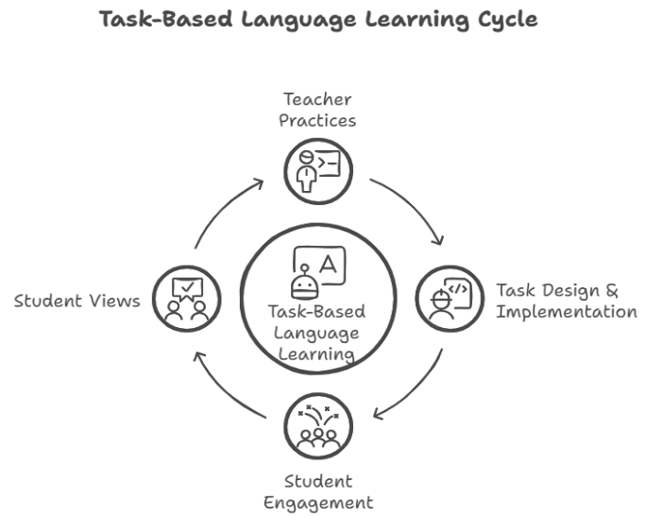
Figure 2.1 Conceptual Framework
Conceptual Framework
This conceptual framework illustrates the relationship among EFL teachers’ instructional practices, the implementation of Task-Based Language Learning (TBL), and students’ engagement in English learning. Teachers serve as initiators who design and facilitate meaningful, communicative tasks aligned with the principles of Task-Based Learning (TBL). These tasks function as the core medium of instruction, influencing students' engagement across three dimensions: cognitive, emotional, and behavioral. Meanwhile, students’ perceptions and experiences of the tasks further shape their engagement, mediating the effectiveness of TBL in fostering active language learning.
Teacher practices initiate the learning process through the selection and facilitation of meaningful tasks. These tasks, aligned with the TBLT approach, serve as the vehicle for language learning. Student engagement emerges as a response to both the tasks themselves and the way they are delivered. Meanwhile, students' perceptions influence how they interpret and engage with the tasks, which in turn affects the success of the learning process.
Tthis literature review demonstrates that while TBLT has been widely recognized for its potential to foster student engagement, several important gaps remain. Most prior studies have either focused on students’ or teachers’ perspectives in isolation, without capturing the interaction between teacher practices and learner responses. Furthermore, research in the Indonesian context, particularly at the secondary level, is still sparse and often lacks a comprehensive examination of engagement in its multiple dimensions. Therefore, this study addresses these gaps by investigating both teacher practices and student perspectives to understand how engagement unfolds during task-based instruction. This integrated perspective is crucial for developing more responsive, contextually grounded, and effective TBLT implementations in EFL classrooms.

CHAPTER III
RESEARCH METHODOLOGY

    - Research Approach
This study used a qualitative approach to explore EFL teachers' practices in task-based learning and students' views regarding their engagement. The qualitative approach was chosen as it allows the researcher to understand the experiences, perspectives, and contexts underlying students' engagement in language learning. This approach also provides flexibility for researchers to adjust the data collection process to real situations in the field, as well as to capture the meaning formed by the interaction between teachers and students in authentic situations (Creswell, J.W. 2014). Thus, the qualitative approach in this study is not only relevant but also very important to describe in full how task-based learning strategies are implemented, as well as how students respond and engage in them from their perspectives.

    - Research Design
This study employs a qualitative descriptive design, which is suitable for providing a comprehensive, straightforward account of phenomena in natural settings. The primary aim of this design is not to interpret data through deep theoretical frameworks, as in phenomenology or grounded theory, but to stay close to the data and offer clear, descriptive summaries of participants and actions in their terms (Sandelowski, 2000). In the context of this research, the design is appropriate because the study seeks to describe how an EFL teacher implements Task-Based Language Learning (TBL) strategies in the classroom and how students perceive their engagement with those tasks. The qualitative descriptive approach allows the researcher to remain grounded in the data, capturing both the instructional practices of the teacher and the nuanced perspectives of the students, without imposing external theoretical constructs. This design enables the collection of rich, detailed insights using interviews, classroom observations, and focus group discussions all aimed at portraying the reality of TBL implementation and student engagement in a real-life Indonesian EFL context.
    - Participants
Hasanuddin 6 Junior High School was selected as the research site because it actively implements task-based learning strategies and has a teacher experienced in using TBLT. This school provides a relevant setting to observe how task-based instruction is applied in real classroom situations and how students engage with it. The presence of varied student characteristics and active task-based practices made it a suitable context for exploring both teacher practices and students’ engagement in the EFL classroom.
Another reason why Researcher selected this school is that it has only one English teacher who teaches all the English classes. This made it easier to coordinate and observe teaching practices consistently. Also, the teacher already has experience using task-based learning, so the implementation of TBLT here could be seen more clearly in practice, not just in theory. By choosing this school, Researcher could directly observe how TBLT strategies are applied to deal with real challenges in the classroom and how they affect student engagement.
The average number of students in each class is about twenty to twenty-two students, which made the observations more focused and manageable. For this study, Researcher purposively selected fifteen students from the teacher’s class. The students have different academic backgrounds and behavioral characteristics, which helps me get various perspectives about their experiences with task-based learning. Since many students at this school tend to have low motivation and are sometimes difficult to manage, it becomes a perfect setting to see how TBLT can help improve student participation and classroom management in a real teaching situation.

    - Data Collection Techniques
The data in this study were collected through several techniques that are aligned with the research questions, which focus on exploring teachers’ practices in implementing TBLT and students’ perceptions of their engagement. For investigating students' views, two main techniques were used. First, a questionnaire was distributed to the selected students to gather general information about their experiences, levels of engagement, and opinions regarding the tasks given during TBLT activities. This questionnaire used open-ended questions to gain qualitative insights. Second, a Focus Group Discussion (FGD) was conducted with a smaller group of students to explore more deeply their thoughts, feelings, and suggestions about the task-based learning process. Through FGD, the researcher expects to capture diverse perspectives and more detailed explanations from the students.
For collecting data related to the teacher’s practices, three techniques were applied. First, classroom observation was conducted during the implementation of TBLT activities to observe how the teacher designs, delivers, and manages the tasks, as well as how students interact and participate. The observations were recorded through field notes focused on aspects such as task structure, student engagement, and teacher feedback. Second, the researcher collected lesson planning documents, including lesson plans and task materials, to analyze how TBLT principles were incorporated into instructional planning. Third, semi-structured interviews and ongoing teacher reflections were used to understand the teacher’s strategies, challenges faced, and self-assessment regarding the task-based teaching practices. The interviews will allow the teacher to elaborate on their experiences, while ongoing reflections will provided continuous insights into the adaptation and adjustment of TBLT in the real classroom context.
Through this study of data collection techniques, the study aimed to gain a comprehensive understanding of how TBLT was practiced by the teacher and how students perceived and experienced their engagement during task-based learning activities.

    - Data Analysis Technique
The data in this study were analyzed using thematic analysis, which is commonly used in qualitative research to identify, analyze, and interpret recurring patterns or themes within a dataset. According to (Braun et al. 2006), thematic analysis provides a flexible yet systematic approach that enables researchers to make sense of rich qualitative data and draw meaning from participants' perspectives and experiences. This method was considered appropriate for the study as it allowed for a thorough exploration of how task-based instruction was implemented by the teacher and perceived by students in the EFL classroom.
The data sources included semi-structured interviews with the English teacher, student questionnaires with both open-ended items, focus group discussions (FGDs), and classroom observation. All qualitative data were transcribed and translated into English. The researcher then engaged in a process of familiarization by reading through the transcripts multiple times to gain a comprehensive understanding of the content. During this stage, initial notes and observations were made.
Next, the researcher manually generated initial codes by identifying meaningful features within the data. Coding was conducted both inductively by allowing themes to emerge from the data and deductively by referring to the research questions and the theoretical framework presented in Chapter II. The researcher then grouped related codes and began identifying overarching patterns that could be developed into themes.
Once potential themes were established, they were reviewed and refined to ensure internal coherence and accurate representation of the data. During this process, some themes were combined, split, or removed to improve clarity and relevance. After refinement, each theme was clearly defined and named to reflect its specific focus. The final themes were then organized into two main categories: (1) Teachers’ Practices in Implementing TBLT and (2) Students’ Engagement and Perceptions.
Thematic analysis in this study enabled a detailed understanding of the teaching strategies used by the teacher and how students responded to the implementation of TBLT in their English classroom. The systematic coding and theme development ensured that the analysis remained grounded in the data and aligned with the study’s research aims.
CHAPTER IV
FINDINGS AND DISCUSSION
This chapter presents the research findings and discussion based on data collected through classroom observation, teacher interviews, student questionnaires, focus group discussions (FGD), and documentation. at SMP Hasanuddin 6, Semarang. The data were gathered to explore how EFL teachers implement strategies to maximize student engagement in task-based language learning (TBLL) and to understand students' perceptions of their engagement during the implementation of TBLL.
    - FINDINGS
- TEACHER PRACTICE
Maximizing student engagement in learning English through TBLL was a conscious goal emphasized by the English teacher at SMP Hasanuddin 6, Semarang. The implementation of Task-Based Language Learning (TBLL) by the English teacher at SMP Hasanuddin 6 in Semarang was explored through a multi-method approach to ensure data credibility. The researcher conducted classroom observations, collected teaching documents (such as lesson plans and task materials), and carried out semi-structured interviews with the teacher. These triangulated data sources provide a comprehensive understanding of how TBLL strategies were designed, delivered, and adjusted in response to student engagement in the classroom.
No. | Interview Question | Teacher Response
1 | Can you explain how you usually design task-based lessons? | "I design task-based lessons by considering the characteristics of my students. Since some are very active and others struggle with focusing, I must be extra patient when preparing materials that match their level of understanding. I usually begin by explaining the material thoroughly to ensure students grasp the context. Then, I ask a few questions to assess their prior understanding before assigning tasks. After that, I encourage students to come to the front of the class to test how well they’ve understood the material."
2 | What are your main considerations when choosing or creating tasks for students? | "My main consideration is connecting the tasks to the students’ everyday lives. This is important so the material becomes more relevant and easier for them to understand, which in turn increas  es their engagement in the learning process."
3 | What do you do to make students more active during task-based activities? | "To increase student participation, I often use learning media such as mobile phones, pictures, and posters. These helps grab students’ attention and make the lessons more interactive and relatable to their world."
4 | How have students responded so far to the tasks you assign? | "In general, students complete the assigned tasks. Although some may occasionally chat with friends or use their phones during tasks, they still make an effort to complete them on time."
5 | What challenges do you usually face in implementing task-based learning (TBLT)? | "One of the most frequent challenges is low student motivation. Some students are lazy, play games on their phones, or are sleepy in the morning because they stayed up late. To address this, I usually ask drowsy students to wash their faces before returning to class, then I provide more intensive guidance during task work."
6 | How do you determine whether students are actively engaged during task-based learning? | "I usually walk around the classroom to check on each student’s progress. I ask questions like, 'How far have you gotten with your task?' or 'Do you understand what you are supposed to do?' This way, I can see who is truly engaged in the learning activity."
7 | Have you ever changed your teaching methods or task strategies? If so, why and how? | "Yes, I often change my teaching strategies. For example, I don’t always use written tasks I also use pictures, presentations, or direct discussions. This helps ensure that assessment is not only based on written results but also on speaking skills and a more comprehensive understanding of concepts."
8 | What do you need to make the implementation of TBLT more effective in class? | "To improve the implementation of TBLT, I need more engaging learning media. One way to do this is by utilizing students’ mobile phones as learning tools so they can focus more on the task instead of just playing games. This also encourages them to be more active in the learning process."
Table 4.1 Teacher Practice
The table above illustrates the teacher’s perceptions and strategies regarding TBLL. It was found that the teacher had a clear understanding of how to adapt lesson content and teaching methods to suit her students’ engagement needs.
According to question 1, the teacher designed lessons by starting with clear explanations to ensure students understood the context. Only then would she proceed with tasks such as poster-making or class presentations. She emphasized assessing prior knowledge to shape relevant tasks. In response to question 2, the teacher believed that connecting tasks with real-life contexts enhanced students’ motivation and helped them understand vocabulary better. This also bridged the gap between classroom content and students lived experiences. When asked about participation strategies, question 3, the teacher used creative and visual media, such as pictures and mobile phones, to grab attention. She viewed these media as effective for involving students who might otherwise be passive. Question 4 confirmed that while not all students were always focused, most made an effort to complete tasks. The teacher addressed issues of distraction through personal engagement and positive reinforcement. As revealed in question 5, the teacher faced challenges like low motivation and distraction from phones. However, she adapted by implementing physical activities (e.g., washing faces) and offering individual guidance during task completion. In question 6, the teacher stated she monitored student engagement by walking around and asking progress questions. This strategy helped her identify which students were participating and which needed support.
In question 7, the teacher explained that she regularly modified her teaching strategy. She did not rely solely on written exercises but also used oral tasks and discussions to evaluate broader language skills. Lastly, in question 8, the teacher highlighted the importance of learning tools. She believed student phones could be used constructively as educational tools to enhance focus rather than distract.
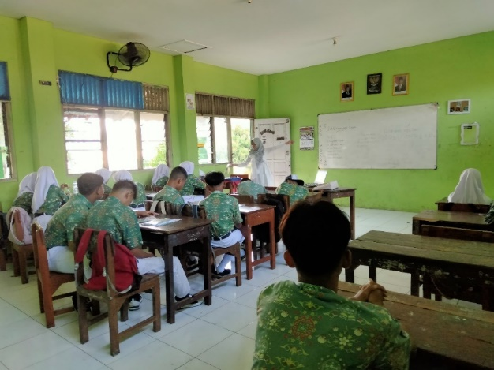
Figure 4.1 Source: Researcher documentation, class
The teacher provides initial instructions at the Pre-Task stage, using posters as learning media. Students discuss in small groups and create prohibition posters, on blank paper distributed by the teacher, as part of the Task Cycle.
Based on the classroom observation, the implementation of Task-Based Learning by the teacher is seen in various stages. As shown in (Figure 4.1), the teacher starts with the Pre-Task stage, introducing the topic of prohibition using visual media. Then, students are actively involved in the Task Cycle stage (Figure 4.2), where they discuss in groups and create a product in the form of a prohibition poster. In the last stage, Language Focus, students collect their work and receive feedback from the teacher and classmates. This process is in line with the principle of Task-Based Learning, where students use language in a real way in a meaningful context.
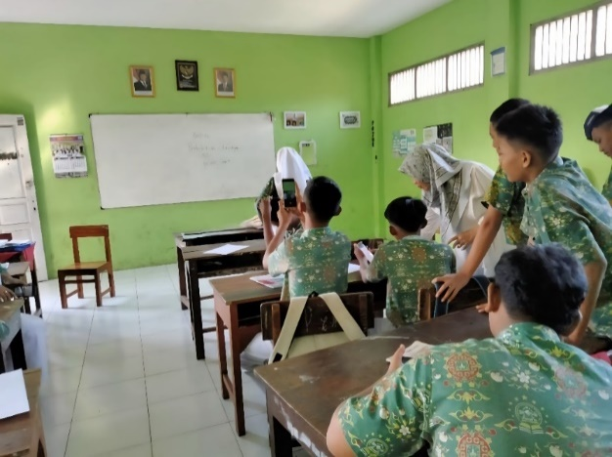
Figure 4.2 Source: Researcher documentation, class
The findings from classroom observation confirmed the teacher's structured and intentional application of TBLL phases, pre-task, task cycle, and language focus during her lessons on prohibition expressions. The key observation points are presented below:

No | Description of Classroom Activity | Observed (✓/✗)
A. Pre-Task Phase
1 | The teacher introduces the topic of Prohibition (e.g., “Don't litter”, “No smoking”). | ✓
2 | The teacher presents visual aids such as signs and posters related to prohibition. | ✓
3 | The teacher explains the learning objectives and why prohibition expressions are useful in daily communication. | ✓
B. Task Cycle Phase
4 | Students are divided into small groups for discussion. | ✓
5 | Each group receives a different prohibition-related situation to discuss and create a response (e.g., a sign or rule). | ✓
6 | Students design posters that display prohibition signs along with their English explanation. | ✓
7 | The teacher monitors and assists with vocabulary (e.g., must not, do not, no). | ✓
8 | Each group presents its poster to the class and explains its meaning. | ✓
9 | Other students respond with questions or comments about the presentations. | ✓
C. Language Focus Phase
10 | The teacher highlights the grammatical structure of prohibition expressions. | ✓
11 | Students complete language exercises focused on “don’t,” “mustn’t,” and “no + verb” patterns. | ✓
 | D. Classroom Management & Engagement
12 | The teacher manages classroom interaction and maintains student focus throughout the session. | ✓
13 | The teacher encourages and ensures equal participation. | ✓
14 | Students actively engage in the task and show collaborative learning behavior. | ✓
 | E. Assessment and Reflection
15 | The teacher assesses the students' performance based on poster content, clarity, creativity, and oral presentation. | ✓
16 | The teacher summarizes the lesson, provides feedback, and assigns follow-up practice. | ✓
Table 4.2 Classroom Observation Checklist
These results align with the responses from the interview. The teacher's preparation was thorough, and the learning process emphasized students’ active engagement through visual, group-based, and task-rich learning. The teacher also demonstrated ongoing reflection by adapting tasks based on student responsiveness, managing classroom energy effectively, and reflecting at the end of the session. These habits show that TBLL was not only implemented procedurally but also dynamically, with attention to the evolving classroom context.
This section shows that the teacher at SMP Hasanuddin 6 implemented TBLL not just to teach prohibition expressions, but to engage students in meaningful language practice. Through media, discussion, and task completion, students were encouraged to participate actively and reflect on language use, achieving a higher level of behavioral and cognitive engagement. The most effective teacher practice in engaging students was the use of creative and collaborative tasks, especially poster-making. This task combined visual media, real-life relevance, and group work, which students found enjoyable and motivating. The teacher’s active monitoring and flexible methods further supported student engagement during the learning process.
Overall, the integration of interview insights, real-time classroom observations, and lesson documentation offers a triangulated perspective on the teacher’s practice. The findings not only reflect the teacher's planned strategies but also how those strategies were enacted and adapted in real classroom situations. This multi-source approach enhances the trustworthiness of the analysis and ensures that the teacher’s practices are captured both from intention and implementation.
- STUDENTS’ VIEWS
This section presents the perceptions of students regarding their engagement during the implementation of Task-Based Language Teaching (TBLT) in the EFL classroom. The data was obtained from an open-ended questionnaire consisting of five questions, distributed to fifteen students. To simplify the presentation of students' responses, each student is referred to using a code beginning with S1 for Student 1, S2 for Student 2, S3 for Student 3, and so on. This coding helps maintain confidentiality while enabling thematic analysis of the students’ perspectives.
  - Favorite Task Types
Most students, specifically S2, S3, S7, S8, S11, S13, and S14, expressed a clear preference for creative tasks, particularly poster-making. These students described such tasks as fun, interesting, and a refreshing alternative to more traditional assignments. They appreciated the opportunity to express themselves visually and often associated these tasks with enjoyment and reduced academic pressure.
For example, S2 simply noted, “Poster”, while S7 explained, “Poster task because it’s more fun.” S8 mentioned, “Making posters because it’s fun,” and S11 shared, “Making posters because I like drawing.” Similarly, S13 stated, “Making posters” as their preferred classroom activity.
These responses highlight a common emotional connection with creative tasks that allow for visual expression, collaborative learning, and reduced anxiety. Such tasks appear to enhance students’ emotional engagement, making them feel more comfortable and involved in the classroom process. In general, students’ task preferences indicate that creative, visual, and context-rich assignments tend to foster positive emotions and greater involvement, reinforcing the importance of variety in TBLT to meet diverse engagement needs.
  - Perceived Boring Tasks
Several students, namely S1, S2, S4, S5, S6, S7, S10, S12, S13, and S14, expressed negative perceptions toward certain types of classroom tasks, especially those that were considered monotonous, unclear, or lacking interaction. These tasks were generally worksheet-based, presentation-heavy, or given without sufficient explanation or feedback.
S1 stated, “When asked to write,” while S13 and S14 both mentioned “doing worksheets” as their least preferred activities. These responses suggest that repetitive written tasks without a clear purpose may hinder emotional and cognitive engagement. Similarly, S6 wrote, “Doing tasks,” reflecting a general disengagement possibly due to unclear task objectives or lack of interest.
Presentation-based tasks were also commonly viewed as disengaging. S4 and S5 both listed “presentation” as a boring activity, with S5 elaborating, “Being asked to present and solve questions,” which may indicate feelings of anxiety or performance pressure. S12 also listed presentations as uninteresting. This highlights how oral performance tasks without emotional support can reduce engagement, especially in students who lack confidence.
A common theme among these responses is the absence of interaction, feedback, and clarity, which led students to disengage emotionally and cognitively. For example, S7 wrote, “When told to do evaluation but there were no answers or readings,” signaling frustration with tasks that lacked closure or instructional support. According to Willis & Willis (2007), the post-task phase in TBLT should include reflection, correction, and feedback elements that were perceived to be missing.
Additionally, the discomfort expressed with oral presentations reflects a need for better scaffolding, emotional encouragement, and clearer preparation stages. This supports the idea from Fredricks et al. (2004) that emotional engagement declines when learners feel unprepared, anxious, or unclear about expectations. Tasks that students perceived as boring were those that lacked interactivity, clarity, and meaningful feedback. These insights underscore the importance of thoughtful task design and delivery in TBLT to maintain student engagement. Varied tasks, transparent instructions, group balance, and teacher support are key to keeping students emotionally and cognitively involved in the learning process.
  - Feelings About Group or Pair Work
Most students, namely S1, S2, S3, S6, S7, and S9, expressed positive feelings toward working in groups or pairs during task-based classroom activities. They described the experience using terms such as “happy,” “very happy,” and “helpful,” suggesting that peer collaboration created a supportive and enjoyable learning environment. For instance, S1 and S2 both responded with “happy,” indicating a general sense of comfort during group work. S3 added, “Very happy, because I often study with friends it’s easier than doing it alone,” while S6 mentioned, “Happy because we understand each other.”
These responses show that social learning settings, such as collaborative tasks, enhance emotional and cognitive engagement by reducing individual pressure and encouraging mutual understanding. The chance to interact and receive help from peers contributed to a more relaxed and motivating atmosphere.
However, not all students shared the same enthusiasm. Several participants, including S5, S10, S12, and S13, noted challenges related to unequal participation or uncooperative peers. S5 explained, “A bit lazy because only one or two people work,” and S10 remarked, “Not fun because not all group members do the task.” These responses indicate that some students experienced frustration due to imbalanced workloads, a form of “social loafing” where certain students contribute less, leaving others to compensate.
The findings reveal that group or pair work is generally well-received by students, particularly when tasks promote active interaction, shared responsibility, and peer support. However, the presence of group imbalances and disengagement among peers indicates a need for intentional task design and teacher facilitation to maximize student engagement in collaborative TBLT settings.

  - Whether Tasks Help Improve English Fluency
Student responses showed varied perspectives on whether classroom tasks helped them improve their English fluency. Several students, specifically S1, S2, S10, S12, S14, and S15, reported positive effects, particularly in vocabulary acquisition and confidence in using the language. These students believed that the repeated exposure to English through tasks helped them gradually improve.
S1 wrote, “English helps,” and S10 confirmed, “Yes,” while S14 added, “Yes, because I learn new vocabulary.” S15 agreed, “Yes, because I learn new vocabulary,” indicating that vocabulary reinforcement through task repetition was a noticeable outcome. Similarly, S12 and S2 simply answered, “Yes,” reinforcing the general sentiment that tasks can support practical language use and retention.
In general, students who reported improvement focused on practical outcomes, such as acquiring new words and practicing speaking. Those who reported no improvement typically cited personal preferences for self-study or challenges with comprehension and confidence. These mixed perceptions highlight the importance of differentiated task design in TBLL. While task-based learning offers communicative and experiential benefits, it must also incorporate scaffolding, clarity, and flexibility to accommodate diverse learner needs and preferences. As Fredricks et al. (2004) suggest, cognitive engagement is closely linked to task value and student self-belief, both of which can fluctuate based on how tasks are framed and supported.
In conclusion, although many students acknowledged the contribution of tasks to their fluency, especially in vocabulary and speaking, others felt less supported due to their learning styles or comprehension challenges. These findings affirm that TBLL can support fluency development, but its success depends on task relevance, learner autonomy, and supportive implementation.

  - Suggestions for More Interesting Tasks
Many students, namely S1, S3, S4, S5, S6, S7, S8, S10, S11, S12, and S14, shared valuable suggestions for improving classroom learning through task-based activities. While their responses were concise, they reflected clear expectations about what makes tasks more engaging, enjoyable, and meaningful. These suggestions clustered around four core areas: interactive media, task relevance, clarity of instruction, and creative delivery formats.
Several students emphasized the use of games and group interaction to make learning more fun. S1 wrote, “Make a game that all students find interesting,” and S11 noted, “Play in groups,” indicating a desire for more collaborative and dynamic tasks. S7 echoed this by saying, “By explaining or practicing,” suggesting that students respond well to active, hands-on learning experiences that involve both instruction and practice. Others focused on the importance of clear and guided instruction. S4 wrote, “Try to explain more clearly,” and S6 commented, “Make learning more connected to student interest,” showing that understanding task purpose and steps is crucial for engagement. S8 also suggested, “Relate the content to students’ interest,” highlighting the importance of personalization and relevance.
Technological integration emerged as a consistent theme. S12 suggested, “Use cellphones as media,” and S14 added, “Use learning media such as mobile phones,” reflecting a preference for digital and multimedia tools that could support task completion, vocabulary learning, or pronunciation practice. This points to a growing student expectation for tech-enhanced instruction that mirrors the digital environments they interact with daily. Pronunciation and authentic language exposure were also mentioned. S5 wrote, “Study British or American accents so it sounds better,” which indicates an interest in tasks that include realistic listening models and cultural content. S3 contributed a simple but meaningful suggestion: “Speak English,” suggesting that immersive, English-only classroom moments may help increase confidence and fluency. Some students also voiced concerns related to classroom behavior. S10 commented, “If all students are not noisy,” showing that peer conduct directly affects the learning atmosphere. A calm, focused environment is essential for ensuring all students can participate meaningfully in task-based activities. Although a few students (e.g., S13, S15) were unsure or provided limited responses, the overall feedback points to a student body that is reflective and aware of what supports or hinders their engagement. Their suggestions highlight the need for structured, student-centered task design that balances interaction, clarity, and creativity.
These suggestions indicate that students are not merely passive participants, but thoughtful learners who understand the elements that enhance their classroom experience. Incorporating their voices into the design of task-based learning activities can improve both emotional and cognitive engagement. In the context of TBLT, these student-driven insights support a more responsive, inclusive, and effective English learning environment.

- FOCUS GROUP DISCUSSION (FGD)
The focus group discussions provided deeper insights into students’ perceptions and emotional responses toward task-based learning activities implemented in the EFL classroom. The discussion involved three groups of students and focused on their experiences with classroom tasks, group work, speaking confidence, and their suggestions for improvement. Overall, the students’ reflections highlighted four core aspects: emotional responses, task preferences, peer influence, and perceived language development.
Many students expressed that task-based activities were generally enjoyable, especially when they involved interaction and a clear purpose. Students in Group 1 and Group 2 reported that tasks such as role-plays, poster-making, and conversational activities helped them stay motivated. They described these tasks as fun and easier to understand, especially when completed in pairs or groups. However, students in Group 3 mentioned feeling stressed when tasks were given with tight deadlines or when instructions were not clear. This suggests that while task-based learning has the potential to boost engagement, it must be carefully managed in terms of time allocation and clarity.
Regarding task preferences, students strongly favored creative and collaborative tasks over traditional ones like memorization and worksheets. They emphasized that hands-on activities helped them understand English better and allowed them to enjoy the learning process. Students from all groups mentioned that tasks like short role-plays, storytelling, and practical conversations were far more effective in helping them stay engaged compared to purely written assignments.
Peer influence was another key theme identified in the discussions. Students consistently stated that group dynamics had a major impact on their participation. If group members were active and cooperative, students felt more motivated to contribute. Conversely, when peers were passive or distracted, such as using phones or avoiding the task, students felt discouraged and less willing to engage. This reinforces the importance of balanced group formation and active monitoring by the teacher to ensure collaborative effectiveness.
When asked about whether the tasks helped improve their English speaking confidence, most students responded positively. They stated that repeated exposure to speaking-based tasks, especially in a non-threatening group environment, helped them overcome anxiety and speak more fluently over time. Initially, many students felt nervous, but as they engaged in more role-plays and group tasks, they became more confident in using English in front of others.
Students also offered thoughtful suggestions for improving classroom tasks. They recommended incorporating more creative formats such as role-plays, podcasts, and interviews, and emphasized the need for clear modeling and instructions before beginning any task. Some students also suggested reducing memorization and increasing practice-based tasks, as well as utilizing multimedia tools to support learning. These suggestions reflected their desire for more practical, interactive, and personalized learning experiences.
In summary, the focus group discussions revealed that while students generally appreciated the interactive nature of task-based learning, their engagement was closely tied to task clarity, group dynamics, and the opportunity for real practice. Their feedback emphasized the need for varied and student-centered task design, teacher guidance, and consistent scaffolding to ensure that TBLT truly supports both emotional and cognitive engagement in the EFL classroom.

    - Discussion
      - Teacher Practice
The findings of this study reveal that the teacher at SMP Hasanuddin 6 demonstrated a conscious, structured, and reflective implementation of Task-Based Language Teaching (TBLT). Her teaching practices reflected a clear understanding of the three core stages of TBLT as proposed by Willis & Willis (2011): the pre-task phase, task cycle, and language focus. This was evident in both the interview responses and the classroom observation checklist, where the teacher introduced tasks using relevant media (e.g., visuals and mobile phones), guided students through collaborative production (poster making), and later emphasized grammar and reflection.
This supports Ellis' (2019) theory, which states that tasks in TBLT should be contextually relevant and focus on real communication. Teachers in this study considered the connection between the tasks and students' daily lives, so that the material became easier to understand and meaningful, and encouraged students' cognitive and emotional engagement. These strategies not only enhance the relevance of the learning materials but also support students' motivation and understanding. For example, the use of group presentations and poster making demonstrates her commitment to using communicative and meaningful tasks, an important characteristic of TBLT.
Furthermore, the teacher's classroom management and observation techniques, such as walking around, asking reflective questions, and adapting strategies based on observed student behavior, illustrate an application of ongoing teacher reflection. Her responses to challenges (e.g., low motivation or distractions from mobile phones) involved both behavioral strategies (e.g., asking sleepy students to wash their faces) and pedagogical ones (e.g., modifying the task format). These strategies reflect the teacher's role as a facilitator in TBLT as described by Littlewood (2007), where the teacher is responsible for creating an interactive and supportive learning environment. This aligns with (Prianty et al., 2021), who emphasize that teachers influence behavioral engagement by creating structured, interactive environments and monitoring student participation. By providing supportive and student-relevant tasks, the teacher fostered a learning climate conducive to active involvement, particularly for those who might otherwise disengage.
Thus, this finding answers the first research question: “How do EFL teachers implement strategies to maximize students' engagement in Task-Based Learning?” Teachers in this study implemented the TBLT approach by aligning the learning content to the students' context, providing supportive media, and demonstrating pedagogical flexibility in adjusting methods according to classroom dynamics. Through the use of media, flexible task formats, and continuous observation, the teacher effectively promoted the cognitive and behavioral dimensions of student engagement in the EFL classroom.

  - Students’ Views
The students’ responses collected from open-ended questionnaires and focus group discussions revealed a diverse range of emotional, cognitive, and behavioral reactions to the TBLT activities conducted in class. In general, the students expressed positive emotional engagement when tasks were visual, interactive, and allowed for creativity. Poster-making and role-play tasks, for example, were repeatedly cited as enjoyable, meaningful, and motivating. This supports the notion that TBLT promotes emotional engagement, as defined by Fredricks et al. (2004), students experience enjoyment and interest when learning activities are novel, relevant, and allow for expressive output. Many students expressed appreciation for tasks that allowed them to “draw,” “speak,” or “create something.” Such creative tasks reduced academic pressure and increased participation.
Conversely, students also reported disengagement during tasks perceived as repetitive or poorly guided, such as worksheets, written assignments, or unstructured presentations. Complaints such as “boring,” “too much writing,” or “lack of explanation” highlight that task design alone is not sufficient; delivery clarity and post-task feedback are critical. These observations align with González-Lloret (2020), who emphasizes that the post-task phase (reflection and feedback) is essential for maintaining motivation and consolidating learning.
The role of peer interaction was also emphasized. Most students felt that group work made learning easier and more enjoyable, especially when peers were cooperative. This reinforces social constructivist views of TBLT, where learning is seen as a collaborative process. However, group imbalance and “social loafing” (as expressed by students who felt burdened when peers didn’t contribute) reveal the need for structured group roles and teacher facilitation.
Regarding the development of English fluency, many students reported improvements, especially in vocabulary acquisition and speaking confidence. This supports the claims of Ellis (2003) and Philp & Duchesne (2016) that TBLT promotes cognitive engagement and oral communication development through repeated practice and meaningful tasks. Yet, some students still preferred individual learning or expressed uncertainty about their progress, highlighting the need for differentiated instruction and scaffolding in TBLT contexts. Student suggestions also reinforced this. Their calls for clearer explanations, more engaging media, and creative tasks (e.g., games, drama, mobile integration) underscore their desire for responsive and inclusive teaching approaches. This reflects a growing student expectation for personalized and technology-supported learning, which teachers should integrate into TBLT planning.
These findings directly answer the research question: “What are the students’ perceptions of their engagement during the implementation of TBLL in EFL classrooms?”
Despite the overall positive perception, several areas for improvement emerged, including the need for greater task variation, more explicit instruction, consistent feedback, and balanced group roles. These findings confirm that student engagement is dynamic and shaped by the design, implementation, and reflection phases of TBLT. Teachers should therefore ensure that tasks are structured, learner-centered, and aligned with students’ interests and abilities to optimize their learning experience and foster long-term engagement in EFL classrooms. Teachers should therefore ensure that tasks are structured, learner-centered, and aligned with students’ interests and abilities to optimize their learning experience and foster long-term engagement in EFL classrooms.
This study integrates teachers’ practices and students’ views because student engagement depends on how tasks are delivered and how learners respond. Combining both perspectives provides a clearer understanding of how TBLL is implemented and how it affects engagement in EFL classrooms.

CHAPTER V
CONCLUSION AND SUGGESTIONS

This chapter presents the conclusion of the research findings and discussion, followed by practical suggestions for teachers, students, institutions, and future researchers in relation to the implementation of Task-Based Language Learning (TBLL) in English as a Foreign Language (EFL) classroom.
      - Conclusion
This research aimed to explore the implementation of TBLL by an EFL teacher and to examine students' perceptions of their engagement during TBLL activities. The study employed a qualitative approach using thematic analysis to interpret data collected from teacher interviews, student questionnaires, and focus group discussions.
Regarding the teacher’s practice in implementing TBLL, the findings revealed that the teacher applied various strategies aligned with the core principles of task-based learning. These strategies included contextualizing tasks based on students’ daily experiences, providing pre-task scaffolding, integrating visual and digital media, and using formative feedback during the task process. The teacher also demonstrated pedagogical flexibility by modifying task formats and offering differentiated support to accommodate diverse student needs. These practices show the teacher’s efforts to maximize student engagement across emotional, cognitive, and behavioral dimensions.
Regarding students’ perceptions of their engagement, the data showed that most students viewed TBLL positively. They found the tasks enjoyable and motivating, particularly those involving group work, visual elements, and real-life simulations. Students reported increased confidence in speaking English and greater focus during collaborative tasks. However, some also expressed concerns regarding unclear instructions, unequal group participation, and limited media support, indicating the need for refinement in task design and classroom management.
Regarding the insights from Focus Group Discussion (FGD), the findings further confirmed that TBLL was experienced as interactive, dynamic, and engaging. Students appreciated the teacher’s encouragement and approachability, which created a safe space for them to express themselves. Nevertheless, suggestions were made for clearer guidelines, more diverse media integration, and better group task coordination to further improve the learning experience.
The implications of this research highlight the importance of teacher readiness, task relevance, and responsiveness to student feedback in implementing TBLL effectively. When properly applied, TBLL has the potential to create meaningful, student-centered learning environments that foster deeper language engagement and skill development.
      - Suggestions
Although this research was conducted in a limited setting with a single classroom context, the findings provide valuable insights for improving TBLL practices in broader EFL environments. The following suggestions are addressed to relevant stakeholders:
        - For Teachers
Teachers are advised to enhance their understanding and application of TBLL by integrating task-based principles with strategies that foster cognitive, emotional, and behavioral engagement. They should develop tasks that are contextually relevant, interactive, and reflective of students’ real-life experiences. Teachers are also encouraged to balance task complexity, clarify instructions, and apply peer/group management strategies to ensure equal participation. Continuous professional reflection and feedback gathering are key to sustaining engagement in TBLL classrooms.
        - For Students
Students are encouraged to actively participate in TBLL activities and view them not only as academic tasks but as opportunities to develop communication, critical thinking, and collaboration skills. They should engage in reflective learning, seek feedback, and work collaboratively to achieve shared learning goals. Building confidence and motivation through active engagement will directly support their language development and foster long-term learning habits.
        - For Future Researchers
This study can serve as a foundation for future research aiming to explore TBLL implementation in broader or comparative contexts. Further studies might examine how student engagement evolves with TBLL, how different teaching styles affect engagement, or how TBLL performs in online versus face-to-face settings. Researchers are also encouraged to use mixed-method approaches to combine perceptual and performance data for a more holistic view of engagement outcomes.

REFERENCES
Astuti, P. (2021). EFL Learners’ Perceptions on Task-Based Language Teaching in Speaking Class. Journal of Language and Linguistic Studies, 17(1), 524–535.
https://www.jlls.org/index.php/jlls/article/view/2789
Baharun, H., Harun, H., Abdullah, H., Zakaria, Z., Zakaria, Z. A., Saazai, N., & Saad, M. (2023). Task-Based Language Teaching (TBLT): Exploring EFL Learners Peer Interaction Engagement Pengajaran Bahasa Berasaskan Tugasan (TBLT): Meneroka penglibatan interaksi rakan sebaya pelajar EFL.
Black, P., & Wiliam, D. (2009). Developing the theory of formative assessment. Educational Assessment, Evaluation and Accountability, 21(1), 5–31. https://doi.org/10.1007/s11092-008-9068-5
Boots, M. M. M. (n.d.). Exploring EFL learners’ positive engagement in Task-Based Language Learning.
Braun, V., & Clarke, V. (2006). Using thematic analysis in psychology. Qualitative Research in Psychology, 3(2), 77– 101. https://doi.org/10.1191/1478088706qp063oa
Brooks, W., & Lutes, P. (n.d.). Task Based Learning Task-Based Learning: Effective Use to Enhance Learner Motivation and Engagement in the EFL Classroom.
Cook-Sather, A. (2006). Articles Sound, Presence, and Power: “Student Voice” in Educational Research and Reform.
Creswell, J. W., & Poth, C. N. (2018). Qualitative Inquiry and Research Design: Choosing Among Five Approaches.
Ellis, R. (2003). Task-Based Language Learning and Teaching. Oxford University Press.
Ellis, R. (2019). Task-Based Language Teaching: Sorting out the misunderstandings. International Journal of Applied Linguistics.
Ellis, R., Skehan, P., Li, S., Shintani, N., & Lambert, C. (2020). Task-based language teaching: Theory and practice. Cambridge University Press.
Fredricks, J. A., Blumenfeld, P. C., & Paris, A. H. (2004). School Engagement: Potential of the Concept, State of the Evidence (Vol. 74, Issue 1).
Huynh, T. S., & Nguyen, V. L. (2023). Review of the effects of Task-based Language Teaching on EFL learners’ speaking performance: What remains to be researched? CTU Journal of Innovation and Sustainable Development, 15(3), 23–33. https://doi.org/10.22144/ctujoisd.2023.048
Ilham. (n.d.). Linguistics and English Language Teaching Journal: Exploring the Implementation of Task-Based Language Learning Model: A Review of Studies on Students’ Perceptions.
Islami, A. P., & Senom, F. (2024). Teachers’ Beliefs and Practices: The Implementation of TBLT in Indonesian Higher Education. AL-ISHLAH: Jurnal Pendidikan, 16(2), 748–757. https://doi.org/10.35445/alishlah.v16i2.5227
Khan Milon, M. R., Ishtiaq, M., Mohammed Ali, T., & Imam, M. S. (2023). Unlocking Fluency: Task-Based Language Teaching (TBLT) in Tertiary Speaking Classes - Insights from Bangladeshi Teachers and Students. ICRRD Quality Index Research Journal, 4(4). https://doi.org/10.53272/icrrd.v4i4.11
Kołsut, S., & Szumilas, M. (2023). Exploring student engagement in task-based and communicative language classrooms. Language Teaching Research. https://doi.org/10.1177/13621688231188800
Kusumaningrum, S. R., & Cahyono, B. Y. (2022). The Implementation of Task-Based Language Teaching in Indonesian EFL Classrooms: Teachers’ Perspectives. Indonesian Journal of Applied Linguistics, 12(2), 318–327. https://ejournal.upi.edu/index.php/IJAL/article/view/45983
Littlewood, W. (n.d.). The task-based approach: some questions and suggestions.
Littlewood, W. (2007). Communicative and task-based language teaching in East Asian classrooms. Language Teaching, 40(3), 243–249. https://doi.org/10.1017/S0261444807004363
Maulana, M. I. (2021). Task-Based Language Teaching: Potential Benefits and Possible Criticisms in Indonesian Contexts. Journal of English Teaching and Learning Issues, 4(2), 69. https://doi.org/10.21043/jetli.v4i2.12183
Molnar and Daniel (2024)Nguyen, D. &, Duong, T. M., Thi, H., & Nguyen, T. (2021). Implementing Task-Based Language Teaching in Vietnamese Secondary Schools: What Hinders EFL Teachers? (Vol. 25, Issue 2).
Nguyen, D. &, Duong, T. M., Thi, H., & Nguyen, T. (2021b). Implementing Task-Based Language Teaching in Vietnamese Secondary Schools: What Hinders EFL Teachers? (Vol. 25, Issue 2).
Nunan, David. (2010b). Task-Based Language Teaching. Cambridge University Press.
Pham, N., Pham, N. T., & Nguyen, H. B. (2018). Teachers’ perceptions about Task-Based Language Teaching and its Implementation European Journal of Foreign Language Teaching TEACHERS’ PERCEPTIONS ABOUT TASK-BASED LANGUAGE TEACHING AND ITS IMPLEMENTATION. 3(2). https://doi.org/10.46827/ejfl.v0i0.1619
Philp, J., & Duchesne, S. (2016). Exploring Engagement in Tasks in the Language Classroom. Annual Review of Applied Linguistics, 36, 50–72. https://doi.org/10.1017/S0267190515000094
Prianty, T., Ngadiso, N., & Wijayanto, A. (2021). Indonesian EFL Teachers’ Perceptions of Task-Based Language Teaching Approach. Pedagogy : Journal of English Language Teaching, 9(1), 26. https://doi.org/10.32332/joelt.v9i1.2194
Sandelowski, M. (2000). Focus on Research Methods Whatever Happened to Qualitative Description? In Research in Nursing & Health (Vol. 23). John Wiley & Sons.
Shaikym MA. (n.d.). THE ROLE OF MOTIVATION IN LEARNING ENGLISH AS A FOREIGN LANGUAGE.
Sugiyono. (2016). Metode Penelitian Kuantitatif, Kualitatif, dan Kombinasi (Mixed Methods). Bandung: Alfabeta.
Teaching English to Undergraduate ESL Learners through Task-Based Learning. (2023). PAKISTAN LANGUAGES AND HUMANITIES REVIEW, 7(IV). https://doi.org/10.47205/plhr.2023(7-iv)35
Tusino, T., Faridi, A., Saleh, M., & Fitriati, S. (2020, January 17). Student Engagement in Hybrid Task-Based Language Teaching in EFL Writing Class. https://doi.org/10.4108/eai.29-6-2019.2290384
Vu Thi Minh, T., & Tran Quoc, T. (2021). NON-ENGLISH MAJOR STUDENTS’ LEARNING ENGAGEMENT IN TASK-BASED LANGUAGE LEARNING. Journal of Science Educational Science, 66(5), 23–32. https://doi.org/10.18173/2354-1075.2021-0233
Viriya, C. (2018). Using Task-Based Learning with Students of Academic English. Arab World English Journal, 9(4), 337–346. https://doi.org/10.24093/awej/vol9no4.25
Wenas, I., Liando, N. V. F., & Rorimpandey, R. (2023). Language, Literature,and Education published by English Education Department Faculty of Languages and Arts. In Culture, Language, Literature, and Education (Vol. 11, Issue 2).
Willis & Willis, Doing Task-Based Teaching. Oxford Univ. Press (2011).
Zepke, N. (2015). Student engagement research: thinking beyond the mainstream. Higher Education Research and Development, 34(6), 1311–1323. https://doi.org/10.1080/07294360.2015.1024635
Zhang, J., & Yanfeng, M. (2025). Task engagement in Chinese university EFL classrooms: a comparative analysis of student and teacher perspectives. In Cogent Education (Vol. 12, Issue 1). Taylor and Francis Ltd. https://doi.org/10.1080/2331186X.2025.2492652
Zhao, J. (2024). Exploring Teachers’ Perceptions towards TaskBased Language Teaching (TBLT) in Teaching English Reading at a Public University in China. SHS Web of Conferences, 182, 01003. https://doi.org/10.1051/shsconf/202418201003

APPENDICES

APPENDIX 1
Teacher response
No. | Interview Question | Teacher Response
1 | Can you explain how you usually design task-based lessons? | "I design task-based lessons by considering the characteristics of my students. Since some are very active and others have trouble focusing, I have to be extra patient in preparing materials that match their level of understanding. I usually begin by explaining the material thoroughly to ensure students grasp the context. Then, I ask a few questions to assess their prior understanding before assigning tasks. After that, I encourage students to come to the front of the class to test how well they’ve understood the material."
2 | What are your main considerations when choosing or creating tasks for students? | "My main consideration is connecting the tasks to the students’ everyday lives. This is important so the material becomes more relevant and easier for them to understand, which in turn increases their engagement in the learning process."
3 | What do you do to make students more active during task-based activities? | "To increase student participation, I often use learning media such as mobile phones, pictures, and posters. These helps grab students’ attention and make the lessons more interactive and relatable to their world."
4 | How have students responded so far to the tasks you assign? | "In general, students complete the assigned tasks. Although some may occasionally chat with friends or use their phones during tasks, they still make an effort to complete them on time."
5 | What challenges do you usually face in implementing task-based learning (TBLT)? | "One of the most frequent challenges is low student motivation. Some students are lazy, play games on their phones, or are sleepy in the morning because they stayed up late. To address this, I usually ask drowsy students to wash their faces before returning to class, then I provide more intensive guidance during task work."
6 | How do you determine whether students are actively engaged during task-based learning? | "I usually walk around the classroom to check on each student’s progress. I ask questions like, 'How far have you gotten with your task?' or 'Do you understand what you are supposed to do?' This way, I can see who is truly engaged in the learning activity."
7 | Have you ever changed your teaching methods or task strategies? If so, why and how? | "Yes, I often change my teaching strategies. For example, I don’t always use written tasks—I also use pictures, presentations, or direct discussions. This helps ensure that assessment is not only based on written results but also on speaking skills and a more comprehensive understanding of concepts."
8 | What do you need to make the implementation of TBLT more effective in class? | "To improve the implementation of TBLT, I need more engaging learning media. One way to do this is by utilizing students’ mobile phones as learning tools so they can focus more on the task instead of just playing games. This also encourages them to be more active in the learning process."

APPENDIX 2
Students' Responses to Open-Ended Questions
Student Code: S1 (Student 1)
Student Code | 1. What type of task do you enjoy the most in English class? Why? | 2. What kind of tasks do you find uninteresting? | 3. How do you feel working in groups or pairs during tasks? | 4. Do English class tasks help you become more fluent in English? Explain. | 5. What are your suggestions to make English class tasks more interesting?
S1 | Social Studies | When asked to write | Happy | English helps | Make a game that all students find interesting
S2 | Poster | Tasks that are hard to understand | Happy | A bit difficult | Don't know
S3 | Teacher explains | Yes, because it's difficult and I don't understand English | Very happy | Because I often study with friends, it's easier than doing it alone | Group games
S4 | Like English | Presentation | Very happy | No | Explained clearly
S5 | Memorizing words | Being asked to present and answer questions | I like it because I have friends | No, because I prefer studying alone | Explain the material more clearly
S6 | Memorizing and saying it | Doing tasks | Happy because we understand each other | Not really, I prefer learning alone | Relate to student interests
S7 | Poster task because it's more fun | When told to evaluate without answers or readings in the book | Very happy and very helpful | No | Learn the British or American accent for better speaking
S8 | Making posters because it's fun | Tasks that are hard to understand | Boys are noisy | Like prohibition and posters, or speaking English | Explain or demonstrate the task
S9 | English/Indonesian/Social Studies because it's easier | None are boring | A bit hard | The words help me memorize | Speak English
S10 | English | Math | Not fun because not all group members do the task | Yes | If students are not noisy
S11 | Making posters, because I like drawing | Math | Just fine | Yes, a bit | —
S12 | Story | Presentation | Group | Yes | —
S13 | Making posters | Doing worksheets | — | Yes | —
S14 | — | Doing worksheets | — | Yes | —
S15 | — | All | — | Yes, because I learn new vocabulary | —

APPENDIX 3
Classroom Observation

No | Description of Classroom Activity | Observed (✓/✗)
A. Pre-Task Phase
1 | The teacher introduces the topic of Prohibition (e.g., “Don't litter”, “No smoking”). | ✓
2 | The teacher presents visual aids such as signs and posters related to prohibition. | ✓
3 | The teacher explains the learning objectives and why prohibition expressions are useful in daily communication. | ✓
B. Task Cycle Phase
4 | Students are divided into small groups for discussion. | ✓
5 | Each group receives a different prohibition-related situation to discuss and create a response (e.g., a sign or rule). | ✓
6 | Students design posters that display prohibition signs along with their English explanation. | ✓
7 | The teacher monitors and assists with vocabulary (e.g., must not, do not, no). | ✓
8 | Each group presents its poster to the class and explains its meaning. | ✓
9 | Other students respond with questions or comments about the presentations. | ✓
C. Language Focus Phase
10 | The teacher highlights the grammatical structure of prohibition expressions. | ✓
11 | Students complete language exercises focused on “don’t,” “mustn’t,” and “no + verb” patterns. | ✓
D. Classroom Management & Engagement
12 | The teacher manages classroom interaction and maintains student focus throughout the session. | ✓
13 | The teacher encourages and ensures equal participation. | ✓
14 | Students actively engage in the task and show collaborative learning behavior. | ✓
E. Assessment and Reflection
15 | The teacher assesses the students' performance based on poster content, clarity, creativity, and oral presentation. | ✓
16 | The teacher summarizes the lesson, provides feedback, and assigns follow-up practice. | ✓

APPENDIX 4
RENCANA PELAKSANAAN PEMBELAJARAN (RPP)

SMP Hasanuddin 6 Semarang
Mata Pelajaran : Bahasa Inggris
Kelas/Semester : VIII / Genap
Materi Pokok : Prohibition (Larangan)
Alokasi Waktu : 3 x 40 Menit (120 Menit)
Pendekatan : Pembelajaran Berbasis Tugas (Task-Based
Learning)

    - Tujuan Pembelajaran
Setelah mengikuti proses pembelajaran, peserta didik diharapkan dapat:
- Mengidentifikasi ungkapan-ungkapan yang digunakan untuk menyatakan larangan (Prohibition).
- Menganalisis fungsi sosial, struktur teks, dan unsur kebahasaan dalam ungkapan larangan.
- Menggunakan ungkapan larangan dalam konteks yang sesuai.
- Berpartisipasi aktif dalam tugas-tugas kelompok maupun individu.
- Menampilkan hasil tugas dalam bentuk dialog lisan atau tulisan yang menggunakan ungkapan larangan.

B. Media, Alat/Bahan, dan Sumber Belajar
- Media: Lembar kerja siswa, gambar situasi, video pendek, audio percakapan
- Alat/Bahan: Papan tulis, spidol, kertas karton, laptop/HP
- Sumber Belajar:
- Buku paket Bahasa Inggris kelas VIII
- Modul Ajar Kurikulum Merdeka
- Video dari YouTube (tentang larangan di tempat umum)
- Lembar kerja siswa

C. Langkah-Langkah Pembelajaran
Tahapan | Kegiatan Pembelajaran | Durasi
Pendahuluan | - Guru memberi salam dan menanyakan kabar siswa.  - Menyampaikan tujuan pembelajaran dan memotivasi siswa dengan menayangkan video singkat tentang situasi larangan (di bandara, perpustakaan, taman, dll).  - Apersepsi: menanyakan apakah siswa pernah melihat tanda larangan dan apa maknanya. | 15 menit
Inti | Kegiatan Literasi  - Siswa membaca berbagai kalimat larangan pada gambar atau teks pendek.  Critical Thinking  - Siswa diminta mengidentifikasi ungkapan larangan (do not…, don’t…, you mustn’t…) dan menjelaskan artinya.  Collaboration  - Dalam kelompok, siswa membuat daftar larangan di tempat-tempat umum (kelas, kantin, perpustakaan, dll).  - Kelompok menyusun dialog pendek yang melibatkan larangan.  Communication  - Siswa mempresentasikan dialog larangan secara bergantian di depan kelas.  - Teman memberikan umpan balik secara sopan.  Creativity  - Siswa diminta membuat poster larangan (berbahasa Inggris) dan memajangnya di kelas. | 90 menit
Penutup | - Siswa menyimpulkan materi hari ini bersama guru.  - Guru memberikan penguatan dan refleksi.  - Siswa diberikan tugas rumah: Membuat 5 kalimat larangan di rumah.  - Guru menutup pelajaran dengan motivasi dan salam. | 15 menit

D. Penilaian Hasil Belajar
  - Pengetahuan
- Teknik: Tes lisan dan tulisan
- Instrumen: Menjawab pertanyaan terkait materi larangan dan melengkapi dialog
  - Keterampilan
- Teknik: Unjuk kerja (praktik dialog), proyek (poster)
- Instrumen: Rubrik penilaian presentasi dan produk kreatif
  - Sikap
- Teknik: Observasi
- Instrumen: Lembar observasi partisipasi aktif dan kerja sama

Disusun oleh:
Guru Bahasa Inggris SMP Hasanuddin 6 Semarang
Nama : Eis sukarsih S.Pd
Tanggal: Semarang, 7 Mei 2025

APPENDIX 5
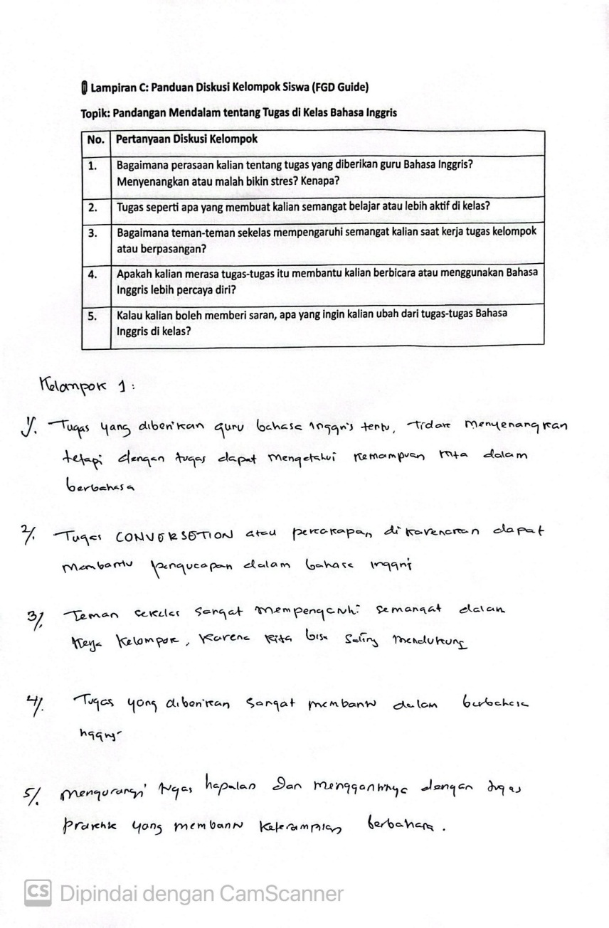
FOCUS GROUP DISCUSSION (FGD)
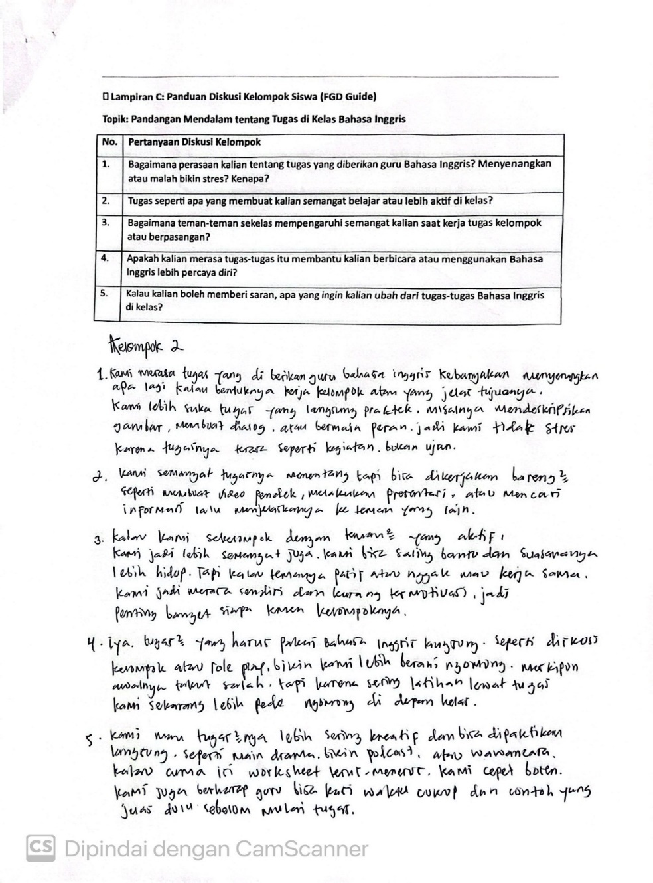
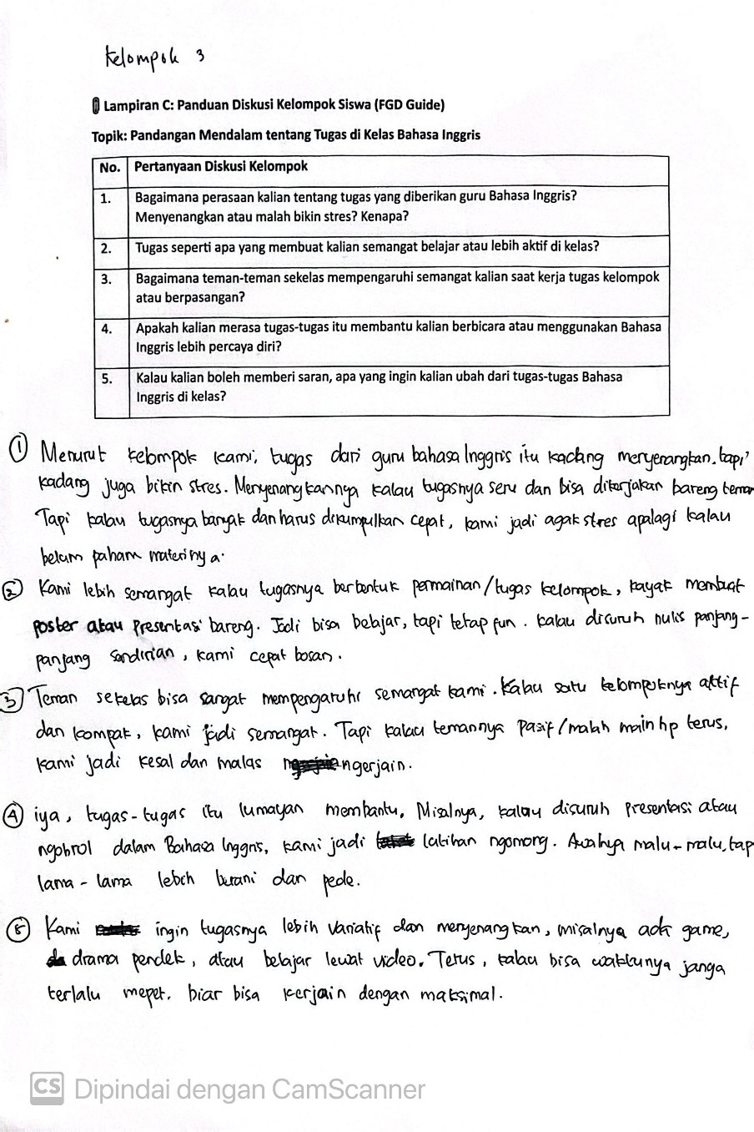
APPENDIX 6
DOCUMENTATION

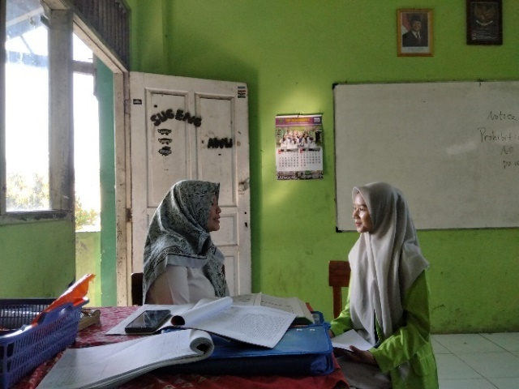
Teacher Interview

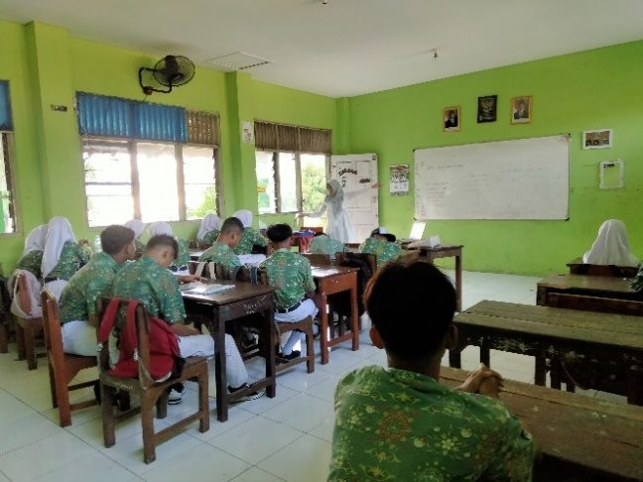
Observation

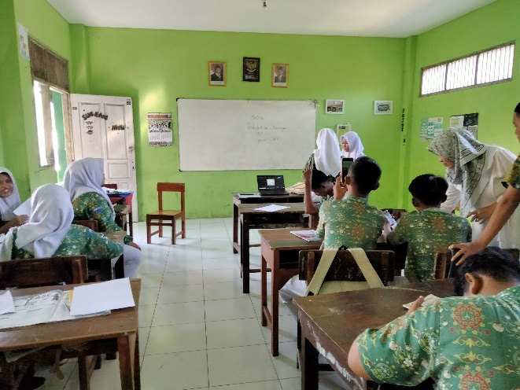
Students' Responses & FGD

CURRICULUM VITAE
- Personal Data
Name | : Amalia Farihal Husna
Place of birth | : Deli tua
Date of birth | : October 26th, 2002
Address | : Dusun VI , Patumbak 1, North Sumatera
Email | : amaliafarihal@gmail.com
- Formal Educations
- TK Fitriah Medan
- SD Negri 101794
- Ponpes, AR-Raudlatul hasanah, Medan
- Ponpes, AR-Raudlatul hasanah, Medan
- Universitas Islam Negeri Walisongo Semarang

Semarang, 11th June 2025
The Researcher,

Amalia Farihal Husna
NIM. 2103046200

