DIGITAL STORYTELLING AS AN INNOVATIVE APPROACH TO ENHANCING SPEAKING AND LISTENING SKILLS: AN AUTOETHNOGRAPHY
THESIS

Submitted in Partial Fulfillment of the Requirement for Gaining the Degree of Bachelor of English Education

Arranged by:
Ulfa Shofiatul Chasanah
1903046066

FAKULTAS ILMU TARBIYAH DAN KEGURUAN
UNIVERSITAS ISLAM NEGERI WALISONGO SEMARANG
2025

THESIS STATEMENT
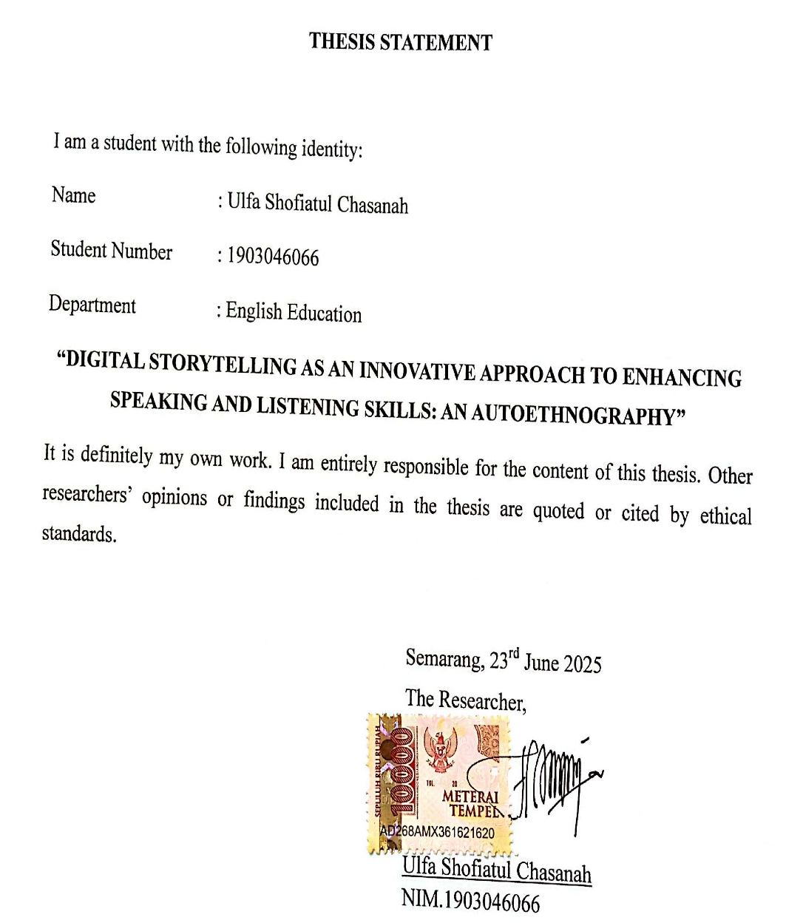

ADVISOR NOTE
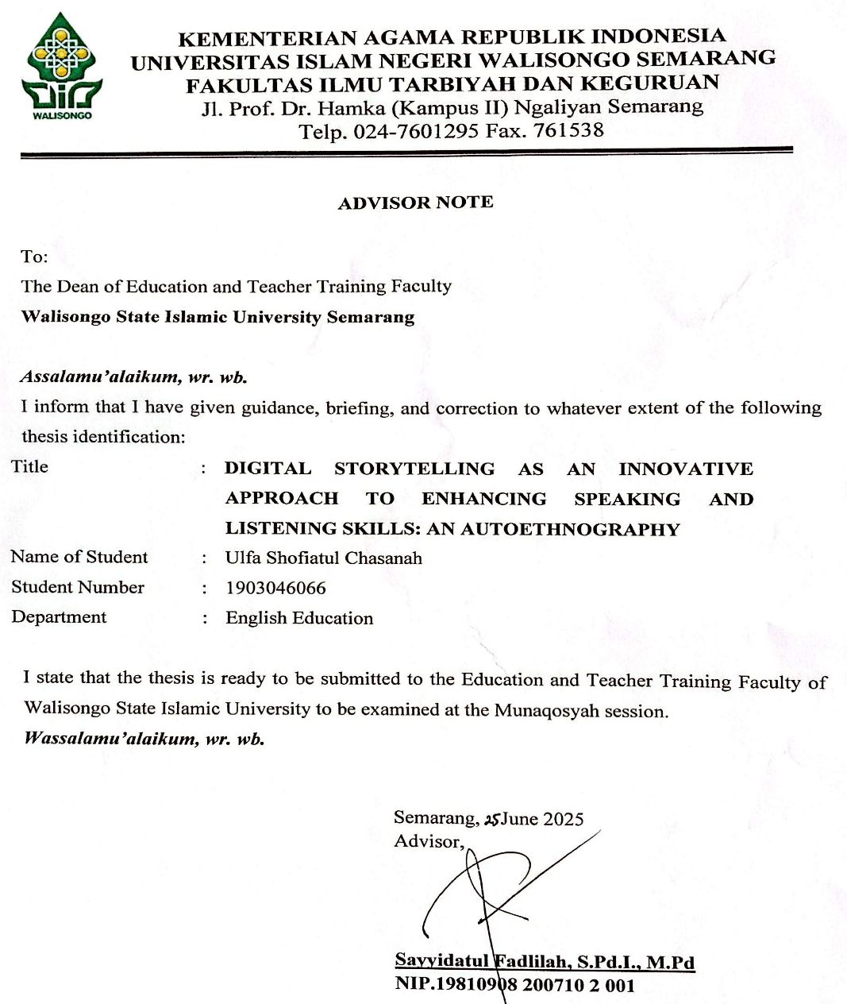

RATIFICATION
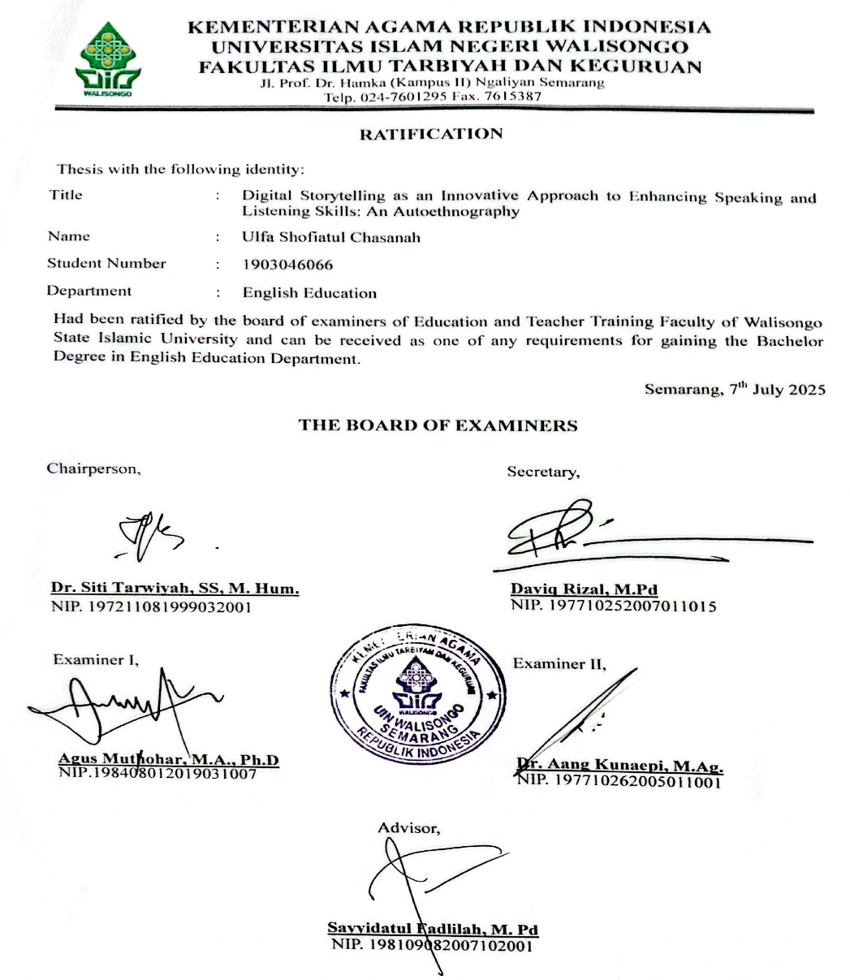

MOTTO

لَقَدْ كَانَ فِي قَصَصِهِمْ عِبْرَةٌ لِأُولِي الْأَلْبَابِۗ
“There was certainly in their stories a lesson for those of understanding”
(QS. Yusuf: 111)

"Learning becomes wisdom only when it is reflected through lived experience."
(Ibn Sina)

“Experience is not merely to be lived, but to be reflected upon—for in reflection, there is wisdom."
(Ulfa Shofiatul Chasanah)

DEDICATION

This thesis is sincerely dedicated to:
- My beloved parents, Mr. Sudarsono and Mrs. Sarmiyatun, for their unconditional love, countless prayers, and constant support that have always been my source of strength.
- For Dr. KH. Fadlolan Musyaffa’, Lc., MA and Hj. Fenty Hidayah Fadlolan, S.Pd.I who have continuously nurtured, directed, and encouraged me to remain steadfast in seeking knowledge, with sincerity, humility, and devotion for the sake of Allah.
- My dear brother and his wife, Mr. Ahmad Khoirul Latif and Mrs. Alvy Nur Aeni for their continuous encouragement, care, and belief in me.
- My dearest friends from childhood to today, Puji, Lestari, and Eka Ayu, thank you for growing up with me, for all the laughter, comfort, and memories we've shared. Your presence has always felt like home.
- My beloved friends at Pondok Pesantren Fadhlul Fadhlan Semarang, thank you for your support, encouragement, and the unforgettable moments we have shared together on this journey. You have made this experience richer and more meaningful.
- The last but not least, to myself, for embracing every challenge with courage, growing through every experience, and always believing in the power of perseverance and hope.

ABSTRACT
Title | : | Digital Storytelling as an Innovative Approach to Enhancing Speaking and Listening Skills: An Autoethnography
Name | : | Ulfa Shofiatul Chasanah
NIM | : | 1903046066

This study investigates the use of Digital Storytelling (DST) to enhance students’ speaking and listening skills in an English as a Foreign Language (EFL) classroom. Using an analytic autoethnography, the research reflects the teacher-researcher’s experience in implementing DST over one week with tenth-grade students at MA Al Musyaffa’. Students worked in groups to plan, write, and present their stories. Although the project did not include audio recordings, students practiced speaking and listened attentively during peer presentations. The process supported oral fluency, vocabulary development, pronunciation, and comprehension. The findings indicate increased student confidence, engagement, and collaboration. The teacher’s reflections revealed pedagogical insights, including the importance of scaffolding, flexibility, and reflective practice in integrating technology into language instruction. In conclusion, DST provides an effective, student-centered strategy for improving oral communication in EFL settings. It also encourages teacher growth through ongoing reflection.
Keywords: autoethnography, digital storytelling, EFL, listening, reflective teaching, speaking

ACKNOWLEDGEMENT
بِسْمِ اللهِ الرَّحْمٰنِ الرَّحِيْمِ

Alhamdulillahi Rabbil ‘Alamin, all praises and gratitude be to Allah Subhanahu wa Ta’ala, who has bestowed His endless mercy, strength, and guidance upon me throughout this journey. May peace and blessings be upon the Prophet Muhammad SAW, the best role model for all of humanity, whose teachings continue to inspire every step I take. This thesis, entitled "Digital Storytelling as an Innovative Approach to Enhancing Speaking and Listening Skills: An Autoethnography," could not have been completed without the help, support, and prayers of many individuals. Therefore, I would like to express my deepest gratitude to:
- Prof. Dr. Fatah Syukur, M. Ag, as the Dean of Faculty of Education and Teacher Training of State Islamic University of Walisongo Semarang.
- Dra. Nuna Mustikawati Dewi, M. Pd, is the head of the English Department of Education and Teacher Training Faculty of UIN Walisongo Semarang.
- Lulut Widyaningrum, M. Pd. as the secretary of English Language Education.
- Sayyidatul Fadlilah, M. Pd. is the academic advisor who always gives valuable time, guidance, correction, and some suggestions during arranging and completing this thesis.
- All lectures of English Education Department who have generously shared their knowledge and provided valuable learning resources and support throughout the course of this study.
- My sincere gratitude is extended to the teachers of MA Al Musyaffa’ for their guidance, support, and dedication throughout my studies.
The researcher acknowledges that the preparation of this thesis is far from perfect. May Allah SWT grant double rewards to all those who have supported and assisted in completing this work. Therefore, the researcher sincerely welcomes any suggestions and constructive criticism from readers. Finally, it is hoped that the objectives of this thesis will be fulfilled as expected.

Semarang, 23th June 2025
The Researcher,

Ulfa Shofiatul Chasanah
NIM. 1903046066

TABLE OF CONTENTS

COVER i
THESIS STATEMENT ii
ADVISOR NOTE iii
RATIFICATION iv
MOTTO v
DEDICATION vi
ABSTRACT viii
ACKNOWLEDGEMENT ix
TABLE OF CONTENTS xii
CHAPTER I INTRODUCTION 1
1.1 Background of the Research 1
1.2 Research Questions 4
1.3 Research Objectives 4
1.4 The Significance of the Study 5
1.4.1 Theoretical Significance 5
1.4.2 Practical Significance 6
1.4.3 Pedagogical Significance 7
CHAPTER II REVIEW OF RELATED LITERATURE 8
2.1 Previous Researches 8
2.1.1 Digital Storytelling (DST) and Speaking Skills 8
2.1.2 Digital Storytelling (DST) and Listening Comprehension 10
2.1.3 Reflective Teaching and Autoethnography 13
2.2 Literature Review 15
2.2.1 Digital Storytelling in the 21st Century Classroom 15
2.2.2 DST and Speaking Skill Development 18
2.2.3 DST and Listening Comprehension 20
2.2.4 Reflective Teaching and Digital Innovation 23
2.3 Conceptual Framework 26
CHAPTER III RESEARCH METHOD 30
3.1 Research Design 30
3.2 Research Settings 32
3.3 Research Participants 33
3.4 Research Instruments 34
3.5 Technique of Data Collection 36
3.6 Technique of Data Analysis 39
CHAPTER IV RESEARCH FINDINGS AND DISCUSSION 42
4.1 Findings 42
4.1.1 The Contribution of Digital Storytelling (DST) to Students’ Speaking and Listening Skills 43
4.1.2 Personal Insights from the Implementation of DST 54
4.1.3 Pedagogical Insights from the Implementation of DST 59
4.2 Discussion 66
4.2.1 DST and the Development of Speaking and Listening Skills 66
4.2.2 Personal Insights from the Implementation of DST 69
4.2.3 Pedagogical Insights from the Implementation of DST 71
CHAPTER V CONCLUSION AND SUGGESTION 75
5.1 Conclusion 75
5.2 Suggestions 77
5.2.1 For English Teacher 77
5.2.2 For Students 78
5.2.3 For Future Researcher 78
5.2.4 For Curriculum Developer 79
REFERENCES 80
APPENDIX 88
CURRICULUM VITAE 123

INTRODUCTION

Background of the Research
Digital Storytelling (DST) emerged in the early 1990s as a medium for personal and community empowerment, combining traditional narrative with digital multimedia elements. It was pioneered by Dana Atchley and Joe Lambert, along with collaborators such as Patrick Milligan and Nina Mullen (Hartley & McWilliam, 2009; Jager et al., 2017). The concept evolved from Atchley’s “short narrated films,” developed at the American Film Institute’s workshop in 1993, and was later refined by Lambert into a structured storytelling format promoted through the Story Center (formerly the Center for Digital Storytelling) in San Francisco (Woletz, 2008). This evolution reflects a broader shift in how narratives are conveyed in modern society, transitioning from oral traditions to digitally mediated experiences.
Historically, storytelling has been central to human communication—long before written language existed. Today, this tradition continues in digital form, where storytelling serves not only as a creative outlet but also as a pedagogical tool (Çetin, 2021). DST integrates text, visuals, voice, music, and video to produce immersive narratives (de Castro & Levesque, 2018; Hung et al., 2012), making it especially appealing in educational settings.
In the 21st-century English language classroom, speaking and listening are vital components of communicative competence. These skills are crucial for academic and real-life interaction, yet many students struggle due to limited exposure to authentic input, low self-confidence, and conventional classroom practices that focus heavily on reading and writing (Fu et al., 2022; Luka & Seniut, n.d.).
Students often face challenges such as unclear pronunciation, lack of fluency, or difficulty constructing sentences-factors worsened by performance anxiety and demotivation (Safitri & Misdi, 2021). Similarly, listening issues arise from fast speech, unfamiliar accents, or limited contextual support. Traditional teaching approaches often neglect these areas, providing few opportunities for real communication.
Digital storytelling (DST) addresses these gaps by encouraging students to become content creators and language users. Through voice recording, image selection, and narrative building, learners develop speaking and listening skills in authentic and meaningful contexts (Robin & Robin, 2016). DST also reduces language anxiety and increases emotional engagement, which improves comprehension and oral expression (Robin, 2008).
For teachers, DST creates space for reflective practice and instructional innovation. By guiding students through story planning and production, educators can observe how learners respond, adapt strategies, and gain insights into their own pedagogy (Hsu, 2015). This study therefore employs an autoethnographic approach to explore how DST influences speaking and listening development, while documenting the researcher’s own professional growth. Based on thus rationale, the study is titled “Digital Storytelling as an Innovative Approach to Enhancing Speaking and Listening Skills: An Autoethnography”.

Research Questions
Based on the background of the research above, the writer formulated the questions in following:

In what ways does digital storytelling (DST) contribute to the development of students' speaking and listening skills in the English classroom?

What personal and pedagogical insights does the teacher-researcher gain as a teacher through the implementation of digital storytelling (DST) in the classroom?

Research Objectives
Based on the research questions above, the research objectives of this study are following:

To investigate how digital storytelling (DST) contributes to the enhancement of students’ speaking and listening skills in the English classroom.

To examine the personal and pedagogical insights gained by the teacher-researcher through the implementation of digital storytelling (DST).

The Significance of the Study

Theoretical Significance
This study contributes to the growing body of literature on the use of digital storytelling in language education. Through an analytic autoethnographic lens, it offers a unique narrative that blends personal teaching experience with broader educational theories. It provides a conceptual understanding of how storytelling, when digitized, can become a powerful tool for communicative competence and learner engagement.

Practical Significance

For the teacher
The study presents practical strategies and reflective insights on how to implement DST in the English classroom to improve students’ speaking and listening abilities. It encourages teachers to use more student-centered and technology-integrated approaches while also engaging in professional reflection.

For the students
The study shows how DST can foster a creative, supportive environment where students gain confidence and fluency in oral communication. It promotes learner autonomy, emotional expression, and greater engagement with the language-learning process.

For the researcher
This research may serve as a foundation for further investigations into the role of digital storytelling in language acquisition, as well as the use of autoethnography as a method of reflective teaching research.

Pedagogical Significance
The study demonstrates how DST can transform conventional language instruction into a more dynamic, student-centered process. It highlights the role of the teacher not only as an instructor but also as a facilitator and reflective practitioner. The research informs instructional design, emphasizing the integration of multimodal materials, narrative structures, and collaborative learning strategies to improve oral communication. It also offers insights into curriculum development that aligns with 21st-century skills and digital literacy.

REVIEW OF RELATED LITERATURE

Previous Researches

Digital Storytelling (DST) and Speaking Skills
The integration of digital storytelling into language acquisition has been actively researched in recent years as an effective approach to enhancing speaking abilities. This method blends narrative production and digital media to promote not just linguistic development but also digital literacy, creativity, and learner autonomy (Jakes, n.d.;Ohler, 2016).
Sadik (2008) wrote that students' speaking skills increased significantly when they participated in digital storytelling projects, notably in terms of confidence, pronunciation, and emotive delivery. These benefits were ascribed to the ability to practice and amend their oral narration, which promoted self-regulation and metacognitive awareness of speech patterns. On the other hand, Reinders added an argument that digital storytelling promotes output-focused learning, which allows students to actively produce language. He claims that task-based language learning encourages deeper processing of language structures and more natural development of speaking fluency (Reinders, 2011).
Furthermore, digital storytelling also improves collaborative speaking skills. In group projects, students negotiate meaning, divide speaking positions, provide peer critique, and rehearse dialogue—all of which are real speaking practices (Alismail, 2015; Hafner & Miller, 2011). This cooperation reflects real world communication and improves students' pragmatic ability.
From a reflective perspective, digital storytelling can serve as a powerful tool for language learners to monitor their speaking growth over time. When combined with autoethnographic reflection, the procedure transforms into a personal language growth journey rather than just an academic exercise, as said (Hull & Katz, 2006; Kim, 2014).
In summary, digital storytelling creates a dynamic and learner-centered environment in which speaking is practiced with intention, contemplation, and creativity. Its adaptability, multimodality, and emotional engagement make it a novel way to strengthening speaking skills, especially in situations where learners would otherwise lack meaningful opportunities for spoken language creation.

Digital Storytelling (DST) and Listening Comprehension
While digital storytelling is commonly recognized for improving speaking skills, it also plays an essential role in developing listening comprehension, which is generally underestimated. Listening comprehension is more than just hearing words in a second language; it also includes understanding meaning, interpreting tone, and processing context. Digital storytelling delivers an immersive environment that seamlessly incorporates these aspects via multisensory interaction and meaningful feedback (Goh & Vandergrift, 2021; Mayer, 2021).
Xu and Peng said that digital storytelling (DST) provides learners with actual spoken language within storylines, making it easier to understand structure, rhythm, and intonation patterns. Because the audio is developed by learners or peers, it is more relevant to their competency levels and interests, fostering more engaged and sustained listening (Xu & Peng, 2017). Furthermore, the visual and audio components of digital storytelling give contextual support. Images, background music, and subtitles improve understanding by reducing cognitive load and helping students to integrate what they hear with what they see (Mayer, 2021).
In addition, when students evaluate digital stories with their peers, their listening comprehension improves. Castañeda found that providing comments on peers' narratives increased students' awareness of tone, expression, and speaker intention, which is crucial for effective listening comprehension (Castañeda, 2013). Yang and Wu (Yang & Wu, 2012) further noted that digital storytelling (DST) encouraged students to participate in thoughtful listening, especially when reviewing their own spoken stories. This technique encouraged students to identify listening gaps, pronunciation weaknesses or areas in which their message may be unclear. They enhanced their performance while also enhancing their comprehension through self-evaluation.
In essence, digital storytelling (DST) improves listening comprehension by providing engaging, contextualized, and repeatable exposure to spoken language. It supports both bottom-up listening skills (e.g., phonological decoding) and top-down strategies (e.g., inference-making and discourse processing), making it a comprehensive tool for listening development in second language learners.

Reflective Teaching and Autoethnography
Farrell (Farrell, 2014a) underlines that reflective reflection promotes the development of teacher identity and pedagogical clarity, particularly when dealing with the difficulties of language teaching. Autoethnography expands on this introspection by urging educators to methodically explore their own experiences as data, tying them to larger professional and cultural discourses (Bullough & Pinnegar, 2001; C. Ellis et al., 2011).
In language education, this approach is especially useful since it helps teachers to question their assumptions, ideas, and teaching philosophies in light of real-world classroom issues. Several research have indicated that reflective and autoethnographic techniques increase greater knowledge of teacher agency, identity formation, and instructional evolution, particularly in multilingual and multicultural settings (Canagarajah, 2012; Johnson & Golombek, 2016).
Recent studies have highlighted how autoethnography empowers educators to reflect on their pedagogical journey while contributing to scholarly discourse. For instance, Hughes and Pennington conducted an autoethnographic study exploring their transitions as novice teacher-researchers and found that the method provided a rich narrative platform to examine internal shifts in belief, identity, and teaching strategies (Hughes & Pennington, 2018).
Canagarajah and Johnson further describe an autoethnography is an inclusive and empowering method, particularly for teacher-researchers from marginalized communities. Autoethnographic reflection, which values human experience as a credible source of knowledge, provides voice to perspectives that are frequently neglected in traditional academic study.
In summary, reflective teaching and autoethnography provide a powerful framework for language educators to comprehend their changing identities, respond to pedagogical issues, and contribute to scholarly discourse based on lived experience

Literature Review

Digital Storytelling in the 21st Century Classroom
Digital storytelling has developed as an important teaching technique for combining technology, narrative, and multimodal communication. It enables learners to create digital content by combining images, audio, video, and text into coherent narratives (Ohler, 2016; Robin, 2008). This technique encourages not only creativity but also meaningful language use, particularly in language classrooms. DST supports learners in expressing themselves with clarity and emotion while navigating digital tools and media, providing them with both linguistic and technological competence.
DST encourages both cognitive and emotional engagement by fostering learner autonomy and reflective thinking. In addition, Courtney (Courtney et al., 2005) highlights the need of multiliteracies, arguing that modern literacy encompasses not just language abilities but also visual, spatial, and digital modes—elements that are intrinsically integrated in DST. When learners construct their own stories using digital tools, they engage in higher-order thinking processes such as synthesizing, analyzing, and evaluating, which are key components of 21st-century competencies.
In Indonesian EFL classrooms, where communicative competency is frequently hampered by limited authentic exposure, DST provides a chance to design learner-centered, task-based activities that are both relevant and engaging (Yunus et al., 2012). It aligns with the demands of 21st-century learning, which emphasizes creativity, cooperation, critical thinking, and communication (Trilling & Fadel, 2009).
Furthermore, digital storytelling plays a transformative role in shaping learner identities and fostering agency in the classroom. According to Robin and McNeil (Robin & McNeil, 2019), DST allows students to become active knowledge constructors rather than passive recipients, as they craft stories based on their experiences and perspectives. This shift in roles empowers students and strengthens their motivation, especially in contexts where learners are not typically encouraged to speak or express opinions openly.
Lastly, DST offers a platform for differentiated instruction, making it adaptable to various learning styles and levels of proficiency. Students with stronger visual or auditory learning preferences can thrive through multimedia-based storytelling. As noted by Sadik (Sadik, 2008), integrating DST in classrooms not only enhances students' academic performance but also boosts digital literacy, collaboration, and problem-solving skills. Consequently, DST stands out as a holistic pedagogical tool that meets the linguistic, technological, and socio-emotional needs of 21st-century learners.

DST and Speaking Skill Development
Several studies have demonstrated the positive impact of digital storytelling (DST) on the development of students' speaking skills. Robin (Robin, 2008) asserts that DST improves oral fluency by encouraging students to rehearse and revise their narratives multiple times before finalizing the product. This iterative process not only builds confidence but also enhances vocabulary acquisition, syntactic control, and narrative coherence. The act of scripting, recording, and editing allows learners to consciously attend to language use, pacing, and intonation—elements crucial for oral proficiency.
In line with this, Yang and Wu found significant improvements in students’ pronunciation and speaking confidence following the integration of DST in a Taiwanese university setting (Yang & Wu, 2012). Students reported feeling more motivated when creating personal or culturally relevant stories. The personal nature of storytelling helps learners connect emotionally with the content, which leads to more expressive and confident speaking. Furthermore, the repetitive nature of recording and revising promotes better articulation and speech clarity.
Abdel-Hack and Helwa highlight how DST enhances not only fluency but also higher-order thinking and discourse awareness (Abdel-Hack et al., 2014). Their study showed that learners engaged more critically with content, leading to richer vocabulary choices and improved structuring of spoken discourse. Rather than seeing speaking as a mechanical task, students began to approach it as a communicative act with purpose and audience. This shift reflects a deeper cognitive engagement and aligns with the communicative language teaching paradigm.
Hafner and Miller also emphasize the social and collaborative dimensions of DST, describing storytelling as an interactive and audience-centered activity (Hafner & Miller, 2011). By sharing stories with peers or wider audiences, students gain a sense of purpose and motivation, which can reduce speaking anxiety. This authentic context creates opportunities for meaningful language use and feedback, which are essential in developing pragmatic competence and interpersonal communication skills.
Moreover, DST serves as a bridge between formal classroom instruction and real-world communication. It enables students to rehearse and perform language in a safe, creative, and supportive environment. As students are given space to express their identities, opinions, and experiences through digital media, they develop not just oral language skills, but also communicative confidence and a sense of ownership over their learning process (Gregori-Signes, 2020). Therefore, DST is a valuable pedagogical tool for fostering holistic speaking proficiency in language learners.

DST and Listening Comprehension
Although much of the research on digital storytelling (DST) emphasizes speaking skill development, its potential to enhance listening comprehension is equally significant. Rooted in Mayer’s Cognitive Theory of Multimedia Learning, DST leverages the dual-channel processing of visual and auditory information, allowing learners to absorb language input more effectively (Mayer, 2021). The simultaneous engagement of auditory and visual stimuli improves not only comprehension but also memory retention, making DST a powerful tool for auditory learning in language classrooms.
DST promotes active rather than passive listening. According to Xu and Peng (Xu & Peng, 2017), the repetitive exposure to peer-created digital stories, combined with varied audio elements like voice modulation, sound effects, and background music, helps students develop better listening strategies. Learners become more attuned to identifying main ideas, detecting tone and emotion, and making inferences—all of which are core components of listening comprehension. Such immersive input conditions offer a richer learning environment than conventional textbook-based listening activities.
In collaborative DST projects, students are not only passive recipients but also active co-creators of listening materials. During the scripting, recording, and editing phases, learners must engage in constant negotiation of meaning, which fosters both receptive and interactive listening skills. This kind of situated learning context—where language is used for real communication—mirrors authentic listening scenarios and encourages deeper cognitive processing of input (Hung et al., 2012). Additionally, peer feedback sessions in DST projects give students more opportunities to practice listening critically and constructively.
Rance-Roney (Rance-Roney & Judith, 2008) points out that DST supports listening development by providing meaningful, student-generated content. Compared to scripted textbook recordings, student-created digital stories are often more relatable and linguistically accessible. Learners are more likely to understand and engage with narratives that reflect familiar experiences or cultural contexts. This emotional and cognitive relevance increases motivation and promotes sustained attention during listening tasks.
Moreover, DST enhances the affective dimension of listening by lowering anxiety and promoting engagement. Students often feel more comfortable and focused when listening to the voices of their peers rather than disembodied textbook narrators. By integrating technology, creativity, and collaboration, DST helps redefine listening comprehension from a traditionally passive skill into an interactive, personal, and socially meaningful experience. This shift is especially beneficial in EFL classrooms where authentic listening exposure is often limited.

Reflective Teaching and Digital Innovation
Reflection is widely recognized as a vital component of professional growth in education. Donald Schön introduced the concept of the "reflective practitioner," arguing that effective teaching emerges from the ability to reflect both on and in action—that is, to think critically about decisions during and after the teaching process (Schön, 2017). In language education, where classrooms are shaped by diverse learner needs and the constant evolution of digital technologies, reflective practice helps teachers remain adaptive and responsive.
In support of this, Farrell (Farrell, 2014a) asserts that reflective teaching encourages educators to examine their beliefs, decisions, and instructional practices more deeply. This process not only fosters self-awareness but also aligns classroom practices with pedagogical goals. When implementing innovations like digital storytelling (DST), reflection becomes crucial for navigating unfamiliar tools, designing appropriate activities, and evaluating learning outcomes. It moves teachers beyond procedural implementation toward meaningful integration.
Digital storytelling introduces several pedagogical shifts that demand thoughtful reflection. Teachers must make decisions about content creation tools, student collaboration, digital literacy support, and assessment strategies. As a result, the adoption of DST calls for a teacher-as-researcher mindset, where educators systematically analyze their teaching experiences, draw conclusions, and refine their approaches based on evidence. This aligns with Cochran-Smith and Lytle’s (Cochran-Smith & Lytle, 2009) view that inquiry-based teaching enhances both teacher learning and classroom practice.
Moreover, reflective practice in the context of digital innovation empowers teachers to mediate between traditional pedagogy and emerging methodologies. Instead of relying solely on prescriptive methods, teachers engage in critical thinking about how and why certain digital tools like DST support language learning. This process fosters greater intentionality in lesson planning and student interaction, ensuring that technology serves pedagogical rather than decorative purposes (Kalantzis & Cope, 2012).
Ultimately, integrating digital storytelling in EFL classrooms is not merely a matter of technical adoption but of pedagogical transformation. Reflective teaching equips educators to navigate this transition thoughtfully, drawing connections between student engagement, language skill development, and evolving digital literacies. As teachers reflect, adapt, and innovate, they become active agents in shaping more responsive, meaningful, and future-oriented learning environments.

Conceptual Framework
This study is grounded in the intersection of digital pedagogy, language skill development, and reflective teaching. Digital Storytelling (DST) serves as both a pedagogical tool and a learning process that integrates technology, narrative construction, and multimodal communication. It aligns with 21st-century educational demands that emphasize creativity, critical thinking, and collaboration (Trilling & Fadel, 2009).
DST supports speaking skill development by encouraging students to rehearse, organize, and present their narratives, thereby promoting fluency, pronunciation, and communicative confidence (Robin, 2008; Yang & Wu, 2012). At the same time, it enhances listening comprehension through exposure to meaningful peer-generated content, the use of sound and visuals, and collaborative discussion (Mayer, 2021; Rance-Roney & Judith, 2008; Xu & Peng, 2017).
From a teacher-researcher perspective, the study employs an analytic autoethnographic approach (L. Anderson, 2006), which emphasizes the role of the teacher as both participant and analyst. Through continuous reflection, the researcher examines instructional decisions, student responses, and the pedagogical value of DST in EFL classrooms. This aligns with the concept of the reflective practitioner (Farrell, 2014a; Schön, 2017), where teaching innovation is informed by introspection and classroom evidence.
The conceptual relationship among these core elements—Digital Storytelling, Reflective Teaching, and Language Skill Development—is illustrated in a cyclical model. In this framework, the implementation of DST fosters reflective teaching as the teacher critically evaluates the instructional process and student engagement. These reflections, in turn, inform and enhance pedagogical strategies, contributing to students’ speaking and listening development. As students' progress and classroom dynamics evolve, the insights gained feed back into the design and adaptation of future DST activities. This continuous cycle of practice, reflection, and improvement represents the dynamic and transformative nature of teaching innovation within an analytic autoethnographic approach.
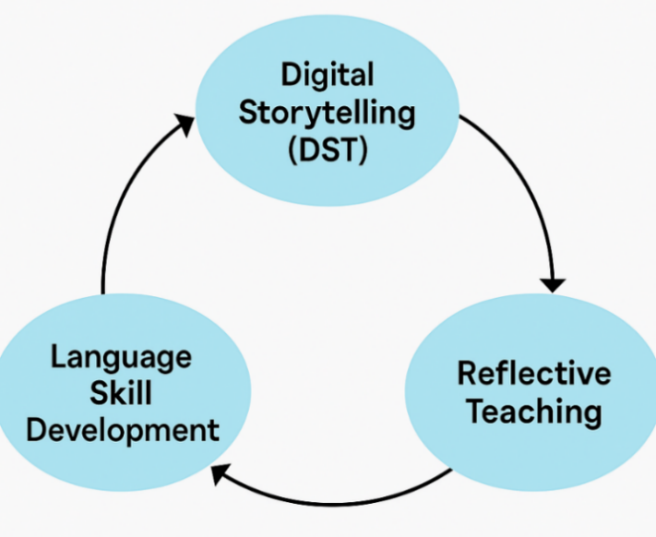
Figure 2.3 Conceptual Framework

RESEARCH METHOD

The methodology used in this research is outlined in this chapter. It includes the research design, setting, participants, instruments, data collection technique, and data analysis.

Research Design
This study employed autoethnography research design, to explore the use of digital storytelling (DST) in enhancing students' speaking and listening skills. As both a teacher and researcher, the writer positioned herself as a complete-member researcher (CMR), reflecting critically on personal teaching experiences within the classroom while maintaining systematic academic rigor (L. Anderson, 2006). This dual role enabled a deeper engagement with the subject matter, blending personal narrative with scholarly inquiry.
Autoethnography as a research method allows for introspective examination of personal experiences while situating them within a wider cultural and educational framework. In this study, the integration of DST in an English as a Foreign Language (EFL) context served as the foundation for reflection, analysis, and narrative construction. The analytic autoethnographic model was chosen to emphasize the importance of transparency, dialogue with existing literature, and reflexive awareness throughout the research process (Chang, 2016a; C. Ellis et al., 2011).
Unlike traditional qualitative research, analytic autoethnography extends beyond narrative description by requiring systematic data collection, thematic analysis, and theoretical engagement. Throughout the study, the researcher maintained field notes, reflective journals, classroom observations, and documentation of student outputs to support self-reflection and provide triangulated data.
This design allowed the researcher to document not only the pedagogical effectiveness of DST but also the transformative journey of the teacher. The reflection focused on decision-making, instructional strategies, and the socio-emotional dynamics of the classroom. The challenges, adaptations, and insights emerging from the DST implementation were interpreted as both individual learning moments and contributions to broader teaching practice.
Ultimately, the analytic autoethnographic approach used in this study provided a powerful means of bridging personal experience with theoretical understanding, promoting a deeper comprehension of how digital innovations like DST can be meaningfully integrated into language education. It positioned the teacher's voice at the center while maintaining academic distance, allowing for critical insight into the intersection of digital pedagogy, student engagement, and teacher development. These multiple sources ensured both the credibility and depth of the research findings.

Research Settings
This research took place at MA Al Musyaffa’ which located at Jl. Robyong Dk. Wonorejo, Kel. Pesantren, Mijen, Semarang City, Central Java. MA Al Musyaffa’ operated under the educational foundation of Pesantren Fadhlul Fadhlan that was a bilingual boarding school that integrated Arabic and English language instruction. The research period was started on May 1st until May 9th 2025.

Research Participants
In line with autoethnographic research principles, the primary participant in this study was the researcher, who also as an English teacher in the classroom where the Digital Storytelling (DST) intervention was deployed. Autoethnography stresses the researcher's function as both observer and subject of inquiry, allowing for deep personal reflection and study of one's own teaching practices (C. Ellis et al., 2011).
As sole participant, the researcher conducted rigorous self-observation, kept reflective teaching journals, and critically analyzed her experiences creating, delivering, and evaluating DST-based education. These reflections served as the study's principal data source, providing a detailed, narrative account of pedagogical growth and classroom practice.
Although the tenth-grade students were not direct research subjects, their participation, reactions, and classroom interactions formed the contextual backdrop of the study. These classroom dynamics were automatically included into the researcher's reflections, which contributed to a better understanding of the educational process.

Research Instruments
In this analytic autoethnographic study, the researcher served as the primary research instrument. As both the teacher and observer, the researcher engaged in reflective documentation of classroom interactions, instructional choices, and pedagogical experiences during the implementation of Digital Storytelling (DST). This dual role allowed for deep immersion in the research context and continuous self-observation, which are central to the autoethnographic tradition (Chang, 2016a; C. Ellis et al., 2011)
To support the primary instrument, several complementary tools were used. Observation checklists were employed to record students’ verbal participation, collaborative engagement, and classroom behaviors related to DST. Additionally, reflective journals were maintained by both the teacher-researcher and students. The teacher’s journal captured personal insights, evolving instructional strategies, and critical events, while students’ journals offered perspectives on their learning experiences and emotional responses throughout the project.
Other supporting instruments included student-produced DST outputs and brief, semi-structured interviews. The digital storytelling projects served as authentic evidence of students’ speaking and listening skill development, while interviews provided feedback on learners’ engagement and perceptions. These combined instruments enabled data triangulation, allowing for a more comprehensive and trustworthy interpretation of the learning process (L. Anderson, 2006).

Technique of Data Collection
In this study, several qualitative data collection techniques were employed to document the teaching and learning process during the implementation of digital storytelling in the classroom. As the researcher simultaneously took the role of a teacher, a participant-observer perspective allowed for deep and sustained engagement with the learning context. The data collection techniques were aligned with the analytic autoethnographic approach, emphasizing introspection, self-observation, and the integration of personal narrative with empirical classroom data. The techniques are described as follows:

Participant Observation
The researcher conducted continuous observations throughout the DST implementation. As a participant in the teaching process, the researcher recorded classroom dynamics, student engagement, learning behaviors, and social interactions. Observations were documented through field notes and sessional reflections written immediately after each session. This allowed the researcher to capture contextual details and emotional nuances that might otherwise be missed.

Reflective Journal
A reflective journal was kept by the researcher to record personal thoughts, pedagogical decisions, emerging challenges, and evolving perspectives. This journal functioned as a core instrument of critical self-reflection, in line with autoethnographic practices (Chang, 2016b; C. Ellis et al., 2011). Through this journal, the researcher connected personal experiences with broader theoretical and instructional themes, thus contributing to both self-understanding and scholarly analysis. In accordance with Anderson’s model of analytic autoethnography, the reflective journal served not only as data but also as a medium for transformation, fostering deeper insight into the intersection between teaching, technology, and language learning (L. Anderson, 2006).

Documentation
Various artifacts and teaching materials were collected during the study. These included student-created DST projects (such as digital presentations), lesson plans, activity worksheets, and other instructional tools. These artifacts served to illustrate learning progress and triangulate other data sources.

Student Feedback
To enrich the researcher's perspective, students were invited to provide feedback through open-ended written responses and informal interviews. Their comments offered insight into how they experienced and interpreted the DST process. This feedback helped to corroborate the researcher’s interpretations and added depth to the reflective analysis.
By combining introspective reflection with classroom-based evidence, these data collection techniques allowed for a holistic and nuanced understanding of how digital storytelling influenced speaking and listening skill development in the English classroom.

Technique of Data Analysis
The data in this study were analyzed using a qualitative approach rooted in analytic autoethnography, which emphasizes both personal narrative and systematic reflection to interpret cultural and educational experiences (L. Anderson, 2006; Chang, 2016a). The analysis followed these five interconnected stages:

Data Organization
All collected data—comprising reflective journals, observation notes, students’ digital storytelling outputs, and classroom documentation—were compiled and organized chronologically. Digital materials were sorted by session topics, while written reflections were coded and labeled to facilitate thematic analysis.

Thematic Analysis
Thematic analysis was employed to identify and interpret recurring patterns across the data. This method involved reading and re-reading reflective journals, observation notes, and student outputs to generate themes related to engagement, language development, and teacher reflection. Braun and Clarke’s (Braun & Clarke, 2006) six-phase framework guided the process: familiarization, coding, theme generation, theme review, definition, and reporting. This systematic yet flexible approach allowed the researcher to capture both explicit and underlying meanings within the data.

Data Triangulation
To enhance the credibility and validity of the findings, data triangulation was applied by incorporating multiple sources of evidence. Observation notes, reflective journals, and student-generated DST projects were cross-examined to ensure consistency of themes. In addition, student feedback—both written and verbal—served as a supporting perspective to verify or challenge the researcher’s interpretations. This triangulation process allowed for a more balanced and comprehensive understanding of the classroom experience from both the teacher’s and learners’ viewpoints.

Linking Personal Experience to Theory
In line with the principles of analytic autoethnography, the researcher critically examined personal teaching experiences and connected them with relevant theoretical frameworks and scholarly literature. This process enabled a deeper understanding of how digital storytelling contributed to students’ development in speaking and listening skills.

Narrative Construction
The final stage involved the construction of a coherent narrative that integrated personal experiences with analytical insights. This narrative not only presented what occurred during the teaching process, but also explored the meanings behind those experiences from the dual perspective of a teacher and a researcher.

RESEARCH FINDINGS AND DISCUSSION
This chapter describes the conclusions of a study conducted at MA Al Musyaffa', a bilingual Arabic-English Islamic boarding school with a character-based salaf foundation. The study examined the use of digital storytelling as an innovative technique for improving students' speaking and listening skills in a tenth-grade English conversation class. Classroom observations, students' digital storytelling projects, reflective journals (both from the teacher-researcher and students), and informal interviews were all used to collect data. Because the study took an autoethnographic approach, the results are presented thematically and intertwined with the researcher's reflecting narratives. This chapter also discusses how the findings relate to key theories and past research.

Findings
The findings of the research are presented as a series of theme reflections based on the researcher's experiences as both a teacher and an observer while implementing digital storytelling in an English-speaking conversation classroom. These findings were derived from classroom observations, students' digital storytelling products, interviews, and reflective journals observed throughout the process.

The Contribution of Digital Storytelling (DST) to Students’ Speaking and Listening Skills

Engaging in Story Planning and Scriptwriting
Before the implementation of Digital Storytelling (DST), students demonstrated low engagement and confidence in speaking and listening activities. Classroom observations revealed that many students hesitated to speak in English due to fear of making mistakes, lack of vocabulary, and limited exposure to authentic listening materials. Their listening comprehension was often hindered by unfamiliar accents and fast speech.
In the first session, I asked them to introduce themselves in English. The responses were extremely short—just names and a few words. Some students giggled nervously, others looked down at their desks. I sensed a strong fear of being wrong (Teacher Reflective Journal, Day 1).

After doing an observation, I began by explaining DST, its elements, and tools in the next meeting. Then, using the LCD projector, I showed students an example of digital storytelling (DST by Angela Megino, "I'm an introvert" on YouTube) with English subtitles. Students watched the video several times to gain a better understanding of the concept.
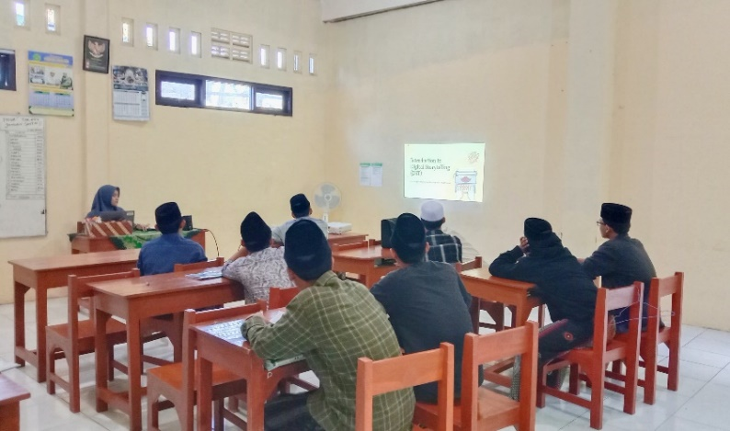
Figure 4.1 The teacher-researcher explained DST in conversation class
Listening comprehension was also restricted. After explaining DST in the class, I asked some questions related to the video displayed for checking the students’ listening skills. The students could grasp single words or recognizable phrases, they frequently struggled to follow whole spoken narratives unless visual aids or translations were available. This was clear when the class listened to a short audio tale, with only a few students successfully summarizing the scenario and answering questions related to the video displayed.

Rehearsing and Presenting Stories Orally
The introduction of DST sparked curiosity and enthusiasm among students. When presented with a sample DST video, they expressed excitement and interest. Group discussions during story planning stages revealed increased collaboration and creativity. Students became more engaged during the scripting and multimedia preparation phases. Many reflected in their journals that creating and sharing stories allowed them to express themselves more freely.
Students' participation in the Digital Storytelling (DST) project was notably helpful, especially given the short timeline for implementation. Despite their initial unfamiliarity with the DST technique, most students rapidly adjusted and became actively involved in the learning process.
At the start of the week and after making some groups, some students were unwilling and unsure of how to proceed with the storytelling assignment. However, as they started working in groups, their engagement jumped dramatically. They worked together to create their narratives, select characters, design slides, and prepare for the presentation. Group collaboration enabled even the most reserved students to share ideas and help organize the tale.
Teacher’s Observation
Although at first they looked confused, they soon became enthusiastic—especially when designing their own characters or choosing story settings (Teacher Reflective Journal, Day 1).

The creative aspect of DST proved to increase motivation. Students were excited to create something unique and visual. Some groups utilized hand-drawn illustrations, while others put photos on slides to depict scenes. The ability to design made the learning experience more personalized and enjoyable.
Student’s Reflection
I like creating stories with my friends. It was enjoyable to think about the storyline, retell it and keep the plot interesting, (student AD).

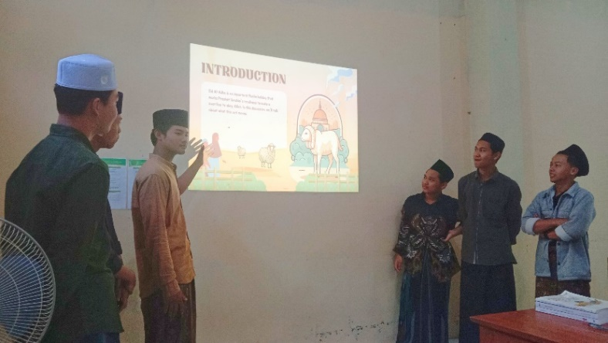
Figure 4.2 The students presented their DST

During presentations, many students acknowledged fear about speaking in front of the conversation class, but they made genuine efforts to share their group's narrative. Their involvement was evident in how they supported each other throughout presentations— prompting, assisting with language, or encouraging a nervous friend.
As they progressed, students demonstrated improved participation and collaboration. They contributed ideas, discussed storylines, and assigned roles within groups. The process fostered peer support and reduced speaking anxiety. Several students began to voluntarily present in front of the class. Their reflections showed growing confidence, emotional investment, and a sense of achievement.
Student’s Reflection
Usually, I feel shy in English class, but when we made our story, I wanted to try to speak, (student HU).

While not all students participated equally in each step of the process, overall participation was strong. During peer presentations, students were more engaged, asking relevant questions and making favorable comments to other groups.

Collaborating Creatively with Peers
Throughout the DST process, students showed observable growth in their language production. In initial sessions, their scripts contained short and simple sentences. By the final presentations, students demonstrated longer utterances, better pronunciation, and improved sentence structure. Group recordings revealed clearer articulation and more expressive speech.
During the early stages of DST production, students began structuring their stories, selecting acceptable photos, and writing something important in English. Each group worked at varying levels of confidence and capability. Some students took the initiative in authoring the scripts, while others concentrated on slide design and storytelling. The teacher offered direction and assistance, notably in the areas of vocabulary, grammar, and tale construction.
Despite challenges such as limited vocabulary and apprehension about using English, many students demonstrated perseverance and a willingness to learn from both their peers and the teacher. As the DST preparation progressed, students demonstrated significant improvements in group cooperation and linguistic application. They started to utilize more English in group discussions, demonstrating a greater understanding of sentence structure and storytelling flow.
On the final day, each group demonstrated its DST project in front of the class. The lectures featured oral storytelling based on PowerPoint slides. Despite the fact that the initiative did not use voice recordings, the live presentations allowed students to practice their speaking skills in a real-world communication context. Most groups delivered their stories fluently, with passionate intonation and suitable gestures. While some students appeared hesitant, their overall performance demonstrated a rising feeling of confidence and competence.
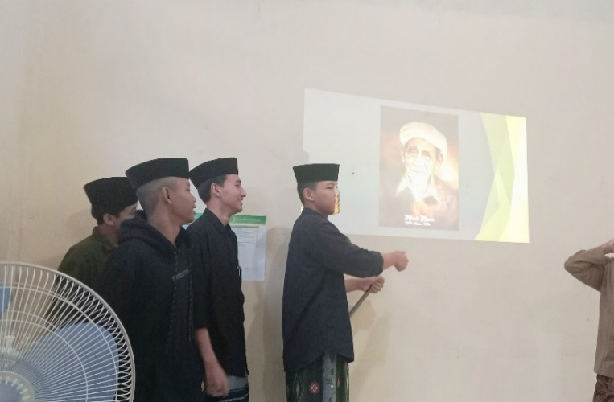
Figure 4.3 The students checked the audiences’ listening skill
Listening activities, such as reviewing peer presentations and giving feedback, also enhanced their comprehension. They learned to focus on intonation, tone, and message clarity. The DST activities encouraged active listening and peer evaluation. The feedback phase was especially beneficial, as students listened critically and responded constructively. This iterative cycle contributed to continuous improvement.

Engaging in Reflective Practice
Students' speaking skills improved significantly through the DST process. The opportunity to write scripts, rehearse, and present their stories helped them internalize vocabulary and grammar structures. Repetition during rehearsal boosted their fluency, while peer collaboration supported pronunciation practice.
When students were first introduced to the concept of storytelling earlier in the week, several of them were apprehensive to speak in English. They tended to provide brief answers, avoided eye contact, and frequently shifted to their original tongue. Their confidence in speaking English was clearly low, especially when asked to narrate simple anecdotes or personal experiences.
Teacher’s Observation (Early Stage)
Most students were hesitant and nervous to say even short sentences. They preferred to write rather than speak and need a lot of encouragement to communicate. (Teacher Reflective Journal, Day 1)

The environment created by DST was non-threatening, allowing students to practice speaking in a supportive setting. Their presentations reflected increased confidence and clarity. In one group, a student who rarely spoke in class confidently narrated an entire segment of their story. These experiences fostered a sense of ownership and pride in their language use.
Teacher Observation (Final Presentation)
Students presented with greater confidence. Some even added personal touches, such as gestures or tone changes, to make their story more engaging. (Teacher Reflective Journal, Day 5)

Several students also employed newly taught vocabulary and narrative expressions, such as “once upon a time,” “in the end,” or “it was very exciting.” Though certain grammatical faults were still evident, their speech was more coherent and better ordered. Their capacity to convey thoughts clearly and sequentially demonstrated improvement over their previous performance.
Student Reflection
At first, I was afraid to speak, but after practicing the story, I felt better. I tried to communicate properly without reading too much, (Student LG).

The last presentation included a brief Q&A session in which students were asked easy questions by their peers and the teacher. This encouraged spontaneous communication, highlighting their capacity to reply without preparation. Although not all students were as confident, few were able to respond accurately and with little hesitation.
Teacher’s Observation (Q&A Session)
Even students who had been quiet earlier attempted to answer questions. Some offered thorough replies and were pleased with their performance. (Teacher Reflective Journal, Day 3)

In addition to speaking, students’ listening skills were also enhanced through DST activities, particularly during the question-and-answer sessions following each presentation. The active student explained in interview session,
I learned to listen more carefully to questions so I could answer them correctly, (Active Student).

This indicated that the project provided opportunities for authentic listening practice, encouraging students to focus and respond in real-time.
To summarize, the DST activity provided an interesting and relevant environment for students to improve their listening abilities. Despite the absence of recorded materials, live presentations and interactive Q&A sessions were effective strategies for encouraging active listening, comprehension, and classroom discussion.

Personal Insights from the Implementation of DST

Increased Empathy Toward Students’ Challenges
The teacher-researcher developed greater empathy for the learning challenges of her students after implementing Digital Storytelling (DST). Observing students struggle with language selection, pronunciation, time constraints, and public speaking anxiety provided direct insight into the emotional and cognitive limitations that students frequently confront.
At the beginning, I noticed how nervous they were to even say simple phrases in English. Some students looked down or avoided eye contact whenever they were asked to speak. (Teacher Reflective Journal, Day 1)

Observing these behaviors firsthand helped the researcher understand that hesitation to speak was typically caused by fear of judgment and low self-confidence, rather than a lack of ability. This understanding changed the teacher's attitude to classroom engagement, causing the teacher-researcher to become more empathetic and sympathetic to the students.
The feedback from students also affirmed this. In an interview, one passive student shared:
I was afraid to make mistakes. But when my group helped and didn’t laugh, I felt more comfortable. (Passive Student)
This moment reminded the teacher that peer support and emotional safety were essential for success. As a result, empathy led to practical tactics such as increased encouragement, scaffolding, and patient repetition throughout the DST process.
"From this experience, I've learnt not to assume that students' silence reflects laziness. Often, it indicates that they are unclear how to express themselves." (Teacher Reflective Journal, Day 3)
By experiencing the learning process via the students' eyes, the teacher gained a newfound sensitivity to pacing, feedback, and classroom emotional climate, which informed the next teaching decisions.

Enhanced Self- Awareness and Confidence
Throughout the implementation of Digital Storytelling (DST), the teacher-researcher became more aware of a teaching approaches, emotional responses, and personal growth. The combined role of teacher and researcher encouraged a reflective mindset, prompting ongoing review of decisions, teaching tactics, and classroom relationships.
After each session, I kept thinking about how I responded to students’ confusion, how I motivated the shy ones, and whether I gave them enough space to express their ideas. These small reflections helped me become more intentional with my teaching. (Reflective Journal, Day 2)
Initially, I questioned my ability to manage this type of inventive approach. I wasn't sure if the students would react positively or if I could effectively guide them through the DST process. However, their participation and progress gradually boosted my confidence. I felt more empowered to make creative teaching decisions and respond to the requirements of the students.
One student's statement during the interview confirmed this shift in my teaching identity.
I was amazed that my teacher let us be creative. It made me feel more respected. (Active Student)

This helped me realize that allowing for student agency not only benefited them, but also reinforced my belief in a more student-centered, reflective teaching approach. By the end of the study, I had gained confidence not only in using DST, but also in my ability to grow as a teacher.

Emotional Fulfillment and Sense of Purpose
Implementing Digital Storytelling (DST) was not only a pedagogical challenge, but also an emotionally rewarding experience for me as a teacher. Seeing my students gain confidence, collaborate with their peers, and share their personal stories gave me a renewed sense of purpose in teaching.
Throughout the process, I was often tremendously moved by the work my students put into their stories. Despite their initial reservations, they approached the assignment with inventiveness and brave. I was thrilled to see them grow from timid, uncertain students to storytellers who could present in English with expression and purpose.
The initiative reminded me that teaching is more than just conveying knowledge; it is also about developing confidence, empathy, and expressiveness. When a normally quiet student offered to speak during the presentation, I had a strong emotional connection to the situation. It demonstrated that the environment we established was safe and empowering.
When I shared our experience in class, I felt both nervous and happy. I never thought I could do it, but I did. (Passive Student)

Pedagogical Insights from the Implementation of DST

Teacher-Centered to Student-Centered Learning
One of the most significant educational realizations I had when implementing Digital Storytelling (DST) was the transition from a teacher-centered to a student-centered learning environment. Prior to this initiative, my teaching style was directive, with me controlling most portions of the course. However, DST required students to take charge of their learning by planning, writing, designing, and performing their own stories.
This transition altered the classroom dynamic. I shifted my role from knowledge transmitter to facilitator, assisting students as they developed their own ideas and made joint judgments. This is consistent with constructivist teaching ideas, which emphasize the value of student agency and active learning.
Students ceased to be passive receivers of information and instead became active makers and communicators. I saw that even the quietest students become more engaged when given the opportunity to shape their group's assignment. This transformation prompted me to reevaluate my role—not simply as a teacher who provides material, but as someone who creates the conditions for learning to develop naturally.
This instructional movement also promoted differentiation. Each group addressed the DST job differently, with some focusing on pictures and others on language. It enabled students with diverse skills to contribute constructively. This reaffirmed my opinion that student-centered learning promotes inclusivity, creativity, and deeper involvement.

The Importance of Scaffolding and Flexibility
Another educational lesson I gained from the DST implementation was the importance of scaffolding and flexibility in the learning process. While students were encouraged to take the initiative in developing their stories, they still needed structured assistance to navigate the unfamiliar activity. Without adequate direction, the initiative may have become challenging, particularly for students with inadequate language ability or digital skills.
At first, I gave students a sample DST video, a story-planning template, and vocabulary help. I also described the components of DST and divided the work into reasonable parts during the week. These scaffolding tools provided a framework for students to develop their creativity and language skills. As I noted in my reflecting journal:
They didn't know where to start at first, but when I demonstrated the stages and provided examples, they began to shape their own ideas more confidently. (Reflective Journal, Day 1)

Equally critical was the necessity to maintain flexibility. Not all students moved at the same speed. Some groups finished their screenplays fast, while others took more time to brainstorm or revise. There were also technical hurdles, such as students' unfamiliarity with producing effective slides or conducting the photos. In response, I had to change the timeframe and reduce some requirements.
Rather than rigidly following to the initial plan, I learnt to adjust to their requirements. To lessen time strain and anxiety, I authorized live presentations rather than recorded narration. This flexibility made students feel encouraged rather than evaluated, and it allowed the project to move along successfully despite classroom limits. During the interview, one student stated,
We were initially confused, but we gradually understood what to do." I appreciated how the teacher helped but didn't tell us what to do. (Passive Student)
Through this process, I recognized that scaffolding is not about controlling students’ work—it is about equipping them with the tools and encouragement to succeed independently. Flexibility, on the other hand, reflects an empathetic and responsive approach to teaching, ensuring that all students have access to meaningful learning experiences.

Teacher’s Reflection on Learning Process
Implementing DST provided the teacher-researcher with significant pedagogical insights. The shift from teacher-centered instruction to a student-driven process revealed the value of creativity and autonomy in language learning. The teacher observed increased student motivation and deeper engagement.
Reflective journal entries captured the challenges faced, such as time management, technology limitations, and guiding students unfamiliar with digital tools. However, these were outweighed by the rewards of witnessing student growth. The experience highlighted the importance of scaffolding, flexibility, and emotional support in facilitating meaningful learning.
Reflecting on the whole implementation of Digital Storytelling (DST) in the classroom, I found the experience to be both illuminating and transformative—not only for students but also for myself as a teacher researcher. In just one week, I saw improvements not just in students' speaking and listening skills, but also in their motivation, confidence, and classroom involvement.
Initially, I was concerned about time constraints and students' readiness to participate in a story and innovative approach to language acquisition. Many of them were unfamiliar with English storytelling, especially when it came to giving presentations in front of their peers. However, as the research developed, I saw that the collaborative element of group work assisted with reducing their nervousness. They helped one another develop, practice, and deliver their stories, which increased their confidence and sense of collaboration.
Given the students' context, the decision to leave out the audio recording component in exchange for a live presentation was suitable. It allowed them to focus more on speaking spontaneously in front of an audience while also creating space for meaningful, real-time connection. While some students continued to rely on notes, others made genuine efforts to talk freely, and I noticed a gradual but positive improvement in their fluency and eagerness to interact.
From a listening perspective, I observed students become more interested when they received language input from their classmates. They paid more attention during presentations since the information was personal, relevant, and understandable. This improved their listening comprehension and made Q&A sessions more engaging. In several cases, students who were previously passive became more active in asking questions and providing feedback.
Another reflection is that DST made language learning more meaningful and personal. Students expressed satisfaction in creating their own stories, and this sense of ownership appeared to boost their drive. Even students who were typically less engaged in class demonstrated increased participation when their group's project was involved.
Of course, challenges occurred. Time limits limited the depth of preparation, and not all students could contribute equally due to differences in language abilities. However, these challenges formed part of the learning process. I discovered the value of offering adequate modeling, scaffolding, and encouragement throughout the process.
In conclusion, the DST project was successful in increasing student involvement and creating a more engaging and entertaining teaching environment. It provided students control over their education and allowed them to use English as a medium of expression and collaboration.
The findings of this study show that implementing Digital Storytelling (DST) for a week improved students' speaking and listening skills by encouraging creativity, teamwork, and active use of English. Students gained confidence in expressing their thoughts, improved their listening skills, and became more interested in the learning process. Both teacher and student feedback indicated that DST generated a supportive and fun classroom environment, making language learning more relevant and engaged.

Discussion
This section discusses the key findings in relation to the research questions, supported by existing theories and related literature. The discussion is organized into three main areas: how DST contributed to students' speaking and listening skills, the personal insights gained by the teacher-researcher, and the pedagogical implications of implementing DST.

DST and the Development of Speaking and Listening Skills

Engaging in Story Planning and Scriptwriting
Planning and scriptwriting allowed students to brainstorm ideas, negotiate meaning, and structure language meaningfully. According to Swain's (1985) Output Hypothesis, producing language pushes learners to process language at a deeper level. When students drafted their stories, they had to focus on vocabulary, grammar, and narrative structure. This phase aligned with task-based language teaching, where real-world language tasks foster meaningful interaction (2003). The collaborative drafting also helped less confident students participate actively.

Rehearsing and Presenting Stories Orally
Oral rehearsal and performance offered authentic opportunities to practice pronunciation, intonation, and fluency. This aligns with Krashen's (1982) Affective Filter Hypothesis, which suggests that low-anxiety environments enhance language acquisition. The iterative rehearsal phase helped students become more fluent and confident. According to Communicative Language Teaching (CLT), speaking in context-rich tasks like DST presentations fosters meaningful output and enhances communicative competence (2006) .
When I talked during our story, I simply wanted to make sure everybody understood. I wasn't too concerned about errors. (Student MA, Student Reflection)

Collaborating Creatively with Peers
Peer collaboration enabled students to co-construct knowledge and language, consistent with Vygotsky's sociocultural theory (1978), which emphasizes learning through social interaction. Students negotiated meaning, divided tasks, and supported one another in planning, designing, and performing. This promoted pragmatic competence and increased learner autonomy. The creative aspect of DST, such as drawing and slide design, increased emotional engagement and motivation.

Engaging in Reflective Practice
Throughout the DST process, students engaged in reflection—both individually and collaboratively. Keeping journals and giving peer feedback helped students evaluate their learning process. This aligns with metacognitive strategies that support self-monitoring and self-regulation (L. W. Anderson & Krathwohl, 2001). Engaging in reflection strengthened both speaking and listening skills as students became more conscious of their language use and receptive behaviors.
Usually, I feel shy in English class, but when we made our story, I wanted to try to speak. (Student HU, Student Reflection)

Personal Insights from the Implementation of DST

Increased Empathy Toward Students’ Challenges
By closely observing students during the DST process, the teacher-researcher gained a deeper understanding of their struggles—ranging from limited vocabulary to anxiety. This fostered a sense of empathy and patience, allowing the teacher to provide better support. As Bullough and Pinnegar (2001) explain, teacher identity is shaped through relational understanding, and empathy is key in nurturing learning environments.
Most students were hesitant and nervous to say even short sentences. They preferred to write rather than speak and need a lot of encouragement to communicate. (Teacher Reflective Journal, Day 1)

Enhanced Self-Awareness and Confidence
Implementing DST prompted the teacher to evaluate personal teaching strengths and areas for growth. Reflecting on classroom experiences led to greater self-awareness regarding instructional choices and emotional responses. This aligns with the concept of the reflective practitioner (Schön, 1983), who continuously learns through action and reflection. The project also boosted the teacher's confidence in using innovative, student-centered methods.

Emotional Fulfillment and Sense of Purpose
Watching students’ progress and enjoy learning through DST gave the teacher a sense of fulfillment. Seeing formerly passive students contribute actively reinforced the teacher's belief in learner-centered approaches. As Day and Qing (2009) suggest, emotional rewards sustain teachers’ motivation and commitment, especially when they witness authentic learning.
Even students who frequently talk less in class were able to describe aspects of their group's story. Some even offered to present without being pushed. (Teacher Reflective Journal, Day 3)

Pedagogical Insights from the Implementation of DST

Teacher-Centered to Student-Centered Learning
DST required the teacher to shift roles—from knowledge provider to facilitator. This transformation mirrors constructivist teaching, where learners actively build knowledge through interaction (Brooks et al., 1993). Students became more autonomous, and the teacher learned to trust in their capabilities.
I saw who were the natural leaders, the quiet creative thinkers, and those who could explain ideas well in English. (Teacher Reflective Journal, Day 3)

The Importance of Scaffolding and Flexibility
The DST process revealed the necessity of scaffolding: providing examples, modeling tasks, and gradually transferring responsibility. Teachers had to adapt to students’ varied proficiency levels, using differentiated instruction. This aligns with Vygotsky's Zone of Proximal Development (ZPD), where learning occurs best when supported just beyond the student's current level.

Teacher’s Reflection on Learning Process
Implementing DST enabled the teacher to reflect deeply on pedagogical practices. Each classroom event, student response, and challenge became data for learning. As Farrell argues, reflective teaching is essential for professional growth (Farrell, 2014b). Through this process, the teacher not only improved instructional methods but also reconnected with the purpose of language education: empowering learners to communicate meaningfully.
The teacher also noted that DST helped them to observe their students' personalities and abilities more comprehensively:
I saw who were the natural leaders, the quiet creative thinkers, and those who could explain ideas well in English. (Teacher Reflective Journal, Day 3).
This kind of observation is valuable for ongoing curriculum planning and student support.

Challenges and Limitations
Despite the positive results, the study had several limitations. First, the short time frame (a week) limited the depth of DST development. In an ideal world, students might modify their stories, receive peer comments, and improve their language skills more fully. Second, due to technology limitations, students were limited to using PowerPoint for their digital stories, which lacked audio and video components. This did not inhibit success, but it did limit DST's multimodal potential.
Another problem was the different levels of participation within groups. Some students were more determined, while others contributed less. This is a prevalent problem in group work, indicating the necessity for clearer role assignments or defined group rubrics in future implementations.

Implications for Language Learning in Islamic Boarding Schools
This study is especially relevant given the background of MA Al Musyaffa', which is a bilingual Islamic boarding school with a strong emphasis on character education. DST enabled the combination of creativity, language acquisition, and cooperation in ways consistent with the school's teaching philosophy. It supported not only cognitive but also affective and social development.
Furthermore, DST demonstrated adaptability even in resource-limited contexts. Its success was not due to sophisticated technology, but to creative task design, instructor assistance, and student participation. This shows that other schools, particularly in comparable pesantren settings, may implement DST with few resources but high involvement.

CONCLUSION AND SUGGESTION
This chapter presents the conclusion and suggestions from the researcher that has been discussed in the previous chapter.

Conclusion

The Contribution of Digital Storytelling (DST) to Students’ Speaking and Listening Skills
This research revealed that Digital Storytelling (DST) contributed significantly to the improvement of students’ oral communication skills. In speaking, students showed progress in fluency, pronunciation, vocabulary usage, and overall confidence. Through stages such as story planning, scriptwriting, rehearsing, and presenting, learners became more expressive and actively engaged. Listening skills were also enhanced as students participated in peer evaluations, interactive Q&A sessions, and group discussions. The multimodal and context-rich nature of DST helped them understand language input more effectively, especially through visual support and peer-generated content. The learning process encouraged meaningful interaction, creativity, and authentic language use.
Overall, DST facilitated a supportive environment that promoted risk-taking and collaboration. Students gained not only linguistic competence but also emotional connection with the content they created. Despite initial hesitation, most students became more motivated and willing to communicate as the project progressed, showing clear improvement in both speaking and listening performance.

Personal and Pedagogical Insights from the Implementation of DST
From the teacher-researcher’s perspective, implementing DST provided valuable insights into both personal growth and pedagogical practice. Personally, the process fostered increased empathy toward students’ learning struggles, enhanced self-awareness, and a renewed sense of purpose as an educator. Reflective practice became central, as classroom moments, challenges, and student responses were critically analyzed to guide decision-making and improvement.
Pedagogically, DST shifted the classroom from a teacher-centered to a student-centered environment. The experience highlighted the importance of scaffolding, flexibility, and responsiveness to students’ needs. It also demonstrated how technology could be integrated meaningfully to support language learning and student engagement. Despite time limitations and technical challenges, the implementation proved that DST could serve as a powerful medium for enhancing EFL instruction in a holistic, creative, and reflective manner.

Suggestions
Based on the implementation and results of this study, the following suggestions are offered:

For English Teacher
English teachers are encouraged to incorporate DST into their instructional practices to foster student engagement and improve oral communication. Teachers should be prepared to provide technical guidance, manage group dynamics, and allocate sufficient time for the creative process. Engaging in reflective teaching throughout the DST implementation is also recommended.

For Students
Students are encouraged to actively participate in DST activities and embrace the opportunity to express themselves through multimedia storytelling. Collaboration, creativity, and reflection are key components of successful DST projects. Students should view the experience as a platform to build confidence and enhance both speaking and listening skills.

For Future Researcher
Further studies can explore the long-term impact of DST on language development or compare its effectiveness across different language skills. Researchers may also investigate the role of DST in diverse educational contexts, including different age groups or proficiency levels. Expanding the autoethnographic reflection to include student voices could also enrich the research perspective.

For Curriculum Developer
DST can be included into English curriculum as a project-based activity that promotes not just language competency but also digital literacy, teamwork, and character development, particularly in bilingual and pesantren-based educational settings.
By continuing to explore and refine the use of DST, educators and researchers can contribute to more meaningful, engaging, and effective language teaching practices.

REFERENCES
Abdel-Hack, Mohamed, E.-S., & Helwa, H. S. E.-D. (2014). Using digital storytelling and weblogs instruction to enhance EFL narrative writing and critical thinking skills among EFL majors. International Journal of English Language and Literature Studies, 3(2), 76–87. https://doi.org/10.18488/journal.23/2014.3.2/23.2.76.87

Alismail, H. A. (2015). Integrate digital storytelling in education. Journal of Education and Practice, 6(9). https://doi.org/10.1007/BF03033420

Anderson, L. (2006). Analytic Autoethnography. Journal of Contemporary Ethnography, 35(4), 373–395. https://doi.org/10.1177/0891241605280449

Anderson, L. W., & Krathwohl, D. R. (2001). A taxonomy for learning, teaching, and assessing: A revision of Bloom’s taxonomy of educational objectives. Longman.

Braun, V., & Clarke, V. (2006). Using thematic analysis in psychology. Qualitative Research in Psychology, 3(2), 77–101. https://doi.org/10.1191/1478088706QP063OA

Brooks, Grennon, J., & Brooks, M. G. (1993). In search of understanding: the case for constructivist classrooms. ASCD.

Bullough, R. V., & Pinnegar, S. (2001). Guidelines for quality in autobiographical forms of self-study research. Educational Researcher, 30(3), 13–21. https://doi.org/10.3102/0013189X030003013

Canagarajah, A. S. (2012). Teacher development in a global profession: an autoethnography. TESOL Quarterly, 46(2), 258–279. https://doi.org/10.1002/TESQ.18

Castañeda, M. E. (2013). “I am proud that I did it and it’s a piece of me”: Digital storytelling in the foreign language classroom. CALICO Journal, 30(1), 44–62. https://doi.org/10.11139/CJ.30.1.44-62

Çetin, E. (2021). Digital storytelling in teacher education and its effect on the digital literacy of pre-service teachers. Thinking Skills and Creativity, 39, 100760. https://doi.org/10.1016/J.TSC.2020.100760

Chang, H. (2016a). Autoethnography as Method. Autoethnography as Method. https://doi.org/10.4324/9781315433370

Clandinin, D. J., & Connelly, F. M. (2000). Narrative Inquiry:Experience and story in qualitative research. Jossey-Bass.

Cochran-Smith, M., & Lytle, S. L. . (2009). Inquiry as stance: practitioner research for the next generation. Practitioners Inquiry. Teachers College Press, 401.
Courtney, C., Bill, C., Norman, F., & Jim, G. (2005). A pedagogy of multiliteracies: Designing social futures. Harvard Educational Review, 66(1), 60–92. https://doi.org/10.17763/HAER.66.1.17370N67V22J160U

Day, C., & Qing, G. (2009). Teacher emotions: Well being and effectiveness. New Understandings of Teacher’s Work: Emotions and Educational Change, 15–31.
https://doi.org/https://doi.org/10.1007/978-90-481-2669-6_2

Ellis, C., Adams, T. E., & Bochner, A. P. (2011). Autoethnography: An overview. Qualitative Social Research, 12(1), Art.10.

Ellis, R. (2003). Task-based language learning and teaching. Oxford University Press.

Farrell, T. S. C. (2014a). Promoting teacher reflection in second language education : a framework for tesol professionals. Promoting Teacher Reflection in Second Language Education. https://doi.org/10.4324/9781315775401

Farrell, T. S. C. (2014b). Reflective practice in ESL teacher development groups: from practices to principles. Palgrave Macmillan.

Fu, J. S., Yang, S. H., & Yeh, H. C. (2022). Exploring the impacts of digital storytelling on English as a foreign language learners’ speaking competence. Journal of Research on Technology in Education, 54(5), 679–694. https://doi.org/10.1080/15391523.2021.1911008

Goh, C. C. M., & Vandergrift, L. (2021). Teaching and learning second language listening: Metacognition in action. Teaching and Learning Second Language Listening: Metacognition in Action, 1–361. https://doi.org/10.4324/9780429287749/

Gregori-Signes, C. (2020). Digital storytelling and multimodal literacy in education. Porta Linguarum Revista Interuniversitaria de Didáctica de Las Lenguas Extranjeras. https://doi.org/10.30827/digibug.53745

Hafner, C. A., & Miller, L. (2011). Fostering learner autonomy in english for science: a collaborative digital video project in a technological learning environment. Language Learning & Technology, 15(3), 68–86.

Hsu, T.-C. (2015). Telling tales: Using storytelling to teach EFL kindergarten students in Taiwan. International Journal of Research Studies in Education, 4(4). https://doi.org/10.5861/IJRSE.2015.848

Hughes, S. A., & Pennington, J. L. (2018). Autoethnography: process, product, and possibility for critical social research. Autoethnography: Process, Product, and Possibility for Critical Social Research.
https://doi.org/10.4135/9781483398594

Hull, G. A., & Katz, M.-L. (2006). Crafting an agentive self crafting an agentive self: case studies of digital storytelling. Research in the Teaching of English, 41(1).

Hung, C.-M., Hwang, G., & Huang, I. (2012). A project-based digital storytelling approach for improving students’ learning motivation, problem-solving competence and learning achievement. J. Educ. Technol. Soc.

Jakes, D. S. (n.d.). Capturing stories, capturing lives: an introduction to digital storytelling. Retrieved April 18, 2025, from http://www.altavista.com

Johnson, K. E., & Golombek, P. R. (2016). Mindful L2 teacher education: A sociocultural perspective on cultivating teachers’ professional development. Mindful L2 Teacher Education: A Sociocultural Perspective on Cultivating Teachers’ Professional Development, 1–178. https://doi.org/10.4324/9781315641447

Kalantzis, M., & Cope, B. (2012). New learning : elements of a science of education. 362. https://books.google.com/books/about/New_Learning.html?hl=id&id=N3z3_0XdVYsC

Kim, S. . (2014). Developing autonomous learning for oral proficiency using digital storytelling. Language Learning & Technology, 18(2), 20–35. https://www.lltjournal.org/item/10125-44364

Krashen, S. D. (1982). Principles and practice in second language acquisition.

Luka, I., & Seniut, I. (n.d.). Developing students’ language competence and essential 21st century skills for future employability: the case of latvia and lithuania. https://doi.org/10.2478/atd-2019-0006

Mayer, R. . (2021). The cambridge handbook of multimedia learning. The Cambridge Handbook of Multimedia Learning. https://doi.org/10.1017/9781108894333

Ohler, J. (2016). Digital storytelling in the classroom: new media pathways to literacy, learning, and creativity. Digital Storytelling in the Classroom: New Media Pathways to Literacy, Learning, and Creativity. https://doi.org/10.4135/9781452277479

Rance-Roney, & Judith. (2008). Digital storytelling for language and culture learning. Essential Teacher, 5(1), 29–31. https://www.tesol.org/docs/pdf/12830.pdf?sfvrsn=380931b9_2

Reinders, H. (2011). Digital storytelling in the foreign language classroom. eltwo, 3. http://archive.nmc.org/summit/

Richards, J. C. (2006). Communicative language teaching today. Cambridge University Press.

Robin, B. R. (2008). Digital storytelling: a powerful technology tool for the 21st century classroom. theory into practice, 47(3), 220–228. https://doi.org/10.1080/00405840802153916

Robin, B. R., & McNeil, S. G. (2019). Digital storytelling. The International Encyclopedia of Media Literacy, 1–8. https://doi.org/10.1002/9781118978238.IEML0056

Robin, B. R., & Robin, B. R. (2016). Robin Digital Education Review-Number 30. http://greav.ub.edu/der/

Sadik, A. (2008). Digital storytelling: A meaningful technology-integrated approach for engaged student learning. Educational Technology Research and Development, 56(4), 487–506. https://doi.org/10.1007/S11423-008-9091-8

Safitri, D., & Misdi, M. (2021). Speaking fluency and EFL learners’ reluctance to speak english among primary school students: factors and evidence. ETERNAL (English Teaching Journal), 12(2), 126–136. https://doi.org/10.26877/eternal.V12I2.9250

Schön, D. A. (1983). The reflective practitioner: how professionals think in action. Basic Books.

Schön, D. A. (2017). The reflective practitioner: How professionals think in action. The Reflective Practitioner: How Professionals Think in Action, 1–374. https://doi.org/10.4324/9781315237473/reflective-practitioner-donald-sch

Swain, M. (1985). Communicative competence: Some roles of comprehensible input and comprehensible output in its development. In C. Gass, Susan M. & Madden (Ed.), Input in Second Language Acquisition (pp. 235–253). Newbury House Publishers.

Trilling, B., & Fadel, C. (2009). 21st Century Skills, Enhanced Edition: Learning for Life in Our Times. John Wiley & Sons, Inc., 45–86. https://www.wiley.com/en-us/21st+Century+Skills%3A+Learning+for+Life+in+Our+Times-p-9780470553916

Vygotsky, L. S. (1978). Mind in society: The development of higher psychological processes (E. Cole, Michael; John-Steiner, Vera; Scribner, Sylvia; Souberman (ed.)). Harvard University Press.

Xu, Y., & Peng, W. (2017). Digital storytelling in education: A meta-analysis. British Journal of Educational Technology, 48(5), 1069–1087. https://doi.org/10.1111/bjet.12538

Yang, Y. T. C., & Wu, W. C. I. (2012). Digital storytelling for enhancing student academic achievement, critical thinking, and learning motivation: A year-long experimental study. Computers & Education, 59(2), 339–352. https://doi.org/10.1016/J.COMPEDU.2011.12.012

Yunus, M. M., Salehi, H., & Chenzi, C. (2012). Integrating social networking tools into ESL writing classroom: Strengths and weaknesses. English Language Teaching, 5(8), 42–48. https://doi.org/10.5539/ELT.V5N8P42

APPENDIX 1
Research Instruments
Interview Guidelines
No. | Questions
1. | Bagaimana perasaanmu saat pertama kali diminta membuat cerita digital (digitalstorytelling)?  How did you feel when you were first asked to create a digital story?
2. | Apa bagian yang paling sulit dalam membuat atau menyampaikan cerita digitalmu?  What was the most difficult part of making or presenting your digital story?
3. | Menurutmu, apakah kemampuan berbicaramu meningkat setelah proyek ini? Bisa dijelaskan bagaimana?  Do you think your speaking skill improved after this project? Can you explain how?
4. | Bagaimana pengalamanmu saat mendengarkan cerita digital dari teman-temanmu?  How was your experience listening to your friends' digital stories?
5. | Setelah mengikuti proyek ini, apakah kamu merasa lebih percaya diri berbicara dalam Bahasa Inggris? Kenapa?  After this project, do you feel more confident speaking in English? Why?
6. | Menurutmu, belajar melalui digital storytelling lebih menyenangkan atau tidak dibandingkan cara belajar biasa? Jelaskan ya.  Do you think learning through digital storytelling is more fun than regular lessons? Please explain.
7. | Apa hal yang paling kamu sukai dari kegiatan digital storytelling ini?  What did you enjoy the most about this digital storytelling activity?
8. | Kalau diberi kesempatan mengulang atau memperbaiki proyek ini, apa yang ingin kamu ubah atau tingkatkan?  If you had the chance to redo or improve the project, what would you change or improve?
Adapted from narrative inquiry and digital storytelling research methods (Clandinin & Connelly, 2000; C. Ellis et al., 2011; Robin, 2008)
Observation Checklist Form
No. | Observed Behavior / Indicator | Yes | No | Notes / Comments
1 | Students show interest when DST is introduced | [ ] | [ ]
2 | Students participate actively in group discussion | [ ] | [ ]
3 | Students contribute ideas to the story development | [ ] | [ ]
4 | Students are able to express their ideas in English | [ ] | [ ]
5 | Students show understanding when listening to other groups’ stories | [ ] | [ ]
6 | Students ask questions or respond during peer presentations | [ ] | [ ]
7 | Students use English naturally during presentation | [ ] | [ ]
8 | Students help each other during project creation | [ ] | [ ]
9 | Students complete the assigned DST task on time | [ ] | [ ]
10 | Students show improvement in speaking fluency or confidence | [ ] | [ ]
Adapted from various sources to the context of this study (L. W. Anderson & Krathwohl, 2001; Robin, 2008).
Letter of Parental Permission for Participation in Academic Research
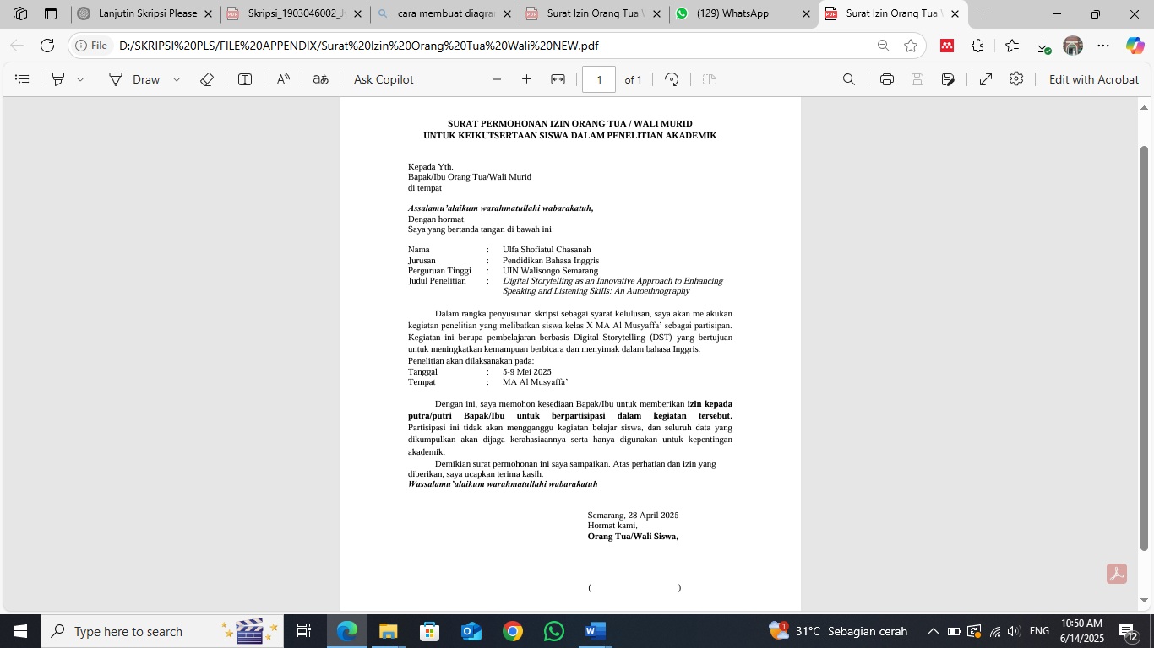
Reflective Journal Format (Student)
1. Apa yang kamu pelajari hari ini dari kegiatan membuat cerita digital?
What did you learn today from the digital storytelling activity?
2. Bagaimana perasaanmu selama proses ini?
How did you feel during the process?
3. Apa bagian tersulit dari kegiatan ini menurutmu? Mengapa?
What was the most difficult part of this activity for you? Why?
4. Apa bagian yang paling menyenangkan atau menarik bagimu?
What was the most enjoyable or interesting part for you?
5. Menurutmu, apakah kegiatan ini membantumu berbicara atau mendengarkan bahasa Inggris dengan lebih baik? Jelaskan!
Do you think this activity helped you speak or listen to English better? Please explain!

Reflective Journal Format (Teacher-researcher)
Date

Session No.
Today's Activity
(What did the students do today?)
Student Response
(How were their attitudes and engagement toward today’s activity?)
Language Development
(Were there any signs of improvement in speaking/listening? Give specific examples)
Challenges
(What difficulties did I face today as a teacher/researcher?)
Personal Feelings
(How did I feel during and after the activity?)
Learning for Myself
(What lesson did I gain as a teacher from this session?)
Additional Notes
(Student quotes, changes of plan, unexpected situations, etc.)

Lesson Planning
Class | : | 10th Grade
School | : | MA Al Musyaffa’
Week | : | 5-9 May 2025
Subject | : | Conversation Class
Topic | : | Digital Storytelling (DST)
Total Meetings | : | 5 (Monday-Friday)
Teacher-Researcher | : | Ulfa Shofiatul Chasanah

Day | Objectives | Activities | Materials | Assessment / Notes
Day 1  (Intro) | Students understand what DST is | - Introduce DST- Watch DST video (Angela Magino)- Class discussion- Group division | LCD, speaker, video DST, worksheet | Students ask questions, show initial curiosity
Day 2  (Planning) | Students plan a story and draft slides | - Each group brainstorms story ideas- | DST worksheet, paper, laptop | Observe group collaboration & creativity
Day 3  (Development) | Students continue DST creation and prepare for presentation | - Finish story- Arrange slides- Teacher assists with vocabulary or clarity | Laptops, dictionaries | Students revise story and practice speaking
Day 4  (Presentation) | Students present their DST projects | - Each group presents their story via PPT- Q&A session after each presentation | PPT slides, projector | Evaluate pronunciation, fluency, and confidence
Day 5  (Reflection) | Students and teacher reflect on learning process | - Fill in reflective journals (students)- Class feedback session- Teacher writes  personal reflection | Journal template, pen | Gather student impressions and challenges
🔖 Notes:
- Presentations were not voice-recorded; instead, they were performed live using PowerPoint and narration.
- Listening skills were assessed through peer Q&A sessions and attentiveness during presentations.
- Reflections from both students and teacher were collected to support the autoethnographic nature of the study.
APPENDIX 2
Research Results
Reflective Journal Students
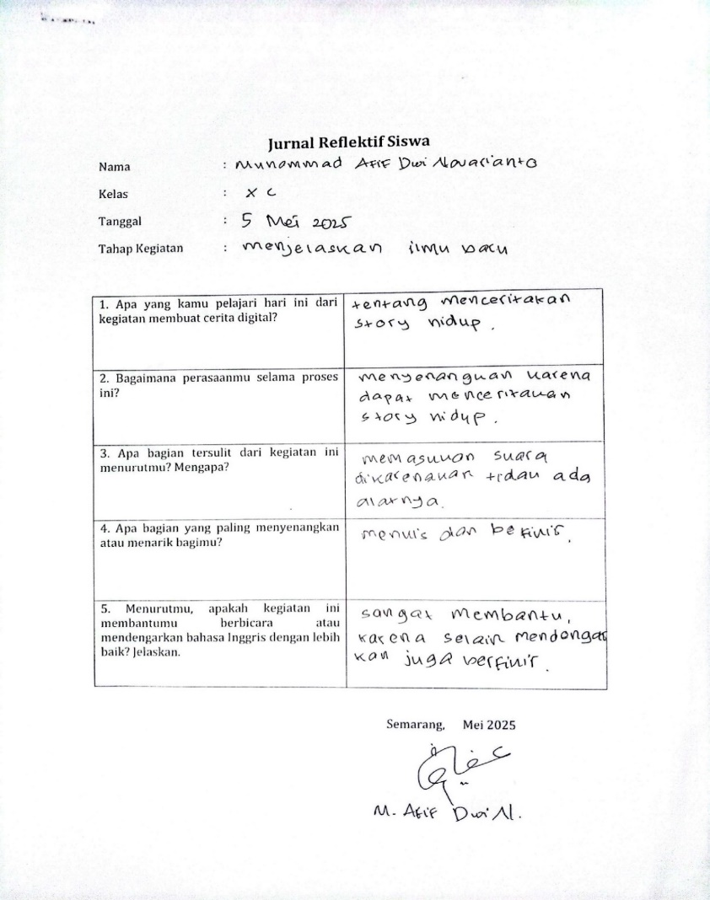
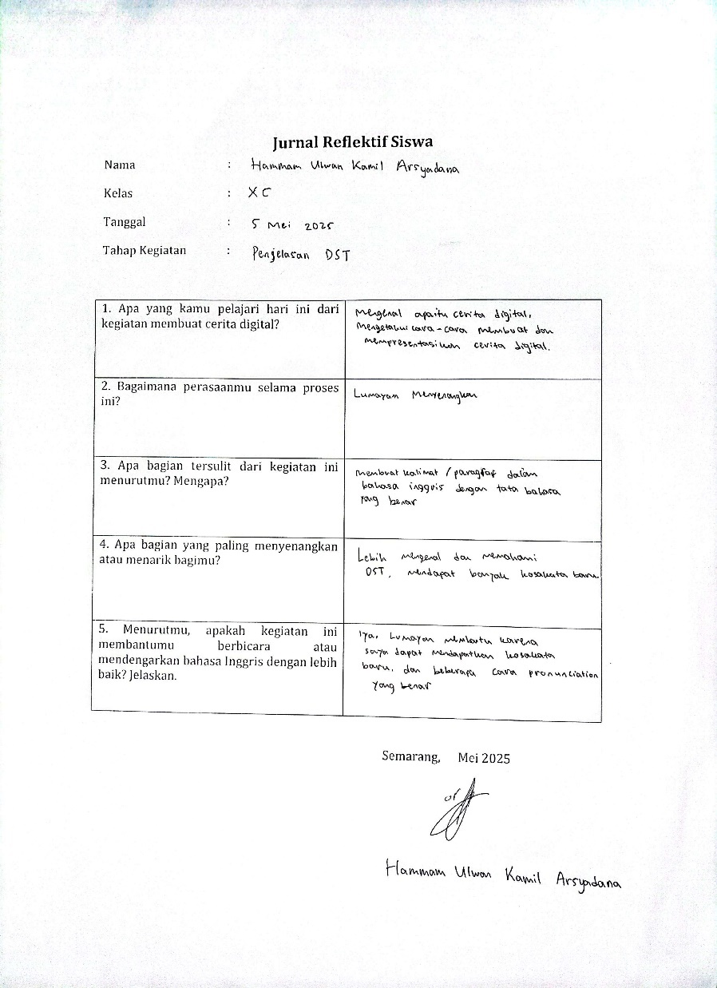
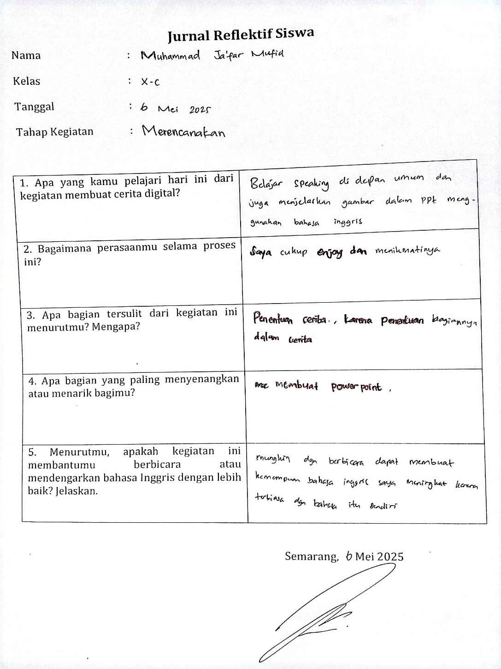
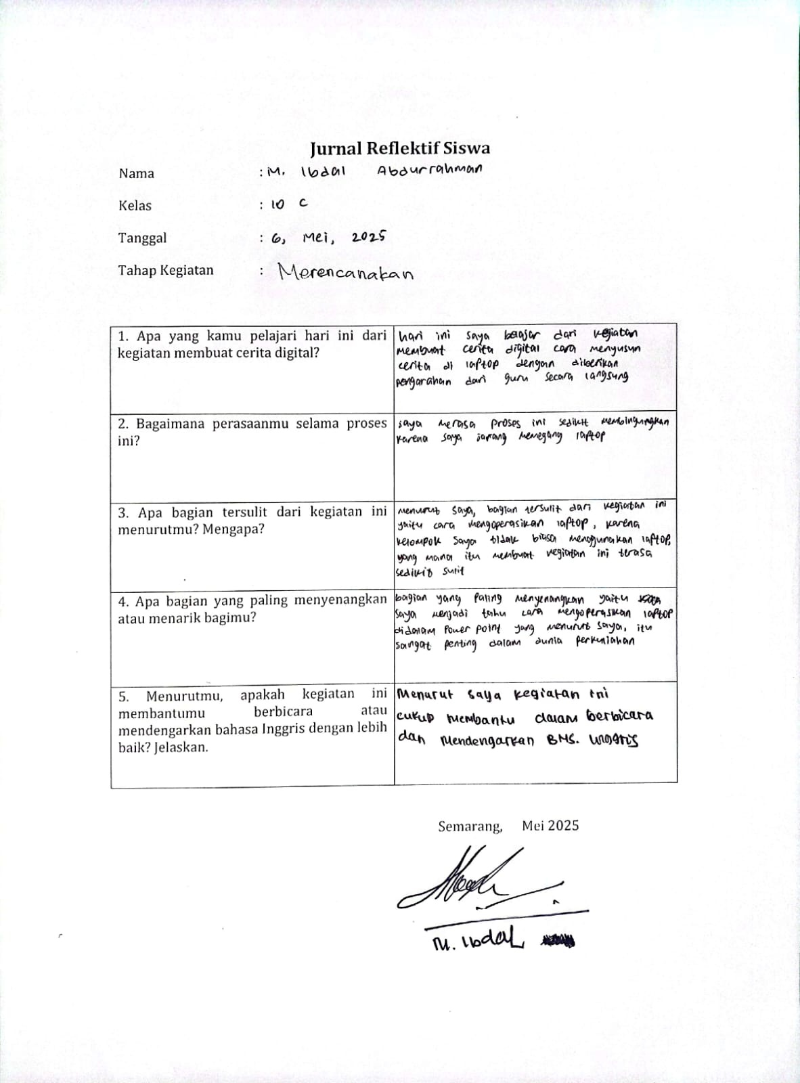
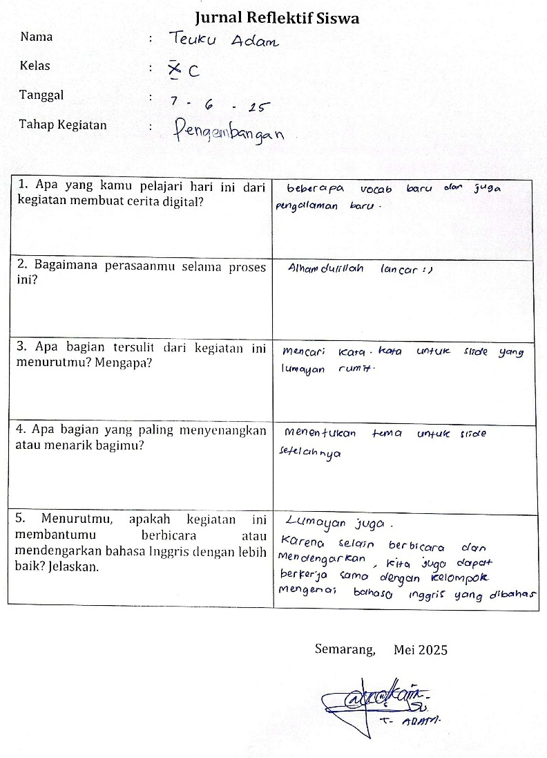
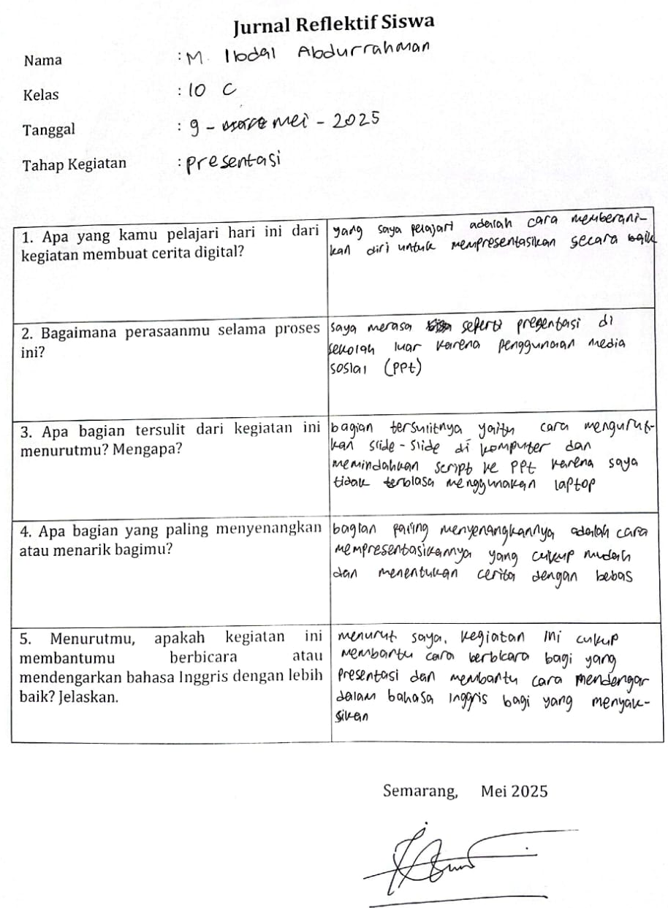
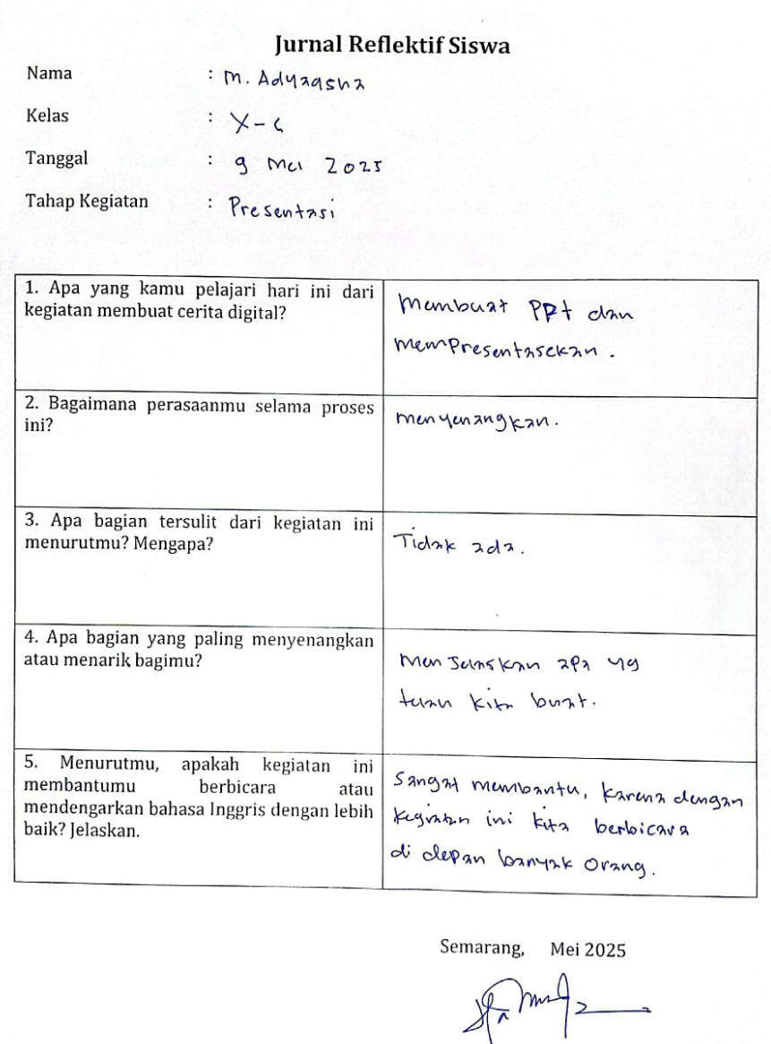
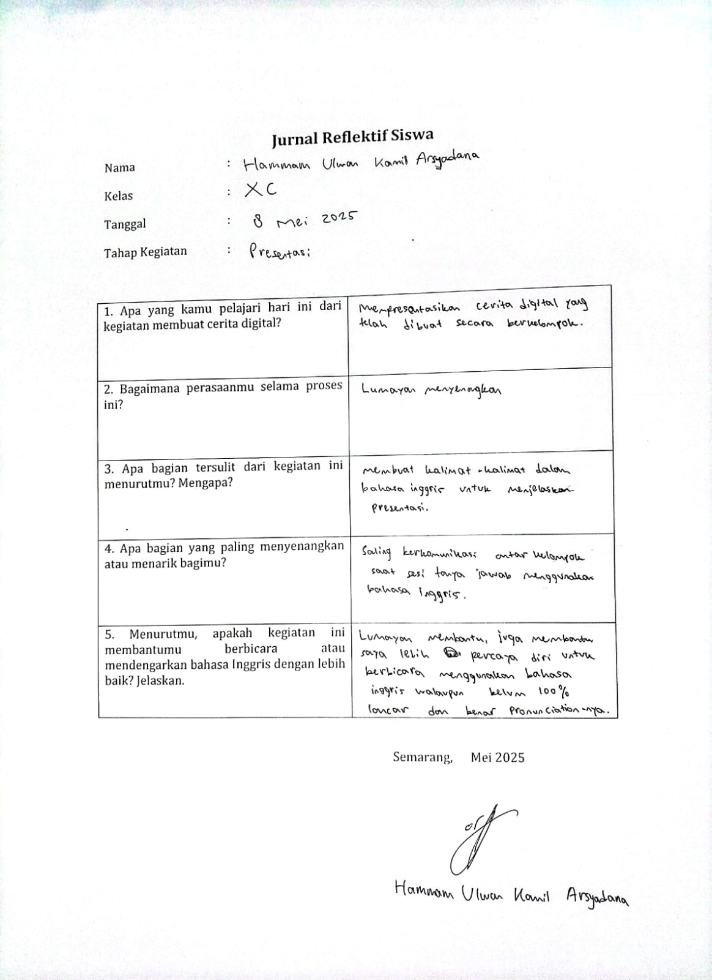
Reflective Journal Teacher-researcher
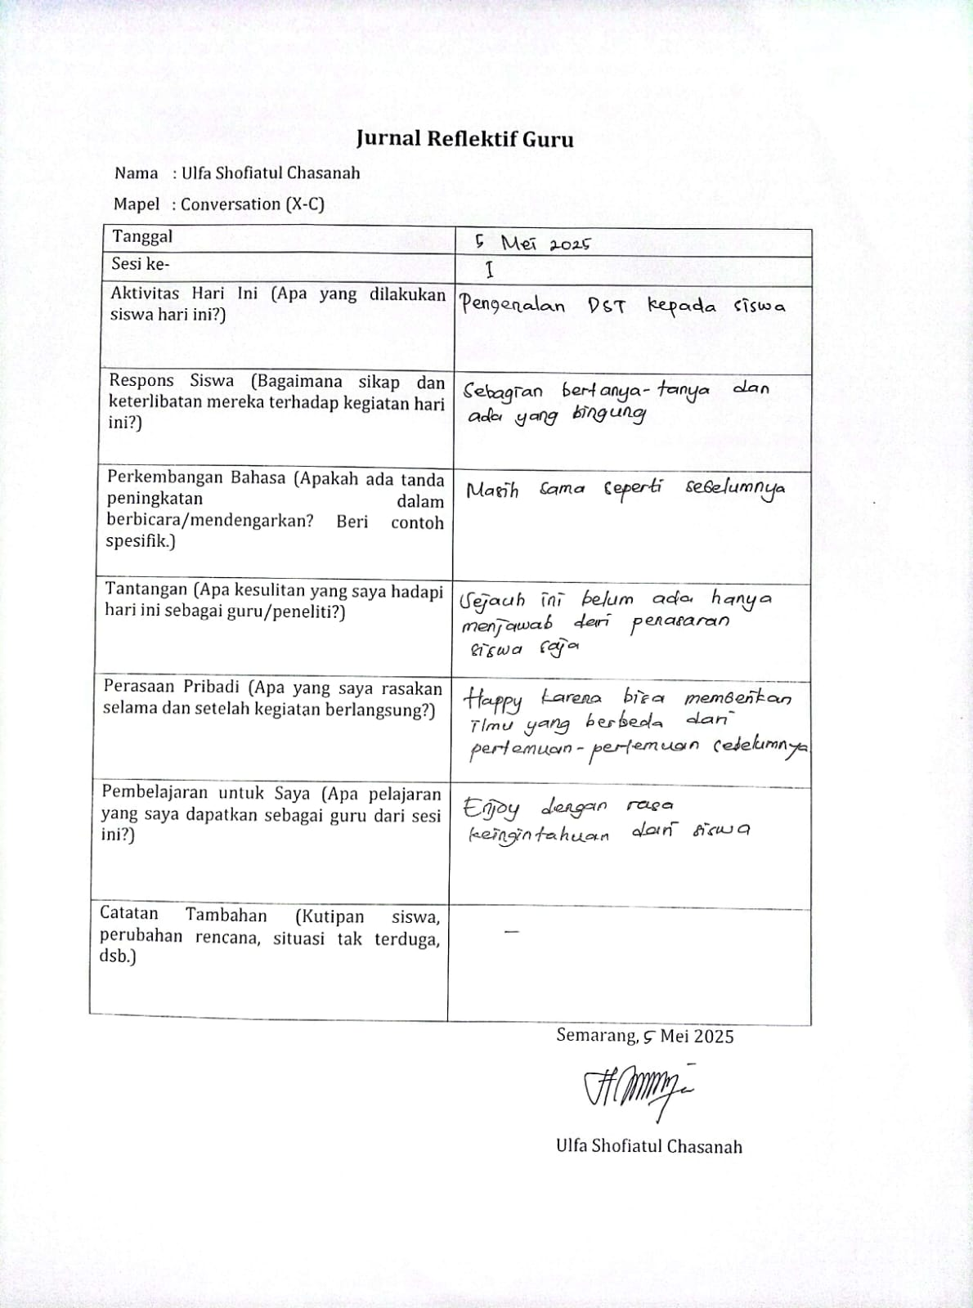
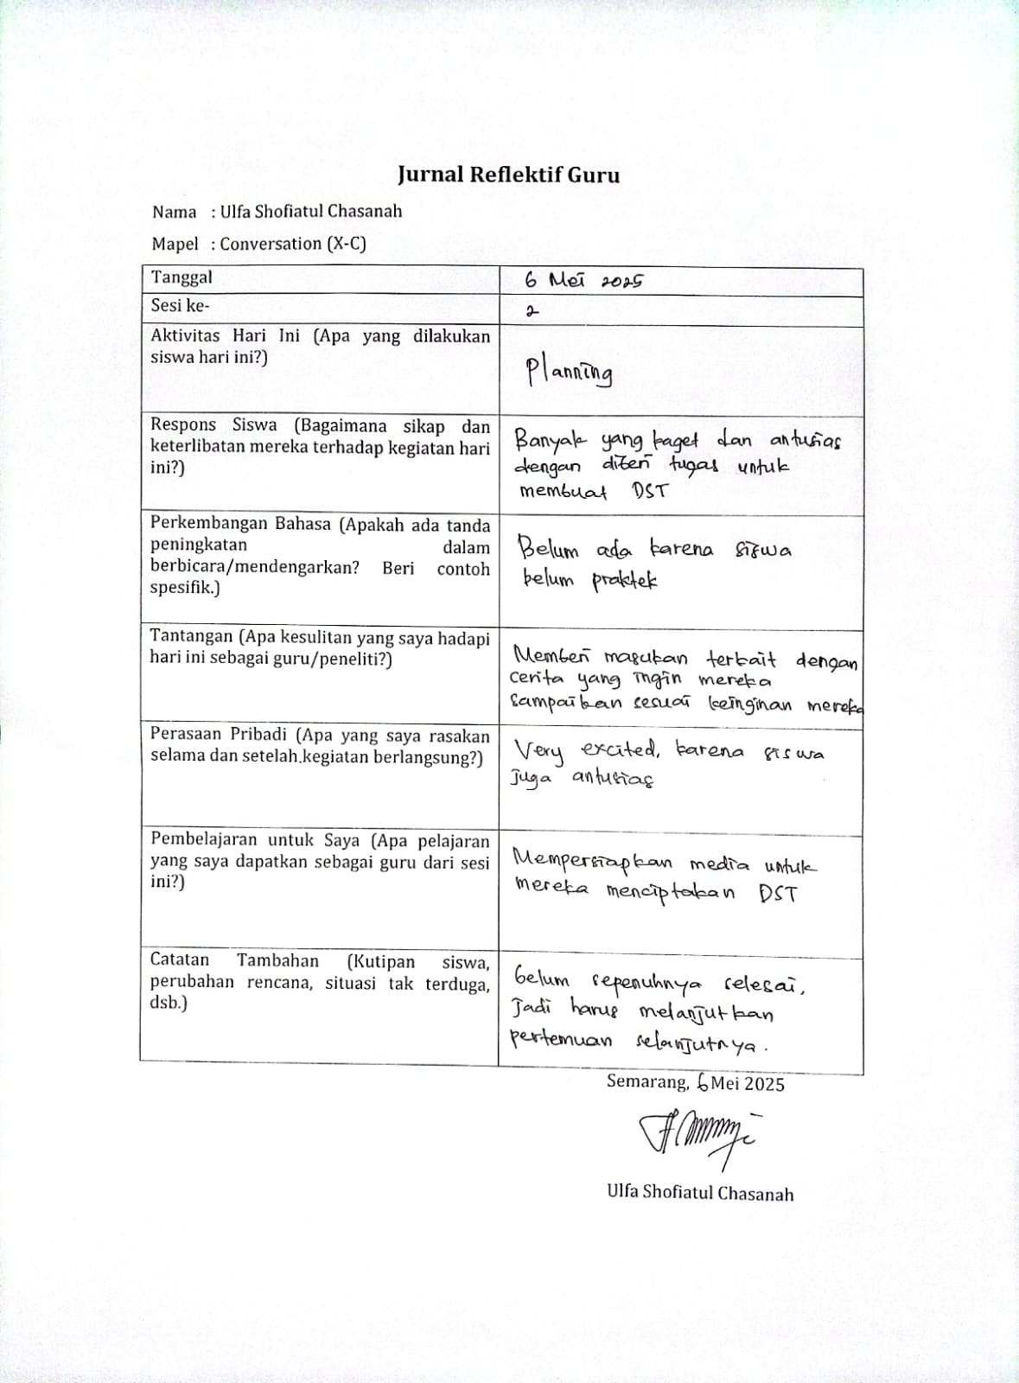
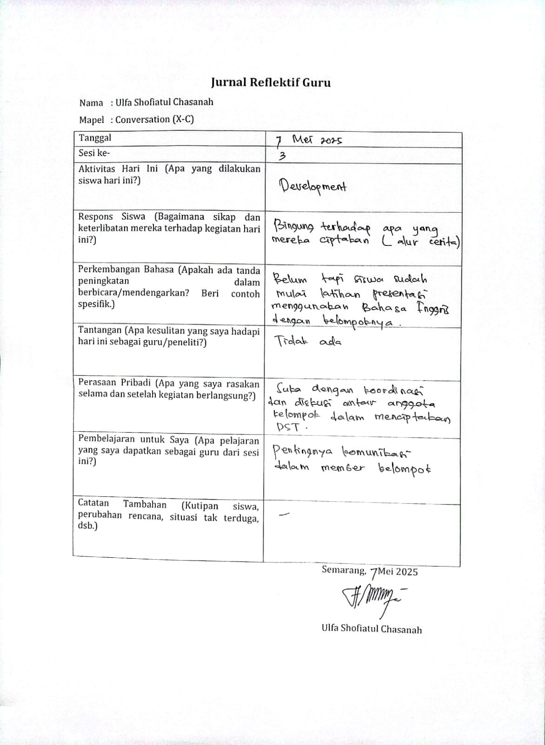
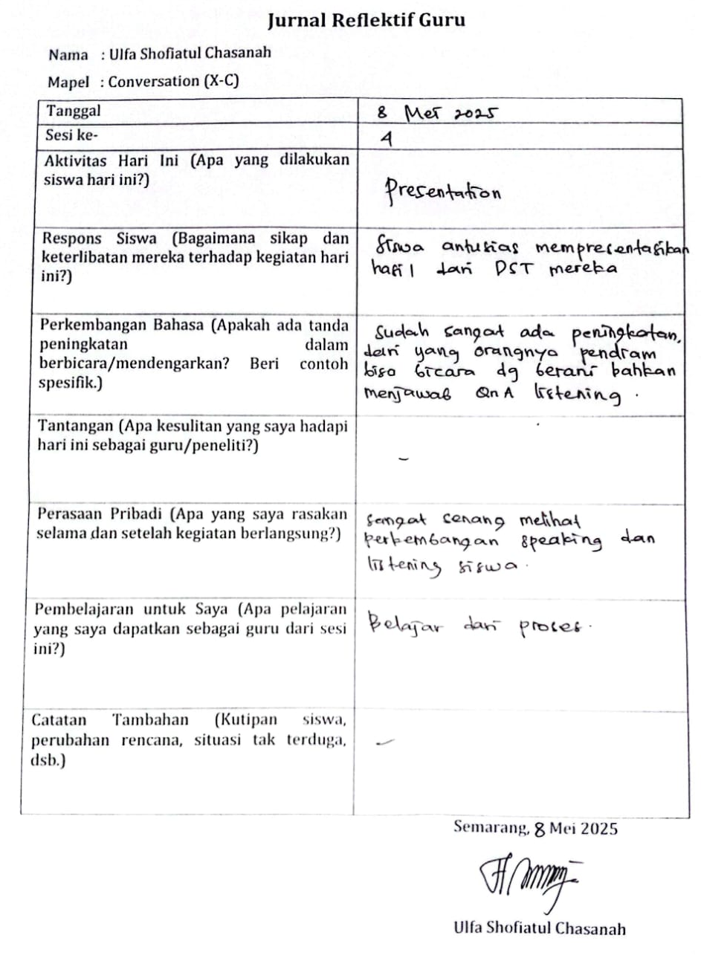
Interview Transcript
Q1: Bagaimana perasaanmu saat pertama kali diminta membuat cerita digital storytelling? (How did you feel when you were first asked to create a digital story?)

RT1: Saat pertama kali diminta membuat cerita digital storytelling, saya merasa tertantang dan bersemangat. Ini pengalaman baru bagi saya untuk membuat cerita yang tidak hanya ditulis, tapi juga harus disusun dalam PowerPoint dan dipresentasikan. Saya merasa senang karena bisa mengekspresikan ide dengan cara yang lebih kreatif dan tentunya meningkatkan skill saya dalam berbahasa Inggris. (When I was first asked to create a digital storytelling project, I felt challenged and excited. It was a new experience for me to create a story that wasn’t just written, but also had to be arranged in PowerPoint and presented. I felt happy because I could express my ideas in a more creative way and, of course, improve my English skills).

RT2: Jujur saya gugup waktu tahu harus presentasi di depan kelas. Saya tidak terlalu suka tampil di depan banyak orang, apalagi bercerita pakai bahasa Inggris. Meski masih grogi saat tampil, saya jadi merasa punya kesempatan untuk mencoba, dan ternyata teman-teman juga mendukung, jadi sedikit demi sedikit rasa takutnya berkurang. (Honestly, I was nervous when I found out I had to present in front of the class. I don’t really like speaking in front of a lot of people, especially telling a story in English. Even though I was still anxious during the presentation, I felt like I had the chance to try, and it turned out my classmates were supportive too, so little by little, the fear started to fade).
Q2: Apa bagian yang paling sulit dalam membuat atau menyampaikan cerita digitalmu? (What was the most difficult part of making or presenting your digital story?)
RT1: Bagian paling sulit menurut saya adalah memilih kata-kata yang tepat dalam bahasa Inggris dan menyusunnya menjadi cerita yang enak didengar. Saya ingin ceritanya menarik, tapi kadang bingung bagaimana menyampaikan ide saya dalam kalimat yang benar. Waktu presentasi juga menantang karena saya harus bicara lancar tanpa terlalu sering melihat slide. Tapi justru dari situ saya belajar banyak untuk meningkatkan speaking saya, terutama soal pengucapan dan intonasi. (The most difficult part for me was choosing the right words in English and organizing them into a story that sounded good. I wanted the story to be interesting, but sometimes I got confused about how to express my ideas in proper sentences. The presentation was also challenging because I had to speak fluently without looking at the slides too often. But that’s exactly where I learned a lot to improve my speaking skills, especially in terms of pronunciation and intonation).
RT2: Buat saya yang paling sulit adalah saat harus menyampaikan cerita di depan kelas. Saya kurang percaya diri berbicara dalam bahasa Inggris, apalagi takut salah ucap atau lupa artinya. Saat menulis ceritanya juga sulit karena saya bingung menyusun kalimat. Tapi karena harus latihan dulu sebelum tampil, saya jadi lebih sering mendengarkan cara pengucapan yang benar dari teman atau dari guru. (For me, the hardest part was delivering the story in front of the class. I wasn’t very confident speaking in English, especially because I was afraid of mispronouncing words or forgetting their meanings. Writing the story was also difficult because I struggled to structure the sentences. But since we had to practice before performing, I ended up listening more often to the correct pronunciation from my friends or the teacher).
Q3: Menurutmu, apakah kemampuan berbicaramu meningkat setelah proyek ini? Bisa dijelaskan bagaimana? (Do you think your speaking skill improved after this project? Can you explain how?)
RT1: Iya, saya merasa kemampuan berbicara saya meningkat setelah membuat dan mempresentasikan digital storytelling ini. Karena saya harus menulis cerita sendiri, lalu latihan membacanya dengan intonasi yang tepat, saya jadi lebih terbiasa memilih kata-kata dan menyampaikan ide dalam bahasa Inggris. Saat presentasi, saya juga belajar untuk lebih percaya diri dan tidak terlalu bergantung pada teks. Jadi, selain meningkatkan grammar, proyek ini juga bantu saya lebih lancar dalam berbicara. (Yes, I feel that my speaking skills improved after creating and presenting this digital storytelling project. Since I had to write my own story and practice reading it with the right intonation, I became more used to choosing words and expressing ideas in English. During the presentation, I also learned to be more confident and not rely too much on the script. So, besides improving my grammar, this project also helped me become more fluent in speaking).
RT2: Menurut saya, ada peningkatan, walaupun belum terlalu besar. Saya biasanya jarang berbicara dalam bahasa Inggris, tapi karena proyek ini saya harus latihan ngomong, minimal membaca teks saya sendiri, jadi sedikit banyak saya belajar pengucapan yang benar. Sekarang saya jadi lebih berani untuk mencoba bicara, walaupun masih pelan-pelan. (In my opinion, there has been some improvement, even though it’s not very significant yet. I usually rarely speak in English, but because of this project, I had to practice speaking, at least by reading my own script, so I learned the correct pronunciation little by little. Now I feel braver to try speaking, even if it’s still slowly).
Q4: Bagaimana pengalamanmu saat mendengarkan cerita digital dari teman-temanmu? (How was your experience listening to your friends' digital stories?)
RT1: Menurut saya, bagian tanya jawab setelah presentasi itu sangat bermanfaat. Saya jadi belajar mendengarkan pertanyaan dari teman-teman dan guru dengan lebih fokus, supaya bisa menjawab dengan tepat. Kadang pertanyaannya sederhana, tapi ada juga yang membuat saya berpikir lebih dalam. Dari situ saya merasa kemampuan listening saya meningkat karena saya benar-benar harus paham apa yang ditanyakan, bukan cuma dengar sekilas. (In my opinion, the Q&A session after the presentation was very valuable. I learned to listen more carefully to questions from my classmates and teacher so I could respond accurately. Sometimes the questions were simple, but there were also ones that made me think more deeply. From that experience, I feel my listening skills improved because I really had to understand what was being asked, not just hear it briefly).
RT2: Waktu sesi tanya jawab, saya cukup tegang karena harus dengar pertanyaan dalam bahasa Inggris dan langsung menjawab. Kadang saya tidak langsung paham, jadi harus benar-benar konsentrasi. Tapi karena itu saya merasa listening saya sedikit-sedikit meningkat. Saya jadi lebih terbiasa memahami bahasa Inggris lisan, meskipun masih pelan-pelan. Dengar teman-teman lain bertanya juga membantu saya belajar dari cara mereka menyampaikan pertanyaan. (During the Q&A session, I felt quite tense because I had to listen to questions in English and respond right away. Sometimes I didn’t understand immediately, so I really had to concentrate. But because of that, I feel my listening skills have gradually improved. I’m becoming more used to understanding spoken English, even if it's still slow. Listening to my classmates ask questions also helped me learn from the way they expressed their ideas).
Q5: Setelah mengikuti proyek ini, apakah kamu merasa lebih percaya diri berbicara dalam Bahasa Inggris? Kenapa? (After this project, do you feel more confident speaking in English? Why?)
RT1: Iya, saya merasa lebih percaya diri sekarang. Karena selama proyek ini saya punya kesempatan untuk menyusun cerita sendiri, latihan bicara, lalu menyampaikan di depan kelas, saya jadi terbiasa menggunakan bahasa Inggris secara langsung. Walaupun awalnya grogi, lama-lama saya merasa nyaman karena teman-teman juga melakukan hal yang sama, dan guru memberikan respon yang positif. Itu membuat saya lebih berani untuk mencoba berbicara. (Yes, I feel more confident now. Throughout this project, I had the opportunity to write my own story, practice speaking, and present it in front of the class, which helped me get used to using English in real situations. Although I was nervous at first, over time I started to feel more comfortable because my classmates were doing the same, and the teacher gave positive feedback. That made me more willing to try speaking).
RT2: Sedikit demi sedikit saya merasa lebih percaya diri. Awalnya saya takut salah ngomong atau diejek, tapi ternyata suasananya mendukung dan semua teman juga belajar. Proyek ini membantu saya keluar dari zona nyaman, karena saya harus latihan bicara dan menjawab pertanyaan. Sekarang saya merasa lebih berani mencoba berbicara meskipun masih sederhana dan terbata-bata. (I have gradually started to feel more confident. At first, I was afraid of making mistakes or being laughed at, but it turned out the atmosphere was supportive and everyone was learning too. This project helped me step out of my comfort zone because I had to practice speaking and answer questions. Now I feel braver to try speaking, even though it’s still simple and a bit hesitant).
Q6: Menurutmu, belajar melalui digital storytelling lebih menyenangkan atau tidak dibandingkan cara belajar biasa? Jelaskan ya. (Do you think learning through digital storytelling is more fun than regular lessons? Please explain).
RT1: Menurut saya, belajar dengan digital storytelling jauh lebih menyenangkan dibanding cara biasa. Saya merasa lebih bebas mengekspresikan ide, dan proses menyusun cerita di PowerPoint membuat saya lebih kreatif. Tidak hanya menulis, tapi juga berpikir bagaimana menyusun gambar, teks, dan alurnya agar menarik. Saya juga merasa lebih terlibat karena bisa menyampaikan langsung di depan kelas, jadi tidak bosan seperti saat hanya mendengarkan penjelasan guru. (In my opinion, learning through digital storytelling was much more enjoyable compared to the usual methods. I felt freer to express my ideas, and the process of arranging the story in PowerPoint made me more creative. It wasn’t just about writing, but also thinking about how to organize images, text, and the flow to make it interesting. I also felt more involved because I got to present directly in front of the class, so it wasn’t boring like just listening to the teacher’s explanation).
RT2: Awalnya saya merasa agak sulit, tapi lama-lama saya merasa lebih senang belajar dengan cara ini. Digital storytelling membuat saya aktif berpikir, bukan cuma duduk mendengarkan. Walaupun saya tidak terlalu suka tampil, saya tetap merasa cara ini lebih menarik daripada mengerjakan tugas biasa atau membaca buku. Saya juga bisa belajar dari cerita teman-teman, jadi suasananya lebih hidup dan tidak membosankan. (At first, I found it a bit difficult, but gradually I started to enjoy learning this way more. Digital storytelling made me actively think, not just sit and listen. Although I didn’t really like presenting, I still felt this method was more interesting than doing regular assignments or reading books. I could also learn from my classmates’ stories, so the atmosphere was livelier and not boring).
Q7: Apa hal yang paling kamu sukai dari kegiatan digital storytelling ini? (What did you enjoy the most about this digital storytelling activity?)
RT1: Saya paling suka bagian saat saya bisa berkreasi memilih gambar dan menyusun cerita sesuai ide saya sendiri. Rasanya menyenangkan bisa menggabungkan teks dan gambar untuk membuat cerita yang menarik. Selain itu, saya juga senang saat harus presentasi karena itu membuat saya merasa lebih percaya diri dan dapat langsung berinteraksi dengan teman-teman. (I liked the part where I could be creative by choosing images and arranging the story according to my own ideas the most. It felt enjoyable to combine text and pictures to create an interesting story. Besides that, I also enjoyed presenting because it made me feel more confident and allowed me to interact directly with my classmates).
RT2: Saya paling suka karena saya bisa belajar dengan cara yang tidak membosankan. Saya juga merasa lebih mudah memahami cerita teman-teman lewat gambar dan teks di PowerPoint. Walaupun saya malu saat presentasi, saya senang karena mendapat kesempatan untuk mencoba dan belajar dari teman-teman. (I liked it the most because I could learn in a way that wasn’t boring. I also found it easier to understand my classmates’ stories through the pictures and text in PowerPoint. Although I felt shy during the presentation, I was happy because I got the chance to try and learn from my friends).
Q8: Kalau diberi kesempatan mengulang atau memperbaiki proyek ini, apa yang ingin kamu ubah atau tingkatkan? (If you had the chance to redo or improve the project, what would you change or improve?)
RT1: Kalau bisa mengulang, saya ingin lebih banyak waktu untuk mempersiapkan cerita dan presentasi supaya bisa membuatnya lebih menarik dan lancar saat menyampaikan. Saya juga ingin mencoba menambahkan lebih banyak elemen visual atau desain di PowerPoint supaya ceritanya makin hidup. Selain itu, saya ingin berlatih speaking supaya saat presentasi saya lebih percaya diri dan tidak grogi. (If I could do it again, I would want more time to prepare the story and presentation so I could make it more interesting and deliver it more smoothly. I would also like to try adding more visual elements or designs in PowerPoint to make the story come alive. Besides that, I want to practice speaking more so that during the presentation I feel more confident and less nervous.)
RT2: Saya ingin belajar lebih banyak tentang cara membuat slide yang bagus dan cara menyusun cerita supaya lebih jelas. Kalau bisa, saya juga ingin latihan presentasi lebih sering supaya tidak terlalu gugup saat berbicara di depan kelas. Saya berharap ada lebih banyak bimbingan atau contoh supaya saya lebih paham langkah-langkahnya. (I want to learn more about how to make good slides and how to organize a story more clearly. If possible, I would also like to practice presenting more often so I’m not too nervous when speaking in front of the class. I hope there will be more guidance or examples so I can better understand the steps).

Observation Checklist Result
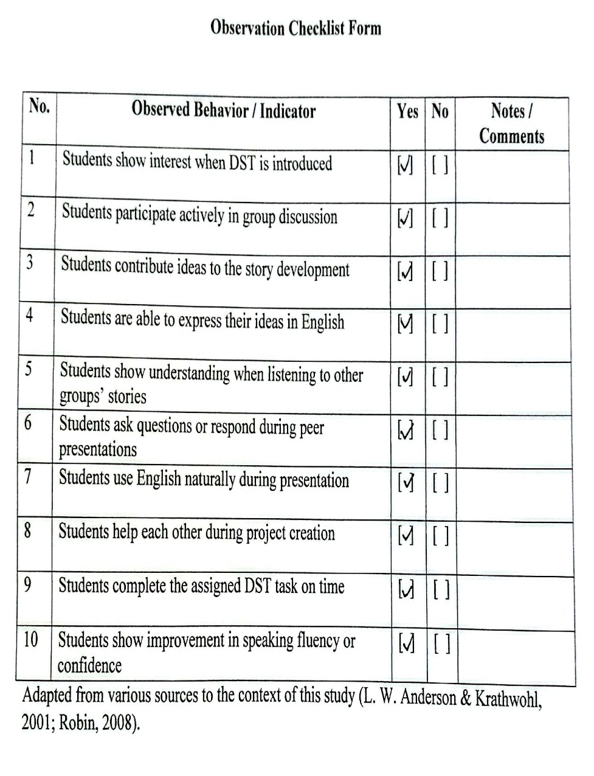

Students’ Worksheets or DST Project
DST Project - Group 1
Title | The Story of Prophet Nuh AS
Presenters | Aqsha, Labiq, Hilmi, Ibdal, Nafis, Rusyan
Slide Preview | Slide 1 - Title Page  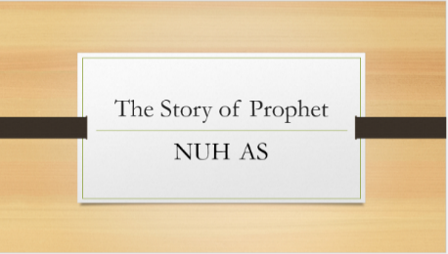
Slide Preview | Slide 4 – Conflict  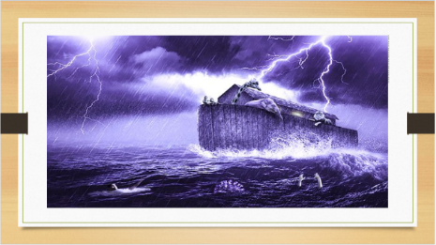
Slide Preview | Slide 7 – Resolution  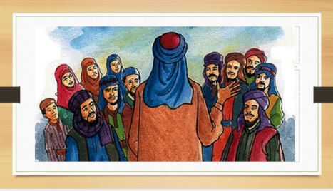
DST Project - Group 2
Title | The Lost Ball
Presenters | Hamam, Ulwan, Adam, Fatan, Khusaini, Fathul
Slide Preview | Slide 1 - Title Page  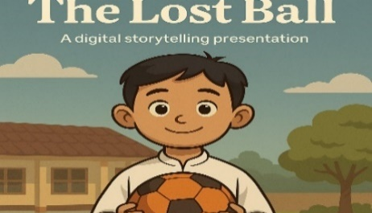
Slide Preview | Slide 4 – Conflict  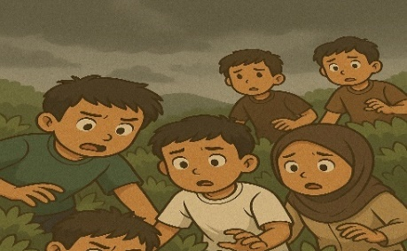
Slide Preview | Slide 7 – Resolution  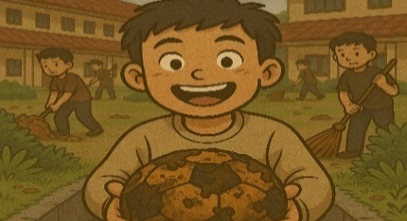

DST Project - Group 3
Title | The Sacrifice of Prophet Ibrahim
Presenters | Zidni, Afif, Kafi, Ja’far, Reyfano, Adib
Slide Preview | Slide 1 - Title Page  
Slide Preview | Slide 4 – Conflict  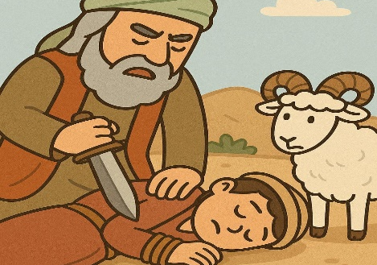
Slide Preview | Slide 7 – Resolution  

APPENDIX 3
Research License
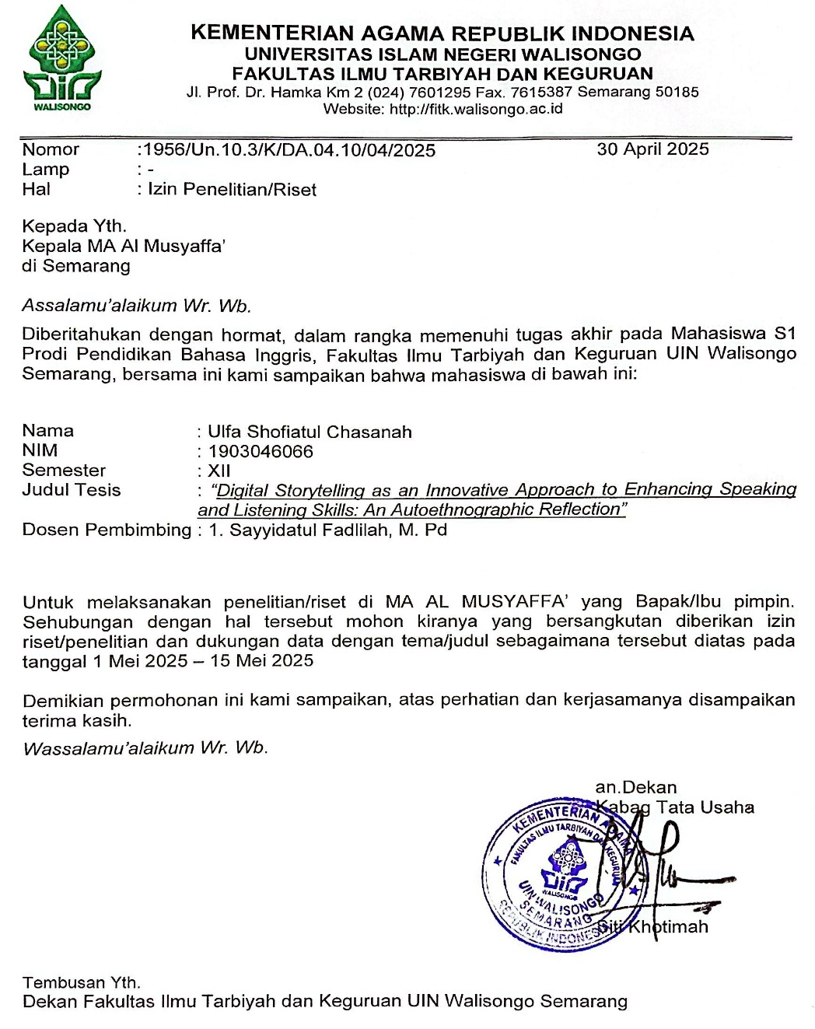

CURRICULUM VITAE
- Personal Data
Name | : | Ulfa Shofiatul Chasanah
Place of Birth | : | Grobogan
Date of Birth | : | 11th May 2001
Address | : | Dsn. Trisik RT 11 RW 1 Ds. Tarub, Kec. Tawangharjo, Grobogan, Central Java.
E-mail | : | ulfasc11@gmail.com
Phone | : | 081225046233

- Education Background
- TK Dharma Wanita 1 Tarub
- SDN 1 Tarub
- MTs Nuril Huda Tarub
- MA Nuril Huda Tarub
- UIN Walisongo Semarang

